Auction Catalogue
Auction conducted by A H Bilimoria & Co.
Auction of Misc Hardware Item/Capital Items, TRF Limited/NTPC Nabinagar
BEING SOLD ON ‘’AS IS WHERE IS AND NO COMPLAINT BASIS’’
Catalogue Serial Number: | TRF/AHB/APRIL/002/24-25
Seller: | TRF Limited / NTPC Nabinagar
Auction website: | www.ahbilimoria.com
e-Auction Date & Time: | 26th April, 2024…..….. at 03:00 PM
Inspection Date & Time: | 25th April, 2024…..….. at 11:00 AM--For inspection of materials the interested customers should report at TRF Limited, NTPC Limited, Ankorha, Nabinagar Super Power Thermal Power Plant, Nabinagar, Bihar - 824301 ------- BY 10:30 AM.  Interested customers have to come with Aadhaar Card, safety shoes, safety jackets & safety helmets at the time of inspection.
Date of Security Money Deposit | 26th April, 2024 Till ……… at 02:00 PM
Contact Details:
For Post Auction @ A H Bilimoria & Company
Area | Contact No. | Email Id
Auction Room | 07003840027/09883421336
Lot Confirmation Related | 08987460668 | ahb@ahbilimoria.com, ahbilimoria.company@gmail.com
For time bound resolution of unresolved issues log into our Customer Complaint Management portal | Type in www.ahbilimoria.com> Go to “Customer Complaint Management Portal” >Log in with your user id and password and write the details of issue.

For Any unresolved Issues beyond two (02) days mail to A H Bilimoria & Company :
Mr. A K Sil (M-09830074122) & Mr. D Pyne (M-09830738481), E-mail: ahb@ahbilimoria.com, ahbilimoria.company@gmail.com
Copy to TRF Ltd/NTPC Nabinagar : Mr. Rajnish Sinha-9308797583 (rajnish.sinha@trf.co.in)

SPECIAL NOTE: -It is the responsibility of the buyer to furnish the valid GST no. & necessary documents to A H Bilimoria & Company before participating in the auction. In case during the transactions, it is found that valid GST no. has not been provided, then all necessary liabilities if any & so accrued would be on account of the buyer. TRF Limited / NTPC Nabinagar & A H Bilimoria & Company would not be responsible for any such liabilities.

Note: TRF LIMITED / NTPC NABINAGAR reserves the right to track IP address, MAC number and geolocation of bidding customers whenever customers participate in any auction on the A H Bilimoria & Co. auction platform for TRF Limited / NTPC Nabinagar

- Payment and Lifting Schedule:
Lot No. | Payment Schedule | Lifting Schedule  (working days from the last payment date)
 | Full Payment
For All Material | 100% payment including taxes within 02 Working day from Date of Lot Confirmation. | As per material list

- Suitable extension of due date for payment and lifting will be accorded in case of any eventualities like Strike/ Bandh/ Special restriction on vehicular movement imposed by the local Administration etc.

- Requirements of participation:
  - Registration: Before participation in the e-Auction, a prospective bidder shall be required to get registered with A H Bilimoria & Co. For details visit www.ahbilimoria.com

  - Security Deposit: Non-Interest bearing security deposit of Rs.60,000/- (Rupees Sixty Thousand only) in favour of “A H Bilimoria & Co.” through Online Payment only : Details as under :

Beneficiary Name | A. H. BILIMORIA & COMPANY
Bank Name | HDFC Bank
Branch Name | 31, Chowringhee Road, Kolkata – 700016
Account No | 06932560001205
IFSC Code | HDFC0000693

- Inspection Rules & Policy:
- All parties to send their request for registration of inspection through registered e-mail to b.bhardwaj@ahbilimoria.com, ahb@ahbilimoria.com, ahbilimoria.company@gmail.com one day prior to the date of inspection.
(Mail request should contain – Person Name, ID Proof, Firm Name, Mobile No., Name of the Auction& Letter of authorization for inspection)
Visitor GP of only those customers would be approved, who have sent their request via mail to A H Bilimoria & Co, one day prior to inspection.
- All interested parties should reach at at TRF Limited, NTPC Limited, Ankorha, Nabinagar Super Power Thermal Power Plant, Nabinagar, Bihar - 824301 by 10:30 AM on the date of inspection.
- Only registered customers/bidders/representatives of firms shall be allowed for inspection of material, subject to fulfilling their safety requirement of the steel works.
- Taking photographs of the material is strictly prohibited.
- Customers are advised to ensure that they inspect the materials on offer on the scheduled date as mentioned in the catalogue, before Participating in the auction. It is reiterated that all materials are offer/sold by TRF Limited / NTPC Nabinagar on “AS-IS-WHERE-IS” and “NO-COMPLAINTS” basis, and no complaint what so ever shall be entertained regarding the quality of materials after the sale.
- “TRF Limited / NTPC Nabinagar” would not accept any claim from any customer for non-inspection of materials.”
Interested bidders have to come with safety shoes, safety fluorescent jackets, and safety goggles & safety helmets at the time of inspection. All interested parties have to arrange for their own safety shoes, safety jackets, safety helmets and safety goggles as per TRF Limited / NTPC Nabinagar standards. No person will be allowed to enter the works without these. Compliance to TRF Limited / NTPC Nabinagar safety norms is a must. No complaints during lifting, in what-so-ever manner, will be entertained if customers fail to inspect the materials during scheduled inspection dates. No ''people movement'' shall be allowed at the loading point during loading/delivery of materials from the yards. TRF Limited / NTPC Nabinagar will not be responsible for any delays arising out of non-compliance to TRF Limited / NTPC Nabinagar norms.

- Bidding modalities:
  - Price Bid Basis: In Indian rupees as per unit of measurement as given in Material List. Price to be quoted is basic, ex- location exclusive of taxes and any other statutory levies.
  - Bid Increment: As specified in the e-auction bid page
  - Type of Auction: English No Ties
  - Bid Validity: Bid shall be valid for 10 (Ten working days excluding Saturdays, Sundays and Bank holidays) working days counted from the next day of auction process in case of auction against a catalogue which is completed on the same day. And if it is continuing on any other day the counting of days for lot confirmation shall be from the next day of completion of entire auction process.
  - Bid duration: For 1st four lots 20 minutes and balance lots 10minutes. If, No bids received within these specified time the lots are closed automatically.

- Taxes & duties:
  - GST : As applicable
  - TCS : As applicable. In case of availing of concessional rate of TCS proper certificate issued by appropriate Income Tax authority are to be issued in favour of the Principal Company along with payment. Self certification of Form no 27C is not acceptable.
  - Any change in taxes applicable at the time of lifting shall be applicable.
  - Customers are required to submit Form 27C/Form 27G against the month of dispatch/expected dispatches. In the absence of Form 27C, TCS will be charged at the time of invoicing.

- Payment terms & conditions :
  - Payments: PAYMENT FACILITY BY RTGS / NEFT ONLY

Account No | 10660310000040
Beneficiary Name | TRF LIMITED
Bank Name | HDFC BANK LTD
IFSC Code | HDFC0001066

  - Full Payment Time: 100% payment including taxes within 02 Working day from Date of Lot Confirmation.
  - Delayed Payment Charges (DPC) : Installment payments with DPC @ five (05) paise per Rs. 100 per day will be accepted up to 4 (Four) working days from due date of installment payment as mentioned in the confirmation letter. This is not applicable for EMD payment.
  - Saturdays (only Bank Holidays)& Sundays are excluded for counting purpose for payment schedule.
  - In the event of Non-Receipt of Payment within the stipulated period of Payment, the Sale Offer for the approved Lot shall stand withdrawn automatically (Refer Clause#8).
  - Buyers have to send the payment deposit slip (UTR No /Scan Copy of NEFT/RTGS Transaction Slip) against Lot No. immediately after the payment to AHB at email id: ahb@ahbilimoria.com& ahbilimoria.company@gmail.com

- Lifting terms & conditions:
  - Loading Charges: All charges while lifting / loading / etc are in the scope of customer.
  - No alteration (Gas cutting , dismantling etc. ) in any form will be allowed at TRF premises .
7.2 Loading shall be given strictly as per the statutory norms & safety norms of TRF Limited / NTPC Nabinagar
7.3 PICK & CHOOSE NOT ALLOWED FOR ANY OF THE LOTS.
7.4 LOT TRANSFER WILL NOT BE ALLOWED.

- Penalty:
  - The following penalties shall be applicable in the eventuality of a buyer defaulting in making the payment of EMD (wherever applicable) or any installment/s, as per the stipulated schedule for each lot, in a financial year:
- In the first instance, a penalty of Rs. 60,000/- (Rupees Sixty Thousand only) shall be recovered from the customer.
- In the second instance, a penalty of Rs.100,000/- (Rupees One Lakh only) shall be recovered from the customer.
- In the third, and any subsequent instance, a penalty of Rs.150,000/-(Rupees One Lakh Fifty thousand only) shall be recovered and the customer shall be debarred from participating in any auction for a period of three months from the date of debarment.
In the event of any default, the customer’s user id will be disabled and the customer will be blocked from participating in any auction of TRF LIMITED / NTPC NABINAGAR with immediate effect.

The defaulting customer shall be allowed 06 (six) working days to deposit the penalty as mentioned above. In case the penalty is not received within the stipulated period, the customer’s security deposit shall be forfeited, and the defaulting customer shall be immediately debarred from participating in any auction of TRF LIMITED / NTPC NABINAGAR.

  - If after making payment of EMD (wherever applicable), the installment payment/s are not made by the customer as per the stipulated schedule for each lot, the entire EMD amount against such lot shall be forfeited.

  - In case of non- lifting of full lot quantity after making full payment, a penalty equivalent to 20% of the material value for the un-lifted quantity against each lot shall be recovered from the customer.

- Lot Closure Norms :
For Lot Closure, the tolerance would be ± 10% of the original quantity.

- Refund :
Refunds will only be made by TRF Limited / NTPC Nabinagar vide RTGS/NEFT and hence all customers are required to submit their bank details to A H Bilimoria & Company or mail at ahb@ahbilimoria.com, ahbilimoria.company@gmail.com, ahbjsr@ahbilimoria.com, b.bhardwaj@ahbilimoria.com. TRF Limited / NTPC Nabinagar or A H Bilimoria & Company will not be responsible for any delay in refunds owing to absence of bank details of the customer.

- Complaints :
Complaints, if any, with regard to any transaction shall have to be lodged by the buyer within three calendar months from the date of last invoice. No complaint shall be entertained thereafter, under any circumstances. Customers can log their complaints at (www.ahbilimoria.com> Go to “Customer Complaint Management Portal” >Log in with your user id and password and write the details of issue.)
- Jurisdiction :
Any dispute arising out of any contract shall be decided in Bihar by the courts in Bihar and by no other courts. The courts in Bihar shall have exclusive jurisdiction to adjudicate upon any such dispute.

- General terms & conditions:
  - Any dispute on quality & quantity of material and bid cancellation shall not be entertained at any point after the auction.
  - All lots are offered/sold on “As is Where is Basis” and “No Complaint Basis”.
  - Lot transfer will not be allowed. Payment and invoicing has to done in the name of the H1 bidder, subject to the prices being approved.
  - Lot purchased should consist of material from the same lot and designated location only. TRF Limited / NTPC Nabinagar has the right to check any vehicle at any moment of time. If material lifted differs from the material that is purchased by the buyer, then the buyer and authorized representative will be permanently debarred. Also TRF Limited / NTPC Nabinagar can take any penal action against the buyer/authorized representative. All the material loaded in the vehicle is to be covered in order to follow the safety compliance of TRF Limited / NTPC Nabinagar works.
  - If the safety compliance is not followed, then TRF Limited / NTPC Nabinagar can penalize the buyer / authorized representative as deemed fit.
  - Customer attested photocopy of valid id proof (Voter id/Aadhaar/Pan card) of all lifters / Authorized persons engaged by customers for lifting of materials from TRF LIMITED / NTPC NABINAGAR is to be enclosed with the authorization letters & to be forwarded to TRF LIMITED / NTPC NABINAGAR for issue of gate pass.
  - Dispatch is subjected to FORCE MAJEURE conditions.
  - The seller reserves the right to terminate any offer at any point of time without assigning any reasons.
  - In the event of termination of the offer, seller shall refund the balance amount after due reconciliation.
  - No claims whatsoever would be entertained after cancellation of the bid.
  - In addition of earlier safety norms, the following would be compulsory:
The drivers of the vehicle must have the eye test certificate. The frequency of the testing would be as below:
1. If the age of the person is less than 45 years - Once in a year
2. If the age of the person is 45 years or more, the testing is required to be done once in every 6 months
Please ensure to comply with the safety norms
  - Weighment: Weight recorded by TRF Limited / NTPC Nabinagar weighbridge will be considered final and binding on the customer.
  - Lifting of above obsolete items must start within 48 Hrs. after receipt of the Sale Order. Party will have to make his own arrangement for loading. Party must ensure lifting as per sales / delivery order. Undue delay in collection will Lead to cancellation of the sales / delivery order and forfeiture of the security Deposit/ EMD Amount.
  - TRF reserves the right to withdraw the materials in part or in full , without assigning any reason , before the materials is removed from the works.
  - Mandatory requirement for vehicle entry & PPE for Driver/ Labours as per Safety Clause in TRF must be followed.
  - Loading of Vehicle must be completed upto 5:00 pm. otherwise TRF will not be responsible for any detention of vehicle.
  - The Customer will be fully responsible for any type of Unethical Activity, Sexual Harassment done inside the company premises by Customer's representative/ driver/ labours etc & will be Panelized as per Co. rules.

14. Compliance to safety norms
14.1 Authorized persons (of the customer) involved in lifting of the materials will be allowed only with Personal Protective Equipment’s (PPE) i.e., Safety Shoes, Safety Helmet, Safety Goggles, Fluorescent Jacket and Hand Gloves. No "people movement" shall be allowed at the time of loading/delivery of materials from the yards" TRF Limited / NTPC Nabinagar will not be responsible for any delays arising out of Non- Compliance to the Safety Norms.

14.2 Documents for verification regarding entry of vehicles inside TRF Limited / NTPC Nabinagar works :
All customers to note that presentation of following set of documents to TRF LIMITED / NTPC NABINAGAR authorities is COMPULSORY at the time of reporting of vehicles at TRF LIMITED / NTPC NABINAGAR designated Gate for entry of Customer trucks/vehicles.
a. Driving License of driver,
b. Registration Card,
c. Commercial Certificate,
d. Fitness Certificate of Vehicle,
e. Re-registration for vehicles older than 15 years
f. Insurance
The checklist form will be filled in at TRF LIMITED / NTPC NABINAGAR designated Gate for entry of Customer trucks/vehicles before entry of vehicle.

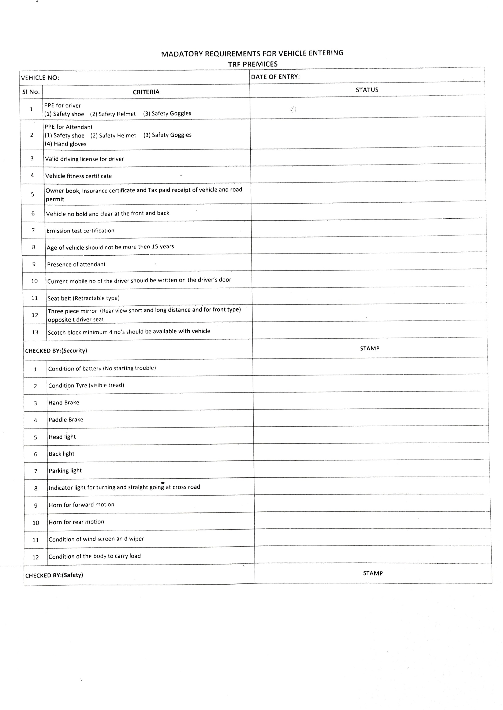
15. DISCLAIMER FOR E-AUCTION
BANDWIDTH PROBLEMS, CONNECTIVITY PROBLEMS WITH THE LOCAL ISP (INTERNET SERVICE PROVIDER), SLOWNESS TO ACCESS PAGES FOR DOWNLOADING ETC. ARE BEYOND THE CONTROL OF TRF LIMITED / NTPC NABINAGAR AND A H BILIMORIA & COMPANY. HENCE NO RESPONSIBILITY LIES WITH TRF LIMITED / NTPC NABINAGAR OR A H BILIMORIA & COMPANY FOR THE ABOVE PROBLEMS FACED, IF ANY, BY THE BIDDERS BEFORE/DURING THE AUCTION ANY. BID PLACED USING THE BIDDER'S USERNAME AND PASSWORD IS UNCONDITIONALLY BINDING ON THE BIDDER TO WHOM SUCH USERNAME AND PASSWORD HAD BEEN ALLOTTED AND HE SHALL BE SOLELY RESPONSIBLE FOR MAINTAINING THE CONFIDENTIALITY OF THE SAME AND FULLY RESPONSIBLE FOR ALL ACTIVITIES THAT OCCUR UNDER THEIR USERNAME AND PASSWORD. HENCE THE USER IS ADVISED TO CHECK THE USERNAME AND PASSWORD BEFORE THE AUCTION,IN ORDER TO FAMILIARISE HIMSELF WITH THE SAME AND IS ADVISED NOT TO REVEAL IT TO ANYONE ELSE SO AS TO PREVENT MISUSE OF THE SAME. THE BIDS MADE BY THE BIDDERS AGAINST THEIR USERNAME AND PASSWORD SHALL BE IRREVOCABLE.THE BIDDERS ARE ADVISED TO REGISTER AND PRE-QUALIFY FOR BIDDING WELL IN ADVANCE AND PLACE THEIR BIDS EARLY IN ORDER TO TAKE CARE OF ANY UNFORESEEN TECHNICAL DIFFICULTY THAT MIGHT SURFACE IN THE INTERNET OPERATIONS.

Lot Photograph: Photographs of lots are at best indicative only and do not necessarily reflect the actual condition of lots. All bidders are advised to physical inspect the offered lots before participating in the auctions. TRF Limited / NTPC Nabinagar or A H Bilimoria & Co. shall not be responsible or liable for any error of judgment or bids put by bidders acting on the basis of these photographs.

Quantity offered is based on eye estimation. Delivery will be made for the estimated quantity or actual ground stock. Estimation error may arise. No complaint of whatsoever nature on estimated /offered quantity shall be entertained under any circumstances. Bidders are advised to make their own judgment on offered quantity before bidding.

MATERIAL DETAILS: AS PER ANNEXURE :
List of materials
Sl. No. | Location | Lot no. | Material Description | Qty | UOM | GST | TCS | Loading | LIFTING PERIOD | Contact person | Contact no
1 | TRF Limited, C/o. NTPC Limited, Ankorha,  Nabinagar Super Power Thermal Power Plant  Nabinagar,  Bihar - 824 301 | TRF/23-24/020 | Oil Cooler (01 No Oil cooler Pressure 15 bar, 50deg C ,130 mm thk,156 Nos copper  tubes 4 rows) “AS IS WHERE IS ". | 1 | No | 18% | 1% | Customer scope | 20 Working Days from the last payment days | Mr. Meraj Ahmad/ Mr. Rajnish Kumar Sinha | 8292643813/9308797583
2 | TRF Limited, C/o. NTPC Limited, Ankorha,  Nabinagar Super Power Thermal Power Plant  Nabinagar,  Bihar - 824 301 | TRF/23-24/021 | IT Items (13 items), List attached.(Computer will be disposed without HARD DISC),“AS IS WHERE IS ". Valid E-waste certificate required | 1 | Lot | 18% | 1% | Customer scope | 20 Working Days from the last payment days | Mr. Meraj Ahmad/ Mr. Rajnish Kumar Sinha | 8292643813/9308797583
3 | TRF Limited, C/o. NTPC Limited, Ankorha,  Nabinagar Super Power Thermal Power Plant  Nabinagar,  Bihar - 824 301 | TRF/23-24/022 | Electrical & Electronic Capital Items (15 items), List attached, “AS IS WHERE IS ". Valid E-waste certificate required | 1 | Lot | 18% | 1% | Customer scope | 20 Working Days from the last payment days | Mr. Meraj Ahmad/ Mr. Rajnish Kumar Sinha | 8292643813/9308797583
4 | TRF Limited, C/o. NTPC Limited, Ankorha,  Nabinagar Super Power Thermal Power Plant  Nabinagar,  Bihar - 824 301 | TRF/23-24/023 | Miscellaneous Items ( 17 Items), List attached, “AS IS WHERE IS " | 1 | Lot | 18% | 1% | Customer scope | 15 Working Days from the last payment days | Mr. Meraj Ahmad/ Mr. Rajnish Kumar Sinha | 8292643813/9308797583

LIST OF IT ASSETS AT NABINAGAR PROJECT SITE (Lot no. TRF/23-24/021)
SR NO | DESCRIPTION | QTY | UOM | REMARKS 1 | Reamrks
1 | Computer with desktop -  MAKE ZENITH | 2 | SET | 1 M/C IS WORKING | Without hard disk
2 | DELL COMPUTER DESK TOP (I3-4130 PRCESSOR)KEYBOARD,MOUSE,17" MONITOR MAKE:- DELL OPTIPLEX 3020 | 2 | SET | 1 M/C - WORKING  1 M/C - NOT WORKING | Without hard disk
3 | COMPUTER SET DESKTOP(OLD & USED) MAKE DELL OPTIPLEX 380 | 2 | SET | WORKING CONDITION | Without hard disk
4 | COMPUTER SET DESKTOP(OLD & USED) MAKE DELL OPTIPLEX 380 | 1 | SET | WORKING CONDITION | Without hard disk
5 | MONITOR(WITHOUTCPU&UPS) | 2 | NOS | NOT WORKING CONDITION | Without hard disk
6 | UPS | 8 | NOS | NOT WORKING CONDITION APC MAKE-7 & INTEX 725 MAKE -1
7 | XEROX CUM PRINTER(RICOH ATICIO) MP2000L2 | 1 | NO | NOT WORKING CONDITION
8 | HP DESIGN PRINTER 510, 42" MY0BN3302Y(PLOTER) | 1 | NO | NOT WORKING CONDITION
9 | PRINTER HPLJM435A3 E 42A SR.NO. CND8H62M24 | 1 | NOS | NOT WORKING CONDITION
10 | PRINTER MAKE HP WITH ADOPTER (CN25G312CX) | 1 | NOS | NOT WORKING CONDITION
11 | HP PRINTER CN539GJ2WF | 1 | SET | FULLY DAMAGE CONITION
12 | AHUJA MEGA PHONE (PUBLIC ADDRESS SYSTEM) | 1 | NOS | NOT WORKING CONDITION
13 | JIO FI ROUTER WITH OUT SIM & WITH OUT BATTERY | 1 | NOS | WORKING CONDITION

MISC ITEMS LIST AT NABINAGAR PROJECT SITE (Lot no. TRF/23-24/023)
SR.NO | DESCRIPTION | QTY | UOM | REMARKS
1 | EXPIRED GREASE BALMEROL LICOM- 2 (182KG PKT) | 1638 | KGS | EXPIRED CONDITION SEAL PACK
2 | FIRE EXTINGUISHER DCP TYPE | 3 | Nos. | CONDITION NOT IN WORKING
3 | FIRE EXTINGUISHER CO2 - 2 KG | 3 | Nos. | CONDITION NOT IN WORKING
4 | FIRE EXTINGUISHER | 11 | NOS | CONDITION NOT IN WORKING
5 | WELDING M/C 400 AMPS, MODEL-YD400AT3DJR (PANASONIC) | 2 | Nos | NOT WORKING
6 | WELDING MACHINE PRIMA MAKE | 2 | NOS | NOT WORKING
7 | TULLU PUMP 2 HP KILESKOSER MAKE | 1 | NOS | WORKING CONDITION
8 | TULLU PUMP 1 HP KILESKOSER MAKE | 1 | NOS | WORKING CONDITION
9 | POWER DB | 4 | NOS | NOT WORKING CONDITION
10 | STEEL CABINE 20'X10'X10 | 1 | NOS | PART DAMAGE
11 | STEEL CABINE 20'X10'X10 | 1 | NOS | PART DAMAGE
12 | MOVING CHAIR/ Iron Chair | 25 | NOS | 2 NOS IN GOOD CONDITION & 23 NOS NOT GOOD
13 | PLASTIC CHAIRS | 21 | NOS | OLD & USED NOT IN GOOD CONDITION
14 | WOODEN TABLE | 10 | NOS | OLD & USED NOT IN GOOD CONDITION
15 | CELILLING FAN | 10 | NOS | FULLY DAMAGE
16 | WALL FAN | 2 | NOS | NOT IN WORKING CONDITION
17 | PEDASTAL FAN | 1 | NOS | NOT IN WORKING CONDITION

Electrical & Electronic Capital Items (15 items) LIST AT NABINAGAR PROJECT SITE (lot no. TRF/23-24/022)
SR.NO | DESCRIPTION | QTY | UOM | REMARKS
1 | AC Make whirlpool | 1 | Nos | DAMAGE CONDITION NOT IN WORKING (COMPRESSOR NOT PRESENT)
2 | AC Whirlpool | 4 | Nos | NOT WORKING CONDITION
3 | AIR CONDITIONER SPLIT AC | 1 | Nos | WORKING CONDITION
4 | AIR CONDITIONER SPLIT AC | 2 | NO. | NOT WORKING, 01 NO OUT DOOR FAN NOT AVAILABLE
5 | AIR CONDITIONER SPLIT AC | 2 | NOS | WORKING CONDITION
6 | WINDOWS AC | 1 | NO | NOT WORKING CONDITION
7 | AIR CONDITIONER SPLIT AC INDOOR ONLY | 1 | NO | NOT WORKING CONDITION
8 | LivGaurd 5 KVA Stabliser | 5 | Nos. | 3 NOS WORKING AND 2 NOS NOT WORKING
9 | STABELIZER (OLD&USED) | 1 | NO | WORKING CONDITION
10 | VOLTAS 4 KVA STABILIZER | 1 | NOS | WORKING CONDITION
11 | ROOM HEATER | 1 | NO | NOT WORKING CONDITION
12 | OVEN (DRYER MACHINE)OLD&USED | 2 | NOS | FULLY DAMAGE
13 | Livpure water filter(R.O) | 2 | Nos | NOT WORKING
14 | AHUJA MEGA PHONE (PUBLIC ADDRESS SYSTEM) | 1 | NOS | NOT WORKING CONDITION
15 | Freeze double door | 1 | NOS | GOOD CONDITION

ALL THE PHOTOGRAPHS ARE INDICATIVE ONLY
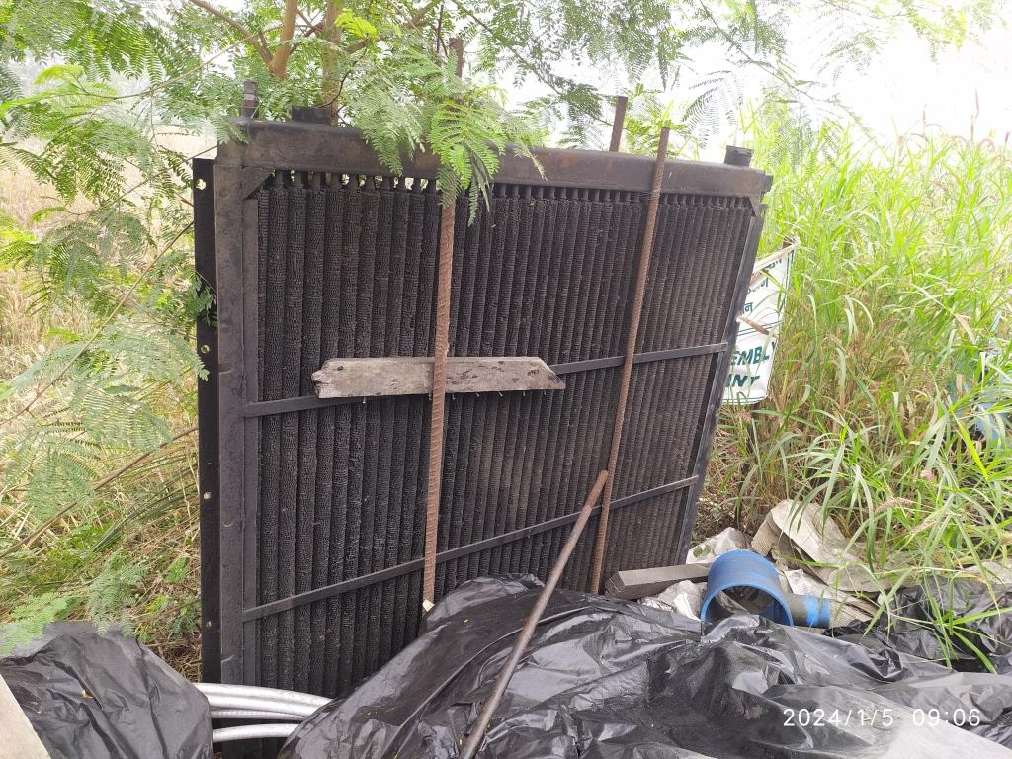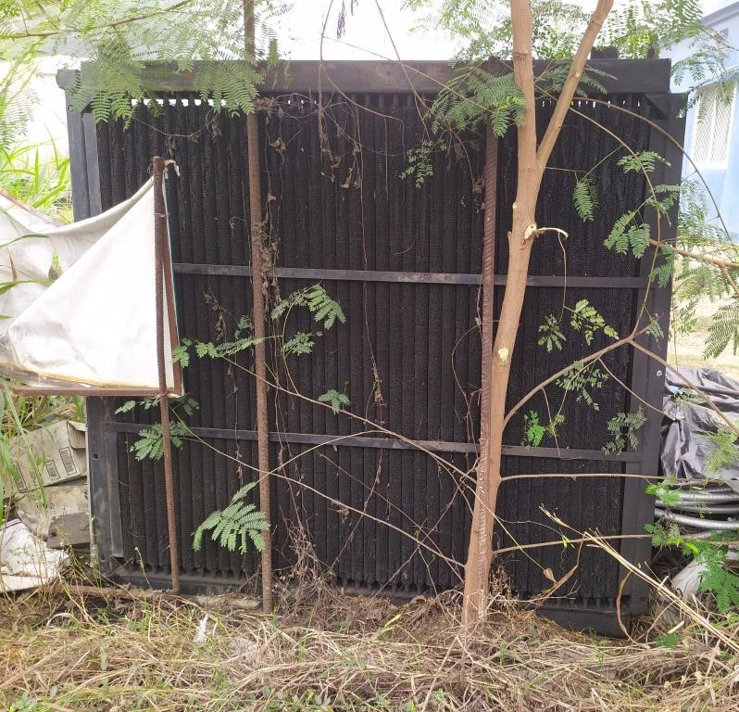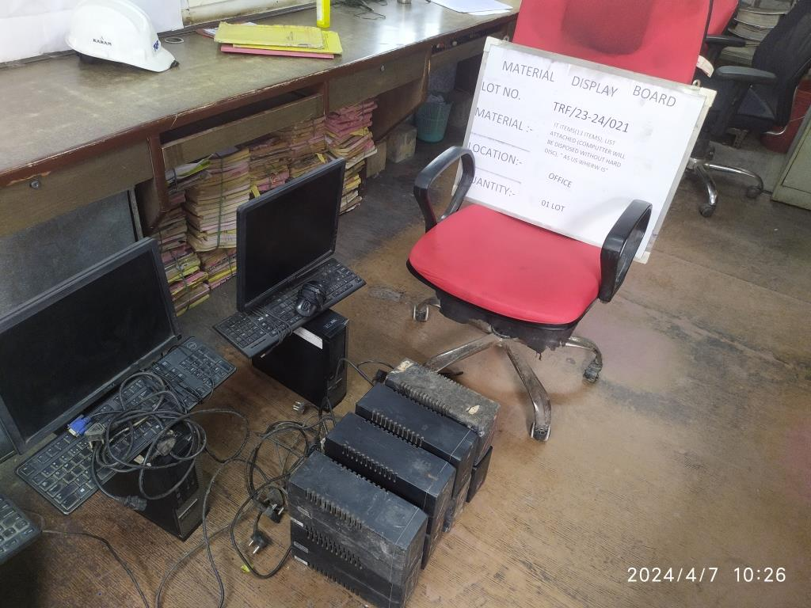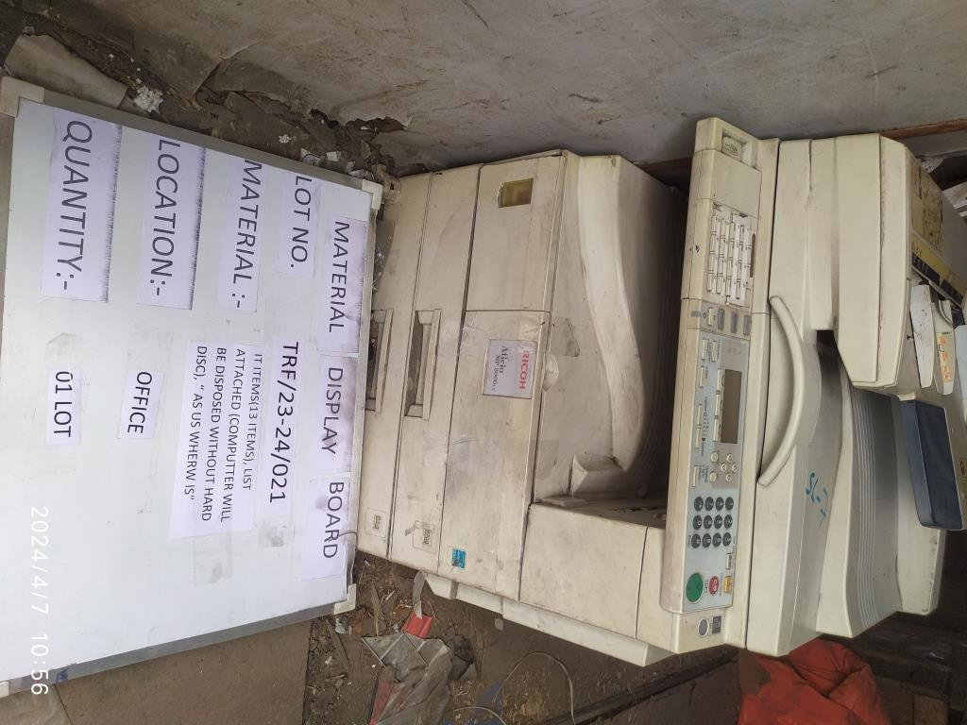
TRF/23-24/020 TRF/23-24/020 TRF/23 - 24/ 021 TRF/23 - 24/ 021
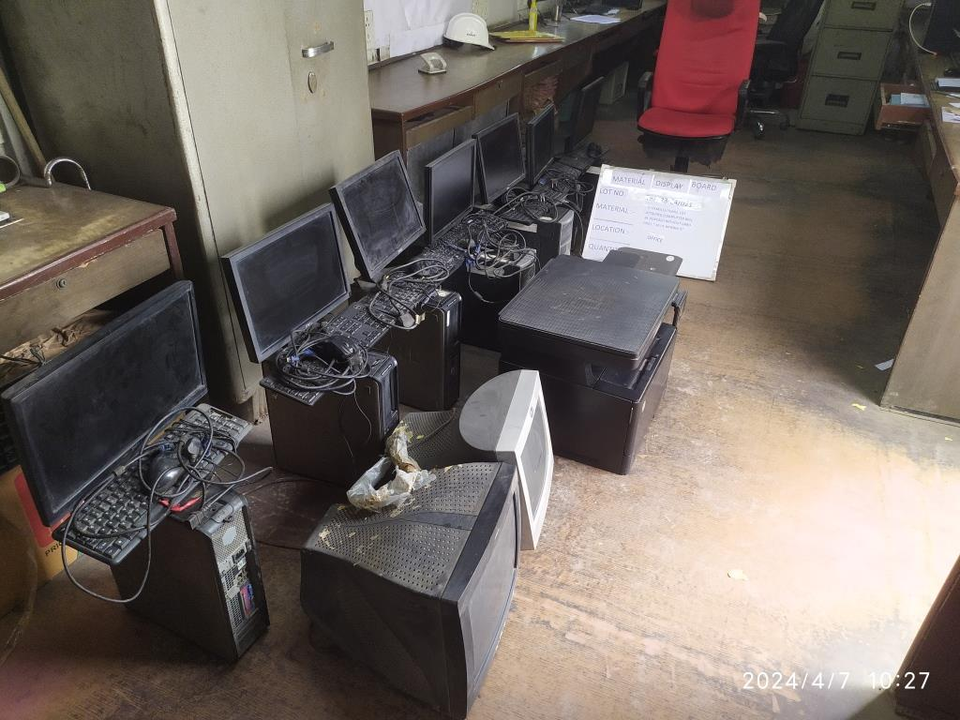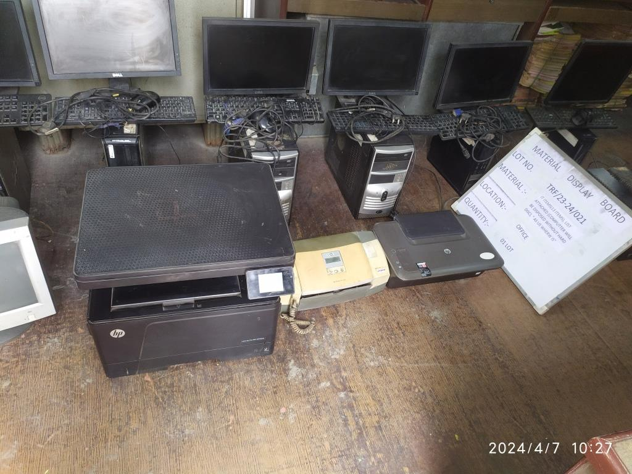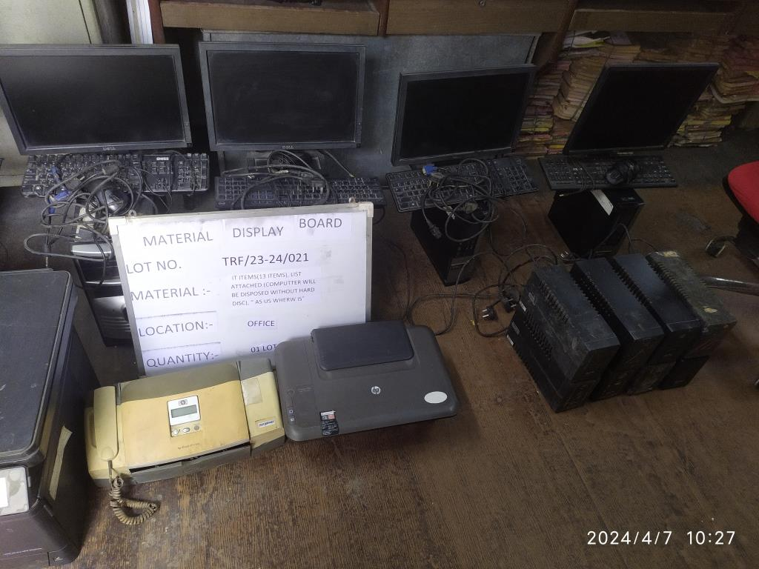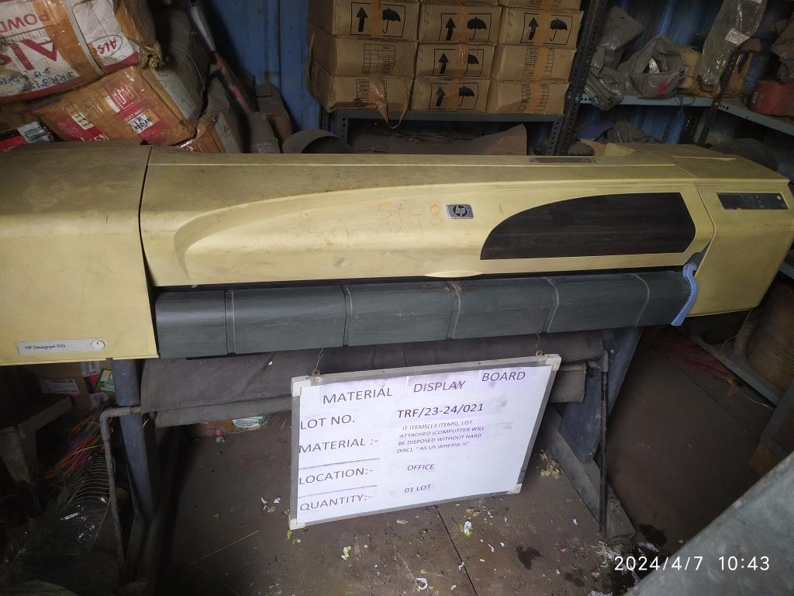
TRF/23 - 24/ 021 TRF/23 - 24/ 021 TRF/23 - 24/ 021 TRF/23 - 24/ 021
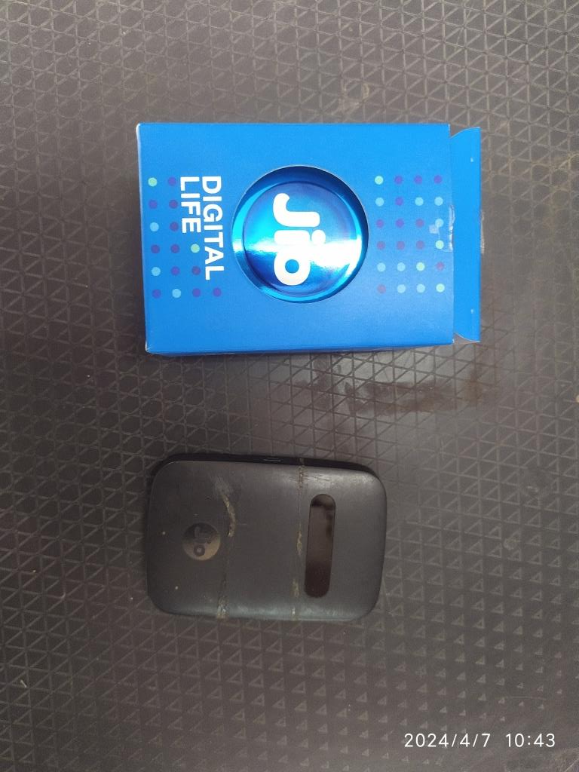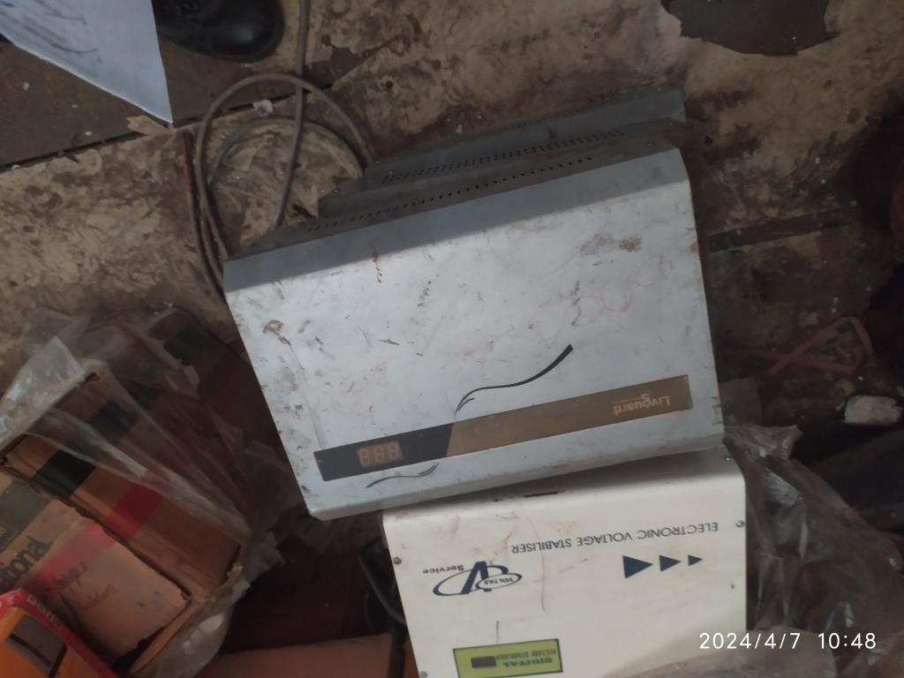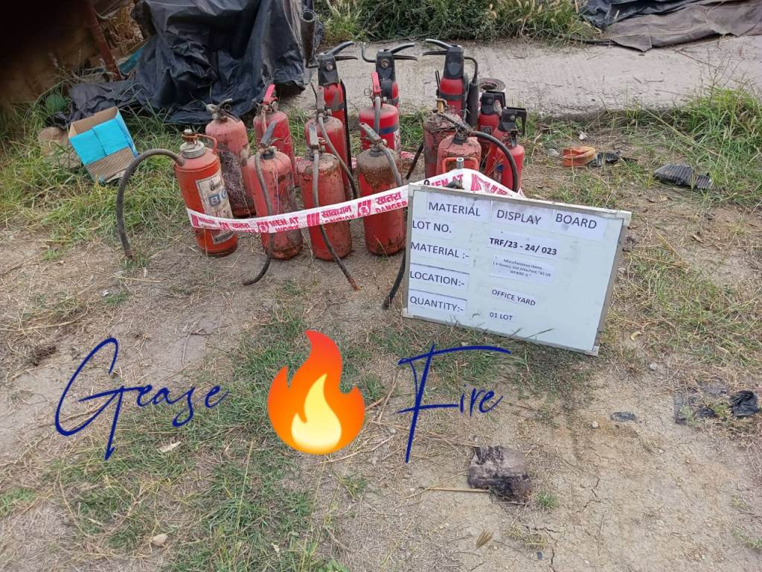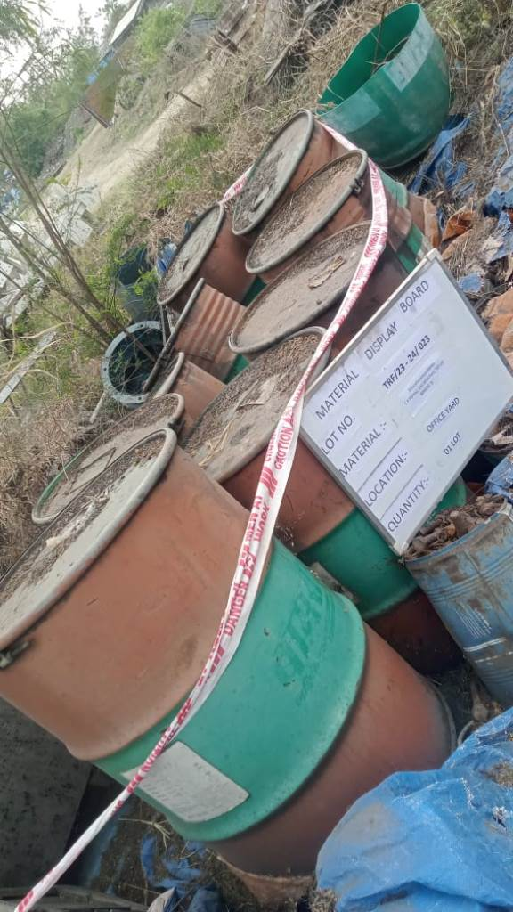
TRF/23 - 24/ 021 TRF/23 - 24/ 021 TRF/23-24/ 023 TRF/23-24/ 023
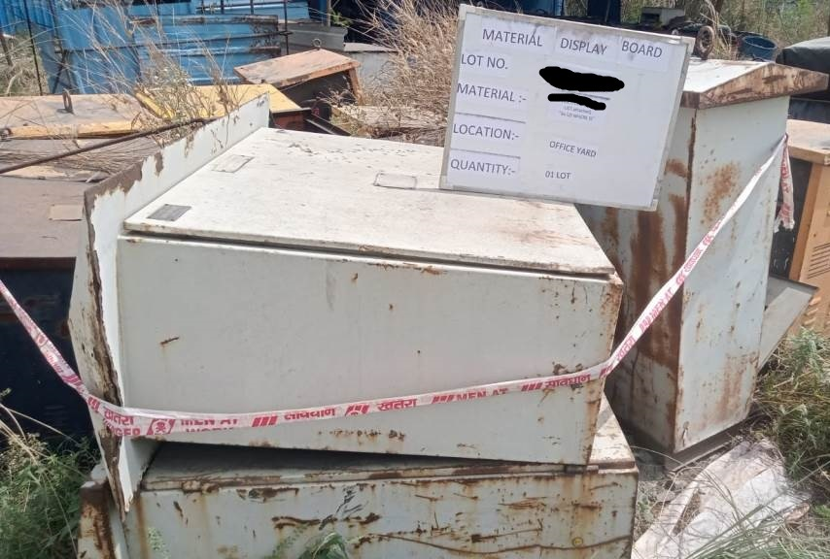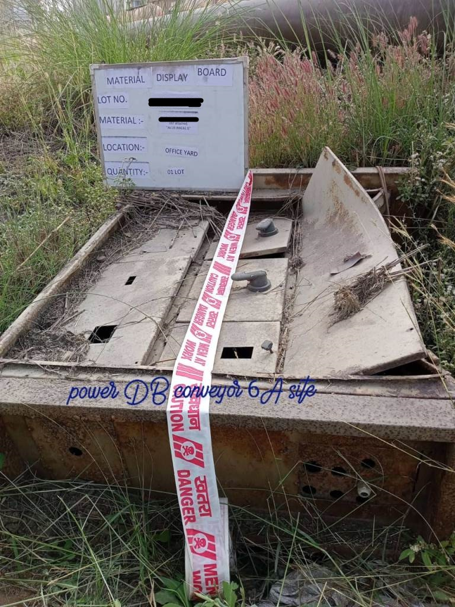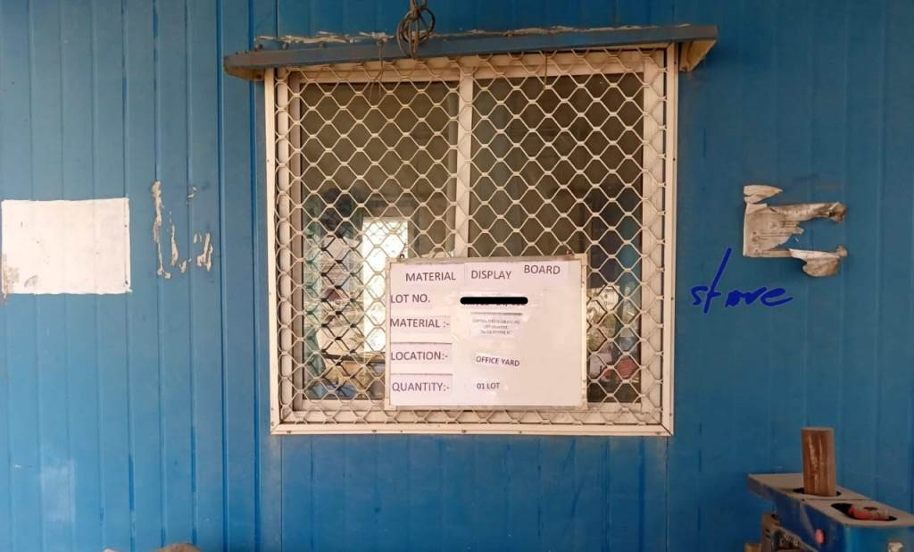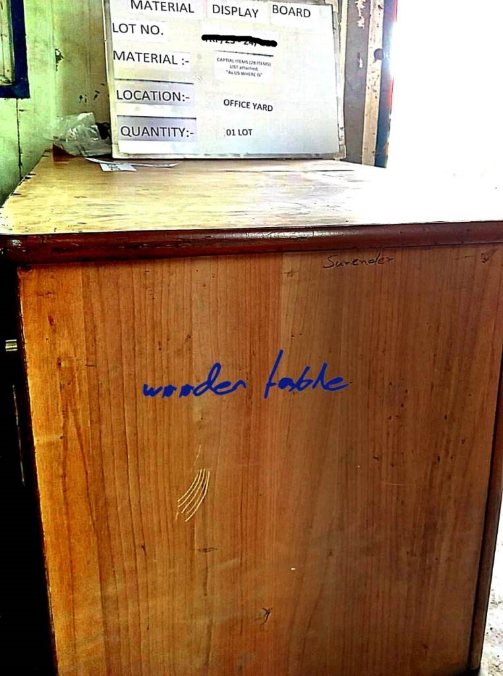
TRF/23-24/023 TRF/23-24/023 TRF/23-24/023 TRF/23-24/023
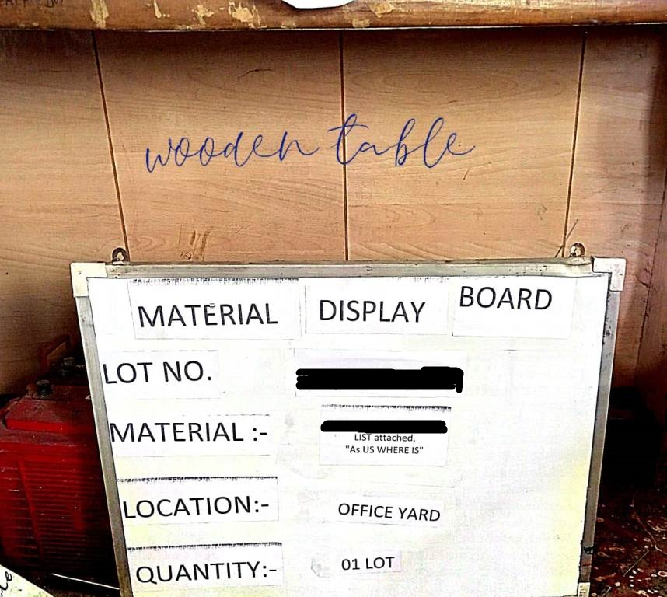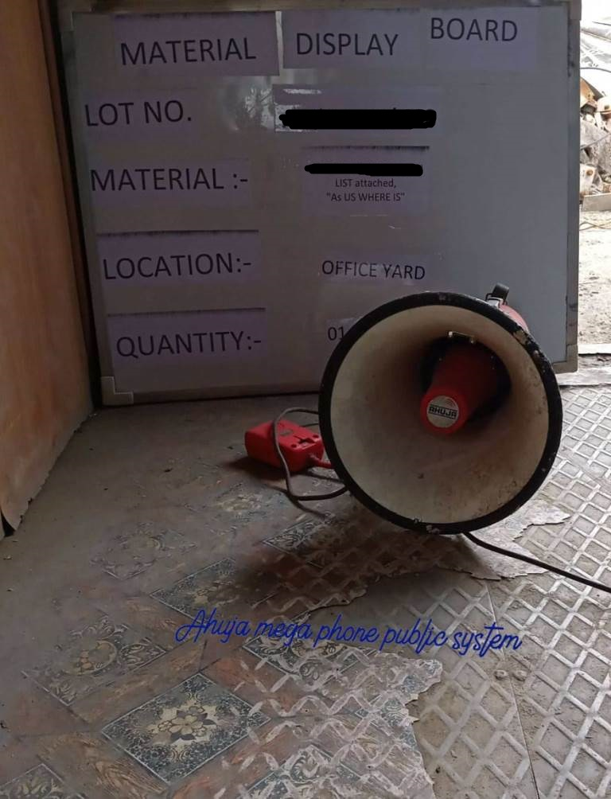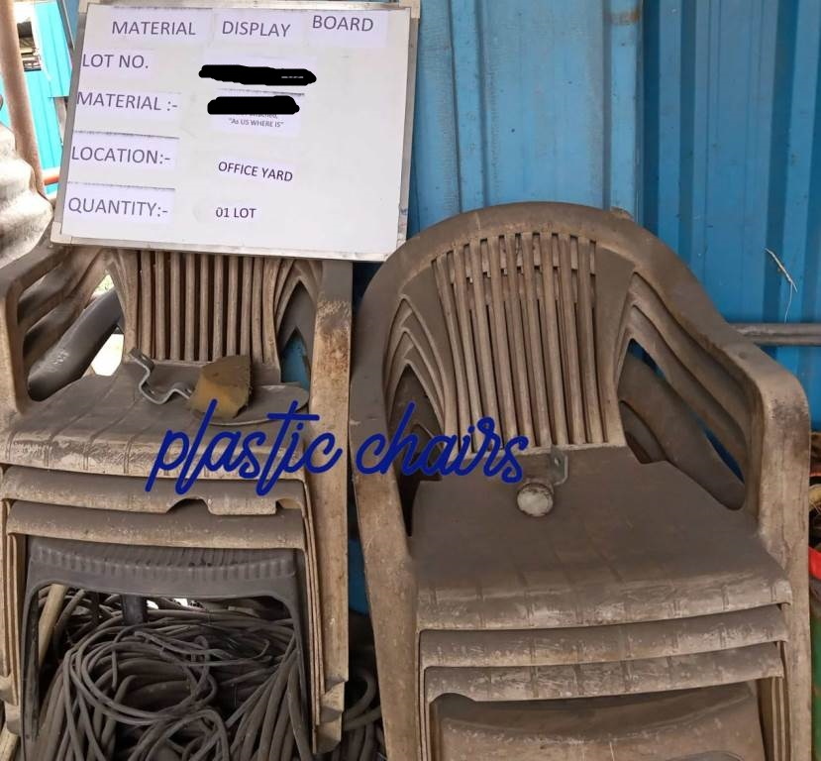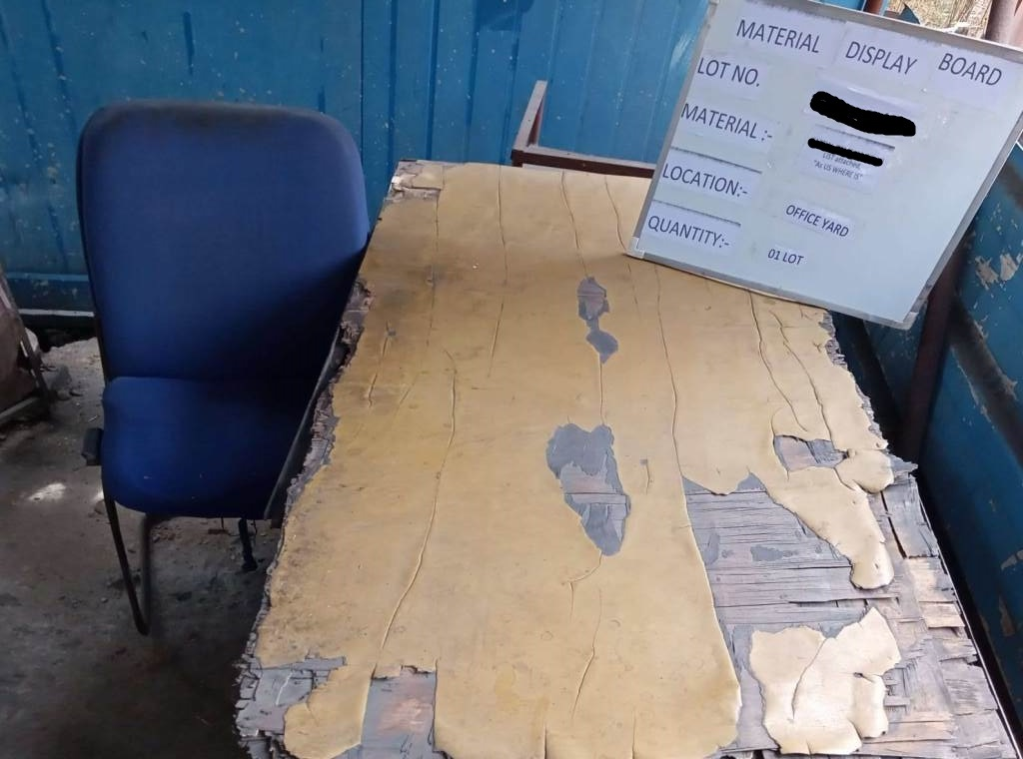
TRF/23-24/023 TRF/23-24/023 TRF/23-24/023 TRF/23-24/023
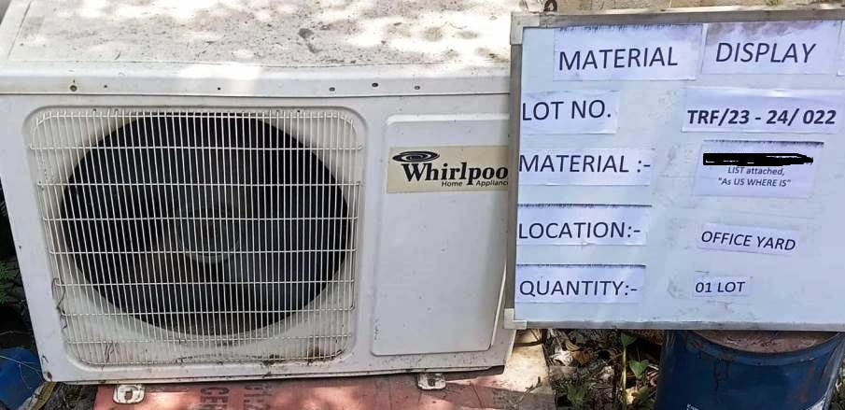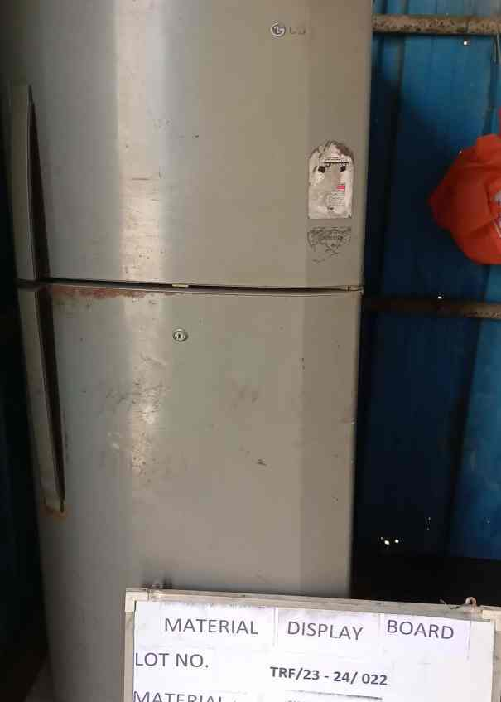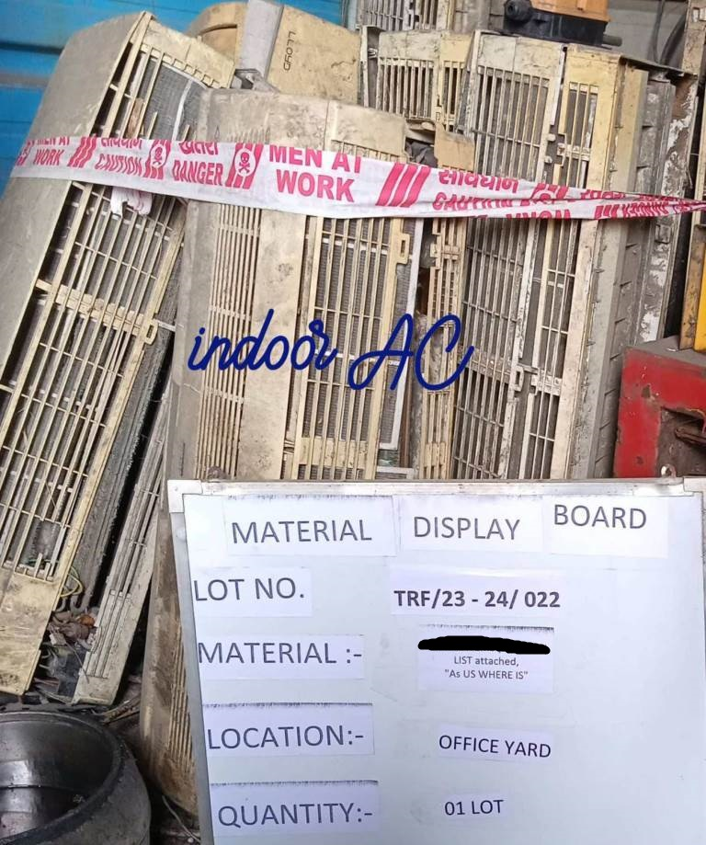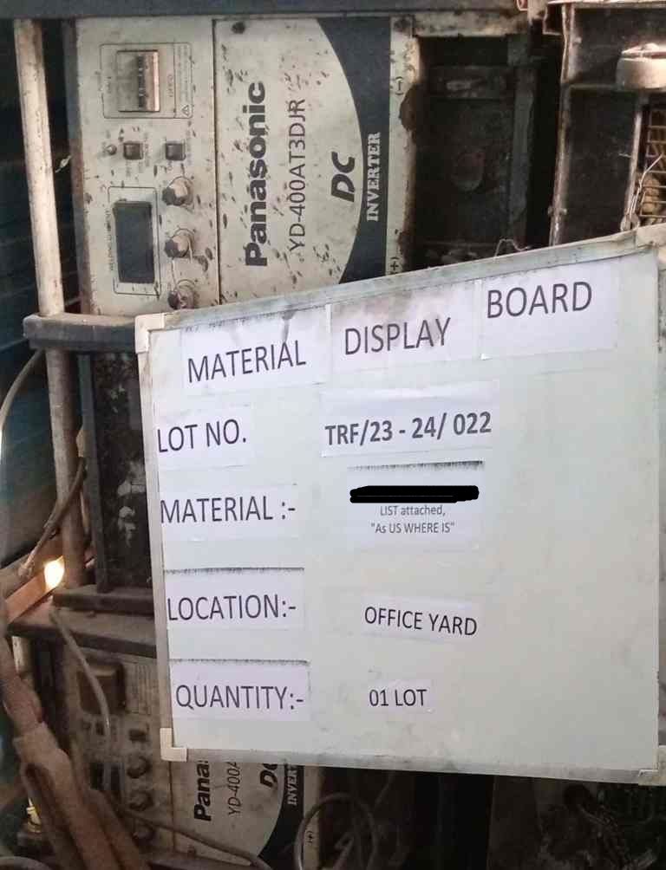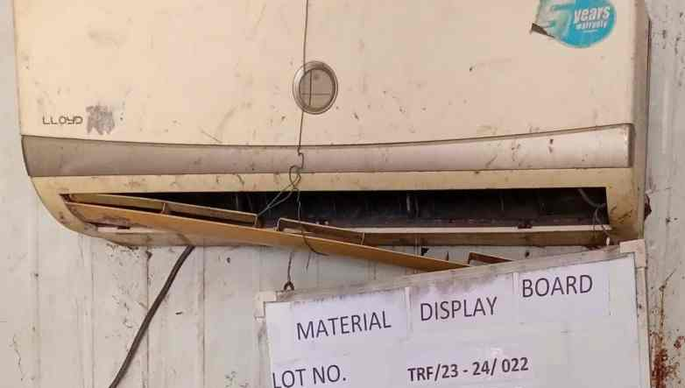
TRF/23-24/022 TRF/23-24/022 TRF/23-24/022 TRF/23-24/022 TRF/23-24/022
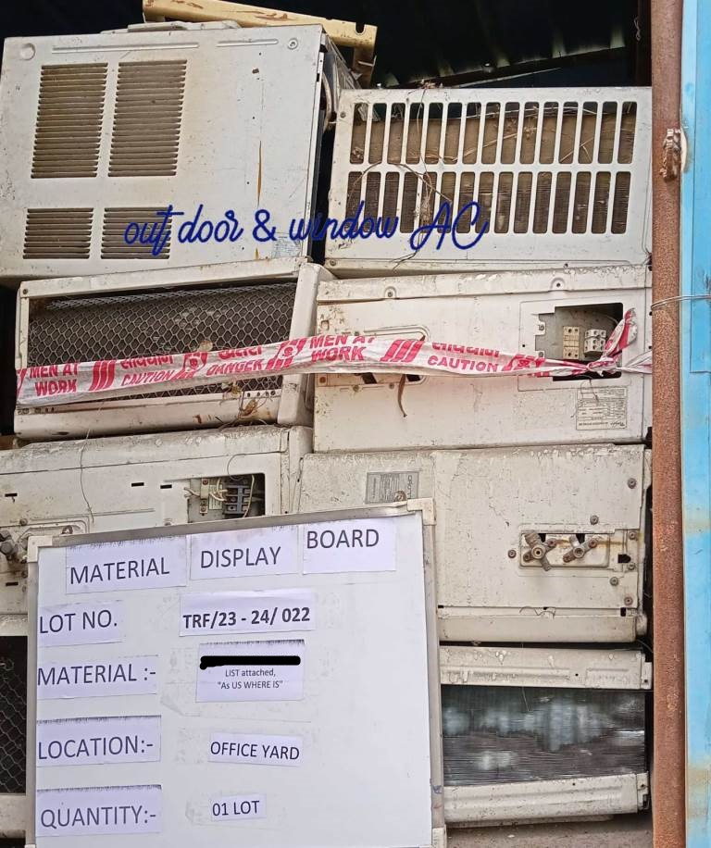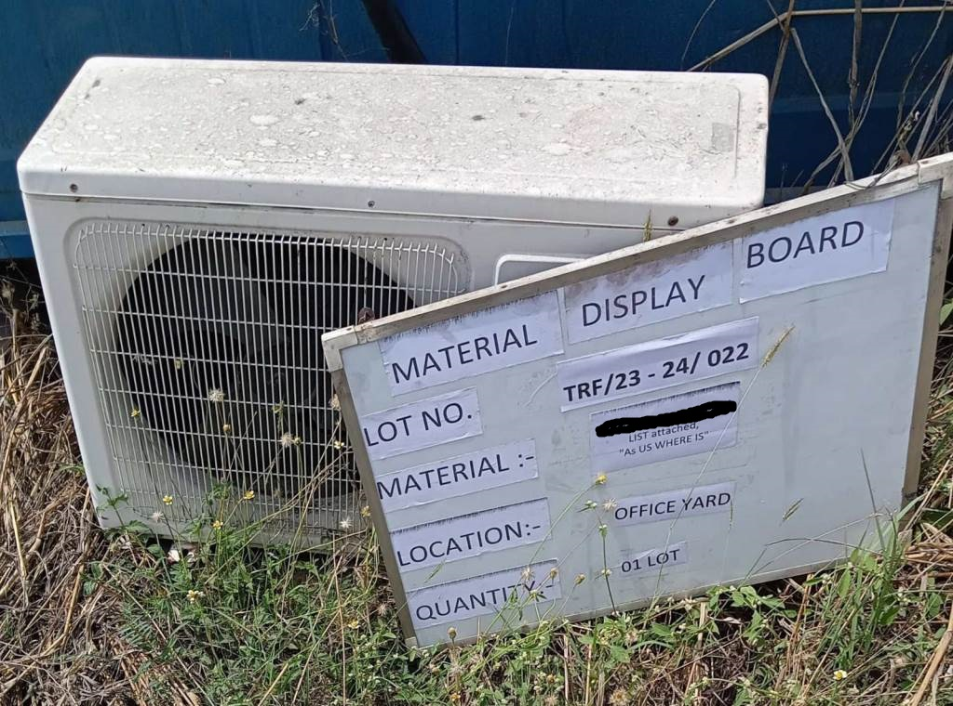
TRF/23-24/022 TRF/23-24/022

Open www.ahbilimoria.com ->Click on Customer Complaint Management Portal
