Auction Catalogue
Auction conducted by A H Bilimoria& Co.
Auction of lazy Capital Jamshedpur-Tata Pigments Ltd.
BEING SOLD ON ‘’AS IS WHERE IS AND NO COMPLAINT BASIS’’
Catalogue Serial Number: | TPL/AHB/NOVEMBER/001/25-26
Seller: | Tata Pigments Limited
Auction website: | www.ahbilimoria.com
e-Auction Date & Time: | 15th November, 2025…..….. at 11:00 AM
Inspection Date & Time: | No physical inspection to be conducted. Interested customers please visit our website for indicative lot photographs/videos. For any assistance please call AHB (7991108353/7003840027) or Tata Pigments Ltd. Officer (7368806070).
Date of Security Money Deposit | 15th November, 2025…..….. ……… at 10:30 AM
Contact Details:
For Post Auction @ A H Bilimoria& Company
Area | Contact No. | Email Id
Auction Room | 033-22294833, 22296577
Lot Confirmation Related | 033-22294833, 22296577 | ahb@ahbilimoria.com, ahbilimoria.company@gmail.com
Payment Related | 033-22294833, 22296577 | ahb@ahbilimoria.com, ahbilimoria.company@gmail.com, ahbjsr@ahbilimoria.com, b.bhardwaj@ahbilimoria.com, m.paul@ahbilimoria.com, sukumar.chandra@ahbilimoria.com
Payment Deviation/Disablement in Tata Pigments Ltd. | 033-22294833, 22296577 | ahb@ahbilimoria.com, ahbilimoria.company@gmail.com,ahbjsr@ahbilimoria.com, b.bhardwaj@ahbilimoria.com,m.paul@ahbilimoria.com, sukumar.chandra@ahbilimoria.com
For time bound resolution of unresolved issues log into our Customer Complaint Management portal | Type in www.ahbilimoria.com> Go to “Customer Complaint Management Portal” >Log in with your user id and password and write the details of issue.

For Any unresolved Issues beyond two (02) days mail to A H Bilimoria& Company :
Mr. A K Sil (M-09830074122) & Mr. D Pyne (M-09830738481), E-mail: ahb@ahbilimoria.com, ahbilimoria.company@gmail.com
Copy to Tata Pigments Ltd : Mr. SANDIP BISWAS, (M-7544002924), E-mail: sandeep@tatapigments.co.in
SPECIAL NOTE: -It is the responsibility of the buyer to furnish the valid GST no. & necessary documents to A H Bilimoria& Company before participating in the auction. In case during the transactions, it is found that valid GST no. has not been provided, then all necessary liabilities if any & so accrued would be on account of the buyer. Tata Pigments Ltd. & A H Bilimoria& Company would not be responsible for any such liabilities.

Note: Tata Pigments Ltd. reserves the right to track IP address, MAC number and geolocation of bidding customers whenever customers participate in any auction on the A H Bilimoria& Co. auction platform for Tata Pigments Ltd.

- Payment and Lifting Schedule:

Lot No. | Payment Schedule |  |  | Lifting Schedule  (working days from the next day of DO release)
Lot No. | EMD | 1st installment | 2nd installment | 1st installment lifting days | 2nd installment lifting days
For All Material | 02 Working days from Date of Lot Confirmation | 02 Working Days From Date of EMD | 03 Working Days from the 1st Installment date  [Only Applicable if material value (Rate X Tonnage) crosses Rs. 10 Lakh] | 7 Days from the D/O date | 3 additional working days at the expiry of 1st Installment DO validity.

- Suitable extension of due date for payment and lifting will be accorded in case of any eventualities like Strike/ Bandh/ Special restriction on vehicular movement imposed by the local Administration etc.

- Requirements of participation:
  - Registration: Before participation in the e-Auction, a prospective bidder shall be required to get registered with A H Bilimoria& Co. For details visit www.ahbilimoria.com

  - Security Deposit: Non-Interest bearing security deposit of Rs.50,000/- (Rupees Fifty Thousand only) in favour of “A H Bilimoria& Co.” through Online Payment only : Details as under :

Beneficiary Name | A. H. BILIMORIA & COMPANY
Bank Name | HDFC Bank
Branch Name | 31, Chowringhee Road, Kolkata – 700016
Account No | 6932560001205
IFSC Code | HDFC0000693

Account No: All the customers will have a unique account number. The unique account number is an alpha numeric code consisting of 12 characters. The Customer’s unique “account number” is a combination of the AHB’ SAP code along with the 6 digit bidder SAP ID and can be used as reference. for all subsequent transactions. The Customer’s Account Number detail is available in “Profile” after the customer logs into our website using the user id and password.

- Inspection Rules & Policy:
No physical inspection to be conducted. Interested customers please visit our website for indicative lot photographs/videos. For any assistance please call AHB (7991108353/7003840027) or Tata Pigments Ltd. Officer (7368806070).

- Bidding modalities:
  - Price Bid Basis: In Indian rupees as per unit of measurement as given in Material List. Price to be quoted is basic, ex- location exclusive of taxes and any other statutory levies.
  - Bid Increment: As specified in the e-auction bid page
  - Type of Auction: English No Ties
  - Bid Validity: Bid shall be valid for 10 (Ten working days excluding Saturdays, Sundays and Bank holidays)working days counted from the next day of auction process in case of auction against a catalogue which is completed on the same day. And if it is continuing on any other day the counting of days for lot confirmation shall be from the next day of completion of entire auction process.
  - Bid duration: For 1st four lots 20 minutes and balance lots 10minutes. If, No bids received within these specified time the lots are closed automatically.

- Taxes & duties:
  - GST : As applicable
  - TCS : As applicable. In case of availing of concessional rate of TCS proper certificate issued by appropriate Income Tax authority are to be issued in favour of the Principal Company along with payment. Self certification of Form no 27C is not acceptable.
  - Any change in taxes applicable at the time of lifting shall be applicable.
  - Customers are required to submit Form 27C/Form 27G against the month of dispatch/expected dispatches. In the absence of Form 27C, TCS will be charged at the time of invoicing.

- Payment terms & conditions :
  - Payments: PAYMENT FACILITY BY RTGS / NEFT ONLY

Account No | 012010200000207
Beneficiary Name | THE TATA PIGMENTS LIMITED
Bank Name | AXIS BANK LIMITED
Branch Name | VOLTAS HOUSE, BISTUPUR, JAMSHEDPUR
IFSC Code | UTIB0000012

  - EMD: 10% of the material value to be paid within 02 (Two) working days from the date of lot confirmation. EMD to be adjusted in the final installment only.
EMD payment is to be made within the time limit as given in letter of confirmation. No extension will be provided for the same.
  - Balance Payment Time: (As per payment schedule)
  - Saturdays, Sundays and Bank holidays are excluded for counting purpose for payment schedule.
  - In the event of Non-Receipt of Payment within the stipulated period of Payment, the Sale Offer for the approved Lot shall stand withdrawn automatically(Refer Clause#8).
  - Buyers have to send the payment deposit slip (UTR No /Scan Copy of NEFT/RTGS Transaction Slip) against Lot No. immediately after the payment to AHB at email id: ahb@ahbilimoria.com& ahbilimoria.company@gmail.com

- Lifting terms & conditions:
7.1 DOs will be handed over to authorized representatives of bidderson receipt of payment. Authorization letter to be issued via registered e-mail id’s. Authorized letter must be duly stamped and signed by the proprietor or partner or director on receipt of payment. Lifting date is calculated from the next day of DO Release date.
7.2 Loading Charges: As mentioned in material list
7.3 Loading shall be given strictly as per the statutory norms & safety norms of Tata Pigments Ltd. Ltd.
7.4 Lifting with Ground Rent: Lifting along with ground rent will be allowed up to 4 (four) working days from the last date of lifting period. In case the lifting is not complete, and no request is made by the customer within the period of four days, the company reserves the right to close the lot, and refund the balance to the party after deducting for any shortfall in lifting as per norms laid down in the catalogue.
7.5 Additional lifting days for advance payment of installment - If the installment payment is made in advance, then additional lifting days (equivalent to the number of days payment made in advance) would be given. This would not be applicable for EMD payment.
7.6 PICK & CHOOSE NOT ALLOWED FOR ANY OF THE LOTS.

7.7 LOT TRANSFER WILL NOT BE ALLOWED.

7.8 Process for transfer of ownership of vehicles sold in auction: Customer shall submit their authorization letter to AHB. AHB will hand over the same to SCMC with a forwarding letter along the authenticated DO copy. AHB will collect the ownership papers from SCMC for handing over to the customer for applying for transfer of ownership in DTO’s office. After transfer of ownership, the customer will show the approach SCMC to collect the delivery advice for the vehicle. AHB will arrange the gate pass for the customer to visit SCMC.

- Penalty:
  - The following penalties shall be applicable in the eventuality of a buyer defaulting in making the payment of EMD (wherever applicable) or any installment/s, as per the stipulated schedule for each lot, in a financial year:
- In the first instance, a penalty of Rs. 50,000/- (Rupees Fifty Thousand only) shall be recovered from the customer.
- In the second instance, a penalty of Rs.100,000/- (Rupees One Lakh only) shall be recovered from the customer.
- In the third, and any subsequent instance, a penalty of Rs.150,000/-(Rupees One Lakh Fifty thousand only) shall be recovered and the customer shall be debarred from participating in any auction for a period of three months from the date of debarment.
In the event of any default, the customer’s user id will be disabled and the customer will be blocked from participating in any auction of Tata Pigments Ltd. with immediate effect.

The defaulting customer shall be allowed 06 (six) working days to deposit the penalty as mentioned above. In case the penalty is not received within the stipulated period, the customer’s security deposit shall be forfeited, and the defaulting customer shall be immediately debarred from participating in any auction of Tata Pigments Ltd.

  - If after making payment of EMD (wherever applicable), the installment payment/s are not made by the customer as per the stipulated schedule for each lot, the entire EMD amount against such lot shall be forfeited.

  - In case of non- lifting of full or partial lot quantity after making full payment, a penalty equivalent to 20% of the material value for the un-lifted quantity against each lot shall be recovered from the customer.

- Lot Closure Norms :
For Lot Closure, pls refer lot description. No pick and choose allowed and entire material is to be lifted. The tolerance for lot closure would be ± 10% of the original quantity.
For High Value Items (>/= Rs 50000 per MT) tolerance for Lot closure is 0% of the lot quantity.

- Refund :
Refunds will only be made by Tata Pigments Ltd. vide RTGS/NEFT and hence all customers are required to submit their bank details to A H Bilimoria& Company or mail at ahb@ahbilimoria.com, ahbilimoria.company@gmail.com, ahbjsr@ahbilimoria.com, b.bhardwaj@ahbilimoria.com. Tata Pigments Ltd. or A H Bilimoria& Company will not be responsible for any delay in refunds owing to absence of bank details of the customer.

- Complaints :
Complaints, if any, with regard to any transaction shall have to be lodged by the buyer within three calendar months from the date of last invoice. No complaint shall be entertained thereafter, under any circumstances. Customers can log their complaints at (www.ahbilimoria.com> Go to “Customer Complaint Management Portal” >Log in with your user id and password and write the details of issue.)

- Jurisdiction :
Any dispute arising out of any contract shall be decided in Jamshedpur by the courts in Jamshedpur and by no other courts. The courts in Jamshedpur shall have exclusive jurisdiction to adjudicate upon any such dispute.

- General terms & conditions:
  - Any dispute on quality & quantity of material and bid cancellation shall not be entertained at any point after the auction.
  - All lots are offered/sold on “As is Where is Basis” and “No Complaint Basis”.
  - Lot transfer will not be allowed. Payment and invoicing has to done in the name of the H1 bidder, subject to the prices being approved.
  - Lot purchased should consist of material from the same lot and designated location only. Tata Pigments Ltd. has the right to check any vehicle at any moment of time. If material lifted differs from the material that is purchased by the buyer, then the buyer and authorized representative will be permanently debarred. Also Tata Pigments Ltd. can take any penal action against the buyer/authorized representative. All the material loaded in the vehicle is to be covered in order to follow the safety compliance of Tata Pigments Ltd. works.
  - If the safety compliance is not followed, then Tata Pigments Ltd. can penalize the buyer / authorized representative as deemed fit.
  - Customer attested photocopy of valid id proof (Voter id/Aadhar/Pan card) of all lifters / Authorized persons engaged by customers for lifting of materials from Tata Pigments Ltd. is to be enclosed with the authorization letters & to be forwarded to Tata Pigments Ltd. for issue of gate pass.
  - Dispatch is subjected to FORCE MAJEURE conditions
  - The seller reserves the right to terminate any offer at any point of time without assigning any reasons
  - In the event of termination of the offer, seller shall refund the balance amount after due reconciliation
  - No claims whatsoever would be entertained after cancellation of the bid
  - In addition of earlier safety norms, the following would be compulsory:
The drivers of the vehicle must have the eye test certificate. The frequency of the testing would be as below:
1. If the age of the person is less than 45 years - Once in a year
2. If the age of the person is 45 years or more, the testing is required to be done once in every 6 months
Please ensure to comply with the safety norms
  - Weighment : Weight recorded by Tata Pigment Ltd. weighbridge will be considered final and binding on the customer.
  - This transaction falls u/s 206C(1). Hence Section 194Q will not be applicable.
  - Compliance in relation to section 206AB/206AA (Furnishing of I.T Return for past 2 Years) will be taken directly from Income Tax Portal till 28th June-2021. If any compliance made in IT Portal by the customer (after 28th June-21), shall be communicated to AHB over mail.

14. Compliance to safety norms
14.1 Authorized persons (of the customer) involved in lifting of the materials will be allowed only with Personal Protective Equipment’s (PPE) i.e., Safety Shoes, Safety Helmet, Safety Goggles, Fluorescent Jacket and Hand Gloves. No "people movement" shall be allowed at the time of loading/delivery of materials from the yards" Tata Pigments Ltd. will not be responsible for any delays arising out of Non- Compliance to the Safety Norms.

14.2 Documents for verification regarding entry of vehicles inside Tata Pigments Ltd. works :
All customers to note that presentation of following set of documents to TATA PIGMENTS LTD. authorities is COMPULSORY at the time of reporting of vehicles at Tata Pigments Ltd. designated Gate for entry of Customer trucks/vehicles.
a. Driving License of driver,
b. Registration Card,
c. Commercial Certificate,
d. Fitness Certificate of Vehicle,
e. Re-registration for vehicles older than 15 years
f. Insurance
The checklist form will be filled in at Tata Pigments Ltd. designated Gate for entry of Customer trucks/vehicles before entry of vehicle.

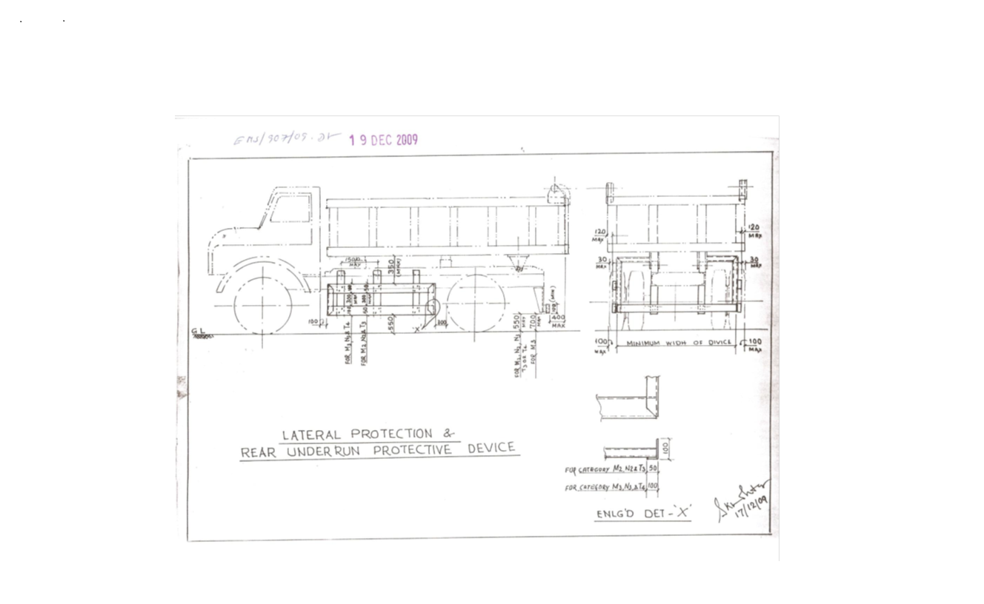

Sl. No. | Safety Parameters to be checked
1 | Three Piece Mirror(Truck, Trailer & Dumper)-Helper side
2 | Single Mirror- Driver side
3 | Rear View Mirror (Tata Ace, 207, Jeep etc.)
4 | Service Brake
5 | Parking Brake
6 | Seat Belt
7 | Head Light
8 | Parking Light
9 | Blinker
10 | Horn
11 | Reverse Alarm
12 | Wiper
13 | Windshield Glass
14 | Air Pressure Min. 7 Kg/Cm^2
15 | Run Under Protection Guard as per Tata Pigments Ltd. standard
16 | Side under Protection Guard as per Tata Pigments Ltd. standard
17 | Tyre Condition (Tread Depth, Cut Mark etc.)
18 | Any Oil Leakage from the vehicle
19 | Physical condition of Dallah
20 | Availability of scotch block
21 | Buzzer with side indicator
22 | Driver's eye examination report
Legal Documents to be checked:
Sl. No. | Documents to be Checked
1 | RC Book
2 | Insurance
3 | Pollution
4 | Driving licence
5 | Fitness for more than 15 years old vehicle
6 | NOC for outside vehicles
15. DISCLAIMER FOR E-AUCTION
BANDWIDTH PROBLEMS, CONNECTIVITY PROBLEMS WITH THE LOCAL ISP (INTERNET SERVICE PROVIDER), SLOWNESS TO ACCESS PAGES FOR DOWNLOADING ETC. ARE BEYOND THE CONTROL OF TATA PIGMENTS LTD. AND A H BILIMORIA & COMPANY. HENCE NO RESPONSIBILITY LIES WITH TATA PIGMENTS LTD. OR A H BILIMORIA & COMPANY FOR THE ABOVE PROBLEMS FACED, IF ANY, BY THE BIDDERS BEFORE/DURING THE AUCTION ANY. BID PLACED USING THE BIDDER'S USERNAME AND PASSWORD IS UNCONDITIONALLY BINDING ON THE BIDDER TO WHOM SUCH USERNAME AND PASSWORD HAD BEEN ALLOTTED AND HE SHALL BE SOLELY RESPONSIBLE FOR MAINTAINING THE CONFIDENTIALITY OF THE SAME AND FULLY RESPONSIBLE FOR ALL ACTIVITIES THAT OCCUR UNDER THEIR USERNAME AND PASSWORD. HENCE THE USER IS ADVISED TO CHECK THE USERNAME AND PASSWORD BEFORE THE AUCTION,IN ORDER TO FAMILIARISE HIMSELF WITH THE SAME AND IS ADVISED NOT TO REVEAL IT TO ANYONE ELSE SO AS TO PREVENT MISUSE OF THE SAME. THE BIDS MADE BY THE BIDDERS AGAINST THEIR USERNAME AND PASSWORD SHALL BE IRREVOCABLE.THE BIDDERS ARE ADVISED TO REGISTER AND PRE-QUALIFY FOR BIDDING WELL IN ADVANCE AND PLACE THEIR BIDS EARLY IN ORDER TO TAKE CARE OF ANY UNFORESEEN TECHNICAL DIFFICULTY THAT MIGHT SURFACE IN THE INTERNET OPERATIONS.

Lot Photograph: Photographs of lots are at best indicative only and do not necessarily reflect the actual condition of lots. All bidders are advised to e- inspect the offered lots before participating in the auctions. Tata Pigments Ltd. or A H Bilimoria& Co. shall not be responsible or liable for any error of judgment or bids put by bidders acting on the basis of these photographs.

Quantity offered is based on eye estimation. Delivery will be made for the estimated quantity or actual ground stock. Estimation error may arise. After e-inspection no complaint of whatsoever nature on estimated /offered quantity shall be entertained under any circumstances. Bidders are advised to make their own judgment on offered quantity before bidding.

MATERIAL DETAILS: AS PER ANNEXURE :

List of materials
(All lifting to be done as per the safety norms and SOPs of Tata Pigments)
Sl. No | Lot No. | Location | Material description | Approx Qty | UOM | GST | TCS | Loading |  |  | LIFTING PERIOD | Contact person | Contact no
1 | TPL-240017 | Besides DOWN ETP AREA | Rej. and scrap G.C. Sheets different size. Entire material is to be lifted. No pick and choose allowed. The qty mentioned is on eye-estimation basis and can have error. | 3 | Ton | 18% | 1% | By customer |  |  | 07 Working Days from the D/O date | Mr. SANDIP BISWAS | 7544002924
2 | TPL-240019 | Besides DOWN ETP AREA | Rej and scrap ELECTRICAL WASTE (TUBE LIGHTS, BULBS, MCB, FUSE, SOCKET, RELAYS, HOLDERS, cables, LED). No pick and choose allowed. The qty mentioned is on eye-estimation basis and can have error. No-Pick and choose allowed. Valid EPR Authorized from CPCB/SPCB as a  producer/recycler/refurbisher of E-Waste | 2 | TON | 18% | 1% | By customer | 07 Working Days from the D/O date |  |  | Mr. SANDIP BISWAS | 7544002924
3 | TPL-240020 | Besides DOWN ETP AREA | Rej and scrap ALUMINIUM ITEMS. No pick and choose allowed. The qty mentioned is on eye-estimation basis and can have error. No-Pick and choose allowed | 200 | KG | 18% | 1% | By customer | 07 Working Days from the D/O date |  |  | Mr. SANDIP BISWAS | 7544002924
4 | TPL-240021 | Besides ETP UP AREA | Rej. & Scrap M.S Pipe different size & Loose M.S Scrap, M.S Structural materials, M.S Scrap with rubber lining. Entire materials to be lifted. The qty mentioned is on eye-estimation basis and can have error. No-Pick and choose allowed | 20 | Ton | 18% | 1% | By customer | 07 Working Days from the D/O date |  |  | Mr. SANDIP BISWAS | 7544002924
5 | TPL-240022 | Besides DOWN ETP AREA | Rejected and scrap Wooden beams, planks, packing box etc. The qty mentioned is on eye-estimation basis and can have error. No-Pick and choose allowed | 2 | TON | 5% | 1% | By customer | 07 Working Days from the D/O date |  |  | Mr. SANDIP BISWAS | 7544002924
6 | TPL-240023 | Behind WGO office | Rej and scrap Tiny scrap, small in size recovered from pigment process. Entire material is to be lifted. The qty mentioned is on eye-estimation basis and can have error. No-Pick and choose allowed | 30 | TON | 18% | 1% | By customer | 07 Working Days from the D/O date |  |  | Mr. SANDIP BISWAS | 7544002924
7 | TPL-240024 | Besides DOWN ETP AREA | Rej and scrap & used HDPE / Plastic / Cotton bags is to be lifted. No pick and choose allowed. The qty mentioned is on eye-estimation basis and can have error. No-Pick and choose allowed. Customer must have Valid CTO/CTE, EPR  registration certificate as a PWP  from SPCB or CPCB (CAT-I) | 2 | TON | 18% | 1% | By customer | 07 Working Days from the D/O date |  |  | Mr. SANDIP BISWAS | 7544002924
8 | TPL-240025 | Besides DOWN ETP AREA | Rej. & Scrap Plastic Jar & Bucket upto 20 Kg . Entire materials to be lifted. The qty mentioned is on eye-estimation basis and can have error. No-Pick and choose allowed. Only authorized parties who have valid authorization from pollution control board are authorised to participate in the auction as per hazardous and other waste rule | 1 | TON | 18% | 1% | By customer | 07 Working Days from the D/O date |  |  | Mr. SANDIP BISWAS | 7544002924
9 | TPL-240026 | Besides ETP UP AREA | Mixed Scraps consisting of (Rej. Small tin box, 4 kg to 20 kg size, Entire materials to be lifted. The qty mentioned is on eye-estimation basis and can have error. No-Pick and choose allowed | 1 | TON | 18% | 1% | By customer | 07 Working Days from the D/O date |  |  | Mr. SANDIP BISWAS | 7544002924
10 | TPL-240027 | BESIDES TATA RED | Rej and scrap Asbestos sheet. No pick and choose allowed. The qty mentioned is on eye-estimation basis and can have error. No-Pick and choose allowed. Customer must have Valid CTO/CTE, EPR  registration certificate as a PWP  from SPCB or CPCB (CAT-I) | 2 | TON | 18% | 1% | By customer | 07 Working Days from the D/O date |  |  | Mr. SANDIP BISWAS | 7544002924
11 | TPL-240028 | BESIDES TATA RED | Rej and scrap FILTER CLOTHS. No pick and choose allowed. The qty mentioned is on eye-estimation basis and can have error. No-Pick and choose allowed | 2 | TON | 18% | 1% | By customer | 07 Working Days from the D/O date |  |  | Mr. SANDIP BISWAS | 7544002924
12 | TPL-240029 | BESIDES TATA RED | Rej and scrap FILTER BAGS. No pick and choose allowed. The qty mentioned is on eye-estimation basis and can have error. No-Pick and choose allowed | 2 | TON | 18% | 1% | By customer | 07 Working Days from the D/O date |  |  | Mr. SANDIP BISWAS | 7544002924
13 | TPL-240030 | maintenance workshop | Rej and scrap copper tubes (4mtrs length, 15mm dia, 6mm thickness) used in chillar machine . No pick and choose allowed. The qty mentioned is on eye-estimation basis and can have error. No-Pick and choose allowed | 1 | TON | 18% | 1% | By customer |  | 07 Working Days from the D/O date |  | Mr. SANDIP BISWAS | 7544002924

ALL THE PHOTOGRAPHS ARE INDICATIVE ONLY
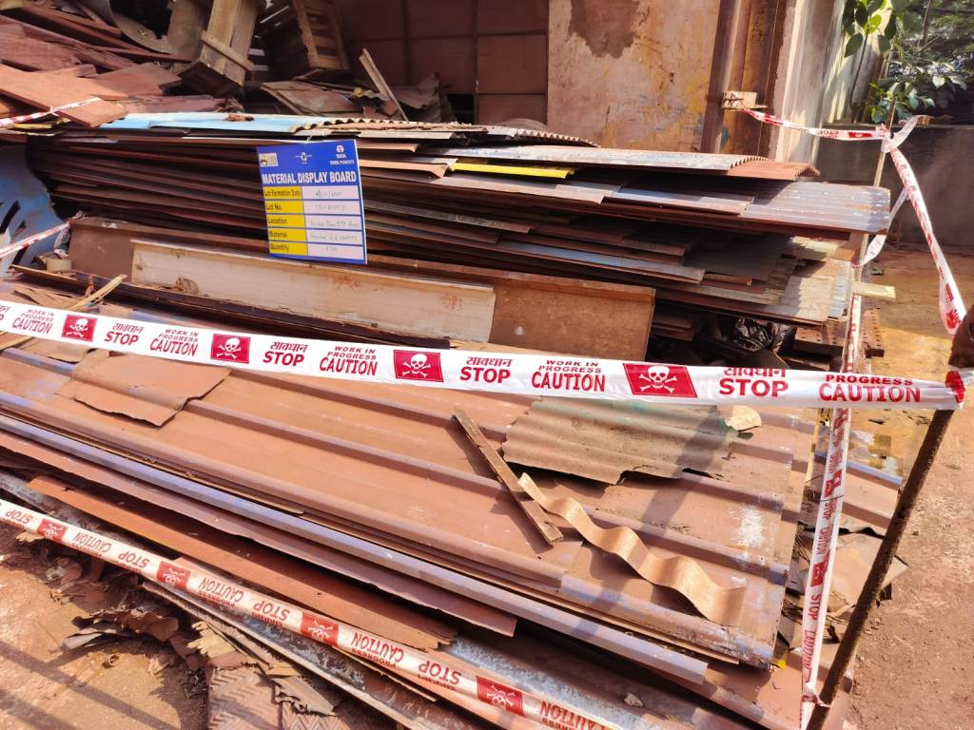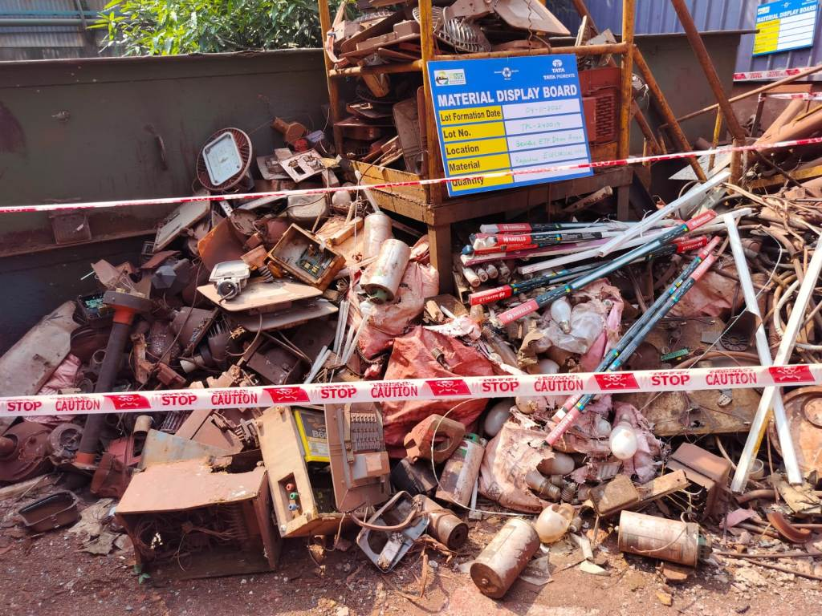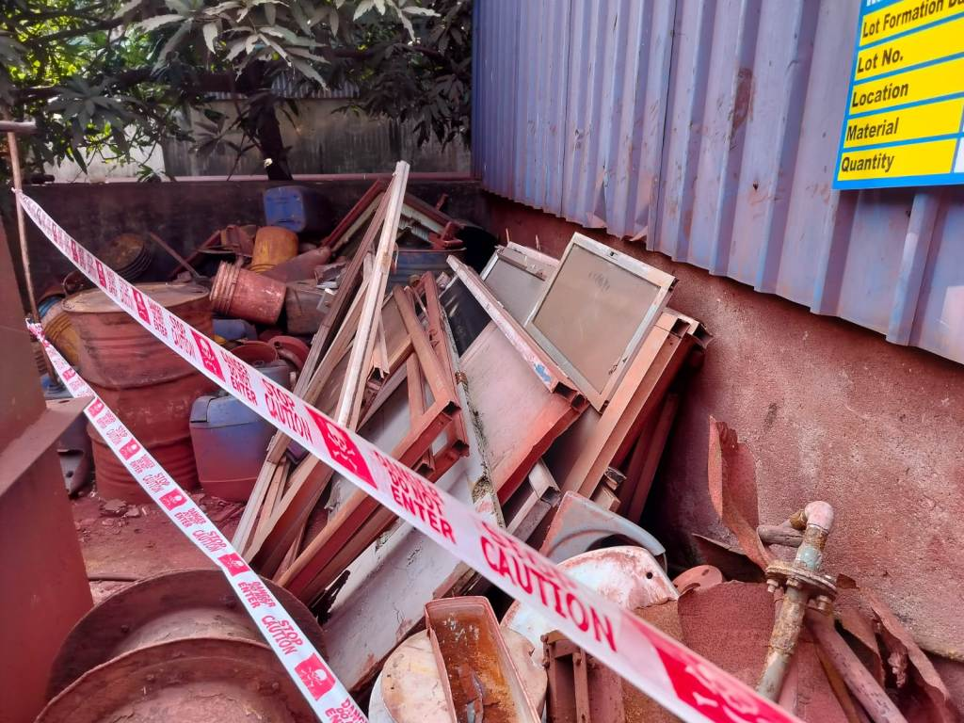
TPL-240017 TPL-240019 TPL-240020
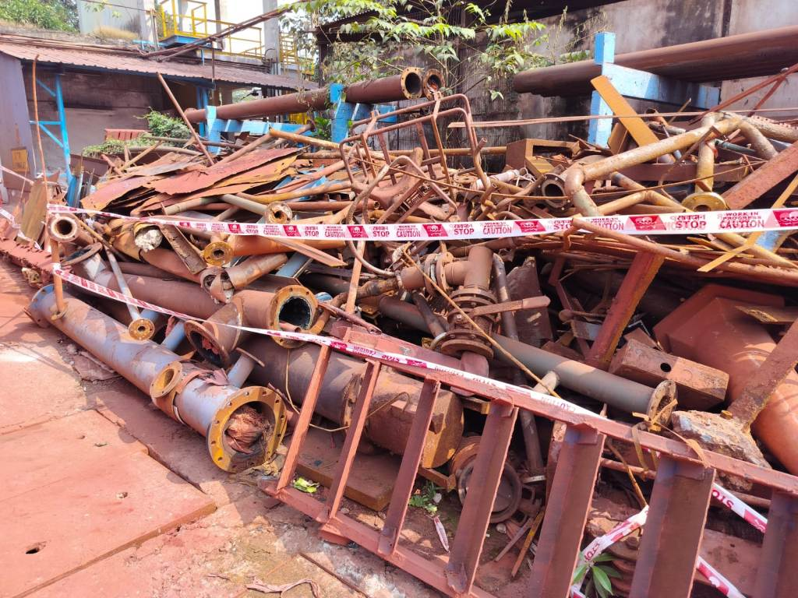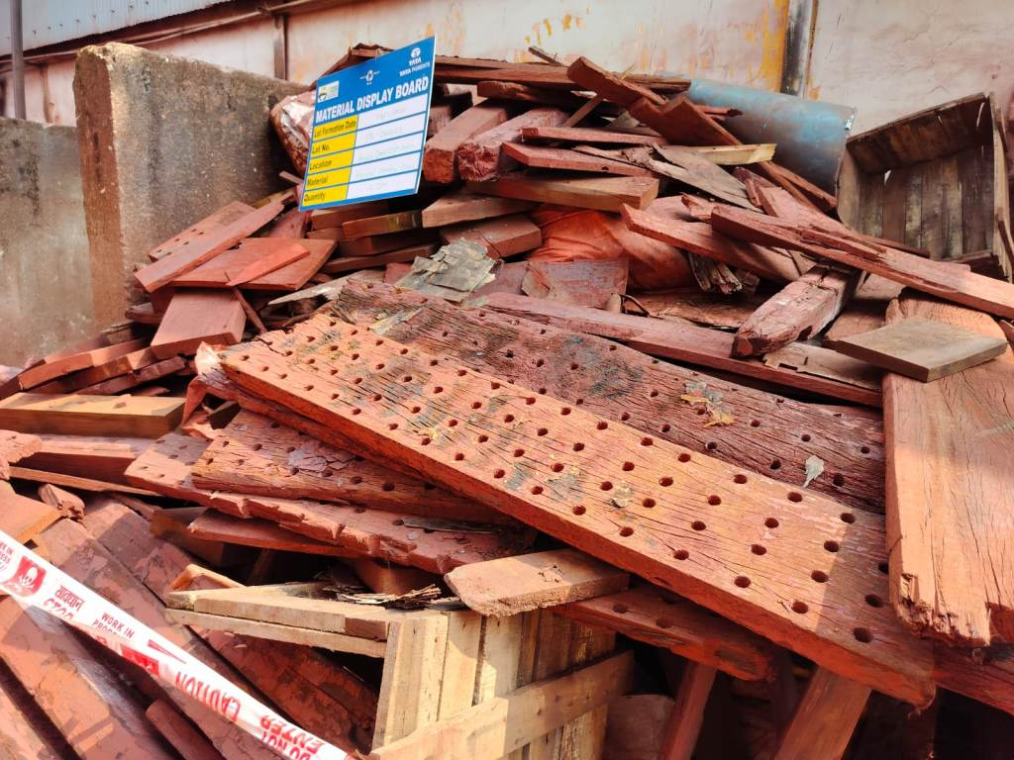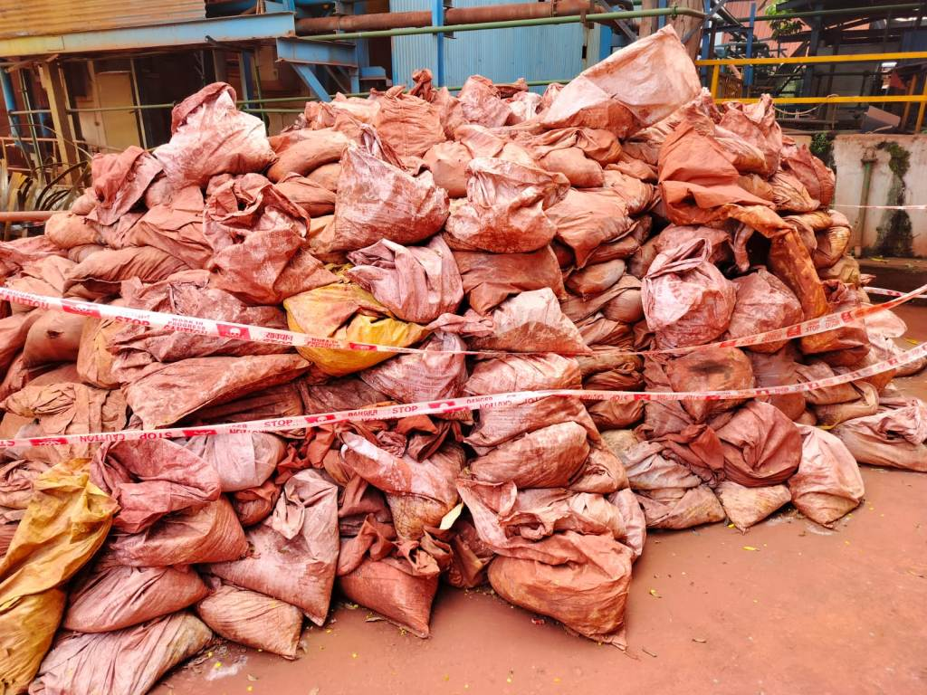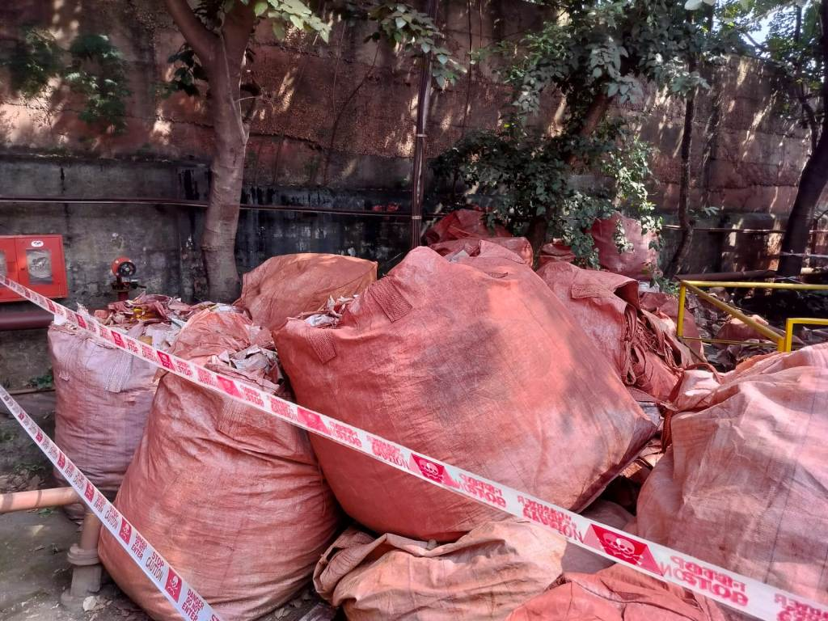
TPL-240021 TPL-240022 TPL-240023 TPL-240024
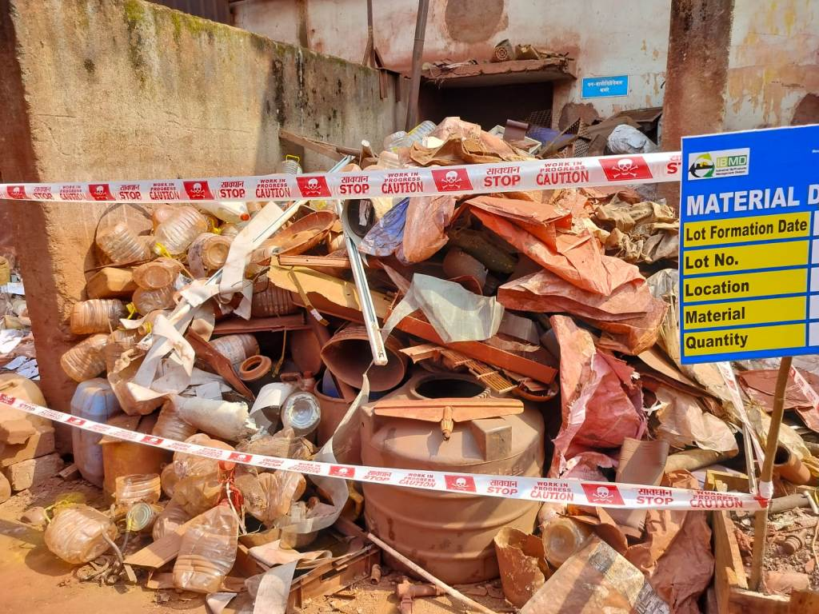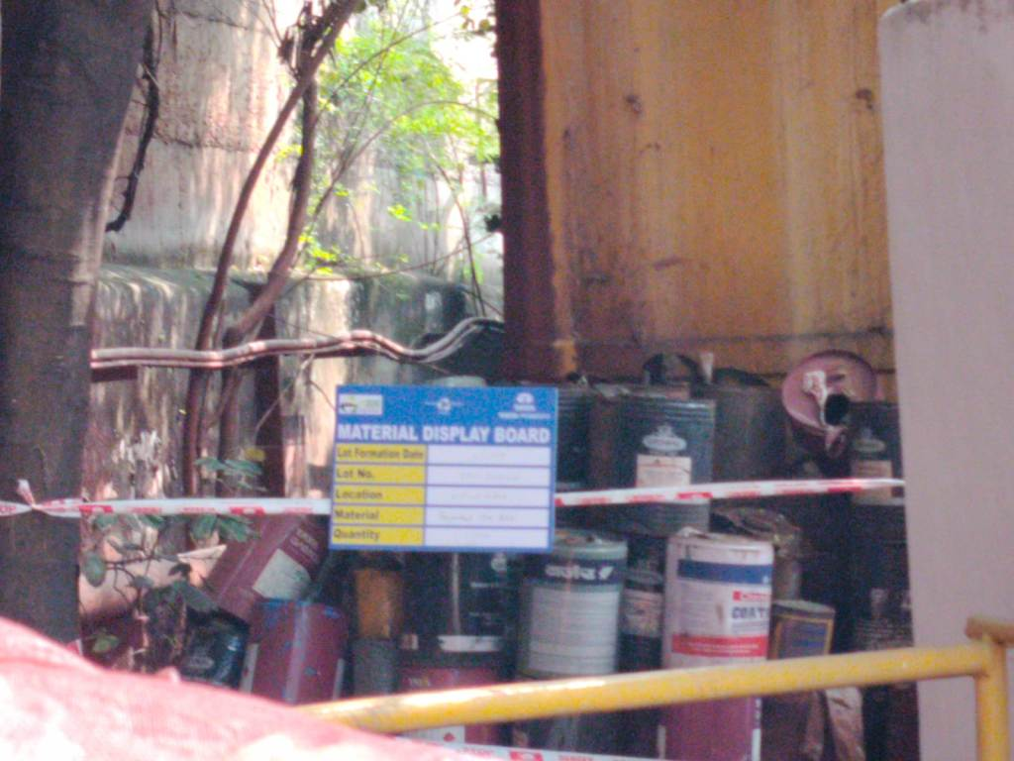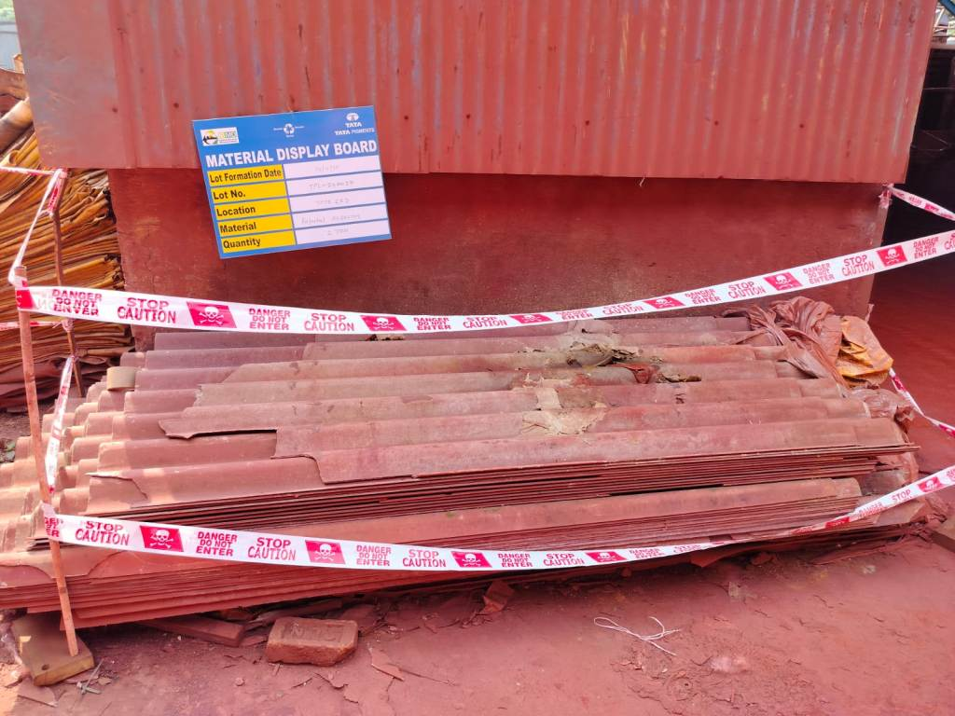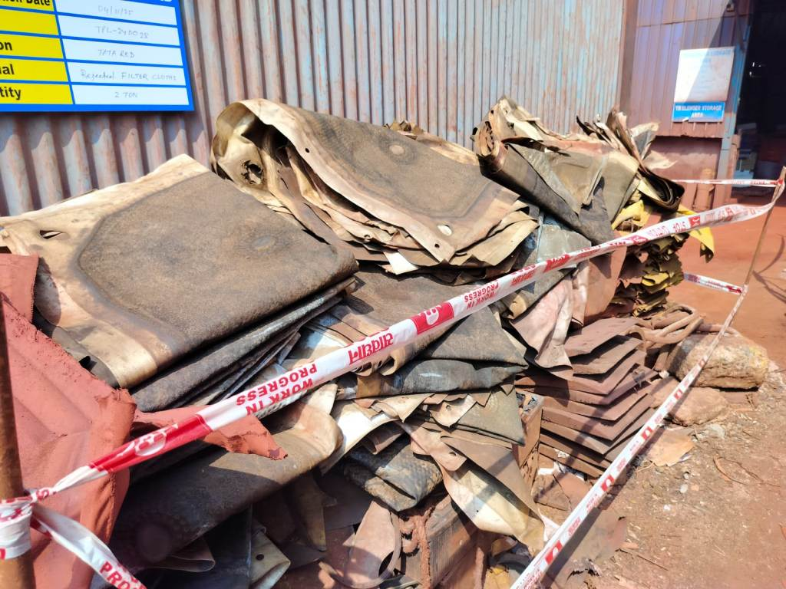
TPL-240025 TPL-240026 TPL-240027 TPL-240028
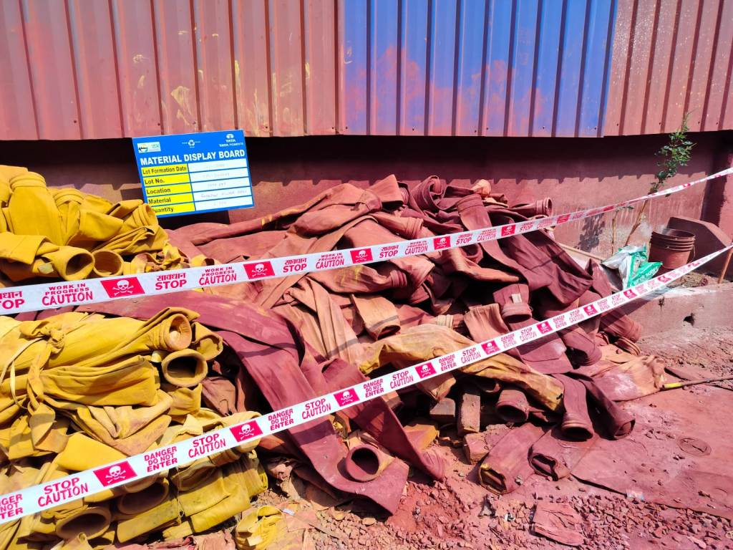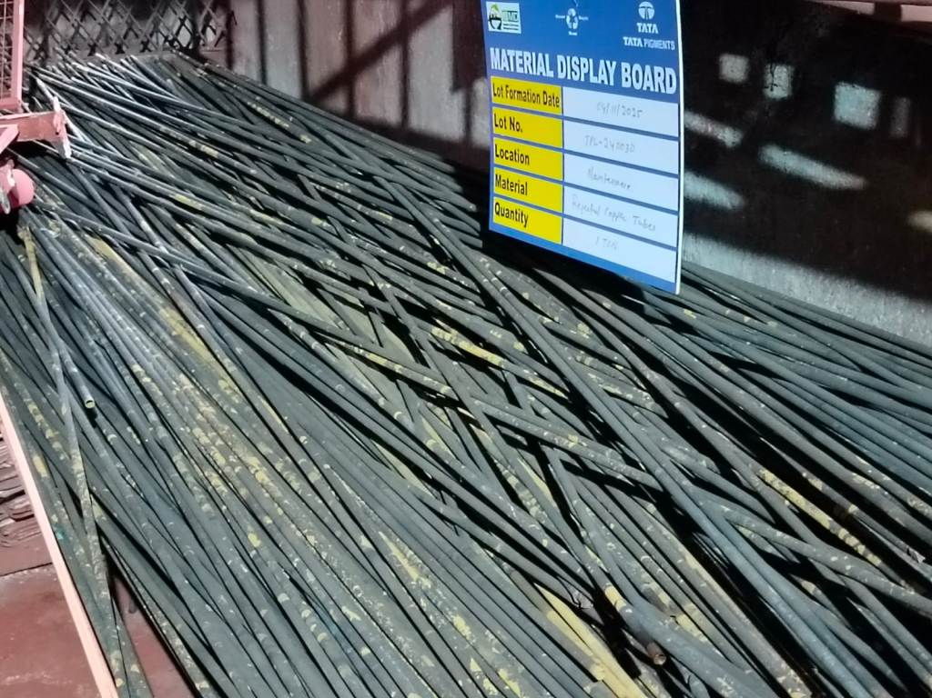
TPL-240029 TPL-240030

Open www.ahbilimoria.com ->Click on Customer Complaint Management Portal

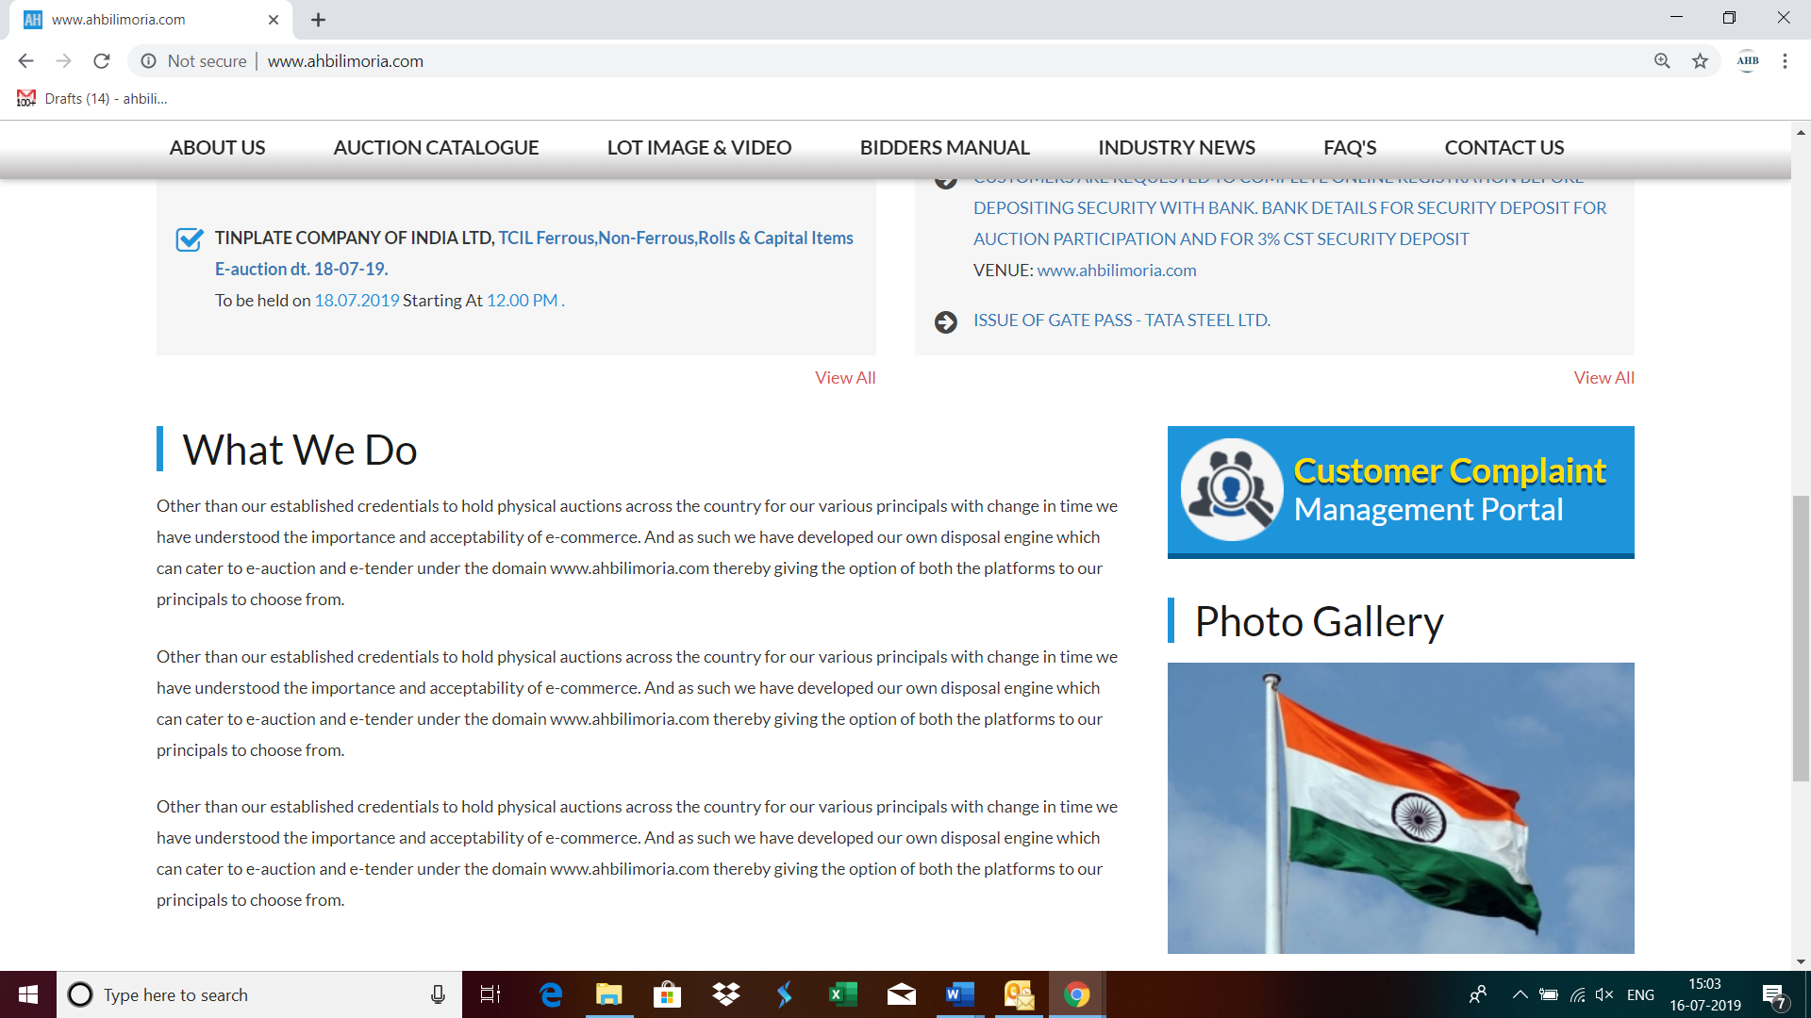

Use your User ID & Password for login

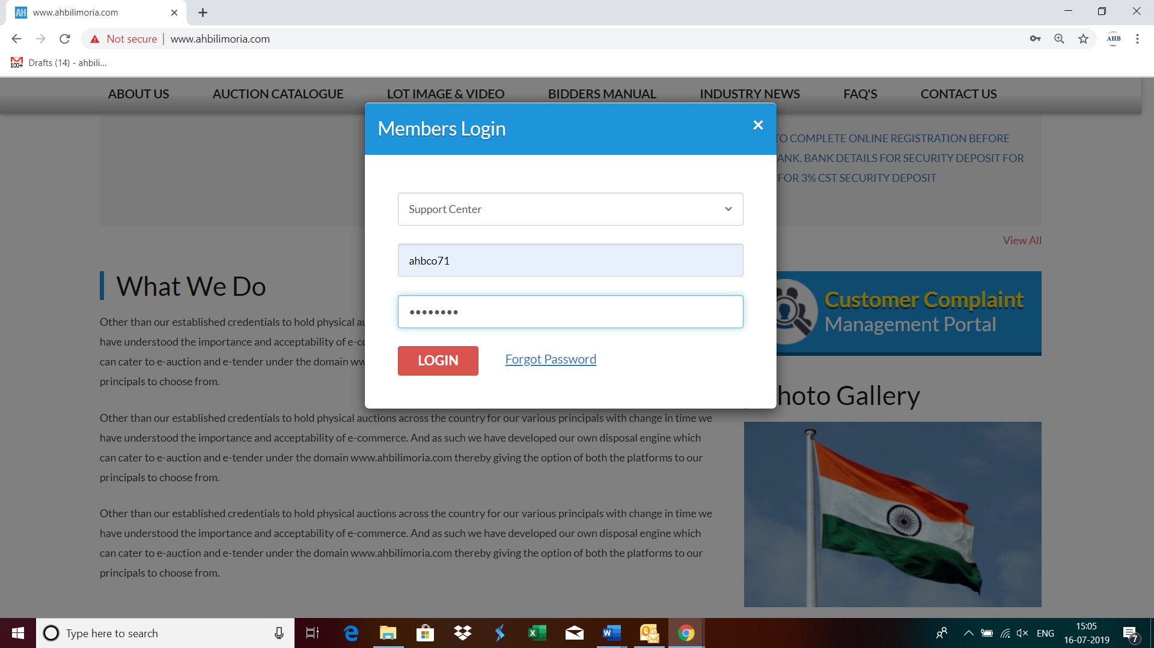

Click Complaint Portal-> Click on “Post a New Ticket”

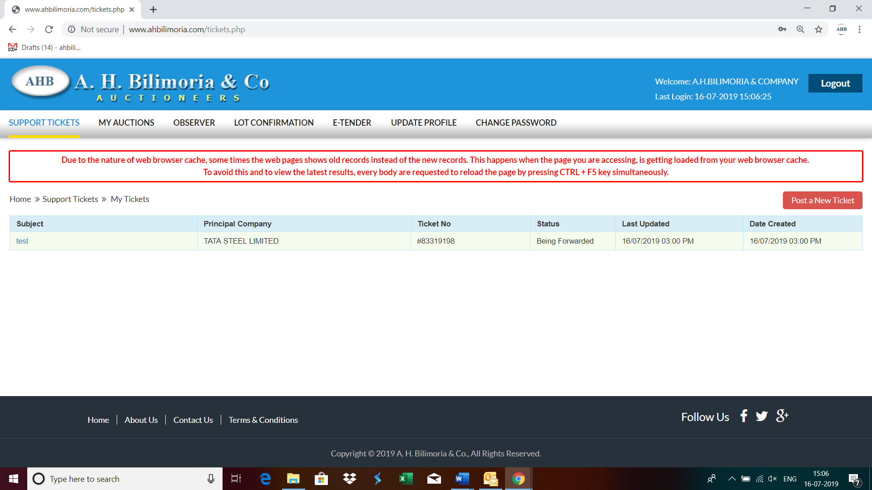

Post a New Ticket->Subject* ->Message* -> Email*->Principal Company*->Attach Document (If required any attachment) ->Submit

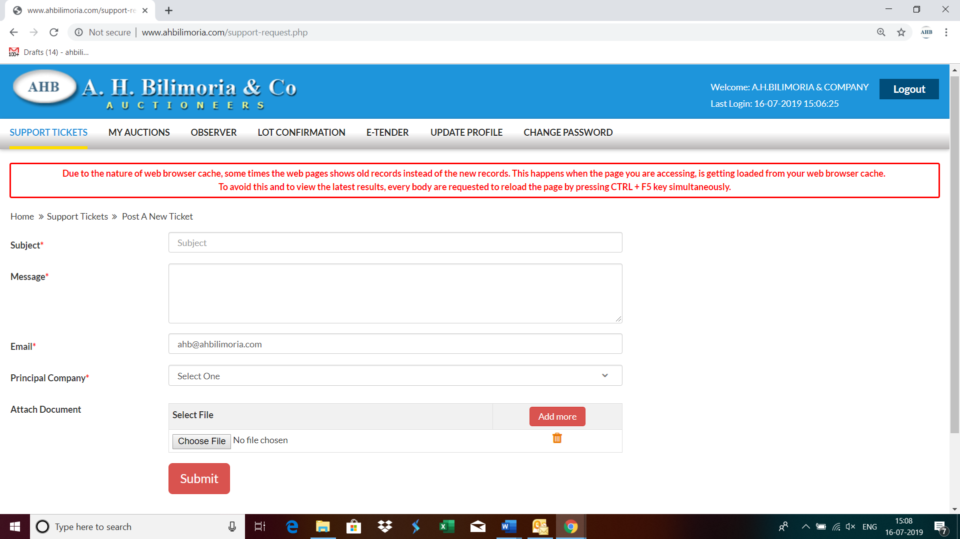

Your support request has been submitted successfully and the Reference No ----- is generated automatically

