E-Auction Catalogue
E-Auction conducted by A H Bilimoria & Co.
SALE OF MISC ITEMS OF TATA STEEL DOWNSTREAM PRODUCTS LIMITED, ON ‘’AS IS WHERE IS AND NO COMPLAINT BASIS’’
Catalogue Serial Number: | TSDPL/AHB/MAY/004/26-27
Materials : | MISC ITEMS At TSDPL
Seller: | Tata Steel Downstream Products Limited
E-Auction website: | www.ahbilimoria.com
E-Auction Date & Time: | 12th May, 2026 at 12:00 PM
Inspection Date & Time: | No physical inspection to be conducted. Interested customers please visit our website for indicative lot photographs. For any assistance please call AHB (7991108353/7003840027) or TSDPL Officer (09065520191).
Date of Security Money Deposit | 12th May, 2026 Till 11:30 AM
Contact Details:
For Post E-Auction @ A H Bilimoria & Company
E-Auction Room | 033-2229-4833/6577
Inspection & Helpdesk | Mr. A Dey- 09831132642, Mr. Bimal Bhardwaj- 09431373386, 08051121855
Sale Confirmation Letter | Mr. A Das - 033-2229-4833 / 6577 / 2760, 30290771
Disablement | Mr. A Mazumdar- 09883421336
Customer Complaint | Mr. A K Sil – 09830074122, Mr. D Pyne – 09830438481
For any unresolved issues | Mr. Bimal Bhardwaj- Email_ ahbjsr@ahbilimoria.com, b.bhardwaj@ahbilimoria.com
Escalation for unresolved issues | Mr. A K Sil – 09830074122, Email-ahb@ahbilimoria.com, ahbilimoria.company@gmail.com.

For Commercial Issue : TATA STEEL DOWNSTREAM PRODUCTS LIMITED :-
Contact Person | Mr. Leo Kumar Rout (leo.rout@tsdpl.in)

For Delivery related Issued @ TATA STEEL DOWNSTREAM PRODUCTS LIMITED :-
Contact Person | - For CR Plant (Inside the Tata Steel Works)- Mir Imdadul Islam (imdadul@tsdpl.in); Contact Number:- 7070896819  - For HR Plant (TSDPL- Bara) - Sujay Kumar Singh (sksingh@tsdpl.in) Contact Number :- 9264430700  - For Demag - Mr.D Saha (dsaha@tsdpl.in), Contact Number: 09234569958.  - For EPA - Abhishek Kumar (abhishek.kumar@tsdpl.in), Contact Number: 9113426768

- MATERIAL DETAILS:
Quantity offered is based on eye estimation. Delivery will be made for the estimated quantity or actual ground stock, whichever is lower. Estimation error may arise. After inspection, no complaint of whatsoever nature on estimated /offered quantity shall be entertained under any circumstances. Bidders are advised to make their own judgement on offered quantity before bidding.

- INFORMATION AND INSTRUCTION
- EMD can be adjusted in the final installment/lot.
- Customers have to ensure regular lifting as and when material availability communicated by TSDPL in writing.
- The offered quantity (in the auction) can be increase if mutual agreement happens between TSDPL and customer.
- For Demag plant any scrap dispatch from Demag unit; Demag unit weighment to be done at Demag only.
- Presence of supervisor during loading is required.
- For all the available stock material the evacuation is to be done within a week time after the confirmation (over phone / mail / msg) of stock by TSDPL, fail to lift within a week time will fetch the penalty equivalent of 1% of the total SO Value, for second instance the penalty will be posed equivalent of 2% of the total SO Value, for the third instance the penalty will be posed equivalent of 3% of the total SO Value and after this total EMD amount will be forfeited and the lot will go for re-auction

Sr. No. | LOCATION | LOT NO | MATERIAL DESCRIPTION | TOTAL QTY | UOM | GST | TCS | LOADING | LIFTING VALIDITY
1 | EPA Ashoka 2 | TSDPL-260501 | Rejected HR Seconds (Range of thickness 1.6mm to 12mm, Width 1100mm to 1600 mm), Length - 1500mm to 3000mm, (STOCK QTY: 60MT) | 60.0 | MT | 18% | 2% | Loading by TSDPL free of cost | 31.05.2026
2 | EPA Ashoka 1 | TSDPL-260502 | Rejected HR Seconds (Range of thickness 1.6mm to 12mm, Width 1100mm to 1600 mm), Length - 1500mm to 3000mm, (STOCK QTY: 50MT) | 50.0 | MT | 18% | 2% | Loading by TSDPL free of cost | 31.05.2026
3 | CR Plant | TSDPL-260503 | C.R. SECOND SHEETS Thickness - 0.3 to 3.2 MM, length - 1500 to 2500 MM, width 900 to 1350 MM (STOCK QTY: 60MT & ARISING: 30MT) (Arising for the months of May-26) | 90.0 | MT | 18% | 2% | Loading by TSDPL free of cost | 31.05.2026
4 | CR Plant | TSDPL-260504 | CR end Cuts(Distribution scrap of SJCR plant) a) CR end cuts(Th: 0.4-3.2mm, Width: 150-1540mm, length: 50-4000mm) (STOCK QTY: 50MT & ARISING: 40MT) (Arising for the months of May-26) | 90.0 | MT | 18% | 2% | Loading by TSDPL free of cost | 31.05.2026
5 | Bara Plant | TSDPL-260505 | Rejected HR Seconds, Thickness range- 1.60mm to 10 mm Width range- 1000mm to 1500 mm, Length range- 1000mm to 3000mm (STOCK QTY: 35MT & ARISING: 20MT) (Arising for the months of May-26) | 55.0 | MT | 18% | 2% | Loading by TSDPL free of cost | 31.05.2026
6 | CR Plant | TSDPL-260506 | Light Melting (including old and rusted)  a) Rej. GP cut sheet(jacketing scrap),  b) Coil ID protector  c) Od protector  d) Side disc removed from incoming RM coils  Mechanized loading shall be in customer's scope. (STOCK QTY: 100MT) | 100.0 | MT | 18% | 2% | Mechanized loading shall be in customer's scope | 30.06.2026
7 | CR Plant | TSDPL-260507 | Heavy melting Scrap material  a)Rej. structural items(Rej. Angle, rej. channel, rej. I-beam,rej. MS plates, rej.round/square pipes, rej. Chequered plates, rej. MS plates),  b)rej and used TMT bars(small cut pieces also) found during civil excavation  c) Metal ID sleeves  Mechanized loading shall be in customer's scope. (STOCK QTY: 50MT) | 50.0 | MT | 18% | 2% | Mechanized loading shall be in customer's scope | 30.06.2026
8 | CR Plant | TSDPL-260508 | Rejected and cut pieces of GC Scrap and colour coated sheet scrap (STOCK QTY: 2MT) | 2.0 | MT | 18% | 2% | Loading by TSDPL free of cost | 30.06.2026
9 | Demag Plant | TSDPL-260509 | wire rope sling (STOCK QTY: 2MT) | 2.0 | MT | 18% | 2% | Loading by TSDPL free of cost | 30.06.2026
10 | CR Plant | TSDPL-260510 | Rejected HR Seconds, Thickness range- 1.60mm to 12 mm Width range- 1000mm to 1600 mm, Length range- 1000mm to 13000mm (STOCK QTY: 50MT) | 50.0 | MT | 18% | 2% | Loading by TSDPL free of cost | 31.05.2026
11 | CR Plant | TSDPL-260511 | Plain GP Sheet a) Rej. Outer body cover packaging sheet in incoming RM coils (STOCK QTY: 5MT) | 5.0 | MT | 18% | 2% | Loading by TSDPL free of cost | 30.06.2026
12 | CR Plant | TSDPL-260512 | Rejected & Used GPCTL Cooling Tower (STOCK QTY: 1No) | 1 | Nos | 18% | 2% | Loading by TSDPL free of cost | 30.06.2026
13 | Bara Plant | TSDPL-260513 | Rejected 210lt empty drum (STOCK QTY: 15Nos) (Only authorized parties who have valid authorization, CTO/CTE from pollution control board are authorized to participate in the auction as per hazardous and other waste rule) | 15 | Nos | 18% | 2% | Loading by TSDPL free of cost | 30.06.2026
14 | DEMAG PLANT | TSDPL-260514 | Rejected Strap end Cuts which also include some old and rusted steel strap. Bundling is allowed for the lot. (STOCK QTY: 8MT & ARISING: 2MT) (Arising for the months of May-26 to June-26) | 10 | MT | 18% | 2% | Loading by TSDPL free of cost | 30.06.2026
15 | Bara Plant | TSDPL-260515 | Rej. CFM Compressor,  Compressor Details:  Model: GAE 22 P  Max. Final Pressure: 7.5 bar  Free Air Delivery: 63.1 l/s  Motor Rating: 22 kW  Serial No.: PNA 025265  Year of Manufacture: 2010  Make: Atlas Copco | 1 | No | 18% | 2% | Loading by TSDPL free of cost | 30.06.2026
16 | CR Plant | TSDPL-260516 | Rej. Compressor,  Compressor Details:  Model: GAE 22 AEL 11  Max. Final Pressure: 7.5 bar  Free Air Delivery: 62.8 l/s  Motor Rating: 22 kW  Serial No.: PNA 603321  Year of Manufacture: 2006  Make: Atlas Copco | 1 | No | 18% | 2% | Loading by TSDPL free of cost | 30.06.2026

- Payment and Lifting Schedule:
Successful customers have to strictly adhere to the payment schedule mentioned below; no deviation in payment terms against arising lots will be permitted.

Lot No. | Lifting Schedule  (working days from the next day of DO release)
Lot No. | EMD (10 % of Total Lot Value ) | Balance Payment Schedule for Arising Quantity | Lifting Schedule
For All Material | 02 Working days from Date of Lot Confirmation | April’26 To June’26 should be deposited by as per schedule  For Stock +Arising of May’26 - Payment to be made within the two working days from the date of EMD.  For arising of June’26 – Payment to be made by 25th May’26. | CUSTOMERS HAVE TO LIFT THE MATERIAL WHENEVER STOCK INCREASES FROM ONE VEHICLE QTYFOR EVERY ITEMS.  For CR • CUSTOMERS HAVE TO LIFT AS PER DETAILS MENTIONED IN ITEM DESCRIPTION.  For All Stock Qty Lifting should be completed within 10 Working Days From the Date of SO.

- Suitable extension of due date for payment and lifting will be accorded in case of any eventualities like Strike/ Bandh/ Special restriction on vehicular movement imposed by the local Administration etc.

- Requirements of participation:
  - Registration: Before participation in the E-Auction, a prospective bidder shall be required to get registered with A H Bilimoria & Co. For details visit www.ahbilimoria.com.

  - Documentation: The following documents need to be submitted by the bidder interested in participating in the E-Auction to A H Bilimoria & Co. prior to the
Date of the E-Auction.
      - PAN Card, GST, Registration Form, Cancelled cheque, letterhead
      - Letter of Interest duly signed and stamped by bidder.

  - Security Deposit: Non-Interest bearing security deposit of Rs.60,000/- (Rupees Sixty Thousand only) in favour of “A H Bilimoria & Co.” payable at Kolkata/Jamshedpur.

  - Modes of Security Deposit: PO / DD / CHQ or through NEFT in favour of "A. H. BILIMORIA & COMPANY" to be deposited with HDFC Bank A/c. No. 06932560001205, IFSC Code: HDFC0000693, Branch name: 31, Chowringhee Road, Kolkata – 700016.

- Inspection Rules & Policy:
No physical inspection to be conducted. Interested customers please visit our website for indicative lot photographs. For any assistance please call AHB (7991108353/7003840027) or TSDPL Officer (09065520191).

4. Bidding modalities:

  - Price Bid Basis: In Indian rupees as per unit of measurement as given in Material List. Price to be quoted is basic, ex- location exclusive of GST (In case of consignment agency sale price to be quoted ex location inclusive of GST), Sales tax and any other statutory levies.
  - Bid Increment : Rs.100/- ( Rupees Hundred only ) / (or as specified)
  - Type of E-Auction: English No Ties
  - Bid Validity: Bid shall be valid for 15(Fifteen)working days excluding Sundays and holidays counted from the next day of E-Auction process in case of E-Auction against a catalogue which is completed on the same day. And if it is continuing on any other day the counting of days for lot confirmation shall be from the next day of completion of entire E-Auction process.

- Taxes & duties:
  - GST : As applicable
  - TCS : As applicable. In case of availing of concessional rate of TCS proper certificate issued by appropriate Income Tax authority are to be issued in favour of the Principal Company along with payment. Self certification of Form no 27C is not acceptable. Form 27C will also have to be certified by appropriate Income tax authorities.

5.3 Any change in GST and levies applicable at the time of lifting shall be applicable.

- Payment terms & conditions :
  - Payments: Virtual account shall be created for each customer and payment to be made on the same account.
  - EMD: 10% of the total material value to be paid within 02 (Two) working days from the date of lot confirmation. EMD will be adjusted in the final installment. EMD payment is to be made within the time limit as given in letter of confirmation. No extension will be provided for the same.
  - Balance Payment Time: (As per payment schedule)
  - Delayed Payment Charges (DPC): Installment payments with DPC @ five (05) paise per Rs. 100 per day will be accepted up to 4 (Four) working days from due date of installment payment as mentioned in the confirmation letter. This is not applicable for EMD payment.
  - Only Sundays are excluded for counting purpose for payment schedule.
  - In the event of Non-Receipt of Payment within the stipulated period of Payment, the Sale Offer for the approved Lot shall stand withdrawn automatically.
  - All payment related confirmation and details should be addressed to Mrs. Nibedita Sahu - nibedita@tsdpl.in.
  - All blocked SO communication should be addressed to Mr. Biplab Dutta (biplab@TSDPL.com), Abhinav Anand (abhinav.anand@tsdpl.in).
  - Material availability communication should be addressed to Mir Imdadul Islam (imdadul@tsdpl.in), Sujay Kumar Singh (sksingh@tsdpl.in),D Saha (dsaha@tsdpl.in) and Abhishek Kumar (abhishek.kumar@tsdpl.in).
  - Any other queries Communication should be addressed to Mr. Leo Kumar Rout (leo.rout@tsdpl.in)

- Lifting terms & conditions:
7.1 Vehicle to be placed upon placement of SO. DO shall be made after loading and weighment.
7.2 Loading Charges: Self, Loading Time: - 8.00 AM to 5.00 PM. Presence of Supervisor is necessary while loading of Scrap.
7.3 Please note Loading shall be given strictly as per the statutory norms & safety norms of TSDPL. Winning bidder must have registration with PF, ESI, LABOUR LICENSE. Party to ensure that the workers engaged by them are covered under PF, ESI/Group Insurance & document should be submitted for applying for gate pass.
7.4 Loading shall be given strictly as per the statutory norms & safety norms of TATA STEEL DOWNSTREAM PRODUCTS LIMITED Ltd. Winning bidder need to provide the Authorization letter for the transporter.
7.5 Customer has to place only the vehicle, which is less than 10 year old from HSM gate.
7.6 Pick & choose not allowed for any of the lots.
7.7 Lot transfer will not be allowed& no stock transfer will be done.
7.8 Use of hydra cranes by customers in any premises/location /stockyards of TATA STEEL DOWNSTREAM PRODUCTS LIMITED and its vendors/ consignment agents' premises is banned.
7.9For lifting of materials from CR Mill, Trucks entering through HSM Gate, Vehicles whose age do not exceed 10 years are to be deployed.
7.10 Material Quantity as mentioned in the catalogue may vary to the tune of +/- 100% and to be lifted accordingly.

- Penalties:
  - The following penalties shall be applicable in the eventuality of a buyer defaulting in making the payment of EMD (wherever applicable) or any installment/s, as per the stipulated schedule for each lot, in a financial year:
- In the first instance, a penalty of Rs. 60,000/- (Rupees Sixty Thousand only) shall be recovered from the customer.
- In the second instance, a penalty of Rs.100,000/- (Rupees One Lakh only) shall be recovered from the customer.
- In the third, and any subsequent instance, a penalty of Rs.150,000/-(Rupees One Lakh Fifty thousand only) shall be recovered and the customer shall be debarred from participating in any E-Auction for a period of three months from the date of debarment.
- In the event of any default, the customer’s user id will be disabled and the customer will be blocked from participating in any E-Auction of TSDPL with immediate effect.
- The defaulting customer shall be allowed 06 (six) working days to deposit the penalty as mentioned above. In case the penalty is not received within the stipulated period, the customer’s security deposit shall be forfeited, and the defaulting customer shall be debarred from participating in any E-Auction of TATA STEEL DOWNSTREAM PRODUCTS LIMITED.

  - If after making payment of EMD (wherever applicable), the installment payment/s are not made by the customer as per the stipulated schedule for each lot, the entire EMD amount against such lot shall be forfeited.

  - In case of non- lifting of full lot quantity against DO after making full payment.

For all the available stock material the evacuation is to be done within a week time after the confirmation (over phone / mail / msg) of stock by TSDPL, fail to lift within a week time will fetch the penalty equivalent of 1% of the total SO Value, for second instance the penalty will be posed equivalent of 2% of the total SO Value, for the third instance the penalty will be posed equivalent of 3% of the total SO Value and after this total EMD amount will be forfeited and the lot will go for re-auction

  - Penalty for dishonour of cheques:
In case of dishonor of a payment instrument deposited by a customer for any reason whatsoever, the following shall be recovered from the customer:-
- Rs.1000/- (service tax inclusive) in form of Demand Draft towards bankers charges per instrument.
- Delayed payment charges @ 5 paise per Rs.100/- per day for the period of delay beyond the due date.
- Penalty @ 1% ( Inclusive of service tax) of the dishonoured amount, subject to a maximum of Rs.25000/- ( Rupees Twenty Five Thousand Only) per dishonoured instrument
In case of non- compliance by the bidder the penalties as given in clause no. 7.1 shall be applicable.

DEFAULTS WOULD BE COUNTED AGAINST TATA STEEL DOWNSTREAM PRODUCTS LIMITED AND NOT AGAINST A PARTICULAR E-AUCTIONEER
- Lot Closure Norms: Material Quantity as mentioned in the catalogue may vary to the tune of +/- 100% and to be lifted accordingly.

- Complaints: Complaints, if any, with regard to any transaction shall have to be lodged by the buyer within three calendar months from the date of last invoice. No complaint shall be entertained thereafter, under any circumstances.

- Jurisdiction: Any dispute arising out of any contract shall be decided in Jamshedpur by the courts in Jamshedpur and by no other courts. The courts in Jamshedpur shall have exclusive jurisdiction to adjudicate upon any such dispute.

- General terms & conditions:
12.1Any dispute on condition of material shall not be entertained at any point after confirmation of lot.
12.2All materials are offered/sold on “As is Where is Basis” and “No Complaint Basis”.
12.3Payment and invoicing has to done in the name of the H1 bidder, subject to the prices being approved.
13.4Material purchased should be the only material being lifted from the designated location. TATA STEEL DOWNSTREAM PRODUCTS LIMITED has the right to check any vehicle at any moment of time. If material lifted differs from the material that is purchased by the buyer, and then the buyer/authorized representative will be permanently debarred and penal action against the buyer/ authorized representative as deemed fit shall be taken by TATA STEEL DOWNSTREAM PRODUCTS LIMITED Ltd.
12.5If the safety compliance is not followed then TATA STEEL DOWNSTREAM PRODUCTS LIMITED can penalize the buyer/authorized representative as deemed fit.
12.6These terms and conditions as stated above supersede the relevant terms & conditions that are given in TATA STEEL DOWNSTREAM PRODUCTS LIMITED Secondary General Terms and Conditions. The terms & conditions not covered above will be as per TATA STEEL DOWNSTREAM PRODUCTS LIMITED’s
12.7Quantity offered is based on eye estimation. Delivery will be made for the estimated quantity or actual ground stock, whichever is lower. Estimation error may arise. After inspection, no complaint of whatsoever nature on estimated /offered quantity shall be entertained under any circumstances. Bidders are advised to make their own judgement on offered quantity before bidding.
12.8Presence of supervisor during loading is required.
12.9Customers have to lift whenever stock increase from one vehicle qty. some material in cr need lifting daily irrespective of stock quantity
12.10The quantity of offered quantity can be increase if mutual agreement happens between TSDPL and Customer.
12.11Please note Loading shall be given strictly as per the statutory norms & safety norms of TSDPL. Winning bidder must have registration with PF, ESI, LABOUR LICENSE. Party to ensure that the workers engaged by them are covered under PF, ESI/Group Insurance & document should be submitted for applying for gate pass.
12.12Loading Time: - 8.00 AM to 5.00 PM
12.13 EMD WILL BE ADJUSTED IN THE FINAL INSTALLMENT. CUSTOMERS HAVE TO LIFT WHENEVER STOCK INCREASE FROM ONE VEHICLE QTY.
12.14 Successful customers have to strictly adhere to the payment schedule mentioned below, no deviation in payment terms against arising lots will be permitted.
12.15 TSDPL reserves the right to track IP address, MAC number and geolocation of bidding customers whenever customers participate in any auction on the A H Bilimoria & Co. auction platform for TATA STEEL DOWNSTREAM PRODUCTS LIMITED.
12.16 Performance Parameters -90% lifting compliance on weekly basis.(User intimation vs actual vehicle placement)-Tracker will be developed, monitored and will be shared with you for all three units. TSDPL reserves the right to decide whether those customers who fails to achieve the desired compliance level, will be on boarded in the next cycle.
12.17 The seller reserves the right to terminate any offer at any point of time without assigning any reasons.
12.18 In the event of termination of the offer, seller shall refund the balance amount after due reconciliation.
12.19 No claims whatsoever would be entertained after cancellation of the bid.

- Lot Photograph: Photographs of lots are at best indicative only and do not necessarily reflect the actual condition of lots. All bidders are advised to physically inspect the offered lots before participating in the E-Auctions. TATA STEEL DOWNSTREAM PRODUCTS LIMITED or AHB shall not be responsible or liable for any error of judgment or bids put by bidders acting on the basis of these photographs.

- Documents for verification regarding entry of vehicles inside TATA STEEL DOWNSTREAM PRODUCTS LIMITED works :
Eye Test certificate production is mandatory for all Truck Drivers. If the age of the driver is less than 45 years frequency of production of such certificate is once a year and if the age of the driver is more than 45 years the frequency of production of such certificate will be at an interval of every 6 months.

15 Compliance to safety norms
15.1 Authorized persons (of the customer) involved in lifting of the materials will be allowed only with Personal Protective Equipments (PPE) i.e., Safety Shoes, Safety Helmet, Safety Goggles, Fluorescent Jacket and Hand Gloves. No "people movement" shall be allowed at the time of loading/delivery of materials from the yards" TATA STEEL DOWNSTREAM PRODUCTS LIMITED will not be responsible for any delays arising out of Non- Compliance to the Safety Norms.

15.2 Documents for verification regarding entry of vehicles inside TATA STEEL DOWNSTREAM PRODUCTS LIMITED works :
All customers to note that presentation of following set of documents to TATA STEEL DOWNSTREAM PRODUCTS LIMITED authorities is COMPULSORY at the time of reporting of vehicles at TATA STEEL DOWNSTREAM PRODUCTS LIMITED designated Gate for entry of Customer trucks/vehicles.
a. Driving License of driver.
b. Registration Card.
c. Commercial Certificate.
d. Fitness Certificate of Vehicle,
e. Re-registration for vehicles older than 15 years
f. Insurance
The checklist form will be filled in at TATA STEEL DOWNSTREAM PRODUCTS LIMITED designated Gate for entry of Customer trucks/vehicles before entry of vehicle.

15.3 The drivers of the vehicle must have the eye test certificate. The frequency of the testing would be as below:

15.3.1. If the age of the person is less than 45 years - Once in a year

15.3.2 If the age of the person is 45 years or more, the testing is required to be done once in every 6 months

15.4Requirements:
a) Buzzer with Turning Indicator:- 1st June ,b) SUPD &RUPD :- With Immediate effect

16. TRUCK DAIGRAM:

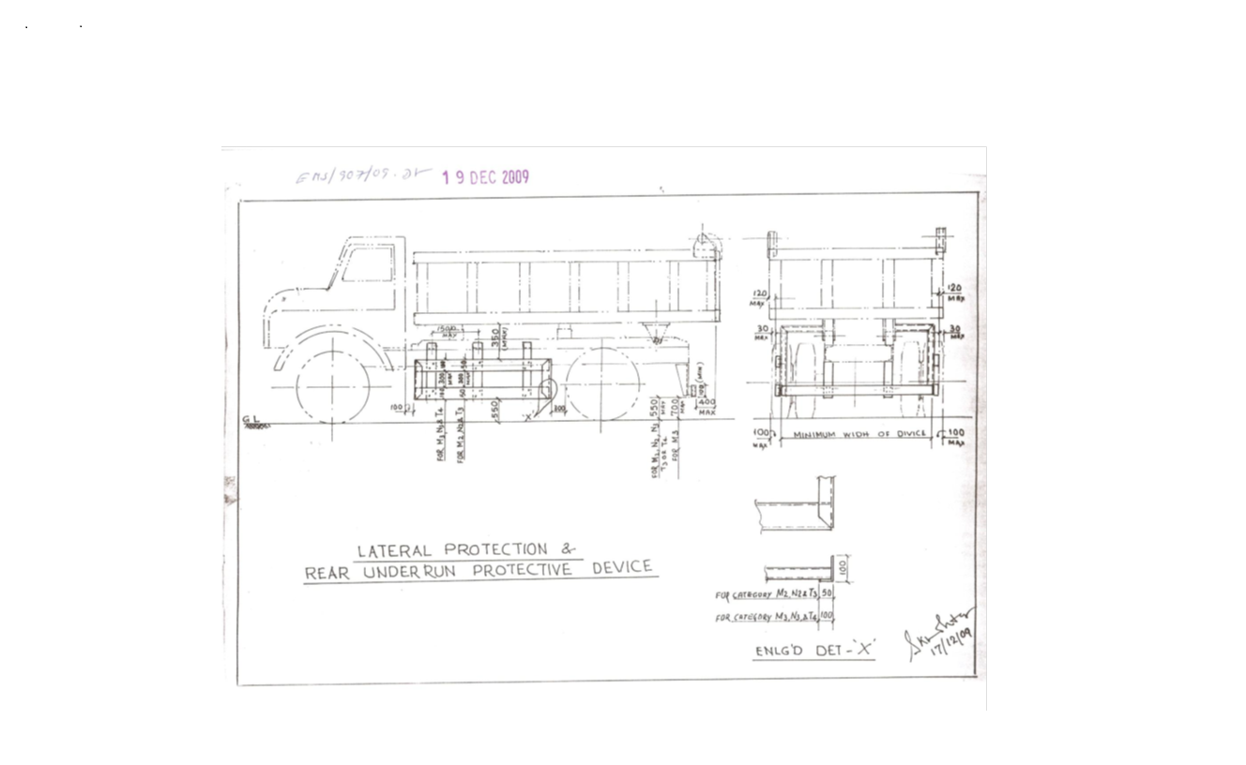
Sl No. | Safety Parameters to be checked
1 | Three Piece Mirror( Truck, Trailer & Dumper)-Helper side
2 | Single Mirror- Driver side
3 | Rear View Mirror (Tata Ace, 207, Jeep etc.)
4 | Service Brake
5 | Parking Brake
6 | Seat Belt
7 | Head Light
8 | Parking Light
9 | Blinker
10 | Horn
11 | Reverse Alarm
12 | Wiper
13 | Windshield Glass
14 | Air Pressure Min. 7 Kg/Cm^2
15 | Run Under Protection Guard as per TATA STEEL DOWNSTREAM PRODUCTS LIMITED standard
16 | Side under Protection Guard as per TATA STEEL DOWNSTREAM PRODUCTS LIMITED standard
17 | Tyre Condition (Tread Depth, Cut Mark etc.)
18 | Any Oil Leakage from the vehicle
19 | Physical condition of Dallah
20 | Availability of scotch block
21 | Buzzer with side indicator
22 | Driver's eye examination report
Legal Documents to be checked:
Sl No. | Documents to be Checked
1 | RC Book
2 | Insurance
3 | Pollution
4 | Driving licence
5 | Fitness for more than 15 years old vehicle
6 | NOC for outside vehicles

SPECIAL TERMS AND CONDITIONS FOR INTERNET E-AUCTION
Bandwidth problems, connectivity problems with the local isp (internet service provider), slowness to access pages for downloading etc. are beyond the control of TSDPL and a h bilimoria & company. Hence no responsibility lies with TSDPL or a h bilimoria & company for the above problems faced, if any, by the bidders before/during the e-auction any bid placed using the bidder's username and password is unconditionally binding on the bidder to whom such username and password had been allotted and he shall be solely responsible for maintaining the confidentiality of the same and fully responsible for all activities that occur under their username and password. Hence the user is advised to check the username and password before the e-auction in order to familiarise himself with the same and is advised not to reveal it to anyone else so as to prevent misuse of the same. the bids made by the bidders against their username and password shall be irrevocable. The bidders are advised to register and pre-qualify for bidding well in advance and place their bids early in order to take care of any unforeseen technical difficulty that might surface in the internet operations.

ALL THE PHOTOGRAPHS ARE INDICATIVE ONLY
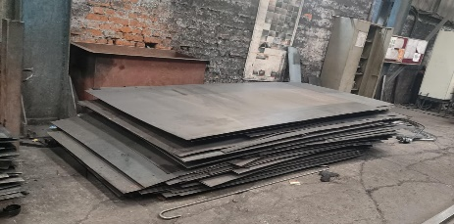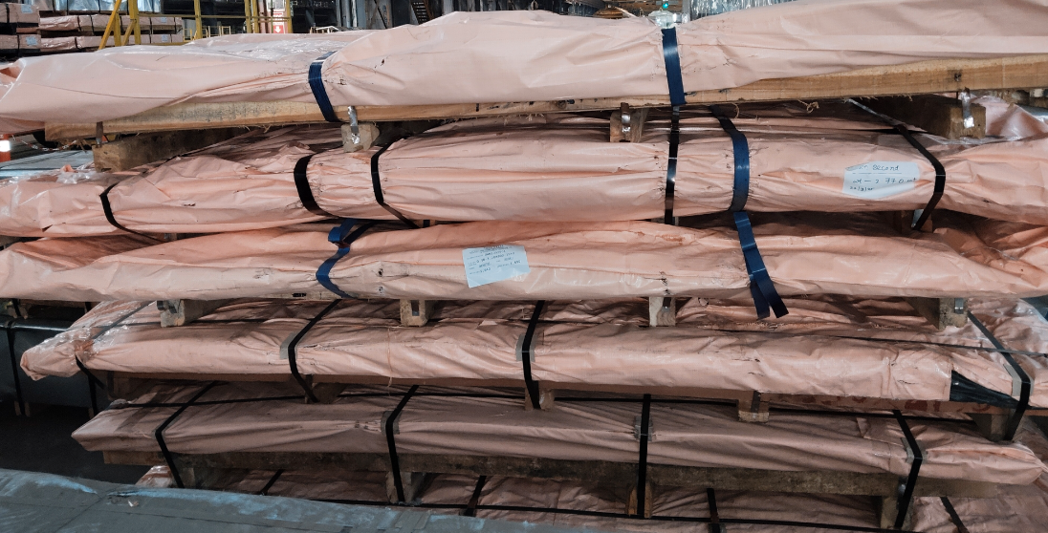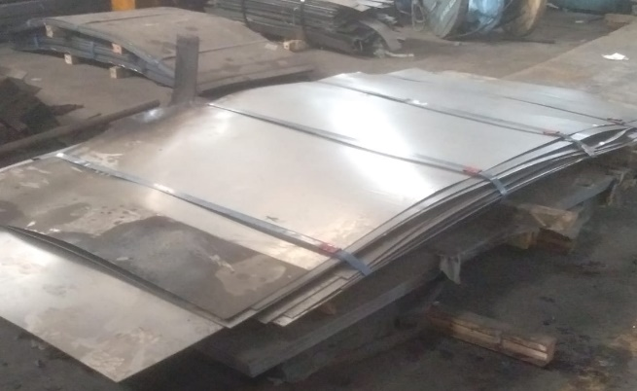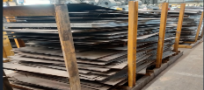
TSDPL-260502 TSDPL-260503 TSDPL-260504 TSDPL-260505
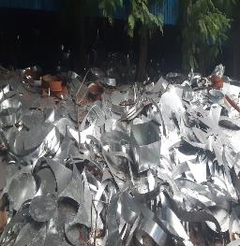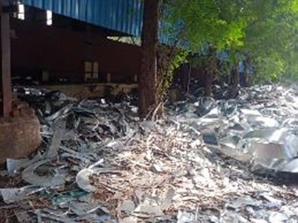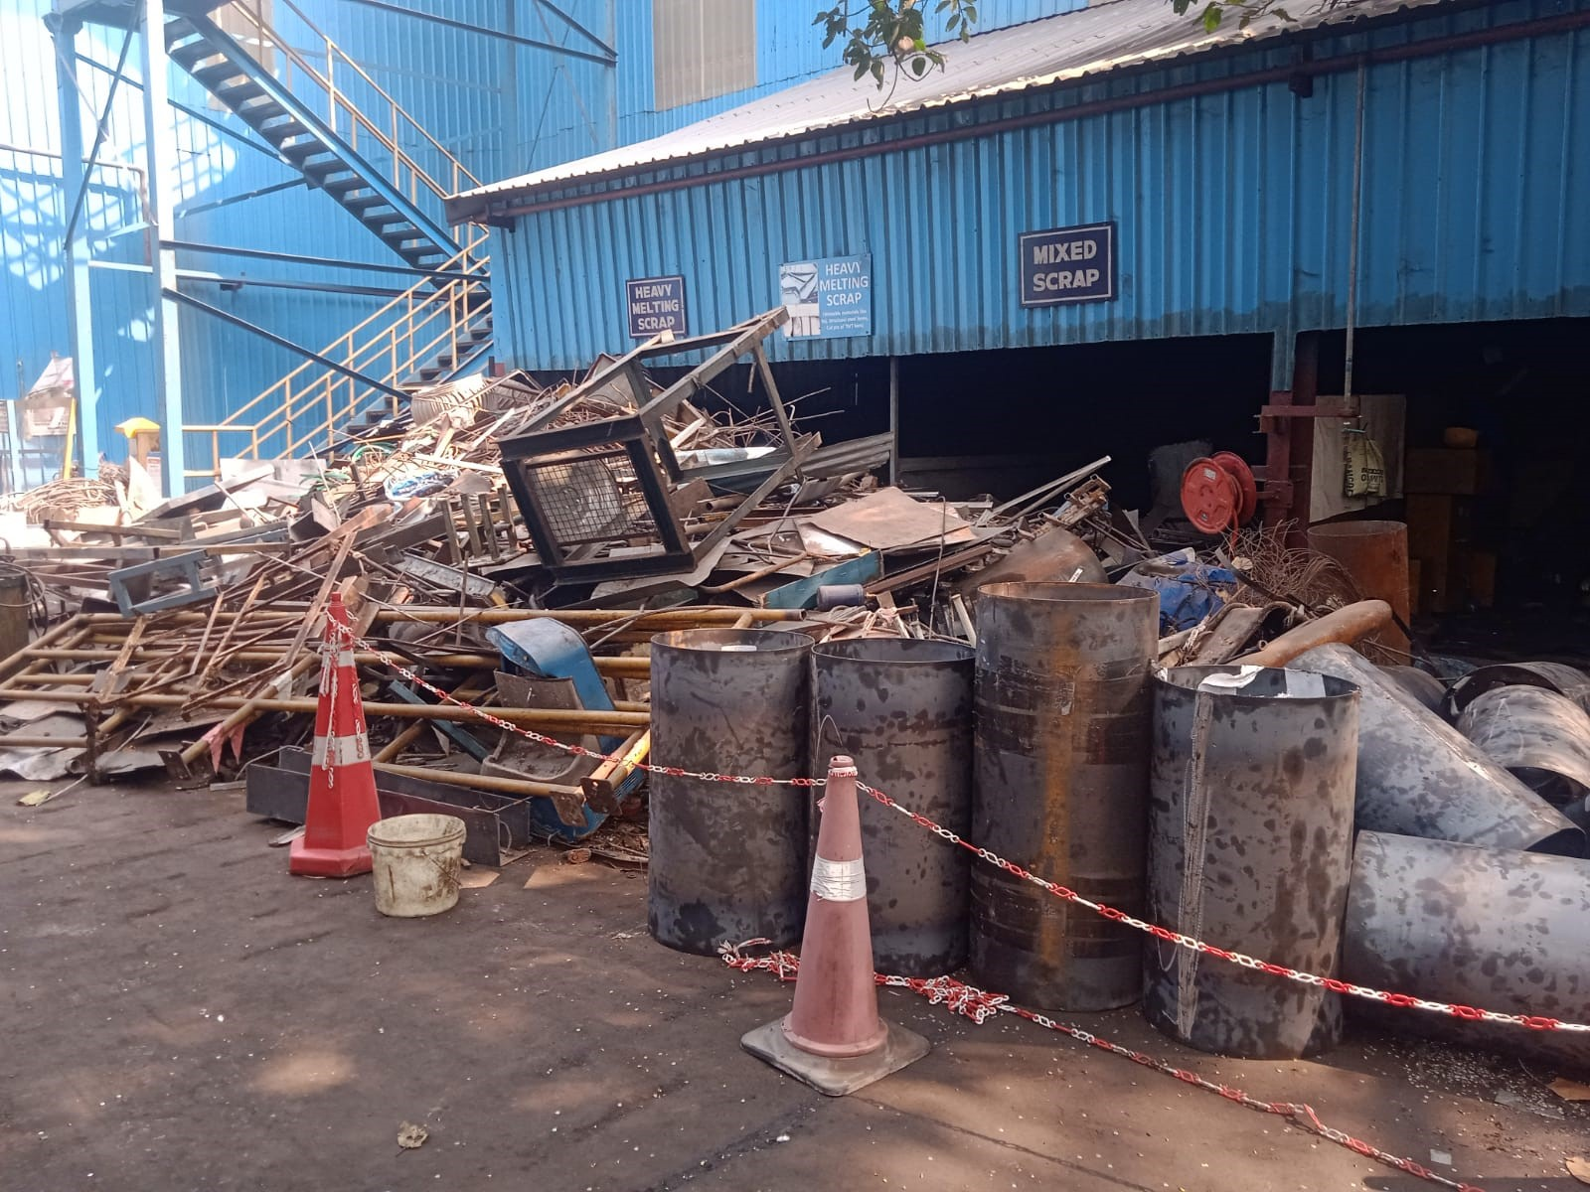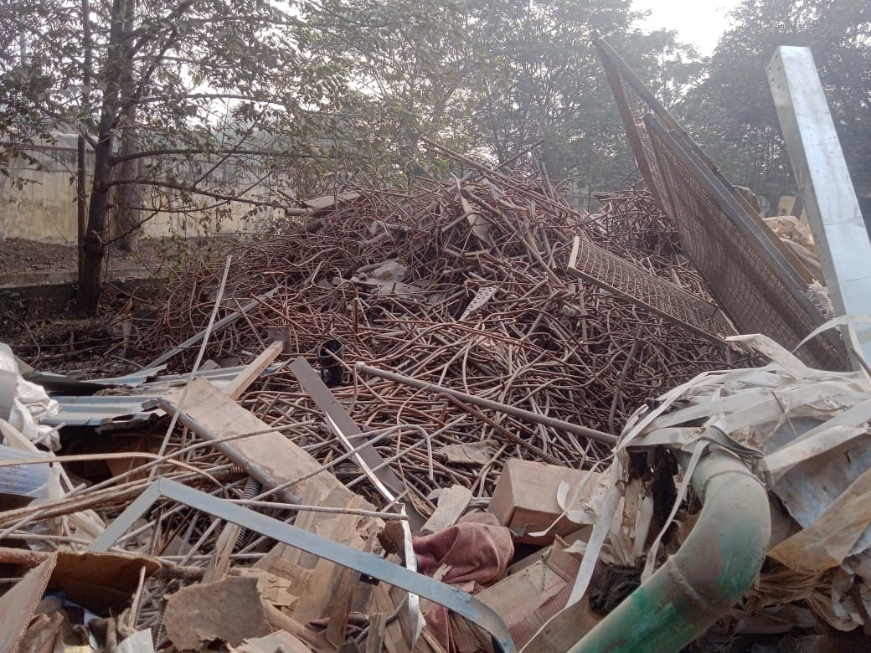
TSDPL-260506 TSDPL-260506 TSDPL-260507 TSDPL-260507
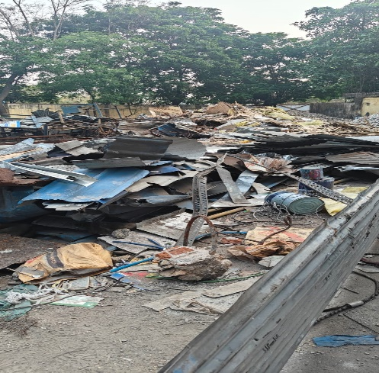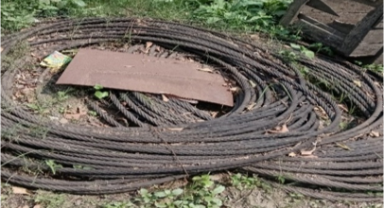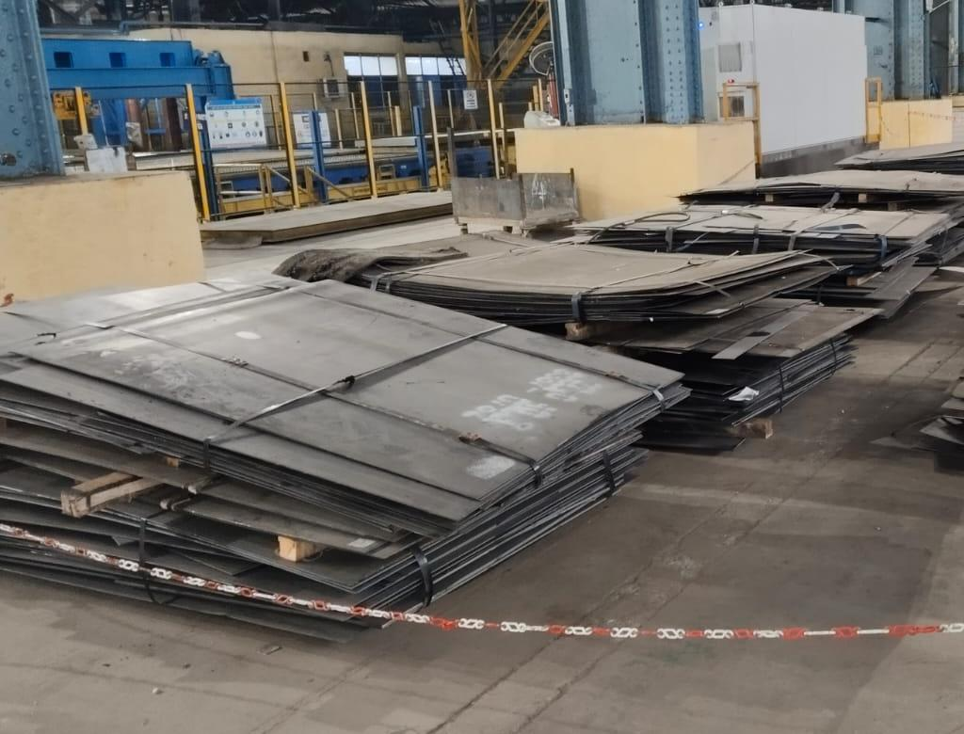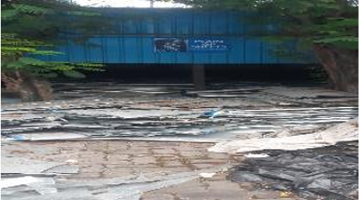
TSDPL-260508 TSDPL-260509 TSDPL-260510 TSDPL-260511
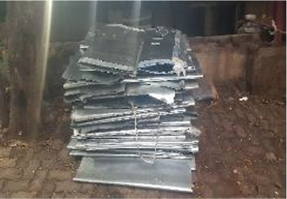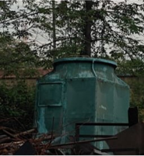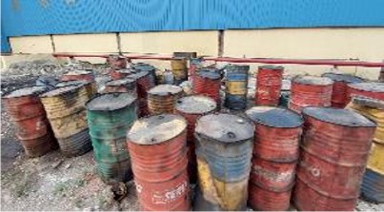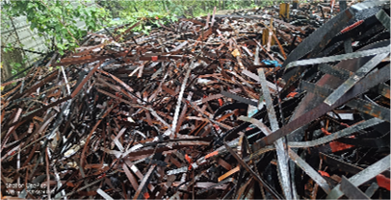
TSDPL-260511 TSDPL-260512 TSDPL-260513 TSDPL-260514

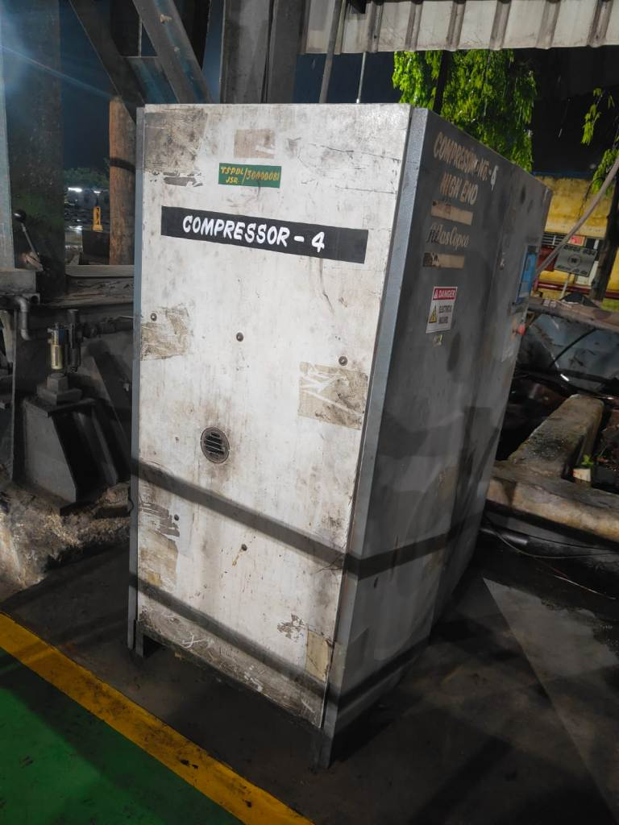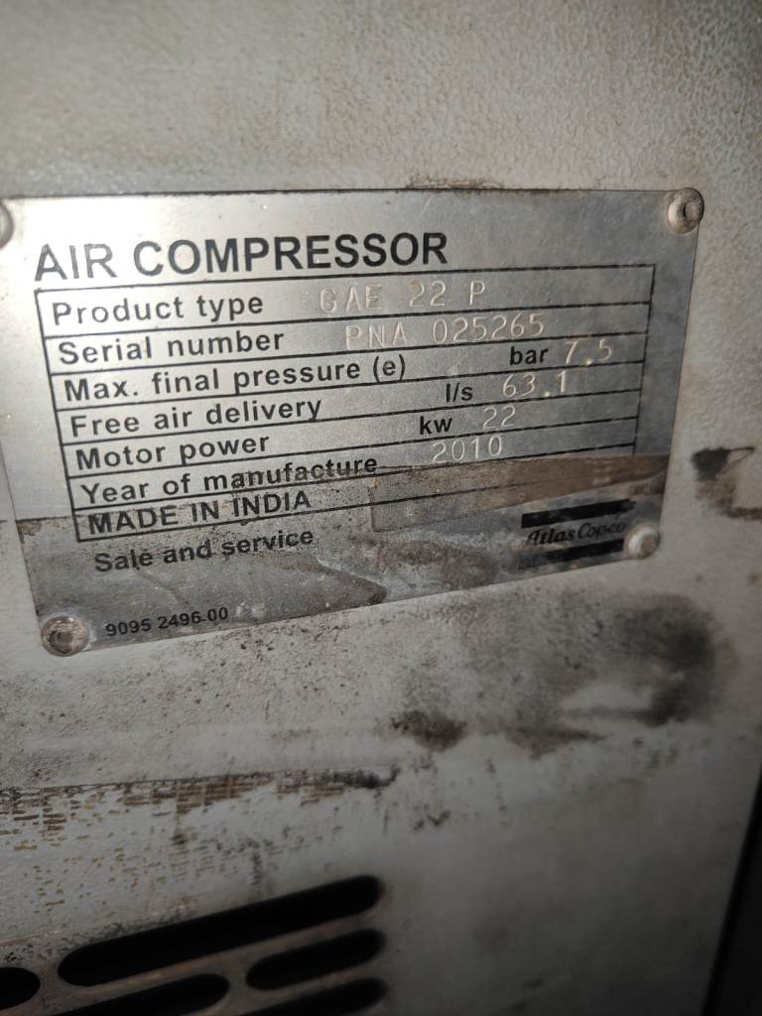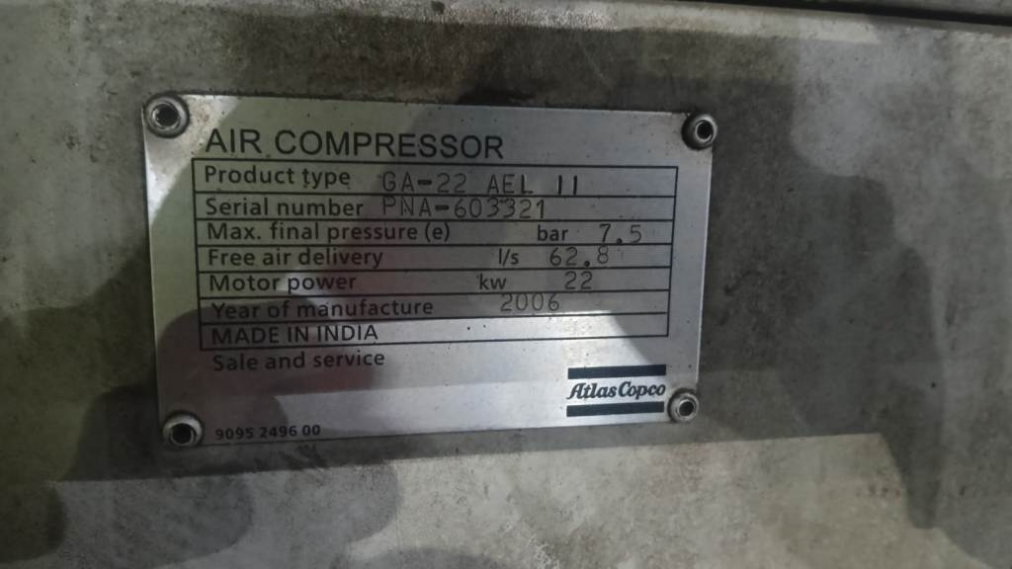
TSDPL-260515 TSDPL-260515 TSDPL-260516
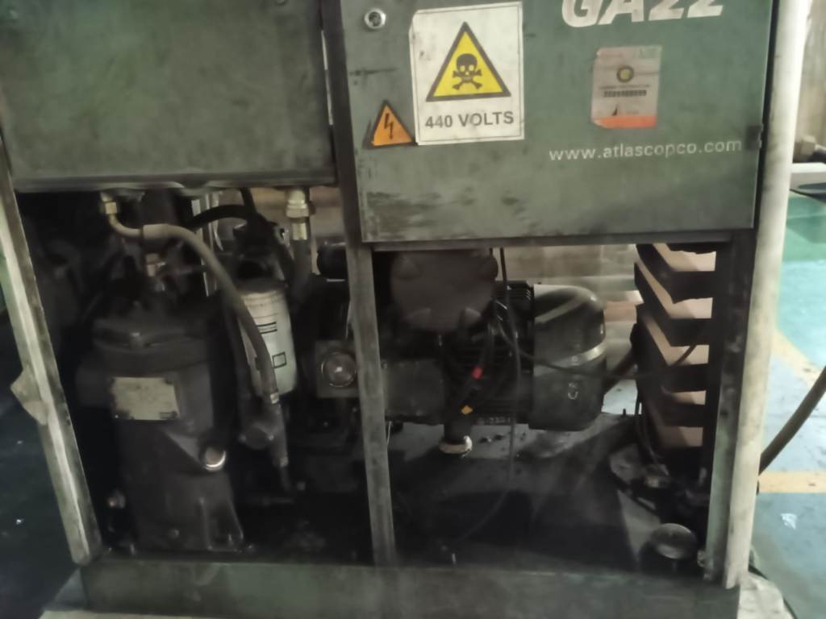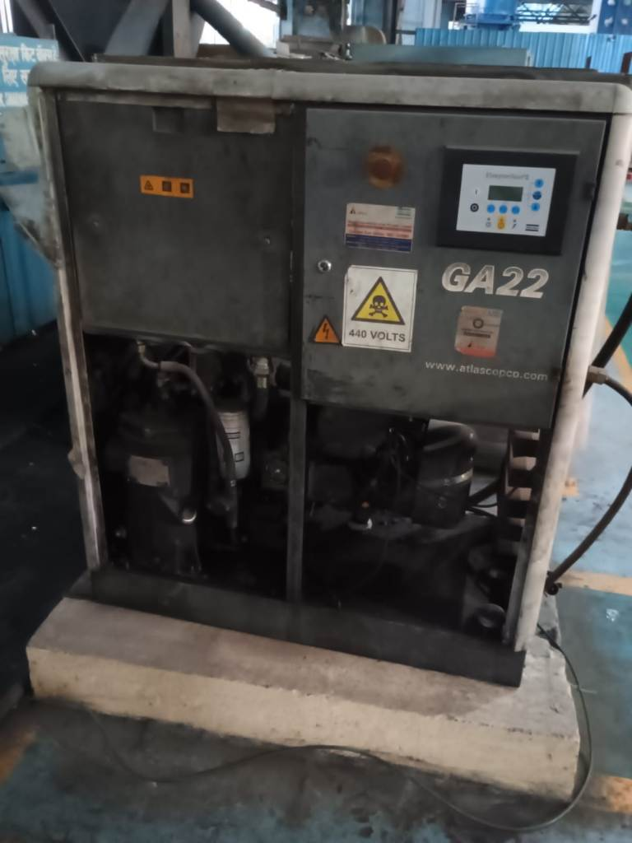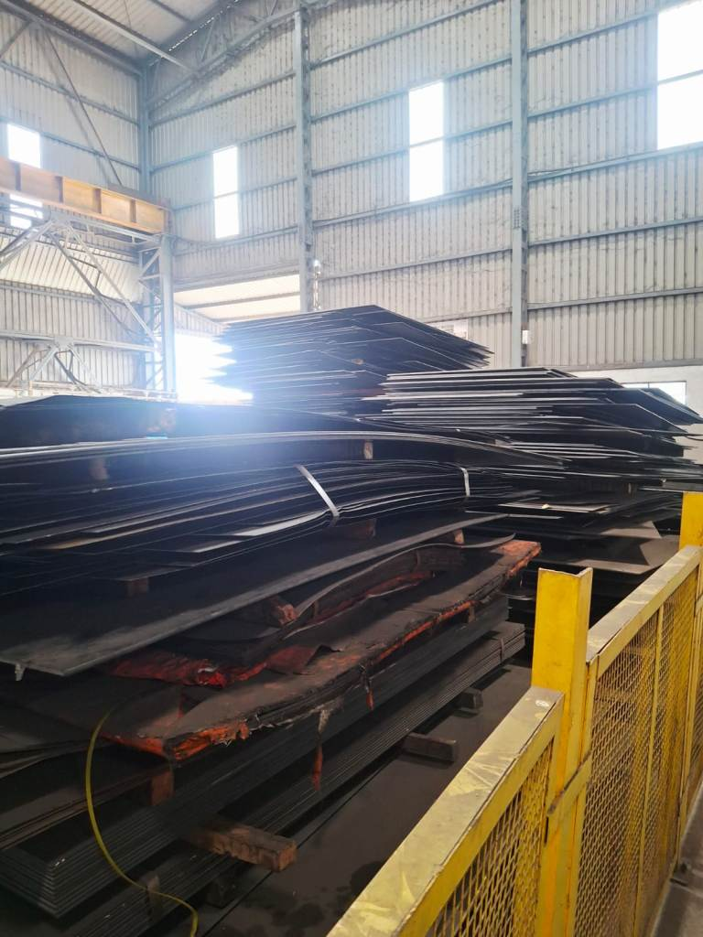
TSDPL-260516 TSDPL-260516 TSDPL-260501

