Auction Catalogue
Auction conducted by A H Bilimoria & Co.
Auction of Capital Items, Noamundi, Joda & Khondbond - IBMD
BEING SOLD ON ‘’AS IS WHERE IS AND NO COMPLAINT BASIS’’
Catalogue Serial Number: | TSL/AHB/MARCH/381/25-26
Seller: | Tata Steel Limited
Auction website: | www.ahbilimoria.com
e-Auction Date & Time: | 05th March, 2026…..….. at 11:00 AM &  06th March, 2026------- at 11:00 AM
Inspection Date & Time: | No physical inspection to be conducted. Interested customers please visit our website for indicative lot photographs/videos. For any assistance please call AHB (9334722391/7003840027) or IBMD Officer (9065515646).
Date of Security Money Deposit | 05th March, 2026 Till ……… at 10:30 AM
Contact Details:
For Post Auction @ A H Bilimoria & Company
Area | Contact No. | Email Id
Auction Room | 07003840027/09883421336
Lot Confirmation Related | 08987460668 | ahb@ahbilimoria.com, ahbilimoria.company@gmail.com
Payment Related | 08987460668/09073711453 | ahb@ahbilimoria.com, ahbilimoria.company@gmail.com, ahbjsr@ahbilimoria.com, b.bhardwaj@ahbilimoria.com, m.paul@ahbilimoria.com, sukumar.chandra@ahbilimoria.com
Delivery Order Related | 09073711453 | ahb@ahbilimoria.com, ahbilimoria.company@gmail.com,ahbjsr@ahbilimoria.com, b.bhardwaj@ahbilimoria.com, m.paul@ahbilimoria.com, sukumar.chandra@ahbilimoria.com
Material Value Refund Related | 09073711453 | ahb@ahbilimoria.com, ahbilimoria.company@gmail.com,ahbjsr@ahbilimoria.com, b.bhardwaj@ahbilimoria.com, m.paul@ahbilimoria.com, sukumar.chandra@ahbilimoria.com
Refund Related | 09073711453 | ahb@ahbilimoria.com, ahbilimoria.company@gmail.com,ahbjsr@ahbilimoria.com, b.bhardwaj@ahbilimoria.com, m.paul@ahbilimoria.com, sukumar.chandra@ahbilimoria.com
TCS Related | 09073711453 | ahb@ahbilimoria.com, ahbilimoria.company@gmail.com,ahbjsr@ahbilimoria.com, b.bhardwaj@ahbilimoria.com,m.paul@ahbilimoria.com, sukumar.chandra@ahbilimoria.com
Payment Deviation/Disablement in Tata Steel | 09073711453 | ahb@ahbilimoria.com, ahbilimoria.company@gmail.com,ahbjsr@ahbilimoria.com, b.bhardwaj@ahbilimoria.com,m.paul@ahbilimoria.com, sukumar.chandra@ahbilimoria.com
Collection of Delivery Order-Tata Steel | 09073711453/09883421336 | ahb@ahbilimoria.com, ahbilimoria.company@gmail.com,ahbjsr@ahbilimoria.com, b.bhardwaj@ahbilimoria.com, m.paul@ahbilimoria.com, sukumar.chandra@ahbilimoria.com
Collection of Delivery Order for Tata Steel Kalinganagar | 09664062791 | ahb@ahbilimoria.com, ahbilimoria.company@gmail.com,ahbjsr@ahbilimoria.com, b.bhardwaj@ahbilimoria.com,m.paul@ahbilimoria.com,sukumar.chandra@ahbilimoria.com, ahbjajpur@gmail.com
For time bound resolution of unresolved issues log into our Customer Complaint Management portal | Type in www.ahbilimoria.com> Go to “Customer Complaint Management Portal” >Log in with your user id and password and write the details of issue.

For Any unresolved Issues beyond two (02) days mail to A H Bilimoria & Company :
Mr. A K Sil (M-09830074122) & Mr. D Pyne (M-09830738481), E-mail: ahb@ahbilimoria.com, ahbilimoria.company@gmail.com
Copy to Tata Steel Ltd : Mr. Akash Sudhir Palekar (akash.palekar@tatasteel.com)

SPECIAL NOTE: -It is the responsibility of the buyer to furnish the valid GST no. & necessary documents to A H Bilimoria & Company before participating in the auction. In case during the transactions, it is found that valid GST no. has not been provided, then all necessary liabilities if any & so accrued would be on account of the buyer. TATA Steel & A H Bilimoria & Company would not be responsible for any such liabilities.

Note: TSL reserves the right to track IP address, MAC number and geolocation of bidding customers whenever customers participate in any auction on the A H Bilimoria & Co. auction platform for TATA Steel.

- Payment and Lifting Schedule:

Lot No. | Payment Schedule |  |  | Lifting Schedule  (working days from the next day of DO release)
Lot No. | EMD (10%) | 1st installment | 2nd installment | 1st installment lifting days | 2nd installment lifting days
For All Materials | 01 Working day from Date of Lot Confirmation | 01 Working Days From Date of EMD | 03 Working Days from the 1st Installment date  [Only Applicable if material value (Rate X Tonnage) crosses Rs. 20 Lakh] | As per material list | 3 additional working days at the expiry of 1st Installment DO validity.
Lot No. | EMD (10%) | Balance Payment |  | Lifting Schedule  (working days from the next day of DO release)
 | 02 working days from Date of Lot Confirmation | 1st installment: 50% of Balance payment within 5 working days of 1st Loading confirmation date.  2nd installment: 50% of Balance payment within 10 working days of 1st installment date. |  | As per material list | 3 additional working days at the expiry of 1st Installment DO validity.
- Suitable extension of due date for payment and lifting will be accorded in case of any eventualities like Strike/ Bandh/ Special restriction on vehicular movement imposed by the local Administration etc.

- Requirements of participation:
  - Registration: Before participation in the e-Auction, a prospective bidder shall be required to get registered with A H Bilimoria & Co. For details visit www.ahbilimoria.com

  - Security Deposit: Non-Interest bearing security deposit of Rs.60,000/- (Rupees Sixty Thousand only) in all lots in favour of “A H Bilimoria & Co.” through Online Payment only : Details as under :

Beneficiary Name | A. H. BILIMORIA & COMPANY
Bank Name | HDFC Bank
Branch Name | 31, Chowringhee Road, Kolkata – 700016
Account No | 06932560001205
IFSC Code | HDFC0000693

Account No: All the customers will have a unique account number. The unique account number is an alpha numeric code consisting of 12 characters. The Customer’s unique “account number” is a combination of the AHB’ SAP code along with the 6 digit bidder SAP ID and can be used as reference. for all subsequent transactions. The Customer’s Account Number detail is available in “Profile” after the customer logs into our website using the user id and password.

- Inspection Rules & Policy:
No physical inspection to be conducted. Interested customers please visit our website for indicative lot photographs/videos. For any assistance please call AHB (9334722391/7003840027) or IBMD Officer (9065515646).

- Bidding modalities:
  - Price Bid Basis: In Indian rupees as per unit of measurement as given in Material List. Price to be quoted is basic, ex- location exclusive of taxes and any other statutory levies.
  - Bid Increment: As specified in the e-auction bid page
  - Type of Auction: English No Ties
  - Bid Validity: Bid shall be valid for 10 (Ten working days excluding Saturdays, Sundays and Bank holidays) working days counted from the next day of auction process in case of auction against a catalogue which is completed on the same day. And if it is continuing on any other day the counting of days for lot confirmation shall be from the next day of completion of entire auction process.
  - Bid duration: For 1st four lots 20 minutes and balance lots 10minutes. If, No bids received within these specified time the lots are closed automatically.

- Taxes & duties:
  - GST : As applicable
  - TCS : As applicable. In case of availing of concessional rate of TCS proper certificate issued by appropriate Income Tax authority are to be issued in favour of the Principal Company along with payment. Self certification of Form no 27C is not acceptable.
  - Any change in taxes applicable at the time of lifting shall be applicable.
  - Customers are required to submit Form 27C/Form 27G against the month of dispatch/expected dispatches. In the absence of Form 27C, TCS will be charged at the time of invoicing.

- Payment terms & conditions :
  - Payments: PAYMENT FACILITY BY RTGS / NEFT ONLY

Account No | TATAHB followed by Party code (Each individual customer will be provided with Account number to be provided by AHB)
Beneficiary Name | TATA STEEL LIMITED A H B
Bank Name | HDFC BANK LTD.
Branch Name | Sandoz Branch, Mumbai
IFSC Code | HDFC0000240
  - EMD: 10% of the material value to be paid within 01 (One) working days from the date of lot confirmation for all lots. EMD to be adjusted in the final installment only.
EMD payment is to be made within the time limit as given in letter of confirmation. No extension will be provided for the same.
  - Balance Payment Time: (As per payment schedule)
  - Delayed Payment Charges (DPC) : Installment payments with DPC @ five (05) paise per Rs. 100 per day will be accepted up to 4 (Four) working days from due date of installment payment as mentioned in the confirmation letter. This is not applicable for EMD payment.
  - 2nd & 4th Saturdays, Sundays and Bank holidays are excluded for counting purpose for payment schedule.
  - In the event of Non-Receipt of Payment within the stipulated period of Payment, the Sale Offer for the approved Lot shall stand withdrawn automatically (Refer Clause#8).
  - Buyers have to send the payment deposit slip (UTR No /Scan Copy of NEFT/RTGS Transaction Slip) against Lot No. immediately after the payment to AHB at email id: ahb@ahbilimoria.com& ahbilimoria.company@gmail.com
  - GST number of TSL Noamundi : 20AAACT2803M2ZO; TSL Joda: 21AAACT2803M1ZN

- Lifting terms & conditions:
7.1 DOs will be handed over to authorized representatives of bidders on receipt of payment. Authorization letter to be issued via registered e-mail id’s. Authorized letter must be duly stamped and signed by the proprietor or partner or director on receipt of payment. Lifting date is calculated from the next day of DO Release date.
7.2 Loading Charges: As mentioned in material list
7.3 Loading shall be given strictly as per the statutory norms & safety norms of Tata Steel Ltd.
7.4 Lifting with Ground Rent: Lifting along with ground rent will be allowed up to 4 (four) working days from the last date of lifting period. In case the lifting is not complete, and no request is made by the customer within the period of four days, the company reserves the right to close the lot, and refund the balance to the party after deducting for any shortfall in lifting as per norms laid down in the catalogue. Ground Rent will be calculated on balance unlifted quantity @ 05 paise (inclusive of tax) per Rs.100/- per day
7.5 Additional lifting days for advance payment of installment - If the installment payment is made in advance, then additional lifting days (equivalent to the number of days payment made in advance) would be given. This would not be applicable for EMD payment.
7.6 PICK & CHOOSE NOT ALLOWED FOR ANY OF THE LOTS.

7.7 LOT TRANSFER WILL NOT BE ALLOWED.

- Penalty:
  - The following penalties shall be applicable in the eventuality of a buyer defaulting in making the payment of EMD (wherever applicable) or any installment/s, as per the stipulated schedule for each lot, in a financial year:
- In the first instance, a penalty of Rs. 60,000/- (Rupees Fifty Thousand only) shall be recovered from the customer.
- In the second instance, a penalty of Rs.100,000/- (Rupees One Lakh only) shall be recovered from the customer.
- In the third, and any subsequent instance, a penalty of Rs.150,000/-(Rupees One Lakh Fifty thousand only) shall be recovered and the customer shall be debarred from participating in any auction for a period of three months from the date of debarment.
In the event of any default, the customer’s user id will be disabled and the customer will be blocked from participating in any auction of TSL with immediate effect.

The defaulting customer shall be allowed 06 (six) working days to deposit the penalty as mentioned above. In case the penalty is not received within the stipulated period, the customer’s security deposit shall be forfeited, and the defaulting customer shall be immediately debarred from participating in any auction of TSL.

  - If after making payment of EMD (wherever applicable), the installment payment/s are not made by the customer as per the stipulated schedule for each lot, the entire EMD amount against such lot shall be forfeited.

  - In case of non- lifting of full lot quantity after making full payment, a penalty equivalent to 20% of the material value for the un-lifted quantity against each lot shall be recovered from the customer.

- Lot Closure Norms :
For Lot Closure, the tolerance would be ± 10% or 1MT whichever is higher of the original quantity.

- Refund :
Refunds will only be made by TATA Steel vide RTGS/NEFT and hence all customers are required to submit their bank details to A H Bilimoria & Company or mail at ahb@ahbilimoria.com, ahbilimoria.company@gmail.com, ahbjsr@ahbilimoria.com, b.bhardwaj@ahbilimoria.com. TATA Steel or A H Bilimoria & Company will not be responsible for any delay in refunds owing to absence of bank details of the customer.

- Complaints :
Complaints, if any, with regard to any transaction shall have to be lodged by the buyer within three calendar months from the date of last invoice. No complaint shall be entertained thereafter, under any circumstances. Customers can log their complaints at (www.ahbilimoria.com> Go to “Customer Complaint Management Portal” >Log in with your user id and password and write the details of issue.)

- Jurisdiction :
Any dispute arising out of any contract shall be decided in Jamshedpur by the courts in Jamshedpur and by no other courts. The courts in Jamshedpur shall have exclusive jurisdiction to adjudicate upon any such dispute.

- General terms & conditions:
  - Any dispute on quality & quantity of material and bid cancellation shall not be entertained at any point after the auction.
  - All lots are offered/sold on “As is Where is Basis” and “No Complaint Basis”.
  - Lot transfer will not be allowed. Payment and invoicing has to done in the name of the H1 bidder, subject to the prices being approved.
  - Lot purchased should consist of material from the same lot and designated location only. Tata Steel has the right to check any vehicle at any moment of time. If material lifted differs from the material that is purchased by the buyer, then the buyer and authorized representative will be permanently debarred. Also Tata Steel can take any penal action against the buyer/authorized representative. All the material loaded in the vehicle is to be covered in order to follow the safety compliance of Tata Steel works.
  - If the safety compliance is not followed, then Tata Steel can penalize the buyer / authorized representative as deemed fit.
  - Customer attested photocopy of valid id proof (Voter id/Aadhar/Pan card) of all lifters / Authorized persons engaged by customers for lifting of materials from TSL is to be enclosed with the authorization letters & to be forwarded to TSL for issue of gate pass.
  - Dispatch is subjected to FORCE MAJEURE conditions
  - The seller reserves the right to terminate any offer at any point of time without assigning any reasons
  - In the event of termination of the offer, seller shall refund the balance amount after due reconciliation
  - No claims whatsoever would be entertained after cancellation of the bid
  - In addition of earlier safety norms, the following would be compulsory:
The drivers of the vehicle must have the eye test certificate. The frequency of the testing would be as below:
1. If the age of the person is less than 45 years - Once in a year
2. If the age of the person is 45 years or more, the testing is required to be done once in every 6 months
Please ensure to comply with the safety norms
  - Weighment : Weight recorded by Tata Steel weighbridge will be considered final and binding on the customer
  - This transaction falls u/s 206C(1). Hence Section 194Q will not be applicable.
  - Compliance in relation to section 206AB/206AA (Furnishing of I.T Return for past 2 Years) will be taken directly from Income Tax Portal till 28th June-2021. If any compliance made in IT Portal by the customer (after 28th June-21), shall be communicated to AHB over mail.

14. Compliance to safety norms
14.1 Authorized persons (of the customer) involved in lifting of the materials will be allowed only with Personal Protective Equipment’s (PPE) i.e.,Safety Shoes, Safety Helmet, Safety Goggles, Fluorescent Jacket and Hand Gloves. No "people movement" shall be allowed at the time of loading/delivery of materials from the yards" Tata Steel will not be responsible for any delays arising out of Non- Compliance to the Safety Norms.

14.2 Documents for verification regarding entry of vehicles inside Tata Steel works :
All customers to note that presentation of following set of documents to TATA STEEL authorities is COMPULSORY at the time of reporting of vehicles at TSL designated Gate for entry of Customer trucks/vehicles.
a. Driving License of driver,
b. Registration Card,
c. Commercial Certificate,
d. Fitness Certificate of Vehicle,
e. Re-registration for vehicles older than 15 years
f. Insurance
The checklist form will be filled in at TSL designated Gate for entry of Customer trucks/vehicles before entry of vehicle.

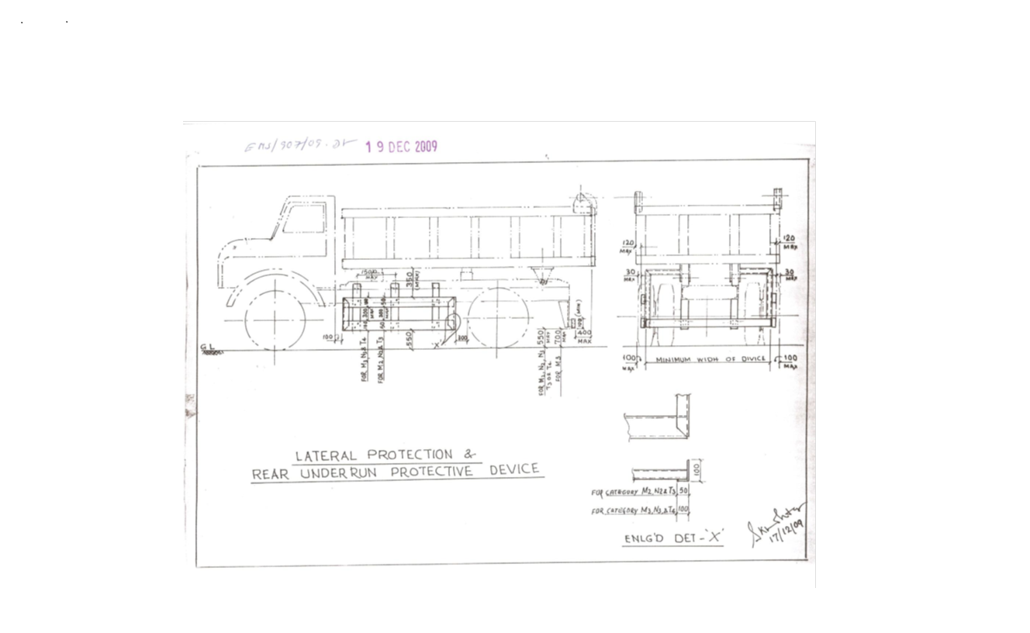

Sl. No. | Safety Parameters to be checked
1 | Three Piece Mirror(Truck, Trailer & Dumper)-Helper side
2 | Single Mirror- Driver side
3 | Rear View Mirror (Tata Ace, 207, Jeep etc.)
4 | Service Brake
5 | Parking Brake
6 | Seat Belt
7 | Head Light
8 | Parking Light
9 | Blinker
10 | Horn
11 | Reverse Alarm
12 | Wiper
13 | Windshield Glass
14 | Air Pressure Min. 7 Kg/Cm^2
15 | Run Under Protection Guard as per TSL standard
16 | Side under Protection Guard as per TSL standard
17 | Tyre Condition (Tread Depth, Cut Mark etc.)
18 | Any Oil Leakage from the vehicle
19 | Physical condition of Dallah
20 | Availability of scotch block
21 | Buzzer with side indicator
22 | Driver's eye examination report
Legal Documents to be checked:
Sl. No. | Documents to be Checked
1 | RC Book
2 | Insurance
3 | Pollution
4 | Driving licence
5 | Fitness for more than 15 years old vehicle
6 | NOC for outside vehicles
For ODC (Over Dimensional Consignment) items Customer / Authorised Lifter has to do Route Mapping in consultation with IBMD prior to vehicle placement for delivery. Customer / Authorised Lifter to indicate final date of vehicle placement.

15. DISCLAIMER FOR E-AUCTION
BANDWIDTH PROBLEMS, CONNECTIVITY PROBLEMS WITH THE LOCAL ISP (INTERNET SERVICE PROVIDER), SLOWNESS TO ACCESS PAGES FOR DOWNLOADING ETC. ARE BEYOND THE CONTROL OF TATA STEEL LTD. AND A H BILIMORIA & COMPANY. HENCE NO RESPONSIBILITY LIES WITH TATA STEEL LTD. OR A H BILIMORIA & COMPANY FOR THE ABOVE PROBLEMS FACED, IF ANY, BY THE BIDDERS BEFORE/DURING THE AUCTION ANY. BID PLACED USING THE BIDDER'S USERNAME AND PASSWORD IS UNCONDITIONALLY BINDING ON THE BIDDER TO WHOM SUCH USERNAME AND PASSWORD HAD BEEN ALLOTTED AND HE SHALL BE SOLELY RESPONSIBLE FOR MAINTAINING THE CONFIDENTIALITY OF THE SAME AND FULLY RESPONSIBLE FOR ALL ACTIVITIES THAT OCCUR UNDER THEIR USERNAME AND PASSWORD. HENCE THE USER IS ADVISED TO CHECK THE USERNAME AND PASSWORD BEFORE THE AUCTION,IN ORDER TO FAMILIARISE HIMSELF WITH THE SAME AND IS ADVISED NOT TO REVEAL IT TO ANYONE ELSE SO AS TO PREVENT MISUSE OF THE SAME. THE BIDS MADE BY THE BIDDERS AGAINST THEIR USERNAME AND PASSWORD SHALL BE IRREVOCABLE.THE BIDDERS ARE ADVISED TO REGISTER AND PRE-QUALIFY FOR BIDDING WELL IN ADVANCE AND PLACE THEIR BIDS EARLY IN ORDER TO TAKE CARE OF ANY UNFORESEEN TECHNICAL DIFFICULTY THAT MIGHT SURFACE IN THE INTERNET OPERATIONS.

Lot Photograph: Photographs of lots are at best indicative only and do not necessarily reflect the actual condition of lots. All bidders are advised to e- inspect the offered lots before participating in the auctions. Tata steel or A H Bilimoria & Co. shall not be responsible or liable for any error of judgment or bids put by bidders acting on the basis of these photographs.

Quantity offered is based on eye estimation. Delivery will be made for the estimated quantity or actual ground stock. Estimation error may arise. After e-inspection, no complaint of whatsoever nature on estimated /offered quantity shall be entertained under any circumstances. Bidders are advised to make their own judgment on offered quantity before bidding.

Speed Limit for Heavy Vehicles to max.25 kms. Anybody exceeding the same may get penalized.
Temporary Gate Pass (GP) will be issued to authorized customer representative’s as per DO validity period. For lots having DO validity more than one month, GP will be issued max. 30 days.

Customers are requested to get lifting program from the Tata Steel Ltd. Authority within 3 days of received of delivery order.
Customers to speak to Mr. Manik Paul Or other personnel of A H Bilimoria & Co. and make plan of lifting at least 2-3 days in advance as loading facility is low, which we will increase very shortly as no cutting is allowed. For placement of vehicles please contact Mr. Srikant Badaik/Ms. Suravi Das one day in advance.
The H1 party is responsible to lift the material himself or through his representative of his own firm against the Delivery Order. The selling and buying of auctioned materials inside Tata Steel premises is strictly prohibited. Any deviation in this regard will be viewed seriously and necessary action will be initiated against the buyer.

Special Instruction:
W.e.f. 10th October, 2024, the CBIC has notified that there shall be deduction of GST TDS @ 2% on supply of metal scrap falling under Chapters 72 to 81 in the First Schedule to the Customs Tariff Act by registered person in B to B supply. The GST TDS shall be deducted when the payment is made or credited to the suppliers Account. The deductor will be liable to pay the TDS amount to the Govt. within ten days after the end of the month in which such deduction is made. A certificate of tax deduction at source shall also be issued by the supplier in the format prescribed in GSTR 7A. Accordingly, it is advised to kindly take necessary actions at your end such as obtaining GST TDS registration and ensure compliances with the GST TDS provisions.

Terms and Conditions for TDS of 2 % on metallic Scrap sales :
- Compliance of GST-TDS Provisions: It shall be the responsibility of the customer to comply with all the requirements prescribed under GST law related to GST-TDS in case of material sold to them.

- Payment of GST-TDS to the Government: The GST-TDS shall be deposited by the customer to the Government within due date prescribed under GST law.

- Filing of GST-TDS Returns: Customer shall file the periodic statements/returns as per GST law. GST-TDS deposited by the customer to the Government shall be refunded to the customer within one month of the day, the paid amount is reflected in GST portal of TSL at GSTN.

- Sharing of GST-TDS payment details with TSL: The customer shall share the invoice wise details of GST-TDS with TSL in excel file to the email id GSTRECON@TATASTEEL.COM.

- Implication of Non- Compliance: Any Impact of non-compliance for GST-TDS under GST law at customer’s end either in financial or other form, shall be borne by the customer only. Further, the customer shall at all times keep TSL indemnified and harmless from any loss/penalty/cost/damages suffered by TSL due to non-compliance of the applicable law by the customer.

MATERIAL DETAILS: AS PER ANNEXURE:
Sr. No. | Location | Lot No | Material Code | Lot Description | QTY | UOM | GST | TCS | Loading | Lifting Period | Contact person | Contact no
1 | IBMD SCRAP YARD NOAMUNDI | NIM-26-154 | 150003735 | Rejected and Scrap RUBBER ATTACHED WITH MS/ALUMINIUM /Screw and nut bolts as is where is basis. Quantity on eye estimation. Loading Vehicle: TRUCK. Lot Closure Norms : For Lot Closure, the tolerance would be ± 10% or 1MT whichever is higher of the original quantity. | 18 | MT | 18% | 1% | By TSL | 8 Working Days from the D/O date | Suravi Das | 9204679789
2 | IBMD SCRAP YARD NOAMUNDI | NIM-26-155 | 150001278 | Rejected and Scrap ALUMINIUM CABLES, as is where is basis, Quantity on eye estimation. Loading Vehicle: TRUCK. Lot Closure Norms : For Lot Closure, the tolerance would be ± 10% or 1MT whichever is higher of the original quantity. | 25 | MT | 18% | 1% | By TSL | 10 Working Days from the D/O date | Suravi Das | 9204679789
3 | IBMD SCRAP YARD NOAMUNDI | NIM-26-156 | 150003723 | Rejected and Scrap MANGANESE ATTACHED WITH NEGLIBLE MS and liners, pan feeder, gizzely bar, as is where is basis. Loading Vehicle: TRUCK. Lot Closure Norms : For Lot Closure, the tolerance would be ± 10% or 1MT whichever is higher of the original quantity. | 40 | MT | 18% | 1% | By TSL | 10 Working Days from the D/O date | Suravi Das | 9204679789
4 | IBMD SCRAP YARD NOAMUNDI | NIM-26-157 | 150005870 | Rejected and Scrap EQUIPMENT AND PLANT PARTS, as is where is basis. Loading vehicle: Truck. Lot Closure Norms : For Lot Closure, the tolerance would be ± 10% or 1MT whichever is higher of the original quantity. | 25 | MT | 18% | 1% | By TSL | 8 Working Days from the D/O date | Suravi Das | 9204679789
5 | IBMD SCRAP YARD NOAMUNDI | NIM-26-158 | 150003043 | Rejected and Scrap BOWL MANTLE LINERS, as is where is basis, Quantity on eye estimation. Loading vehicle: Truck. Lot Closure Norms : For Lot Closure, the tolerance would be ± 10% or 1MT whichever is higher of the original quantity. | 20 | MT | 18% | 1% | By TSL | 8 Working Days from the D/O date | Suravi Das | 9204679789
6 | BOTTOM BIN SCRAP YARD NOAMUNDI | NIM-26-160 | 150003039 | Rejected and Scrap Conveyor Belts (Nylon) BELOW 25 meters, as is where is basis. Quantity on eye estimation. Loading Vehicle: TRUCK. Lot Closure Norms : For Lot Closure, the tolerance would be ± 10% or 1MT whichever is higher of the original quantity. | 40 | MT | 18% | 1% | By TSL | 12 Working Days from the D/O date | Suravi Das | 9204679789
7 | NEW MEGA CENTRE NOAMUNDI | NIM-26-161 | 150001755 | Rejected and scrap HOSE PIPES AND FILTERS as is where is basis. Quantity on eye estimation, Loading Vehicle: TRUCK, Valid PC & MOEF certificate required. Lot Closure Norms : For Lot Closure, the tolerance would be ± 10% or 1MT whichever is higher of the original quantity. | 6.00 | MT | 18% | 1% | By TSL | 8 Working Days from the D/O date | Suravi Das | 9204679789
8 | IBMD SCRAP YARD NOAMUNDI | NIM-26-162 | 150004360 | Rejected and Scrap EMPTY PLASTIC JAR, as is where is basis. Loading Vehicle: TRUCK. Only authorized parties who have valid authorization from CPCB/State Pollution Control Board are authorized to participate in the auction as per hazardous and other waste rule. Lot Closure Norms : For Lot Closure, the tolerance would be ± 10% or 1MT whichever is higher of the original quantity. | 0.50 | MT | 18% | 1% | By TSL | 8 Working Days from the D/O date | Suravi Das | 9204679789
9 | IBMD SCRAP YARD NOAMUNDI | NIM-26-163 | 150004038 | Rejected and Scrap Mix Tyres without rim, as is where is basis. Loading Vehicle: TRUCK. Valid EPR authorized waste tyre recyclers are allowed to participate in the lot. Lot Closure Norms : For Lot Closure, the tolerance would be ± 10% or 1MT whichever is higher of the original quantity. | 3 | MT | 18% | 1% | By TSL | 8 Working Days from the D/O date | Suravi Das | 9204679789
10 | IBMD SCRAP YARD NOAMUNDI | NIM-26-164 | 150001863 | REJECTED AND SCRAP DRUM PULLY, as is where is basis, Quantity on eye estimation. Loading vehicle: Truck. Lot Closure Norms : For Lot Closure, the tolerance would be ± 10% or 1MT whichever is higher of the original quantity. | 5 | MT | 18% | 1% | By TSL | 8 Working Days from the D/O date | Suravi Das | 9204679789
11 | IBMD SCRAP YARD NOAMUNDI | NIM-26-165 | 150003725 | Rejected and Scrap RADIATORS, attached with/without MS, as is where is basis, Quantity on eye estimation. Loading vehicle: Truck. Lot Closure Norms : For Lot Closure, the tolerance would be ± 10% or 1MT whichever is higher of the original quantity. | 1.00 | MT | 18% | 1% | By TSL | 8 Working Days from the D/O date | Suravi Das | 9204679789
12 | IBMD SCRAP YARD NOAMUNDI | NIM-26-166 | 150001901 | Used and Scrap GEAR BOX with attach Motor, as is where is basis, Quantity on eye estimation. Loading vehicle: Truck. Lot Closure Norms : For Lot Closure, the tolerance would be ± 10% or 1MT whichever is higher of the original quantity. | 3 | MT | 18% | 1% | By TSL | 8 Working Days from the D/O date | Suravi Das | 9204679789
13 | IBMD SCRAP YARD NOAMUNDI | NIM-26-167 | 150005171 | Used and Scrap TRANSFORMER, as is where is basis, Quantity on eye estimation. Loading vehicle: Truck. Lot Closure Norms : For Lot Closure, the tolerance would be ± 10% or 1MT whichever is higher of the original quantity. | 7 | MT | 18% | 1% | By TSL | 8 Working Days from the D/O date | Suravi Das | 9204679789
14 | IBMD SCRAP YARD NOAMUNDI | NIM-26-168 | 150003732 | REJECTED AND SCRAP ELECTRICAL ITEMS, as is where is basis, Quantity on eye estimation. Lot Closure Norms : For Lot Closure, the tolerance would be ± 10% or 1MT whichever is higher of the original quantity. | 1.50 | MT | 18% | 1% | By TSL | 8 Working Days from the D/O date | Suravi Das | 9204679789
15 | IBMD SCRAP YARD NOAMUNDI | NIM-26-169 | 150003728 | Rejected and Scrap PLASTIC SINTEX, as is where is basis, Quantity on eye estimation. Loading Vehicle: TRUCK. Only authorized parties who have valid authorization from CPCB/State Pollution Control Board are authorized to participate in the auction as per hazardous and other waste rule. Lot Closure Norms : For Lot Closure, the tolerance would be ± 10% or 1MT whichever is higher of the original quantity. | 0.40 | MT | 18% | 1% | By TSL | 8 Working Days from the D/O date | Suravi Das | 9204679789
16 | IBMD SCRAP YARD NOAMUNDI | NIM-26-170 | 150003207 | REJECTED AND SCRAP TOOTH POINT, as is where is basis, Quantity on eye estimation. Loading vehicle: Truck. Lot Closure Norms : For Lot Closure, the tolerance would be ± 10% or 1MT whichever is higher of the original quantity. | 15 | MT | 18% | 1% | By TSL | 8 Working Days from the D/O date | Suravi Das | 9204679789
17 | IBMD SCRAP YARD NOAMUNDI | NIM-26-171 | 150007512 | Rejected and Scrap E-WASTE ITEMS. as is where is basis. Quantity on eye estimation. Loading Vehicle: TRUCK. Valid EPR Authorized from CPCB/SPCB as a producer/recycler/ Refurbisher of E-Waste. Lot Closure Norms : For Lot Closure, the tolerance would be ± 10% or 1MT whichever is higher of the original quantity. | 2 | MT | 18% | 1% | By TSL | 8 Working Days from the D/O date | Suravi Das | 9204679789
18 | IBMD SCRAP YARD NOAMUNDI | NIM-26-172 |  | REJECTED AND SCRAP WIRING WIRE, as is where is basis, Quantity on eye estimation. Loading vehicle: Truck. Lot Closure Norms : For Lot Closure, the tolerance would be ± 10% or 1MT whichever is higher of the original quantity. | 0.20 | MT | 18% | 1% | By TSL | 8 Working Days from the D/O date | Suravi Das | 9204679789
19 | IBMD SCRAP YARD NOAMUNDI | NIM-26-173 | 150007461 | REJECTED AND SCRAP MOTOR, as is where is basis. Loading vehicle: Truck. Lot Closure Norms : For Lot Closure, the tolerance would be ± 10% or 1MT whichever is higher of the original quantity. | 2 | MT | 18% | 1% | By TSL | 8 Working Days from the D/O date | Suravi Das | 9204679789
20 | IBMD SCRAP YARD NOAMUNDI | NIM-26-174 | 150005560 | REJECTED AND SCRAP DRILL BIT, as is where is basis, Quantity on eye estimation. Loading vehicle: Truck. Lot Closure Norms : For Lot Closure, the tolerance would be ± 10% or 1MT whichever is higher of the original quantity. | 3.50 | MT | 18% | 1% | By TSL | 8 Working Days from the D/O date | Suravi Das | 9204679789
21 | IBMD SCRAP YARD NOAMUNDI | NIM-26-176 | 150001852 | Rejected and Scrap RUBBER IDLERS, as is where is basis. Quantity on eye estimation. Loading Vehicle: TRUCK. Lot Closure Norms : For Lot Closure, the tolerance would be ± 10% or 1MT whichever is higher of the original quantity. | 15 | MT | 18% | 1% | By TSL | 8 Working Days from the D/O date | Suravi Das | 9204679789
22 | IBMD SCRAP YARD NOAMUNDI | NIM-26-177 |  | Rejected and Scrap ALLUMINIUM PULL CORD SWITCH, attached with negligible MS/SS, as is where is basis. Quantity on eye estimation. Loading Vehicle: TRUCK. Lot Closure Norms : For Lot Closure, the tolerance would be ± 10% or 1MT whichever is higher of the original quantity. | 1.50 | MT | 18% | 1% | By TSL | 8 Working Days from the D/O date | Suravi Das | 9204679789
23 | IBMD SCRAP YARD NOAMUNDI | NIM-26-178 | 150004781 | Rejected and Scrap CONVEYOR BELT ABOVE 25Mtr (nylon) as is where is basis. Quantity on eye estimation. Loading Vehicle: TRUCK. Lot Closure Norms : For Lot Closure, the tolerance would be ± 10% or 1MT whichever is higher of the original quantity. | 15 | MT | 18% | 1% | By TSL | 8 Working Days from the D/O date | Suravi Das | 9204679789
24 | IBMD SCRAP YARD NOAMUNDI | NIM-26-179 | 150004782 | Rejected and Scrap GC, CC SHEET as is where is basis. Quantity on eye estimation. Loading Vehicle: TRUCK. Lot Closure Norms : For Lot Closure, the tolerance would be ± 10% or 1MT whichever is higher of the original quantity. | 1.50 | MT | 18% | 1% | By TSL | 8 Working Days from the D/O date | Suravi Das | 9204679789
25 | IBMD SCRAP YARD NOAMUNDI | NIM-26-180 | 150003732 | Rejected and Scrap ELECTRICAL SELF ITEMS attached with/without copper, as is where is basis. Quantity on eye estimation. Loading Vehicle: TRUCK. Lot Closure Norms : For Lot Closure, the tolerance would be ± 10% or 1MT whichever is higher of the original quantity. | 1.20 | MT | 18% | 1% | By TSL | 8 Working Days from the D/O date | Suravi Das | 9204679789
26 | IBMD SCRAP YARD NOAMUNDI | NIM-26-181 | 150003735 | Rejected and Scrap RUBBER AND CONVEYOR CUT PIECES, as is where is basis. Quantity on eye estimation. Loading Vehicle: TRUCK. Lot Closure Norms : For Lot Closure, the tolerance would be ± 10% or 1MT whichever is higher of the original quantity. | 2.20 | MT | 18% | 1% | By TSL | 8 Working Days from the D/O date | Suravi Das | 9204679789
27 | IBMD SCRAP YARD NOAMUNDI | NIM-26-182 | 150003728 | Rejected and Scrap EMPTY PLASTIC POLY CONTAINER WITH STAND, as is where is basis. Quantity on eye estimation. Loading Vehicle: TRUCK. Lot Closure Norms : For Lot Closure, the tolerance would be ± 10% or 1MT whichever is higher of the original quantity. Only authorized parties who have valid authorization from CPCB/State Pollution Control Board are authorized to participate in the auction as per hazardous and other waste rule | 112 | No | 18% | 1% | By TSL | 8 Working Days from the D/O date | Suravi Das | 9204679789
28 | IBMD SCRAP YARD NOAMUNDI | NIM-26-138 | 150006181 | Rejected and Scrap Metallic Dry Filter, as is where is basis, Entire material to be lifted. Site to be cleared, Quantity on eye estimation. Loading Vehicle: TRUCK. Lot Closure Norms : For Lot Closure, the tolerance would be ± 10% or 1MT whichever is higher of the original quantity. | 1.5 | MT | 18% | 1% | By TSL | 8 Working Days from the D/O date | Suravi Das | 9204679789
29 | IBMD SCRAP YARD NOAMUNDI | NIM-26-122 | 150003735 | Rejected and Scrap PU-PANELS, as is where is basis, Entire material to be lifted. Site to be cleared, Quantity on eye estimation. Loading Vehicle: TRUCK. Lot Closure Norms : For Lot Closure, the tolerance would be ± 10% or 1MT whichever is higher of the original quantity. | 15 | MT | 18% | 1% | By TSL | 8 Working Days from the D/O date | Suravi Das | 9204679789
30 | IBMD SCRAP YARD JEIM | JIM-26-140 | 150003039 | Rejected and Scrap Conveyor belts BELOW 25 meter (Nylon) as is where is basis. Quantity on eye estimation. Loading Vehicle: TRUCK. Lot Closure Norms : For Lot Closure, the tolerance would be ± 10% or 1MT whichever is higher of the original quantity. | 18 | MT | 18% | 1% | By TSL | 10 Working Days from the D/O date | Srikant Badaik | 8018003312
31 | IBMD SCRAP YARD JEIM | JIM-26-141 | 150003735 | Rejected and Scrap RUBBER ATTACHED WITH MS AND ALUMINIUM as is where is basis. Quantity on eye estimation. Loading Vehicle: TRUCK. Lot Closure Norms : For Lot Closure, the tolerance would be ± 10% or 1MT whichever is higher of the original quantity. | 12 | MT | 18% | 1% | By TSL | 10 Working Days from the D/O date | Srikant Badaik | 8018003312
32 | IBMD SCRAP YARD JEIM | JIM-26-142 | 150001278 | Rejected and Scrap ALUMINIUM CABLES, as is where is basis, Quantity on eye estimation. Loading Vehicle: TRUCK. Lot Closure Norms : For Lot Closure, the tolerance would be ± 10% or 1MT whichever is higher of the original quantity. | 12 | MT | 18% | 1% | By TSL | 10 Working Days from the D/O date | Srikant Badaik | 8018003312
33 | IBMD SCRAP YARD JEIM | JIM-26-143 | 150001866 | Rejected and Scrap DUMPER DALA IN CUT CONDITION as is where is basis, Quantity on eye estimation. Loading Vehicle: TRUCK. Lot Closure Norms : For Lot Closure, the tolerance would be ± 10% or 1MT whichever is higher of the original quantity. | 20 | MT | 18% | 1% | By TSL | 10 Working Days from the D/O date | Srikant Badaik | 8018003312
34 | CIVIL GODOWN JEIM | JIM-26-144 | 150001887 | Rejected and Scrap WOOD (WOODEN DOORS, WINDOWS, BATTENS,WOOD PIECES )as is where is basis. Quantity on eye estimation. Loading Vehicle: TRUCK. Lot Closure Norms : For Lot Closure, the tolerance would be ± 10% or 1MT whichever is higher of the original quantity. | 8 | MT | 5% | 1% | By TSL | 10 Working Days from the D/O date | Srikant Badaik | 8018003312
35 | IBMD SCRAP YARD JEIM | JIM-26-145 | 150004781 | Rejected and Scrap STEEL CORD Conveyor belts ABOVE 25 meter as is where is basis. Quantity on eye estimation. Loading Vehicle: TRUCK. Lot Closure Norms : For Lot Closure, the tolerance would be ± 10% or 1MT whichever is higher of the original quantity. | 18 | MT | 18% | 1% | By TSL | 10 Working Days from the D/O date | Srikant Badaik | 8018003312
36 | IBMD SCRAP YARD JEIM | JIM-26-146 | 150001907 | Rejected and Scrap Dumper tyres (27R49) as is where is basis, Entire material to be lifted. Quantity on eye estimation. Loading Vehicle: TRAILER. Valid EPR authorized waste tyre recyclers are allowed to participate in the lot | 36 | NOS | 18% | 1% | By TSL | 10 Working Days from the D/O date | Srikant Badaik | 8018003312
37 | IBMD SCRAP YARD JEIM | JIM-26-147 | 150005440 | Rejected and Scrap OBSOLETE HYDRAULIC TROLLEY ASSEMBLY, as is where is basis, Quantity on eye estimation. Loading vehicle: Truck. Lot Closure Norms : For Lot Closure, the tolerance would be ± 10% or 1MT whichever is higher of the original quantity. | 3 | MT | 18% | 1% | By TSL | 10 Working Days from the D/O date | Srikant Badaik | 8018003312
38 | IBMD SCRAP YARD ,CIVIL GODOWN JEIM | JIM-26-148 | 150001861 | Rejected and scrap ALUMINIUM as is where is basis. Quantity on eye estimation. Loading Vehicle: TRUCK. Lot Closure Norms : For Lot Closure, the tolerance would be ± 10% or 1MT whichever is higher of the original quantity. | 1 | MT | 18% | 1% | By TSL | 10 Working Days from the D/O date | Srikant Badaik | 8018003312
39 | IBMD SCRAP YARD JEIM | JIM-26-149 | 150001900 | Rejected and scrap PUMP AND VALVES as is where is basis. Quantity on eye estimation. Loading Vehicle: TRUCK. Lot Closure Norms : For Lot Closure, the tolerance would be ± 10% or 1MT whichever is higher of the original quantity. | 7 | MT | 18% | 1% | By TSL | 10 Working Days from the D/O date | Srikant Badaik | 8018003312
40 | IBMD SCRAP YARD JEIM | JIM-26-150 | 150003735 | Rejected and scrap PU PANELS as is where is basis. Quantity on eye estimation. Loading Vehicle: TRUCK. Lot Closure Norms : For Lot Closure, the tolerance would be ± 10% or 1MT whichever is higher of the original quantity. | 5 | MT | 18% | 1% | By TSL | 10 Working Days from the D/O date | Srikant Badaik | 8018003312
41 | EQUIPMENT DRY FILTER GODOWN | JIM-26-151 |  | Rejected and scrap DRY FILTERS as is where is basis. Quantity on eye estimation. Loading Vehicle: TRUCK. Lot Closure Norms : For Lot Closure, the tolerance would be ± 10% or 1MT whichever is higher of the original quantity. | 1 | MT | 18% | 1% | By TSL | 10 Working Days from the D/O date | Srikant Badaik | 8018003312
42 | CIVIL GODOWN JEIM,EQUIPMENT SCRAPYARD | JIM-26-152 | 150004360 | Rejected and scrap SINTEX TANK as is where is basis. Quantity on eye estimation. Loading Vehicle: TRUCK. Only authorized parties who have valid authorization from Odisha State Pollution Control Board are authorized to participate in the auction as per hazardous and other waste rule | 30 | NOS | 18% | 1% | By TSL | 10 Working Days from the D/O date | Srikant Badaik | 8018003312
43 | IBMD SCRAP YARD JEIM | JIM-26-153 | 150005870 | Rejected and scrap EQUIPMENT PARTS as is where is basis. Quantity on eye estimation. Loading Vehicle: TRUCK. Lot Closure Norms : For Lot Closure, the tolerance would be ± 10% or 1MT whichever is higher of the original quantity. | 12 | MT | 18% | 1% | By TSL | 10 Working Days from the D/O date | Srikant Badaik | 8018003312
44 | IBMD SCRAP YARD JEIM | JIM-26-154 | 150003207 | Rejected and Scrap MANGANESE attached with negligible MS, as is where is basis, Quantity on eye estimation. Loading vehicle: Truck. Lot Closure Norms : For Lot Closure, the tolerance would be ± 10% or 1MT whichever is higher of the original quantity. | 12 | MT | 18% | 1% | By TSL | 10 Working Days from the D/O date | Srikant Badaik | 8018003312
45 | IBMD SCRAP YARD JEIM | JIM-26-156 | 140006830 | Rejected and scrap BATTERIES as is where is basis. Quantity on eye estimation. Loading Vehicle: TRUCK. Lot Closure Norms : For Lot Closure, the tolerance would be ± 10% or 1MT whichever is higher of the original quantity. Valid EPR authorized battery recyclers are allowed to participate in the lot. | 4 | MT | 18% | 1% | By TSL | 10 Working Days from the D/O date | Srikant Badaik | 8018003312
46 | IBMD SCRAP YARD JEIM | JIM-26-157 | 150003725 | Rejected and scrap RADIATORS attached with/without ms frame.as is where is basis. Quantity on eye estimation. Loading Vehicle: TRUCK. Lot Closure Norms : For Lot Closure, the tolerance would be ± 10% or 1MT whichever is higher of the original quantity. | 1 | MT | 18% | 1% | By TSL | 10 Working Days from the D/O date | Srikant Badaik | 8018003312
47 | IBMD SCRAP YARD JEIM | JIM-26-158 | 150001852 | Rejected and scrap RUBBER IDLERS as is where is basis. Quantity on eye estimation. Loading Vehicle: TRUCK. Lot Closure Norms : For Lot Closure, the tolerance would be ± 10% or 1MT whichever is higher of the original quantity. | 14 | MT | 18% | 1% | By TSL | 10 Working Days from the D/O date | Srikant Badaik | 8018003312
48 | IBMD SCRAP YARD JEIM | JIM-26-159 | 150004360 | Rejected and scrap PLASTIC JARS as is where is basis. Quantity on eye estimation. Loading Vehicle: TRUCK. Only authorized parties who have valid authorization from Odisha State Pollution Control Board are authorized to participate in the auction as per hazardous and other waste rule | 70 | NOS | 18% | 1% | By TSL | 10 Working Days from the D/O date | Srikant Badaik | 8018003312
49 | IBMD SCRAP YARD JEIM | JIM-26-160 | 150004883 | Rejected and scrap RUBBER WITH CONVEYOR CUT PIECES as is where is basis. Quantity on eye estimation. Loading Vehicle: TRUCK. Lot Closure Norms : For Lot Closure, the tolerance would be ± 10% or 1MT whichever is higher of the original quantity. | 20 | MT | 18% | 1% | By TSL | 10 Working Days from the D/O date | Srikant Badaik | 8018003312
50 | EQUIPMENT IMPERVIOUS PIT | JIM-26-113 [Re auc] | 150001755 | Rejected and scrap HOSE PIPES AND FILTERS as is where is basis. Quantity on eye estimation. Loading Vehicle: TRUCK. Valid PC & MOEF certificate required. OSPCB authorization required. Lot Closure Norms : For Lot Closure, the tolerance would be ± 10% or 1MT whichever is higher of the original quantity. | 10 | MT | 18% | 1% | By TSL | 10 Working Days from the D/O date | Srikant Badaik | 8018003312
51 | EQUIPMENT YARD JEIM | JIM-26-120 [Re auction] | 150005870 | Rejected and scrap EX 1200 SHOVEL in dismantled condition as is where is basis, Entire material to be lifted. Quantity on eye estimation. Loading Vehicle: TRAILER/TRUCK. After getting confirmation from the loading department for loading of equipment. EX1200 Shovel dismantled component Boom- 1,Arm-1,Upper turret- 1,PTO with pump-1, Cooler- 1 ,Radiator -1, Bucket. Lot Closure Norms : For Lot Closure, the tolerance would be ± 10% or 1MT whichever is higher of the original quantity. | 36 | MT | 18% | 1% | By TSL | 10 Working Days from the D/O date | Srikant Badaik | 8018003312
52 | IBMD SCRAP YARD JEIM | JIM-26-122 [Re auc] | 150003039 | Rejected and Scrap Conveyor belts BELOW 25 meter (Nylon) as is where is basis. Quantity on eye estimation. Loading Vehicle: TRUCK. Lot Closure Norms : For Lot Closure, the tolerance would be ± 10% or 1MT whichever is higher of the original quantity. | 18 | MT | 18% | 1% | By TSL | 10 Working Days from the D/O date | Srikant Badaik | 8018003312
53 | IBMD SCRAP YARD JEIM | JIM-26-123 [Re auc] | 150003039 | Rejected and Scrap Conveyor belts BELOW 25 meter (Nylon) as is where is basis. Quantity on eye estimation. Loading Vehicle: TRUCK. Lot Closure Norms : For Lot Closure, the tolerance would be ± 10% or 1MT whichever is higher of the original quantity. | 22 | MT | 18% | 1% | By TSL | 10 Working Days from the D/O date | Srikant Badaik | 8018003312
54 | IBMD SCRAP YARD JEIM | JIM-26-131 [Re auc] | 150004781 | Rejected and Scrap Conveyor belts ABOVE 25 meter (Nylon) as is where is basis. Quantity on eye estimation. Loading Vehicle: TRUCK. Lot Closure Norms : For Lot Closure, the tolerance would be ± 10% or 1MT whichever is higher of the original quantity. | 25 | MT | 18% | 1% | By TSL | 10 Working Days from the D/O date | Srikant Badaik | 8018003312
55 | IBMD SCRAP YARD JEIM | JIM-26-137 (ARISING) Only authorized parties who have valid authorization from Odisha State Pollution Control Board are authorized to participate in the auction as per hazardous and other waste rule | 150003726 | Rej. & used Empty oil/grease Drums with or without lid (Ferrous Drum), as is where is basis & e-inspected condition, Quantity on eye estimation. Loading Vehicle: TRUCK. Loading will not allowed above Vehicle Dala body. (Arising for the month of MAR-26 to MAY-26). Arising Qty:108 nos per Month. Customer will place vehicle within a four days after giving confirmation of lifting material by department. Only authorized parties who have valid authorization from Odisha State Pollution Control Board are authorized to participate in the auction as per hazardous and other waste rule. | 324 | NOS | 18% | 1% | By TSL | Till 30th May’26 | Srikant Badaik | 8018003312
56 | IBMD SCRAP YARD JEIM | JIM-26-135 [Re auc] | 150003207 | Rejected and Scrap TOOTH POINTS, as is where is basis, Quantity on eye estimation. Loading vehicle: Truck. Lot Closure Norms : For Lot Closure, the tolerance would be ± 10% or 1MT whichever is higher of the original quantity. | 10 | MT | 18% | 1% | By TSL | 10 Working Days from the D/O date | Srikant Badaik | 8018003312
57 | IBMD SCRAP YARD KIM | KIM-26-29 | 150004360 | REJECTED AND SCRAP SINTEX WATER TANK, as is where is basis, Quantity on eye estimation. Loading vehicle: Truck. Lot Closure Norms :For Lot Closure, the tolerance would be ± 10% or 1MT whichever is higher of the original quantity. Only authorized parties who have valid authorization from Odisha State Pollution Control Board are authorized to participate in the auction as per hazardous and other waste rule. Lot Closure Norms : For Lot Closure, the tolerance would be ± 10% or 1MT whichever is higher of the original quantity. | 0.5 | MT | 18% | 1% | By TSL | 12 Working Days from the D/O date | Srikant Badaik | 8018003312
58 | IBMD SCRAP YARD KIM | KIM-26-58 | 150003039 | Rejected and Scrap Conveyor Belts (Nylon) BELOW 25 meters as is where is basis. Quantity on eye estimation. Loading Vehicle: TRUCK. Lot Closure Norms : For Lot Closure, the tolerance would be ± 10% or 1MT whichever is higher of the original quantity. | 8 | MT | 18% | 1% | By TSL | 12 Working Days from the D/O date | Srikant Badaik | 8018003312
59 | IBMD SCRAP YARD KIM | KIM-26-59 | 150003721 | REJECTED AND SCRAP VARIOUS SIZE OF TRANSFORMERS, as is where is basis. Loading vehicle: Truck. Lot Closure Norms : For Lot Closure, the tolerance would be ± 10% or 1MT whichever is higher of the original quantity. | 1 | MT | 18% | 1% | By TSL | 12 Working Days from the D/O date | Srikant Badaik | 8018003312
60 | IBMD SCRAP YARD KIM | KIM-26-64 | 150003039 | Rejected and Scrap Conveyor Belts (Nylon) BELOW 25 meters as is where is basis. Quantity on eye estimation. Loading Vehicle: TRUCK. Lot Closure Norms : For Lot Closure, the tolerance would be ± 10% or 1MT whichever is higher of the original quantity. | 30 | MT | 18% | 1% | By TSL | 12 Working Days from the D/O date | Srikant Badaik | 8018003312
61 | IBMD SCRAP YARD | KIM-26-77 | 150003043 | Rejected and Scrap BOWL MANTLE LINERS, as is where is basis, Quantity on eye estimation. Loading vehicle: Truck. Lot Closure Norms : For Lot Closure, the tolerance would be ± 10% or 1MT whichever is higher of the original quantity. | 16 | MT | 18% | 1% | By TSL | 12 Working Days from the D/O date | Srikant Badaik | 8018003312
62 | IBMD SCRAP YARD | KIM-26-80 | 150004883 | Rejected and Scrap RUBBER & CONVEYOR CUT PIECES (NYLON),as is where is basis, Quantity on eye estimation. Loading vehicle: Truck . Lot Closure Norms : For Lot Closure, the tolerance would be ± 10% or 1MT whichever is higher of the original quantity. | 20 | MT | 18% | 1% | By TSL | 12 Working Days from the D/O date | Srikant Badaik | 8018003312
63 | IBMD SCRAP YARD | KIM-26-81 | 150003723 | Rejected and Scrap MANGANESE ATTACHED WITH NEGLIBLE MS as is where is basis. Quantity on eye estimation. Loading Vehicle: TRUCK. Lot Closure Norms : For Lot Closure, the tolerance would be ± 10% or 1MT whichever is higher of the original quantity. | 12 | MT | 18% | 1% | By TSL | 12 Working Days from the D/O date | Srikant Badaik | 8018003312
64 | IBMD SCRAP YARD | KIM-26-82 | 150005870 | Rejected and Scrap TRACK CHAIN as is where is basis. Quantity on eye estimation. Loading Vehicle: TRUCK. Lot Closure Norms : For Lot Closure, the tolerance would be ± 10% or 1MT whichever is higher of the original quantity. | 16 | MT | 18% | 1% | By TSL | 12 Working Days from the D/O date | Srikant Badaik | 8018003312
65 | IBMD SCRAP YARD | KIM-26-83 | 150001852 | Rejected and Scrap RUBBER IDLER as is where is basis. Quantity on eye estimation. Loading Vehicle: TRUCK. Lot Closure Norms : For Lot Closure, the tolerance would be ± 10% or 1MT whichever is higher of the original quantity. | 3 | MT | 18% | 1% | By TSL | 12 Working Days from the D/O date | Srikant Badaik | 8018003312
66 | IBMD SCRAP YARD | KIM-26-84 | 150003039 | Rejected and Scrap Conveyor Belts (STEEL CORD) BELOW 25 meters as is where is basis. Quantity on eye estimation. Loading Vehicle: TRUCK. Lot Closure Norms : For Lot Closure, the tolerance would be ± 10% or 1MT whichever is higher of the original quantity. | 20 | MT | 18% | 1% | By TSL | 12 Working Days from the D/O date | Srikant Badaik | 8018003312
67 | IBMD SCRAP YARD | KIM-26-85 | 150003735 | REJECTED AND SCRAP PU PANNEL, as is where is basis, Quantity on eye estimation. Loading vehicle: Truck. Lot Closure Norms : For Lot Closure, the tolerance would be ± 10% or 1MT whichever is higher of the original quantity. | 8 | MT | 18% | 1% | By TSL | 12 Working Days from the D/O date | Srikant Badaik | 8018003312
68 | IBMD SCRAP YARD | KIM-26-86 | 150001863 | REJECTED AND SCRAP DRUM PULLY, as is where is basis, Quantity on eye estimation. Loading vehicle: Truck. Lot Closure Norms :For Lot Closure, the tolerance would be ± 10% or 1MT whichever is higher of the original quantity | 3 | MT | 18% | 1% | By TSL | 12 Working Days from the D/O date | Srikant Badaik | 8018003312
69 | IBMD SCRAP YARD | KIM-26-87 | 150001865 | REJECTED AND SCRAP COPPER CABLE, as is where is basis, Quantity on eye estimation. Loading vehicle: Truck. Lot Closure Norms :For Lot Closure, the tolerance would be ± 10% or 1MT whichever is higher of the original quantity (Only authorized COPPER CERTIFICATE recyclers are allowed to participate in the lot) WITHDRAWN | 3 | MT | 18% | 1% | By TSL | 12 Working Days from the D/O date | Srikant Badaik | 8018003312
70 | IBMD SCRAP YARD | KIM-26-88 | 150001863 | REJECTED AND SCRAP HEMM SPARE PARTS, as is where is basis, Quantity on eye estimation. Loading vehicle: Truck. Lot Closure Norms : For Lot Closure, the tolerance would be ± 10% or 1MT whichever is higher of the original quantity. | 18 | MT | 18% | 1% | By TSL | 12 Working Days from the D/O date | Srikant Badaik | 8018003312
71 | IBMD SCRAP YARD | KIM-26-89 | 150003735 | REJECTED AND SCRAP RUBBER ATTACHED MS & negligible ALUMINUM, as is where is basis, Quantity on eye estimation. Loading vehicle: Truck. Lot Closure Norms : For Lot Closure, the tolerance would be ± 10% or 1MT whichever is higher of the original quantity. | 6 | MT | 18% | 1% | By TSL | 12 Working Days from the D/O date | Srikant Badaik | 8018003312
72 | EQUIPMENT SCRAP YARD KIM | KIM-26-90 | 150001907 | REJECTED AND SCRAP (27R49) TYRES, as is where is basis, Quantity on eye estimation. Loading vehicle: Truck, Valid EPR authorized waste tyre recyclers are allowed to participate in the lot | 36 | NO | 18% | 1% | By TSL | 12 Working Days from the D/O date | Srikant Badaik | 8018003312
73 | COMMISSIONING YARD | KIM-26-91 | 150001907 | REJECTED AND SCRAP (45R65) TYRES, as is where is basis, Quantity on eye estimation. Loading vehicle: Truck, Valid EPR authorized waste tyre recyclers are allowed to participate in the lot | 2 | NO | 18% | 1% | By TSL | 12 Working Days from the D/O date | Srikant Badaik | 8018003312
74 | COMMISSIONING YARD | KIM-26-92 | 150001907 | REJECTED AND SCRAP (24R35) TYRES, as is where is basis, Quantity on eye estimation. Loading vehicle: Truck, Valid EPR authorized waste tyre recyclers are allowed to participate in the lot | 2 | NO | 18% | 1% | By TSL | 12 Working Days from the D/O date | Srikant Badaik | 8018003312
75 | COMMISSIONING YARD | KIM26-94 | 150003207 | REJECTED AND SCRAP TOOTH POINT, as is where is basis, Quantity on eye estimation. Loading vehicle: Truck. Lot Closure Norms : For Lot Closure, the tolerance would be ± 10% or 1MT whichever is higher of the original quantity. | 7 | MT | 18% | 1% | By TSL | 12 Working Days from the D/O date | Srikant Badaik | 8018003312
76 | IBMD SCRAP YARD KIM | KIM-26-79 (ARISING) Authorisation Letter from Odisha State Pollution Control Board required | 150003726 | Rej. & used Empty oil/grease Drums with or without lid (Ferrous Drum), as is where is basis & e-inspected condition, Quantity on eye estimation. Loading Vehicle: TRUCK. Loading will not allowed above Vehicle Dala body. (Arising for the month of JAN-26 to MAR-26). Arising Qty: 54 nos per Month. Customer will place vehicle within a four days after giving confirmation of lifting material by department.  Only authorized parties who have valid authorization from Odisha State Pollution Control Board are authorized to participate in the auction as per hazardous and other waste rule | 162 | No | 18% | 1% | By TSL | Till 30th May’26 | Srikant Badaik | 8018003312
77 | IBMD SCRAP YARD KIM | KIM-26-71 | 150003039 | Rejected and Scrap Conveyor Belts (Nylon) BELOW 25 meters as is where is basis, Entire material to be lifted. Site to be cleared, Quantity on eye estimation. Loading Vehicle: TRUCK. Lot Closure Norms : For Lot Closure, the tolerance would be ± 10% or 1MT whichever is higher of the original quantity. | 30 | MT | 18% | 1% | By TSL | 12 Working Days from the D/O date | Srikant Badaik | 8018003312
78 | IBMD SCRAP YARD KIM | KIM-26-72 | 150003723 | Rejected and Scrap MANGANESE ATTACHED WITH NEGLIBLE MS as is where is basis, Entire material to be lifted. Site to be cleared, Quantity on eye estimation. Loading Vehicle: TRUCK. Lot Closure Norms : For Lot Closure, the tolerance would be ± 10% or 1MT whichever is higher of the original quantity. | 8 | MT | 18% | 1% | By TSL | 12 Working Days from the D/O date | Srikant Badaik | 8018003312
ALL THE PHOTOGRAPHS ARE INDICATIVE ONLY
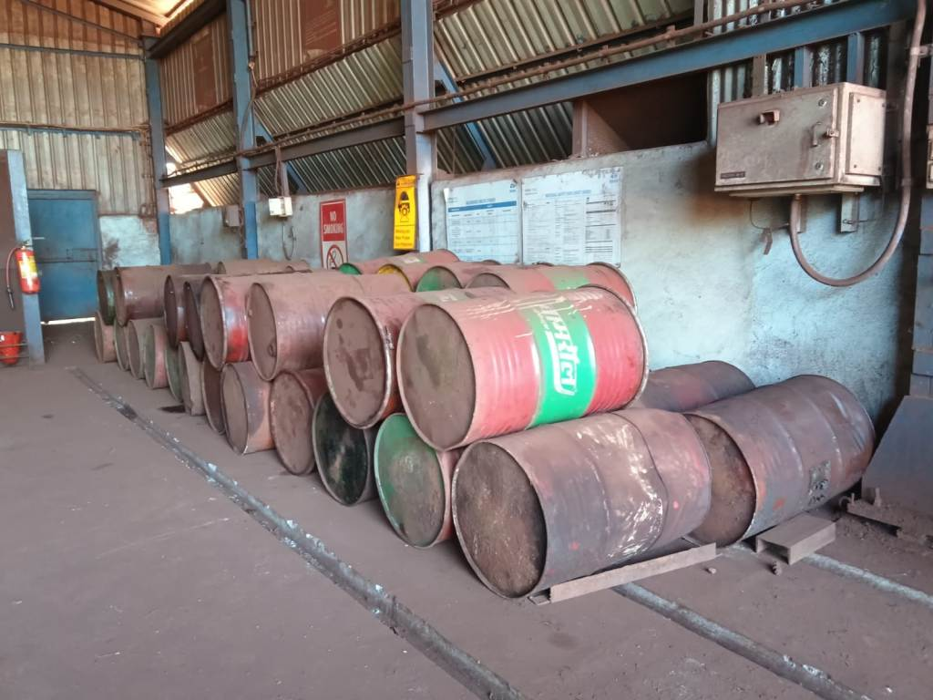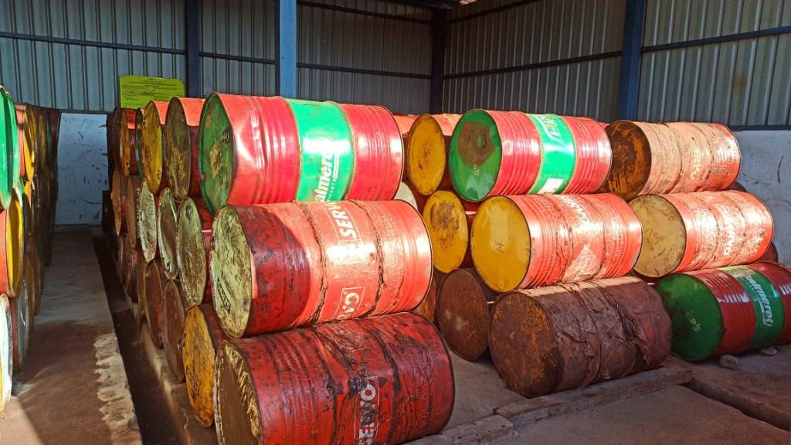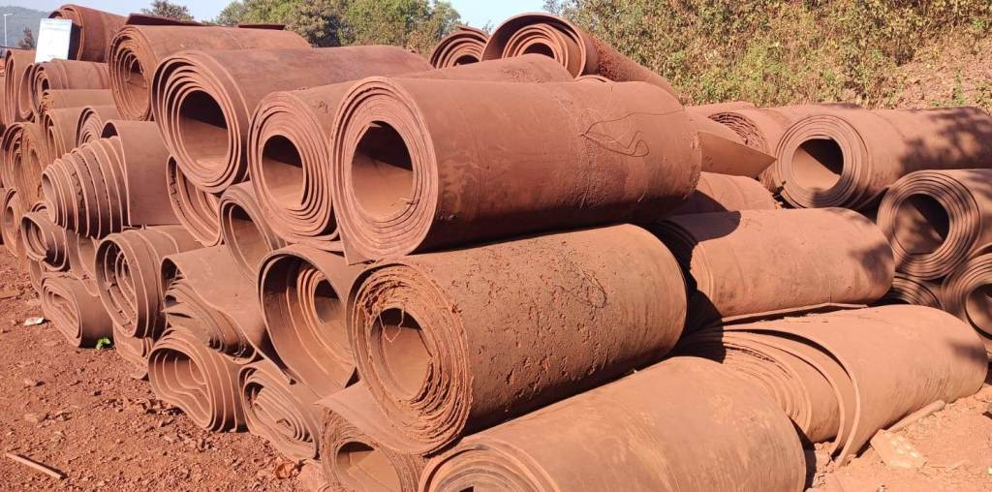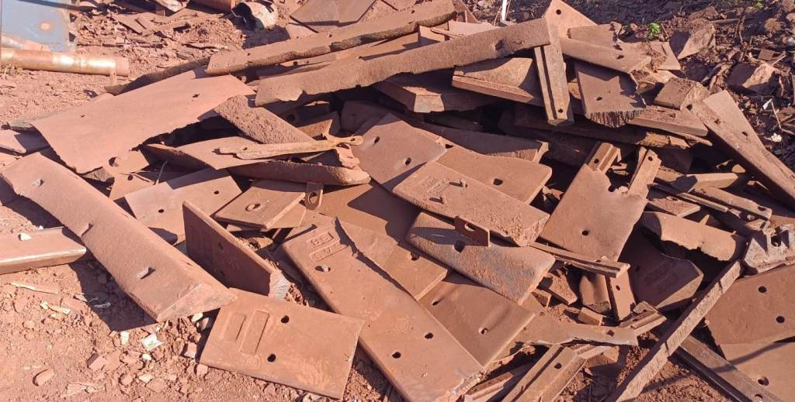
KIM-26-79 JIM-26-137 KIM-26-71 KIM-26-72
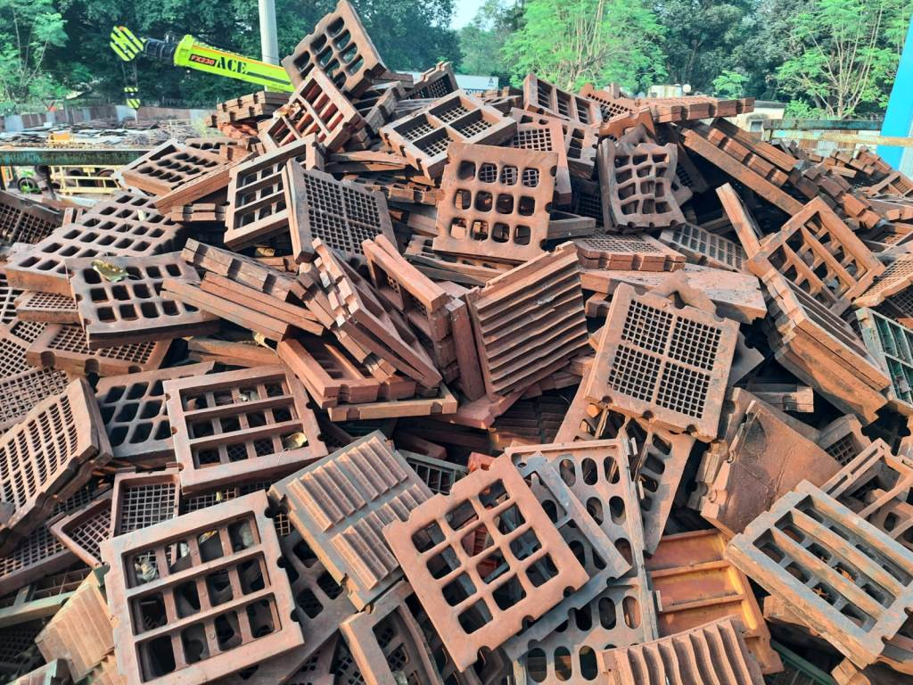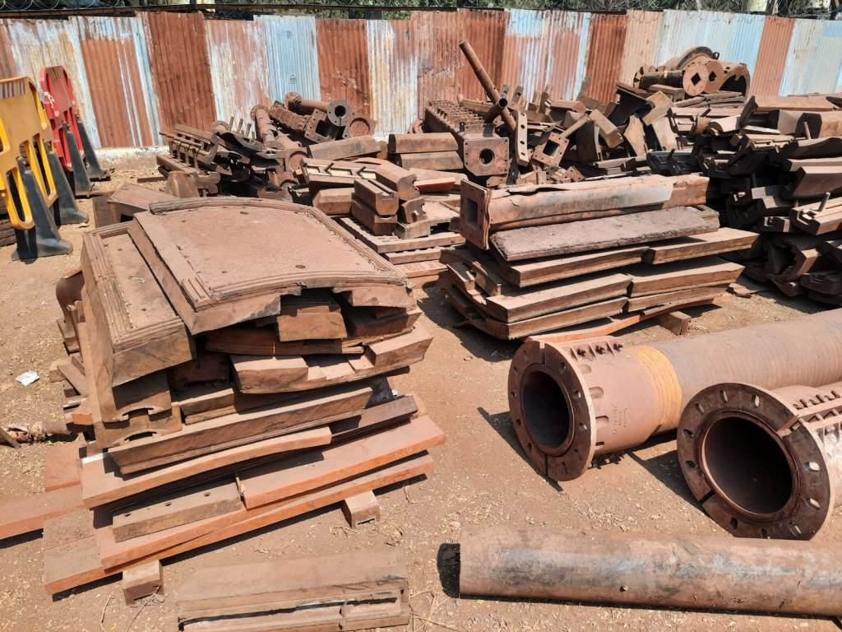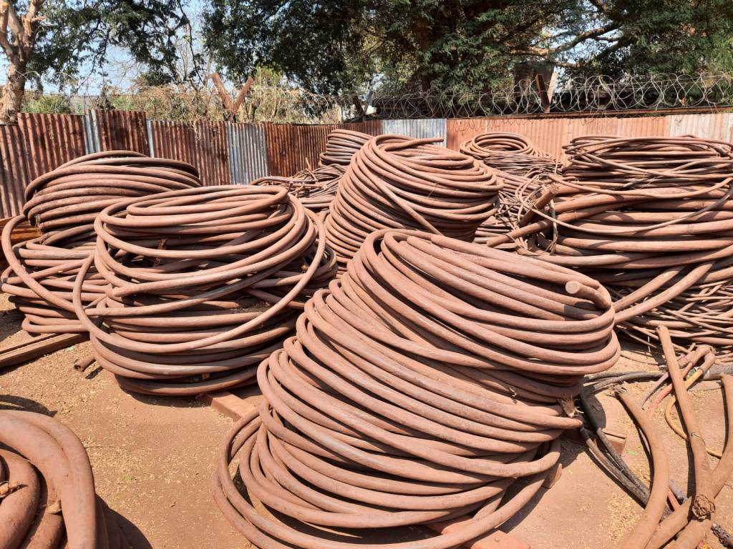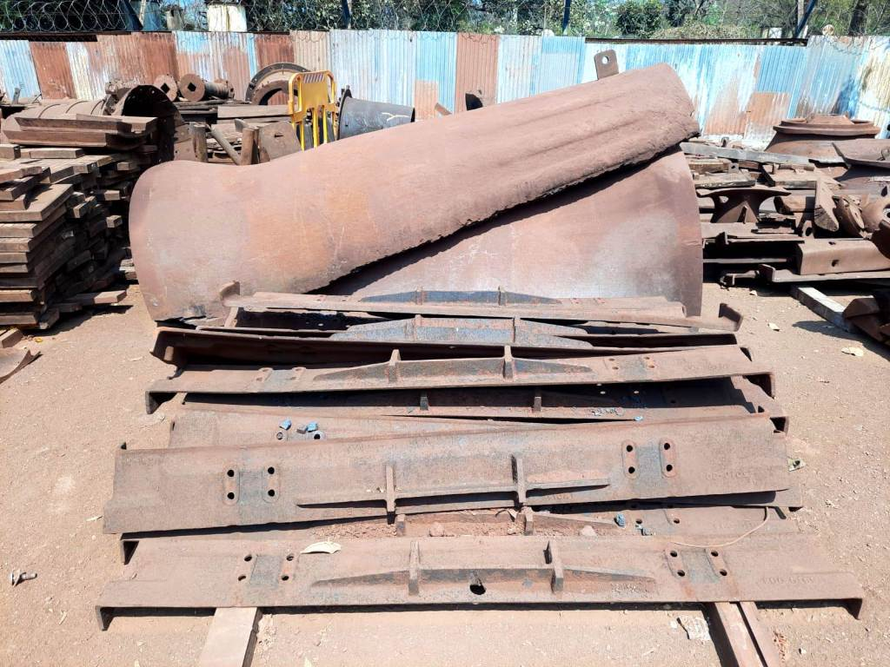
NIM-26-122 NIM-26-154 NIM-26-155 NIM-26-156
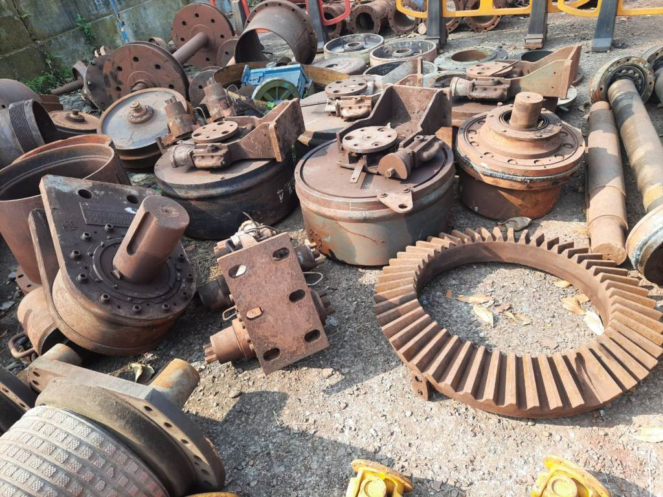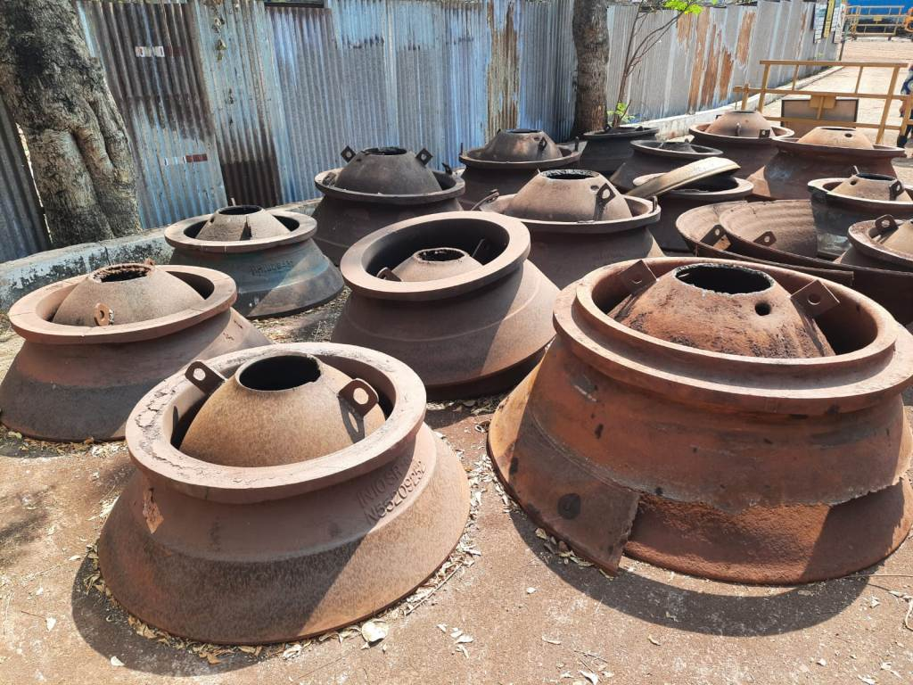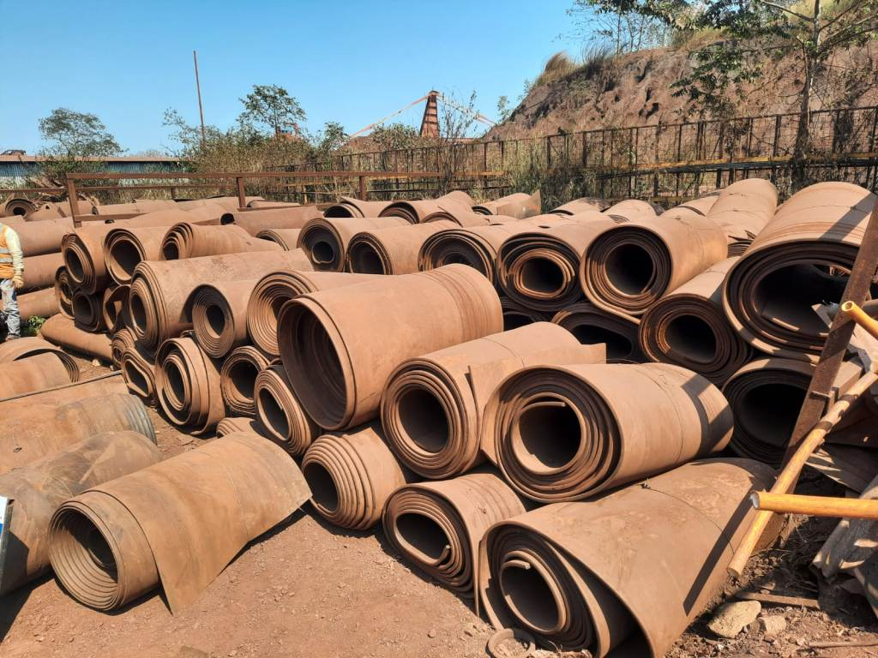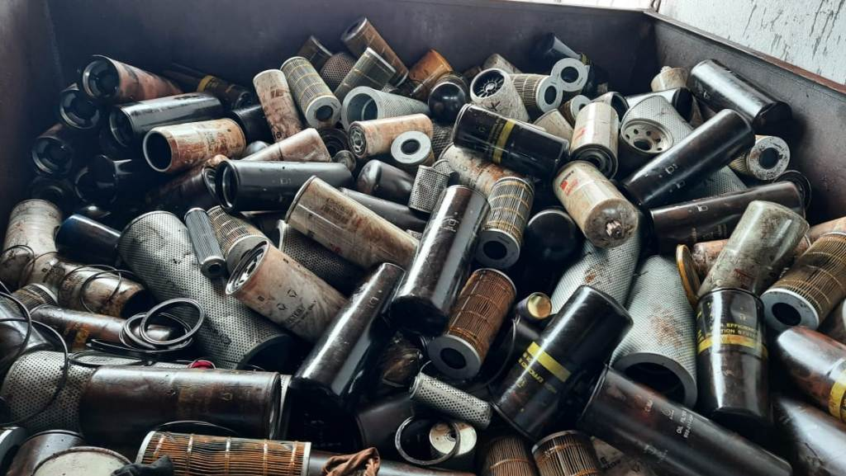
NIM-26-157 NIM-26-158 NIM-26-160 NIM-26-161
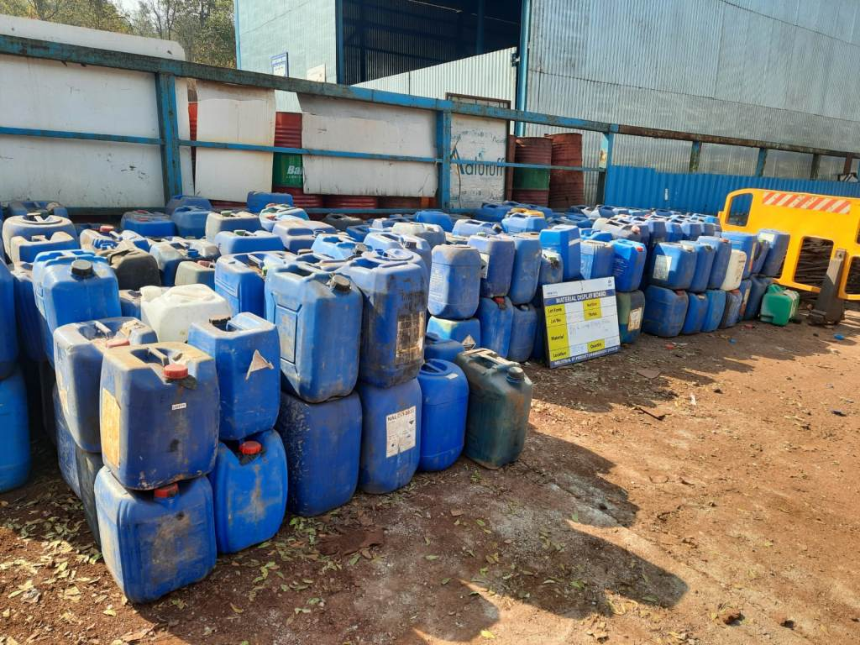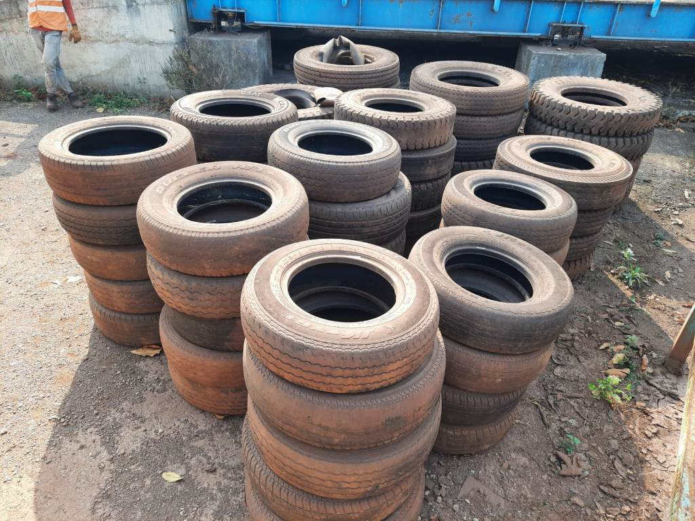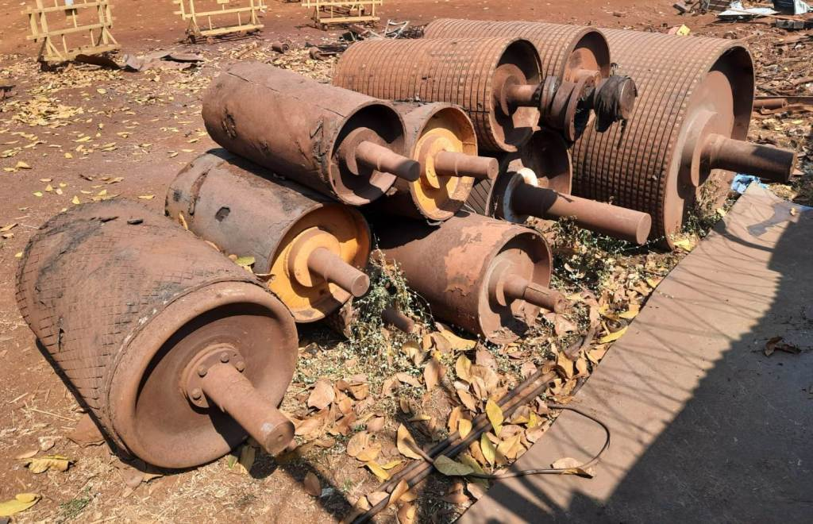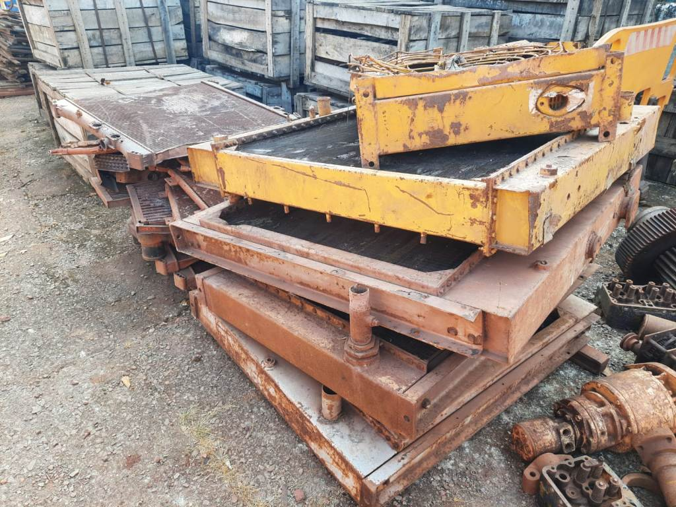
NIM-26-162 NIM-26-163 NIM-26-164 NIM-26-165
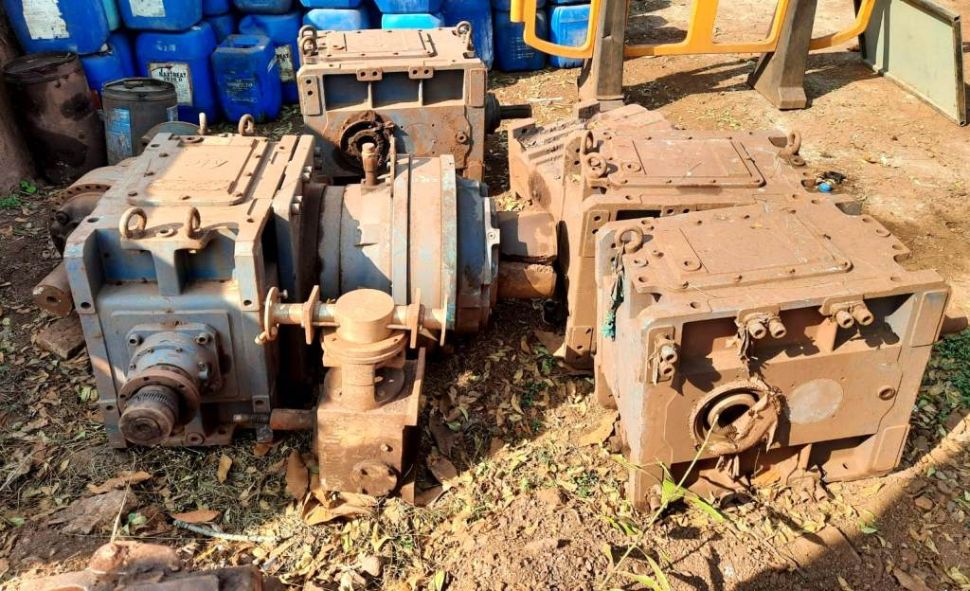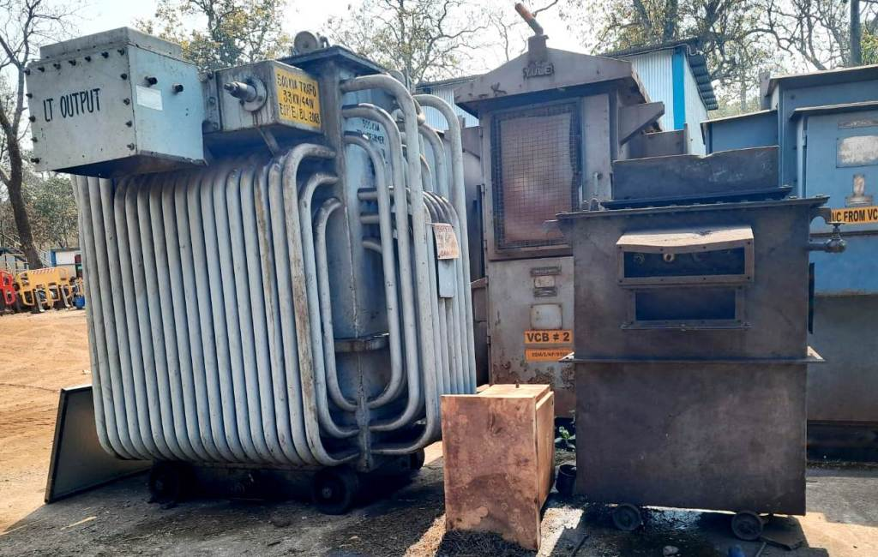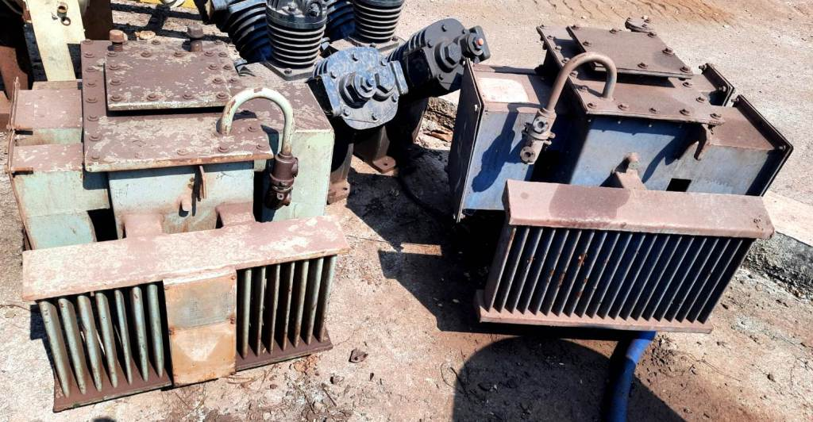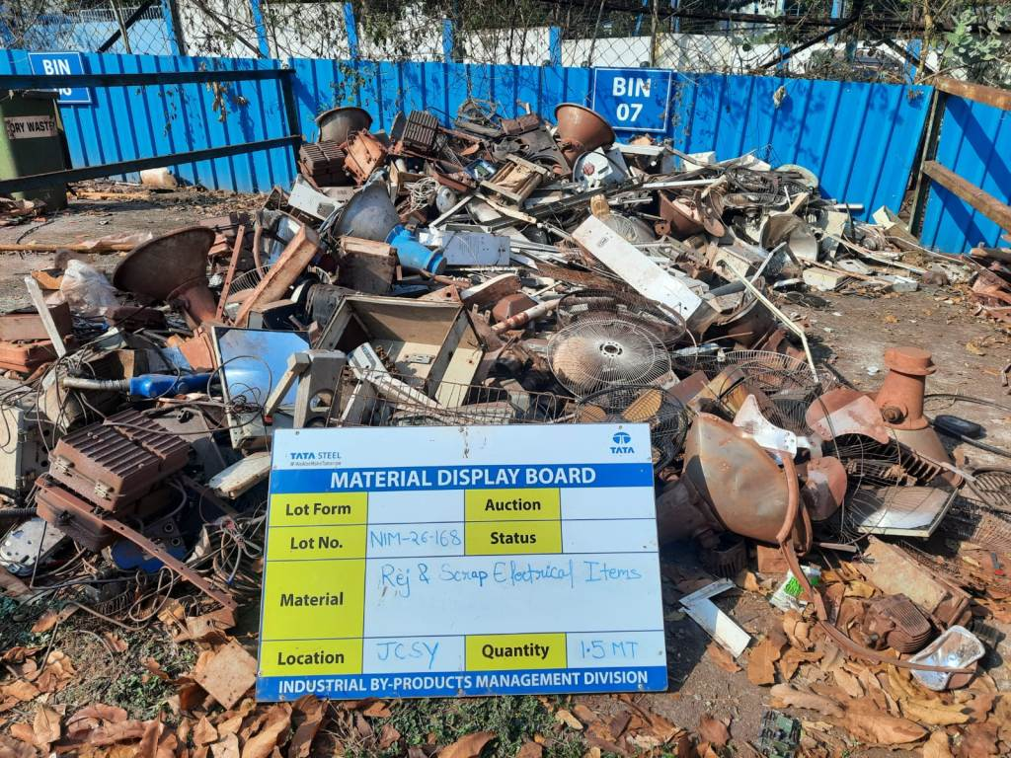
NIM-26-166 NIM-26-167 NIM-26-167 NIM-26-168
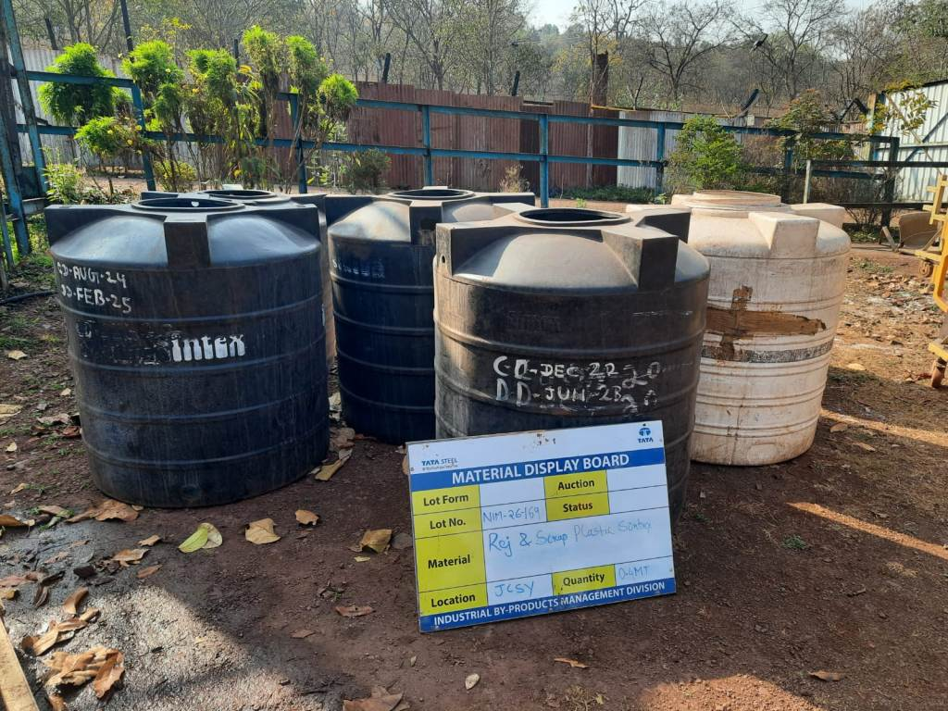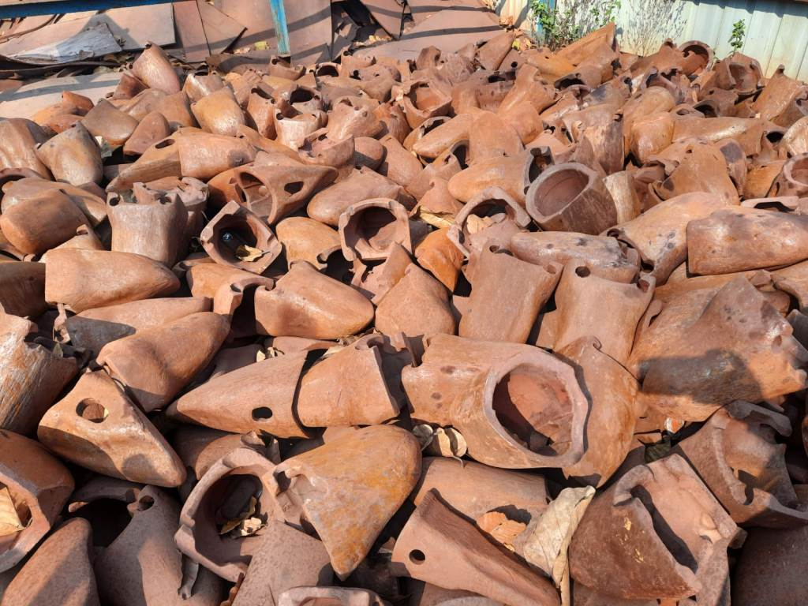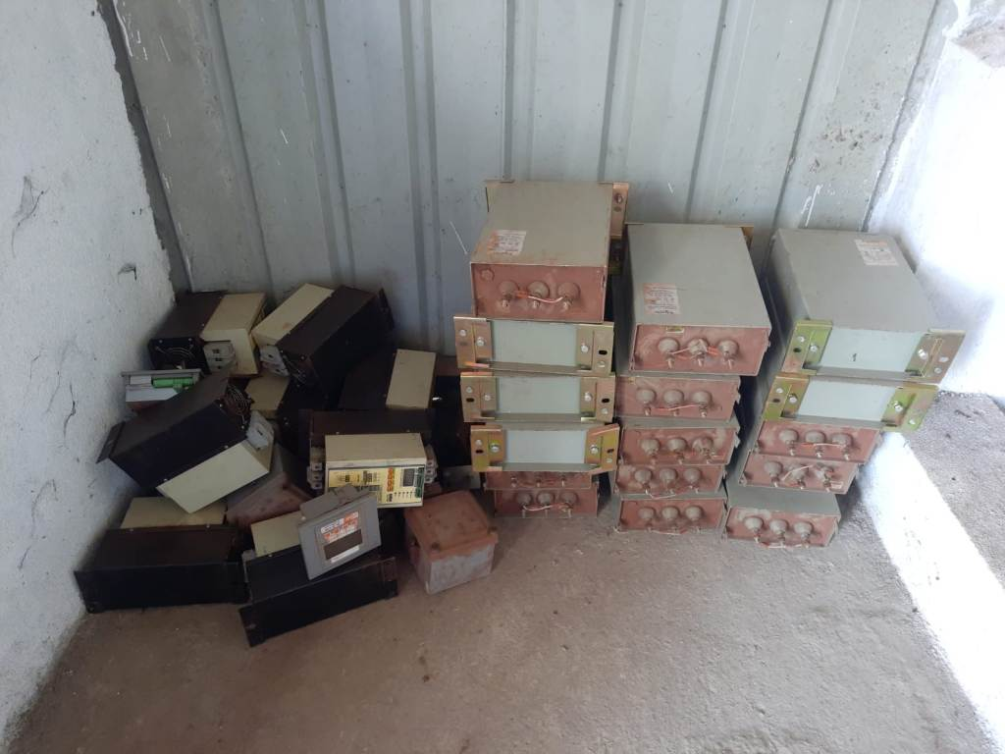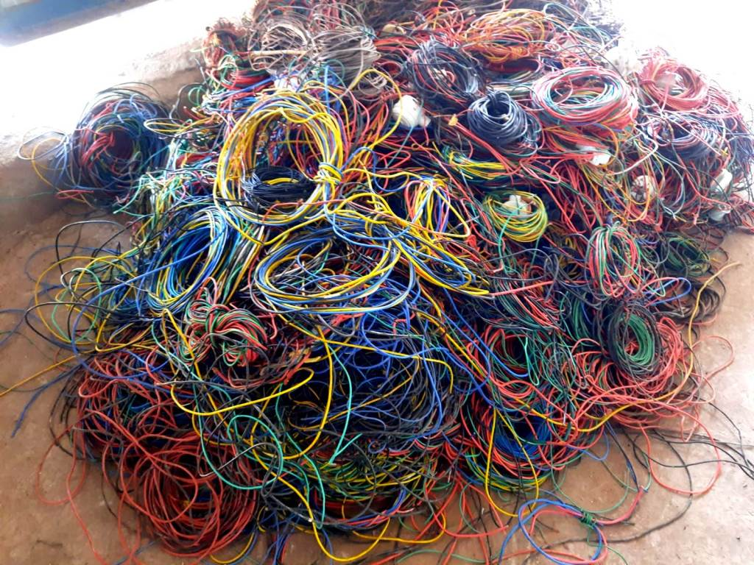
NIM-26-169 NIM-26-170 NIM-26-171 NIM-26-172
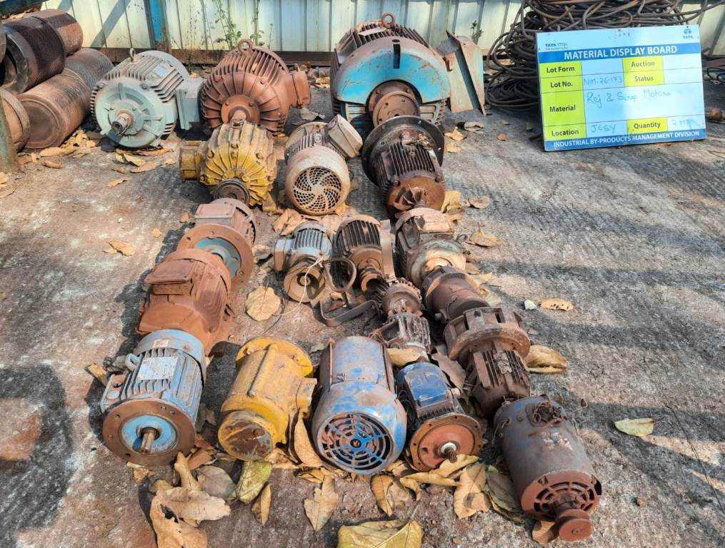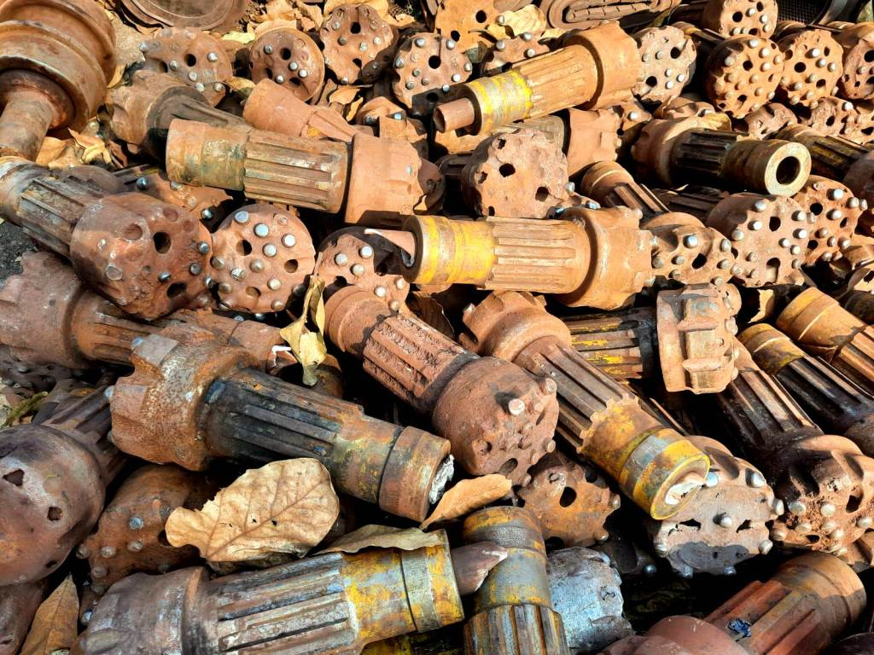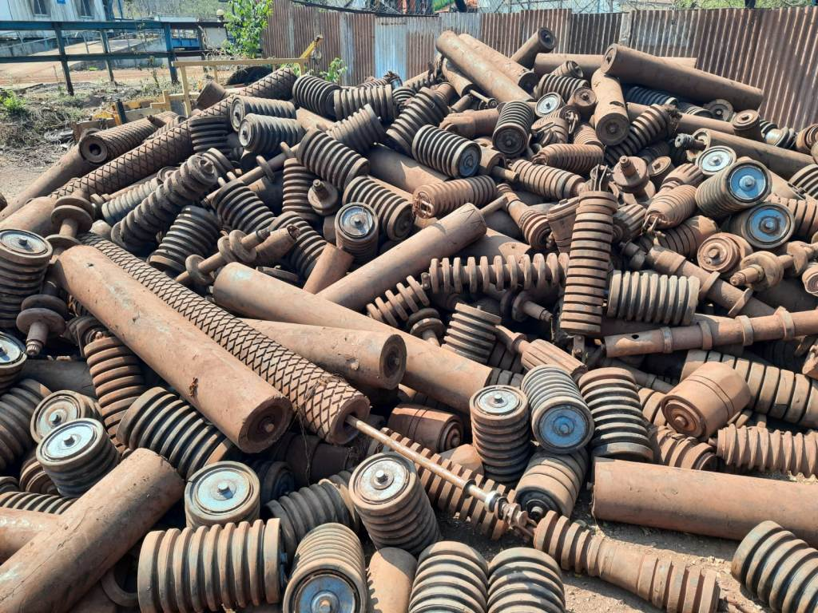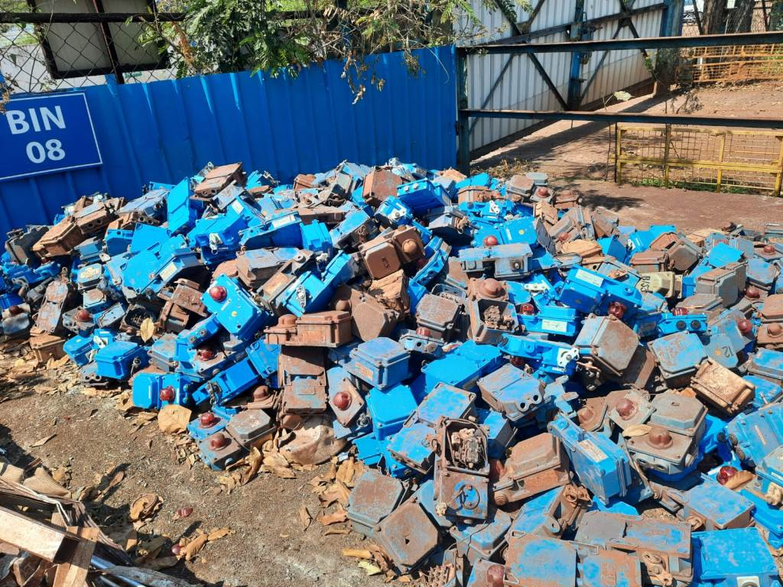
NIM-26-173 NIM-26-174 NIM-26-176 NIM-26-177
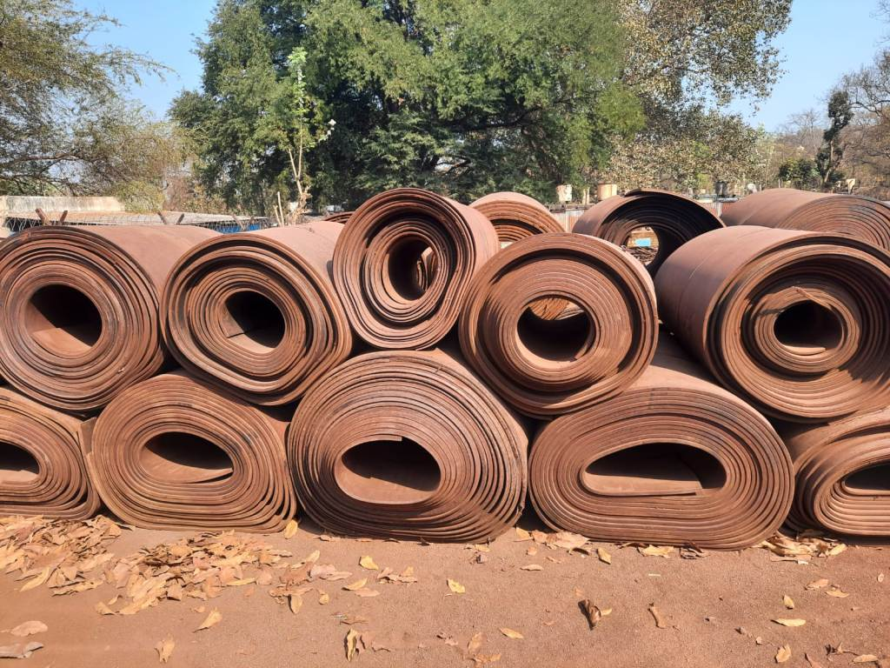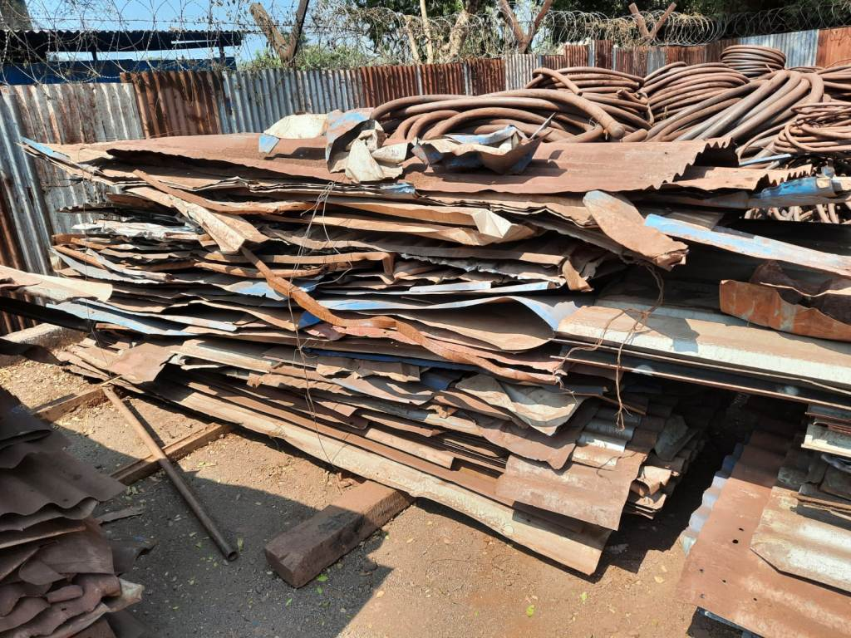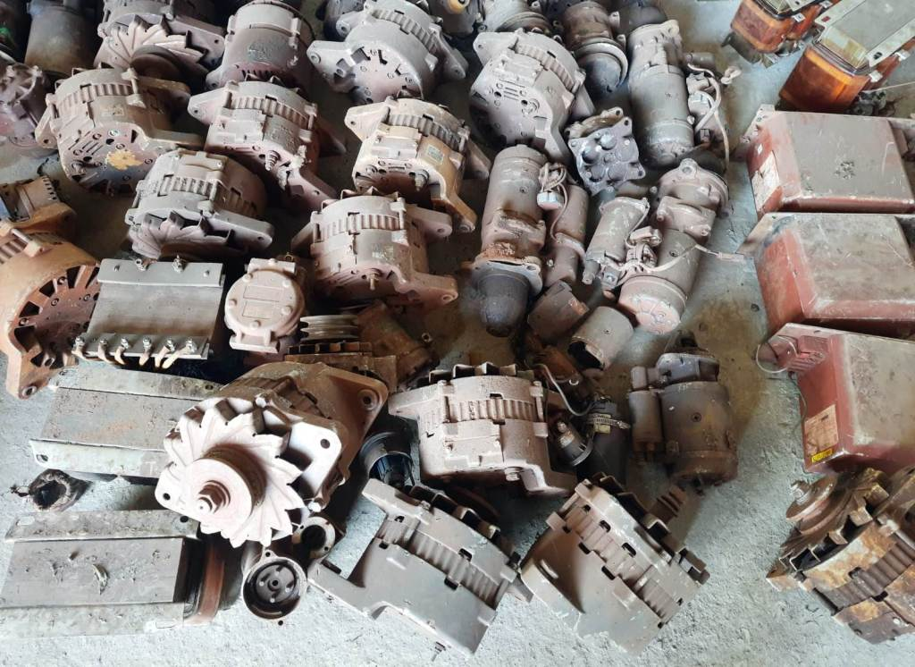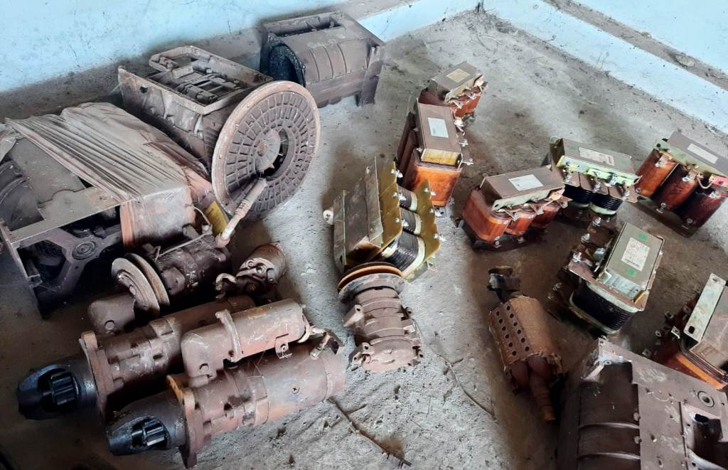
NIM-26-178 NIM-26-179 NIM-26-180 NIM-26-180
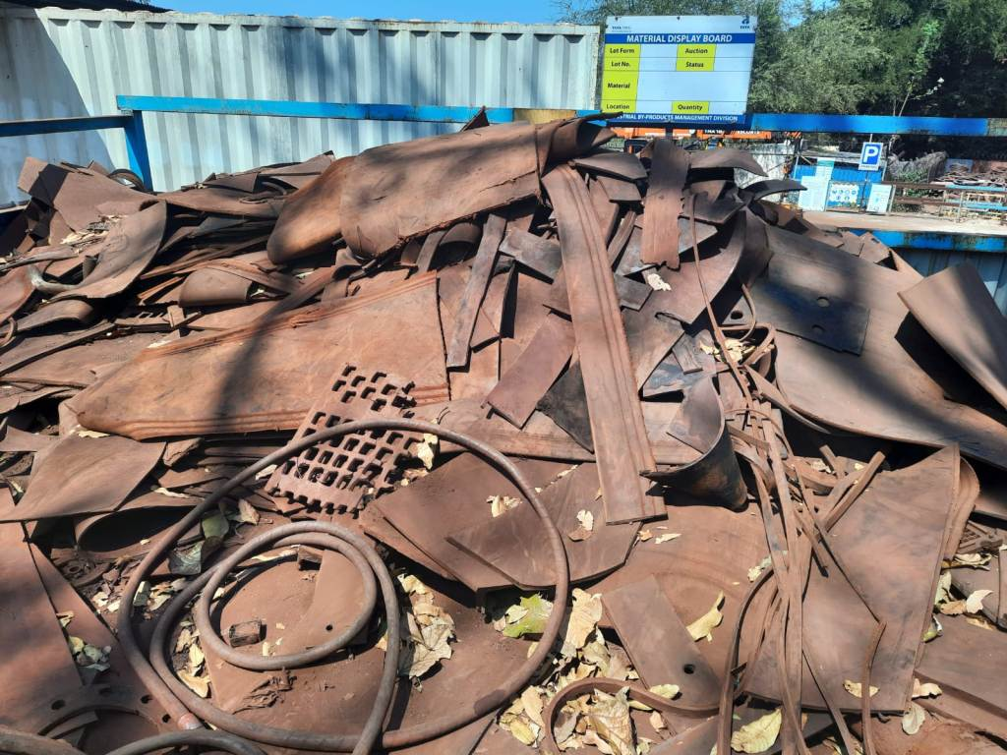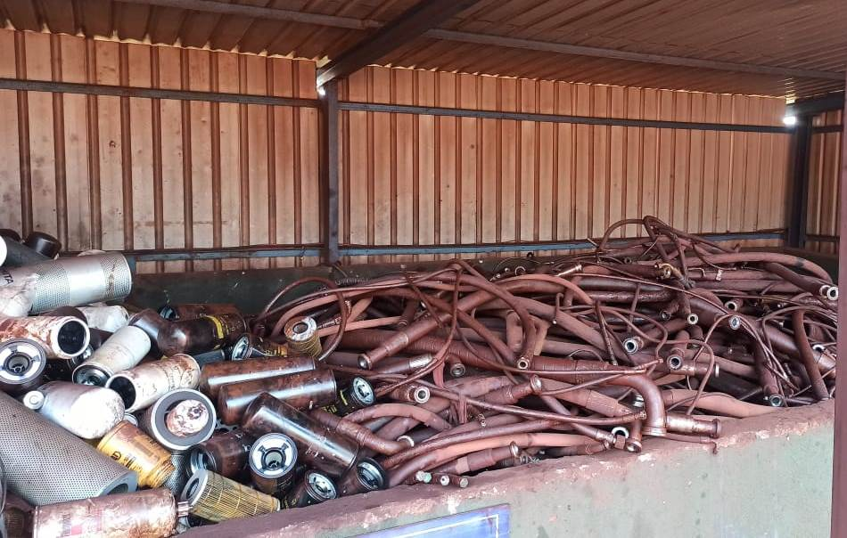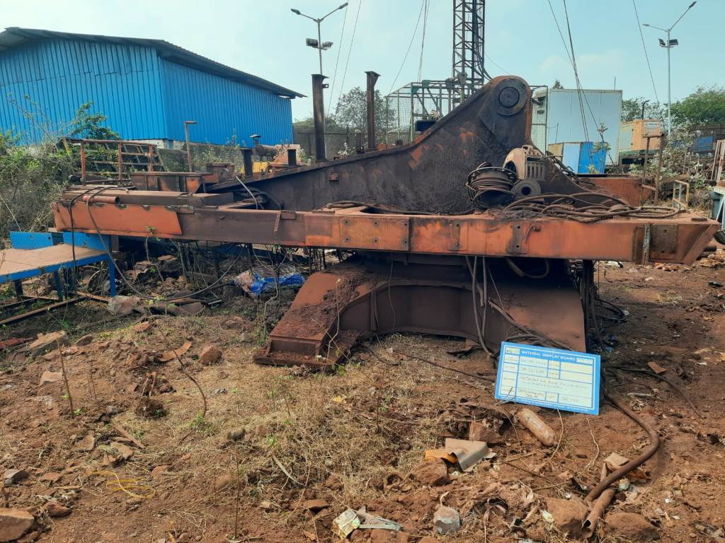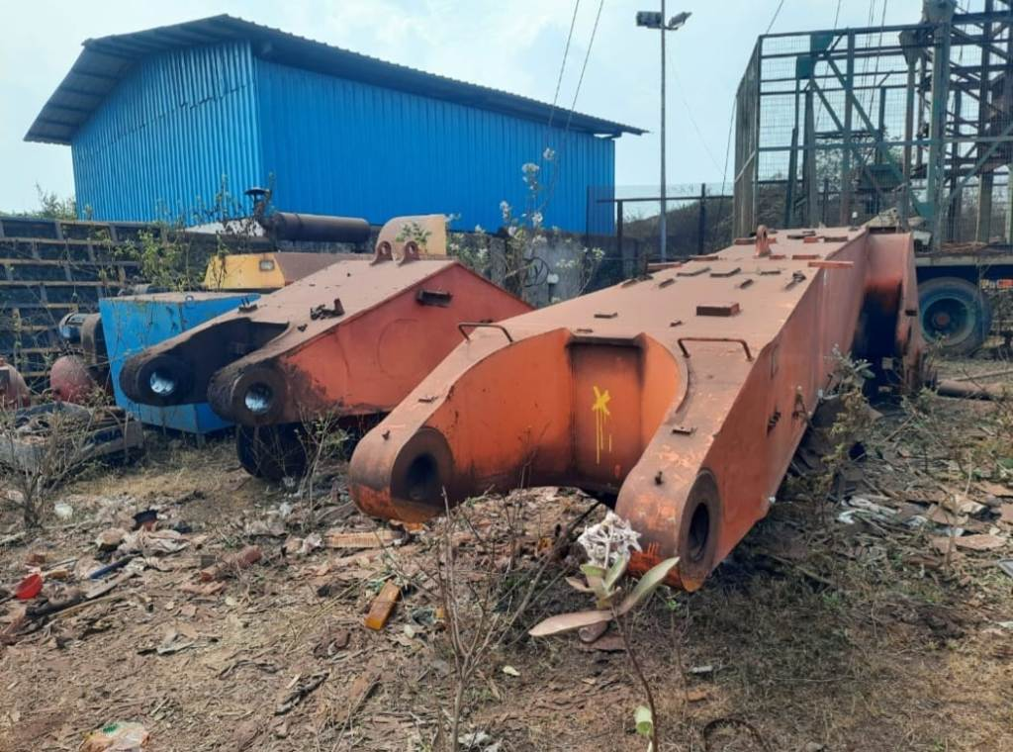
NIM-26-181 JIM-26-113 JIM-26-120 JIM-26-120
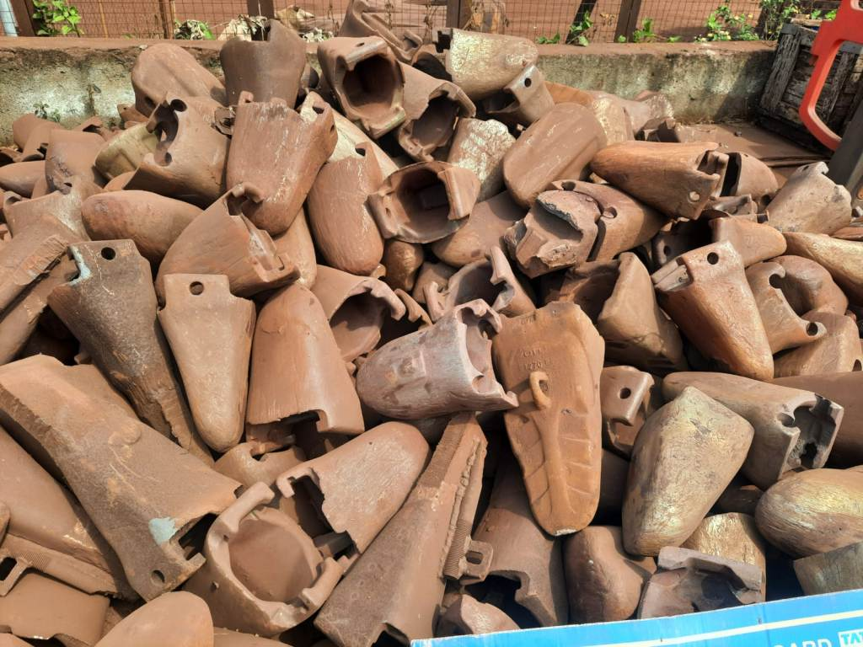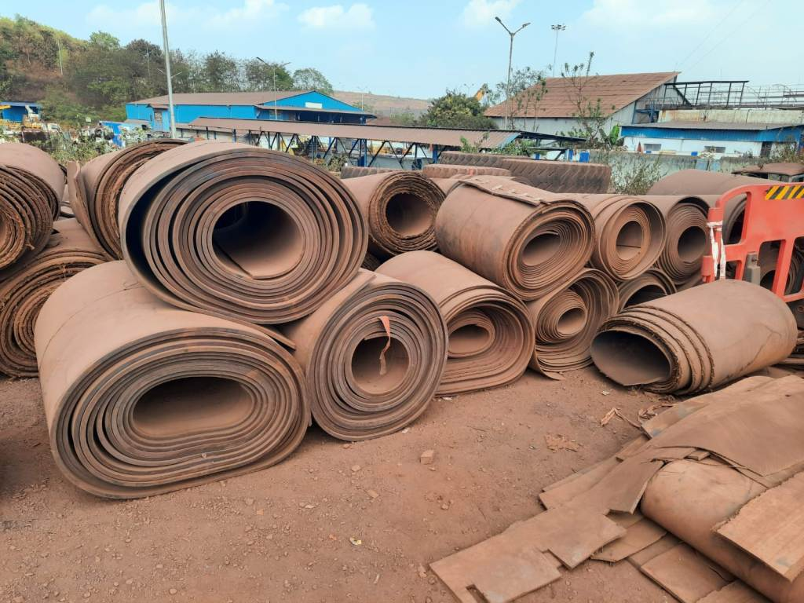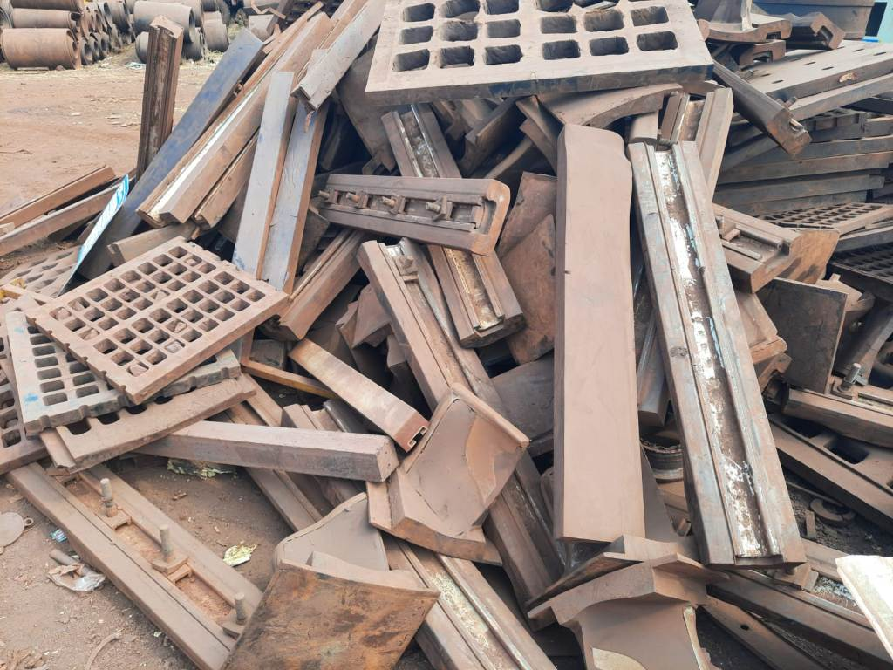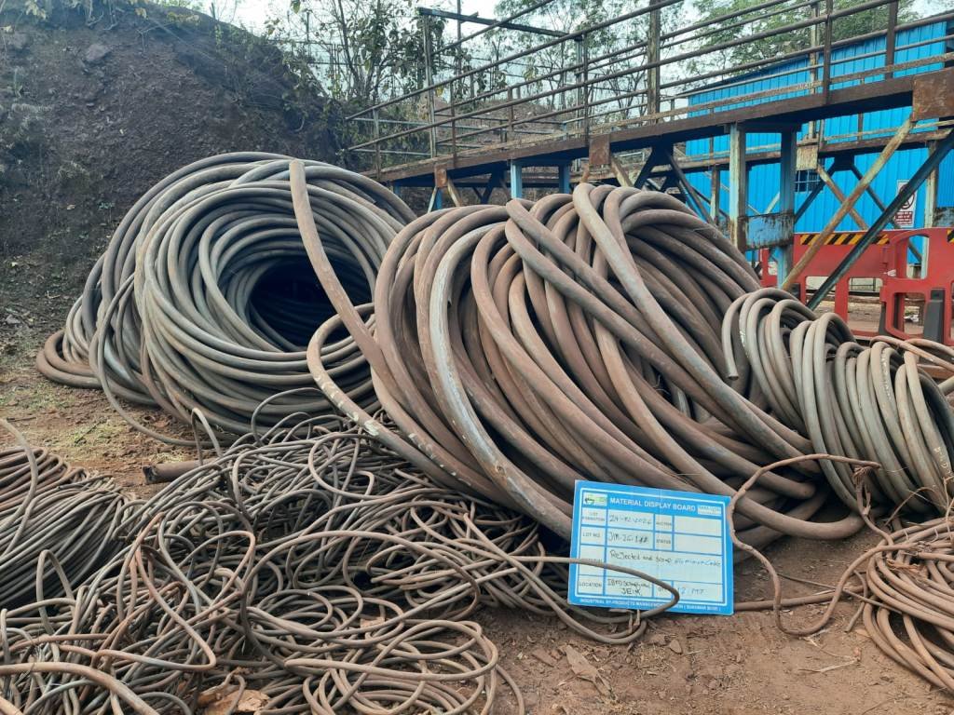
JIM-26-135 JIM-26-140 JIM-26-141 JIM-26-142
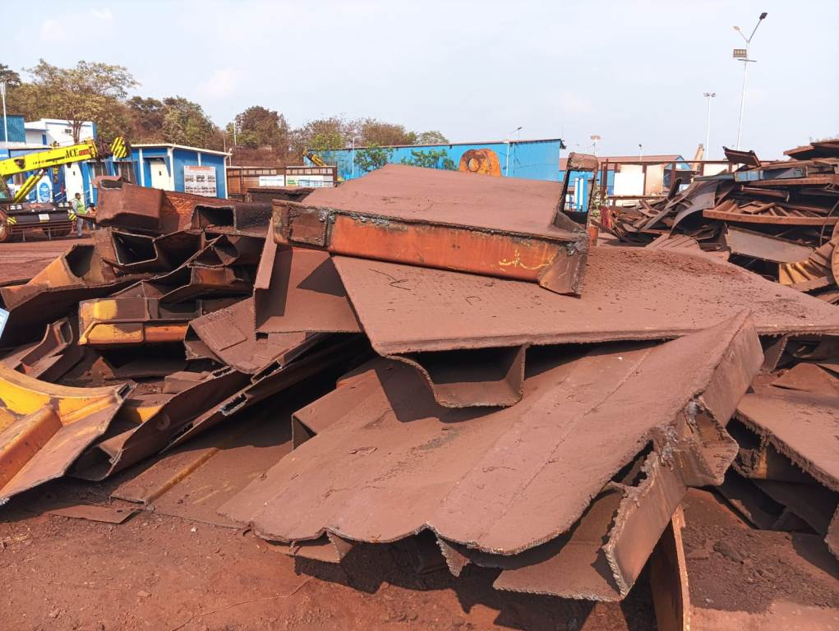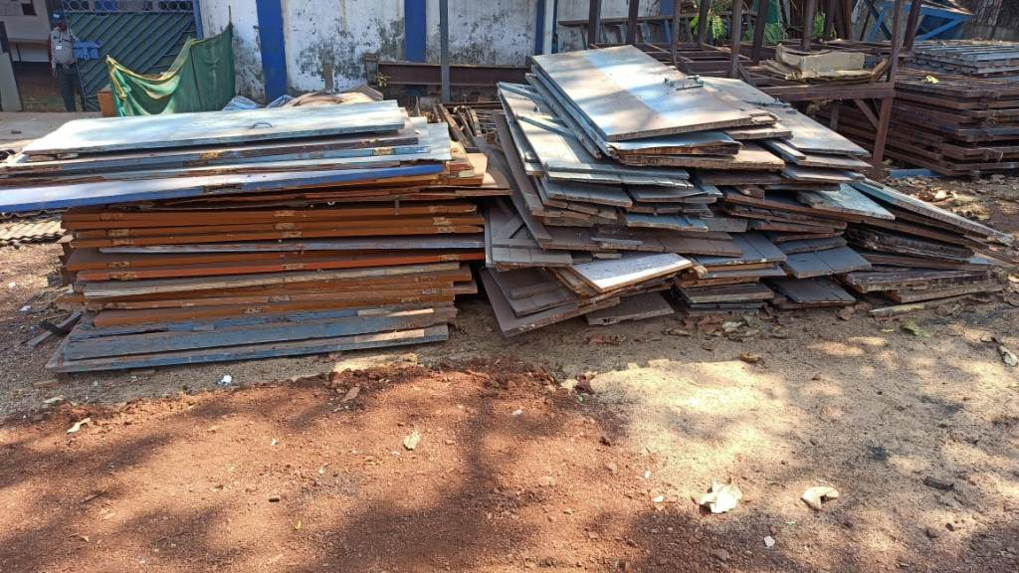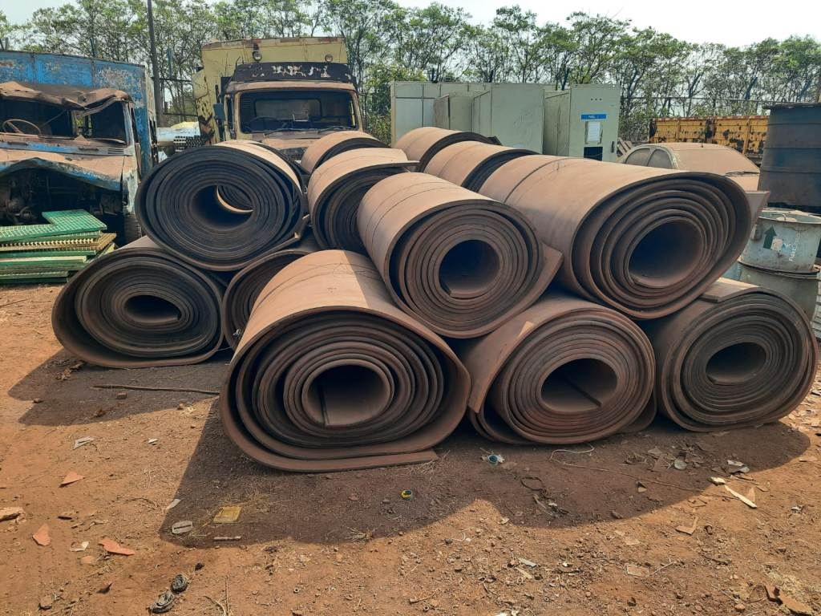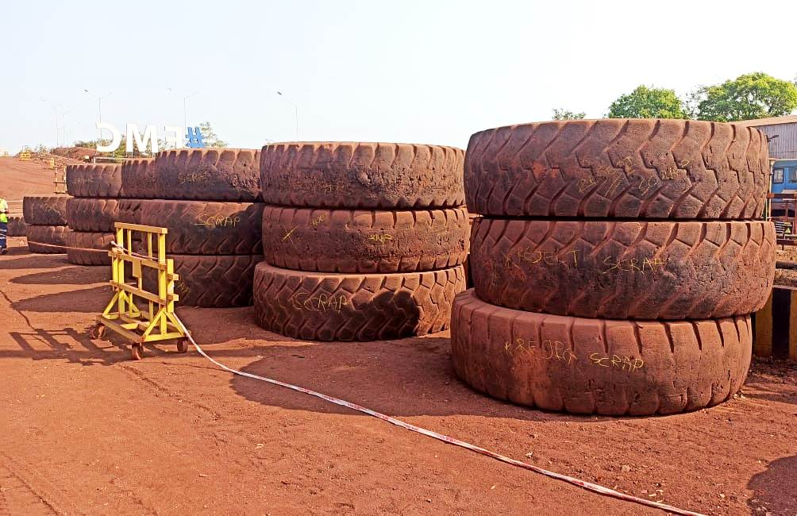
JIM-26-143 JIM-26-144 JIM-26-145 JIM-26-146
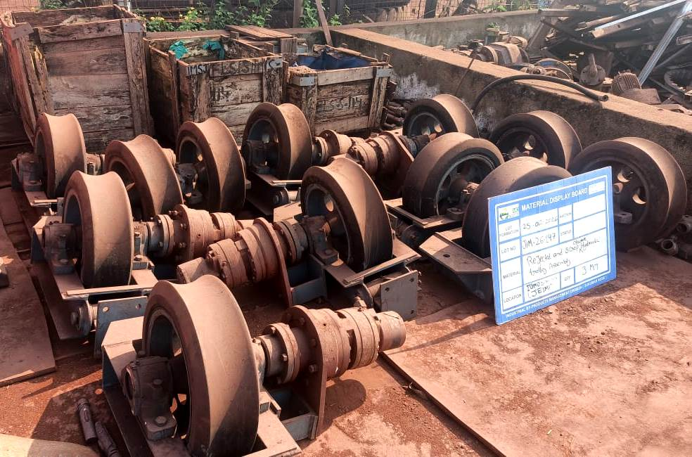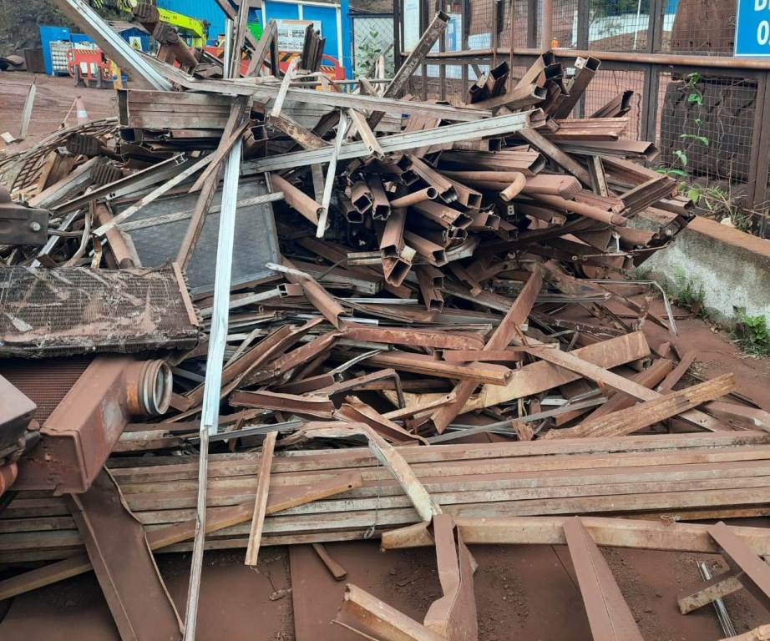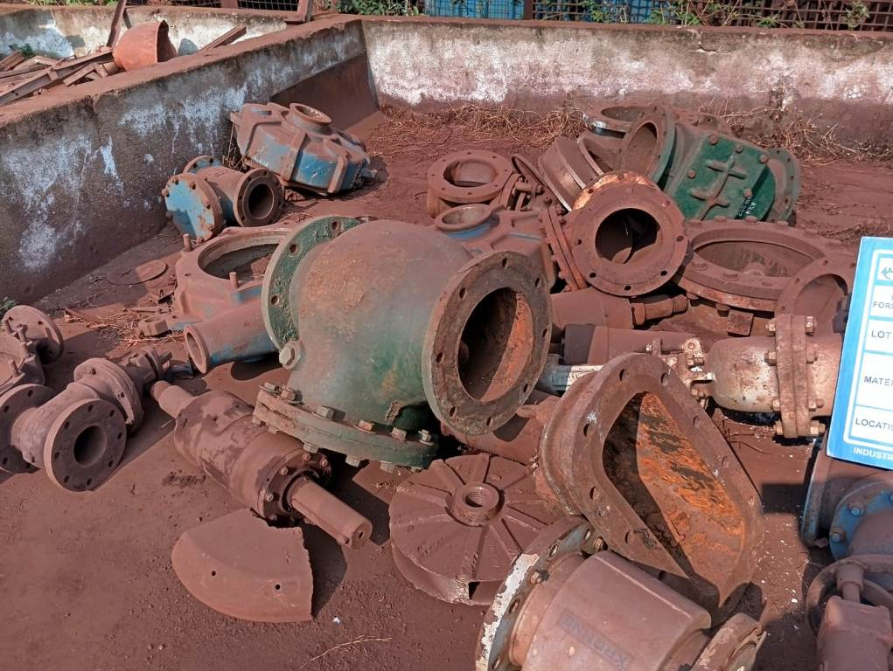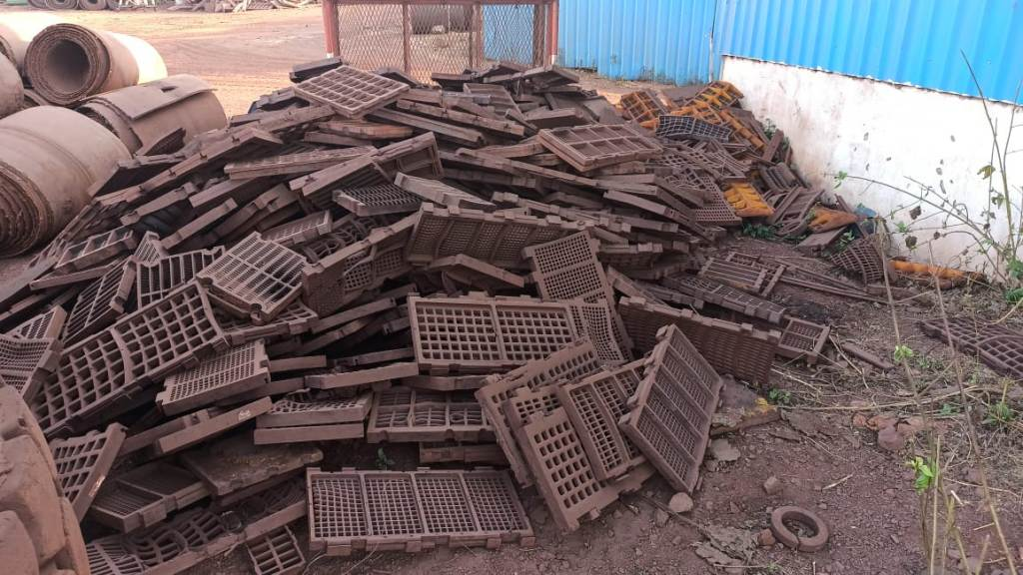
JIM-26-147 JIM-26-148 JIM-26-149 JIM-26-150
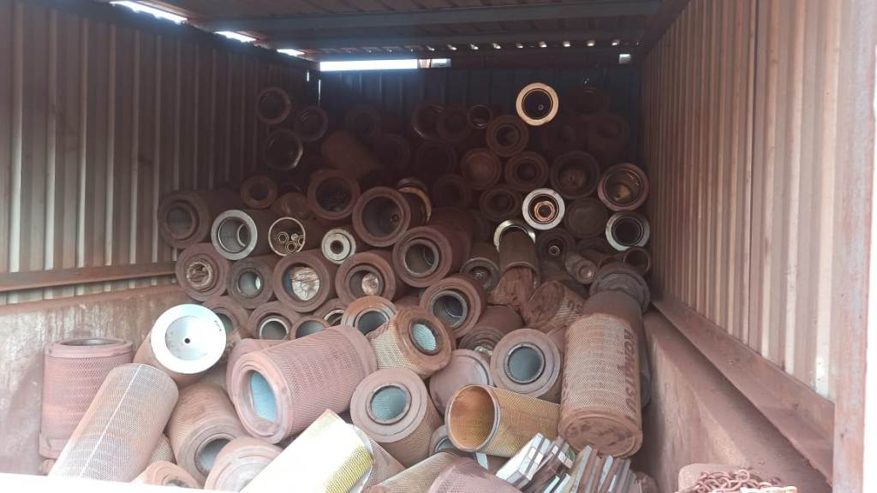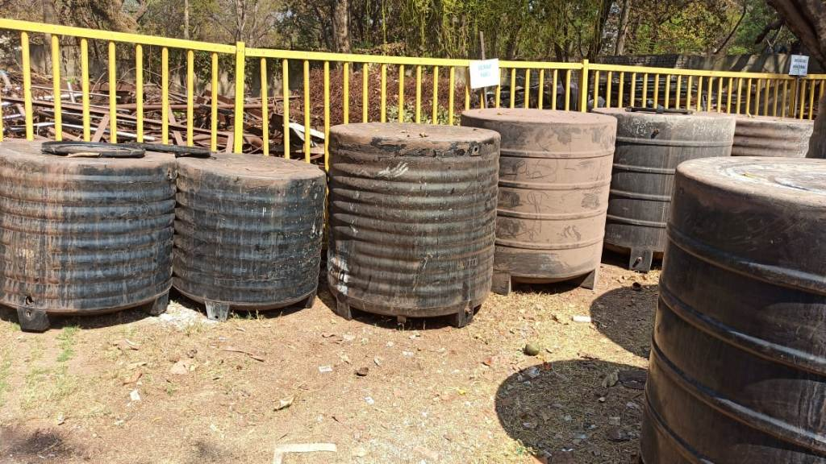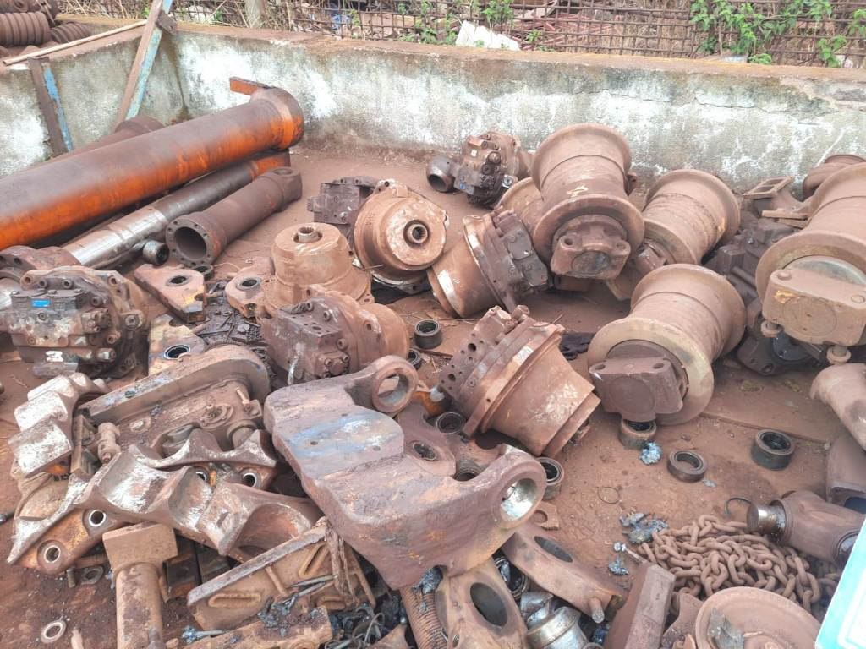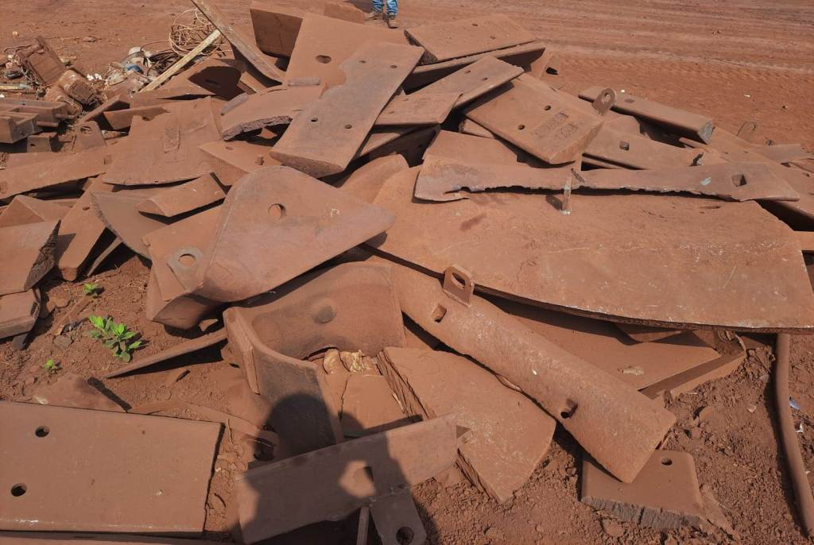
JIM-26-151 JIM-26-152 JIM-26-153 JIM-26-154
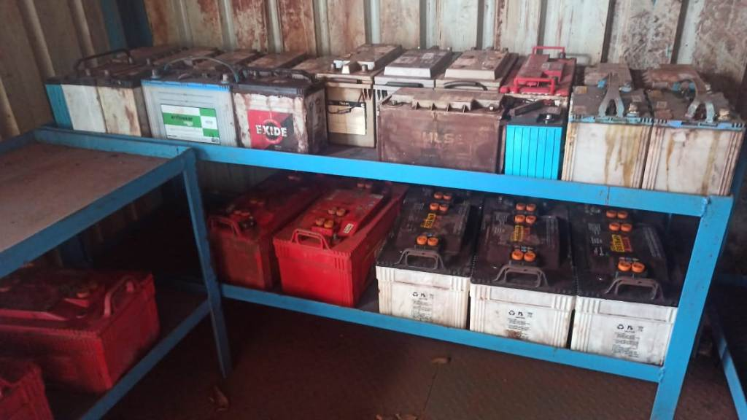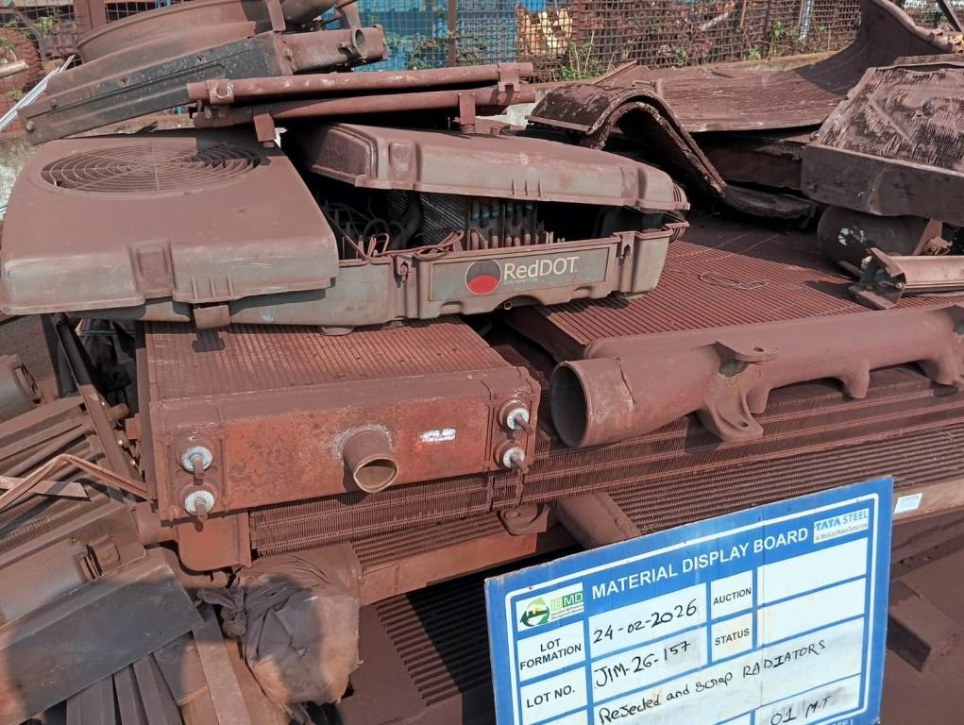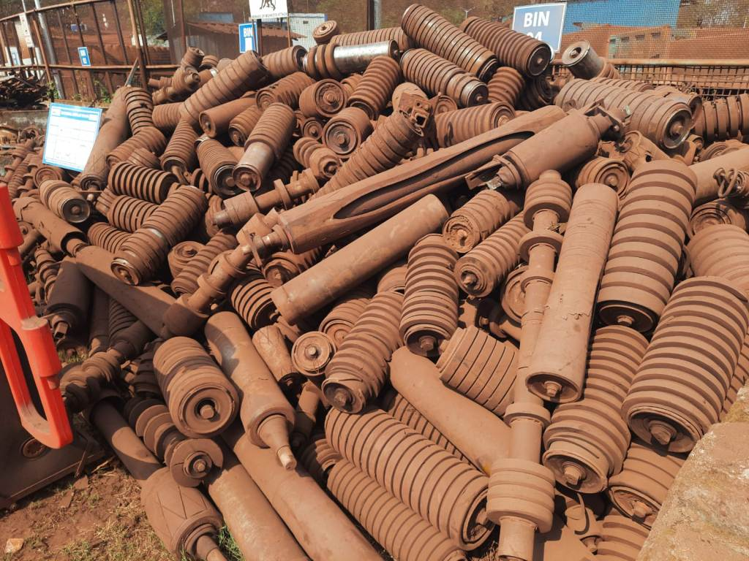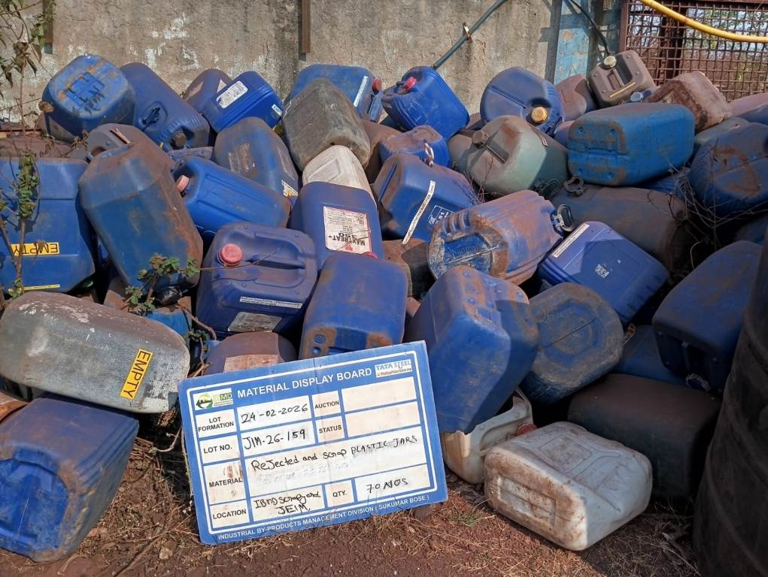
JIM-26-156 JIM-26-157 JIM-26-158 JIM-26-159
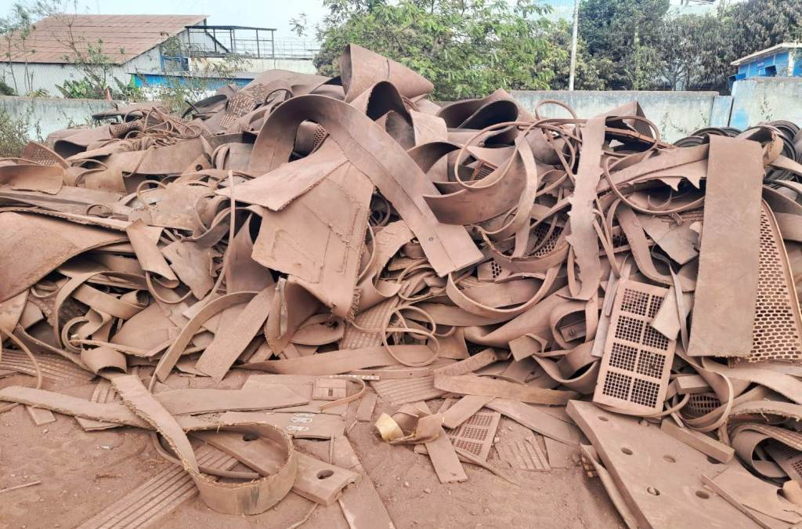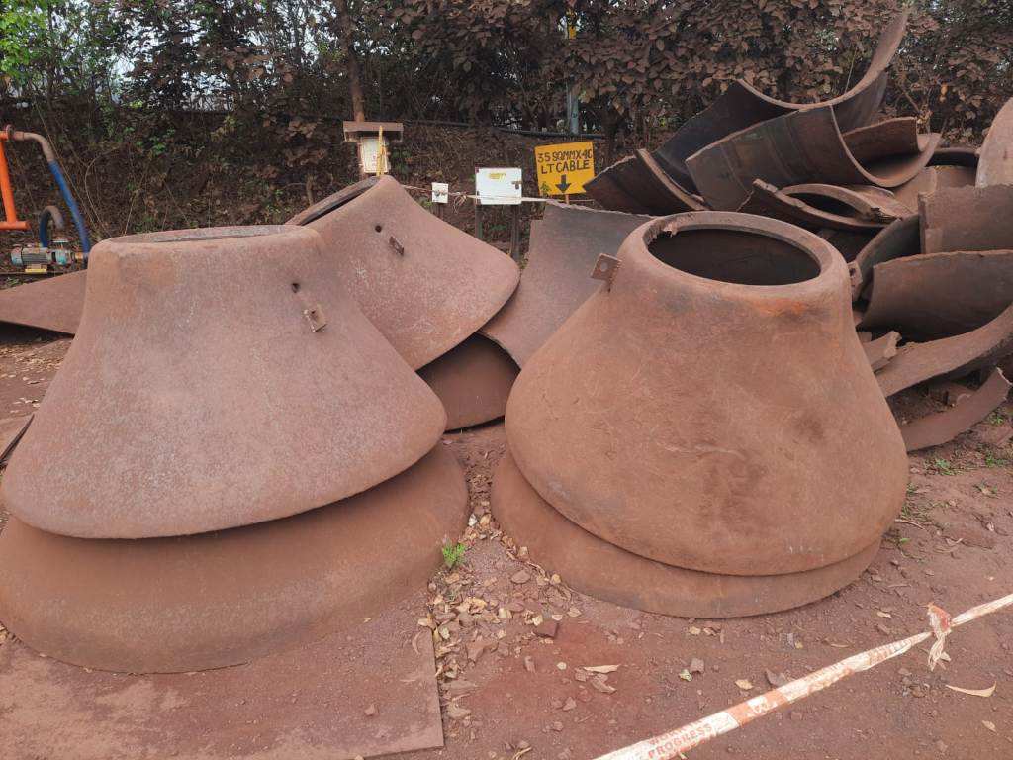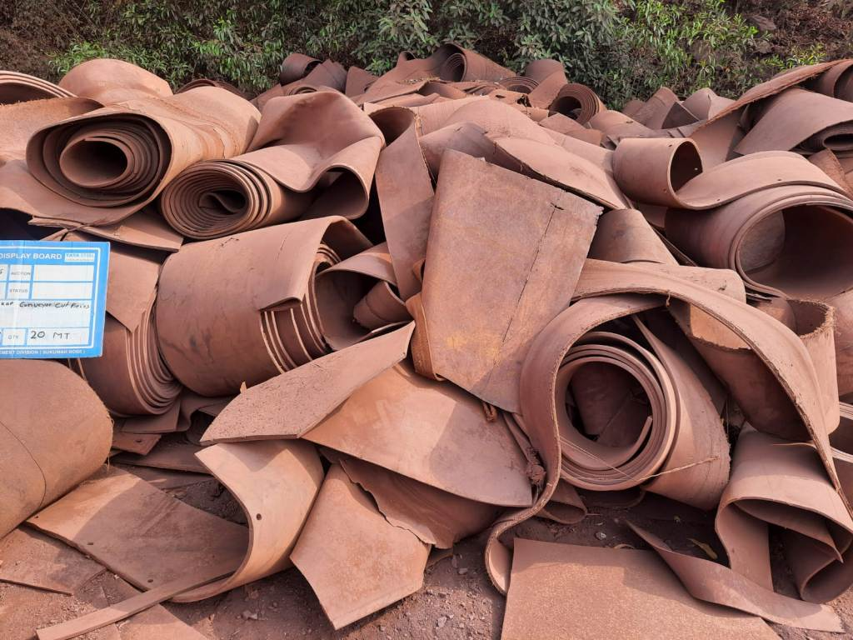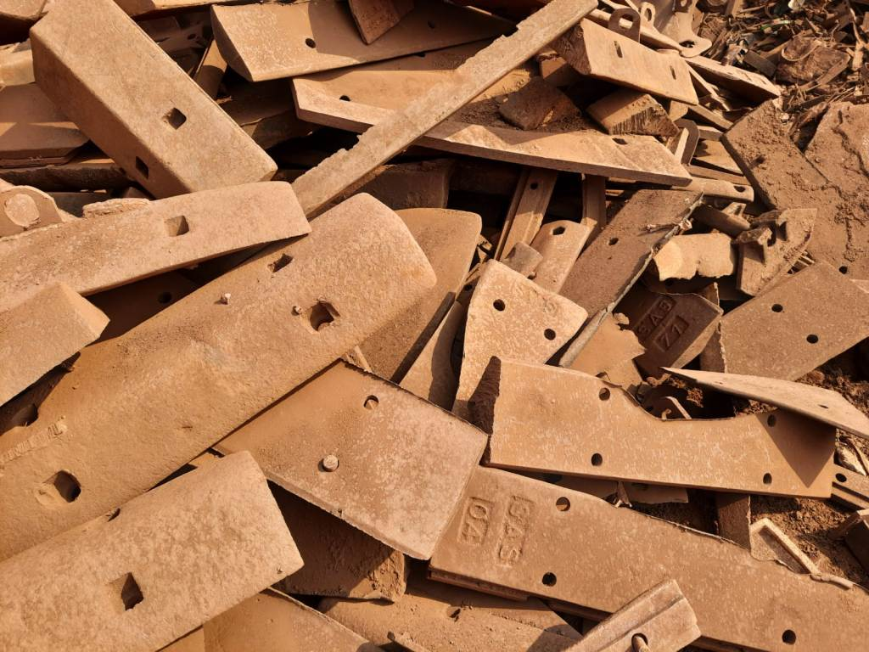
JIM-26-160 KIM-26-77 KIM-26-80 KIM-26-81
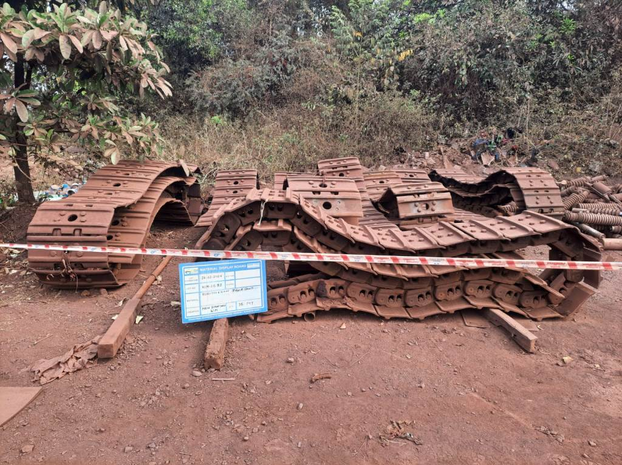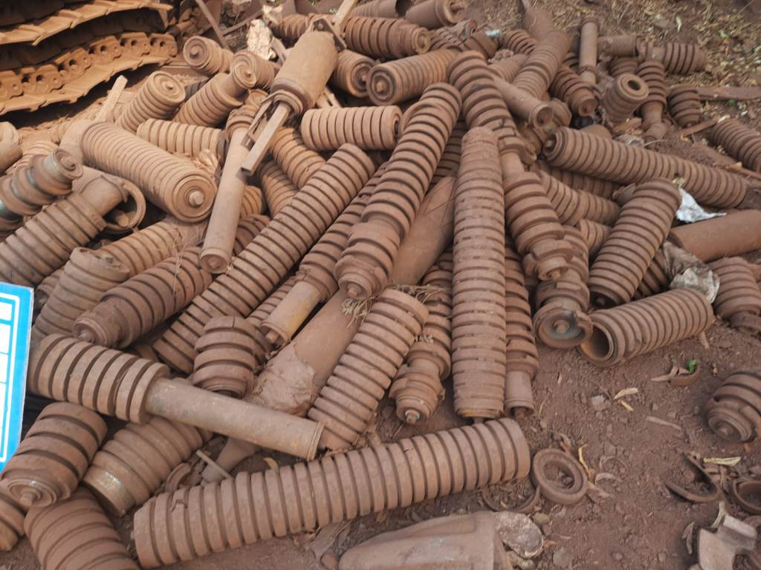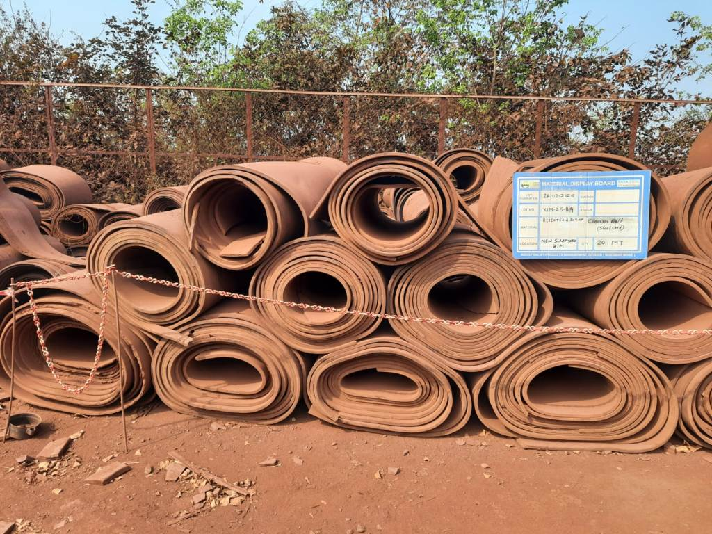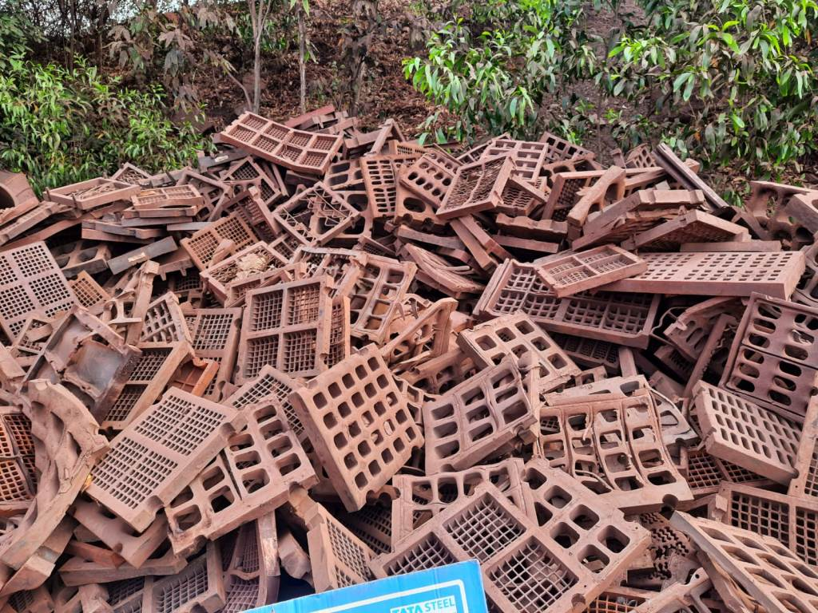
KIM-26-82 KIM-26-83 KIM-26-84 KIM-26-85
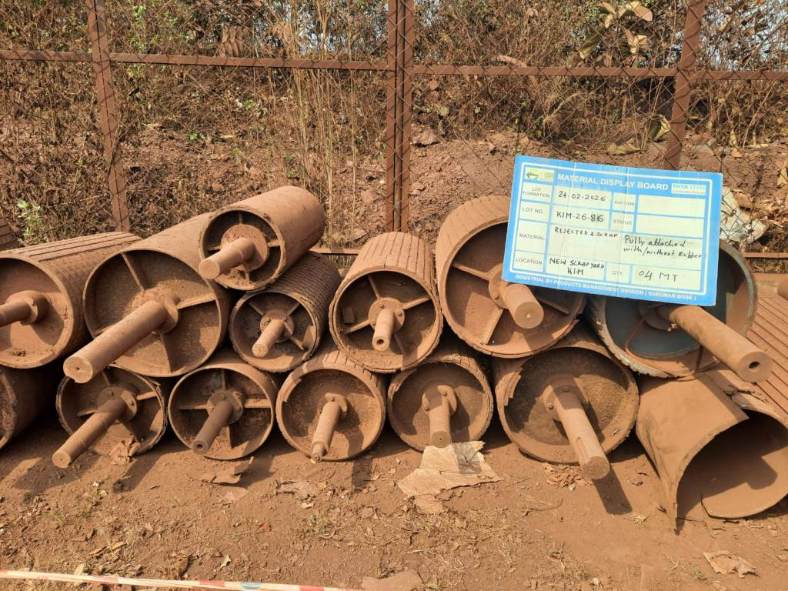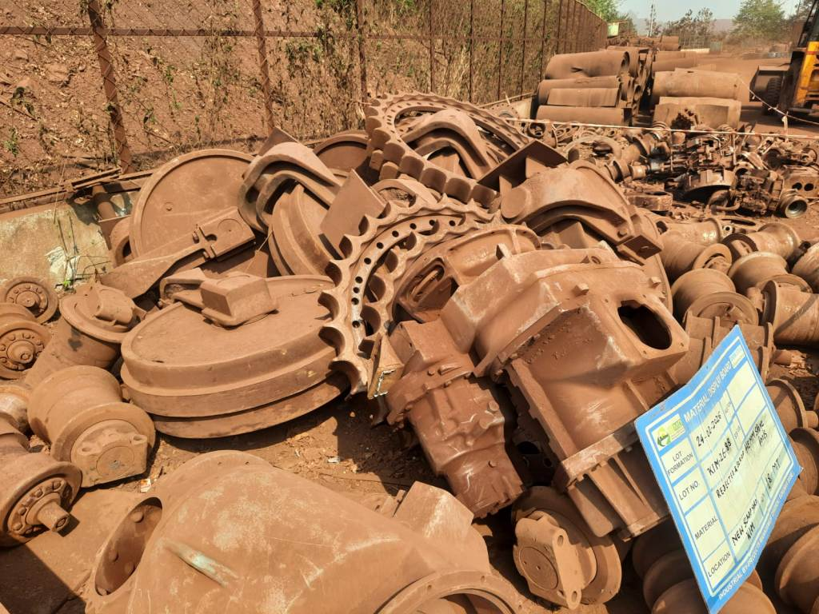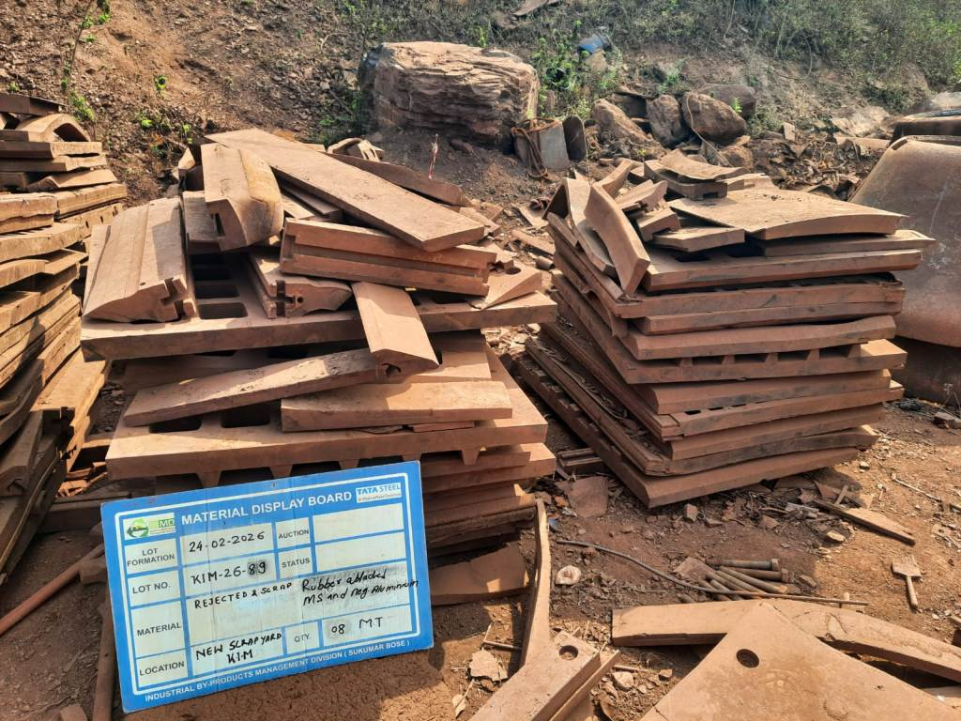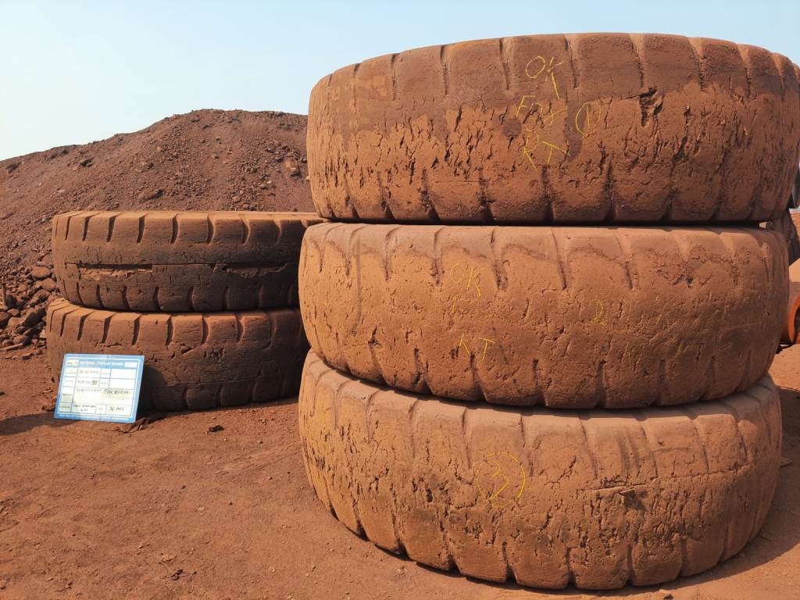
KIM-26-86 KIM-26-88 KIM-26-89 KIM-26-90
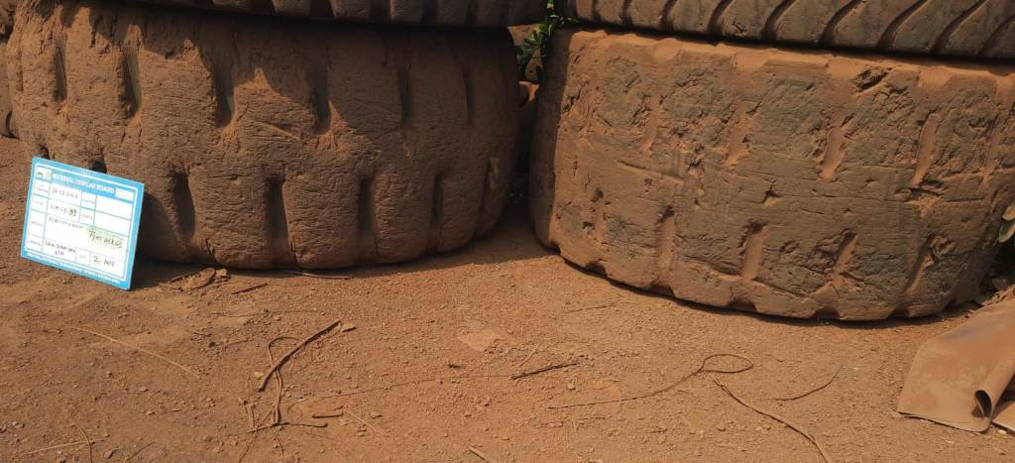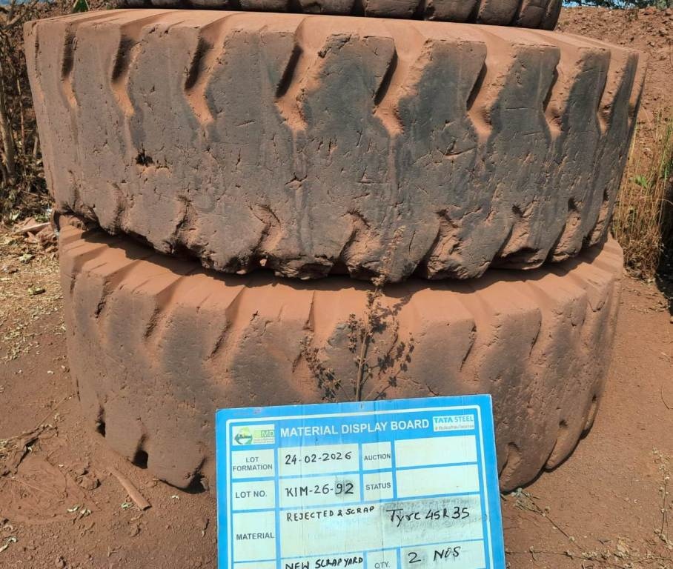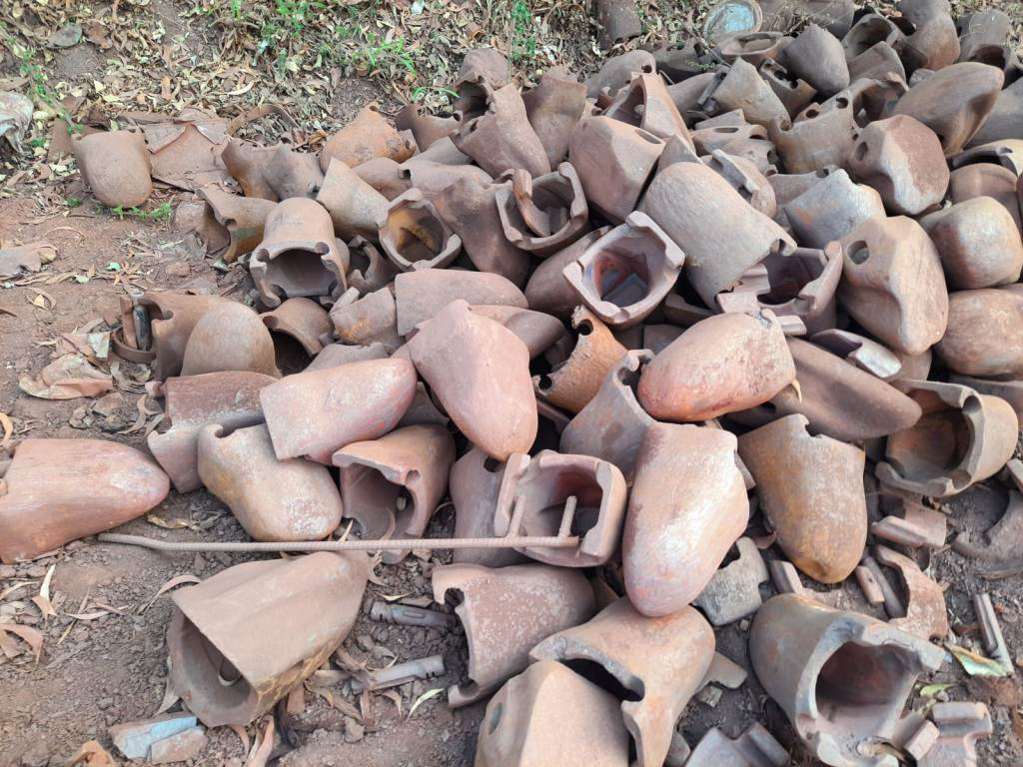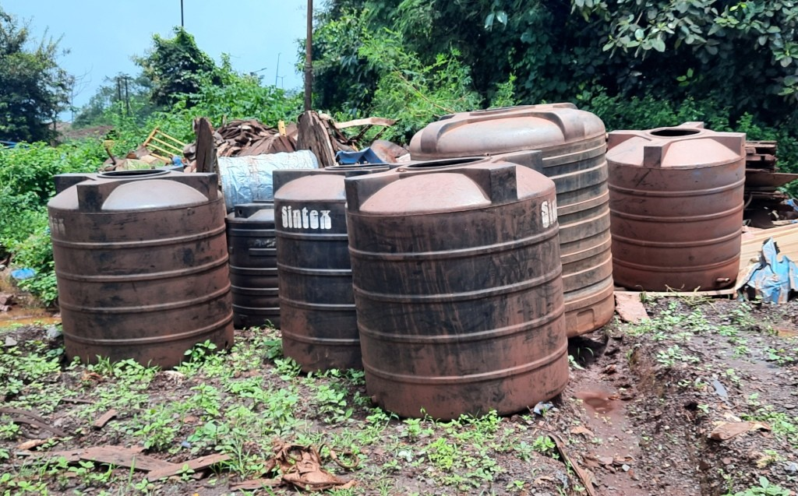
KIM-26-91 KIM-26-92 KIM26-94 KIM-26-29
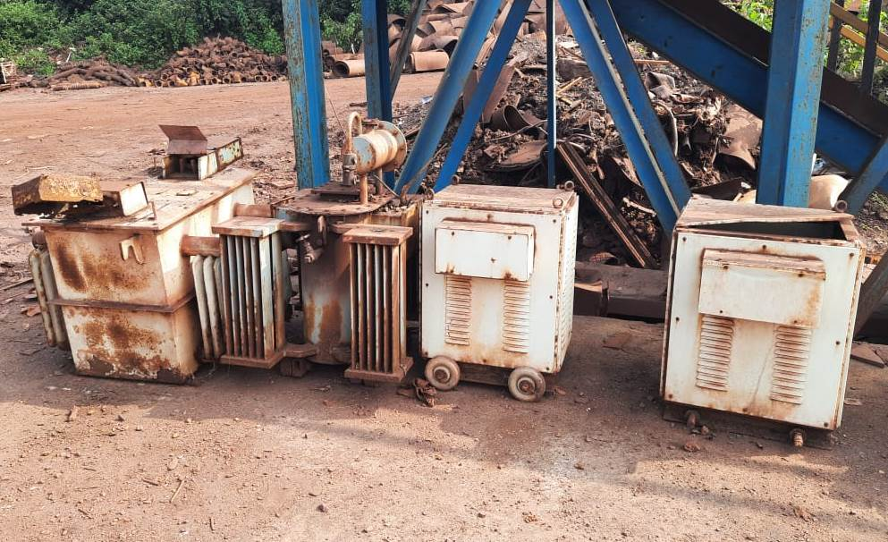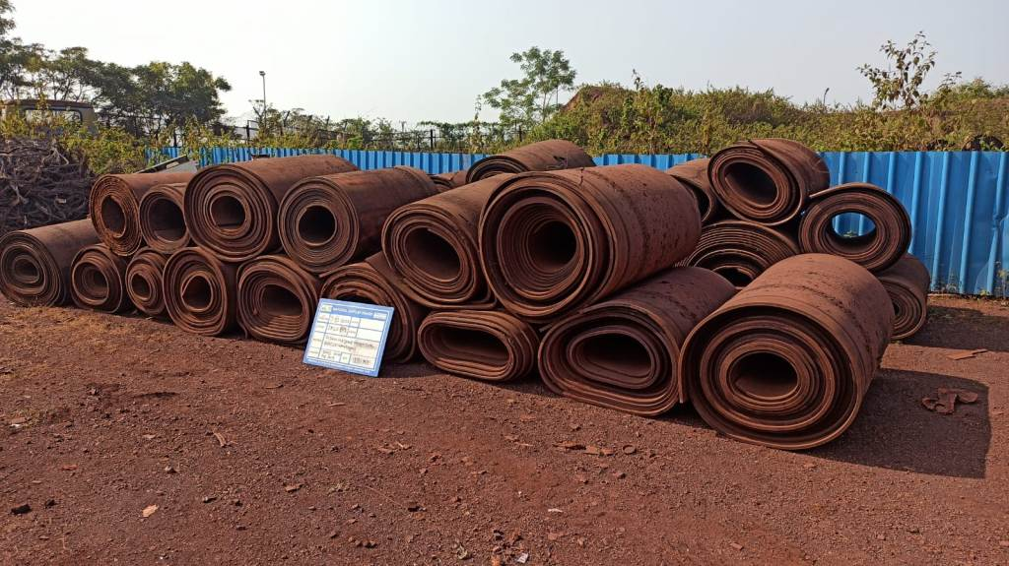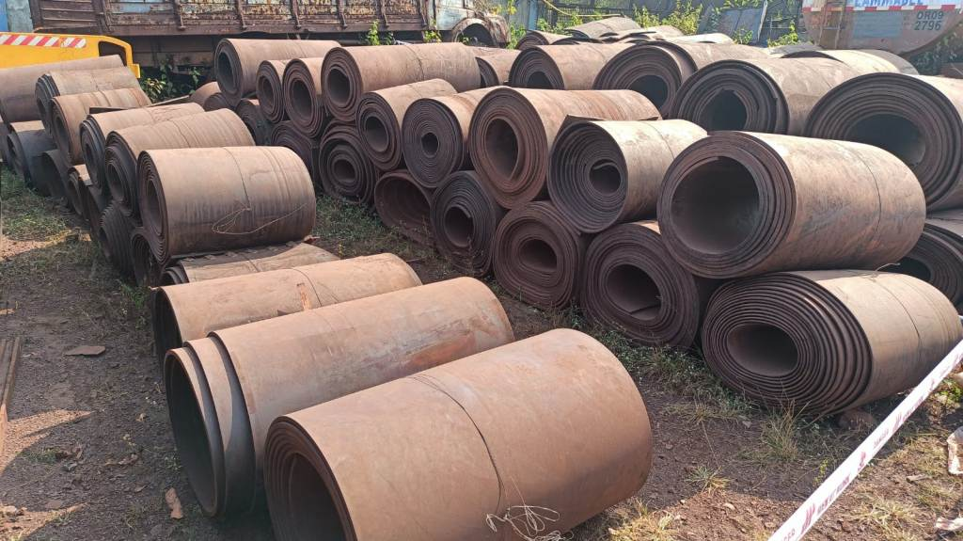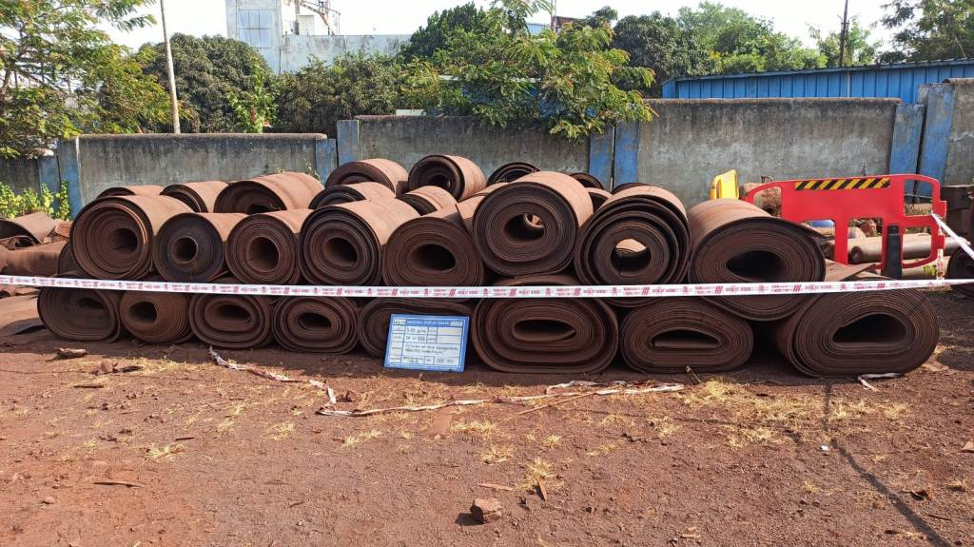
KIM-26-59 JIM-26-122 JIM-26-123 JIM-26-131
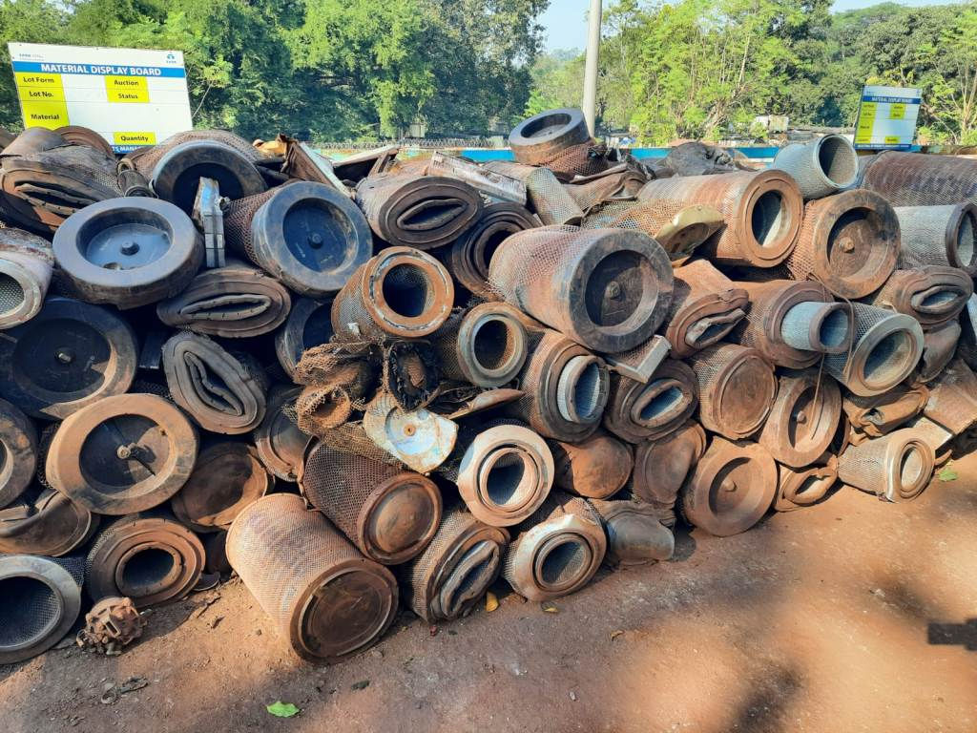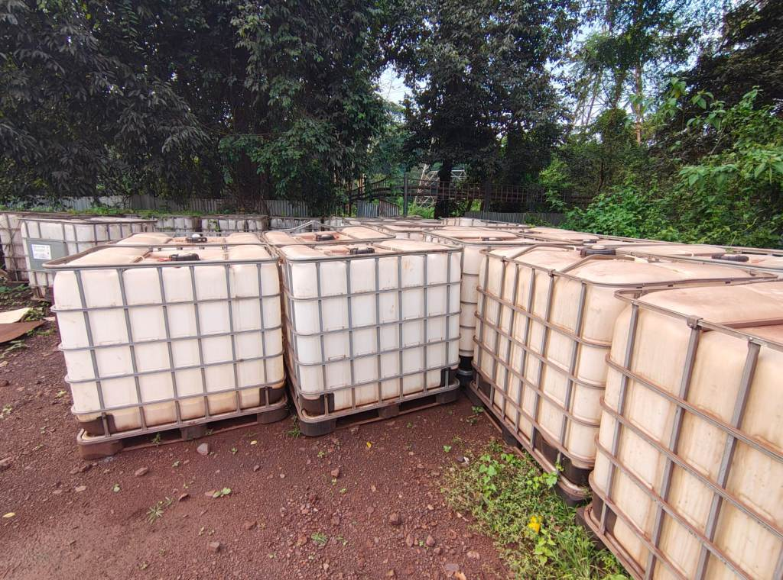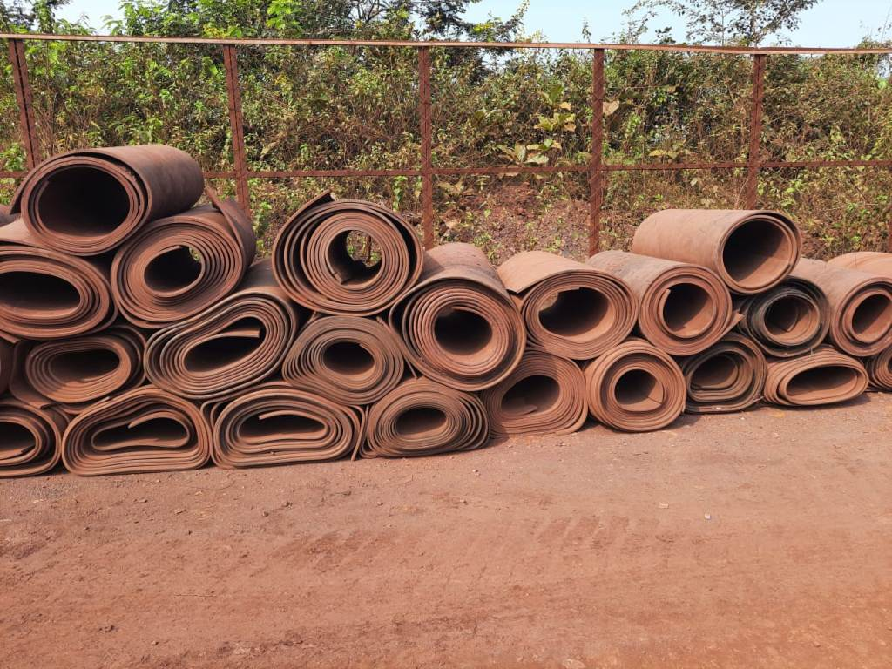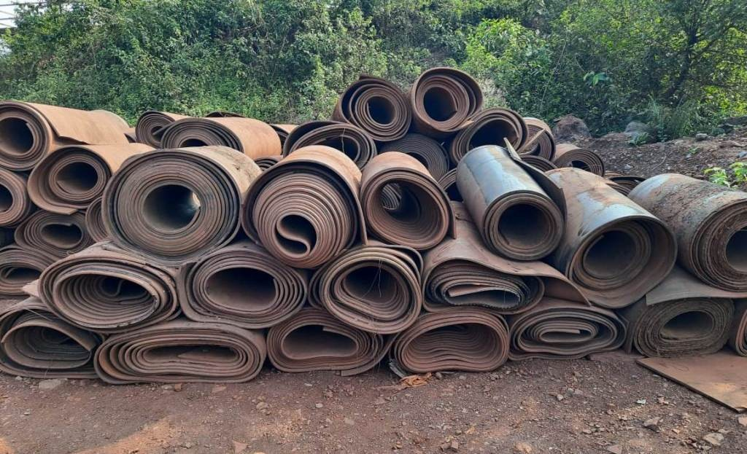
NIM-26-138 NIM-26-182 KIM-26-58 KIM-26-64

Open www.ahbilimoria.com ->Click on Customer Complaint Management Portal

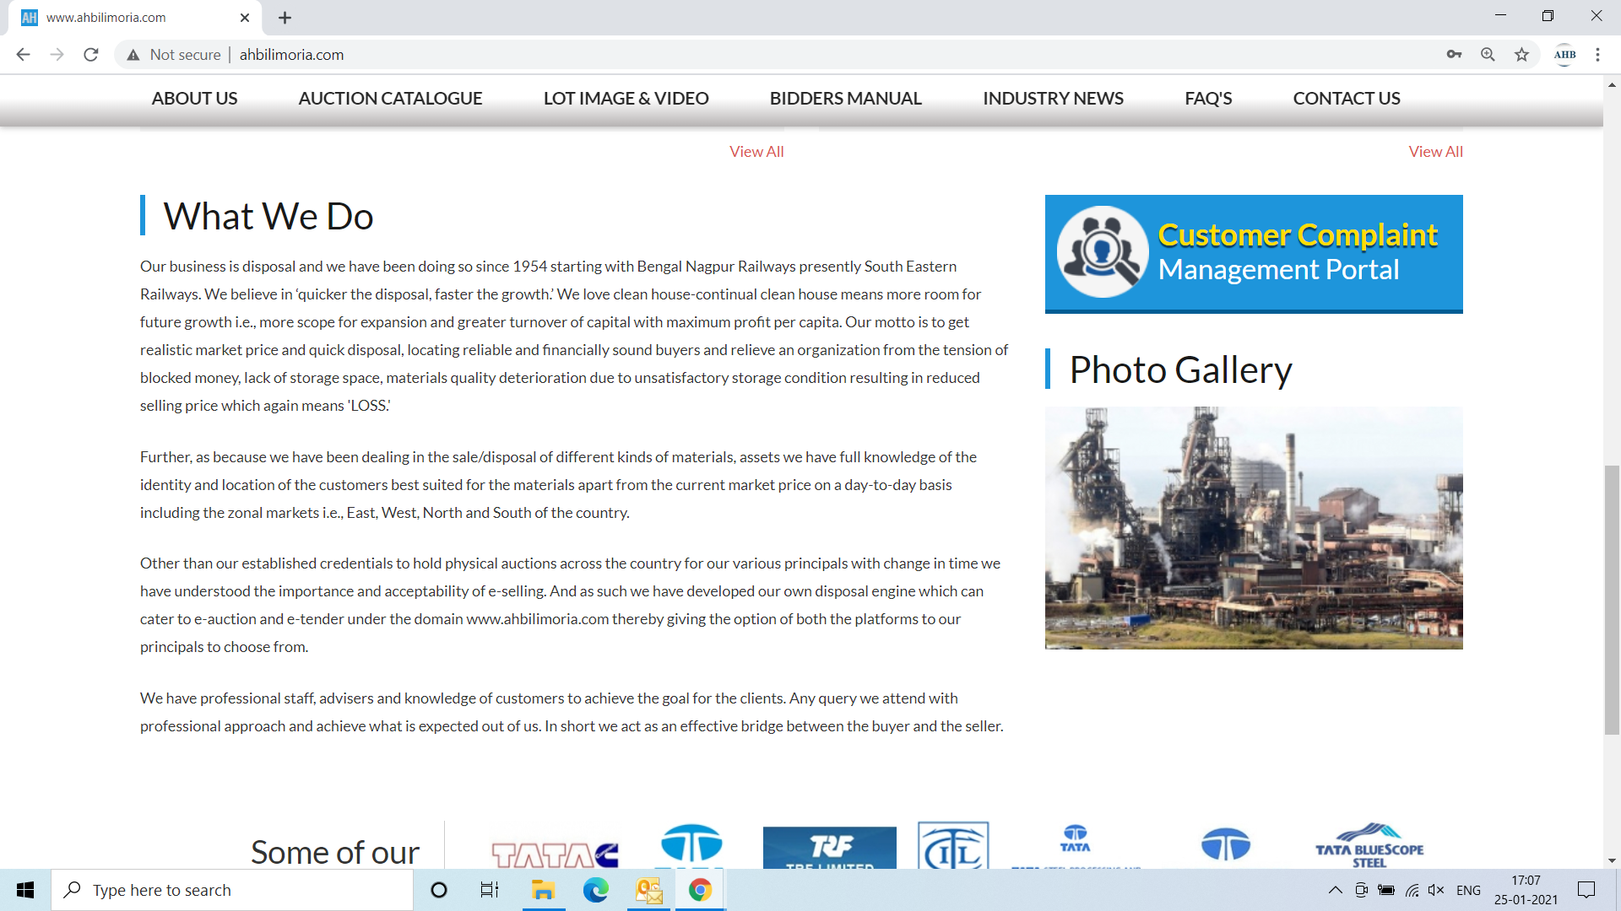

Use your User ID & Password for login

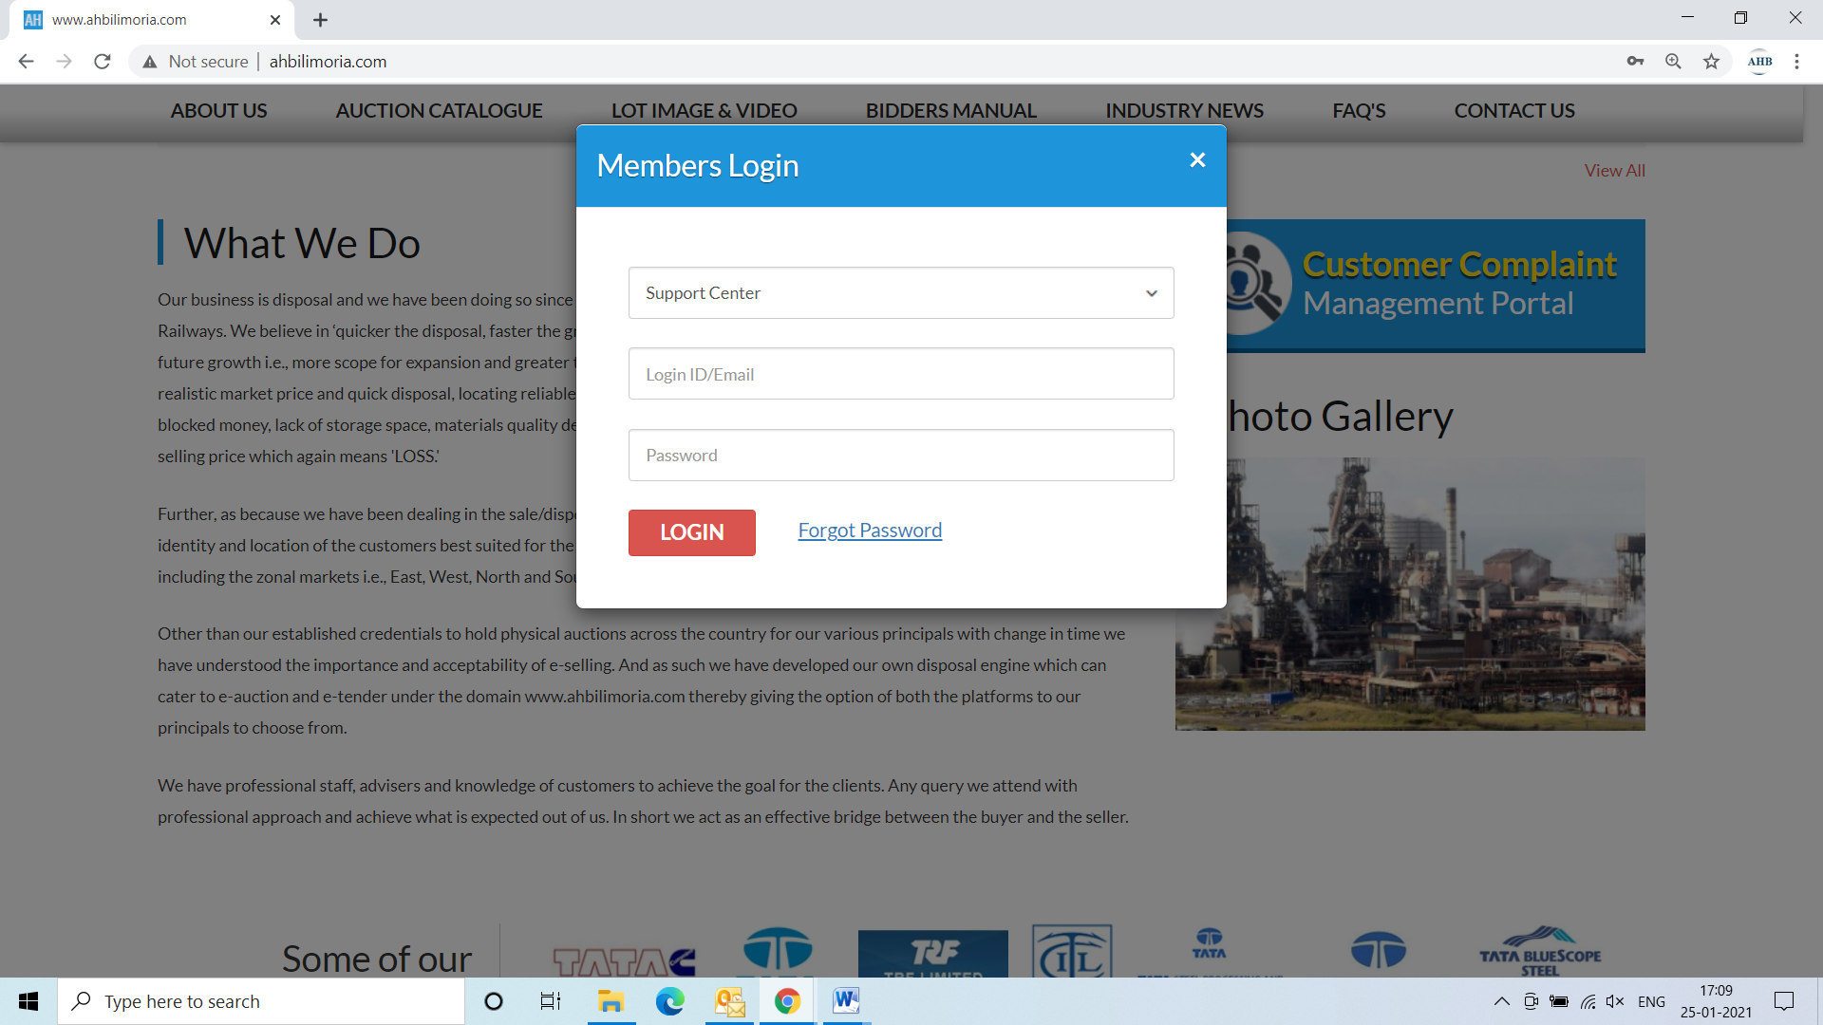

Click Complaint Portal-> Click on “Post a New Ticket”

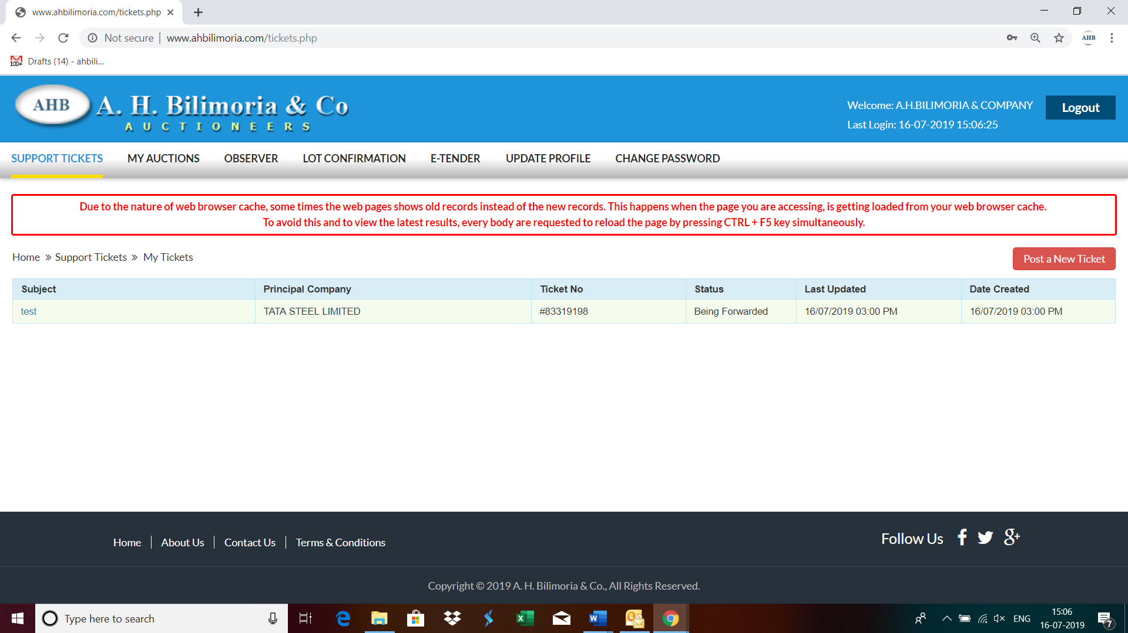

Post a New Ticket->Subject* ->Message* -> Email*->Principal Company*->Attach Document (If required any attachment) ->Submit

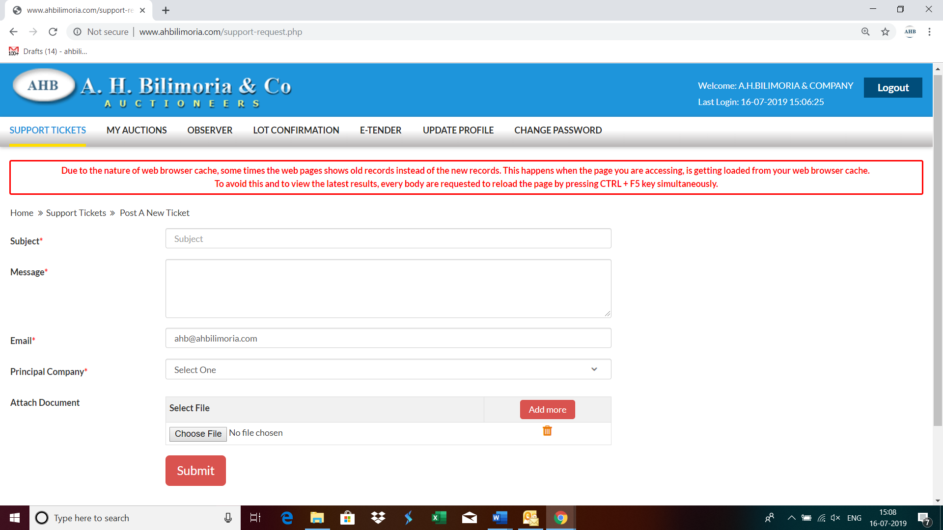

Your support request has been submitted successfully and the Reference No ----- is generated automatically

