**Auction Catalogue**

**Auction conducted by A H Bilimoria& Co.**

**Auction of Capital Items, Ramkrishna Forgings Limited & RAMKRISHNA CASTING SOLUTIONS LTD. , Adityapur, Jamshedpur, Jharkhand**

**BEING SOLD ON ‘’AS IS WHERE IS AND NO COMPLAINT BASIS’’**

|  |  |
| --- | --- |
| **Catalogue Serial Number:** | **RKFL/AHB/JUNE/001/25-26** |
| **Seller:** | Ramkrishna Casting Solutions Limited, Plant 1, [2](https://www.google.com/maps/search/1+:+Phase+1+Adityapur?entry=gmail&source=g), 4 & 6 Adityapur, Jamshedpur |
| **Auction website:** | [**www.ahbilimoria.com**](http://www.ahbilimoria.com) |
| **e-Auction Date & Time:** | **12th June, 2025…..….. at 03:00 PM** |
| **Inspection Date & Time:** | **No physical inspection to be conducted. Interested customers please visit our website for indicative lot photographs/video. For any assistance please call AHB (7991108353).** |
| Date of Security Money Deposit | **12th June, 2025 Till at 02:30 PM** |
| **Contact Details:** | |
| |  |  |  | | --- | --- | --- | | **For Post Auction @ A H Bilimoria & Company** | | | | **Area** | **Contact No.** | **Email Id** | | Auction Room | 07003840027/09883421336 | | | Lot Confirmation Related | 08987460668 | ahb@ahbilimoria.com, [ahbilimoria.company@gmail.com](mailto:ahbilimoria.company@gmail.com) | | Payment Related | 08987460668/09073711453 | ahb@ahbilimoria.com, [ahbilimoria.company@gmail.com](mailto:ahbilimoria.company@gmail.com), [ahbjsr@ahbilimoria.com, b.bhardwaj@ahbilimoria.com](mailto:ahbjsr@ahbilimoria.com,%20b.bhardwaj@ahbilimoria.com), [m.paul@ahbilimoria.com](mailto:m.paul@ahbilimoria.com), sukumar.chandra@ahbilimoria.com | | For time bound resolution of unresolved issues log into our Customer Complaint Management portal | Type in [www.ahbilimoria.com](http://www.ahbilimoria.com)> Go to “Customer Complaint Management Portal” >Log in with your user id and password and write the details of issue. | |   For Any unresolved issues beyond two (02) days mail to A H Bilimoria& Company :  Mr. A K Sil (M-09830074122) & Mr. D Pyne (M-09830738481), E-mail: [ahb@ahbilimoria.com](mailto:ahb@ahbilimoria.com), ahbilimoria.company@gmail.com | |

**SPECIAL NOTE: -It is the responsibility of the buyer to furnish the valid GST no. & necessary documents to A H Bilimoria & Company before participating in the auction. In case, during the transactions, it is found that valid GST no. has not been provided, then all necessary liabilities if any & so accrued would be on account of the buyer. Ramkrishna Forgings Limited/Ramkrishna Casting Solutions Ltd. & A H Bilimoria & Company would not be responsible for any such liabilities.**

**Note: RAMKRISHAN FORGINGS LIMITED /RAMKRISHNA CASTING SOLUTIONS LTD. Auto reserves the right to track IP address, MAC number and geolocation of bidding customers whenever customers participate**

**in any auction on the A H Bilimoria & Co. auction platform for Ramkrishna Forgings Limited.**

1. **Payment and Lifting Schedule:**

|  |  |  |  |  |  |
| --- | --- | --- | --- | --- | --- |
| **Lot No.** | **Payment Schedule** | | | **Lifting Schedule**  **(working days from the next day of DO release)** | |
| **EMD (10% of lot value)** | **1st installment** | **2nd installment** | **1st installment lifting days** | **2nd installment lifting days** |
| **For All Material** | **02 Working Days from Date of Lot Confirmation** | **02 Working Days from Date of EMD** | **03 Working Days from the 1st Installment date**  **[Only Applicable if material value (Rate X Tonnage) crosses Rs. 10 Lakh]** | **12 Working Days from the D/O date** | **03 Working Days at the expiry of 1st Installment DO validity.** |

1. **Suitable extension of due date for payment and lifting will be accorded only in case of any eventualities like Strike/ Bandh/ Special restriction on vehicular movement imposed by the local Administration etc.**
2. **Requirements of participation:**
   1. Registration: Before participation in the e-Auction, a prospective bidder shall be required to get registered with A H Bilimoria & Co. For details visit [www.ahbilimoria.com](http://www.ahbilimoria.com)
   2. Security Deposit: Non-Interest bearing security deposit of **Rs.60,000/- (Rupees Sixty thousand only)** in favour of **“A H Bilimoria & Co.”** through Online Payment only : Details as under :

|  |  |
| --- | --- |
| Beneficiary Name | A. H. BILIMORIA & COMPANY |
| Bank Name | HDFC Bank |
| Branch Name | 31, Chowringhee Road, Kolkata – 700016 |
| Account No | 06932560001205 |
| IFSC Code | HDFC0000693 |

1. **Inspection Rules & Policy**:

**No physical inspection to be conducted. Interested customers please visit our website for indicative lot photographs/video. For any assistance please call AHB (7991108353).**

1. **Bidding modalities:** 
   1. Price Bid Basis: In Indian rupees as per unit of measurement as given in Material List. **Price to be quoted is basic**, **ex- location exclusive of taxes and any other statutory levies**. **Dismantling unloading, shifting charges to be borne by customers**
   2. Bid Increment: **As specified in the e-auction bid page**
   3. Type of Auction: English No Ties
   4. Bid Validity: Bid shall be valid for **10** (Ten working days excluding Saturdays, Sundays and Bank holidays) working days counted from the next day of auction process in case of auction against a catalogue which is completed on the same day. And if it is continuing on any other day the counting of days for lot confirmation shall be from the next day of completion of entire auction process.
   5. Bid duration: For 1st four lots 20 minutes and balance lots 10 minutes. If, No bids received within these specified time the lots are closed automatically.
2. **Taxes & duties: (To be paid by Customers)**
   1. **GST : As applicable**
   2. **TCS: As applicable. In case of availing of concessional rate of TCS proper certificate issued by appropriate Income Tax authority are to be issued in favour of the Principal Company along with payment. Self-certification of Form no 27C is not acceptable.**
   3. **Any change in taxes applicable at the time of lifting shall be applicable.**
   4. **Customers are required to submit Form 27C/Form 27G against the month of dispatch/expected dispatches. In the absence of Form 27C, TCS will be charged at the time of invoicing.**
3. **Payment terms & conditions:**
   1. Payments: **PAYMENT FACILITY BY RTGS / NEFT ONLY**

|  |  |
| --- | --- |
| **Bank Details:** | |
| **Name** | **RAMKRISHNA CASTING SOLUTIONS LIMITED** |
| **Bank** | AXIS BANK LTD |
|  | CBB KOLKATA , Kolkata |
|  | Kolkata - 700071 |
| **Account No.** | 924030033025078 |
| **IFSC Code** | UTIB0001164 |

* 1. EMD: **10%** of the material value to be paid within **02 (Two)** working days from the date of lot confirmation. EMD to be adjusted in the final installment only. EMD payment is to be made within the time limit as given in letter of confirmation. No extension will be provided for the same.
  2. Balance Payment Time: (As per payment schedule)
  3. Saturdays (Only Bank Holidays) & Sundays are excluded for counting purpose for payment schedule.
  4. In the event of Non-Receipt of Payment within the stipulated period of Payment, the Sale Offer for the approved Lot shall stand withdrawn automatically (Refer Clause#8).
  5. Buyers have to send the payment deposit slip (UTR No /Scan Copy of NEFT/RTGS Transaction Slip) against Lot No. immediately after the payment to AHB at email id: [**ahb@ahbilimoria.com**](mailto:ahb@ahbilimoria.com)**& ahbilimoria.company@gmail.com**

1. **Lifting terms & conditions:**
   1. DOs will be handed over to authorized representatives of bidders on receipt of payment. Authorization letter to be issued via registered e-mail id’s. Authorized letter must be

Duly stamped and signed by the proprietor or partner or director on receipt of payment. Lifting date is calculated from the next day of DO Release date.

7.2 Loading Charges: **As mentioned in material list (Loading includes dismantling also wherever applicable)**

7.3 Loading shall be given strictly as per the statutory norms & safety norms of Ramkrishna Forgings Limited/ Ramkrishna Casting Solutions Ltd. .

7.4 **PICK & CHOOSE NOT ALLOWED FOR ANY OF THE LOTS.**

7.7 **LOT TRANSFER WILL NOT BE ALLOWED.**

1. **Penalty:**
   1. The following penalties shall be applicable in the eventuality of a buyer defaulting in making the payment of EMD (wherever applicable) or any installment/s, as per the stipulated schedule for each lot, in a financial year:

* In the first instance, a penalty of Rs. 2,00,000/- (Rupees Two lakh only) shall be recovered from the customer.
* In the second instance, a penalty of Rs. 2,50,000/- (Rupees Two Lakh Fifty thousand only) shall be recovered from the customer.
* In the third, and any subsequent instance, a penalty of Rs. 3,00,000/- (Rupees Three Lakh only) shall be recovered and the customer shall be debarred from participating in any auction for a period of three months from the date of debarment.

In the event of any default, the customer’s user id will be disabled and the customer will be blocked from participating in any auction of RKFL with immediate effect.

The defaulting customer shall be allowed 06 (six) working days to deposit the penalty as mentioned above. In case the penalty is not received within the stipulated period, the customer’s security deposit shall be forfeited, and the defaulting customer shall be immediately debarred from participating in any auction of RKFL.

* 1. **If after making payment of EMD (wherever applicable), the installment payment/s are not made by the customer as per the stipulated schedule for each lot, the entire EMD amount against such lot shall be forfeited.**
  2. **In case of non- lifting of full lot quantity after making full payment (as per schedule given by RKFL/Ramkrishna Casting Solutions Ltd. .), a penalty equivalent to 20% of the material value for the un-lifted quantity against each lot shall be recovered from the customer.**

1. **Lot Closure Norms :**

For Lot Closure, the tolerance would be site to clear and entire materials to be lifted.

1. **Refund :**

Refunds will only be made by Ramkrishna Forgings Limited/Ramkrishna Casting Solutions Ltd. vide RTGS/NEFT and hence all customers are required to submit their bank details to A H Bilimoria & Company or mail at ahb@ahbilimoria.com, [ahbilimoria.company@gmail.com](mailto:ahbilimoria.company@gmail.com), [ahbjsr@ahbilimoria.com, b.bhardwaj@ahbilimoria.com](mailto:ahbjsr@ahbilimoria.com,%20b.bhardwaj@ahbilimoria.com). Ramkrishna Forgings Limited or A H Bilimoria& Company will not be responsible for any delay in refunds owing to absence of bank details of the customer.

1. **Complaints :**

Complaints, if any, with regard to any transaction shall have to be lodged by the buyer within one calendar months from the date of last invoice. No complaint shall be entertained thereafter, under any circumstances. Customers can log their complaints at **(**[**www.ahbilimoria.com**](http://www.ahbilimoria.com)**> Go to “Customer Complaint Management Portal” >Log in with your user id and password and write the details of issue).**

1. **Jurisdiction :**

Any dispute arising out of any contract shall be decided in Adityapur by the courts in Saraikela-Kharsawan and by no other courts. The courts in Saraikela-Kharsawan shall have exclusive jurisdiction to adjudicate upon any such dispute.

1. **General terms & conditions:**
   1. Any dispute on quality & quantity of material and bid cancellation shall not be entertained at any point after the auction.
   2. All lots are offered/sold on “**As is where is Basis**” and “**No Complaint Basis**”
   3. Lot transfer will not be allowed. Payment and invoicing has to done in the name of the H1 bidder, subject to the prices being approved.
   4. Lot purchased should consist of material from the same lot and designated location only. Ramkrishna Forgings Limited and Ramkrishna Casting Solutions Ltd. has the right to check any vehicle at any moment of time. If material lifted differs from the material that is purchased by the buyer, then the buyer and authorized representative will be permanently debarred. Also Ramkrishna Forgings Limited and Ramkrishna Casting Solutions Ltd. can take any penal action against the buyer/authorized representative. All the material loaded in the vehicle is to be covered in order to follow the safety compliance of Ramkrishna Forgings Limited and Ramkrishna Casting Solutions Ltd. works.
   5. If the safety compliance is not followed, then Ramkrishna Forgings Limited and Ramkrishna Casting Solutions Ltd. can penalize the buyer / authorized representative as deemed fit.
   6. **Customer attested photocopy of valid id proof (Voter id/Aadhar/Pan card) of all lifters / Authorized persons engaged by customers for lifting of materials from**

**Ramkrishna Forgings Limited and Ramkrishna Casting Solutions Ltd. is to be enclosed with the authorization letters & to be forwarded to Ramkrishna Forgings Limited and Ramkrishna Casting Solutions Ltd. for issue of gate pass.**

* 1. **Dispatch is subject to FORCE MAJEURE conditions.**
  2. The seller reserves the right to terminate any offer at any point of time without assigning any reasons.
  3. In the event of termination of the offer, seller shall refund the balance amount after due reconciliation, within 7 days
  4. No claims whatsoever would be entertained on cancellation or after cancellation of the bid.

**14**. **Compliance to safety norms**

Authorized persons (of the customer) involved in lifting of the materials will be allowed entry, only with Personal Protective Equipment’s (PPE) i.e. Safety Shoes, Safety Helmet, Safety Goggles, Fluorescent Jacket and Hand Gloves, provided by RKFL/Ramkrishna Casting Solutions Ltd. . No "people movement" shall be allowed at the time of loading/delivery of materials from the yards" Ramkrishna Forgings Limited will not be responsible for any delays arising out of Non- Compliance to the Safety Norms.

**15. DISCLAIMER FOR E-AUCTION**

BANDWIDTH PROBLEMS, CONNECTIVITY PROBLEMS WITH THE LOCAL ISP (INTERNET SERVICE PROVIDER), SLOWNESS TO ACCESS PAGES FOR DOWNLOADING ETC. ARE BEYOND THE CONTROL OF RAMKRISHNA FORGINGS LIMITED LTD/Ramkrishna Casting Solutions Ltd. . AND A H BILIMORIA & COMPANY. HENCE NO RESPONSIBILITY LIES WITH RAMKRISHNA FORGINGS LIMITED LTD/Ramkrishna Casting Solutions Ltd. . OR A H BILIMORIA & COMPANY FOR THE ABOVE PROBLEMS FACED, IF ANY, BY THE BIDDERS BEFORE/DURING THE AUCTION ANY. BID PLACED USING THE BIDDER'S USERNAME AND PASSWORD IS UNCONDITIONALLY BINDING ON THE BIDDER TO WHOM SUCH USERNAME AND PASSWORD HAD BEEN ALLOTTED AND HE SHALL BE SOLELY RESPONSIBLE FOR MAINTAINING THE CONFIDENTIALITY OF THE SAME AND FULLY RESPONSIBLE FOR ALL ACTIVITIES THAT OCCUR UNDER THEIR USERNAME AND PASSWORD. HENCE THE USER IS ADVISED TO CHECK THE USERNAME AND PASSWORD BEFORE THE AUCTION, IN ORDER TO FAMILIARISE HIMSELF WITH THE SAME AND IS ADVISED NOT TO REVEAL IT TO ANYONE ELSE SO AS TO PREVENT MISUSE OF THE SAME. THE BIDS MADE BY THE BIDDERS AGAINST THEIR USERNAME AND PASSWORD SHALL BE IRREVOCABLE.THE BIDDERS ARE ADVISED TO REGISTER AND PRE-QUALIFY FOR BIDDING WELL IN ADVANCE AND PLACE THEIR BIDS EARLY IN ORDER TO TAKE CARE OF ANY UNFORESEEN TECHNICAL DIFFICULTY THAT MIGHT SURFACE IN THE INTERNET OPERATIONS.

**Lot Photograph: Photographs of lots are at best indicative only and do not necessarily reflect the actual condition of lots. All bidders are advised to physically inspect the offered lots before participating in the auctions. Ramkrishna Forgings Limited/Ramkrishna Casting Solutions Ltd. or A H Bilimoria & Co. shall not be responsible or liable for any error of judgment or bids put by bidders acting on the basis of these photographs.**

**Quantity offered is based on eye estimation. Delivery will be made for the estimated quantity or actual ground stock. Estimation error may arise. No complaint of whatsoever nature on estimated /offered quantity shall be entertained under any circumstances. Bidders are advised to make their own judgment on offered quantity before bidding.**

**Please note: Any damage incurred by way of accident to property/person during dismantling and loading of the material shall be the liability of the Customer and all incidental costs of such damage shall be borne by the Customer.**

**MATERIAL DETAILS: AS PER ANNEXURE:**

|  |  |  |  |  |  |  |  |  |  |  |  |
| --- | --- | --- | --- | --- | --- | --- | --- | --- | --- | --- | --- |
| **Sl. No.** | **Location** | **Lot no.** | **Material Description** | **Qty** | **UOM** | **GST** | **TCS** | **Loading** | **LIFTING PERIOD** | **Contact person** | **Contact no** |
| **1** | Ramkrishna Casting Solutions Limited, Plant 1, [2](https://www.google.com/maps/search/1+:+Phase+1+Adityapur?entry=gmail&source=g), 4 & 6 Adityapur, Jamshedpur | **RKCL250501** | **Boring Scrap** | **200** | **MT** | **18%** | **1%** | **Loading by customer** | **20 Working Days from the D/O date** | **Mr. Om Prakash Singh** | **8404901179** |
| **2** | Ramkrishna Casting Solutions Limited, Plant 1, [2](https://www.google.com/maps/search/1+:+Phase+1+Adityapur?entry=gmail&source=g), 4 & 6 Adityapur, Jamshedpur | **RKCL250502** | **Boring Bundle** | **200** | **MT** | **18%** | **1%** | **Loading by customer** | **20 Working Days from the D/O date** | **Mr. Om Prakash Singh** | **8404901179** |

**ALL THE PHOTOGRAPHS ARE INDICATIVE ONLY**

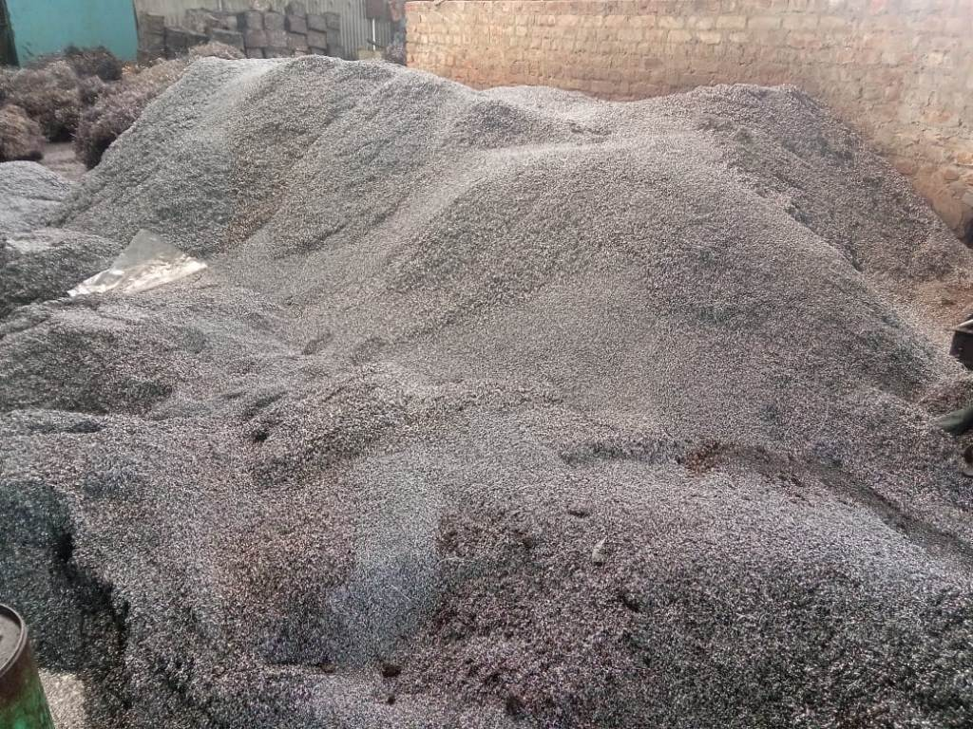 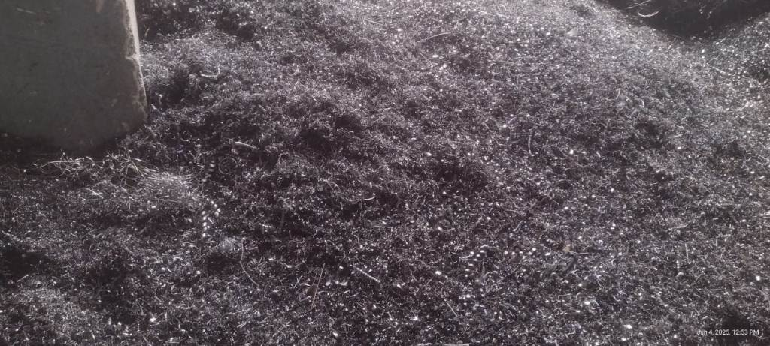 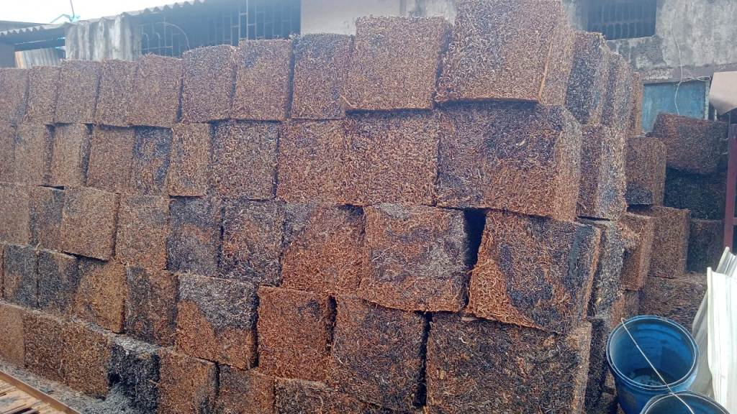 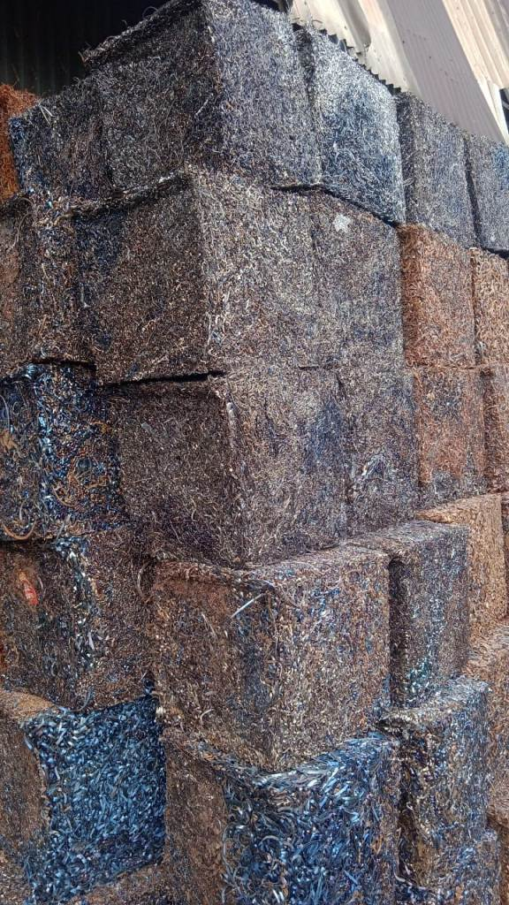

**Boring Scrap Boring Scrap Boring Bundle Boring Bundl**

**Open** [**www.ahbilimoria.com**](http://www.ahbilimoria.com) **->Click on Customer Complaint Management Portal**

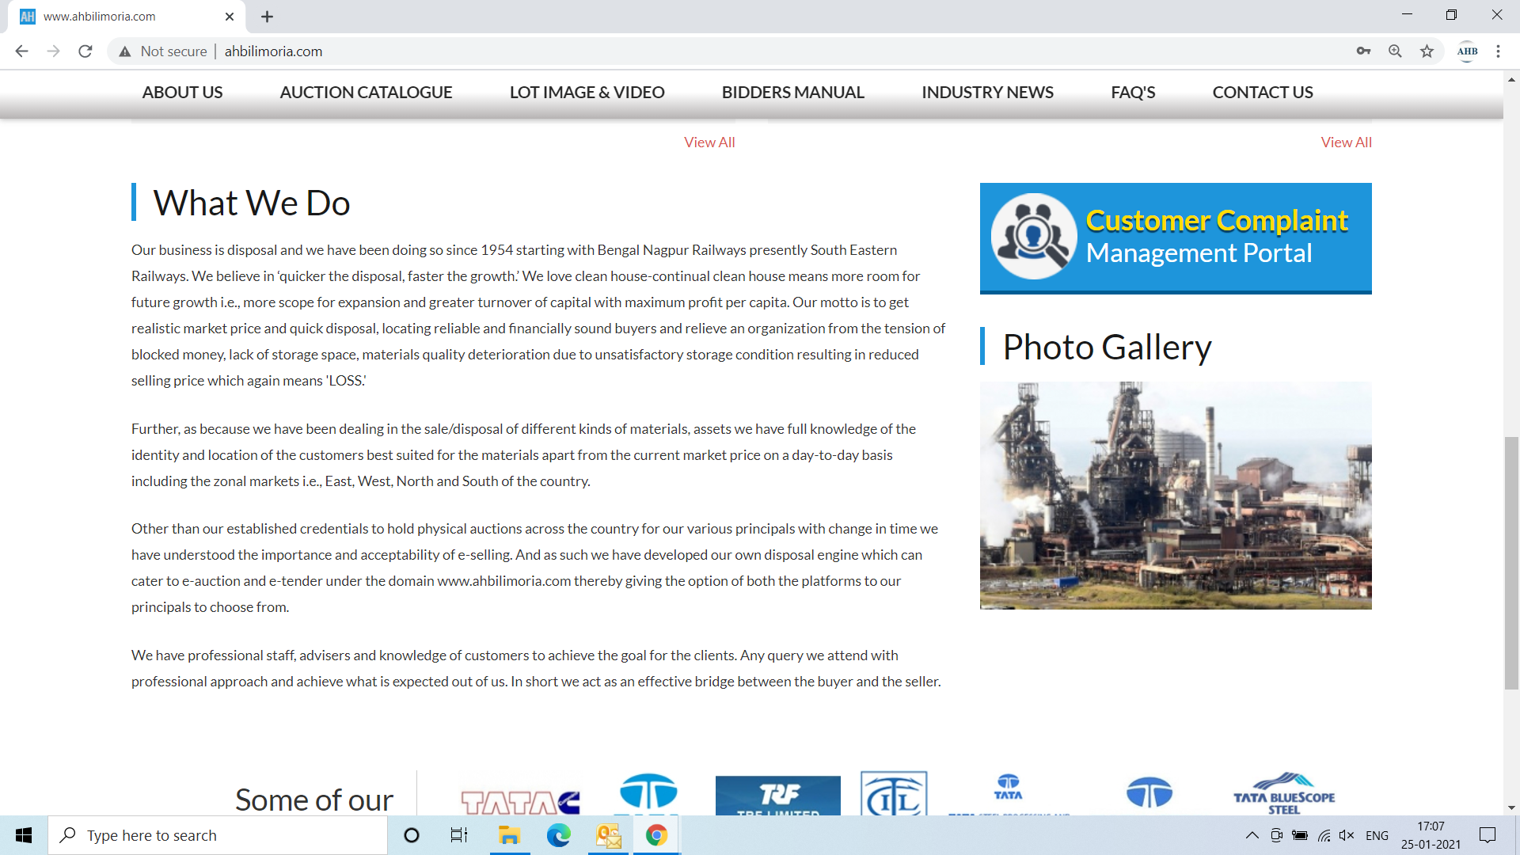

**Use your User ID & Password for login**

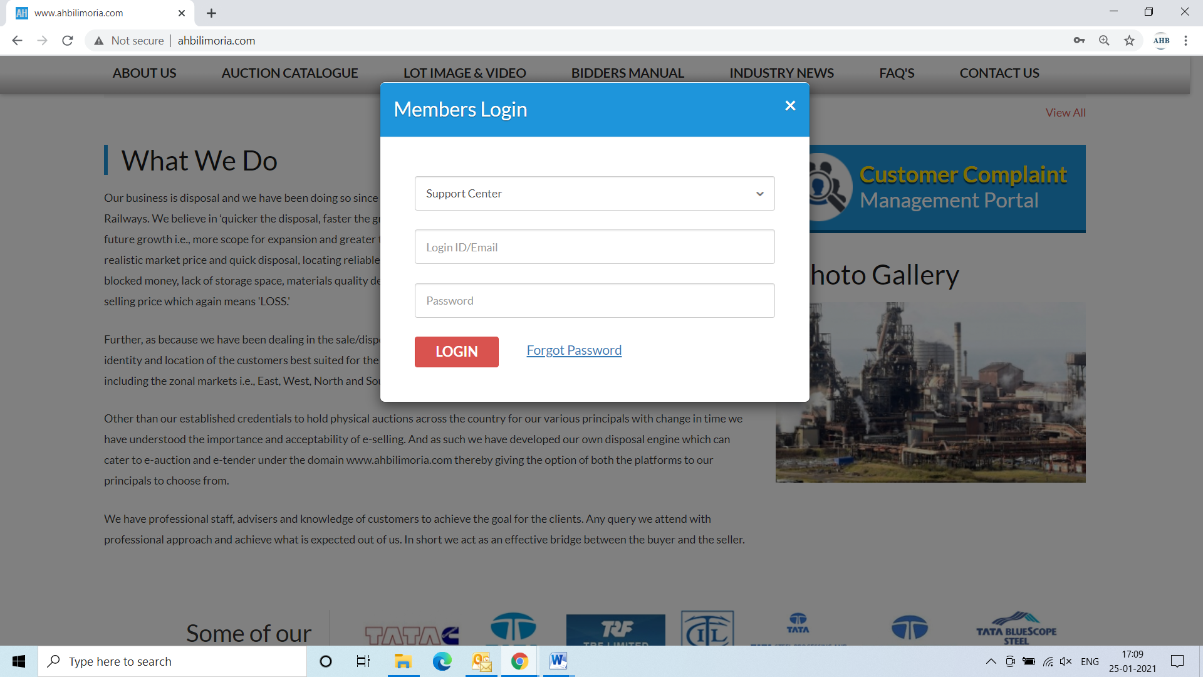

**Click Complaint Portal-> Click on “Post a New Ticket”**

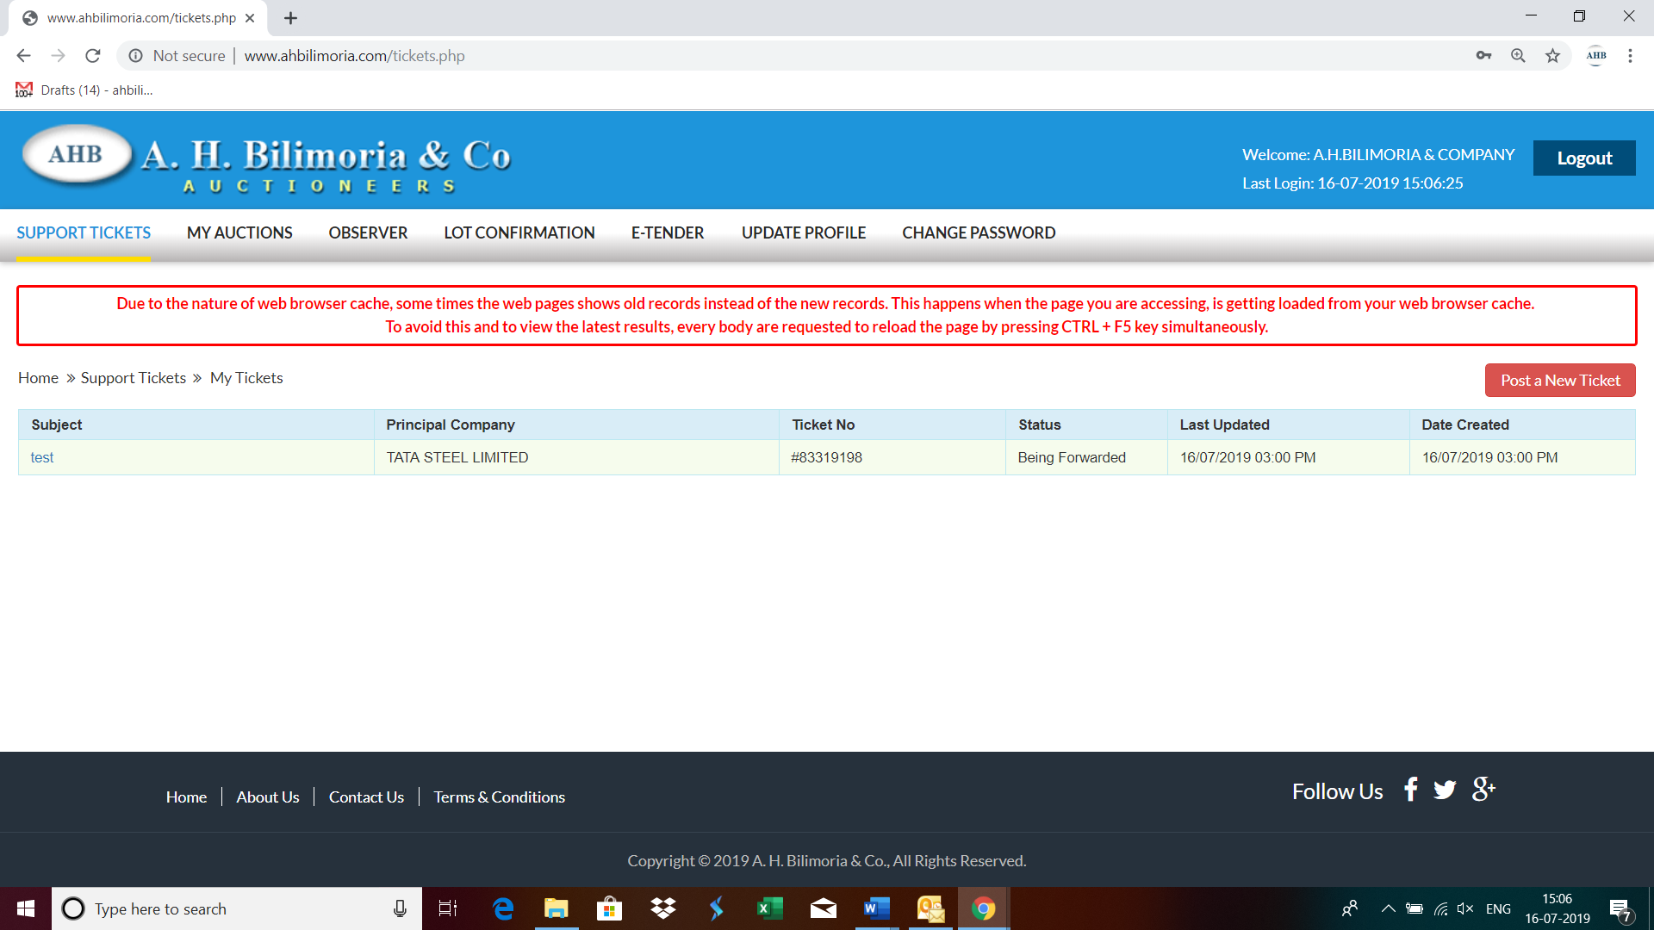

**Post a New Ticket->Subject* ->Message* -> Email*->Principal Company*->Attach Document (If required any attachment) ->Submit**

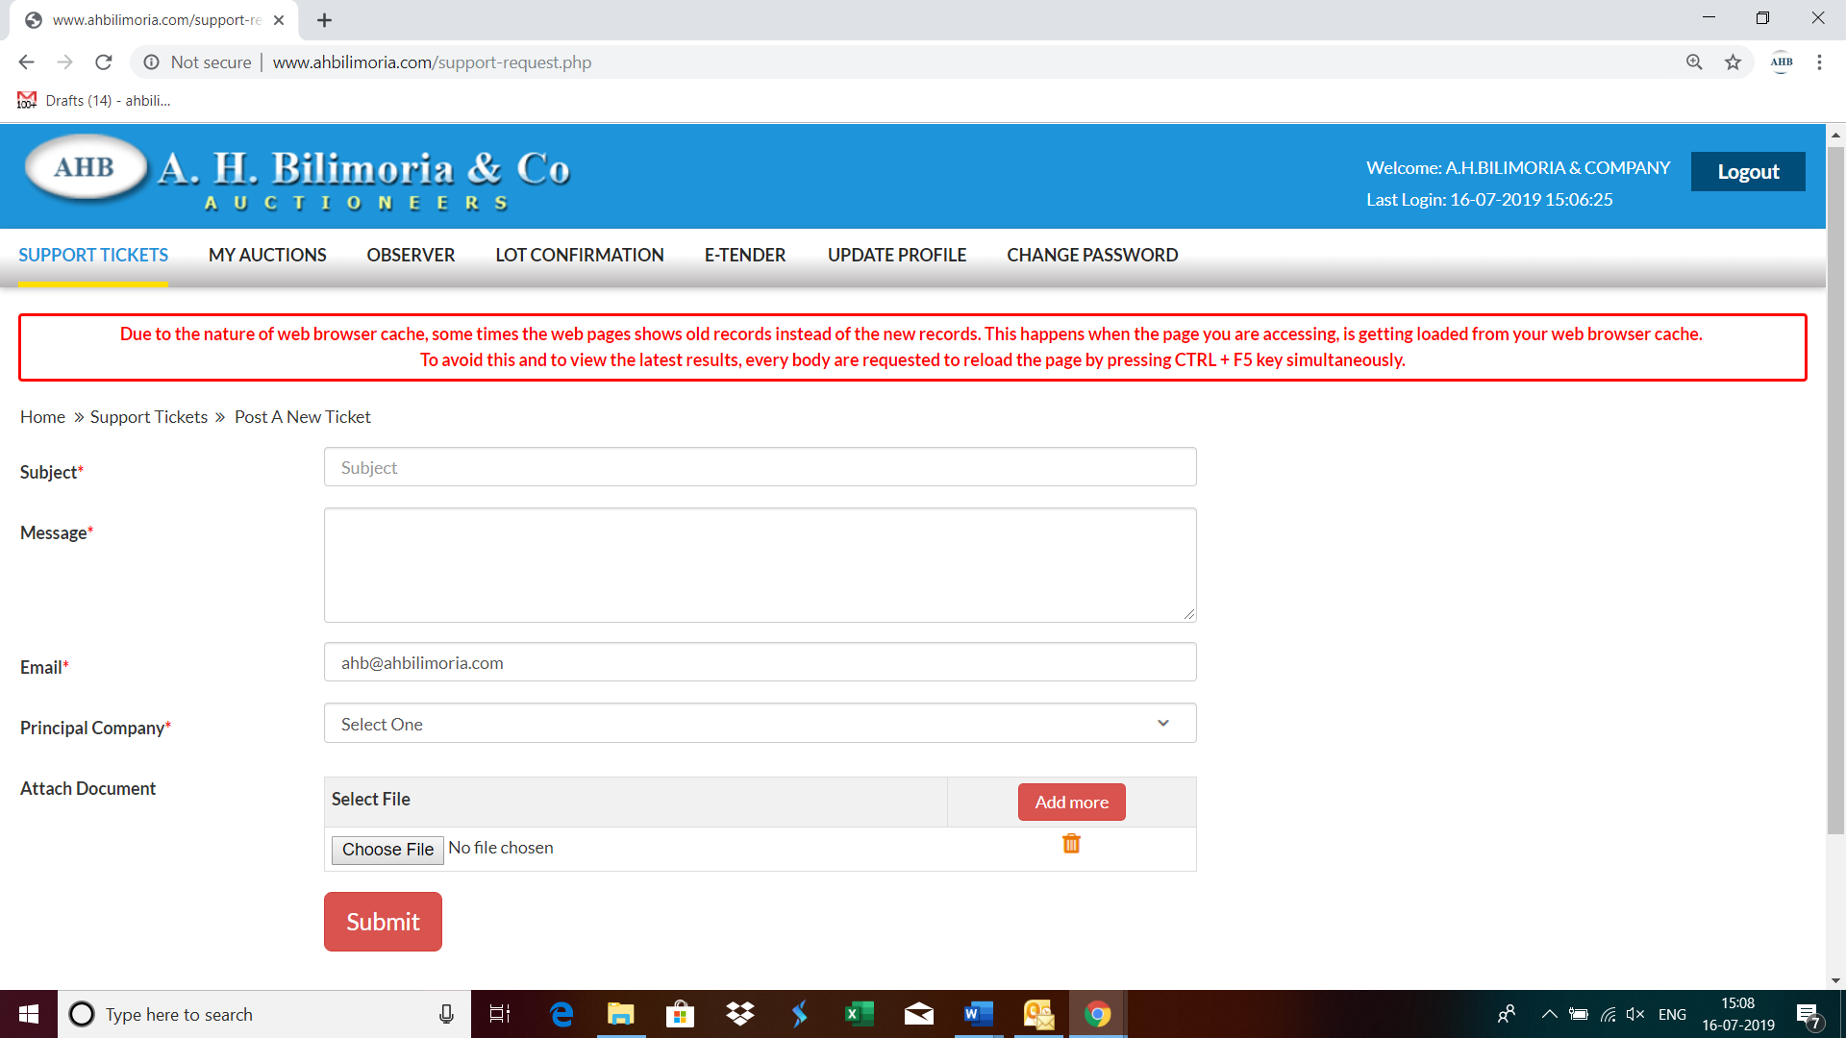

**Your support request has been submitted successfully and the Reference No ----- is generated automatically**

