Auction Catalogue
Auction conducted by A H Bilimoria & Co.
Auction of Capital & Misc Items, Tata Steel - Bearing Div, Kharagpur
BEING SOLD ON ‘’AS IS WHERE IS AND NO COMPLAINT BASIS’’

Catalogue Serial Number: | TATA STEEL - BEARING DIVISION/KHARAGPUR/OCTOBER/006/25-26
Seller: | Tata Steel Ltd. – Bearing Division
Auction website: | www.ahbilimoria.com
e-Auction Date & Time: | 22nd October, 2025…..….. at 02:30 PM
Inspection Date & Time: | 21st October, 2025: At 09:30AM ---- Interested customers should reach at the main gate of TATA STEEL BEARING DIVISION, Kharagpur by 9.00 a.m. sharp / No extension of time for Inspection will be allowed.  Interested bidders have to come with safety shoes, safety fluorescent jackets and safety helmets as per TSL Bearing Div. norms at the time of inspection.
Date of Security Money Deposit | 22nd October, 2025 Till ……… 02:00 PM
Contact Details:
For Post Auction @ A H Bilimoria & Company
Area | Contact No. | Email Id
Auction Room | 033-22294833, 22296577
Lot Confirmation Related | 033-22294833, 22296577 | ahb@ahbilimoria.com, ahbilimoria.company@gmail.com
Payment Related | 033-22294833, 22296577 | ahb@ahbilimoria.com, ahbilimoria.company@gmail.com, ahbjsr@ahbilimoria.com, b.bhardwaj@ahbilimoria.com, m.paul@ahbilimoria.com, sukumar.chandra@ahbilimoria.com
Delivery Order Related | 033-22294833, 22296577 | ahb@ahbilimoria.com, ahbilimoria.company@gmail.com, ahbjsr@ahbilimoria.com, b.bhardwaj@ahbilimoria.com, m.paul@ahbilimoria.com, sukumar.chandra@ahbilimoria.com
Material Value Refund Related | 033-22294833, 22296577 | ahb@ahbilimoria.com, ahbilimoria.company@gmail.com, ahbjsr@ahbilimoria.com, b.bhardwaj@ahbilimoria.com, m.paul@ahbilimoria.com, sukumar.chandra@ahbilimoria.com
Refund Related | 033-22294833, 22296577 | ahb@ahbilimoria.com, ahbilimoria.company@gmail.com, ahbjsr@ahbilimoria.com, b.bhardwaj@ahbilimoria.com, m.paul@ahbilimoria.com, sukumar.chandra@ahbilimoria.com
TCS Related | 033-22294833, 22296577 | ahb@ahbilimoria.com, ahbilimoria.company@gmail.com, ahbjsr@ahbilimoria.com, b.bhardwaj@ahbilimoria.com, m.paul@ahbilimoria.com,sukumar.chandra@ahbilimoria.com,
Payment Deviation/Disablement in Tata Steel-Bearing Div. | 033-22294833, 22296577 | ahb@ahbilimoria.com, ahbilimoria.company@gmail.com,ahbjsr@ahbilimoria.com, b.bhardwaj@ahbilimoria.com,m.paul@ahbilimoria.com, sukumar.chandra@ahbilimoria.com
Collection of Delivery Order-Tata Steel | 033-22294833, 22296577 | ahb@ahbilimoria.com, ahbilimoria.company@gmail.com, ahbjsr@ahbilimoria.com, b.bhardwaj@ahbilimoria.com, m.paul@ahbilimoria.com, sukumar.chandra@ahbilimoria.com
Collection of Delivery Order for Tata Steel Kalinganagar | 9664062791/7665242742 | ahb@ahbilimoria.com, ahbilimoria.company@gmail.com, ahbjsr@ahbilimoria.com, b.bhardwaj@ahbilimoria.com, m.paul@ahbilimoria.com, sukumar.chandra@ahbilimoria.com, m.k.bal1994@gmail.com
For time bound resolution of unresolved issues log into our Customer Complaint Management portal | Type in www.ahbilimoria.com> Go to “Customer Complaint Management Portal” >Log in with your user id and password and write the details of issue.

For Any unresolved Issues beyond two (02) days mail to A H Bilimoria & Company :

Mr. A K Sil (M-09830074122) & Mr. D Pyne (M-09830738481), E-mail: ahb@ahbilimoria.com, ahbilimoria.company@gmail.com
Copy to Tata Steel - Bearing Division: Mr. Ravishankar Dubey (M- 7667690148/9046005255), E-mail: ravishankar.dubey@tatasteel.com
SPECIAL NOTE: -It is the responsibility of the buyer to furnish the valid GST no. & necessary documents to A H Bilimoria & Company before participating in the auction. In case during the transactions, it is found that valid GST no. has not been provided, then all necessary liabilities if any & so accrued would be on account of the buyer. Tata Steel-Bearing Div. & A H Bilimoria & Company would not be responsible for any such liabilities.

Note: Tata Steel-Bearing Div. reserves the right to track IP address, MAC number and geolocation of bidding customers whenever customers participate in any auction on the A H Bilimoria & Co. auction platform for Tata Steel-Bearing Div.
- Payment and Lifting Schedule:

Lot No. | Payment Schedule |  |  | Lifting Schedule  (working days from the next day of DO release)
Lot No. | EMD | 1st installment | 2nd installment | 1st installment lifting days | 2nd installment lifting days
For All Mat  erial | 02 Working days from Date of Lot Confirmation | 03 Working Days From Date of EMD | 03 Working Days from the 1st Installment date  [Only Applicable if material value (Rate X Tonnage) crosses Rs. 10 Lakh] | As per material list | As per material list

- Suitable extension of due date for payment and lifting will be accorded in case of any eventualities like Strike/ Bandh/ Special restriction on vehicular movement imposed by the local Administration etc.

- Requirements of participation:
  - Registration: Before participation in the e-Auction, a prospective bidder shall be required to get registered with A H Bilimoria & Co. For details visit www.ahbilimoria.com

  - Security Deposit: Non-Interest bearing security deposit of Rs. 60,000/- (Rupees Sixty thousand only) in favour of “A H Bilimoria & Co.” through Online Payment only : Details as under :

Beneficiary Name | A. H. BILIMORIA & COMPANY
Bank Name | HDFC Bank
Branch Name | 31, Chowringhee Road, Kolkata – 700016
Account No | 6932560001205
IFSC Code | HDFC0000693

Account No: All the customers will have a unique account number. The unique account number is an alpha numeric code consisting of 12 characters. The Customer’s unique “account number” is a combination of the AHB’ SAP code along with the 6 digit bidder SAP ID and can be used as reference. for all subsequent transactions. The Customer’s Account Number detail is available in “Profile” after the customer logs into our website using the user id and password.

- Inspection Rules & Policy:
09th July, 2025: At 09:30AM ---- Interested customers should reach at the main gate of TATA STEEL BEARING DIVISION, Kharagpur by 9.00 a.m. sharp / No extension of time for Inspection will be allowed.
Interested bidders have to come with safety shoes, safety fluorescent jackets and safety helmets as per TSL Bearing Div. norms at the time of inspection.

- Bidding modalities:
  - Price Bid Basis: In Indian rupees as per unit of measurement as given in Material List. Price to be quoted is basic, ex- location exclusive of taxes and any other statutory levies.
  - Bid Increment: As specified in the e-auction bid page
  - Type of Auction: English No Ties
  - Bid Validity: Bid shall be valid for 10 (Ten working days excluding Saturdays, Sundays and Bank holidays)working days counted from the next day of auction process in case of auction against a catalogue which is completed on the same day. And if it is continuing on any other day the counting of days for lot confirmation shall be from the next day of completion of entire auction process.
  - Bid duration: For 1st four lots 20 minutes and balance lots 10minutes. If, No bids received within these specified time the lots are closed automatically.

- Taxes & duties:
  - GST : As applicable
  - TCS : As applicable. In case of availing of concessional rate of TCS proper certificate issued by appropriate Income Tax authority are to be issued in favour of the Principal Company along with payment. Self certification of Form no 27C is not acceptable.
  - Any change in taxes applicable at the time of lifting shall be applicable.
  - Customers are required to submit Form 27C/Form 27G against the month of dispatch/expected dispatches. In the absence of Form 27C, TCS will be charged at the time of invoicing.

- Payment terms & conditions :
  - Payments: PAYMENT FACILITY BY RTGS / NEFT ONLY : All Payment to be deposited through the HDFC Virtual Account only.
If the Customer does not have the HDFC Virtual Account no., the same needs to be created through Accounts.
  - EMD: 10% of the material value to be paid within 02 (Two) working days from the date of lot confirmation. EMD to be adjusted in the final installment only.
EMD payment is to be made within the time limit as given in letter of confirmation. No extension will be provided for the same.
  - Balance Payment Time: (As per payment schedule)
  - Delayed Payment Charges (DPC) : Installment payments with DPC @ five (05) paise per Rs. 100 per day will be accepted up to 4 (Four) working days from due date of installment payment as mentioned in the confirmation letter. This is not applicable for EMD payment.
  - Saturdays(only Bank Holidays)& Sundays are excluded for counting purpose for payment schedule.
  - In the event of Non-Receipt of Payment within the stipulated period of Payment, the Sale Offer for the approved Lot shall stand withdrawn automatically (Refer Clause#8).
  - Buyers have to send the payment deposit slip (UTR No /Scan Copy of NEFT/RTGS Transaction Slip) against Lot No. immediately after the payment to AHB at email id: ahb@ahbilimoria.com & ahbilimoria.company@gmail.com

- Lifting terms & conditions:
7.1 DOs will be handed over to authorized representatives of bidders on receipt of payment. Authorization letter to be issued via registered e-mail id’s. Authorized letter must be duly stamped and signed by the proprietor or partner or director on receipt of payment. Lifting date is calculated from the next day of DO Release date.
7.2 Loading Charges: As mentioned in material list
7.3 Loading shall be given strictly as per the statutory norms & safety norms of Tata Steel-Bearing Div. Ltd.
7.4 Lifting with Ground Rent: Lifting along with ground rent will be allowed up to 4 (four) working days from the last date of lifting period. In case the lifting is not complete, and no request is made by the customer within the period of four days, the company reserves the right to close the lot, and refund the balance to the party after deducting for any shortfall in lifting as per norms laid down in the catalogue. Ground Rent will be calculated on balance unlifted quantity @ 05 paise (inclusive of tax) per Rs.100/- per day
7.5 Additional lifting days for advance payment of installment - If the installment payment is made in advance, then additional lifting days (equivalent to the number of days payment made in advance) would be given. This would not be applicable for EMD payment.
7.6 PICK & CHOOSE NOT ALLOWED FOR ANY OF THE LOTS.

7.7 LOT TRANSFER WILL NOT BE ALLOWED.

7.8 Process for transfer of ownership of vehicles sold in auction: Customer shall submit their authorization letter to AHB. AHB will hand over the same to SCMC with a forwarding letter along the authenticated DO copy. AHB will collect the ownership papers from SCMC for handing over to the customer for applying for transfer of ownership in DTO’s office. After transfer of ownership, the customer will show the approach SCMC to collect the delivery advice for the vehicle. AHB will arrange the gate pass for the customer to visit SCMC.

- Penalty:
  - The following penalties shall be applicable in the eventuality of a buyer defaulting in making the payment of EMD (wherever applicable) or any installment/s, as per the stipulated schedule for each lot, in a financial year:
- In the first instance, a penalty of Rs. 2,00,000/- (Rupees Two lakhs only) shall be recovered from the customer.
- In the second instance, a penalty of Rs.100,000/- (Rupees One Lakh only) shall be recovered from the customer.
- In the third, and any subsequent instance, a penalty of Rs.150,000/-(Rupees One Lakh Fifty thousand only) shall be recovered and the customer shall be debarred from participating in any auction for a period of three months from the date of debarment.
In the event of any default, the customer’s user id will be disabled and the customer will be blocked from participating in any auction of Tata Steel-Bearing Div. with immediate effect.

The defaulting customer shall be allowed 06 (six) working days to deposit the penalty as mentioned above. In case the penalty is not received within the stipulated period, the customer’s security deposit shall be forfeited, and the defaulting customer shall be immediately debarred from participating in any auction of Tata Steel-Bearing Div.

  - If after making payment of EMD (wherever applicable), the installment payment/s are not made by the customer as per the stipulated schedule for each lot, the entire EMD amount against such lot shall be forfeited.

  - In case of non- lifting of full lot quantity after making full payment, a penalty equivalent to 20% of the material value for the un-lifted quantity against each lot shall be recovered from the customer.

- Lot Closure Norms :
For Lot Closure, the tolerance would be ± 20% of the original quantity. Actual Lot Quantity may vary by +/- 20% from the indicated Qty for the Arising . a) In the event of the Lot Quantity lower than 80% due to no generation of the Scrap, the actual Qty available shall be provided. b) If the total Arising Qty. is HIGHER than 20% of the Lot Qty. then the Lot qty. increase shall be done with Management approval.

- Refund :
Refunds will only be made by Tata Steel-Bearing Div. vide RTGS/NEFT and hence all customers are required to submit their bank details to A H Bilimoria & Company or mail at ahb@ahbilimoria.com, ahbilimoria.company@gmail.com, ahbjsr@ahbilimoria.com, b.bhardwaj@ahbilimoria.com. Tata Steel-Bearing Div. or A H Bilimoria & Company will not be responsible for any delay in refunds owing to absence of bank details of the customer.

- Complaints :
Complaints, if any, with regard to any transaction shall have to be lodged by the buyer within three calendar months from the date of last invoice. No complaint shall be entertained thereafter, under any circumstances. Customers can log their complaints at (www.ahbilimoria.com> Go to “Customer Complaint Management Portal” >Log in with your user id and password and write the details of issue.)

- Jurisdiction :
Any dispute arising out of any contract shall be decided in Kolkata by the courts in Kolkata and by no other courts. The courts in Kolkata shall have exclusive jurisdiction to adjudicate upon any such dispute.

- General terms & conditions:
  - Any dispute on quality & quantity of material and bid cancellation shall not be entertained at any point after the auction.
  - All lots are offered/sold on “As is Where is Basis” and “No Complaint Basis”.
  - Lot transfer will not be allowed. Payment and invoicing has to done in the name of the H1 bidder, subject to the prices being approved.
  - Lot purchased should consist of material from the same lot and designated location only. Tata Steel-Bearing Div. has the right to check any vehicle at any moment of time. If material lifted differs from the material that is purchased by the buyer, then the buyer and authorized representative will be permanently debarred. Also Tata Steel-Bearing Div. can take any penal action against the buyer/authorized representative. All the material loaded in the vehicle is to be covered in order to follow the safety compliance of Tata Steel-Bearing Div. works.
  - If the safety compliance is not followed, then Tata Steel-Bearing Div. can penalize the buyer / authorized representative as deemed fit.
  - Customer attested photocopy of valid id proof (Voter id/Aadhar/Pan card) of all lifters / Authorized persons engaged by customers for lifting of materials from Tata Steel-Bearing Div. is to be enclosed with the authorization letters & to be forwarded to Tata Steel-Bearing Div. for issue of gate pass.
  - Dispatch is subjected to FORCE MAJEURE conditions
  - The seller reserves the right to terminate any offer at any point of time without assigning any reasons
  - In the event of termination of the offer, seller shall refund the balance amount after due reconciliation
  - No claims whatsoever would be entertained after cancellation of the bid
  - In addition of earlier safety norms, the following would be compulsory:
The drivers of the vehicle must have the eye test certificate. The frequency of the testing would be as below:
1. If the age of the person is less than 45 years - Once in a year
2. If the age of the person is 45 years or more, the testing is required to be done once in every 6 months
Please ensure to comply with the safety norms
  - Safety Guidelines : All Safety measures must be followed by the Labourers / Transporters while lifting the Scrap material as per Tata Steel Bearings Division, Kharagpur norms.
  - Weighment : Weight recorded by Tata Steel weighbridge will be considered final and binding on the customer.
  - This transaction falls u/s 206C(1). Hence Section 194Q will not be applicable.
  - Compliance in relation to section 206AB/206AA (Furnishing of I.T Return for past 2 Years) will be taken directly from Income Tax Portal till 28th June-2021. If any compliance made in IT Portal by the customer (after 28th June-21), shall be communicated to AHB over mail.

14. Compliance to safety norms
14.1 Authorized persons (of the customer) involved in lifting of the materials will be allowed only with Personal Protective Equipment’s (PPE) i.e., Safety Shoes, Safety Helmet, Safety Goggles, Fluorescent Jacket and Hand Gloves. No "people movement" shall be allowed at the time of loading/delivery of materials from the yards" Tata Steel-Bearing Div. will not be responsible for any delays arising out of Non- Compliance to the Safety Norms.

14.2 Documents for verification regarding entry of vehicles inside Tata Steel-Bearing Div. works :
All customers to note that presentation of following set of documents to TATA STEEL-BEARING DIV. authorities is COMPULSORY at the time of reporting of vehicles at Tata Steel-Bearing Div. designated Gate for entry of Customer trucks/vehicles.
a. Driving License of driver,
b. Registration Card,
c. Commercial Certificate,
d. Fitness Certificate of Vehicle,
e. Re-registration for vehicles older than 15 years
f. Insurance
The checklist form will be filled in at Tata Steel-Bearing Div. designated Gate for entry of Customer trucks/vehicles before entry of vehicle.

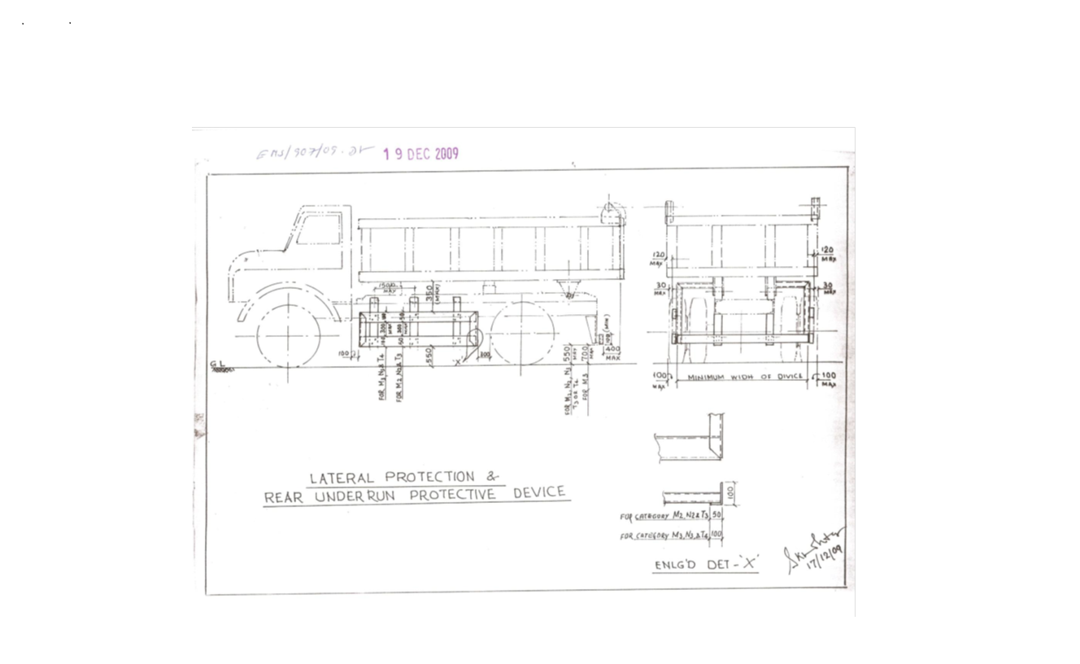

Sl. No. | Safety Parameters to be checked
1 | Three Piece Mirror(Truck, Trailer & Dumper)-Helper side
2 | Single Mirror- Driver side
3 | Rear View Mirror (Tata Ace, 207, Jeep etc.)
4 | Service Brake
5 | Parking Brake
6 | Seat Belt
7 | Head Light
8 | Parking Light
9 | Blinker
10 | Horn
11 | Reverse Alarm
12 | Wiper
13 | Windshield Glass
14 | Air Pressure Min. 7 Kg/Cm^2
15 | Run Under Protection Guard as per Tata Steel-Bearing Div. standard
16 | Side under Protection Guard as per Tata Steel-Bearing Div. standard
17 | Tyre Condition (Tread Depth, Cut Mark etc.)
18 | Any Oil Leakage from the vehicle
19 | Physical condition of Dallah
20 | Availability of scotch block
21 | Buzzer with side indicator
22 | Driver's eye examination report
Legal Documents to be checked:
Sl. No. | Documents to be Checked
1 | RC Book
2 | Insurance
3 | Pollution
4 | Driving licence
5 | Fitness for more than 15 years old vehicle
6 | NOC for outside vehicles

15. DISCLAIMER FOR E-AUCTION
BANDWIDTH PROBLEMS, CONNECTIVITY PROBLEMS WITH THE LOCAL ISP (INTERNET SERVICE PROVIDER), SLOWNESS TO ACCESS PAGES FOR DOWNLOADING ETC. ARE BEYOND THE CONTROL OF TATA STEEL-BEARING DIV. AND A H BILIMORIA & COMPANY. HENCE NO RESPONSIBILITY LIES WITH TATA STEEL-BEARING DIV. OR A H BILIMORIA & COMPANY FOR THE ABOVE PROBLEMS FACED, IF ANY, BY THE BIDDERS BEFORE/DURING THE AUCTION ANY. BID PLACED USING THE BIDDER'S USERNAME AND PASSWORD IS UNCONDITIONALLY BINDING ON THE BIDDER TO WHOM SUCH USERNAME AND PASSWORD HAD BEEN ALLOTTED AND HE SHALL BE SOLELY RESPONSIBLE FOR MAINTAINING THE CONFIDENTIALITY OF THE SAME AND FULLY RESPONSIBLE FOR ALL ACTIVITIES THAT OCCUR UNDER THEIR USERNAME AND PASSWORD. HENCE THE USER IS ADVISED TO CHECK THE USERNAME AND PASSWORD BEFORE THE AUCTION,IN ORDER TO FAMILIARISE HIMSELF WITH THE SAME AND IS ADVISED NOT TO REVEAL IT TO ANYONE ELSE SO AS TO PREVENT MISUSE OF THE SAME. THE BIDS MADE BY THE BIDDERS AGAINST THEIR USERNAME AND PASSWORD SHALL BE IRREVOCABLE.THE BIDDERS ARE ADVISED TO REGISTER AND PRE-QUALIFY FOR BIDDING WELL IN ADVANCE AND PLACE THEIR BIDS EARLY IN ORDER TO TAKE CARE OF ANY UNFORESEEN TECHNICAL DIFFICULTY THAT MIGHT SURFACE IN THE INTERNET OPERATIONS.

Lot Photograph: Photographs of lots are at best indicative only and do not necessarily reflect the actual condition of lots. All bidders are advised to e- inspect the offered lots before participating in the auctions. Tata Steel-Bearing Div. or A H Bilimoria & Co. shall not be responsible or liable for any error of judgment or bids put by bidders acting on the basis of these photographs.

Quantity offered is based on eye estimation. Delivery will be made for the estimated quantity or actual ground stock. Estimation error may arise. After e-inspection, no complaint of whatsoever nature on estimated /offered quantity shall be entertained under any circumstances. Bidders are advised to make their own judgment on offered quantity before bidding.

Special Instruction:
1. Driver must carry face mask& hand gloves.
2. Hand sanitizer/soap must be available with driver.
3. Driver must be aware about the safety norms of Covid-19.

Process for ISSUE of GATE PASS to enter the PLANT at Bearings Division Kharagpur :

- PFA the procedure to apply for e Gate Pass.

- Following is the new link for e-gate pass without vendor code:
- https://clm.tatasteel.co.in/clm_99/frmspgpreg.aspx
- The applicant needs to upload proof of DOB like Aadhar Card. He also needs to upload undertakings for Character/PV and Medical (format attached) and
- ESI/Medical Insurance for the workmen to be uploaded in the same file.
- Before starting job, Stores and Safety together must impart safety training and maintain records.

Declaration for Rej plastic items for Traders & Recyclers:
1) All plastic waste processors (recyclers) shall have to register with Central Pollution Control Board (CPCB) in accordance with provision 13(3) of Plastic Waste Management Rules, 2016 on the centralized portal developed by CPCB.
2) All plastic waste processors (recyclers) shall have to mandatorily furnish their EPR certificate along with other environmental NOC’s (EC, CTO etc).
3) Plastic waste processors(Recyclers) registered under Plastic Waste Management Rules, 2016, as amended, shall mandatorily provide certificates i.e. EPR Credits against the amount of plastic waste taken for processing, except in case of use of plastic waste in road construction from the company premises through online mode in the centralised EPR Portal in the name of Tata Steel Limited.
4) The EPR certificates i.e. EPR Credits will be for plastic packaging category-wise taken for processing from the premises.
5) The entity must refrain itself from incinerating & open dumping of plastic wastes taken from the company premises.
6) In future, if any complaint from Pollution Control Board received regarding mis-management of plastic waste by the concerned Indemnifier, then consequence management and liable penalty will be imposed for the same.
7) That the Indemnifier shall pay any such amount as claimed or demanded by the Principal within seven days without any demur and protest against any violation observed on any of the terms mentioned above.

ON Rs. 100/- Non-Judicial Stamp Paper
INDEMNITY CUM UNDERTAKING BOND
This Indemnity Cum Undertaking Bond made on _______ day of _______________ 2023.

In favour of

Tata Steel Limited having its registered office at Bombay House, 24, Homi Mody Street, Fort, Mumbai and having its Works at Jamshedpur hereinafter referred to as “Principal.”
By __________, having its office at ___________ through it’s ___________ Mr./Mrs.___________ S/o, D/o ____________ R/o ___________hereinafter referred to as ‘Indemnifier’ (which term shall include its successors, legal heirs, representatives and assigns) on the following terms

Whereas the Principal is a leading integrated steel manufacturer having its works at Jamshedpur and generates LD slag during steel manufacturing process.
And Whereas the Indemnifier has received waste plastic items under Category-1 as per Plastic Waste Management Rules, 2022 notified by MoEFCC ¹ dt 16.02.2022 as packing or used items on the basis of: -

Now therefore the Indemnifier submits this bond on the following conditions:

- That Indemnifier undertakes that it shall only trade the above-mentioned items without changing the nature of the same.
- In case the nature of items is changed, the traders will ensure to sell the waste plastic to CPCB authorized Plastic Waste Processors having valid EPR Certificate for recycling/processing of plastic waste ³ of same category as per the above-mentioned guidelines.
- Must ensure to prevent open dumping & incineration of the waste plastic taken from the company premises.
- Plastic waste disposal to be complied based on the laid down mandate under Plastic Waste Management Rules, 2022.
- In future, if any complaint from JSPCB received regarding mismanagement of plastic waste by the concerned Indemnifier, then consequence management and liable penalty will be imposed for the same.
- That Indemnifier irrevocably agrees to indemnify and hold harmless the principal and its directors, officers, employees and representatives from and against all actions, inquiry, suits, proceedings, claims, damages, losses, expenses and demands of every nature and description including but not limited to liability under Pollution Control Legislations and rules framed thereunder or guidelines and notifications issued.
- That the Indemnifier shall pay any such amount as claimed or demanded by the principal within seven days without any demur and protest against any violation observed on any of the terms mentioned above.
- That this Indemnity Bond shall remain in force and virtue till the principal releases the Indemnifier from its obligation under this Bond.
- That Mr./Mrs.___________ is competent to sign this Bond on behalf of the Indemnifier.

This Indemnity Bond shall be valid from the date mentioned hereinabove.

Signature of the Indemnifier

Witness

Signature:

Name:

Address:

NOTE : The Quantity mentioned below are estimated as per monthly generation (except Single LOT materials). The actual Qty. may vary by +/- 20% during the period of the validity up to 30th Sept 2024.

MATERIAL DETAILS: AS PER ANNEXURE :
List of materials
Sl. No | Location | Lot No. | Material Code | Material description | Qty | UOM | GST | TCS | Loading | LIFTING PERIOD | Contact person | Contact no
1 | TSL-Bearing Div., Kharagpur | BD/OCT/08/25-26 | - | Reciprocating Compressor (3no with spare) | 1 | lot | 18% | 1% | Self | Valid till 31st DEC’25 | Mr. R.K. Singh / Tarun K . Chatterjee | 9234611796 / 7908439292
2 | TSL-Bearing Div., Kharagpur | BD/OCT/04/25-26 | BRPRSC058 | MISC IRON & STEEL | 10 | MT | 18% | 1% | Self | Valid till 31st DEC’25 | Mr. R.K. Singh / Tarun K . Chatterjee | 9234611796 / 7908439292
3 | TSL-Bearing Div., Kharagpur | BD/OCT/05/25-26 | BRPRSC005 | BEARING COMPONENTS | 12 | MT | 18% | 1% | Self | Valid till 31st DEC’25 | Mr. R.K. Singh / Tarun K . Chatterjee | 9234611796 / 7908439292
4 | TSL-Bearing Div., Kharagpur | BD/OCT/06/25-26 | BRPRSC085 | BEARING | 4000 | KG | 18% | 1% | Self | Valid till 31st DEC’25 | Mr. R.K. Singh / Tarun K . Chatterjee | 9234611796 / 7908439292
5 | TSL-Bearing Div., Kharagpur | BD/OCT/01/25-26 | BRNPRSC1003 | EMPTY PLASTIC BARREL (20 TO 50 Ltr.) Only authorized parties who have valid authorization from pollution control board are authorised to participate in the auction as per hazardous and other waste rule | 70 | NOS | 18% | 1% | Self | Valid till 31st DEC’25 | Mr. R.K. Singh / Tarun K . Chatterjee | 9234611796 / 7908439292
6 | TSL-Bearing Div., Kharagpur | BD/OCT/02/25-26 | BRNPRSC023 | EMPTY PLASTIC BARREL-210 ltr, Only authorized parties who have valid authorization from pollution control board are authorised to participate in the auction as per hazardous and other waste rule | 40 | NOS | 18% | 1% | Self | Valid till 31st DEC’25 | Mr. R.K. Singh / Tarun K . Chatterjee | 9234611796 / 7908439292
7 | TSL-Bearing Div., Kharagpur | BD/OCT/03/25-26 | BRNPRSC022 | EMPTY STEEL BARREL - 210 LTR, Only authorized parties who have valid authorization from pollution control board are authorised to participate in the auction as per hazardous and other waste rule | 80 | NOS | 18% | 1% | Self | Valid till 31st DEC’25 | Mr. R.K. Singh / Tarun K . Chatterjee | 9234611796 / 7908439292
8 | TSL-Bearing Div., Kharagpur | BD/OCT/07/25-26 | BRNPRSC028 | EMPTY BARREL 2ND GRADE, Only authorized parties who have valid authorization from pollution control board are authorised to participate in the auction as per hazardous and other waste rule | 4 | MT | 18% | 1% | Self | Valid till 31st DEC’25 | Mr. R.K. Singh / Tarun K . Chatterjee | 9234611796 / 7908439292

ALL THE PHOTOGRAPHS ARE INDICATIVE ONLY
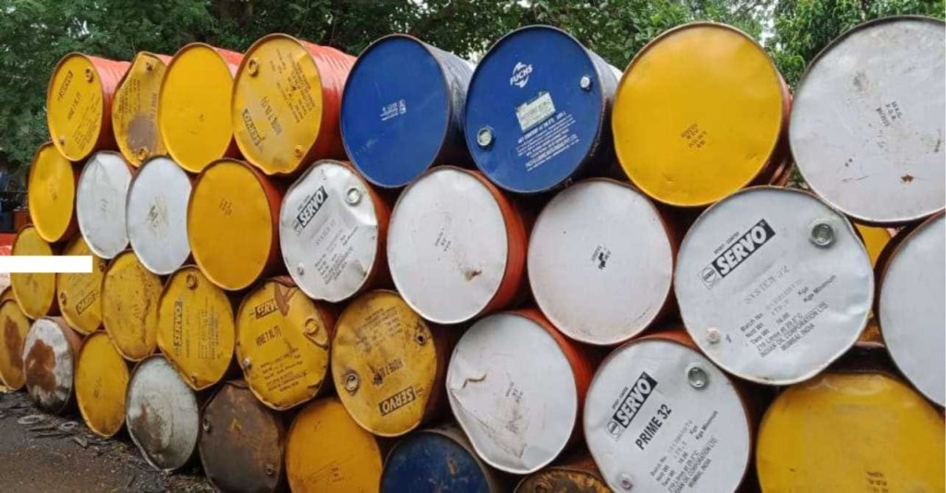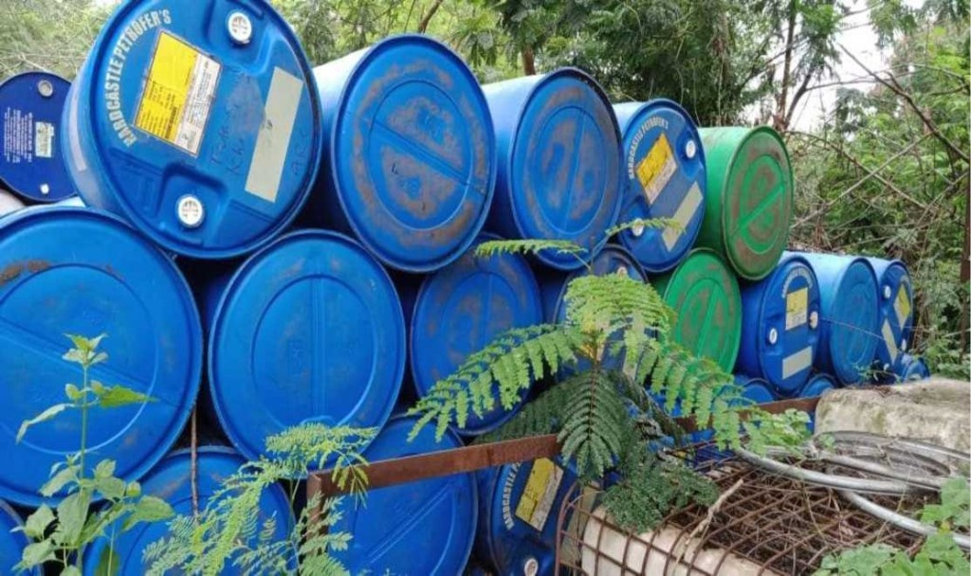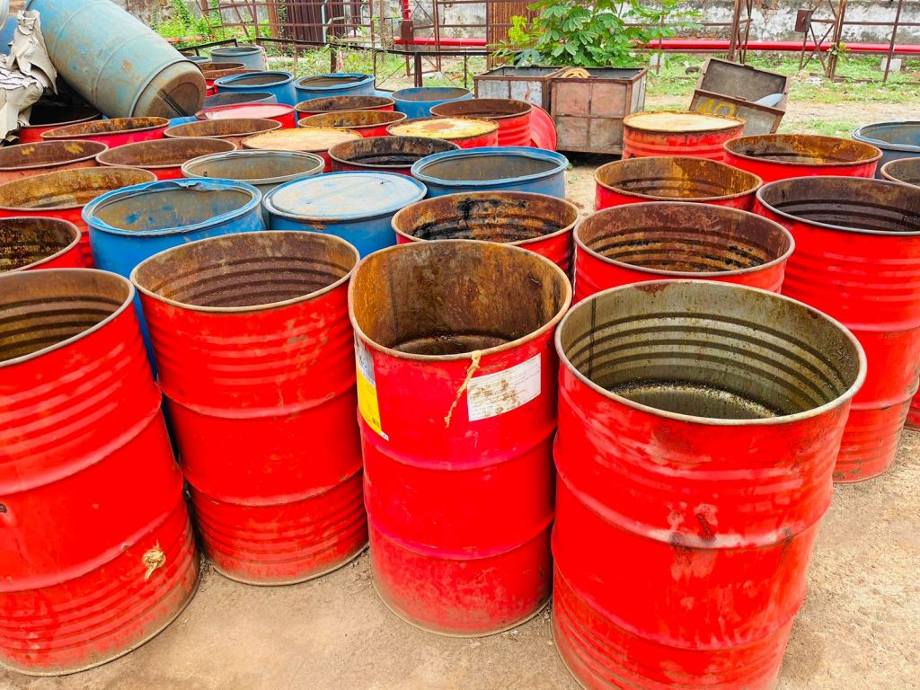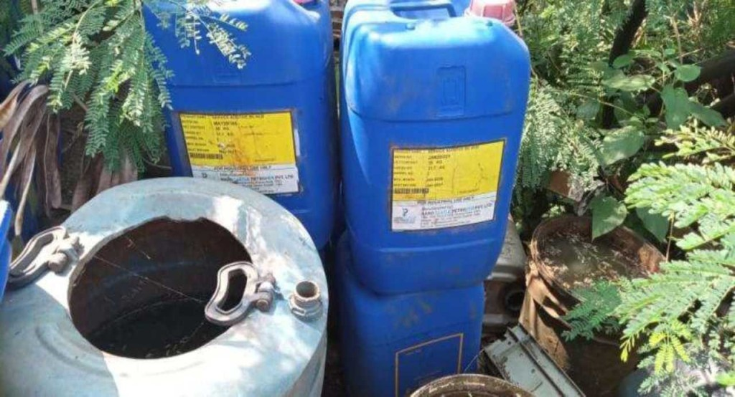
BD/OCT/03/25-26 BD/OCT/02/25-26 BD/OCT/07/25-26 BD/OCT/01/25-26
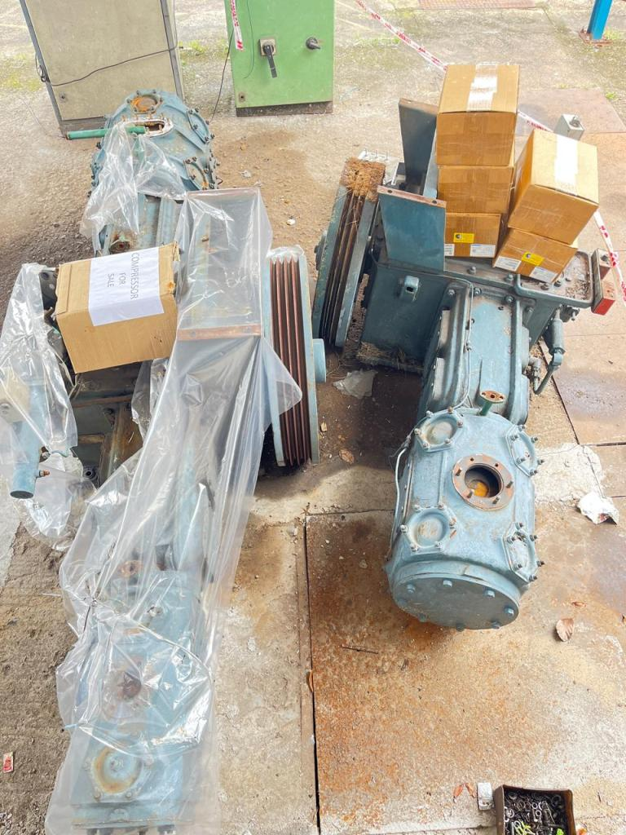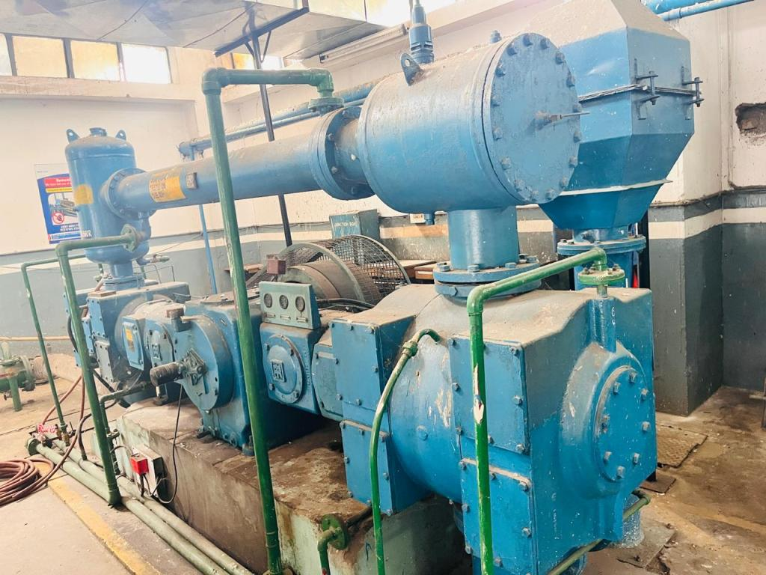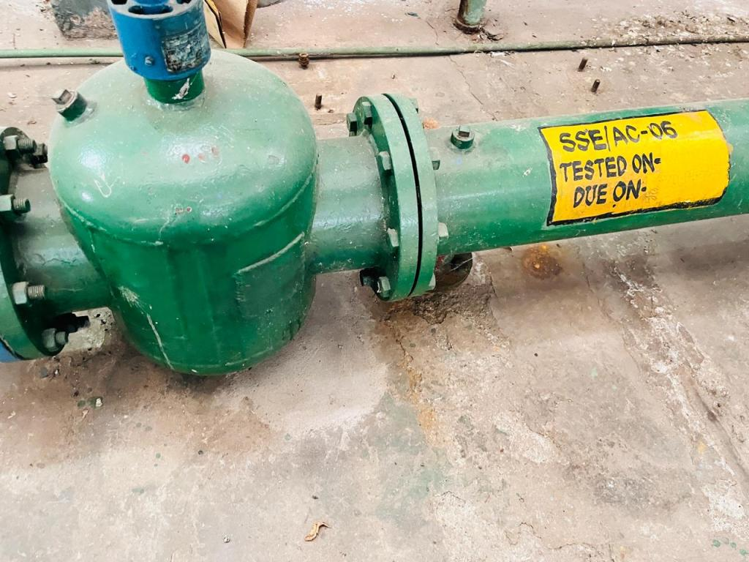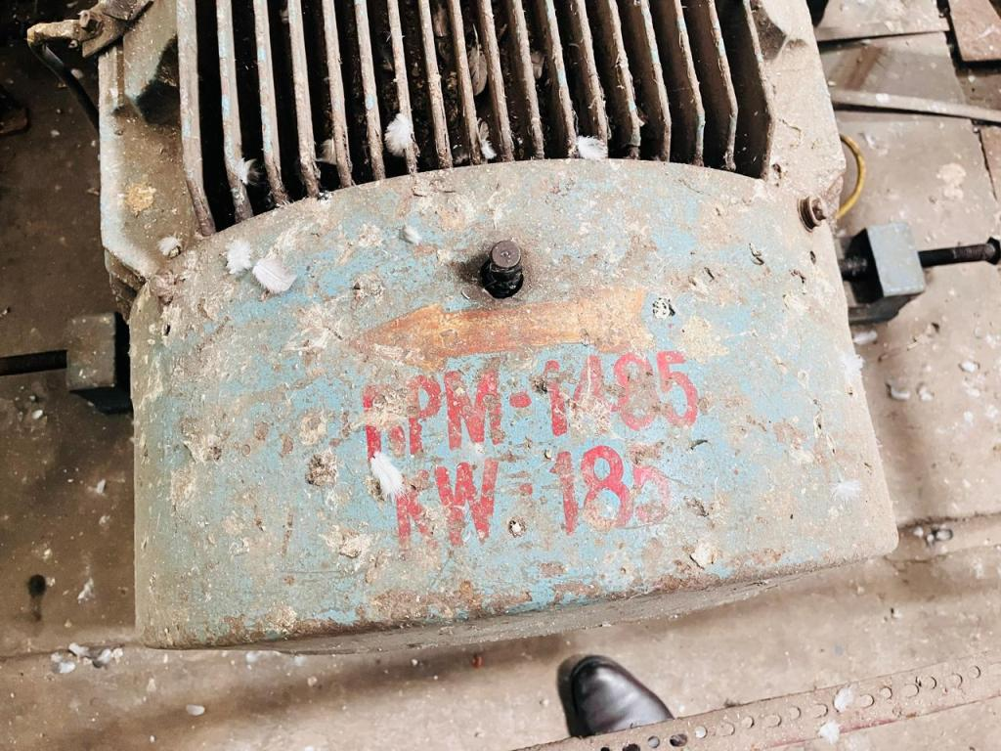
BD/OCT/08/25-26 BD/OCT/08/25-26 BD/OCT/08/25-26 BD/OCT/08/25-26
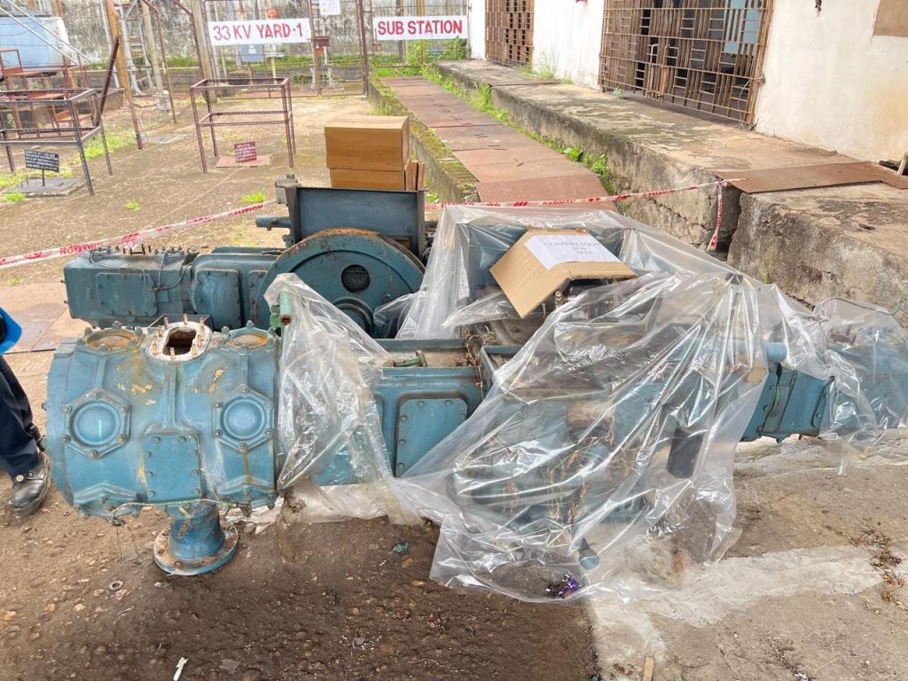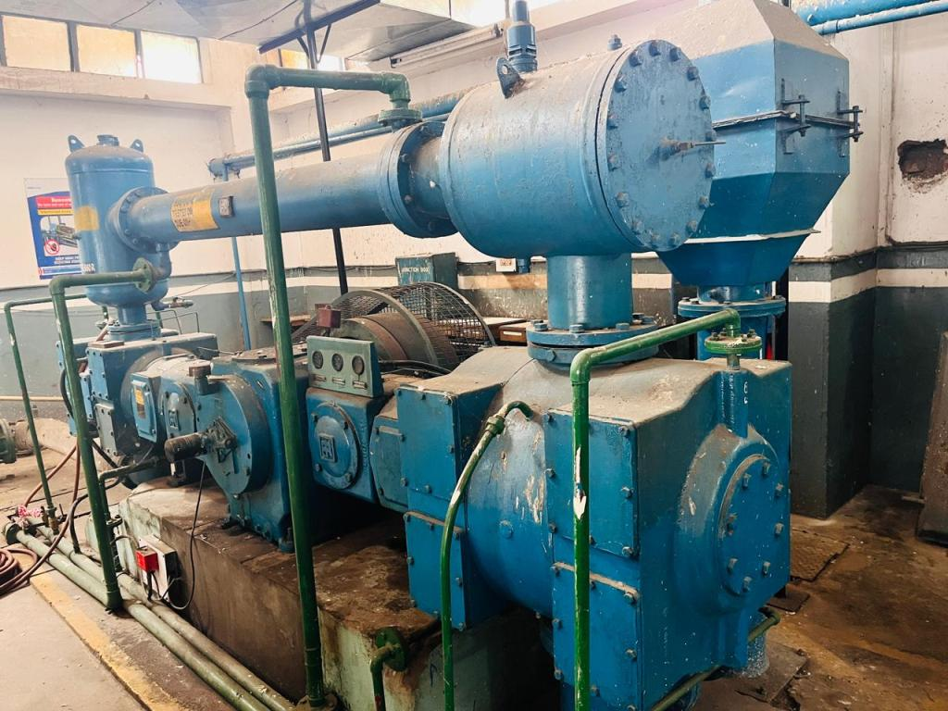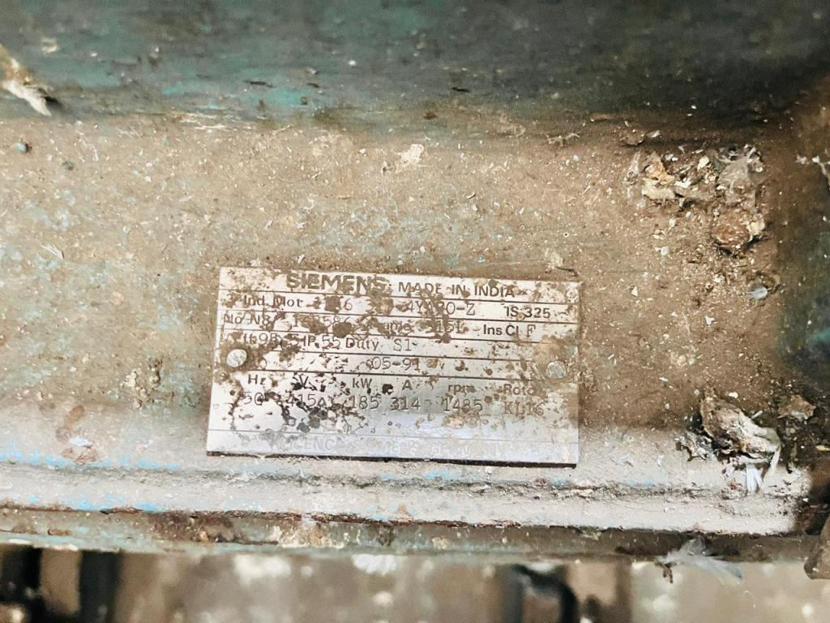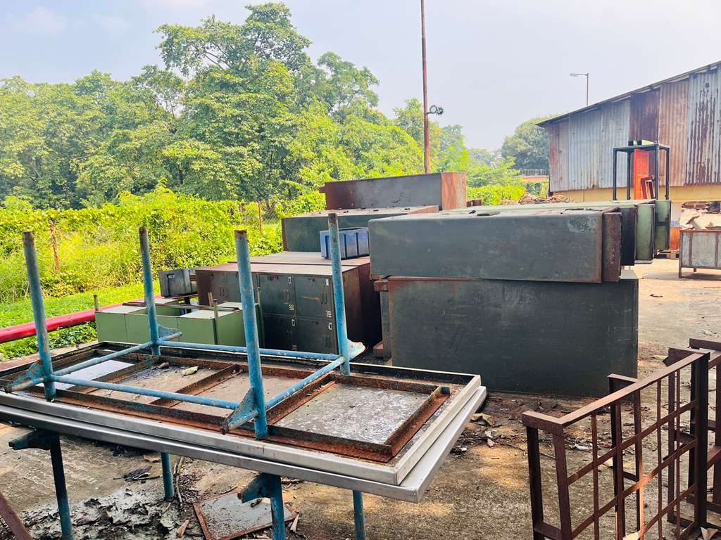
BD/OCT/08/25-26 BD/OCT/08/25-26 BD/OCT/08/25-26 BD/OCT/04/25-26
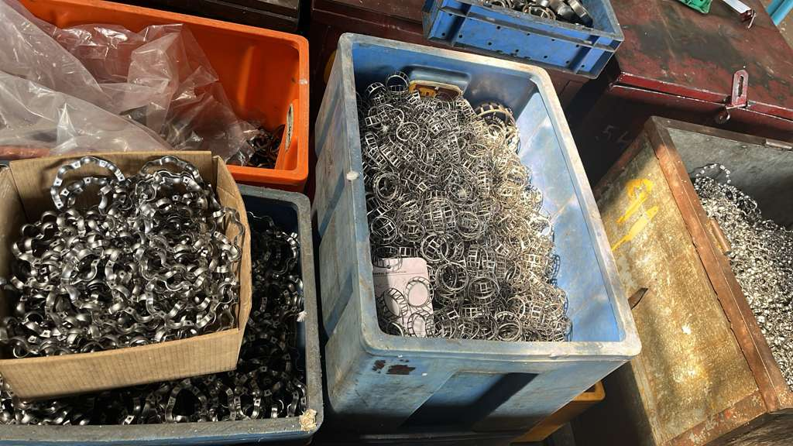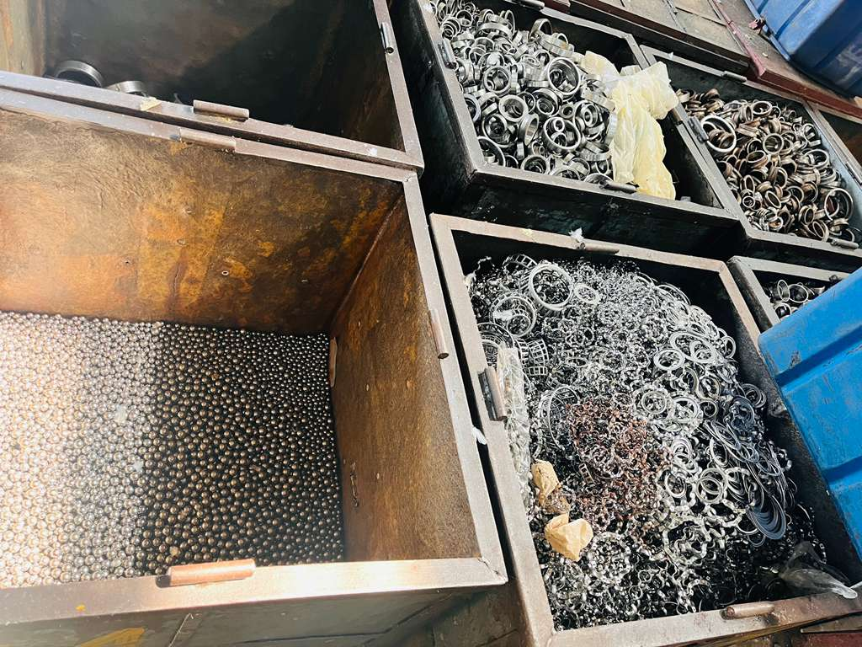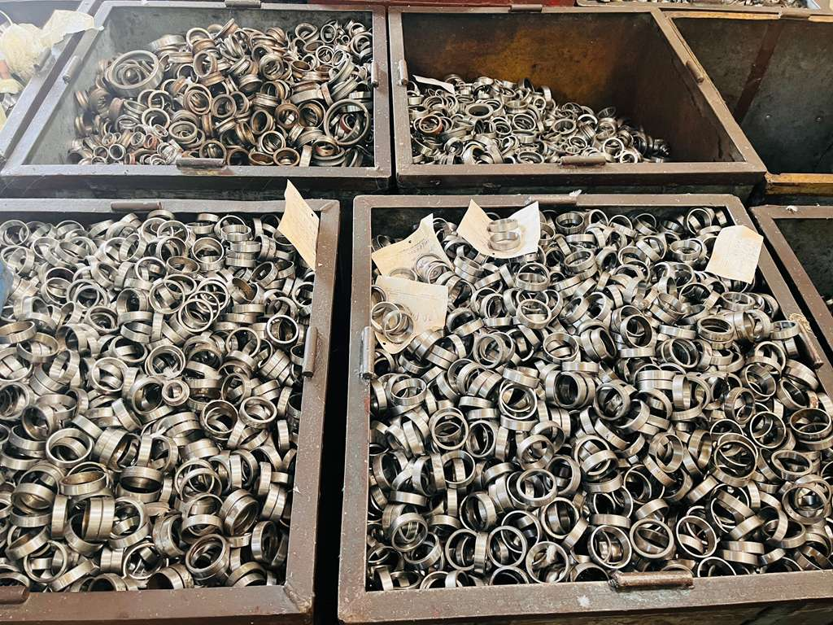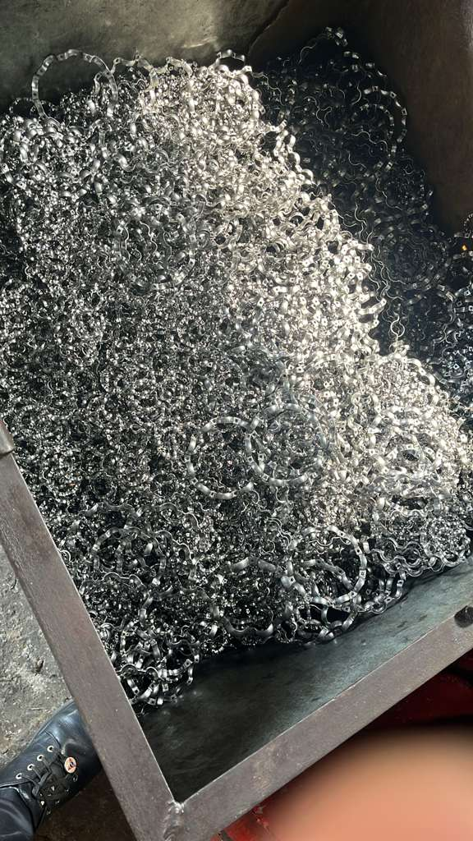
BD/OCT/05/25-26 BD/OCT/05/25-26 BD/OCT/05/25-26 BD/OCT/05/25-26
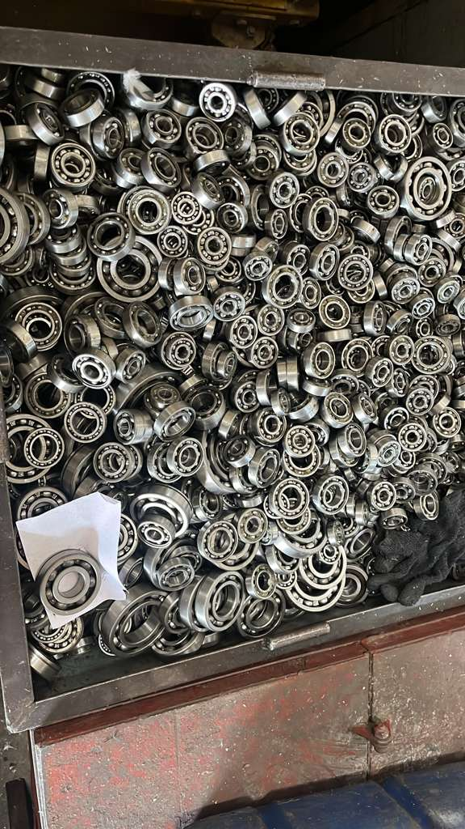
BD/OCT/06/25-26
Open www.ahbilimoria.com ->Click on Customer Complaint Management Portal

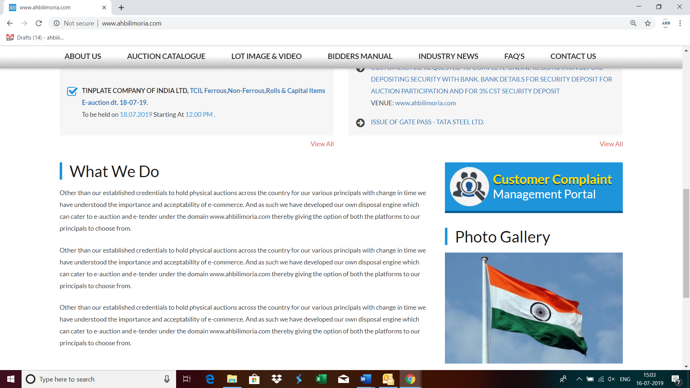S

Use your User ID & Password for login

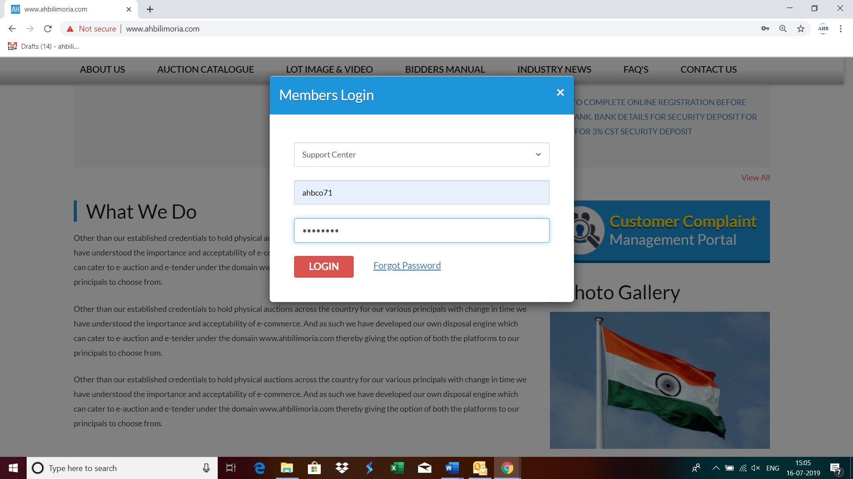

Click Complaint Portal-> Click on “Post a New Ticket”

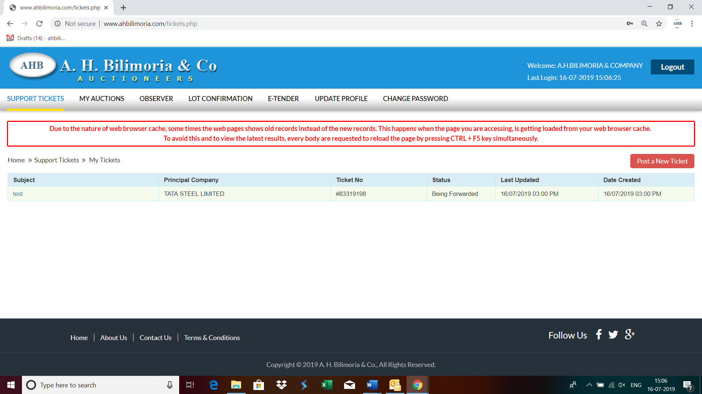

Post a New Ticket->Subject* ->Message* -> Email*->Principal Company*->Attach Document (If required any attachment) ->Submit

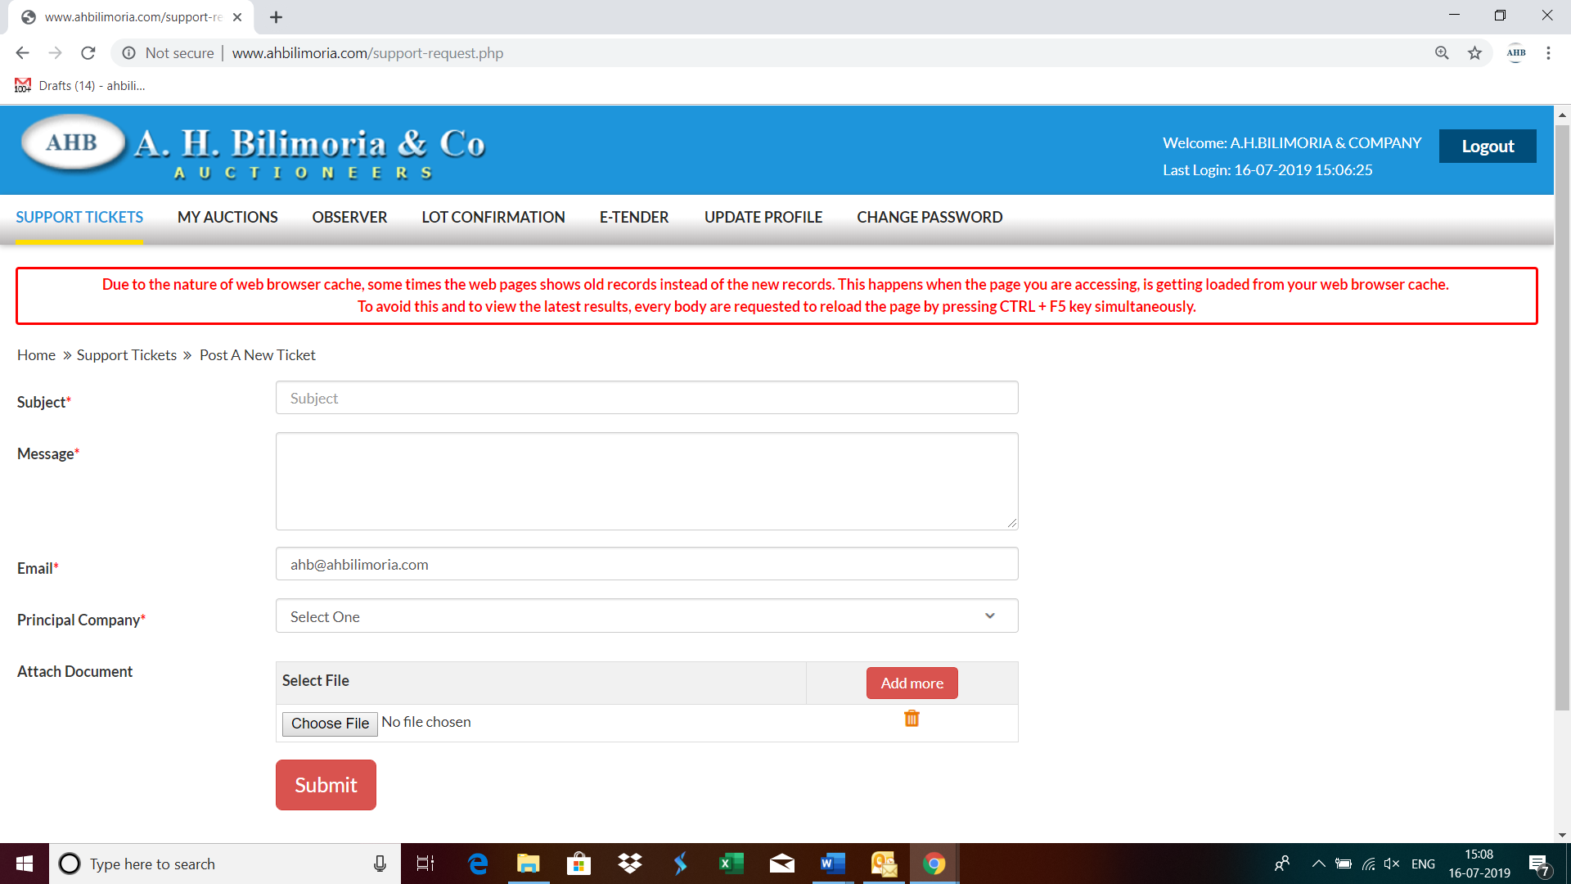

Your support request has been submitted successfully and the Reference No ----- is generated automatically

