Auction Catalogue
Auction conducted by A H Bilimoria & Co.
Auction of Scrap Items, Tata Steel Ltd. Metaliks Division, Kharagpur
BEING SOLD ON ‘’AS IS WHERE IS AND NO COMPLAINT BASIS’’
Catalogue Serial Number: | TML/AHB/DECEMBER/019/25-26 (Re-Auction)
Seller: | Tata Steel Ltd. Metaliks Division, Vill – Maheshpur, P.O. Samraipur, PS – Kharagpur (Local), Paschim Medinipur, Pin-721301
Auction website: | www.ahbilimoria.com
e-Auction Date & Time: | 30th December, 2025…..….. at 12:00 PM
Inspection Completed Date & Time: | 02nd December, 2025 ------ at 10:30 AM ---- For inspection of materials the interested customers should report at Tata Steel Limited, Metaliks Division, Vill – Maheshpur, P.O. Samraipur, PS – Kharagpur (Local), Paschim Medinipur, Pin – 721301, West Bengal before 10:00 AM.  Interested customers have to come with Aadhaar Card, safety shoes, safety jackets & safety helmets at the time of inspection.
Date of Security Money Deposit | 30th December, 20254 Till ……… at 11:30 AM
Contact Details:
For Post Auction @ A H Bilimoria & Company
Area | Contact No. | Email Id
Auction Room | 07003840027/09883421336
Lot Confirmation Related | 08981460668 | ahb@ahbilimoria.com, ahbilimoria.company@gmail.com
Customer code, Payment, Refund Related and TCS Related. TATA STEEL LIMITED (METALIKS DIVISION), Kharagpur | Mr. Ashish Roshan (7004437376) | ashish.roshan@tatasteel.com,
Sales order, Loading & Inspection, TATA STEEL LIMITED (METALIKS DIVISION), Kharagpur. | Mr. Samir Kumar Pal (8373059325) | samir.pal@tatasteel.com
For time bound resolution of unresolved issues log into our Customer Complaint Management portal | Type in www.ahbilimoria.com> Go to “Customer Complaint Management Portal” >Log in with your user id and password and write the details of issue.

For Any unresolved Issues beyond two (02) days mail to A H Bilimoria & Company :
Mr. A K Sil (M-09830074122) & Mr. D Pyne (M-09830738481), E-mail: ahb@ahbilimoria.com, ahbilimoria.company@gmail.com
Copy to Tata Steel Ltd, Metaliks Division : Mr. Samir Kumar Pal (samir.pal@tatasteel.com)

SPECIAL NOTE: -It is the responsibility of the buyer to furnish the valid GST no. & necessary documents to A H Bilimoria & Co. before participating in the auction. In case during the transactions, it is found that valid GST no. has not been provided, then all necessary liabilities if any & so accrued would be on account of the buyer. Tata Steel Ltd. Metaliks Division & A H Bilimoria & Co. would not be responsible for any such liabilities.

Note: TSL reserves the right to track IP address, MAC number and geolocation of bidding customers whenever customers participate in any auction on the A H Bilimoria & Co. auction platform for Tata Steel Ltd. Metaliks Division.

- Payment and Lifting Schedule:

Lot No. | Payment Schedule |  |  | Lifting Schedule  (working days from the next day of DO release)
Lot No. | EMD (10% of lot value) | 1st installment (For 125MT) | 2nd installment (For 125MT)
For All Material | 02 Working day from Date of Lot Confirmation | 04 Working Days From Date of EMD | 15 Working Days from the 1st Installment date. EMD to be adjusted in the final installment | As per material list
- Suitable extension of due date for payment and lifting will be accorded in case of any eventualities like Strike/ Bandh/ Special restriction on vehicular movement imposed by the local Administration etc.

- Requirements of participation:
  - Registration: Before participation in the e-Auction, a prospective bidder shall be required to get registered with A H Bilimoria & Co. For details visit www.ahbilimoria.com

  - Security Deposit: Non-Interest bearing security deposit of Rs.60,000/- (Rupees Sixty Thousand only) in favour of “A H Bilimoria & Co.” through Online Payment only : Details as under :

Beneficiary Name | A. H. BILIMORIA & COMPANY
Bank Name | HDFC Bank
Branch Name | 31, Chowringhee Road, Kolkata – 700016
Account No | 06932560001205
IFSC Code | HDFC0000693

Account No: All the customers will have a unique account number. The unique account number is an alpha numeric code consisting of 12 characters. The Customer’s unique “account number” is a combination of the AHB’ SAP code along with the 6 digit bidder SAP ID and can be used as reference. for all subsequent transactions. The Customer’s Account Number detail is available in “Profile” after the customer logs into our website using the user id and password.

- Inspection Rules & Policy:
- All parties to send their request for registration of inspection through registered e-mail to ahb@ahbilimoria.com, ahbilimoria.company@gmail.com, one day prior to the date of inspection.
(Mail request should contain – Person Name, ID Proof, Firm Name, Mobile No., Name of the Rank Based Sealed Bid & Letter of authorization for inspection)
Customers are requested to generate individual gate pass by clicking on the following link http://203.197.123.30/vgps/
Visitor GP of only those customers would be approved, who have sent their request via mail to A H Bilimoria & Co, one day prior to inspection.
- All interested parties should reach at Tata Steel Limited, Metaliks Division, Vill – Maheshpur, P.O. Samraipur, PS – Kharagpur (Local), Paschim Medinipur, Pin – 721301, West Bengal by 10:00 AM on the date of inspection.
- Only registered customers/bidders/representatives of firms shall be allowed for inspection of material, subject to fulfilling their safety requirement of the steel works.
- Taking photographs of the material is strictly prohibited.
- Customers are advised to ensure that they inspect the materials on offer on the scheduled date as mentioned in the catalogue, before Participating in the Rank Based Sealed Bid. It is reiterated that all materials are offer / sold by Tata Steel on “AS-IS-WHERE-IS” and “NO-COMPLAINTS” basis, and no complaint what so ever shall be entertained regarding the quality of materials after the sale.
- “TATA Steel would not accept any claim from any customer for non-inspection of materials.”
Interested bidders have to come with safety shoes, safety fluorescent jackets, and safety goggles & safety helmets at the time of inspection. All interested parties have to arrange for their own safety shoes, safety jackets, safety helmets and safety goggles as per Tata Steel standards. No person will be allowed to enter the works without these. Compliance to Tata Steel safety norms is a must. No complaints during lifting, in what-so-ever manner, will be entertained if customers fail to inspect the materials during scheduled inspection dates. No ''people movement'' shall be allowed at the loading point during loading/delivery of materials from the yards. Tata Steel will not be responsible for any delays arising out of non-compliance to Tata Steel norms.

- Bidding modalities:
  - Price Bid Basis: In Indian rupees as per unit of measurement as given in Material List. Price to be quoted is basic, ex- location exclusive of taxes and any other statutory levies.
  - Bid Increment: As specified in the e-auction bid page
  - Type of Auction: English No Ties
  - Bid Validity: Bid shall be valid for 10 (Ten working days excluding Saturdays, Sundays and Bank holidays) working days counted from the next day of auction process in case of auction against a catalogue which is completed on the same day. And if it is continuing on any other day the counting of days for lot confirmation shall be from the next day of completion of entire auction process.
  - Bid duration: For 1st four lots 20 minutes and balance lots 10minutes. If, No bids received within these specified time the lots are closed automatically.

- Taxes & duties:
  - GST : As applicable
  - TCS : As applicable.
  - Any change in taxes applicable at the time of lifting shall be applicable.

- Payment terms & conditions :
  - Payments: PAYMENT FACILITY BY RTGS / NEFT ONLY
Payment should made through Virtual Account Number – (Each individual customer will be provided Virtual Account number by TATA STEEL LTD- METALIKS DIVISION.
  - EMD: 10% of the material value to be paid within 02 (Two) working day from the date of lot confirmation. EMD to be adjusted in the final installment only.
EMD payment is to be made within the time limit as given in letter of confirmation. No extension will be provided for the same.
  - Balance Payment Time: (As per payment schedule)
  - Saturdays, Sundays and Bank holidays are excluded for counting purpose for payment schedule.
  - In the event of Non-Receipt of Payment within the stipulated period of Payment, the Sale Offer for the approved Lot shall stand withdrawn automatically.
  - Buyers have to send the payment deposit slip (UTR No /Scan Copy of NEFT/RTGS Transaction Slip) against Lot No. immediately after the payment to AHB at email id: ahb@ahbilimoria.com& ahbilimoria.company@gmail.com

- Lifting terms & conditions:
7.1 DO Number will be handed over to authorized representatives of bidders on receipt of payment. Authorization letter to be issued via registered e-mail id’s. Authorized letter must be duly stamped and signed by the proprietor or partner or director on receipt of payment. Lifting date is calculated from the next day of DO Release date.
7.2 Loading shall be given strictly as per the statutory norms & safety norms of Tata Steel Ltd.
7.3 Lifting with Ground Rent: Lifting along with ground rent will be allowed up to 4 (four) working days from the last date of lifting period. In case the lifting is not complete, and no request is made by the customer within the period of four days, the company reserves the right to close the lot, and refund the balance to the party after deducting for any shortfall in lifting as per norms laid down in the catalogue. Ground Rent will be calculated on balance unlifted quantity @ 05 paise (inclusive of tax) per Rs.100/- per day
7.4 Additional lifting days for advance payment of installment - If the installment payment is made in advance, then additional lifting days (equivalent to the number of days payment made in advance) would be given. This would not be applicable for EMD payment.

7.5 PICK & CHOOSE NOT ALLOWED FOR ANY OF THE LOTS.

7.6 LOT TRANSFER WILL NOT BE ALLOWED.

7.7 Process for transfer of ownership of vehicles sold in auction: Customer shall submit their authorization letter to AHB. AHB will hand over the same to SCMC with a forwarding letter along the authenticated DO copy. AHB will collect the ownership papers from SCMC for handing over to the customer for applying for transfer of ownership in DTO’s office. After transfer of ownership, the customer will show the approach SCMC to collect the delivery advice for the vehicle. AHB will arrange the gate pass for the customer to visit SCMC.
- Penalty:
  - The following penalties shall be applicable in the eventuality of a buyer defaulting in making the payment of payment (wherever applicable), as per the stipulated schedule for each lot, in a financial year:
- In the first instance, a penalty of Rs. 60,000/- (Rupees Sixty Thousand only) shall be recovered from the customer.
- In the second instance, a penalty of Rs.100,000/- (Rupees One Lakh only) shall be recovered from the customer.
- In the third, and any subsequent instance, a penalty of Rs.150,000/-(Rupees One Lakh Fifty thousand only) shall be recovered and the customer shall be debarred from participating in any auction for a period of three months from the date of debarment.
In the event of any default, the customer’s user id will be disabled and the customer will be blocked from participating in any auction of TSL with immediate effect.

The defaulting customer shall be allowed 06 (six) working days to deposit the penalty as mentioned above. In case the penalty is not received within the stipulated period, the customer’s security deposit shall be forfeited, and the defaulting customer shall be immediately debarred from participating in any auction of TSL.

  - In case of non-lifting of full lot quantity after making full payment, a penalty equivalent to 20% of the material value for the un-lifted quantity against each lot shall be recovered from the customer.

- Lot Closure Norms :
For Lot Closure, the tolerance would be ± 10% of the original quantity.
For High Value Items (>/= Rs 50000 per MT) tolerance for Lot closure is 0% of the lot quantity.

- Refund :
Refunds will only be made by Tata Steel Limited, Metaliks Division vide RTGS/NEFT and hence all customers are required to submit their bank details to A H Bilimoria & Company or mail at ahb@ahbilimoria.com, ahbilimoria.company@gmail.com. Tata Steel Limited, Metaliks Division or A H Bilimoria & Company will not be responsible for any delay in refunds owing to absence of bank details of the customer.

- Complaints :
Complaints, if any, with regard to any transaction shall have to be lodged by the buyer within three calendar months from the date of last invoice. No complaint shall be entertained thereafter, under any circumstances. Customers can log their complaints at (www.ahbilimoria.com> Go to “Customer Complaint Management Portal” >Log in with your user id and password and write the details of issue.)

- Jurisdiction :
Any dispute arising out of any contract shall be decided in Kolkata by the courts in Kolkata and by no other courts. The courts in Kolkata shall have exclusive jurisdiction to adjudicate upon any such dispute.

- General terms & conditions:
  - Any dispute on quality & quantity of material and bid cancellation shall not be entertained at any point after the auction.
  - All lots are offered/sold on “As is Where is Basis” and “No Complaint Basis”.
  - Lot transfer will not be allowed. Payment and invoicing has to done in the name of the H1 bidder, subject to the prices being approved.
  - Lot purchased should consist of material from the same lot and designated location only. Tata Steel Ltd. Metaliks Division has the right to check any vehicle at any moment of time. If material lifted differs from the material that is purchased by the buyer, then the buyer and authorized representative will be permanently debarred. Also Tata Steel Ltd. Metaliks Division can take any penal action against the buyer/authorized representative. All the material loaded in the vehicle is to be covered in order to follow the safety compliance of Tata Steel Ltd. Metaliks Division works.
  - If the safety compliance is not followed, then Tata Steel can penalize the buyer / authorized representative as deemed fit.
  - Customer attested photocopy of valid id proof (Voter id/Aadhar/Pan card) of all lifters / Authorized persons engaged by customers for lifting of materials from
Tata Steel Limited, Metaliks Division is to be enclosed with the authorization letters & to be forwarded to Tata Steel Limited, Metaliks Division for issue of gate pass.
  - Dispatch is subjected to FORCE MAJEURE conditions
  - The seller reserves the right to terminate any offer at any point of time without assigning any reasons
  - In the event of termination of the offer, seller shall refund the balance amount after due reconciliation
  - No claims whatsoever would be entertained after cancellation of the bid
  - In addition of earlier safety norms, the following would be compulsory:
The drivers of the vehicle must have the eye test certificate. The frequency of the testing would be as below:
1. If the age of the person is less than 45 years - Once in a year
2. If the age of the person is 45 years or more, the testing is required to be done once in every 6 months
Please ensure to comply with the safety norms
  - Weighment : Weight recorded by Tata Steel Limited, Metaliks Division weighbridge will be considered final and binding on the customer.
  - No Punjab dala to be allowed inside works in any area of operation.
  - Mandatory usage of reverse Camera/Horn in all customer vehicles for lifting of materials.

14. Compliance to safety norms
14.1 Authorized persons (of the customer) involved in lifting of the materials will be allowed only with Personal Protective Equipment’s (PPE) i.e., Safety Shoes, Safety Helmet, Safety Goggles, Fluorescent Jacket and Hand Gloves. No "people movement" shall be allowed at the time of loading/delivery of materials from the yards" Tata Steel Ltd. Metaliks Division will not be responsible for any delays arising out of Non- Compliance to the Safety Norms.

14.2 Documents for verification regarding entry of vehicles inside Tata Steel Ltd. Metaliks Division works :
All customers to note that presentation of following set of documents to TATA STEEL authorities is COMPULSORY at the time of reporting of vehicles at TSL designated Gate for entry of Customer trucks/vehicles.
a. Driving License of driver,
b. Registration Card,
c. Commercial Certificate,
d. Fitness Certificate of Vehicle,
e. Re-registration for vehicles older than 15 years
f. Insurance
The checklist form will be filled in at TSL designated Gate for entry of Customer trucks/vehicles before entry of vehicle.

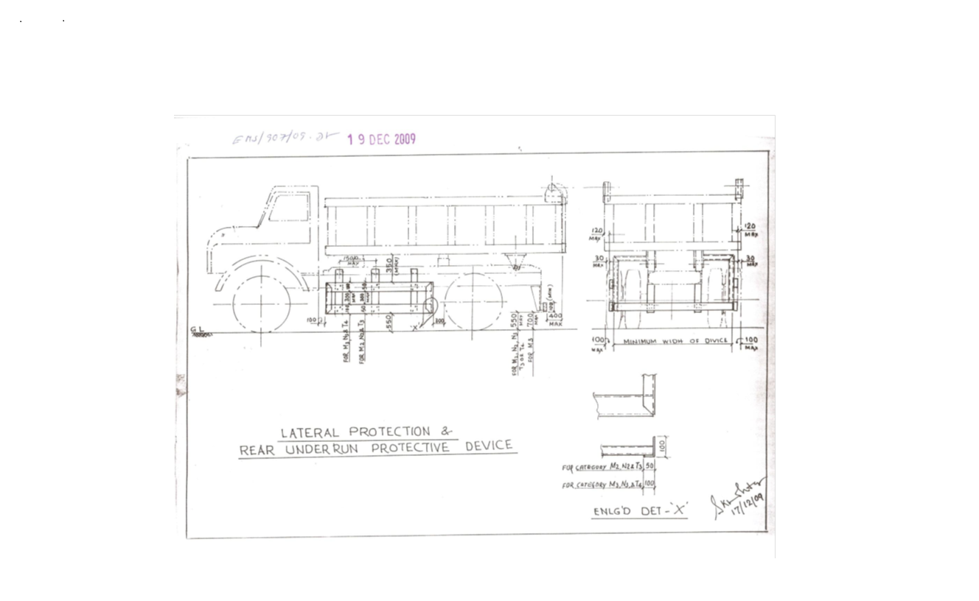

Sl. No. | Safety Parameters to be checked
1 | Three Piece Mirror(Truck, Trailer & Dumper)-Helper side
2 | Single Mirror- Driver side
3 | Rear View Mirror (Tata Ace, 207, Jeep etc.)
4 | Service Brake
5 | Parking Brake
6 | Seat Belt
7 | Head Light
8 | Parking Light
9 | Blinker
10 | Horn
11 | Reverse Alarm
12 | Wiper
13 | Windshield Glass
14 | Air Pressure Min. 7 Kg/Cm^2
15 | Run Under Protection Guard as per TSL standard
16 | Side under Protection Guard as per TSL standard
17 | Tyre Condition (Tread Depth, Cut Mark etc.)
18 | Any Oil Leakage from the vehicle
19 | Physical condition of Dallah
20 | Availability of scotch block
21 | Buzzer with side indicator
22 | Driver's eye examination report
Legal Documents to be checked:
Sl. No. | Documents to be Checked
1 | RC Book
2 | Insurance
3 | Pollution
4 | Driving licence
5 | Fitness for more than 15 years old vehicle
6 | NOC for outside vehicles
15. DISCLAIMER FOR E-AUCTION
BANDWIDTH PROBLEMS, CONNECTIVITY PROBLEMS WITH THE LOCAL ISP (INTERNET SERVICE PROVIDER), SLOWNESS TO ACCESS PAGES FOR DOWNLOADING ETC. ARE BEYOND THE CONTROL OF TATA STEEL LTD. METALIKS DIVISION AND A H BILIMORIA & COMPANY. HENCE NO RESPONSIBILITY LIES WITH TATA STEEL LTD. METALIKS DIVISION OR A H BILIMORIA & COMPANY FOR THE ABOVE PROBLEMS FACED, IF ANY, BY THE BIDDERS BEFORE/DURING THE AUCTION ANY. BID PLACED USING THE BIDDER'S USERNAME AND PASSWORD IS UNCONDITIONALLY BINDING ON THE BIDDER TO WHOM SUCH USERNAME AND PASSWORD HAD BEEN ALLOTTED AND HE SHALL BE SOLELY RESPONSIBLE FOR MAINTAINING THE CONFIDENTIALITY OF THE SAME AND FULLY RESPONSIBLE FOR ALL ACTIVITIES THAT OCCUR UNDER THEIR USERNAME AND PASSWORD. HENCE THE USER IS ADVISED TO CHECK THE USERNAME AND PASSWORD BEFORE THE AUCTION,IN ORDER TO FAMILIARISE HIMSELF WITH THE SAME AND IS ADVISED NOT TO REVEAL IT TO ANYONE ELSE SO AS TO PREVENT MISUSE OF THE SAME. THE BIDS MADE BY THE BIDDERS AGAINST THEIR USERNAME AND PASSWORD SHALL BE IRREVOCABLE.THE BIDDERS ARE ADVISED TO REGISTER AND PRE-QUALIFY FOR BIDDING WELL IN ADVANCE AND PLACE THEIR BIDS EARLY IN ORDER TO TAKE CARE OF ANY UNFORESEEN TECHNICAL DIFFICULTY THAT MIGHT SURFACE IN THE INTERNET OPERATIONS.

Lot Photograph: Photographs of lots are at best indicative only and do not necessarily reflect the actual condition of lots. All bidders are advised to physical inspection the offered lots before participating in the auctions. Tata steel Ltd. Metaliks Division or A H Bilimoria & Co. shall not be responsible or liable for any error of judgment or bids put by bidders acting on the basis of these photographs.

Quantity offered is based on eye estimation. Delivery will be made for the estimated quantity or actual ground stock. Estimation error may arise. No complaint of whatsoever nature on estimated /offered quantity shall be entertained under any circumstances. Bidders are advised to make their own judgment on offered quantity before bidding.

Special Instruction of Tata Steel Ltd. Metaliks Division:
1. Arrangement for transportation of materials is under the scope of the customer/buyer. Customer should Follow All safety rules and other applicable rules followed by Tata Steel Ltd. Metaliks Division for vehicles during entry/exit of vehicle.
2. Customers should clarify any query before participation in auction. No complaint will be entertained post auction.
- Bilty/ Consignment note is mandatory for taking delivery of materials of value higher than Rs. 50,000/- as per GST rule.

- Gas cutting (ONLY FOR MS SCRAP) and loading will be under by Tata Steel Ltd. Metaliks Division Scope as per following norms: -
i) Cutting of the MS scrap can be loaded on to trucks by Tata Steel Ltd. Metaliks Division.
ii) No overloading of truck is allowed.
iii) Except MS scrap and no other materials cutting will be allowed inside plant premises by TSMD.
MATERIAL DETAILS: AS PER ANNEXURE :
List of materials
Sl. No. | Location | Lot no. | Material code | Material Description | Qty | UOM | GST | TCS | Loading | LIFTING PERIOD | Contact person | Contact no
1 | RHMS AREA, SINTER PLANT AREA, 132 KV YARD  , PI POND SIDE, SLAG YARD AREA, RHMS AND GROUND HOPPER AREA, AREA BETWEEN SINTER PLANT AND SLAG YARD, OXYGEN PLANT, RMD YARD,  Tata Steel Ltd. Metaliks division, Kharagpur | TSMD-251202 | 3789135 | MS Scrap (heavy) with/without attached refractories- It consists of others mild steel scrap items like pieces of channel, Angle, Plates, Rejected/used structure etc. in as is where is basis and no complaint basis. Only Heavy MS Scrap will be delivered in presence of customer’s representative. cutting by company upto truck length size | 250 | MT | 18% | 1% | By company free of cost | 60 Working Days from the D/O date | Mr. Samir Kumar Pal | 8373059325
2 | RHMS AREA, SINTER PLANT AREA, 132 KV YARD  , PI POND SIDE, SLAG YARD AREA, RHMS AND GROUND HOPPER AREA, AREA BETWEEN SINTER PLANT AND SLAG YARD, OXYGEN PLANT, RMD YARD,  Tata Steel Ltd. Metaliks division, Kharagpur | TSMD-251203 | 3789135 | MS Scrap (heavy) with/without attached refractories - It consists of others mild steel scrap items like pieces of channel, Angle, Plates, Rejected/used structure etc. in as is where is basis and no complaint basis. Only Heavy MS Scrap will be delivered in presence of customer’s representative. cutting by company upto truck length size | 250 | MT | 18% | 1% | By company free of cost | 60 Working Days from the D/O date | Mr. Samir Kumar Pal | 8373059325

ALL THE PHOTOGRAPHS ARE INDICATIVE ONLY
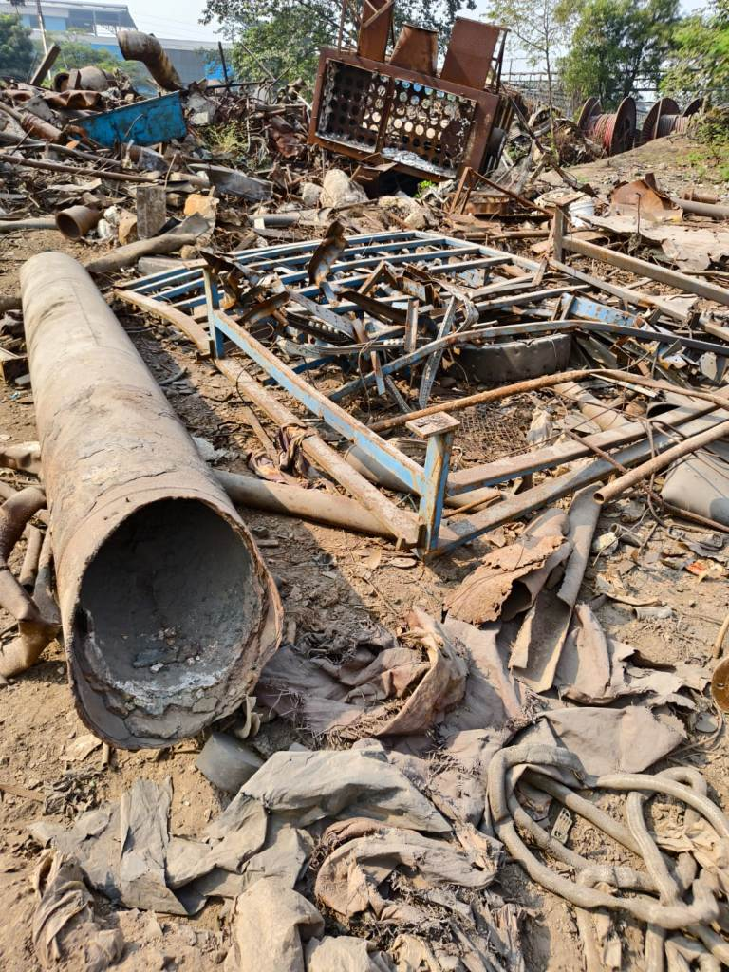
MS Scrap (Heavy)
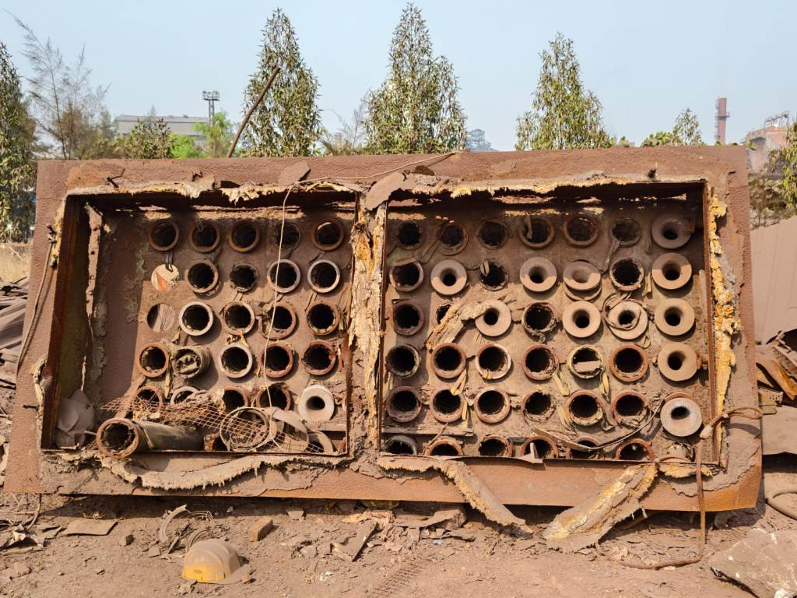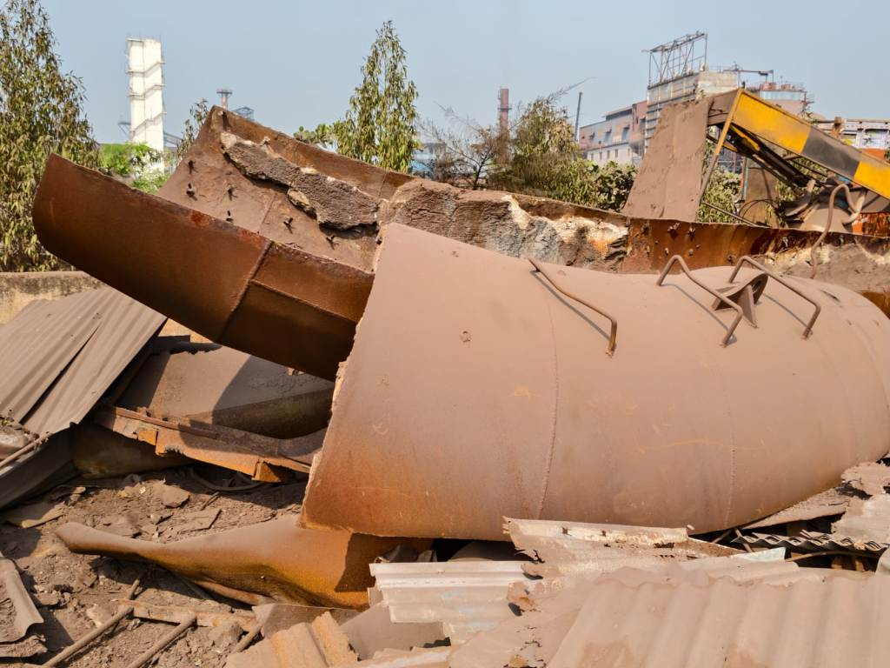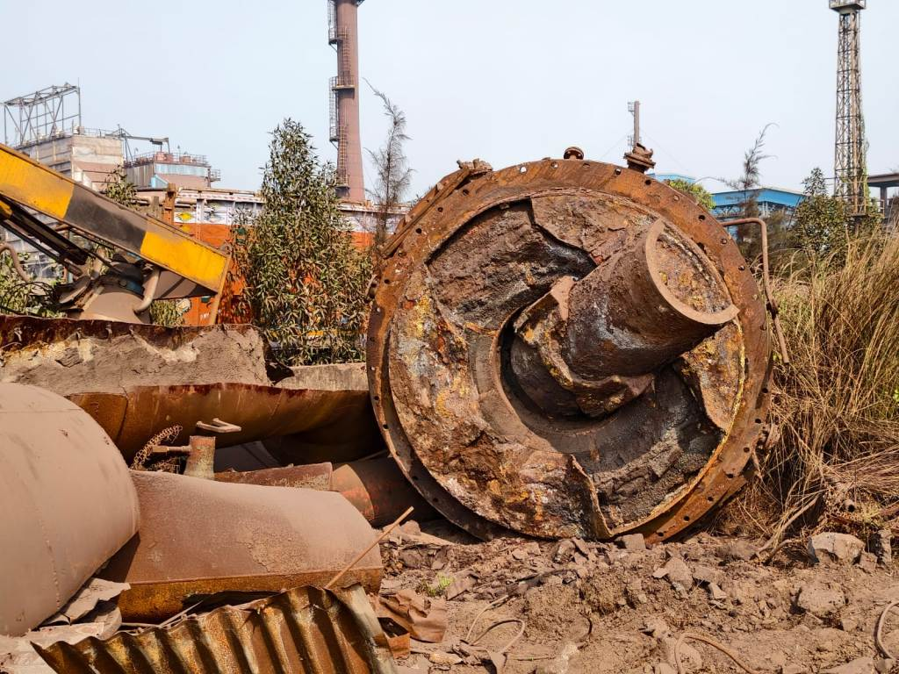
MS Scrap (Heavy) MS Scrap (Heavy) MS Scrap (Heavy)
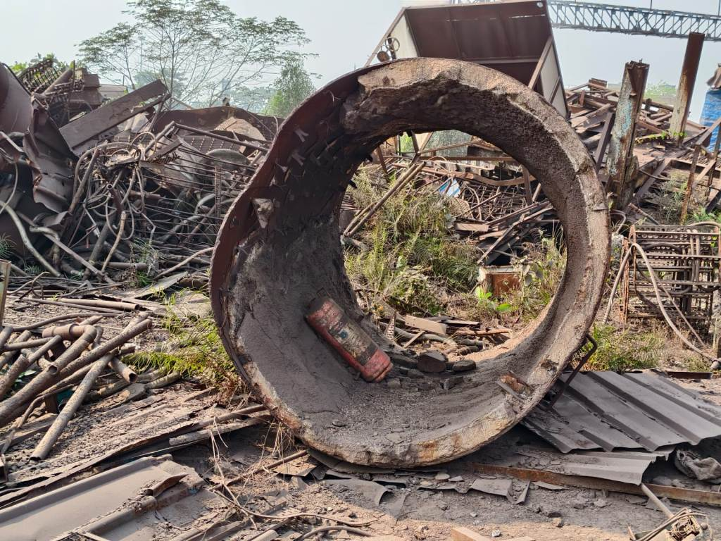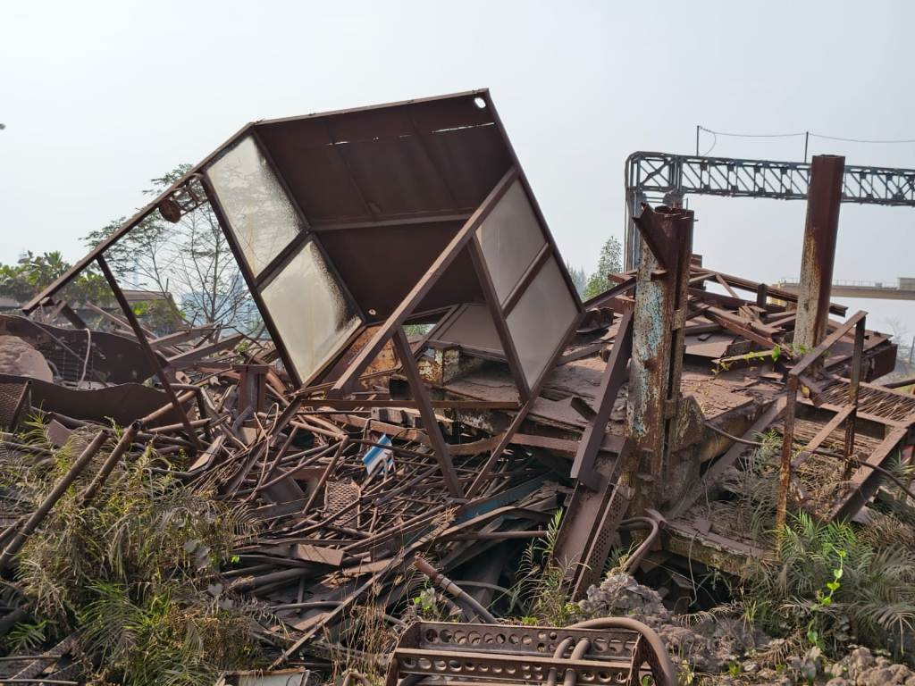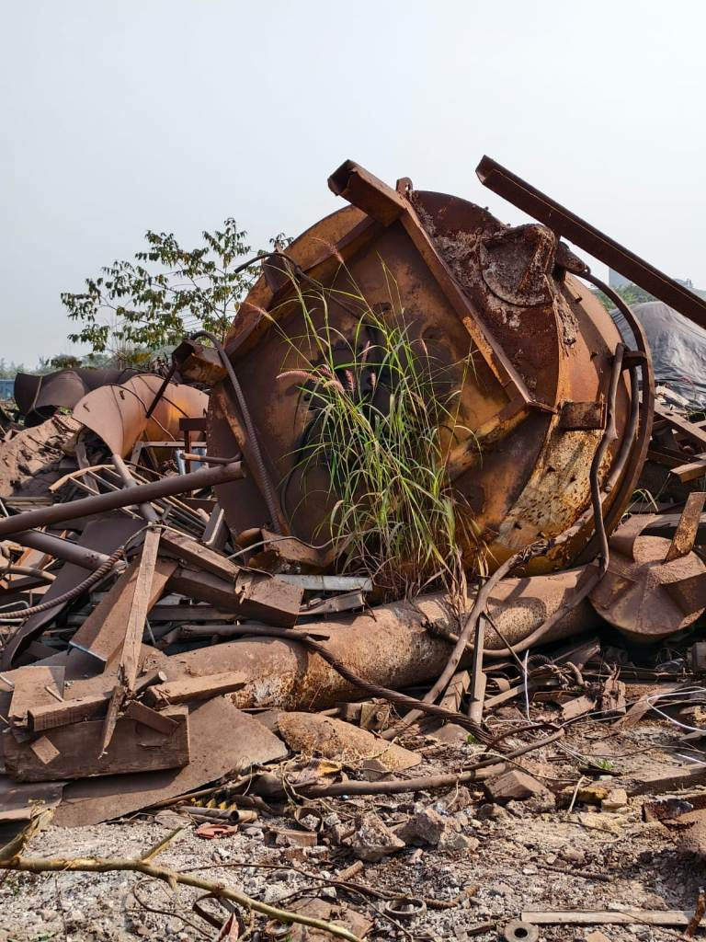
MS Scrap (Heavy) MS Scrap (Heavy) MS Scrap (Heavy)
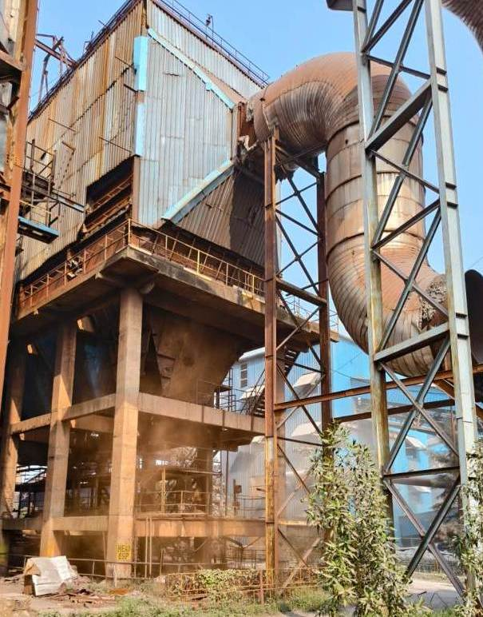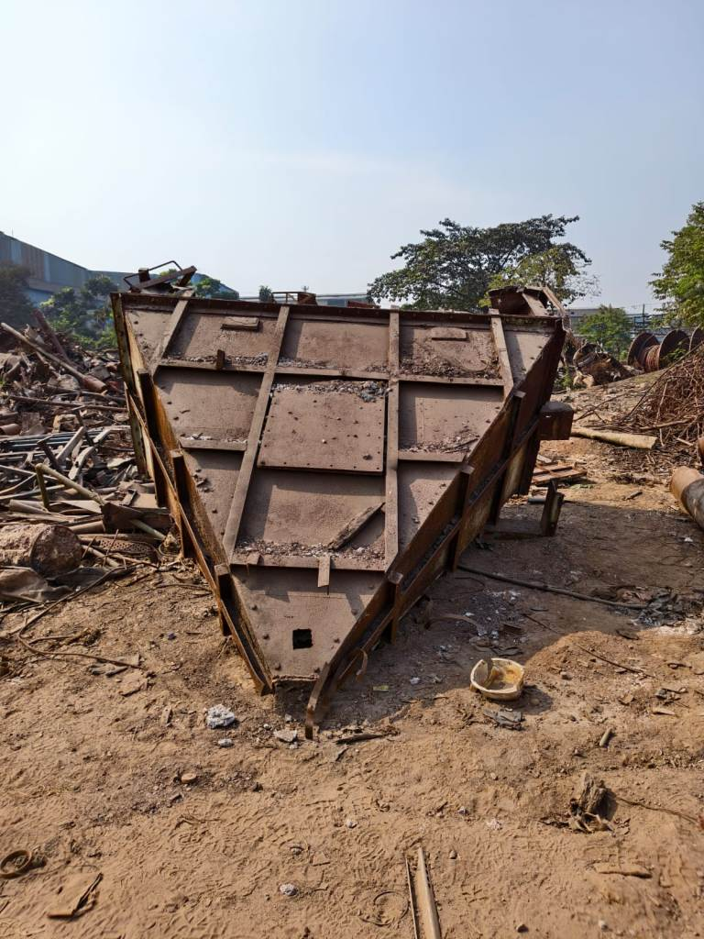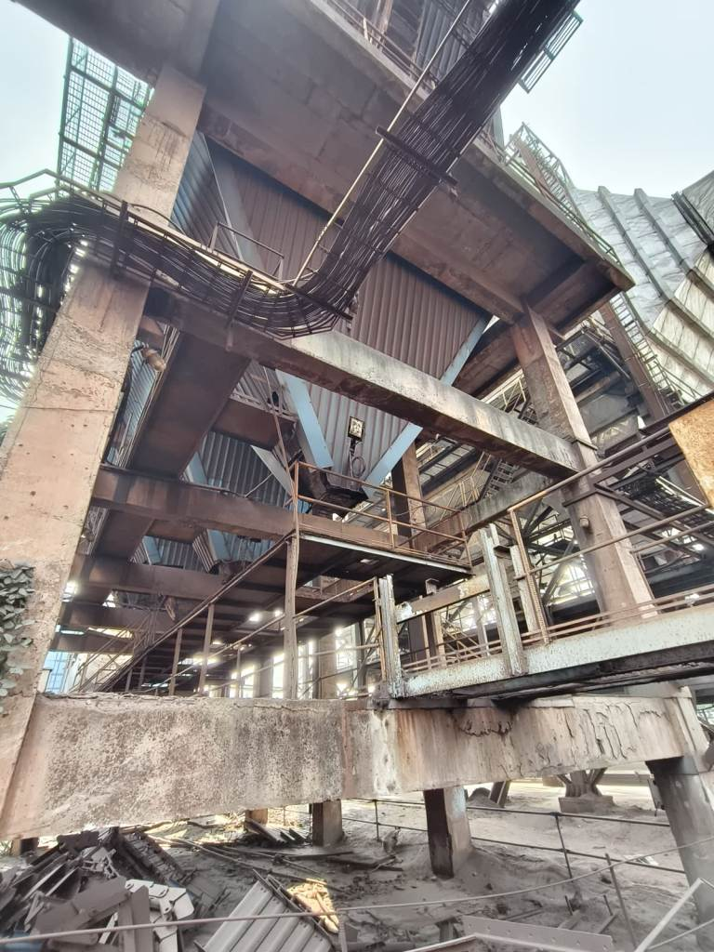
MS Scrap (Heavy) MS Scrap (Heavy) MS Scrap (Heavy)
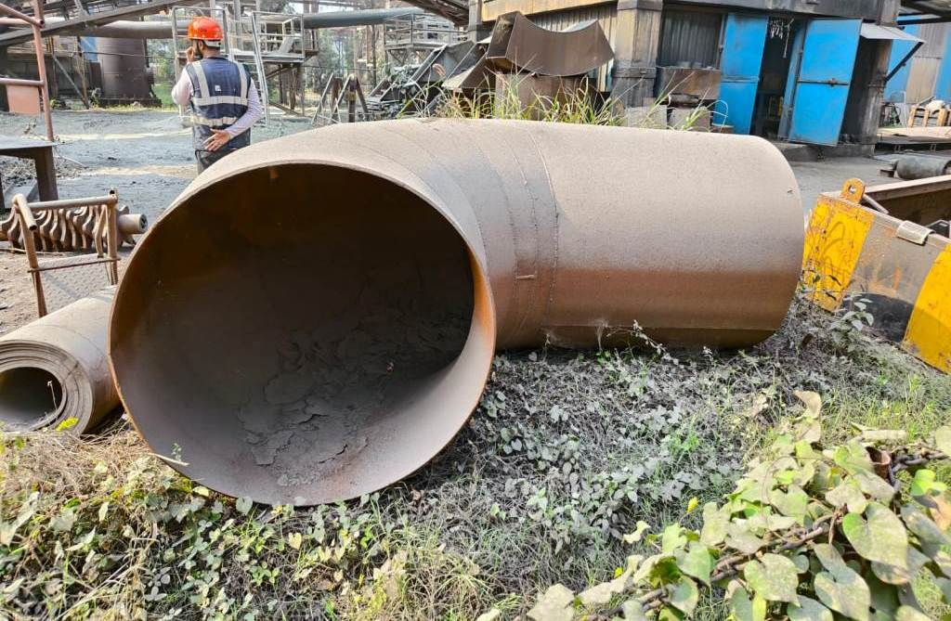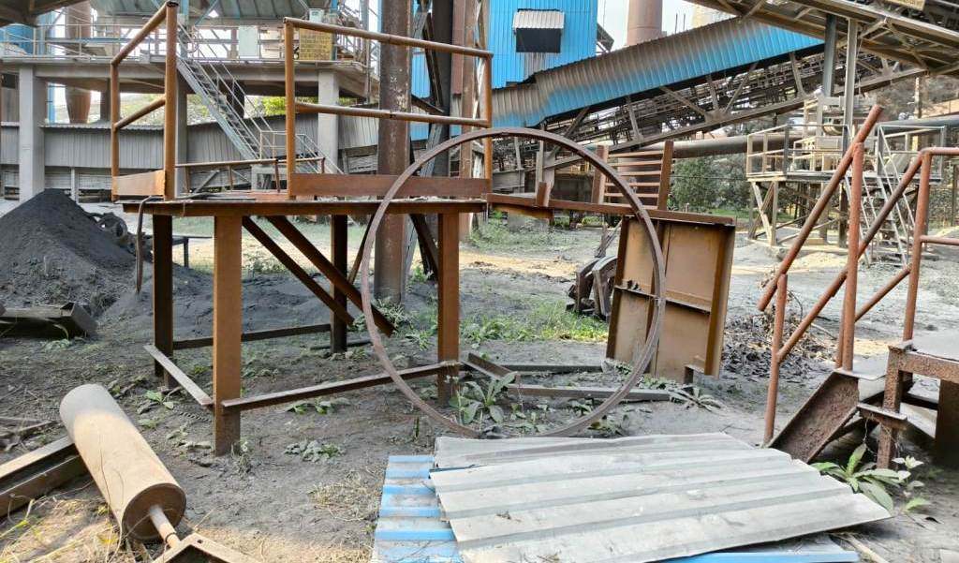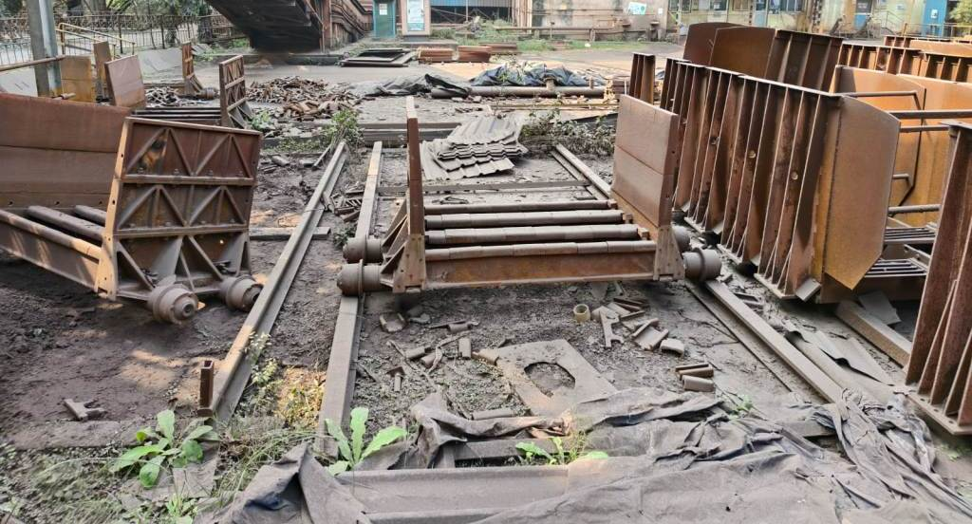
MS Scrap (Heavy) MS Scrap (Heavy) MS Scrap (Heavy)
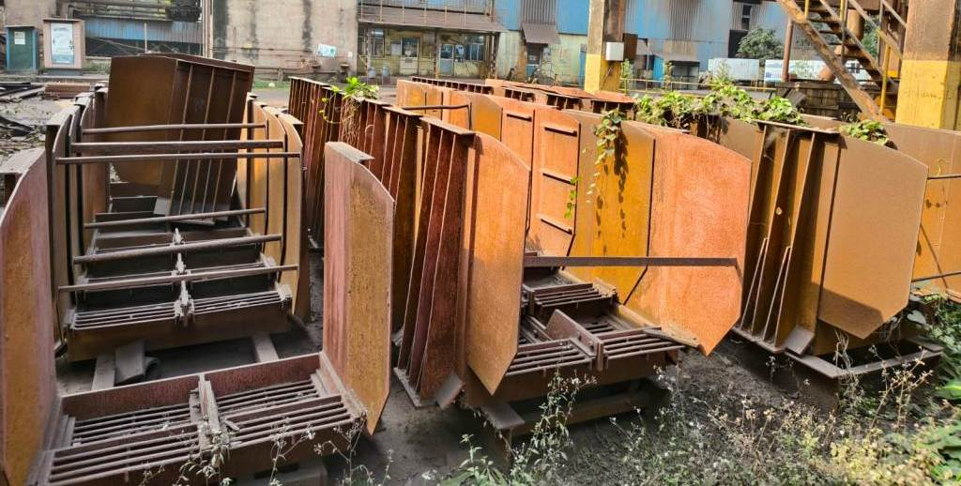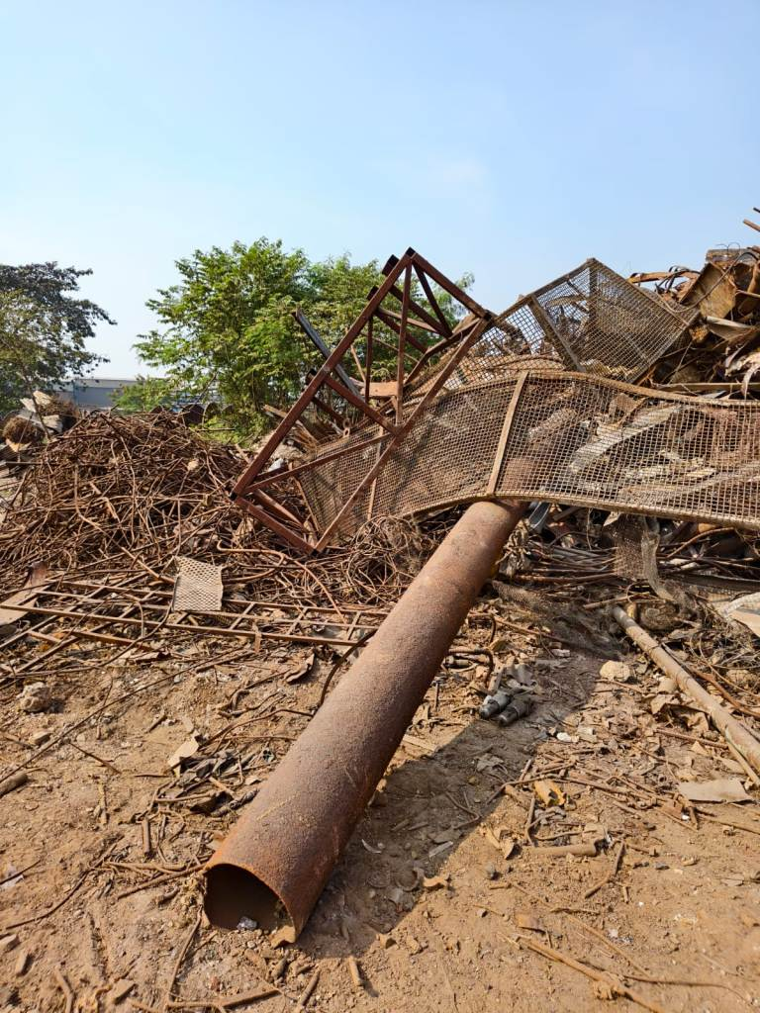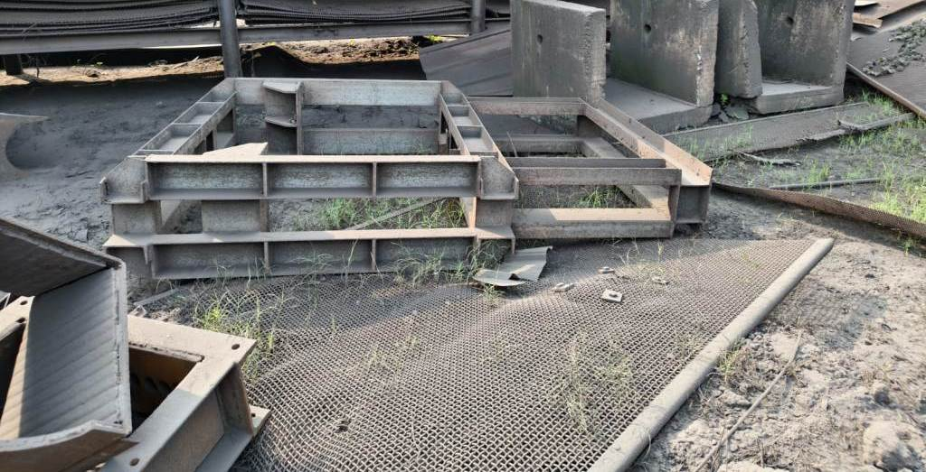
MS Scrap (Heavy) MS Scrap (Heavy) MS Scrap (Heavy)
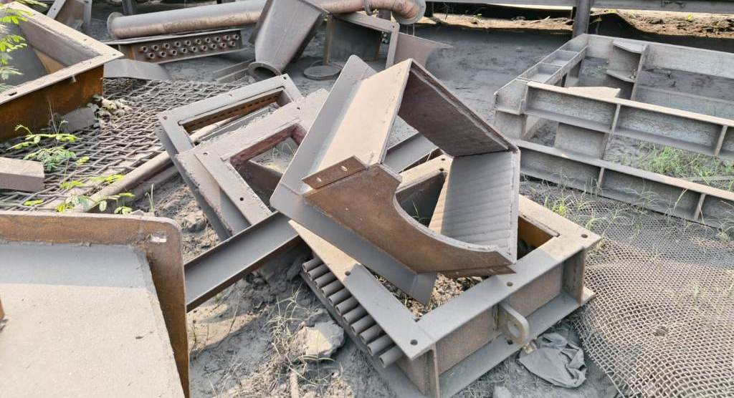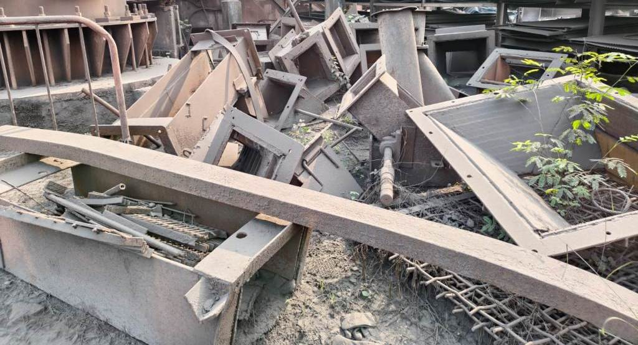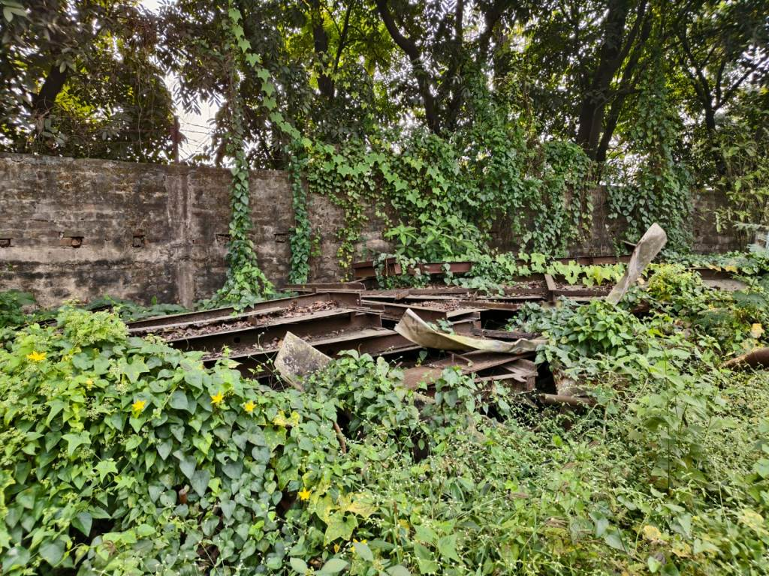
MS Scrap (Heavy) MS Scrap (Heavy) MS Scrap (Heavy)
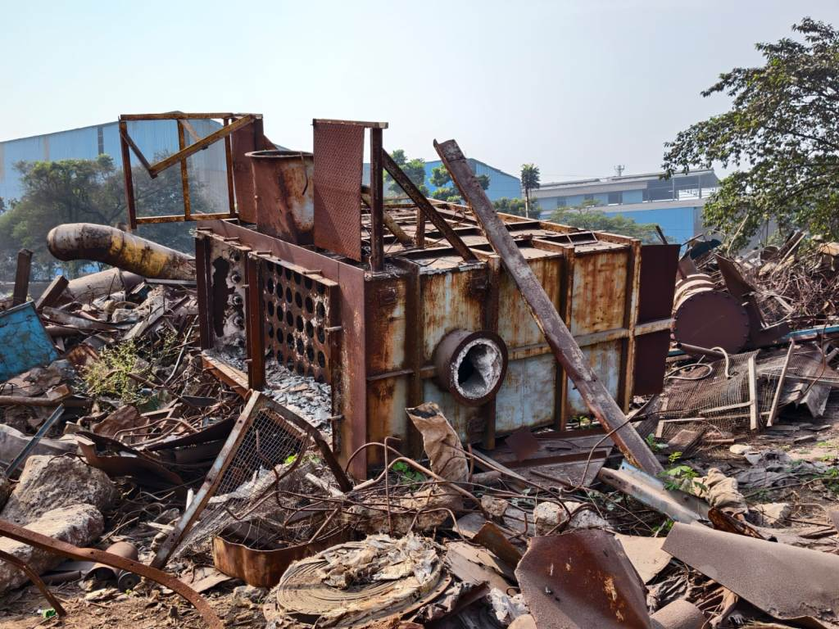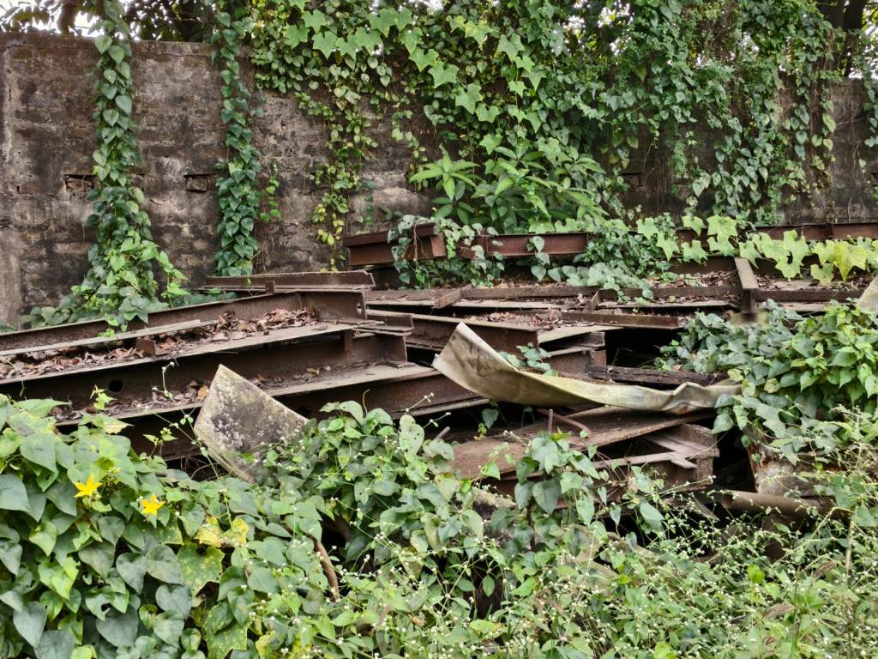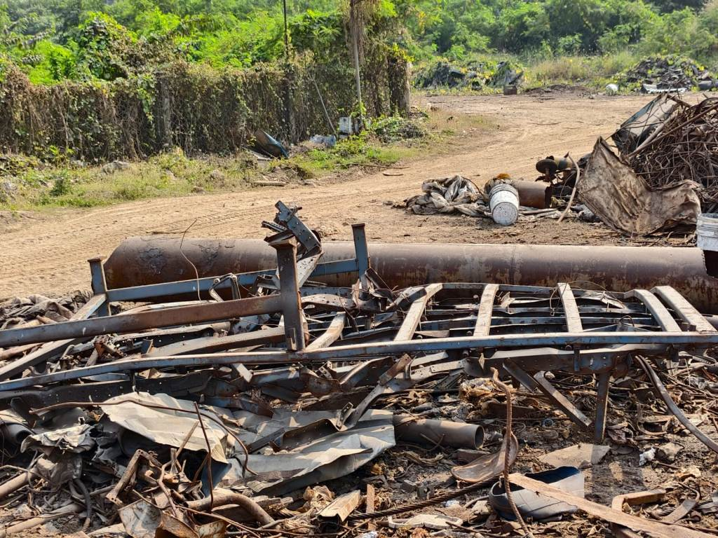
MS Scrap (Heavy) MS Scrap (Heavy) MS Scrap (Heavy)
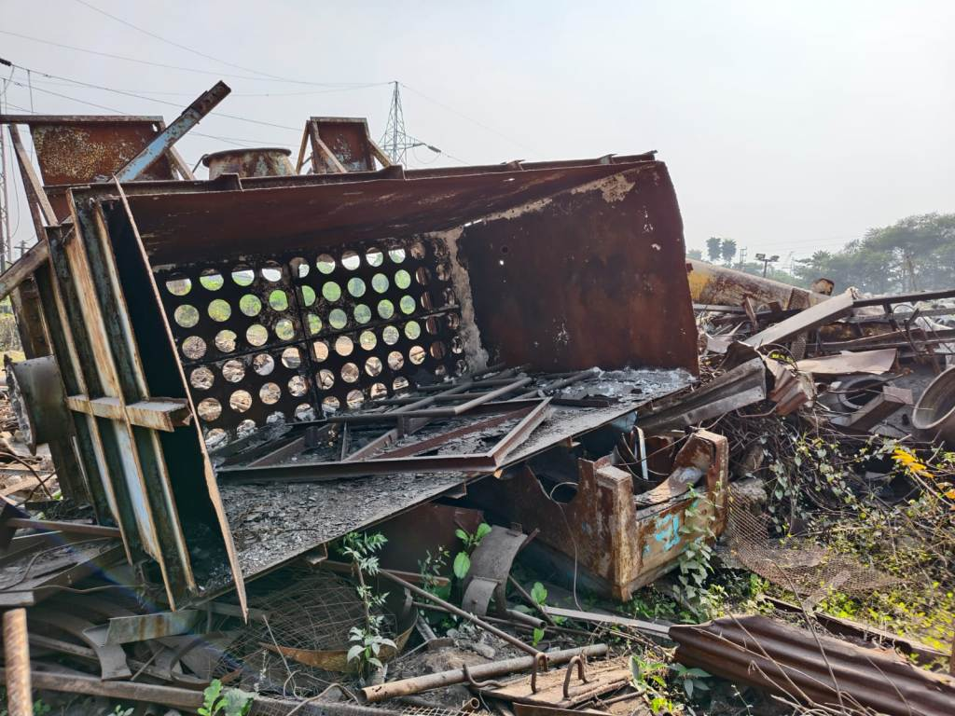
MS Scrap (Heavy)
Open www.ahbilimoria.com ->Click on Customer Complaint Management Portal
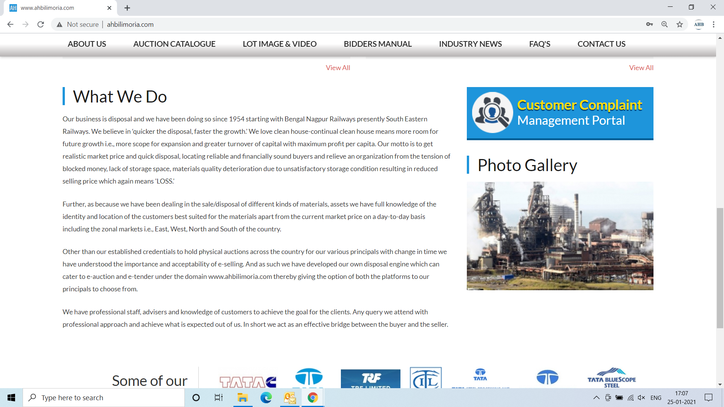

Use your User ID & Password for login

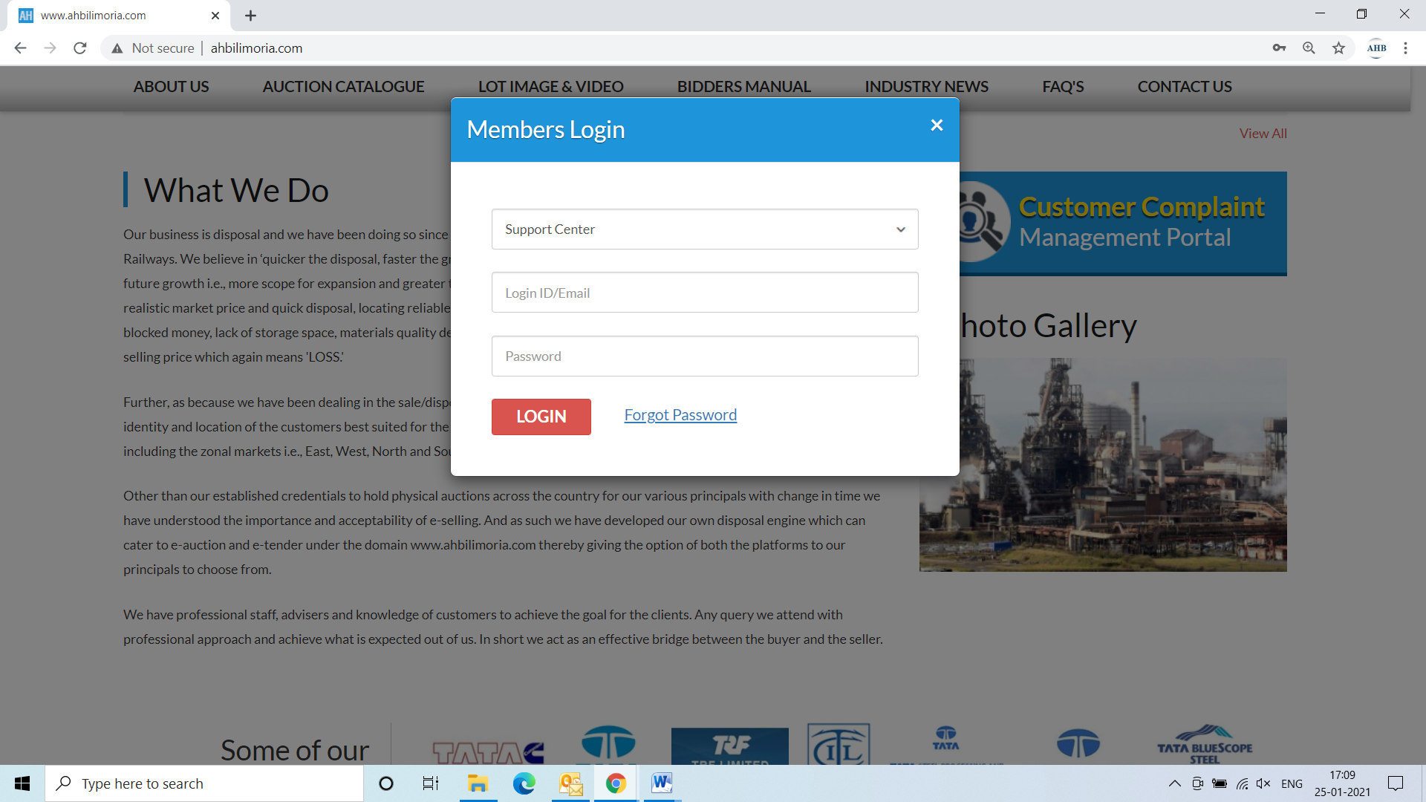
Click Complaint Portal-> Click on “Post a New Ticket”

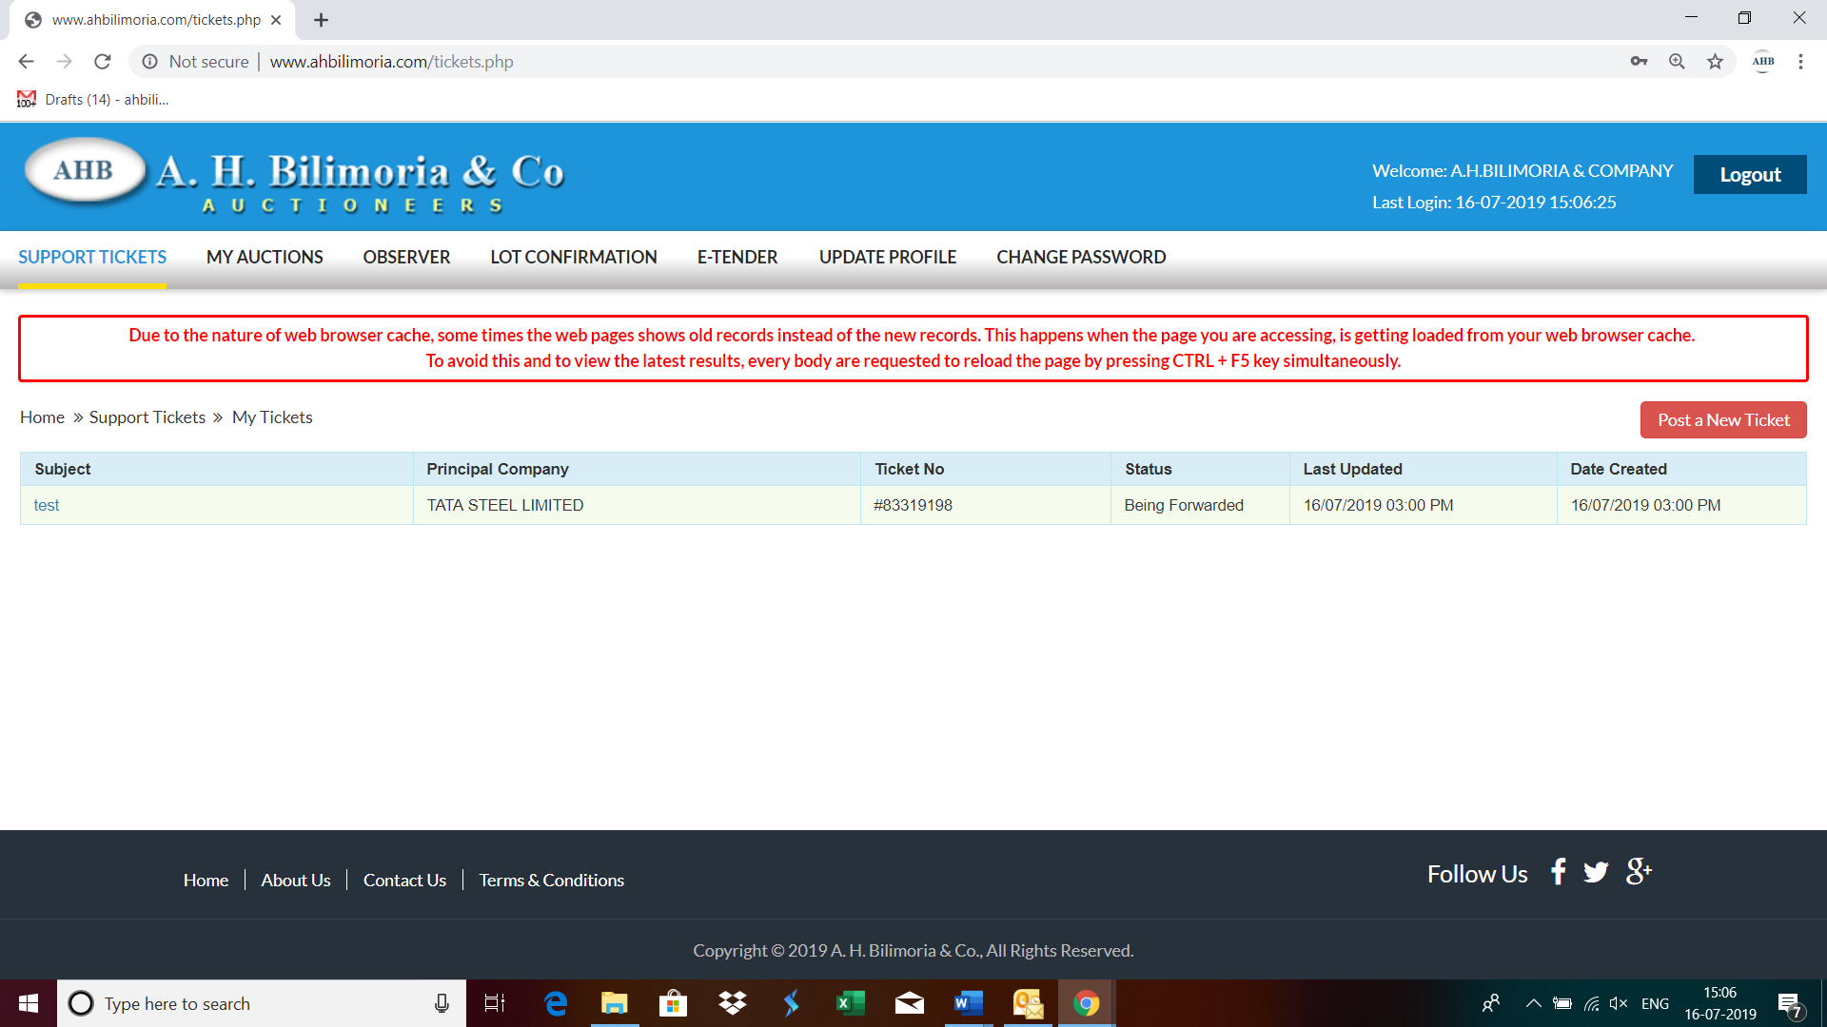

Post a New Ticket->Subject* ->Message* -> Email*->Principal Company*->Attach Document (If required any attachment) ->Submit

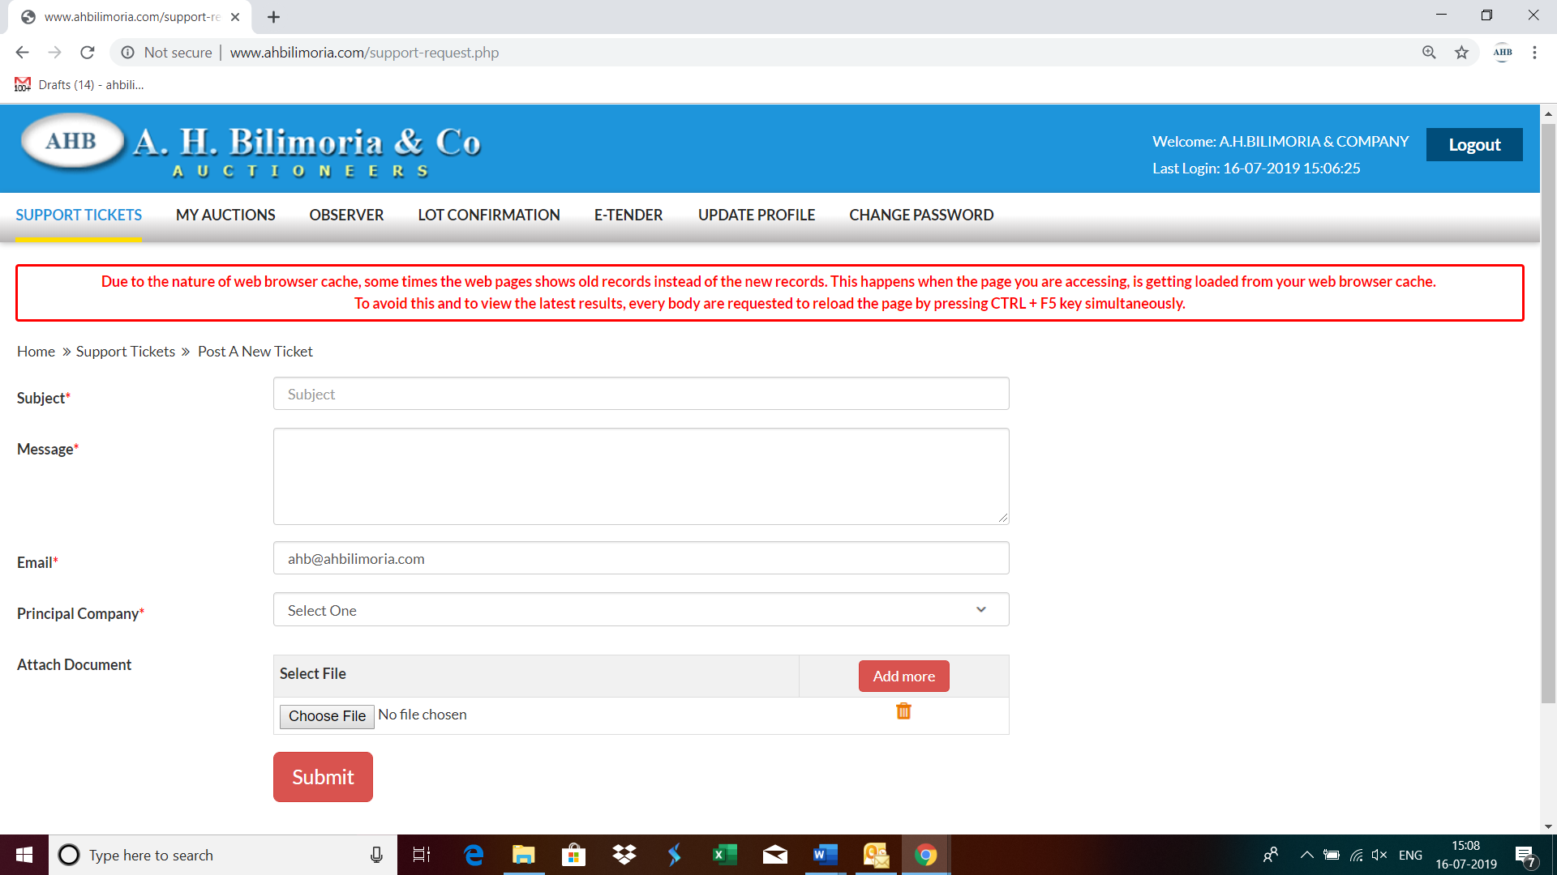

Your support request has been submitted successfully and the Reference No ----- is generated automatically

