Auction Catalogue
Auction conducted by A H Bilimoria & Co.
Auction of Capital Items, Jamshedpur - IBMD
BEING SOLD ON ‘’AS IS WHERE IS AND NO COMPLAINT BASIS’’
Catalogue Serial Number: | CEIL/AHB/APRIL/001/26-27
Seller: | CAPARO ENGINEERING INDIA LTD.  Unit-1 : C21/22&C24-26,4th Phase, Adityapur Ind Area, Gamharia, JSR-832108; Mr. Varun Singh-9204651383  Unit-2 : M5,Large Sector, Gamharia, Saraikela Kharsawan, JSR-832108, Mr. Siddhartha Hazra-8674970091
Auction website: | www.ahbilimoria.com
e-Auction Date & Time: | 22nd April, 2026…..….. at 12:00 PM
Inspection Date & Time: | 21st April, 2026: At 11:30 AM ----------For inspection of Plant materials the interested customers should report at CAPARO ENGINEERING INDIA LTD. , Jamshedpur BY 10:30 AM.  Interested bidders have to come with safety shoes, safety fluorescent jackets and safety helmets as per CAPARO ENGINEERING INDIA LTD. norms at the time of inspection.
Date of Security Money Deposit | 22nd April, 2026 Till ……… at 11:30 AM
Contact Details:
For Post Auction @ A H Bilimoria & Company
Area | Contact No. | Email Id
Auction Room | 08336985888/09830610150/09883421336
Lot Confirmation Related | 8987460668/9836594864 |  | ahb@ahbilimoria.com, ahbilimoria.company@gmail.com
Payment Related
Delivery Order Related
Material Value Refund Related
Security deposit Refund Related | 08336985888/09830610150/09883421336 |  | ahb@ahbilimoria.com, ahbilimoria.company@gmail.com
For time bound resolution of unresolved issues log into our Customer Complaint Management portal | Type in www.ahbilimoria.com> Go to “Customer Complaint Management Portal” >Log in with your user id and password and write the details of issue.

For Any unresolved Issues beyond two (02) days mail to A H Bilimoria & Company :
Mr. A K Sil (M-09830074122) & Mr. D Pyne (M-09830738481), E-mail: ahb@ahbilimoria.com, ahbilimoria.company@gmail.com

SPECIAL NOTE: -It is the responsibility of the buyer to furnish the valid GST no. & necessary documents to A H Bilimoria & Company before participating in the auction. In case during the transactions, it is found that valid GST no. has not been provided, then all necessary liabilities if any & so accrued would be on account of the buyer. CAPARO ENGINEERING INDIA LTD & A H Bilimoria & Company would not be responsible for any such liabilities.

Note: CAPARO ENGINEERING INDIA LTD reserves the right to track IP address, MAC number and geolocation of bidding customers whenever customers participate in any auction on the A H Bilimoria & Co. auction platform for CAPARO ENGINEERING INDIA LTD.

- Payment and Lifting Schedule:
Lot No. | Payment Schedule |  |  | Lifting Schedule  (working days from the next day of DO release)
Lot No. | EMD (10% of lot value) | 1st installment | 2nd installment | 1st installment lifting days | 2nd installment lifting days
For All Material | 02 Working day from Date of Lot Confirmation | 03 Working Days From Date of confirmation | 03 Working Days from the 1st Installment date  [Only Applicable if material value (Rate X Tonnage) crosses Rs. 25 Lakh] | 000 Working days from the D/O date | 3 additional working days at the expiry of 1st Installment DO validity.
- Suitable extension of due date for payment and lifting will be accorded in case of any eventualities like Strike/ Bandh/ Special restriction on vehicular movement imposed by the local Administration etc.

- Requirements of participation:
  - Registration: Before participation in the e-Auction, a prospective bidder shall be required to get registered with A H Bilimoria & Co. For details visit www.ahbilimoria.com

  - Security Deposit: Non-Interest bearing security deposit of Rs.60,000/- (Rupees Sixty Thousand only) for all lots in favour of “A H Bilimoria & Co.” through Online Payment only : Details as under :

Beneficiary Name | A. H. BILIMORIA & COMPANY
Bank Name | HDFC Bank
Branch Name | 31, Chowringhee Road, Kolkata – 700016
Account No | 06932560001205
IFSC Code | HDFC0000693

- Inspection Rules & Policy:
27th February, 2026 : At 11:00 AM ----------For inspection of Plant materials the interested customers should report at CAPARO ENGINEERING INDIA LTD., Jamshedpur BY 10:30 AM.
Interested bidders have to come with safety shoes, safety fluorescent jackets and safety helmets as per CAPARO ENGINEERING INDIA LTD. norms at the time of inspection.

- Bidding modalities:
  - Price Bid Basis: In Indian rupees as per unit of measurement as given in Material List. Price to be quoted is basic, ex- location exclusive of taxes and any other statutory levies.
  - Bid Increment: As specified in the e-auction bid page
  - Type of Auction: English No Ties
  - Bid Validity: Bid shall be valid for 10 (Ten working days excluding 2nd & 4th Saturdays, Sundays and Bank holidays) working days counted from the next day of auction process in case of auction against a catalogue which is completed on the same day. And if it is continuing on any other day the counting of days for lot confirmation shall be from the next day of completion of entire auction process.
  - Bid duration: For 1st four lots 20 minutes and balance lots 05 minutes. If, No bids received within these specified time the lots are closed automatically.
  - Auto Extension of the Auction Timings: In the event of bids in the last sixty (60) seconds of the scheduled bid time, the Bid Timings are automatically extended for One hundred eighty (180) seconds from each such bid. Such Auto Extension shall continue until no bids are placed for sixty (60) seconds (Engine remains inactive for sixty (60) seconds. The Inactivity Time for Auto Extension purpose is normally “3” minutes. "Service Provider" however retains the right to change the “Inactivity Time” as well as “Extension Period”. The Inactivity Time applicable for the particular Online Bid shall be visible to the customers on the Bidding page.

- Taxes & duties:
  - GST : As applicable
  - TCS : As applicable..
  - Any change in taxes applicable at the time of lifting shall be applicable.
  - Customers are required to submit Form 27C/Form 27G against the month of dispatch/expected dispatches. In the absence of Form 27C, TCS will be charged at the time of invoicing.

- Payment terms & conditions :
  - Payments: PAYMENT FACILITY BY RTGS / NEFT ONLY

CAPARO ENGINEERING INDIA LTD. UNIT 1
Account No. | 30398826847
Beneficiary Name | CAPARO ENGINEERING INDIA LTD.
Beneficiary Bank Name | STATE BANK OF INDIA
Branch Name | S.M.E, ADITYAPUR
IFSC Code | SBIN0006726

CAPARO ENGINEERING INDIA LTD. UNIT 2
Account No. | 31802592369
Beneficiary Name | CAPARO ENGINEERING INDIA LTD.
Beneficiary Bank Name | STATE BANK OF INDIA
Branch Name | S.M.E, ADITYAPUR
IFSC Code | SBIN0006726

  - EMD: 10% of the material value to be paid within 02 (Two) working day from the date of lot confirmation. EMD to be adjusted in the final installment only.
EMD payment is to be made within the time limit as given in letter of confirmation. No extension will be provided for the same.
  - Balance Payment Time: (As per payment schedule)
  - Saturdays, Sundays and Bank holidays are excluded for counting purpose for payment schedule.
  - In the event of Non-Receipt of Payment within the stipulated period of Payment, the Sale Offer for the approved Lot shall stand withdrawn automatically (Refer Clause#8).
  - Buyers have to send the payment deposit slip (UTR No /Scan Copy of NEFT/RTGS Transaction Slip) against Lot No. immediately after the payment to AHB at email id: ahb@ahbilimoria.com& ahbilimoria.company@gmail.com

- Lifting terms & conditions:
7.1 DOs will be handed over to authorized representatives of bidders on receipt of payment. Authorization letter to be issued via registered e-mail id’s. Authorized letter must be duly stamped and signed by the proprietor or partner or director on receipt of payment. Lifting date is calculated from the next day of DO Release date.
7.2 Loading Charges: As mentioned in material list
7.3 Loading shall be given strictly as per the statutory norms & safety norms of CAPARO ENGINEERING INDIA LTD.
7.4 PICK & CHOOSE NOT ALLOWED FOR ANY OF THE LOTS.
7.7 LOT TRANSFER WILL NOT BE ALLOWED.

- Penalty:
  - The following penalties shall be applicable in the eventuality of a buyer defaulting in making the payment of EMD (wherever applicable) or any installment/s, as per the stipulated schedule for each lot, in a financial year:
- In the first instance, a penalty of Rs. 60,000/- (Rupees Sixty Thousand only) shall be recovered from the customer.
- In the second instance, a penalty of Rs.100,000/- (Rupees One Lakh only) shall be recovered from the customer.
- In the third, and any subsequent instance, a penalty of Rs.150,000/-(Rupees One Lakh Fifty thousand only) shall be recovered and the customer shall be debarred from participating in any auction for a period of three months from the date of debarment.
In the event of any default, the customer’s user id will be disabled and the customer will be blocked from participating in any auction of CAPARO ENGINEERING INDIA LTD with immediate effect.

The defaulting customer shall be allowed 06 (six) working days to deposit the penalty as mentioned above. In case the penalty is not received within the stipulated period, the customer’s security deposit shall be forfeited, and the defaulting customer shall be immediately debarred from participating in any auction of CAPARO ENGINEERING INDIA LTD.

  - If after making payment of EMD (wherever applicable), the installment payment/s are not made by the customer as per the stipulated schedule for each lot, the entire EMD amount against such lot shall be forfeited.

  - In case of non- lifting of full lot quantity after making full payment, a penalty equivalent to 20% of the material value for the un-lifted quantity against each lot shall be recovered from the customer.

- Lot Closure Norms :
For Lot Closure, the tolerance would be ± 10% of the original quantity of all lots.

- Refund :
Refunds will only be made by CAPARO ENGINEERING INDIA LTD vide RTGS/NEFT and hence all customers are required to submit their bank details to A H Bilimoria & Company or mail at ahb@ahbilimoria.com, ahbilimoria.company@gmail.com, ahbjsr@ahbilimoria.com, b.bhardwaj@ahbilimoria.com. CAPARO ENGINEERING INDIA LTD or A H Bilimoria & Company will not be responsible for any delay in refunds owing to absence of bank details of the customer.

- Complaints :
Complaints, if any, with regard to any transaction shall have to be lodged by the buyer within three calendar months from the date of last invoice. No complaint shall be entertained thereafter, under any circumstances. Customers can log their complaints at (www.ahbilimoria.com> Go to “Customer Complaint Management Portal” >Log in with your user id and password and write the details of issue.)

- Jurisdiction :
Any dispute arising out of any contract shall be decided in Jamshedpur by the courts in Jamshedpur and by no other courts. The courts in Jamshedpur shall have exclusive jurisdiction to adjudicate upon any such dispute.

- General terms & conditions:
  - Any dispute on quality & quantity of material and bid cancellation shall not be entertained at any point after the auction.
  - All lots are offered/sold on “As is Where is Basis” and “No Complaint Basis”.
  - Lot transfer will not be allowed. Payment and invoicing has to done in the name of the H1 bidder, subject to the prices being approved.
  - Lot purchased should consist of material from the same lot and designated location only. CAPARO ENGINEERING INDIA LTD has the right to check any vehicle at any moment of time. If material lifted differs from the material that is purchased by the buyer, then the buyer and authorized representative will be permanently debarred. Also CAPARO ENGINEERING INDIA LTD can take any penal action against the buyer/authorized representative. All the material loaded in the vehicle is to be covered in order to follow the safety compliance of CAPARO ENGINEERING INDIA LTD works.
  - If the safety compliance is not followed, then CAPARO ENGINEERING INDIA LTD can penalize the buyer / authorized representative as deemed fit.
  - Customer attested photocopy of valid id proof (Voter id/Aadhar/Pan card) of all lifters / Authorized persons engaged by customers for lifting of materials from CAPARO ENGINEERING INDIA LTD is to be enclosed with the authorization letters & to be forwarded to CAPARO ENGINEERING INDIA LTD for issue of gate pass.
  - Dispatch is subjected to FORCE MAJEURE conditions
  - The seller reserves the right to terminate any offer at any point of time without assigning any reasons
  - In the event of termination of the offer, seller shall refund the balance amount after due reconciliation
  - No claims whatsoever would be entertained after cancellation of the bid
  - In addition of earlier safety norms, the following would be compulsory:
The drivers of the vehicle must have the eye test certificate. The frequency of the testing would be as below:
1. If the age of the person is less than 45 years - Once in a year
2. If the age of the person is 45 years or more, the testing is required to be done once in every 6 months
Please ensure to comply with the safety norms
  - Weighment : Weight recorded by CAPARO ENGINEERING INDIA LTD weighbridge will be considered final and binding on the customer.
  - Non lifting of will penalised as per agreements
  - No segregation in our plant except bundling.
  - Labor to be supplied by scrap lifter.
  - Scrap lifting time 9.00 am to 5.30 pm
  - Bundling timing will be 7.00 AM to 5.30 PM
  - No vehicles will halt at night in plant otherwise penalised @10000.00 per day.
  - Electrical charge will be applicable
  - No scrap lifting/bundling will be allowed on Sunday/holidays.
  - “Payments should be made one day prior to placing the vehicle in form of RTGS only” NO OTHER MODE OF PAYMENT WILL BE ACCEPTED.
  - If Scrap is lying outside the area allocated to you a penalty of Rs 5000/ per day will be imposed.

14. Compliance to safety norms
14.1 Authorized persons (of the customer) involved in lifting of the materials will be allowed only with Personal Protective Equipment’s (PPE) i.e., Safety Shoes, Safety Helmet, Safety Goggles, Fluorescent Jacket and Hand Gloves. No "people movement" shall be allowed at the time of loading/delivery of materials from the yards" CAPARO ENGINEERING INDIA LTD will not be responsible for any delays arising out of Non- Compliance to the Safety Norms.

14.2 Documents for verification regarding entry of vehicles inside CAPARO ENGINEERING INDIA LTD works :
All customers to note that presentation of following set of documents to CAPARO ENGINEERING INDIA LTD authorities is COMPULSORY at the time of reporting of vehicles at CAPARO ENGINEERING INDIA LTD designated Gate for entry of Customer trucks/vehicles.
a. Driving License of driver,
b. Registration Card,
c. Commercial Certificate,
d. Fitness Certificate of Vehicle,
e. Re-registration for vehicles older than 15 years
f. Insurance
The checklist form will be filled in at CAPARO ENGINEERING INDIA LTD designated Gate for entry of Customer trucks/vehicles before entry of vehicle.

Sl. No. | Safety Parameters to be checked
1 | Three Piece Mirror(Truck, Trailer & Dumper)-Helper side
2 | Single Mirror- Driver side
3 | Rear View Mirror (Tata Ace, 207, Jeep etc.)
4 | Service Brake
5 | Parking Brake
6 | Seat Belt
7 | Head Light
8 | Parking Light
9 | Blinker
10 | Horn
11 | Reverse Alarm
12 | Wiper
13 | Windshield Glass
14 | Air Pressure Min. 7 Kg/Cm^2
15 | Run Under Protection Guard as per CAPARO ENGINEERING INDIA LTD standard
16 | Side under Protection Guard as per CAPARO ENGINEERING INDIA LTD standard
17 | Tyre Condition (Tread Depth, Cut Mark etc.)
18 | Any Oil Leakage from the vehicle
19 | Physical condition of Dallah
20 | Availability of scotch block
21 | Buzzer with side indicator
22 | Driver's eye examination report
Legal Documents to be checked:
Sl. No. | Documents to be Checked
1 | RC Book
2 | Insurance
3 | Pollution
4 | Driving licence
5 | Fitness for more than 15 years old vehicle
6 | NOC for outside vehicles

15. DISCLAIMER FOR E-AUCTION
BANDWIDTH PROBLEMS, CONNECTIVITY PROBLEMS WITH THE LOCAL ISP (INTERNET SERVICE PROVIDER), SLOWNESS TO ACCESS PAGES FOR DOWNLOADING ETC. ARE BEYOND THE CONTROL OF CAPARO ENGINEERING INDIA LTD AND A H BILIMORIA & COMPANY. HENCE NO RESPONSIBILITY LIES WITH CAPARO ENGINEERING INDIA LTD OR A H BILIMORIA & COMPANY FOR THE ABOVE PROBLEMS FACED, IF ANY, BY THE BIDDERS BEFORE/DURING THE AUCTION ANY. BID PLACED USING THE BIDDER'S USERNAME AND PASSWORD IS UNCONDITIONALLY BINDING ON THE BIDDER TO WHOM SUCH USERNAME AND PASSWORD HAD BEEN ALLOTTED AND HE SHALL BE SOLELY RESPONSIBLE FOR MAINTAINING THE CONFIDENTIALITY OF THE SAME AND FULLY RESPONSIBLE FOR ALL ACTIVITIES THAT OCCUR UNDER THEIR USERNAME AND PASSWORD. HENCE THE USER IS ADVISED TO CHECK THE USERNAME AND PASSWORD BEFORE THE AUCTION,IN ORDER TO FAMILIARISE HIMSELF WITH THE SAME AND IS ADVISED NOT TO REVEAL IT TO ANYONE ELSE SO AS TO PREVENT MISUSE OF THE SAME. THE BIDS MADE BY THE BIDDERS AGAINST THEIR USERNAME AND PASSWORD SHALL BE IRREVOCABLE.THE BIDDERS ARE ADVISED TO REGISTER AND PRE-QUALIFY FOR BIDDING WELL IN ADVANCE AND PLACE THEIR BIDS EARLY IN ORDER TO TAKE CARE OF ANY UNFORESEEN TECHNICAL DIFFICULTY THAT MIGHT SURFACE IN THE INTERNET OPERATIONS.

Lot Photograph: Photographs of lots are at best indicative only and do not necessarily reflect the actual condition of lots. All bidders are advised to physical/e-inspection the offered lots before participating in the auctions. CAPARO ENGINEERING INDIA LTD or A H Bilimoria & Co. shall not be responsible or liable for any error of judgment or bids put by bidders acting on the basis of these photographs.

Quantity offered is based on eye estimation. Delivery will be made for the estimated quantity or actual ground stock. Estimation error may arise. No complaint of whatsoever nature on estimated /offered quantity shall be entertained under any circumstances. Bidders are advised to make their own judgment on offered quantity before bidding.

MATERIAL DETAILS:
CAPARO ENGINEERING INDIA LTD: LIST OF MATERIALS
Sl. No | Location | LOT no. | Material Description | Qty | UOM | GST | TCS | Loading | Lifting period | Contact person | Contact no
1 | CAPARO ENGINEERING INDIA LTD. , UNIT 1, Gamharia, JSR | CAPARO260401 | SCRAP - EMPTY PLASTIC DRUM (200 LTR) -Plant -1 | 40 | No | 18% | 2% | Customer | 10 working days from date of approval | Mr. Varun Singh/ Mr. Siddhartha Hazra | 9204651383/ 8674970091
2 | CAPARO ENGINEERING INDIA LTD. , UNIT 2, Gamharia, JSR | CAPARO260402 | SCRAP – WOODEN – Plant 1 & Plant -2 | 5000 | KG | 18% | 2% | Customer | 10 working days from date of approval | Mr. Varun Singh/ Mr. Siddhartha Hazra | 9204651383/ 8674970091
3 | CAPARO ENGINEERING INDIA LTD. , UNIT 1, Gamharia, JSR | CAPARO260403 | SCRAP - PLASTIC (35 JAR) Plant 1 | 300 | No | 18% | 2% | Customer | 10 working days from date of approval | Mr. Varun Singh/ Mr. Siddhartha Hazra | 9204651383/ 8674970091
4 | CAPARO ENGINEERING INDIA LTD. , UNIT 1 & 2, Gamharia, JSR | CAPARO260404 | SCRAP - (TIN PAPER IRON) – Plant – 1 & 2 | 2500 | KG | 18% | 2% | Customer | 10 working days from date of approval | Mr. Varun Singh/ Mr. Siddhartha Hazra | 9204651383/ 8674970091
5 | CAPARO ENGINEERING INDIA LTD. , UNIT 1, Gamharia, JSR | CAPARO260405 | SCRAP - EMPTY DRUM (20 LTR) Plant -1 | 1000 | No | 18% | 2% | Customer | 10 working days from date of approval | Mr. Varun Singh/ Mr. Siddhartha Hazra | 9204651383/ 8674970091
6 | CAPARO ENGINEERING INDIA LTD. , UNIT 1 & 2, Gamharia, JSR | CAPARO260406 | SCRAP MS PACKING STRIP – Plant 1 & Plant 2 | 5000 | KG | 18% | 2% | Customer | 10 working days from date of approval | Mr. Varun Singh/ Mr. Siddhartha Hazra | 9204651383/ 8674970091
7 | CAPARO ENGINEERING INDIA LTD. , UNIT 1, Gamharia, JSR | CAPARO260407 | GAS CUTTING CHAI – Plant -1 | 1000 | KG | 18% | 2% | Customer | 10 working days from date of approval | Mr. Varun Singh/ Mr. Siddhartha Hazra | 9204651383/ 8674970091

ALL THE PHOTOGRAPHS ARE INDICATIVE ONLY
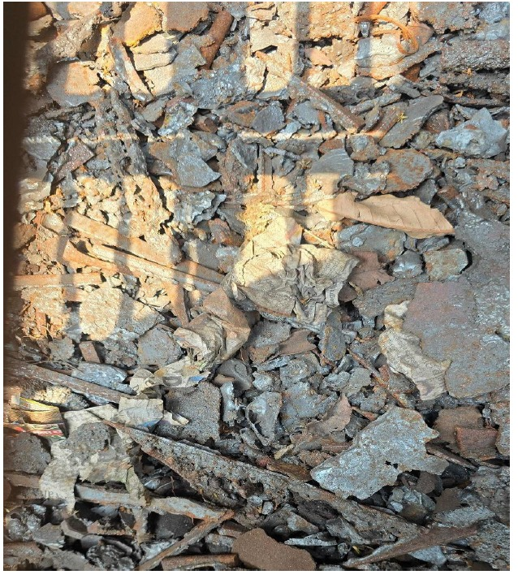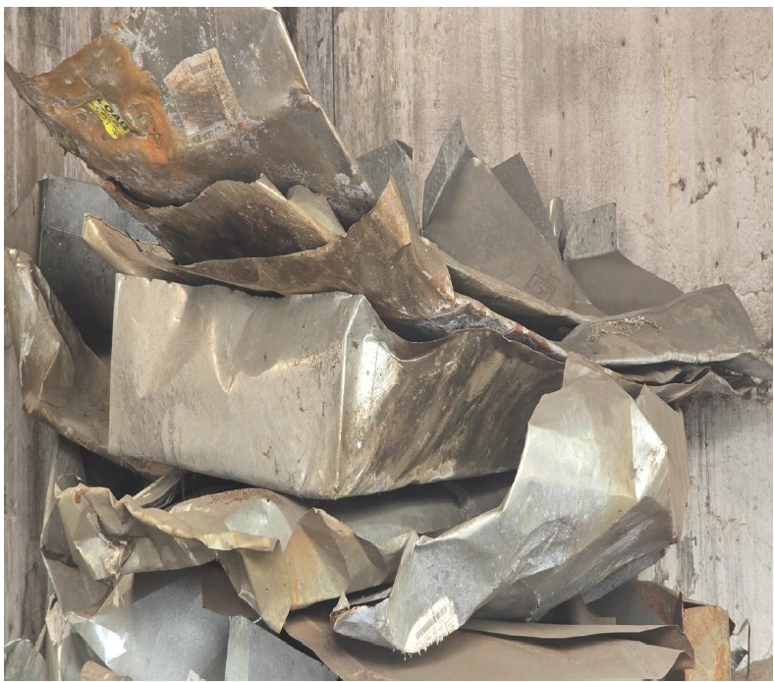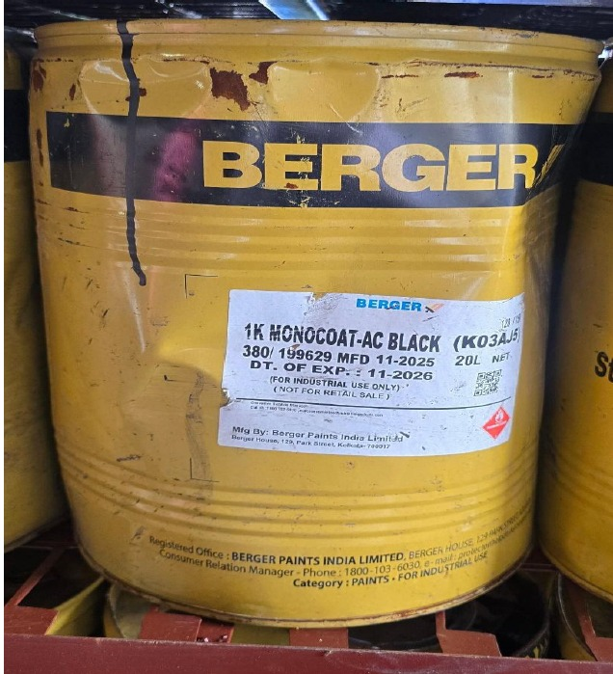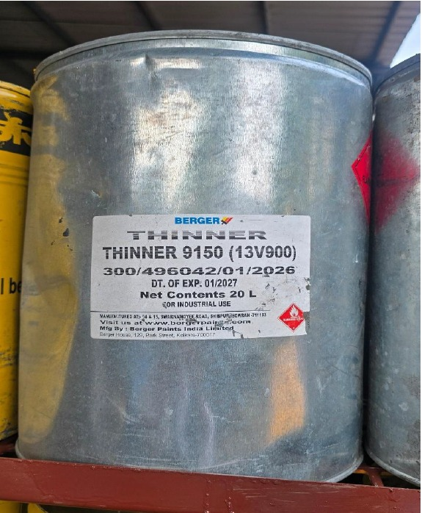
GAS CUTTING CHAI SCRAP - (TIN PAPER IRON) SCRAP- EMPTY DRUM (20 LTR) SCRAP- EMPTY DRUM (20 LTR)
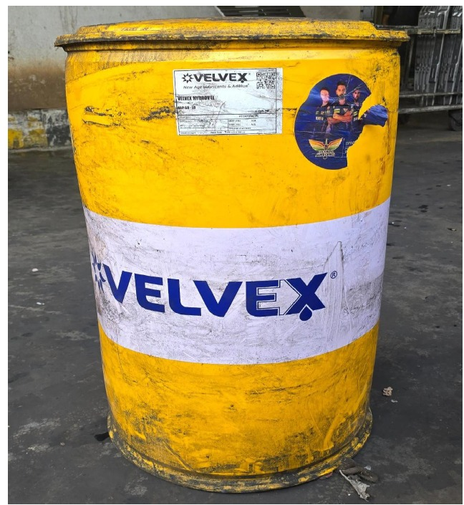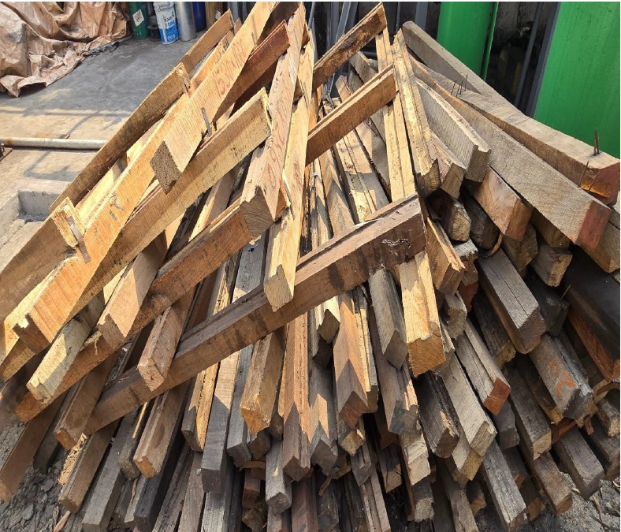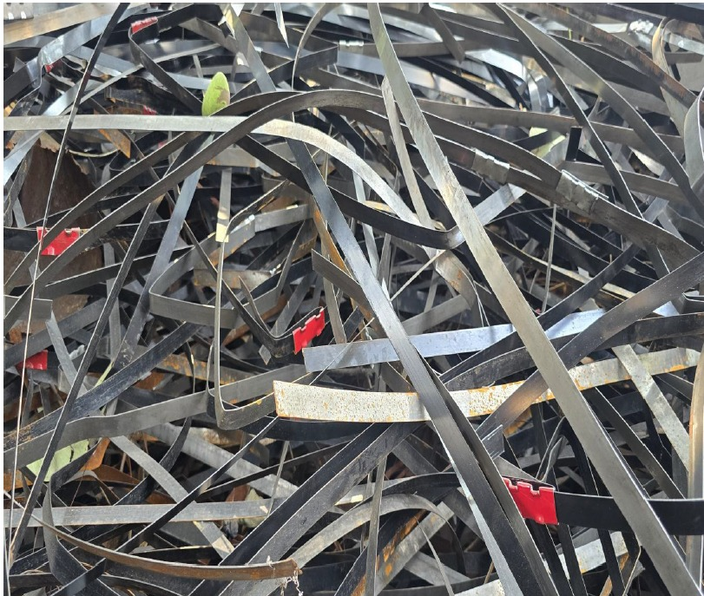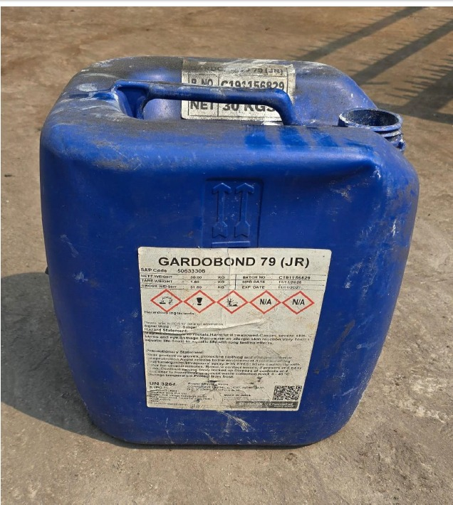
SCRAP-EMPTY PLASTIC DRUM (200LTR) SCRAP – WOODEN SCRAP MS PACKING STRIP SCRAP - PLASTIC (35 JAR)

Open www.ahbilimoria.com ->Click on Customer Complaint Management Portal
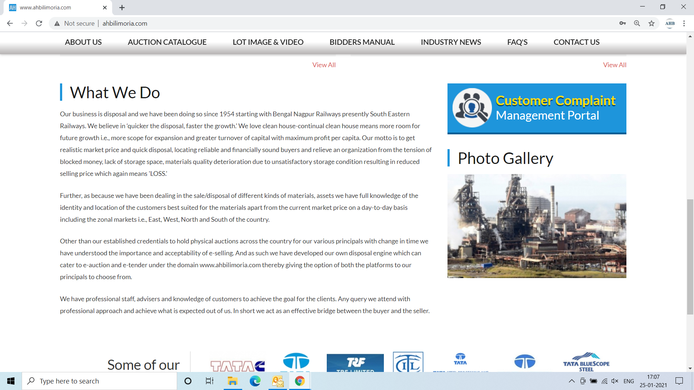

Use your User ID & Password for login

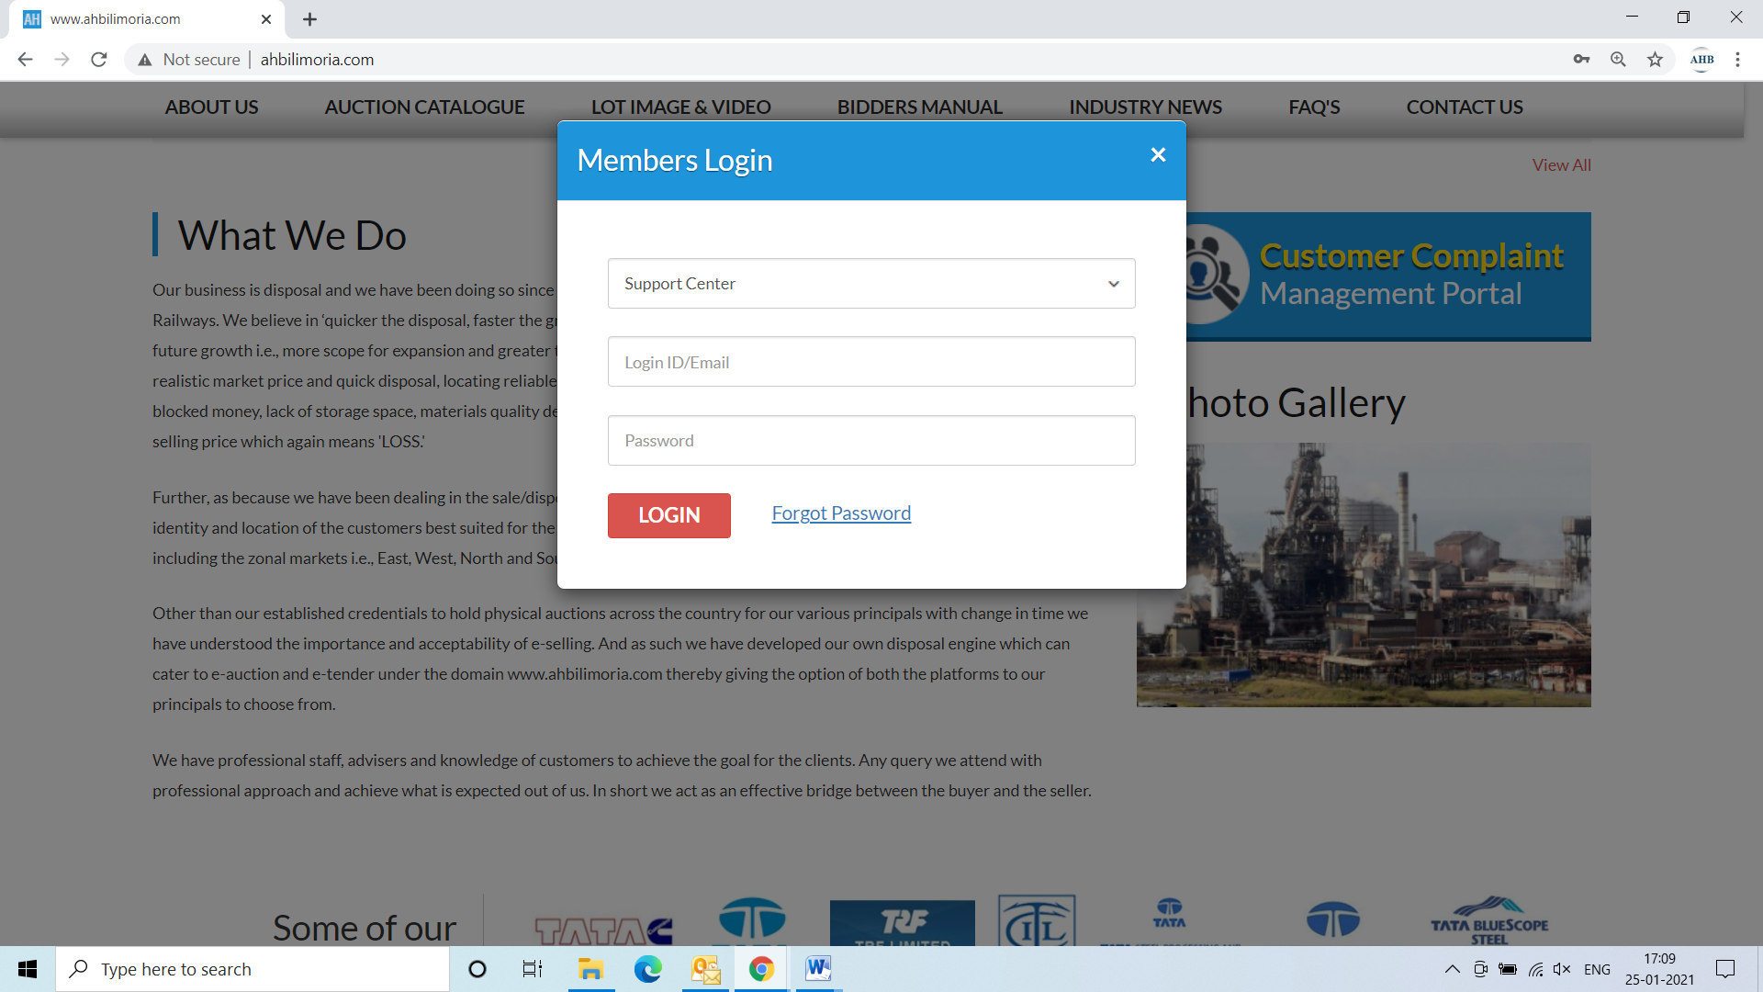
Click Complaint Portal-> Click on “Post a New Ticket”

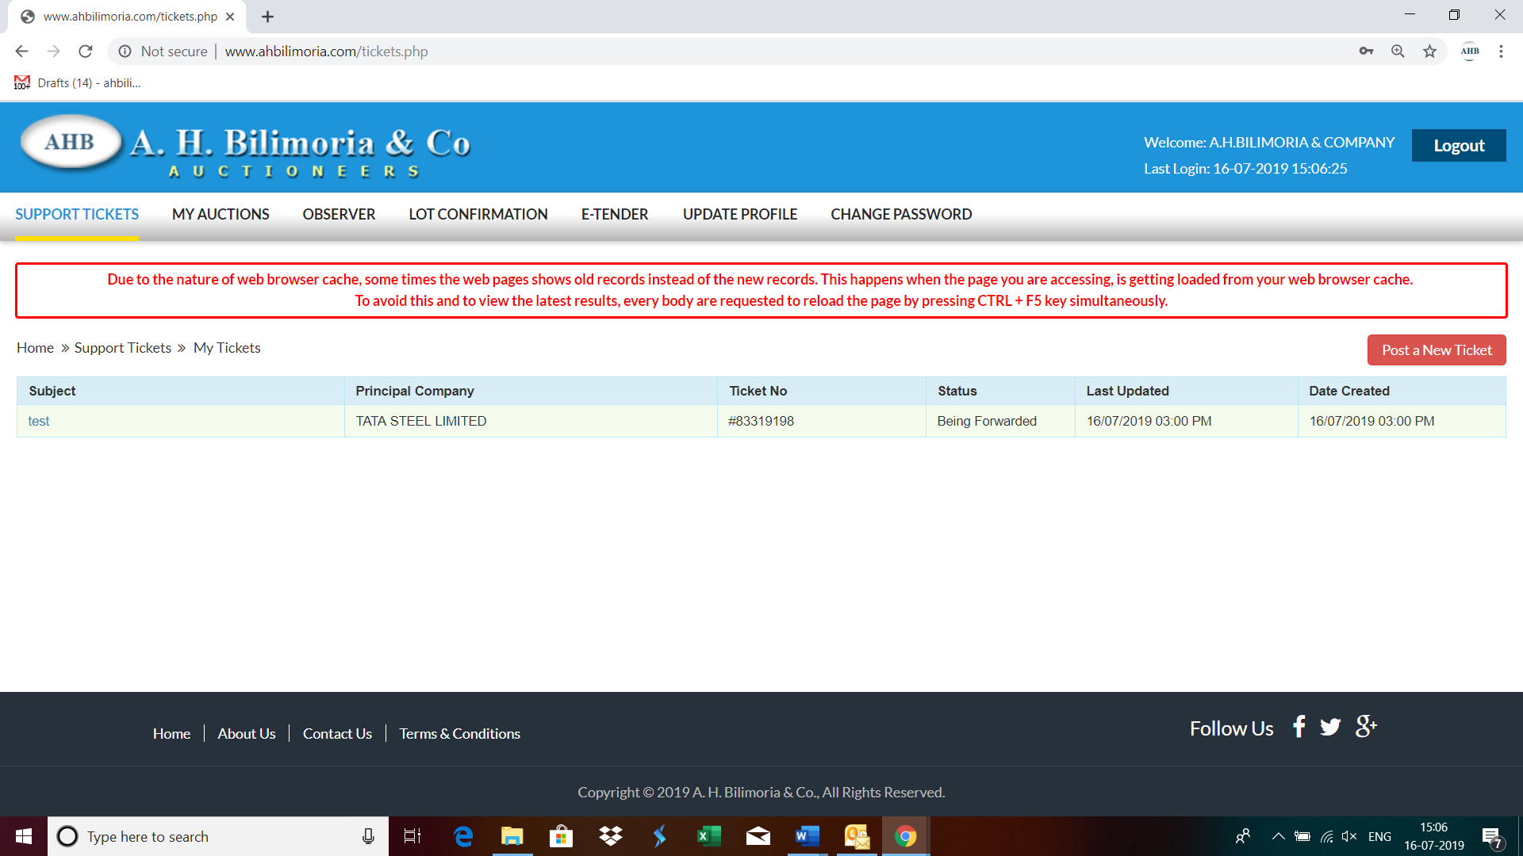

Post a New Ticket->Subject* ->Message* -> Email*->Principal Company*->Attach Document (If required any attachment) ->Submit

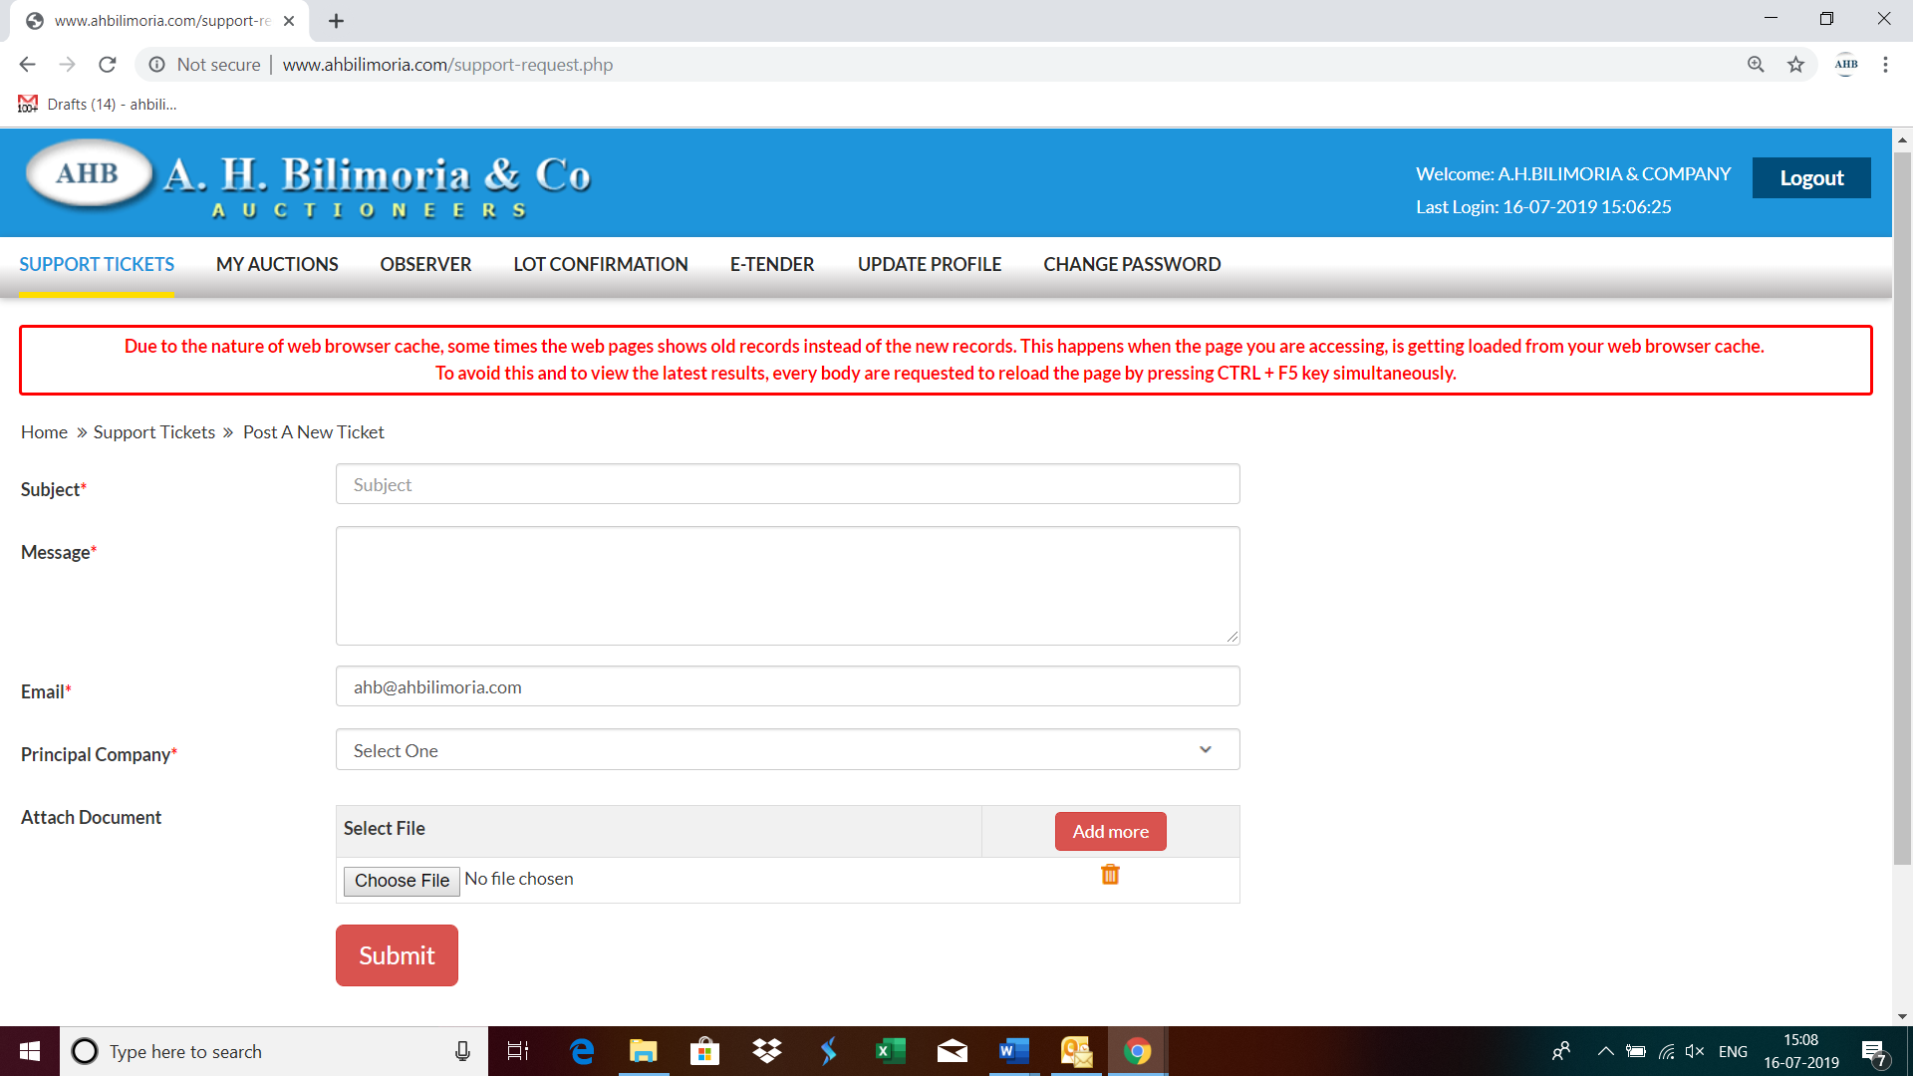

Your support request has been submitted successfully and the Reference No ----- is generated automatically

