Auction Catalogue
Auction conducted by A H Bilimoria & Co.
Auction of Industrial Items, Jamshedpur
BEING SOLD ON ‘’AS IS WHERE IS AND NO COMPLAINT BASIS’’
Catalogue Serial Number: | TSL(Tinplate Div.)/INDUSTRIAL/AHB/SEPTEMBER/56/26-27
Seller: | Tata Steel Limited (Tinplate Division)
Auction website: | www.ahbilimoria.com
e-Auction Date & Time: | 15th September, 2026…..…..at 03:00 PM
Inspection Date & Time: | No physical inspection to be conducted. For any assistance please call AHB (9830610150/8336985888) or TSL (Tinplate Div.) Officer Baldev Singh-(08409395264).
Date of Security Money Deposit | 14th September, 2026 till………at 05:30 PM
Contact Details:
For Post Auction @ A H Bilimoria & Company
Area | Contact No. | Email Id
Auction Room | 09883421336
Lot Confirmation Related | 09830610150 | ahb@ahbilimoria.com, ahbilimoria.company@gmail.com, sukumar.chandra@ahbilimoria.com
Payment Related | 06289241136 | ahb@ahbilimoria.com, ahbilimoria.company@gmail.com, sukumar.chandra@ahbilimoria.com
Delivery Order Related | 06289241136 | ahb@ahbilimoria.com, ahbilimoria.company@gmail.com, sukumar.chandra@ahbilimoria.com
Material Value Refund Related | 06289241136 | ahb@ahbilimoria.com, ahbilimoria.company@gmail.com, sukumar.chandra@ahbilimoria.com
SD Refund Related | 06289241136 | ahb@ahbilimoria.com, ahbilimoria.company@gmail.com, sukumar.chandra@ahbilimoria.com
TCS Related | 06289241136 | ahb@ahbilimoria.com, ahbilimoria.company@gmail.com, sukumar.chandra@ahbilimoria.com
Payment Deviation/Disablement in TSL (Tinplate Div.) | 06289241136 | ahb@ahbilimoria.com, ahbilimoria.company@gmail.com, sukumar.chandra@ahbilimoria.com
Collection of Delivery Order-TSL (Tinplate Div.) | 06289241136 | ahb@ahbilimoria.com, ahbilimoria.company@gmail.com, sukumar.chandra@ahbilimoria.com
Collection of Delivery Order for TSL (Tinplate Div.) | 06289241136 | ahb@ahbilimoria.com, ahbilimoria.company@gmail.com, sukumar.chandra@ahbilimoria.com
For time bound resolution of unresolved issues log into our Customer Complaint Management portal | Type in www.ahbilimoria.com> Go to “Customer Complaint Management Portal” >Log in with your user id and password and write the details of issue.

For Any unresolved Issues beyond two (02) days mail to A H Bilimoria & Company :
Mr. A K Sil (M-09830074122) & Mr. D Pyne (M-09830738481), E-mail: ahb@ahbilimoria.com, ahbilimoria.company@gmail.com
Copy to TSL (Tinplate Div.) : Mr. Somen Bhattacharya (somen.bhattacharjee@tatasteel.com), Mr. Chetan Bharti (chetan.bharti@tatasteel.com)
For any transaction related query please call Mr. Chetan Bharti (JSR), M: 9204066824
For loading related query please call Mr. Baldev Singh (JSR), M: 8409395264
SPECIAL NOTE: -It is the responsibility of the buyer to furnish the valid GST no. & necessary documents to A H Bilimoria & Company before participating in the auction. In case during the transactions, it is found that valid GST no. has not been provided, then all necessary liabilities if any & so accrued would be on account of the buyer. TSL (Tinplate Div.) & A H Bilimoria & Co. would not be responsible for any such liabilities.

Note: TSL (Tinplate Div.) reserves the right to track IP address, MAC number and geolocation of bidding customers whenever customers participate in any auction on the A H Bilimoria & Co. auction platform for TSL (Tinplate Div.).

- Payment and Lifting Schedule:

Lot No. | Payment Schedule | Lifting Schedule  (working days from the next day of DO release)
Lot No. | For full installment | lifting days
For Stock Material | 01 Working Days From Date of lot confirmation (No partial payment is allowed) | 02 Working days from the D/O date
For Arising Material | 01 Working Days From Date of intimation of material availability in lot (No partial payment is allowed) | 02 Working days from the D/O date

- Suitable extension of due date for payment and lifting will be accorded in case of any eventualities like Strike/ Bandh/ Special restriction on vehicular movement imposed by the local Administration etc.

- Requirements of participation:
  - Registration: Before participation in the e-Auction, a prospective bidder shall be required to get registered with A H Bilimoria & Co. For details visit www.ahbilimoria.com

  - Security Deposit: Non-Interest bearing security deposit of Rs.60,000/- (Rupees Sixty Thousand only) in favour of “A H Bilimoria & Co.” through Online Payment only : Details as under :

Beneficiary Name | A. H. BILIMORIA & COMPANY
Bank Name | HDFC Bank
Branch Name | 31, Chowringhee Road, Kolkata – 700016
Account No | 06932560001205
IFSC Code | HDFC0000693

Account No: All the customers will have a unique account number. The unique account number is an alpha numeric code consisting of 12 characters. The Customer’s unique “account number” is a combination of the AHB’ SAP code along with the 6 digit bidder SAP ID and can be used as reference for all subsequent transactions. The Customer’s Account Number detail is available in “Profile” after the customer logs into our website using the user id and password.

- Inspection Rules & Policy:
No physical inspection to be conducted. For any assistance please call AHB (9830610150/8336985888) or TSL (Tinplate Div.) Officer (9204066824).

- Bidding modalities:
  - Price Bid Basis: In Indian rupees as per unit of measurement as given in Material List. Price to be quoted is basic, ex- location exclusive of taxes and any other statutory levies.
  - Bid Increment: As specified in the e-auction bid page
  - Type of Auction: English No Ties
  - Bid Validity: Bid shall be valid for 10 (Ten working days excluding Saturdays, Sundays and Bank holidays) working days counted from the next day of auction process in case of auction against a catalogue which is completed on the same day. And if it is continuing on any other day the counting of days for lot confirmation shall be from the next day of completion of entire auction process.
  - Bid duration: For 1st four lots 20 minutes and balance lots 10minutes. If, No bids received within these specified time the lots are closed automatically.

- Taxes & duties:
  - GST : As applicable
  - TCS : As applicable. In case of availing of concessional rate of TCS proper certificate issued by appropriate Income Tax authority are to be issued in favour of the Principal Company along with payment. Self-certification of Form no 27C is not acceptable.
  - Any change in taxes applicable at the time of lifting shall be applicable.
  - Customers are required to submit Form 127C against the month of dispatch/expected dispatches. In the absence of Form 127C, TCS will be charged at the time of invoicing.

- Payment terms & conditions :
  - Payments: PAYMENT FACILITY BY RTGS / NEFT ONLY

Account No | TATAHB followed by Party code (Each individual customer will be provided with Account number to be provided by AHB)
Beneficiary Name | TATA STEEL LIMITED A H B
Bank Name | HDFC BANK LTD.
Branch Name | Sandoz Branch, Mumbai
IFSC Code | HDFC0000240

  - Delayed Payment Charges (DPC) : Installment payments with DPC @ five (05) paise per Rs. 100 per day will be accepted up to 2 (Two) working days (after on approval from TSL authority) from due date of installment payment as mentioned in the confirmation letter. GST @ 18% would be charged in addition to the above DPC amount.
  - Saturdays, Sundays and Bank holidays are excluded for counting purpose for payment schedule.
  - In the event of Non-Receipt of Payment within the stipulated period of Payment, the Sale Offer for the approved Lot shall stand withdrawn automatically (Refer Clause#8).
  - Buyers have to send the payment deposit slip (UTR No /Scan Copy of NEFT/RTGS Transaction Slip) against Lot No. immediately after the payment to AHB at email id: ahb@ahbilimoria.com& ahbilimoria.company@gmail.com
  - GST number of TSL : 20AAACT2803M2ZO

- Lifting terms & conditions:
7.1 DOs will be handed over to authorized representatives of bidders on receipt of payment. Authorization letter to be issued via registered e-mail id’s. Authorized letter must be duly stamped and signed by the proprietor or partner or director on receipt of payment. Lifting date is calculated from the next day of DO Release date.
7.2 Loading Charges: As mentioned in material list
7.3 Loading shall be given strictly as per the statutory norms & safety norms of TSL (Tinplate Div.)
Lifting date is calculated from the next day of DO Release date. Note: Sundays are optional for the purpose of arriving at the lifting schedule. Loading shall be given strictly as per the statutory norms & safety norms of TATA STEEL Ltd. Loading Advise timing for Customers at gate : 6 am to 2 PM only. Loading at TSL (TINPLATE DIV.) storage location will be closed for customer on Sundays & National Holidays. Loading at TSL (TINPLATE DIV.) will be done from 7.30 am to 5 pm only. Customer’s Representative with vehicle should reach parking at 5 AM for completing all necessary procedure of vehicle entry and reach TSL (TINPLATE DIV.) Plant Yard by 7:30 AM before safety time.
7.4 Lifting with Ground Rent: Lifting along with ground rent will be allowed up to 4 (four) working days from the last date of lifting period. In case the lifting is not complete, and no request is made by the customer within the period of four days, the company reserves the right to close the lot, and refund the balance to the party after deducting for any shortfall in lifting as per norms laid down in the catalogue. Ground Rent will be calculated on balance unlifted quantity @ 05 paise (inclusive of tax) per Rs.100/- per day. GST @ 18% would be charged in addition to the above ground rent amount.
7.5 Additional lifting days for advance payment of installment - If the installment payment is made in advance, then additional lifting days (equivalent to the number of days payment made in advance) would be given.
7.6 PICK & CHOOSE NOT ALLOWED FOR ANY OF THE LOTS.

7.7 LOT TRANSFER WILL NOT BE ALLOWED.

7.8 A validity period of 30 days from the date of auction shall be allowed for the conversion of all Arising Lots into Stock Lots. Upon expiry of this period, any pending Arising Lots shall be closed automatically. Once confirmed by the Operations Team, Arising Lots shall be treated as Confirmed Lots, and all applicable norms, including lot closure and penalty provisions, shall apply.

7.9 Process for transfer of ownership of vehicles sold in auction: Customer shall submit their authorization letter to AHB. AHB will hand over the same to SCMC with a forwarding letter along the authenticated DO copy. AHB will collect the ownership papers from SCMC for handing over to the customer for applying for transfer of ownership in DTO’s office. After transfer of ownership, the customer will show the approach SCMC to collect the delivery advice for the vehicle. AHB will arrange the gate pass for the customer to visit SCMC.

8.0 For lifting of any type of sheet/packet (HR Black/ ETP/TFS) from BARYARD , only OPEN BODY TRAILER to be placed.

This is to inform you that the Vehicle Tracking System (VTS) has been implemented at TSL (Tinplate Division). This will help Tinplate Division to ascertain the number of vehicles en route or inside their premises, allowing them to plan loading/unloading and other logistics activities systematically. The outcome of this system will be reduction in Vehicle In-Vehicle Out (VIVO) time. Therefore, all vehicles entering the Tinplate Division's premises must follow this process. Please ensure that all vehicles destined for Tinplate Division must be registered in VTS from 19th Jan’26 onwards- any new process has some initial glitches/doubts, and we are there to help. In case of any query, please connect with following persons-Saurabh Shashank-9038538919,Abhinav Chandra Gagan-7073723928, Md. Farouque-9835105870,Raja Vikram Singh-8334801345

Important Note:
GPS Installation in Vehicles: GPS will be mandatory for each vehicle entering TSL ( TINPLATE DIV.) Works with effect from 1st September 2015, GPS will be installed by vendor E- Trans outside TSL ( TINPLATE DIV.) Works gate with a nominal charges of Rs. 100 per vehicle. “With effect from 6tht Aug 16 it will be mandatory for all customer representatives to furnish the Original Police Verification document of their customer representative obtained from the SSP’s office Jamshedpur along with other existing requisite documents to get the Delivery Orders from AHB Office JSR”. Material is sold on AS-IS-WHERE-IS AND NO-COMPLAINTS BASIS, No Complaint at any point (from auction to sale) is acceptable. Material Specification and Photographs if any given in the catalogue is indicative only.

- Penalty:
  - The following penalties shall be applicable in the eventuality of a buyer defaulting in making the payment of any installment/s, as per the stipulated schedule for each lot, in a financial year:
- In the first instance, a penalty of Rs. 60,000/- (Rupees Sixty Thousand only) shall be recovered from the customer. The above penalty amount would be inclusive of GST amount @18%.
- In the second instance, a penalty of Rs.1,20,000/- (Rupees One Lakh Twenty Thousand only) shall be recovered from the customer. The above penalty amount would be inclusive of GST amount @18%.
- In the third, and any subsequent instance, a penalty of Rs.1,80,000/-(Rupees One Lakh Eighty thousand only) shall be recovered and the customer shall be debarred from participating in any auction for a period of three months from the date of debarment. The above penalty amount would be inclusive of GST amount @18%.
In the event of any default, the customer’s user id will be disabled and the customer will be blocked from participating in any auction of TSL with immediate effect.

The defaulting customer shall be allowed 06 (six) working days to deposit the penalty as mentioned above. In case the penalty is not received within the stipulated period, the customer’s security deposit shall be forfeited, and the defaulting customer shall be immediately debarred from participating in any auction of TSL.

  - In case of non- lifting of full lot quantity after making full payment, a penalty equivalent to 20% of the material value for the un-lifted quantity against each lot shall be recovered from the customer.

- Lot Closure Norms :
For Lot Closure, the tolerance would be (+/-) 10% of the original quantity.

Taxes & duties:
IMPLEMENTATION OF TAX COLLECTED AT SOURCE (TCS) ON SALE OF GOODS WITH EFFECT FROM October 1, 2020 The Finance Act 2020 introduced a new Section 206C (1H) for extending the scope of Tax Collected at Source (TCS) on sale of any Goods with effect from 1st of October 2020. Hitherto, TCS was only applicable to the sale of certain specific categories of goods e.g., Scrap, Coal etc.
The salient features of section 206C(1H) are briefly enumerated below-
-With effect from 1st April 2026, TCS on sale would be as follows, TCS @2% to be treated as scrap, TCS @0.1% to be treated as non-scrap.
-Intra State Sale: CGST &SGST: 50% each of GST Rate.
-Inter State Sale: IGST: CGST Rate as applicable.
-9.2 In view of above, to facilitate the dispatches buyer are requested to pay the excess amount for the balance quantity or confirm the adjustment in quantity within the deposited amount.
-TCS shall be collected on the consideration in excess of Rs. 50 Lakhs in a financial year.
-TCS shall not be collected under this section, if it is covered by any other provision of TCS/TDS under the Income Tax Act. For example – TCS on Coal, Scrap.
In view of the above amendment TCS component will be incorporated in all our sales invoices and Debit notes after GST component i.e., TCS will be computed on total invoice value inclusive of GST. You are requested to process payment of the Sales Invoice inclusive of the TCS component. Such TCS components will appear in 26AS at the end of the quarter and the necessary TCS Certificate as per Income Tax Act will be issued. Note: In the case of Scrap &Coal by product sales also (where the current provision of TCS @2% is applicable),
TCS will be incorporated in the sales invoices &Debit Notes. Customers are required to submit Form 27C/Form 27G against the month of dispatch/expected dispatches. In the absence of Form 27C, TCS will be charged at the time of invoicing.
Revision wef 1st April’26 - There has been a revision in Form 27 C format (now Form 127) and now forms have to be submitted by each customer availing TCS exemption by submitted form against each transaction/DO, mentioning TCS amount &payment date. Earlier, customers used to earlier submit one single form for the entire month with no mention of exact amount and date of payment and this practice has now been revoked.
With effect from 1st April’26, in order to maintain compliances and avoid any discomfort to customers, TSL have decided to withdraw exemption/waiver of TCS amount that was provided against each DO after submission of Form 27C (now Form 127 – attached) by the respective customers. This will be applicable for an interim period of one month or until further communication of our end. We will use this interim period to establish the process of recording Form 27C’s (now Form 127) and proper tracking.
Those customers who intend or used to avail TCS exemption upon submission of Form 27C (now Form 127) are now requested to please take note of above point marked in BOLD and participate in auction accordingly. Please feel free to contact
Attn: Customers depositing TDS u/s 194Q while making the payment to Tata Steel Limited.
Sub: Refund on account of TDS u/s 194Q
In order to claim the refund of the TDS deposited u/s 194Q while making the payment to Tata Steel Limited, you are advised to send the necessary details as per the below format to our O2C
Collection Team (Mail ID - o2c.collection@tatasteel.com) along with TDS Certificate*.

*TDS Certificate must include
Duly downloaded from Income Tax site mentioning Period (Qtr), TAN No of Deductor (Customer), Name of Deductor (Customer), Amount of Transaction &TDS
Duly digitally signed by authorized person
Nature of Payment -194Q
Deductee- TATA STEEL LIMITED

** PAN No, TDS Amt (194Q), Period are available at TDS Certificate itself

1.Compliance of GST-TDS Provisions: It shall be the responsibility of the customer to comply with all the requirements prescribed under GST law related to GST-TDS in case of material sold to them.
2.Payment of GST-TDS to the Government: The GST-TDS shall be deposited by the customer to the Government within due date prescribed under GST law.
3.Filing of GST-TDS Returns: Customer shall file the periodic statements/returns as per GST law. GST-TDS deposited by the customer to the Government shall be refunded to the customer within one month of the day, the paid amount is reflected in GST portal of TSL at GSTN.
4.Sharing of GST-TDS payment details with TSL: The customer shall share the invoice wise details of GST-TDS with TSL in excel file to the email id GSTRECON@TATASTEEL.COM.
5.Implication of Non- Compliance: Any Impact of non-compliance for GST-TDS under GST law at customer’s end either in financial or other form, shall be borne by the customer only . Further, the customer shall at all times keep TSL indemnified and harmless from any loss/penalty/cost/damages suffered by TSL due to non-compliance of the applicable law by the customer.

Category Scrap:
This transaction falls u/s 206C(1). Hence Section 194Q will not be applicable.
Compliance in relation to section 206AB (Furnishing of I.T Return for past 2 Years) will be taken directly from Income Tax Portal till 28th June-2021. If any compliance made in IT Portal by the customer after 28th June-21, then it shall be communicated to A. H. Bilimoria & Co. over mail. In case of non-compliance as per section 206AB of Income Tax Act 1961, a higher rate of TCS @ 5% will be charged during invoicing W.e.f 1st of July 2021, invoicing will be done as per new Income Tax provisions.
Form 27C &Form 27G shall become inoperative &higher rate of TCS shall be charged if the customer defaults u/s 206AB of Income Tax Act 1961.
Category Non - Scrap:
This transaction falls u/s 194O. Hence Section 194Q &section 206(1H) shall not be applicable.
This transaction falls u/s 194Q/206(1H) depending upon the customer`s previous year turnover.
Customer has to ensure deduction of TDS u/s 194Q at their end (if applicable). TSL shall not be responsible for any noncompliance at customer end.
To avoid administrative difficulties, the buyer is required to pay full amount against the purchase; and the amount for TDS u/s 194Q shall be paid separately to the Government. The TDS shall be treated as security deposit with Tata Steel Limited and on submission of TDS certificate the same can be refunded/adjusted against future purchases. Illustration showing TDS amount payable.
Refer the below example for TDS computation assuming the sales has crossed the minimum threshold limit
TDS Payable = Amount paid to TSL/(100%-0.10%") X 0.10%
Example:
In case the buyer has not submitted the declaration w.r.t turnover prior to the date of auction, then TSL will assume the turnover to be less than 10 Cr &TCS @ 0.1% will be collected accordingly during invoicing Compliance in relation to section 206AB (Furnishing of I.T Return for past 2 Years) will be taken directly from Income Tax Portal till 28th June-2021. If any compliance made in IT Portal by the customer after 28th June-21, then it shall be communicated to A. H. Bilimoria & Co. over mail. In case of non-compliance as per section 206AB of Income Tax Act 1961, a higher rate of TCS
@ 5% will be charged during invoicing.
W.e.f 1st of July 2021, invoicing will be done as per new Income Tax provisions. Photographs of lots are at best indicative only and do not necessarily reflect the actual condition of lots. All bidders are advised to physically inspect the offered lots before participating in the auctions. Tata steel Ltd or AHB shall not be responsible or liable for any error of Judgment or bids put by bidders acting on the basis of these photographs.”
Invoice-wise Reporting Functionality in Form GSTR-7 on portal-reg.
GSTIN has issued Advisory dated 26th September, 2025, were the functionality for invoice wise reporting in GSTR 7 has been made operational in GSTIN Portal from Sep’25 tax period onwards. Invoice wise furnishing will facilitate the deductee to have visibility of the Invoices on which the GTDS has been deducted.
Fast and better reconciliation of GTDS deducted and deposited by the Deductor. Optimum availment and utilization of GTDS.

- Refund :
Refunds will only be made by TSL (Tinplate Div.) vide RTGS/NEFT and hence all customers are required to submit their bank details to A H Bilimoria & Company or mail at ahb@ahbilimoria.com, ahbilimoria.company@gmail.com. TSL (Tinplate Div.) or A H Bilimoria & Company will not be responsible for any delay in refunds owing to absence of bank details of the customer.

- Complaints :
Complaints, if any, with regard to any transaction shall have to be lodged by the buyer within three calendar months from the date of last invoice. No complaint shall be entertained thereafter, under any circumstances. Customers can log their complaints at (www.ahbilimoria.com> Go to “Customer Complaint Management Portal” >Log in with your user id and password and write the details of issue.)

- Jurisdiction :
Any dispute arising out of any contract shall be decided in Jamshedpur by the courts in Jamshedpur and by no other courts. The courts in Jamshedpur shall have exclusive jurisdiction to adjudicate upon any such dispute.

- General terms & conditions:
  - Any dispute on quality & quantity of material and bid cancellation shall not be entertained at any point after the auction.
  - All lots are offered/sold on “As is Where is Basis” and “No Complaint Basis”.
  - Lot transfer will not be allowed. Payment and invoicing has to done in the name of the H1 bidder, subject to the prices being approved.
  - Lot purchased should consist of material from the same lot and designated location only. TSL (Tinplate Div.) has the right to check any vehicle at any moment of time. If material lifted differs from the material that is purchased by the buyer, then the buyer and authorized representative will be permanently debarred. Also TSL (Tinplate Div.) can take any penal action against the buyer/authorized representative. All the material loaded in the vehicle is to be covered in order to follow the safety compliance of TSL (Tinplate Div.) works.
  - If the safety compliance is not followed, then TSL (Tinplate Div.) can penalize the buyer / authorized representative as deemed fit.
  - Customer attested photocopy of valid id proof (Voter id/Aadhar/Pan card) of all lifters / Authorized persons engaged by customers for lifting of materials from TSL is to be enclosed with the authorization letters & to be forwarded to TSL for issue of gate pass.
  - Dispatch is subjected to FORCE MAJEURE conditions
  - The seller reserves the right to terminate any offer at any point of time without assigning any reasons
  - In the event of termination of the offer, seller shall refund the balance amount after due reconciliation
  - No claims whatsoever would be entertained after cancellation of the bid
  - In addition of earlier safety norms, the following would be compulsory:
The drivers of the vehicle must have the eye test certificate. The frequency of the testing would be as below:
1. If the age of the person is less than 45 years - Once in a year
2. If the age of the person is 45 years or more, the testing is required to be done once in every 6 months
Please ensure to comply with the safety norms
  - Weighment : Weight recorded by TSL (Tinplate Div.) weighbridge will be considered final and binding on the customer.
  - This transaction falls u/s 206C(1). Hence Section 194Q will not be applicable.
  - Compliance in relation to section 206AB/206AA (Furnishing of I.T Return for past 2 Years) will be taken directly from Income Tax Portal till 28th June-2021. If any compliance made in IT Portal by the customer (after 28th June-21), shall be communicated to AHB over mail.
  - No Punjab dala to be allowed inside works in any area of operation.
  - Mandatory usage of reverse Camera in all customer vehicles for lifting of materials.

14. Compliance to safety norms
14.1 Authorized persons (of the customer) involved in lifting of the materials will be allowed only with Personal Protective Equipment’s (PPE) i.e., Safety Shoes, Safety Helmet, Safety Goggles, Fluorescent Jacket and Hand Gloves. No "people movement" shall be allowed at the time of loading/delivery of materials from the yards" TSL (Tinplate Div.) will not be responsible for any delays arising out of Non- Compliance to the Safety Norms.

14.2 Documents for verification regarding entry of vehicles inside TSL (Tinplate Div.) :
All customers to note that presentation of following set of documents to TSL (Tinplate Div.) authorities is COMPULSORY at the time of reporting of vehicles at TSL designated Gate for entry of Customer trucks/vehicles.
a. Driving License of driver,
b. Registration Card,
c. Commercial Certificate,
d. Fitness Certificate of Vehicle,
e. Re-registration for vehicles older than 15 years
f. Insurance
The checklist form will be filled in at TSL (Tinplate Div.) designated Gate for entry of Customer trucks/vehicles before entry of vehicle.

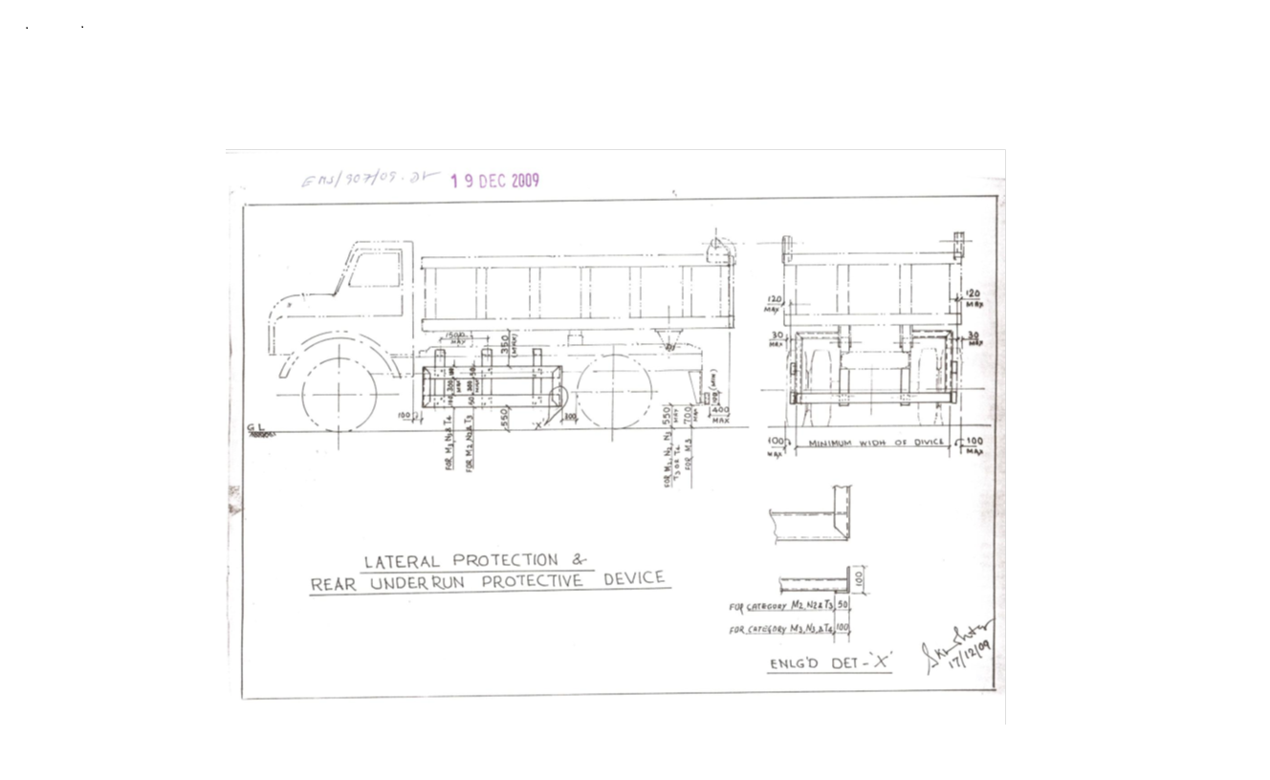

Sl. No. | Safety Parameters to be checked
1 | Three Piece Mirror(Truck, Trailer & Dumper)-Helper side
2 | Single Mirror- Driver side
3 | Rear View Mirror (Tata Ace, 207, Jeep etc.)
4 | Service Brake
5 | Parking Brake
6 | Seat Belt
7 | Head Light
8 | Parking Light
9 | Blinker
10 | Horn
11 | Reverse Alarm
12 | Wiper
13 | Windshield Glass
14 | Air Pressure Min. 7 Kg/Cm^2
15 | Run Under Protection Guard as per TSL standard
16 | Side under Protection Guard as per TSL standard
17 | Tyre Condition (Tread Depth, Cut Mark etc.)
18 | Any Oil Leakage from the vehicle
19 | Physical condition of Dallah
20 | Availability of scotch block
21 | Buzzer with side indicator
22 | Driver's eye examination report
Legal Documents to be checked:
Sl. No. | Documents to be Checked
1 | RC Book
2 | Insurance
3 | Pollution
4 | Driving licence
5 | Fitness for more than 15 years old vehicle
6 | NOC for outside vehicles
For ODC (Over Dimensional Consignment) items Customer / Authorised Lifter has to do Route Mapping in consultation with IBMD prior to vehicle placement for delivery. Customer / Authorised Lifter to indicate final date of vehicle placement.

15. DISCLAIMER FOR E-AUCTION
BANDWIDTH PROBLEMS, CONNECTIVITY PROBLEMS WITH THE LOCAL ISP (INTERNET SERVICE PROVIDER), SLOWNESS TO ACCESS PAGES FOR DOWNLOADING ETC. ARE BEYOND THE CONTROL OF TSL (Tinplate Div.) AND A H BILIMORIA & COMPANY. HENCE NO RESPONSIBILITY LIES WITH TSL (Tinplate Div.) OR A H BILIMORIA & COMPANY FOR THE ABOVE PROBLEMS FACED, IF ANY, BY THE BIDDERS BEFORE/DURING THE AUCTION ANY. BID PLACED USING THE BIDDER'S USERNAME AND PASSWORD IS UNCONDITIONALLY BINDING ON THE BIDDER TO WHOM SUCH USERNAME AND PASSWORD HAD BEEN ALLOTTED AND HE SHALL BE SOLELY RESPONSIBLE FOR MAINTAINING THE CONFIDENTIALITY OF THE SAME AND FULLY RESPONSIBLE FOR ALL ACTIVITIES THAT OCCUR UNDER THEIR USERNAME AND PASSWORD. HENCE THE USER IS ADVISED TO CHECK THE USERNAME AND PASSWORD BEFORE THE AUCTION,IN ORDER TO FAMILIARISE HIMSELF WITH THE SAME AND IS ADVISED NOT TO REVEAL IT TO ANYONE ELSE SO AS TO PREVENT MISUSE OF THE SAME. THE BIDS MADE BY THE BIDDERS AGAINST THEIR USERNAME AND PASSWORD SHALL BE IRREVOCABLE.THE BIDDERS ARE ADVISED TO REGISTER AND PRE-QUALIFY FOR BIDDING WELL IN ADVANCE AND PLACE THEIR BIDS EARLY IN ORDER TO TAKE CARE OF ANY UNFORESEEN TECHNICAL DIFFICULTY THAT MIGHT SURFACE IN THE INTERNET OPERATIONS.

Lot Photograph: Photographs of lots are at best indicative only and do not necessarily reflect the actual condition of lots. All bidders are advised to e-inspect the offered lots before participating in the auctions. TSL (Tinplate Div.) or A H Bilimoria & Co. shall not be responsible or liable for any error of judgment or bids put by bidders acting on the basis of these photographs.

Quantity offered is based on eye estimation. Delivery will be made for the estimated quantity or actual ground stock. Estimation error may arise. No complaint of whatsoever nature on estimated /offered quantity shall be entertained under any circumstances. Bidders are advised to make their own judgment on offered quantity before bidding.

Special instruction: Process for issuance of Loading slip for outside locations
- Presently the H1 bidder is authorizing the lifter with signature being attested along with photo. Now, id proof no. should be mentioned in the same letter.
- Customer when collecting the loading slip to also bring photocopy of DO with photo id proof.
- At the back of the photocopy to mentioned the vehicle no. for which loading slip is requested and give self declaration that vehicle is meeting all safe standards.
Speed Limit for Heavy Vehicles to max.25 kms. Any body exceeding the same may get penalized.

Temporary Gate Pass (GP) will be issued to authorized customer representative’s as per DO validity period. For lots having DO validity more than one month, GP will be issued max. 30 days.

Special Instruction:
W.e.f. 10th October, 2024, the CBIC has notified that there shall be deduction of GST TDS @ 2% on supply of metal scrap falling under Chapters 72 to 81 in the First Schedule to the Customs Tariff Act by registered person in B to B supply. The GST TDS shall be deducted when the payment is made or credited to the suppliers Account. The deductor will be liable to pay the TDS amount to the Govt. within ten days after the end of the month in which such deduction is made. A certificate of tax deduction at source shall also be issued by the supplier in the format prescribed in GSTR 7A. Accordingly, it is advised to kindly take necessary actions at your end such as obtaining GST TDS registration and ensure compliances with the GST TDS provisions.

Terms and Conditions for TDS of 2 % on metallic Scrap sales :
- Compliance of GST-TDS Provisions: It shall be the responsibility of the customer to comply with all the requirements prescribed under GST law related to GST-TDS in case of material sold to them.

- Payment of GST-TDS to the Government: The GST-TDS shall be deposited by the customer to the Government within due date prescribed under GST law.

- Filing of GST-TDS Returns: Customer shall file the periodic statements/returns as per GST law. GST-TDS deposited by the customer to the Government shall be refunded to the customer within one month of the day, the paid amount is reflected in GST portal of TSL at GSTN.

- Sharing of GST-TDS payment details with TSL: The customer shall share the invoice wise details of GST-TDS with TSL in excel file to the email id GSTRECON@TATASTEEL.COM.

- Implication of Non- Compliance: Any Impact of non-compliance for GST-TDS under GST law at customer’s end either in financial or other form, shall be borne by the customer only. Further, the customer shall at all times keep TSL indemnified and harmless from any loss/penalty/cost/damages suffered by TSL due to non-compliance of the applicable law by the customer.

No Punjab dala to be allowed inside works in any area of operation.

MATERIAL DETAILS: AS PER ANNEXURE :
Sl. No | Lot No | Material Description | Material No | Qty | UOM | Location | Loading Equipment | Vehicle Type | Loading Charges
1 | A/HR/11Sep26/01 | Rej. HR Coil End (Mixed Thickness) (Arising)  (Magnet loading 20% less than actual capacity of truck) | 146003653 | 60 | MT | Secondary Yard | F15/MAGNET | Truck, Trailer | Rs 200/mt
2 | A/HR/11Sep26/02 | Rej. HR Coil End (Mixed Thickness) (Arising)  (Magnet loading 20% less than actual capacity of truck) | 146003653 | 60 | MT | Secondary Yard | F15/MAGNET | Truck, Trailer | Rs 200/mt
3 | A/HR/11Sep26/03 | Rej. HR Coil End (Mixed Thickness) (Arising)  (Magnet loading 20% less than actual capacity of truck) | 146003653 | 60 | MT | Secondary Yard | F15/MAGNET | Truck, Trailer | Rs 200/mt
4 | A/HR/11Sep26/04 | Rej. HR Coil End (Mixed Thickness) (Arising)  (Magnet loading 20% less than actual capacity of truck) | 146003653 | 60 | MT | Secondary Yard | F15/MAGNET | Truck, Trailer | Rs 200/mt
5 | A/HR/11Sep26/05 | Rej. HR Coil End (Mixed Thickness) (Arising)  (Magnet loading 20% less than actual capacity of truck) | 146003653 | 60 | MT | Secondary Yard | F15/MAGNET | Truck, Trailer | Rs 200/mt
6 | A/HR/11Sep26/06 | Rej. HR Coil End (Mixed Thickness) (Arising)  (Magnet loading 20% less than actual capacity of truck) | 146003653 | 60 | MT | Secondary Yard | F15/MAGNET | Truck, Trailer | Rs 200/mt
7 | A/HR/11Sep26/07 | Rej. HR Coil End (Mixed Thickness) (Arising)  (Magnet loading 20% less than actual capacity of truck) | 146003653 | 60 | MT | Secondary Yard | F15/MAGNET | Truck, Trailer | Rs 200/mt
8 | A/HR/11Sep26/08 | Rej. HR Coil End (Mixed Thickness) (Arising)  (Magnet loading 20% less than actual capacity of truck) | 146003653 | 60 | MT | Secondary Yard | F15/MAGNET | Truck, Trailer | Rs 200/mt
9 | A/HR/11Sep26/09 | Rej. HR Coil End (Mixed Thickness) (Arising)  (Magnet loading 20% less than actual capacity of truck) | 146003653 | 60 | MT | Secondary Yard | F15/MAGNET | Truck, Trailer | Rs 200/mt
10 | A/HR/11Sep26/10 | Rej. HR Coil End (Mixed Thickness) (Arising)  (Magnet loading 20% less than actual capacity of truck) | 146003653 | 60 | MT | Secondary Yard | F15/MAGNET | Truck, Trailer | Rs 200/mt

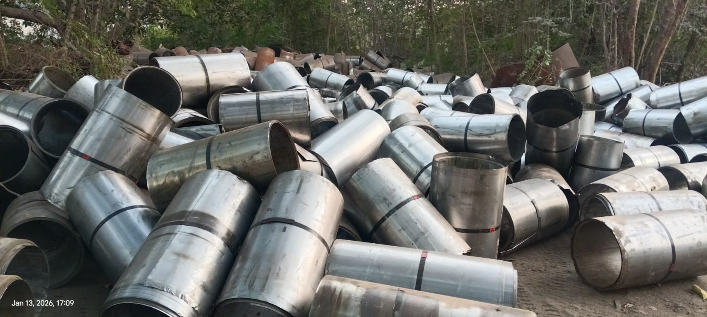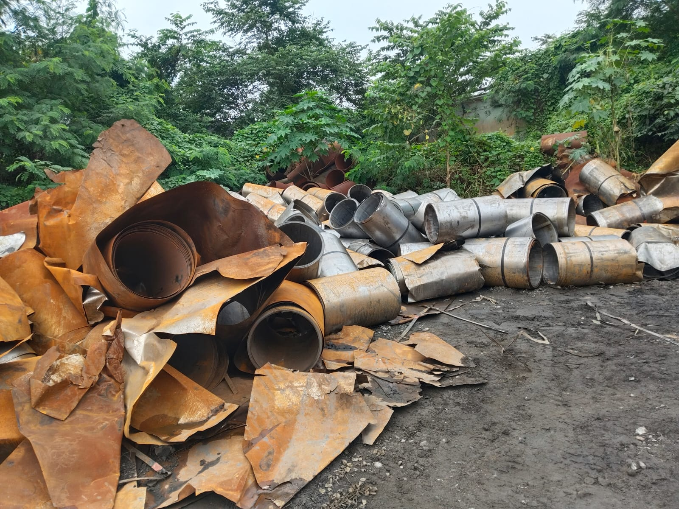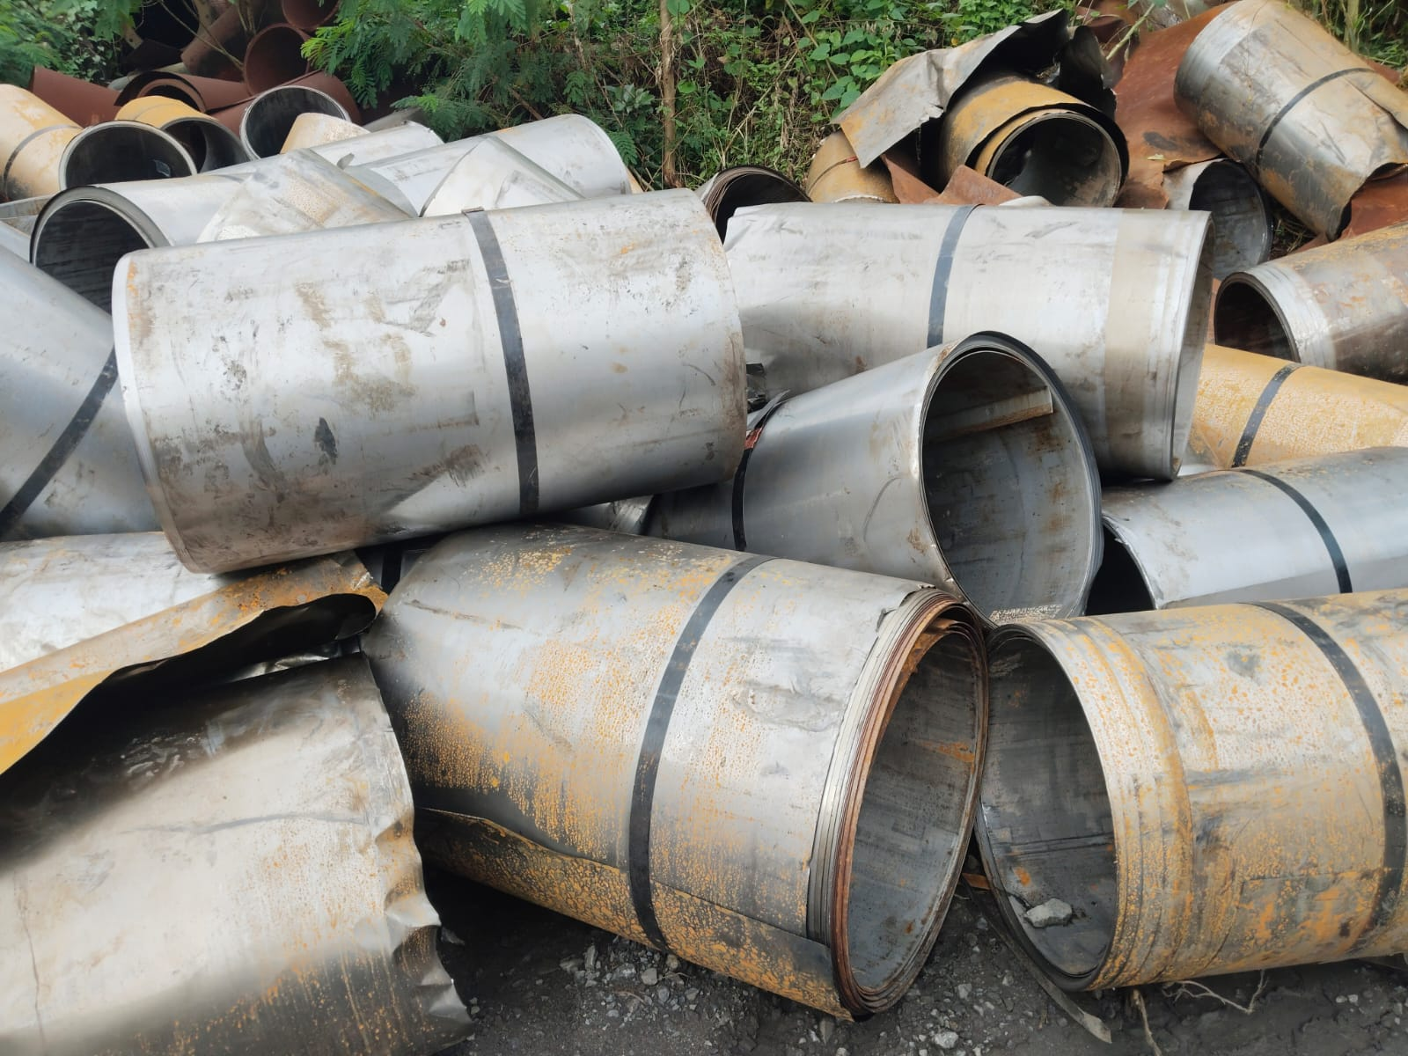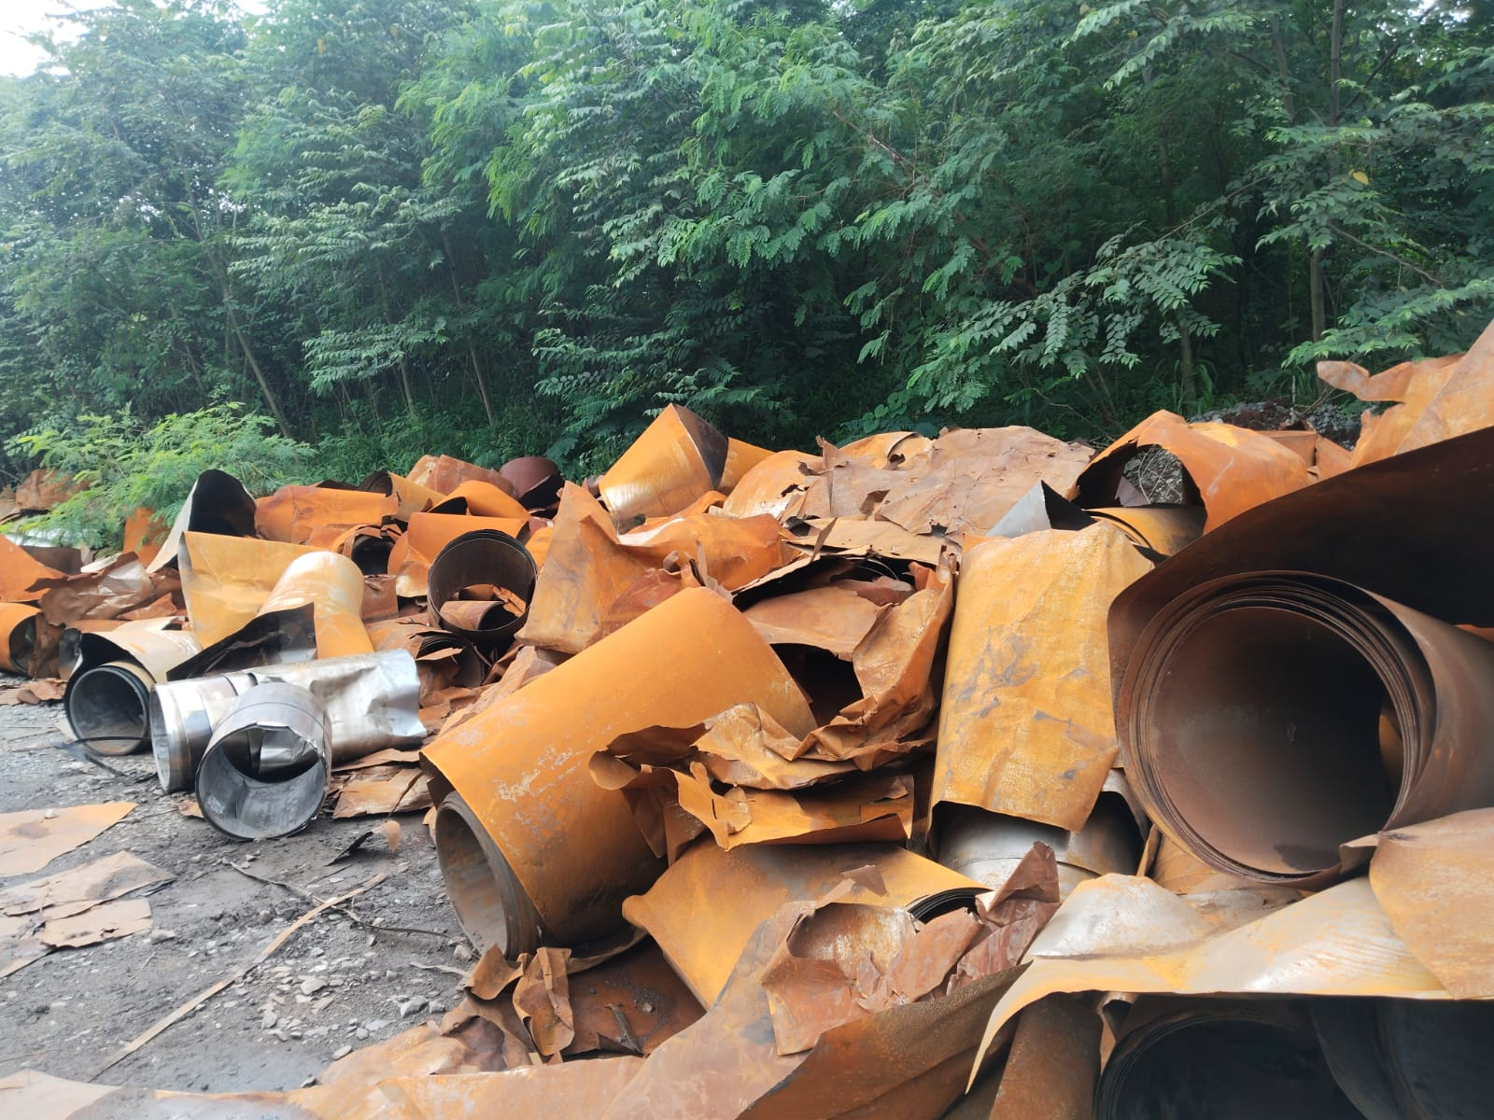
Rej. HR Coil End (Mixed Thickness) Rej. HR Coil End (Mixed Thickness) Rej. HR Coil End (Mixed Thickness) Rej. HR Coil End (Mixed Thickness)

All the above pictures are indicative in nature

In case of safety violations by customer vehicle drivers as mentioned below:
S.no | Violation Type | Consequence Management (Penalty)
i. | Unwanted and unauthorized movement | Penalty as per major road safety violation. (Pls refer point. 2.a)
ii. | Use of mobile phone in areas where the use is prohibited
iii. | During driving or working under the influence of ‘alcohol or drugs’ inside the plant
iv. | Any other site-specific Fatality / Serious injury potential unsafe act / Behaviour

1. Consequence management on drivers:
- Unwanted and unauthorized movement/ Use of mobile phone in areas where the use is prohibited / Non-compliance in use of PPE – Driver gate pass will be blocked for 1 day
- During driving or working under the influence of ‘alcohol or drugs’ inside the plant – 1st instance driver gate pass will be blocked for 30 days & in case of 2nd instance in the same year – Permanent blocking of gate pass.
- Any other site-specific Fatality / Serious injury potential unsafe act / Behaviour – Driver gate pass will be blocked for 15 days.
- Guidance from road safety team will be taken regarding banning of driver/vehicle, if required.

- Non-compliances of Road safety / Workplace safety standards

a. Major safety violations:
- 1st instance – Rs. 50000/- will be deducted as penalty or actual loss occurred to TSL if any whichever is higher.
- In case of 2nd instance within the same year amount of Rs. 100000/- will be deducted.
- Minor safety violations:
- In case of noncompliance of PPE- Rs. 2000/- will be deducted from the customer.
- In case of High speed, unsafe parking, not putting barricades around breakdown vehicles, vehicle breakdown due to low fuel etc. an amount of Rs. 25000/- will be deducted as penalty.
- All other violation which does not the part of Major safety violation list will be treated as minor safety violation.
- Consequence management on drivers involved in the major road safety violation:
- In case of 1st violation- 7 days blocking of gate pass.
- In case of 2nd violation within 1 year – 30 days blocking of gate pass.
- In case of 3rd violation within 1 year – Permanent blocking of gate pass.

- Consequence management on vehicle involved in the major road safety violation:
- Vehicle gate pass to be seized and vehicle to be banned for 15 Days,

- List of Major road safety violations are given below:

- Vehicle dashing to any person/structure or collision to any other vehicle causing serious injury or property damage.
- Persons sitting in material body or inside cabin without proper permission.
- Poor upkeep of vehicles and not maintaining safety features of vehicles like RUPD, SUPD, fail safe break, three-piece mirror, rear view camera, wiper etc.
- Wrong overtaking/ Overtaking in no overtaking zones
- Vehicle moving on restricted road or in wrong direction on one-way road.
- Not wearing seat belt (Front & rear).
- Vehicle forcibly entering the manned or unmanned level crossing despite stop signal.
- Heavy vehicle movement in non-specified time.
- Driving without valid driving license / training certificate not available with flagman.
- Repeated road safety violations (3 times and more within 12 months).
- Driver absconding after any road incident.
- Any spillage from vehicle on the road and potential to lead major incident.
- Any major noncompliance identified during Road/Rail Safety audit by safety professionals / line managers.
- Hyvas /Tipper truck moving with Dala in raised condition.
- Toppling incident involving Tipper/Hyva/Dumper/Truck.
- Movement of Over Dimensional Consignments (ODC) at unspecified times.
- No scotch block on vehicle parked (or unattended)
- Tailgating (driving closely behind) a HEMM.

Open www.ahbilimoria.com ->Click on Customer Complaint Management Portal
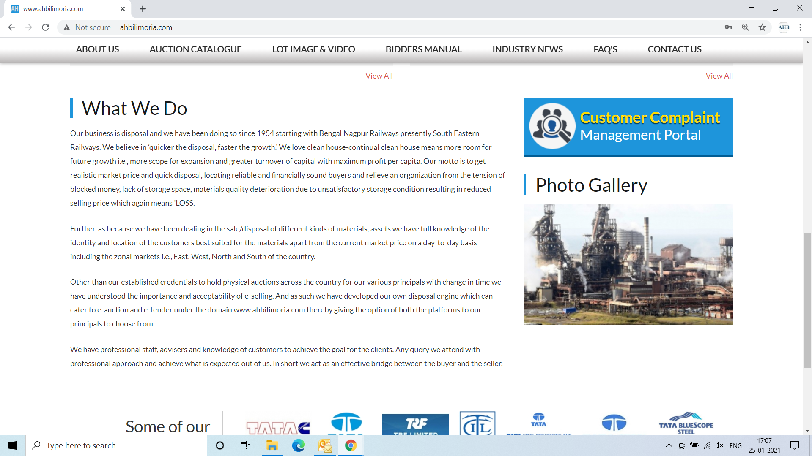

Use your User ID & Password for login

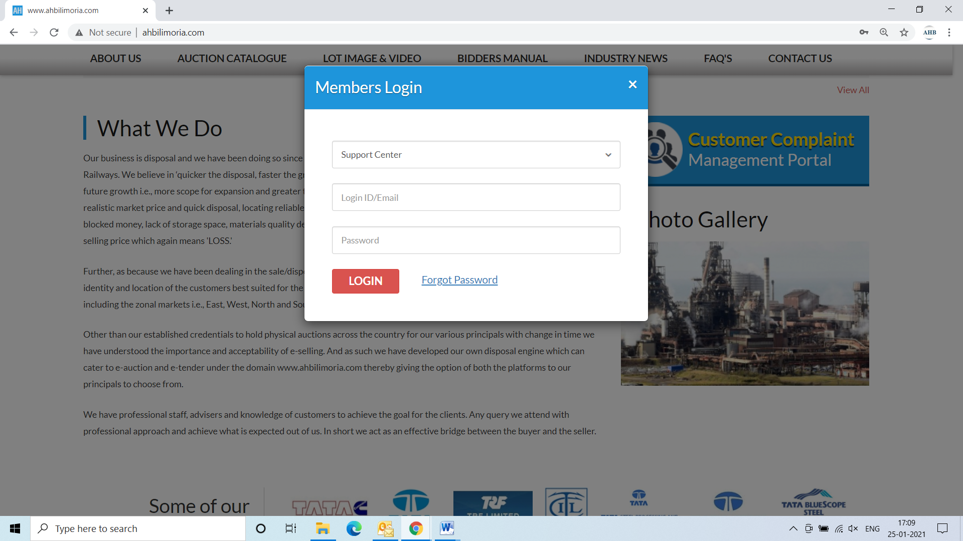

Click Complaint Portal-> Click on “Post a New Ticket”

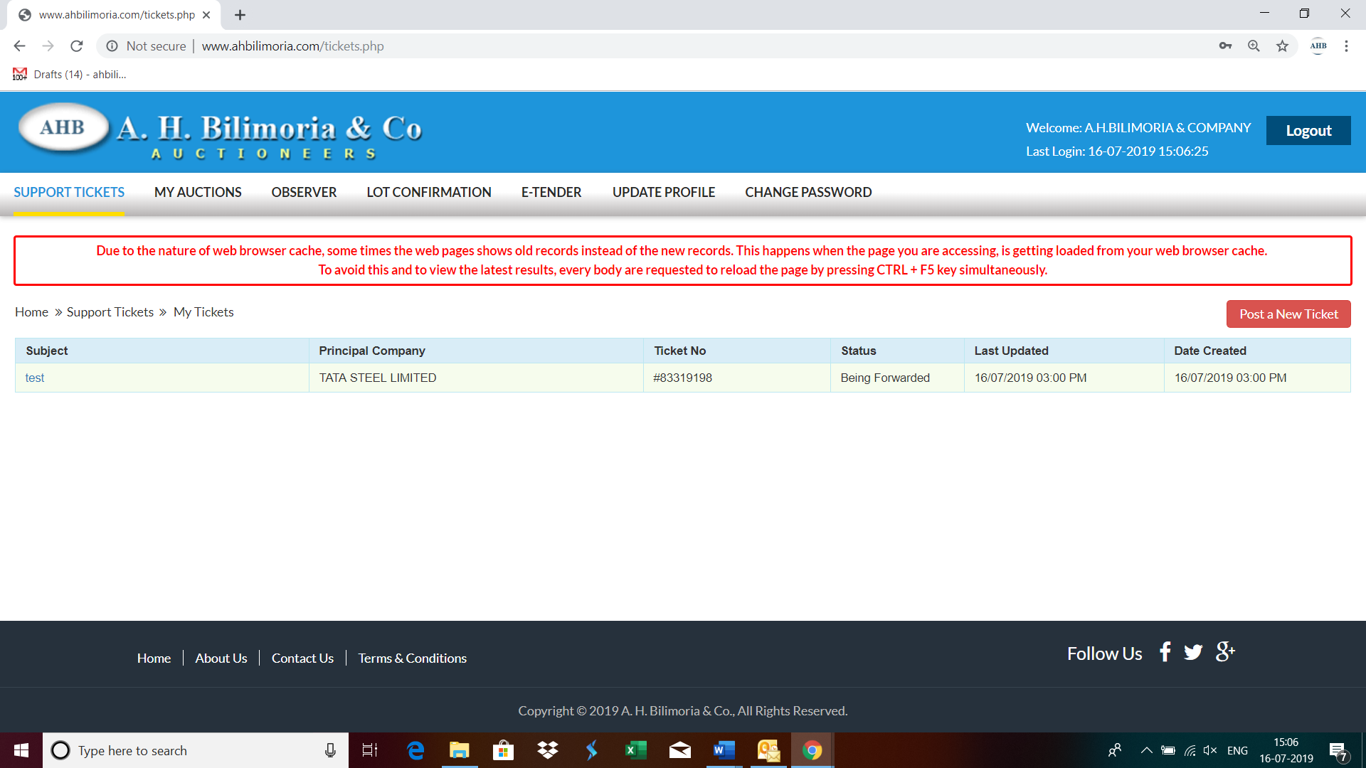

Post a New Ticket->Subject* ->Message* -> Email*->Principal Company*->Attach Document (If required any attachment) ->Submit

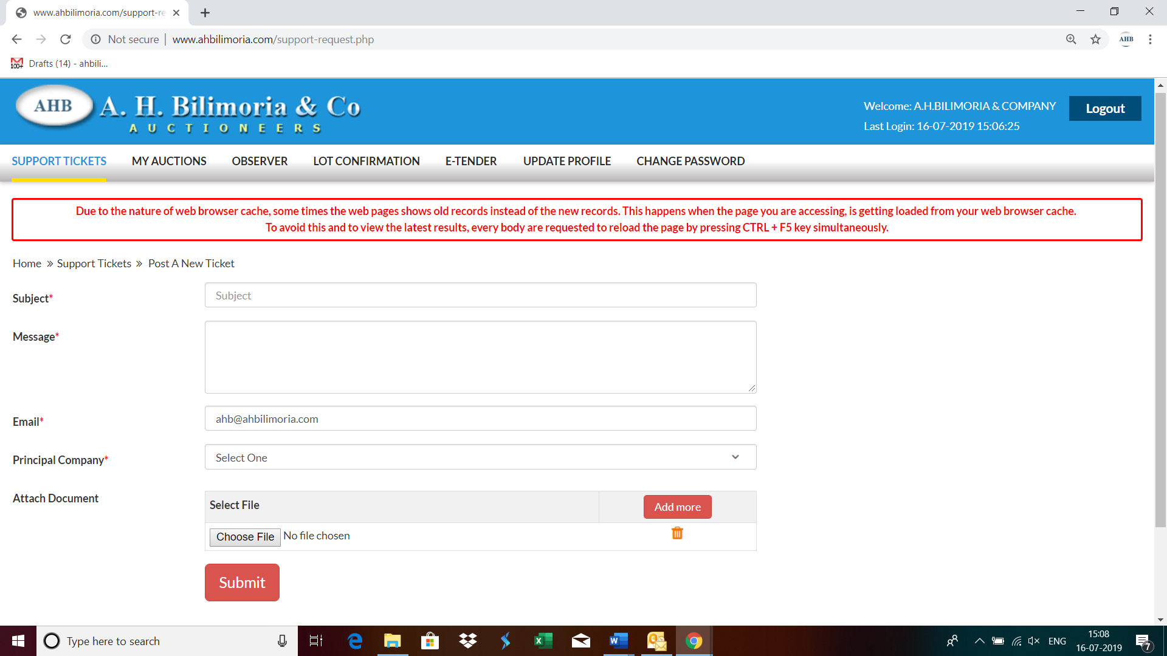

Your support request has been submitted successfully and the Reference No ----- is generated automatically



