Auction Catalogue
Auction conducted by A H Bilimoria & Co.
Auction of Capital Items, Jamshedpur - IBMD
BEING SOLD ON ‘’AS IS WHERE IS AND NO COMPLAINT BASIS’’
Catalogue Serial Number: | TSL/AHB/SEPTEMBER/220/26-27
Seller: | Tata Steel Limited
Auction website: | www.ahbilimoria.com
e-Auction Date & Time: | 14th September, 2026…..….. at 11:00 AM
Inspection Date & Time: | No physical inspection to be conducted. Interested customers please visit our website for indicative lot photographs/videos. For any assistance please call AHB (7991108353/7003840027) or IBMD Officer (9035025731).
Date of Security Money Deposit | 14th September, 2026 Till ……… at 10:30 AM
Contact Details:
For Post Auction @ A H Bilimoria & Company
Area | Contact No. | Email Id
Auction Room | 07003840027/09883421336
Lot Confirmation Related | 08987460668 | ahb@ahbilimoria.com, ahbilimoria.company@gmail.com
Payment Related | 9073259310/9123717907  /8013429959/9830772334 | ahb@ahbilimoria.com, ahbilimoria.company@gmail.com, ahbjsr@ahbilimoria.com, b.bhardwaj@ahbilimoria.com, m.paul@ahbilimoria.com, sukumar.chandra@ahbilimoria.com
Delivery Order Related | 9073259310/9123717907  /8013429959/9830772334 | ahb@ahbilimoria.com, ahbilimoria.company@gmail.com, ahbjsr@ahbilimoria.com, b.bhardwaj@ahbilimoria.com, m.paul@ahbilimoria.com, sukumar.chandra@ahbilimoria.com
Material Value Refund Related | 9073259310/9123717907  /8013429959/9830772334 | ahb@ahbilimoria.com, ahbilimoria.company@gmail.com, ahbjsr@ahbilimoria.com, b.bhardwaj@ahbilimoria.com, m.paul@ahbilimoria.com, sukumar.chandra@ahbilimoria.com
Refund Related | 9073259310/9123717907  /8013429959/9830772334 | ahb@ahbilimoria.com, ahbilimoria.company@gmail.com, ahbjsr@ahbilimoria.com, b.bhardwaj@ahbilimoria.com, m.paul@ahbilimoria.com, sukumar.chandra@ahbilimoria.com
TCS Related | 9073259310/9123717907  /8013429959/9830772334 | ahb@ahbilimoria.com, ahbilimoria.company@gmail.com, ahbjsr@ahbilimoria.com, b.bhardwaj@ahbilimoria.com, m.paul@ahbilimoria.com,sukumar.chandra@ahbilimoria.com,
Payment Deviation/Disablement in Tata Steel | 9073259310/9123717907  /8013429959/9830772334 | ahb@ahbilimoria.com, ahbilimoria.company@gmail.com, ahbjsr@ahbilimoria.com, b.bhardwaj@ahbilimoria.com, m.paul@ahbilimoria.com, sukumar.chandra@ahbilimoria.com
Collection of Delivery Order-Tata Steel | 9073259310/9123717907  /8013429959/9830772334 | ahb@ahbilimoria.com, ahbilimoria.company@gmail.com, ahbjsr@ahbilimoria.com, b.bhardwaj@ahbilimoria.com, m.paul@ahbilimoria.com, sukumar.chandra@ahbilimoria.com
Collection of Delivery Order for Tata Steel Kalinganagar | 9073259310/9123717907  /8013429959/9830772334 | ahb@ahbilimoria.com, ahbilimoria.company@gmail.com, ahbjsr@ahbilimoria.com, b.bhardwaj@ahbilimoria.com, m.paul@ahbilimoria.com, sukumar.chandra@ahbilimoria.com, m.k.bal1994@gmail.com
For time bound resolution of unresolved issues log into our Customer Complaint Management portal | Type in www.ahbilimoria.com> Go to “Customer Complaint Management Portal” >Log in with your user id and password and write the details of issue.

For Any unresolved Issues beyond two (02) days mail to A H Bilimoria & Company :
Mr. A K Sil (M-09830074122) & Mr. D Pyne (M-09830738481), E-mail: ahb@ahbilimoria.com, ahbilimoria.company@gmail.com
Copy to Tata Steel Ltd : Mr. Surajit Sen (surajits@tatasteel.com), Mr. Mohit Raj (mohit.raj@tatasteel.com)
For loading related query please call Mr. Puneeth Param Senapati (RAMY), M: 7749990834 & Mr. Umesh Sharma (IBMD MARINE DRIVE), M: 7364089647
SPECIAL NOTE: -It is the responsibility of the buyer to furnish the valid GST no. & necessary documents to A H Bilimoria & Company before participating in the auction. In case during the transactions, it is found that valid GST no. has not been provided, then all necessary liabilities if any & so accrued would be on account of the buyer. TATA Steel & A H Bilimoria & Company would not be responsible for any such liabilities.

Note: TSL reserves the right to track IP address, MAC number and geolocation of bidding customers whenever customers participate in any auction on the A H Bilimoria & Co. auction platform for TATA Steel.

- Payment and Lifting Schedule:
Lot No. | Payment Schedule |  |  | Lifting Schedule  (working days from the next day of DO release)
Lot No. | EMD (10% of lot value) | 1st installment | 2nd installment | 1st installment lifting days | 2nd installment lifting days
For All Material | 01 Working day from Date of Lot Confirmation | 02 Working Days From Date of confirmation | 03 Working Days from the 1st Installment date  [Only Applicable if material value (Rate X Tonnage) crosses Rs. 25 Lakh] | 07 Working days from the D/O date | 3 additional working days at the expiry of 1st Installment DO validity.
- Suitable extension of due date for payment and lifting will be accorded in case of any eventualities like Strike/ Bandh/ Special restriction on vehicular movement imposed by the local Administration etc.

- Requirements of participation:
  - Registration: Before participation in the e-Auction, a prospective bidder shall be required to get registered with A H Bilimoria & Co. For details visit www.ahbilimoria.com

  - Security Deposit: Non-Interest bearing security deposit of Rs.60,000/- (Rupees Sixty Thousand only) for all lots in favour of “A H Bilimoria & Co.” through Online Payment only : Details as under :

Beneficiary Name | A. H. BILIMORIA & COMPANY
Bank Name | HDFC Bank
Branch Name | 31, Chowringhee Road, Kolkata – 700016
Account No | 06932560001205
IFSC Code | HDFC0000693

Account No: All the customers will have a unique account number. The unique account number is an alpha numeric code consisting of 12 characters. The Customer’s unique “account number” is a combination of the AHB’ SAP code along with the 6 digit bidder SAP ID and can be used as reference. for all subsequent transactions. The Customer’s Account Number detail is available in “Profile” after the customer logs into our website using the user id and password.

- Inspection Rules & Policy:
No physical inspection to be conducted. Interested customers please visit our website (www.ahbilimoria.com) for indicative lot photographs/videos. For any assistance please call AHB (7991108353/7003840027) or IBMD Officer (9035025731).

- Bidding modalities:
  - Price Bid Basis: In Indian rupees as per unit of measurement as given in Material List. Price to be quoted is basic, ex- location exclusive of taxes and any other statutory levies.
  - Bid Increment: As specified in the e-auction bid page
  - Type of Auction: English No Ties
  - Bid Validity: Bid shall be valid for 10 (Ten working days excluding Saturdays, Sundays and Bank holidays) working days counted from the next day of auction process in case of auction against a catalogue which is completed on the same day. And if it is continuing on any other day the counting of days for lot confirmation shall be from the next day of completion of entire auction process.
  - Bid duration: For 1st four lots 20 minutes and balance lots 10minutes. If, No bids received within these specified time the lots are closed automatically.
  - Auto Extension of the Auction Timings: In the event of bids in the last sixty (60) seconds of the scheduled bid time, the Bid Timings are automatically extended for One hundred eighty (180) seconds from each such bid. Such Auto Extension shall continue until no bids are placed for sixty (60) seconds (Engine remains inactive for sixty (60) seconds. The Inactivity Time for Auto Extension purpose is normally “3” minutes. "Service Provider" however retains the right to change the “Inactivity Time” as well as “Extension Period”. The Inactivity Time applicable for the particular Online Bid shall be visible to the customers on the Bidding page.
- Taxes & duties:
  - GST : As applicable
  - TCS : As applicable
  - Any change in taxes applicable at the time of lifting shall be applicable.

- Payment terms & conditions :
  - Payments: PAYMENT FACILITY BY RTGS / NEFT ONLY

Account No | TATAHB followed by Party code (Each individual customer will be provided with Account number to be provided by AHB)
Beneficiary Name | TATA STEEL LIMITED A H B
Bank Name | HDFC BANK LTD.
Branch Name | Sandoz Branch, Mumbai
IFSC Code | HDFC0000240

  - EMD: 10% of the material value to be paid within 01 (One) working day from the date of lot confirmation. EMD to be adjusted in the final installment only.
EMD payment is to be made within the time limit as given in letter of confirmation. No extension will be provided for the same.
  - Balance Payment Time: (As per payment schedule)
  - Delayed Payment Charges (DPC) : Installment payments with DPC @ five (05) paise per Rs. 100 per day will be accepted up to 02 (Two) working days (after on approval from TSL authority) from due date of installment payment as mentioned in the confirmation letter. This is not applicable for EMD payment. GST @ 18% would be charged in addition to the above DPC amount.
  - Saturdays, Sundays and Bank holidays are excluded for counting purpose for payment schedule.
  - In the event of Non-Receipt of Payment within the stipulated period of Payment, the Sale Offer for the approved Lot shall stand withdrawn automatically (Refer Clause#8).
  - Buyers have to send the payment deposit slip (UTR No /Scan Copy of NEFT/RTGS Transaction Slip) against Lot No. immediately after the payment to AHB at email id: ahb@ahbilimoria.com& ahbilimoria.company@gmail.com
  - GST number of TSL : 20AAACT2803M2ZO

- Lifting terms & conditions:
7.1 DOs will be handed over to authorized representatives of bidders on receipt of payment. Authorization letter to be issued via registered e-mail id’s. Authorized letter must be duly stamped and signed by the proprietor or partner or director on receipt of payment. Lifting date is calculated from the next day of DO Release date.
7.2 Loading Charges: As mentioned in material list
7.3 Loading shall be given strictly as per the statutory norms & safety norms of Tata Steel Ltd.
7.4 Lifting with Ground Rent: Lifting along with ground rent will be allowed up to 4 (four) working days from the last date of lifting period. In case the lifting is not complete, and no request is made by the customer within the period of four days, the company reserves the right to close the lot, and refund the balance to the party after deducting for any shortfall in lifting as per norms laid down in the catalogue. Ground Rent will be calculated on balance unlifted quantity @ 05 paise (inclusive of tax) per Rs.100/- per day. GST @ 18% would be charged in addition to the above ground rent amount.
7.5 Additional lifting days for advance payment of installment - If the installment payment is made in advance, then additional lifting days (equivalent to the number of days payment made in advance) would be given. This would not be applicable for EMD payment.
7.6 PICK & CHOOSE NOT ALLOWED FOR ANY OF THE LOTS.

7.7 LOT TRANSFER WILL NOT BE ALLOWED.

- Penalty:
  - The following penalties shall be applicable in the eventuality of a buyer defaulting in making the payment of EMD (wherever applicable) or any installment/s, as per the stipulated schedule for each lot, in a financial year:
- In the first instance, a penalty of Rs. 60,000/- (Rupees Sixty Thousand only) shall be recovered from the customer. The above penalty amount would be inclusive of GST amount @18%.
- In the second instance, a penalty of Rs.120,000/- (Rupees One Lakh Twenty Thousand only) shall be recovered from the customer. The above penalty amount would be inclusive of GST amount @18%.
- In the third, and any subsequent instance, a penalty of Rs.180,000/-(Rupees One Lakh Eighty thousand only) shall be recovered and the customer shall be debarred from participating in any auction for a period of three months from the date of debarment. The above penalty amount would be inclusive of GST amount @18%.

In the event of any default, the customer’s user id will be disabled and the customer will be blocked from participating in any auction of TSL with immediate effect.

The defaulting customer shall be allowed 06 (six) working days to deposit the penalty as mentioned above. In case the penalty is not received within the stipulated period, the customer’s security deposit shall be forfeited, and the defaulting customer shall be immediately debarred from participating in any auction of TSL.

  - If after making payment of EMD (wherever applicable), the installment payment/s are not made by the customer as per the stipulated schedule for each lot, the entire EMD amount against such lot shall be forfeited.

  - In case of non- lifting of full lot quantity after making full payment, a penalty equivalent to 20% of the material value for the un-lifted quantity against each lot shall be recovered from the customer.

- Lot Closure Norms :
For Lot Closure, the tolerance would be ± 10% of the original quantity of all lots.
For High Value Items (>/= Rs 50000 per MT) tolerance for Lot closure is 0% of the lot quantity.

- Refund :
Refunds will only be made by TATA Steel vide RTGS/NEFT and hence all customers are required to submit their bank details to A H Bilimoria & Company or mail at ahb@ahbilimoria.com, ahbilimoria.company@gmail.com, ahbjsr@ahbilimoria.com, b.bhardwaj@ahbilimoria.com. TATA Steel or A H Bilimoria & Company will not be responsible for any delay in refunds owing to absence of bank details of the customer.

- Complaints :
Complaints, if any, with regard to any transaction shall have to be lodged by the buyer within three calendar months from the date of last invoice. No complaint shall be entertained thereafter, under any circumstances. Customers can log their complaints at (www.ahbilimoria.com> Go to “Customer Complaint Management Portal” >Log in with your user id and password and write the details of issue.)

- Jurisdiction :
Any dispute arising out of any contract shall be decided in Jamshedpur by the courts in Jamshedpur and by no other courts. The courts in Jamshedpur shall have exclusive jurisdiction to adjudicate upon any such dispute.

- General terms & conditions:
  - Any dispute on quality & quantity of material and bid cancellation shall not be entertained at any point after the auction.
  - All lots are offered/sold on “As is Where is Basis” and “No Complaint Basis”.
  - Lot transfer will not be allowed. Payment and invoicing has to done in the name of the H1 bidder, subject to the prices being approved.
  - Lot purchased should consist of material from the same lot and designated location only. Tata Steel has the right to check any vehicle at any moment of time. If material lifted differs from the material that is purchased by the buyer, then the buyer and authorized representative will be permanently debarred. Also Tata Steel can take any penal action against the buyer/authorized representative. All the material loaded in the vehicle is to be covered in order to follow the safety compliance of Tata Steel works.
  - If the safety compliance is not followed, then Tata Steel can penalize the buyer / authorized representative as deemed fit.
  - Customer attested photocopy of valid id proof (Voter id/Aadhar/Pan card) of all lifters / Authorized persons engaged by customers for lifting of materials from TSL is to be enclosed with the authorization letters & to be forwarded to TSL for issue of gate pass.
  - Dispatch is subjected to FORCE MAJEURE conditions
  - The seller reserves the right to terminate any offer at any point of time without assigning any reasons
  - In the event of termination of the offer, seller shall refund the balance amount after due reconciliation
  - No claims whatsoever would be entertained after cancellation of the bid
  - In addition of earlier safety norms, the following would be compulsory:
The drivers of the vehicle must have the eye test certificate. The frequency of the testing would be as below:
1. If the age of the person is less than 45 years - Once in a year
2. If the age of the person is 45 years or more, the testing is required to be done once in every 6 months
Please ensure to comply with the safety norms
  - Weighment : Weight recorded by Tata Steel weighbridge will be considered final and binding on the customer.
  - This transaction falls u/s 206C(1). Hence Section 194Q will not be applicable.
  - Compliance in relation to section 206AB/206AA (Furnishing of I.T Return for past 2 Years) will be taken directly from Income Tax Portal till 28th June-2021. If any compliance made in IT Portal by the customer (after 28th June-21), shall be communicated to AHB over mail.
  - No Punjab dala to be allowed inside works in any area of operation.
  - Mandatory usage of reverse Camera in all customer vehicles for lifting of materials.

14. Compliance to safety norms
14.1 Authorized persons (of the customer) involved in lifting of the materials will be allowed only with Personal Protective Equipment’s (PPE) i.e., Safety Shoes, Safety Helmet, Safety Goggles, Fluorescent Jacket and Hand Gloves. No "people movement" shall be allowed at the time of loading/delivery of materials from the yards" Tata Steel will not be responsible for any delays arising out of Non- Compliance to the Safety Norms.

14.2 Documents for verification regarding entry of vehicles inside Tata Steel works :
All customers to note that presentation of following set of documents to TATA STEEL authorities is COMPULSORY at the time of reporting of vehicles at TSL designated Gate for entry of Customer trucks/vehicles.
a. Driving License of driver,
b. Registration Card,
c. Commercial Certificate,
d. Fitness Certificate of Vehicle,
e. Re-registration for vehicles older than 15 years
f. Insurance
The checklist form will be filled in at TSL designated Gate for entry of Customer trucks/vehicles before entry of vehicle.

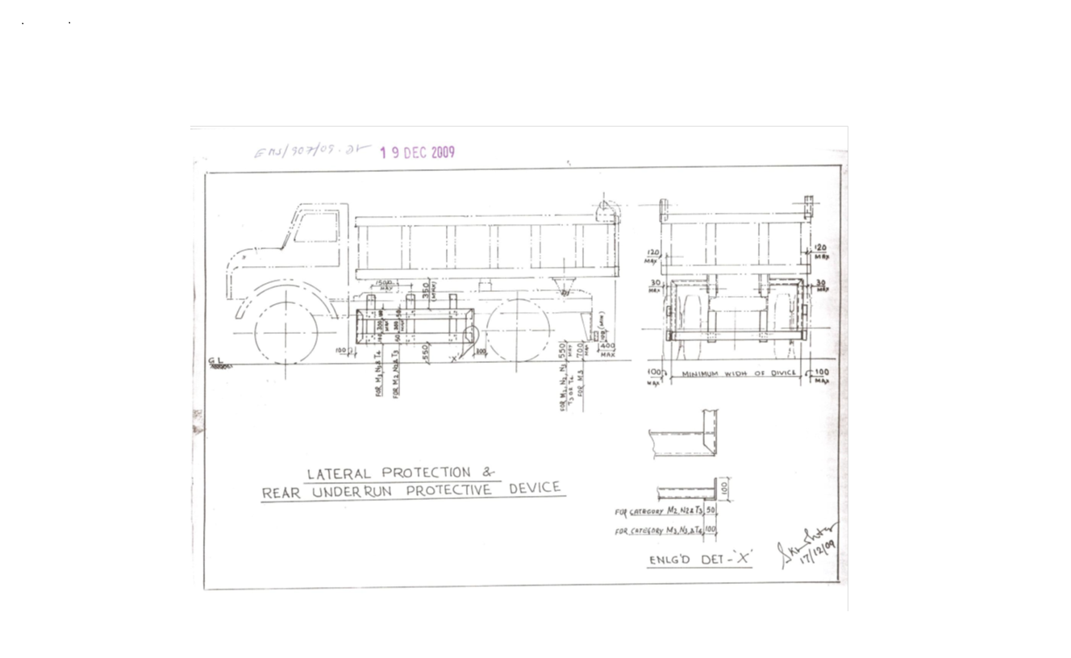

Sl. No. | Safety Parameters to be checked
1 | Three Piece Mirror(Truck, Trailer & Dumper)-Helper side
2 | Single Mirror- Driver side
3 | Rear View Mirror (Tata Ace, 207, Jeep etc.)
4 | Service Brake
5 | Parking Brake
6 | Seat Belt
7 | Head Light
8 | Parking Light
9 | Blinker
10 | Horn
11 | Reverse Alarm
12 | Wiper
13 | Windshield Glass
14 | Air Pressure Min. 7 Kg/Cm^2
15 | Run Under Protection Guard as per TSL standard
16 | Side under Protection Guard as per TSL standard
17 | Tyre Condition (Tread Depth, Cut Mark etc.)
18 | Any Oil Leakage from the vehicle
19 | Physical condition of Dallah
20 | Availability of scotch block
21 | Buzzer with side indicator
22 | Driver's eye examination report
Legal Documents to be checked:
Sl. No. | Documents to be Checked
1 | RC Book
2 | Insurance
3 | Pollution
4 | Driving licence
5 | Fitness for more than 15 years old vehicle
6 | NOC for outside vehicles
For ODC (Over Dimensional Consignment) items Customer / Authorised Lifter has to do Route Mapping in consultation with IBMD prior to vehicle placement for delivery. Customer / Authorised Lifter to indicate final date of vehicle placement.

15. DISCLAIMER FOR E-AUCTION
BANDWIDTH PROBLEMS, CONNECTIVITY PROBLEMS WITH THE LOCAL ISP (INTERNET SERVICE PROVIDER), SLOWNESS TO ACCESS PAGES FOR DOWNLOADING ETC. ARE BEYOND THE CONTROL OF TATA STEEL LTD. AND A H BILIMORIA & COMPANY. HENCE NO RESPONSIBILITY LIES WITH TATA STEEL LTD. OR A H BILIMORIA & COMPANY FOR THE ABOVE PROBLEMS FACED, IF ANY, BY THE BIDDERS BEFORE/DURING THE AUCTION ANY. BID PLACED USING THE BIDDER'S USERNAME AND PASSWORD IS UNCONDITIONALLY BINDING ON THE BIDDER TO WHOM SUCH USERNAME AND PASSWORD HAD BEEN ALLOTTED AND HE SHALL BE SOLELY RESPONSIBLE FOR MAINTAINING THE CONFIDENTIALITY OF THE SAME AND FULLY RESPONSIBLE FOR ALL ACTIVITIES THAT OCCUR UNDER THEIR USERNAME AND PASSWORD. HENCE THE USER IS ADVISED TO CHECK THE USERNAME AND PASSWORD BEFORE THE AUCTION,IN ORDER TO FAMILIARISE HIMSELF WITH THE SAME AND IS ADVISED NOT TO REVEAL IT TO ANYONE ELSE SO AS TO PREVENT MISUSE OF THE SAME. THE BIDS MADE BY THE BIDDERS AGAINST THEIR USERNAME AND PASSWORD SHALL BE IRREVOCABLE.THE BIDDERS ARE ADVISED TO REGISTER AND PRE-QUALIFY FOR BIDDING WELL IN ADVANCE AND PLACE THEIR BIDS EARLY IN ORDER TO TAKE CARE OF ANY UNFORESEEN TECHNICAL DIFFICULTY THAT MIGHT SURFACE IN THE INTERNET OPERATIONS.

STANDARD OPERATING PROCEDURE
FORM.NO.EHSMSM/446/4013 FORM REV.NO.:01 EFFECTIVE DATE:01.04.2009
SOP NO. | IBMD/BPSS/Tran/SOP | EFFECTIVE DATE | 01.04.2022 | REVISION NO. | 01
SOP DESCRIPTION | Management of External Despatch Vehicle at Transport Park | SECTION | BPS Steel
DEPARTMENT | IBMD(BPSS) | PAGE | 1 Of 8

S.No. | Work | Work related hazrads/impact | Responsibility | Process / PPEs (How) | Remarks/References
01 | General Awareness | Safety:  - Unaware of dangers of steel plant  - Unaware of use of PPEs  - Unaware of Tata Steel’s Safety Standards  - Unaware of workplace hazards  - Unaware of Covid-19 virus  Environment:- Not Applicable  Quality:- Not Applicable | Transport park Supervisor | - Ensure that all drivers/lifters are trained on safety and the records are well maintained | SS/ENGG-07
01 | General Awareness |  | All workers | - Be sure to use PPE such as a safety helmet, safety shoe, safety goggles, fluorescent jacket, dust mask.  - Check all PPE before inspection  - Replace the faulty one immediately.  - Ensure that COVID 19 guidelines such as social distancing, travel history, temperature check and use of face masks are followed. | SS/ENGG-07
01 | General Awareness |  | Driver of the vehicle | - Keep the required documents | SS/ENGG-07
02 | Checking of documents |  |  | Verification of documents like Driving License, Driver's Aadhar Card/Voter Card, PPE, Vehicle Registration Card/Book, Pollution Test, Permit, Road Tax, Vehicle Fitness, Vehicle Parking Slip, Work Order/DO Copy, Covid Test and Eye Test Certificate  - Entry of details in the register  - Revealing the veracity of the documents to the vehicle security checking team.
03. | Vehicle safety check | Safety:  • Car colliosion  •Run over  • Vehicle rolling  • Slip/Trip/Fall  Environment: N/A  Quality: N/A | Transport park Supervisor | - Get the details of the vehicle checked from the document verification team  - Proceed to the parking lot for security check using the barricaded path.  - Make sure to use proper PPE as per the standard.  - Follow all road safety rules.  - Vehicles are to be checked as per Vehicle Checklist. (Form no SHE/WP/RRM/FOR/16)  - Do not use mobile in parking and during vehicle checking.  - Do not check vehicles parked in no parking areas and outside the parking lot.  - During inspection ensure proper body condition of the vehicle and scotch block in the wheels  - Maintain a safe distance from previously checked vehicles.  - If the vehicle is found to be fine as per the checklist (tyres, blinkers, back camera, head light, back horn etc.), the completed checklist may be handed over to the driver/lifter.  - If the vehicle is not found in good condition, then checklist with proper remarks is to be given to the concerned driver/lifter for rectification and re-examined after rectification.  - Ensure that no vehicle is checked more than twice in a day
04. | Safety training to driver and issue of security pass and photo pass to driver | Safety:  • Safety training to drivers • Workplace Safety  Environment: N/A  Quality: N/A | Transport park Supervisor | - Check Vehicle Safety Checklist issued by Vehicle Safety Checking Agency  - If vehicle is fine as per check list then proceed for driver safety training.  - Make sure that the concerned driver has verified vehicle check list, Aadhar/Voter card, driving license, vehicle parking slip, work order/DO copy, eye check certificate and proper PPE before making security pass.  - Driver is fit to drive the vehicle.  - Drivers should be shown safety videos.  - Following guidelines for mobile usage to be given to Drivers:  - Heavy Vehicle /Mobile crane /HEMM drivers should keep his mobile in switch off or silent mode while on driving seat. Mobile phone should only be used after stopping the vehicles appropriately .  (Cell Phone/Mobile phone signifies any device that makes or receives phone calls, sends text messages, surfs the Internet, or downloads and allows for the reading of and responding to email, whether the device is company owned or personally owned. Earphones / Headphones / Hands free / Bluetooth enabled hearing devices will be considered a part of Cell Phone. It also includes any type of music/ gaming device such as iPods, Portable Music through earphone etc.)  - Make sure the driving license is verified through the Mparivahan App.  - The photo pass (entry gate pass) should be made and handed over to the concerned driver only after security training, verification of ID (Aadhaar/Voter Card, Driving License, Security Pass, Vehicle Parking Slip) of the concerned driver and verification of registration number of the concerned vehicle and verified checklist as well as DO copy for IBMD vehicle and for supply/store car
05 | Issuance of loading advice and GPS | Safety: NA  Environment: NA  Quality: N/A | Transport park Supervisor | - loading advice to be made only after checking paper like DO copy, vehicle safety verified checklist, lifter authority etc.  - Entry of DO number in TSL(IBMD IS) system.  - Check DO details in the system  - If found correct, print out the loading advice to be given after entering the loading location as mentioned in the DO  - After mapping the loading location, GPS should be given as per the loading advice issued to the driver.
06. | Emergency preparedness. | Safety:  Bodily injury to any worker during the course of work.  Environment: N/A  Quality: N/A | All Tata Steel workers and contract wokers | In case of any emergency, immediately inform the following concerned agencies clearly mentioning the exact location of the incident. • Hire one person as a guide, who will escort the agencies to the right location if the location is a bit internal. • Keep a fire extinguisher and first aid box in the office  TSL Emergency no.: - 0657 66 47777  Fire Brigade – 06572645101  First aid (East) - 0657 66 43214  First aid (West) - 0657 66 43412  Security officer – 9204652485  Manager MRD- 9234500733 (Mobile)  Sr. Manager MRD- 9040094833 (Mobile)  Head (MR & SPP) - 9204058272 (Mobile)

FORMAT: SHE/WP/RRM/FOR/16
Checklist for HMV & LMV (Supply material, outbound material and Raw material)
Vehicle Type: |  |  | Capacity of the vehicle:
Vehicle Regd. No |  |  | Projection details(mm):
Transporter Name |  |  | Right Side: |  |  | Left Side:
Consignment Type |  |  | Length: |  |  | Height:
SL. No. | Items to be Inspected |  |  | OK | Not OK | Remarks
1 | PPE must be in good condition & available with driver/operator
2 | General:
 | a) Front Wide shields – no crack, no scratches, and clear visibility.
 | b) Seat Belt in usable condition.
 | c) Physical Condition of Dallah /Bed.
 | d) Rear view mirror, Helper side – 03 Pcs & Driver side- 01 Pcs.
 | e) Visible registration number plate in front & rear side.
 | f) Wiper blade in working condition.
 | g) Scotch block in place at the time of parking.
 | h) Lights, Horn & Electrical :
 | - Parking Light(Front & Rear).
 | - Head Light & Dipper light
 | - Indicator Light (Front & Rear) with buzzer
 | - Brake light (Rear & Side)
 | - Reverse light
 | - Trolley side light(If applicable)
 | - Extended material
 | - Reverse horn(Compulsory) & Camera
 | - Main horn
 | - Battery clamp condition & tightness
 | - Self-starter (vehicle should start within 5-8sec). Tie rod end play(Within 20 to 30 mm)
3 | Tyre Condition & Under Carriage:
 | a) Resoling /rethreading/surface plain in front wheel is not allowed.
b) If central part is at/thread depth less than 1 inch-Not ok(Only trailer may be allowed for single
tyre problem. Supporting tyre to be ok).
 | c) Centre part of the tyre should not be at.
 | d) Any kind of side cut not allowed-depth more than ½ inch not allowed
 | e) Air pressure-Min 7kg/CM2 (Visual Checking).
4 | R.U.P.G / S.U.P.G:
 | a) 550MM height from ground
 | b) Distance From horse (Cabin side)-500 mm.
 | c) Distance from Rear Tyre-300mm
5 | Brakes:
 | a) Foot brake (Service brake)
 | b) Hand brake/Parking brake( No loose of brake chamber stud)
 | c) Fail safe brake ( It will work when air fall below 6.0 kg/cm2).
 | d) Trolley brake in working condition ( If applicable ).
 | e) Leakage from wheel brake actuators & hoses.
6 | Others:
 | a) Alcohol Checking
b) Driving License
c) Diesel Level
7 | Ensure safety during Transportation –If Applicable
 | a) Fixing Proper Wedge.
 | b) Side guard/post.
 | c) Welding of clit, wedge.
 | d) Fixing of ag & caution light.
8 | Chain: (Only For Trailers)
 | a) All link chains of 16 mm dia. of iron / 12mm dia. of steel (Test load = 6.3 t) as per IS 2429.
 | b) The chain shall be free from bent, twisted, damaged or cracked links.
 | c) Chain should not be hammered.
 | d) It must have Valid TPI certi cate & No. of chain :03.
9 | D shackle:
 | 1.D Shackle: D shackle of ¾”dia
 | 2.Hook of 16mm dia
 | 3.Locking pin: ¾” dia
10 | Turn buckles of dia. 1 & 1/2 " diameter (38 MM) (test load = 6.3 t) as per IS 3121

For permanent gate pass

Sign. Of Vendor Representative ______________________________Vehicle Fitness Validity Up to___________________________Sign. Of TSL representative___________________________

In case of safety violations by customer vehicle drivers as mentioned below:

S.no | Violation Type | Consequence Management (Penalty)
i. | Unwanted and unauthorized movement | Penalty as per major road safety violation. (Pls refer point. 2.a)
ii. | Use of mobile phone in areas where the use is prohibited
iii. | During driving or working under the influence of ‘alcohol or drugs’ inside the plant
iv. | Any other site-specific Fatality / Serious injury potential unsafe act / Behaviour

1. Consequence management on drivers:
- Unwanted and unauthorized movement/ Use of mobile phone in areas where the use is prohibited / Non-compliance in use of PPE – Driver gate pass will be blocked for 1 day
- During driving or working under the influence of ‘alcohol or drugs’ inside the plant – 1st instance driver gate pass will be blocked for 30 days & in case of 2nd instance in the same year – Permanent blocking of gate pass.
- Any other site-specific Fatality / Serious injury potential unsafe act / Behaviour – Driver gate pass will be blocked for 15 days.
- Guidance from road safety team will be taken regarding banning of driver/vehicle, if required.

- Non-compliances of Road safety / Workplace safety standards

a. Major safety violations:
- 1st instance – Rs. 50000/- will be deducted as penalty or actual loss occurred to TSL if any whichever is higher.
- In case of 2nd instance within the same year amount of Rs. 100000/- will be deducted.
- Minor safety violations:
- In case of noncompliance of PPE- Rs. 2000/- will be deducted from the customer.
- In case of High speed, unsafe parking, not putting barricades around breakdown vehicles, vehicle breakdown due to low fuel etc. an amount of Rs. 25000/- will be deducted as penalty.
- All other violation which does not the part of Major safety violation list will be treated as minor safety violation.
- Consequence management on drivers involved in the major road safety violation:
- In case of 1st violation- 7 days blocking of gate pass.
- In case of 2nd violation within 1 year – 30 days blocking of gate pass.
- In case of 3rd violation within 1 year – Permanent blocking of gate pass.

- Consequence management on vehicle involved in the major road safety violation:
- Vehicle gate pass to be seized and vehicle to be banned for 15 Days,

- List of Major road safety violations are given below:
- Vehicle dashing to any person/structure or collision to any other vehicle causing serious injury or property damage.
- Persons sitting in material body or inside cabin without proper permission.
- Poor upkeep of vehicles and not maintaining safety features of vehicles like RUPD, SUPD, fail safe break, three-piece mirror, rear view camera, wiper etc.
- Wrong overtaking/ Overtaking in no overtaking zones
- Vehicle moving on restricted road or in wrong direction on one-way road.
- Not wearing seat belt (Front & rear).
- Vehicle forcibly entering the manned or unmanned level crossing despite stop signal.
- Heavy vehicle movement in non-specified time.
- Driving without valid driving license / training certificate not available with flagman.
- Repeated road safety violations (3 times and more within 12 months).
- Driver absconding after any road incident.
- Any spillage from vehicle on the road and potential to lead major incident.
- Any major noncompliance identified during Road/Rail Safety audit by safety professionals / line managers.
- Hyvas /Tipper truck moving with Dala in raised condition.
- Toppling incident involving Tipper/Hyva/Dumper/Truck.
- Movement of Over Dimensional Consignments (ODC) at unspecified times.
- No scotch block on vehicle parked (or unattended)
- Tailgating (driving closely behind) a HEMM.

Lot Photograph: Photographs of lots are at best indicative only and do not necessarily reflect the actual condition of lots. All bidders are advised to e-inspect the offered lots before participating in the auctions. Tata steel or A H Bilimoria & Co. shall not be responsible or liable for any error of judgment or bids put by bidders acting on the basis of these photographs.

Quantity offered is based on eye estimation. Delivery will be made for the estimated quantity or actual ground stock. Estimation error may arise. No complaint of whatsoever nature on estimated /offered quantity shall be entertained under any circumstances. Bidders are advised to make their own judgment on offered quantity before bidding.

Special instruction: Process for issuance of Loading slip for outside locations
- Presently the H1 bidder is authorizing the lifter with signature being attested along with photo. Now, id proof no. should be mentioned in the same letter.
- Customer when collecting the loading slip to also bring photocopy of DO with photo id proof.
- At the back of the photocopy to mentioned the vehicle no. for which loading slip is requested and give self declaration that vehicle is meeting all safe standards.
Speed Limit for Heavy Vehicles to max.25 kms. Any body exceeding the same may get penalized.

Temporary Gate Pass (GP) will be issued to authorized customer representative’s as per DO validity period. For lots having DO validity more than one month, GP will be issued max. 30 days.

Special Instruction:
W.e.f. 10th October, 2024, the CBIC has notified that there shall be deduction of GST TDS @ 2% on supply of metal scrap falling under Chapters 72 to 81 in the First Schedule to the Customs Tariff Act by registered person in B to B supply. The GST TDS shall be deducted when the payment is made or credited to the suppliers Account. The deductor will be liable to pay the TDS amount to the Govt. within ten days after the end of the month in which such deduction is made. A certificate of tax deduction at source shall also be issued by the supplier in the format prescribed in GSTR 7A. Accordingly, it is advised to kindly take necessary actions at your end such as obtaining GST TDS registration and ensure compliances with the GST TDS provisions.

Terms and Conditions for TDS of 2 % on metallic Scrap sales :
- Compliance of GST-TDS Provisions: It shall be the responsibility of the customer to comply with all the requirements prescribed under GST law related to GST-TDS in case of material sold to them.

- Payment of GST-TDS to the Government: The GST-TDS shall be deposited by the customer to the Government within due date prescribed under GST law.

- Filing of GST-TDS Returns: Customer shall file the periodic statements/returns as per GST law. GST-TDS deposited by the customer to the Government shall be refunded to the customer within one month of the day, the paid amount is reflected in GST portal of TSL at GSTN.

- Sharing of GST-TDS payment details with TSL: The customer shall share the invoice wise details of GST-TDS with TSL in excel file to the email id GSTRECON@TATASTEEL.COM.

- Implication of Non- Compliance: Any Impact of non-compliance for GST-TDS under GST law at customer’s end either in financial or other form, shall be borne by the customer only. Further, the customer shall at all times keep TSL indemnified and harmless from any loss/penalty/cost/damages suffered by TSL due to non-compliance of the applicable law by the customer.

No Punjab dala to be allowed inside works in any area of operation.

MATERIAL DETAILS:
LIST OF MATERIALS
Sl. No | Source | Location | LOT no. | Material No. | Material Description | Qty | UOM | GST | TCS | Loading | Lifting period | Contact person | Contact no
1 | PH #4, HBF | Ram Mandir Yard, 2nd Floor 'B' Block Bin-17, JSR | RYAUG26054 | 150001861 | Rej. Aluminium Scrap attached with / without negligible M.S. Screw, Loading by GRABBER, Loading vehicle: TRUCK | 1.31 | MT | 18% | 2% | Rs.35/- Per MT | 07 Working Days from the D/O date | Mr. Puneeth Param Senapati | 7749990834
2 | SPH1 | Ram Mandir Yard, 2nd Floor Just beside to Ramp 'B' Block, JSR | RYSEP26019 | 150001912 | Rej. G.C. & C.C Sheet with / without hole, Loading by MAGNET, Loading vehicle: TRUCK | 7.00 | MT | 18% | 2% | Rs.75/- Per MT | 07 Working Days from the D/O date | Mr. Puneeth Param Senapati | 7749990834
3 | LD #1, LD #2  HSM, RMM  GBF | Ram Mandir Yard, 2nd Floor Bin-20, JSR | RYSEP26011 | 150001912 | Rej. G.C. Sheet with / without hole, Loading by MAGNET, Loading vehicle: TRUCK | 17.28 | MT | 18% | 2% | Rs.75/- Per MT | 07 Working Days from the D/O date | Mr. Puneeth Param Senapati | 7749990834
4 | MRP, LD #2 | Ram Mandir Yard, 3rd Floor Near Col-50, JSR | RYAUG26052 | 140003711 | Rej. Broken Top Lance, Loading by GRABBER, Loading vehicle: TRUCK | 22.98 | MT | 18% | 2% | Rs.35/- Per MT | 07 Working Days from the D/O date | Mr. Puneeth Param Senapati | 7749990834
5 | HBF, IBF  R&D, LD #1  HSM | Ram Mandir Yard, 2nd Floor Bin-17, JSR | RYAUG26051 | 150001905 | Rej. Fan, Loading by GRABBER, Loading vehicle: TRUCK | 1.40 | MT | 18% | 2% | Rs.35/- Per MT | 07 Working Days from the D/O date | Mr. Puneeth Param Senapati | 7749990834
6 | GBF | Ram Mandir Yard, 3rd Floor Near Col-48, JSR | RYSEP26007 | 150001866 | Rej. Trough Cover (M.S. attached Refractory), Loading by CRANE, Loading vehicle: TRUCK | 8.48 | MT | 18% | 2% | Rs.150/- Per MT | 07 Working Days from the D/O date | Mr. Puneeth Param Senapati | 7749990834
7 | LD #2 | Ram Mandir Yard, 3rd Floor P.I. Fines Area, JSR | RYSEP26020 | 150001866 | Rej. Snorkel (M.S. attached Refractory), Loading by CRANE, Loading vehicle: TRUCK | 13.36 | MT | 18% | 2% | Rs.150/- Per MT | 07 Working Days from the D/O date | Mr. Puneeth Param Senapati | 7749990834
8 | A.C. Section | Ram Mandir Yard, 2nd Floor Bin-1C, JSR | RYJUL26054 | 150001863 | Rej. Compressor of AC, Loading by CRANE, Loading vehicle: TRUCK | 1.91 | MT | 18% | 2% | Rs.150/- Per MT | 07 Working Days from the D/O date | Mr. Puneeth Param Senapati | 7749990834
9 | Pellet Plant | Ram Mandir Yard, 3rd Floor Near Col-70, JSR | RYJUN26071 | 150001860 | Rej. S.S. Jali attached M.S., Loading by GRABBER, Loading vehicle: TRUCK | 1.46 | MT | 18% | 2% | Rs.35/- Per MT | 07 Working Days from the D/O date | Mr. Puneeth Param Senapati | 7749990834
10 | CSD | Ram Mandir Yard, 2nd Floor Bin-2, JSR | RYJUL26032 | 150007730 | Rej. Side Trim of G.P. Sheet, Loading by GRABBER, Loading vehicle: TRUCK | 1.57 | MT | 18% | 2% | Rs.35/- Per MT | 07 Working Days from the D/O date | Mr. Puneeth Param Senapati | 7749990834
11 | Battery #7, Coke Plant, EQMS, HSM | Ram Mandir Yard, 2nd Floor A Block, JSR | RYAUG26021 | 150001902 | Rej. Panel, Loading by CRANE, Loading vehicle: TRUCK | 2.57 | MT | 18% | 2% | Rs.150/- Per MT | 07 Working Days from the D/O date | Mr. Puneeth Param Senapati | 7749990834
12 | LD#1, Coke Plant, LD#2, LD#3, SMD, Seg. Shop | Ram Mandir Yard, 2nd Floor Bin-1A, JSR | RYAUG26024 | 150001860 | Rej. S.S Hose attached with/without negligible M.S & Cloth, Loading by GRABBER, Loading vehicle: TRUCK | 2.27 | MT | 18% | 2% | Rs.35/- Per MT | 07 Working Days from the D/O date | Mr. Puneeth Param Senapati | 7749990834
13 | LD#1, Coke Plant, LD#2 | Ram Mandir Yard, 3rd Floor Bin-1B, JSR | RYSEP26010 | 150001864 | Rej. Aluminium Cable, Loading by GRABBER, Loading vehicle: TRUCK | 8.61 | MT | 18% | 2% | Rs.35/- Per MT | 07 Working Days from the D/O date | Mr. Puneeth Param Senapati | 7749990834
14 | Assembly shop, A to F B/F, GBF, Coke Plant | Ram Mandir Yard, 3rd Floor Bin-4, JSR | RYAUG26057 | 150001867 | Rej. Cast Iron, Loading by CRANE / GRABBER, Loading vehicle: TRUCK / DALA TRAILER | 14.25 | MT | 18% | 2% | Rs.150/- Per MT | 07 Working Days from the D/O date | Mr. Puneeth Param Senapati | 7749990834
15 | GBF | New Long Tom, JSR | NLSEP26002 | 150001892 | Re. Hot Valve attached refractory & negligible M.S, Loading by CRANE, Loading vehicle: TRAILER | 11.26 | MT | 18% | 2% | Rs.150/- Per MT | 07 Working Days from the D/O date | Mr. Puneeth Param Senapati | 7749990834
16 | LD # 1, SP # 3, Seg. shop, Long Tom yard, Coke plant, HSM | Ram Mandir Yard, 1st Floor, Bin - 12, JSR | RYAUG26010 | 150001860 | Rej. S.S. Scrap attached with/without neg. M.S and grease, Loading by GRABBER, Loading vehicle: TRUCK | 2.39 | MT | 18% | 2% | Rs.35/- Per MT | 07 Working Days from the D/O date | Mr. Puneeth Param Senapati | 7749990834
17 | IBF, SP # 4, S&T, Lime plant, RMBB # 2, NBM, Coke plant, CRM, BH # 2 | Ram Mandir Yard, 1st Floor, Bin - J, JSR | RYAUG26050 | 150001905 | Rej. Light Fittings, Loading by HITACHI BUCKET, Loading vehicle: TRUCK | 3.10 | MT | 18% | 2% | Rs.35/- Per MT | 07 Working Days from the D/O date | Mr. Puneeth Param Senapati | 7749990834
18 | HSM | Ram Mandir Yard, 3rd Floor P.I. fines area, JSR | RYAUG26006 |  | Rej. Acoustic Panel, Loading by MAGNET, Loading vehicle: TRUCK | 1.05 | MT | 18% | 2% | Rs.75/- Per MT | 07 Working Days from the D/O date | Mr. Puneeth Param Senapati | 7749990834
19 | Lime Plant, HSM, BH#2 | Ram Mandir Yard, 3rd floor near column-51, JSR | RYJUL26028 | 150001863 | Rej. Welding Machine & LVDH Machine, Loading by CRANE, Loading vehicle: TRUCK | 1.26 | MT | 18% | 2% | Rs.150/- Per MT | 07 Working Days from the D/O date | Mr. Puneeth Param Senapati | 7749990834
20 | Lime Plant | Ram Mandir Yard, 3rd Floor Hero Honda side pakka area, JSR | RYJUL26040 | 150001860 | Rej. S.S Roll attached M.S, Loading by CRANE, Loading vehicle: TRUCK | 3.28 | MT | 18% | 2% | Rs.150/- Per MT | 07 Working Days from the D/O date | Mr. Puneeth Param Senapati | 7749990834
21 | S&T, SP#1 | Ram Mandir Yard, 3rd floor near column-46, JSR | RYJUL26031 | 150000191 | Rej. Transformer without oil (160.90 KVA X 2 Nos.), Loading by CRANE, Loading vehicle: TRUCK | 3.24 | MT | 18% | 2% | Rs.150/- Per MT | 07 Working Days from the D/O date | Mr. Puneeth Param Senapati | 7749990834
22 | Pellet plant, RMM, HBF, IBF | Ram Mandir Yard, 3rd Floor, Beside of +300 processed H.S.I, JSR | RYAUG26018 | 150004781 | Rej. Conveyor belt (nylon cord) above 25 mtrs., Loading by CRANE, Loading vehicle: TRUCK | 9.44 | MT | 18% | 2% | Rs.150/- Per MT | 07 Working Days from the D/O date | Mr. Puneeth Param Senapati | 7749990834
23 | Coke Plant, Lime Plant, LD#3 | New Long Tom, JSR | NLSEP26001 | 150004781 | Rej. Conveyor belt nylon cord above 25 Mtr attached M.S Stand, Loading by CRANE, Loading vehicle: LOW BED TRAILER | 30.04 | MT | 18% | 2% | Rs.150/- Per MT | 07 Working Days from the D/O date | Mr. Puneeth Param Senapati | 7749990834
24 | SP # 4 | Ram Mandir Yard, 3rd Floor, Bin - 1 C, JSR | RYAUG26040 | 140004690 | Rej. Grate bar (Magnetic), Loading by MAGNET, Loading vehicle: TRUCK | 9.06 | MT | 18% | 2% | Rs.75/- Per MT | 07 Working Days from the D/O date | Mr. Puneeth Param Senapati | 7749990834
25 | LD #2 | Ram Mandir Yard, 3rd Floor Near Col- 43 & 54-55, JSR | RYJUN26040 | 150004685 | Rej. Tyres (in two location), Loading by CRANE, Loading vehicle: TRUCK (Valid EPR authorized waste tyre recyclers are allowed to participate in the Lot) | 4.98 | MT | 18% | 2% | Rs.150/- Per MT | 07 Working Days from the D/O date | Mr. Puneeth Param Senapati | 7749990834
26 | RMM, Coke Plant, General Office, Merchant Mill, SP#3 | Ram Mandir Yard, 1st Floor Bin-2, JSR | RYJUL26059 | 150001905 | Rej. Light fittings, Loading by HITACHI BUCKET, Loading vehicle: TRUCK | 1.78 | MT | 18% | 2% | Rs.35/- Per MT | 07 Working Days from the D/O date | Mr. Puneeth Param Senapati | 7749990834
27 | Pellet plant | Ram Mandir Yard, 3rd Floor Bin-4, JSR | RYAUG26033 | 150001866 | Rej. Rubber Idler (M.S attached rubber), Loading by MAGNET / GRABBER, Loading vehicle: TRUCK | 3.62 | MT | 18% | 2% | Rs.75/- Per MT | 07 Working Days from the D/O date | Mr. Puneeth Param Senapati | 7749990834
28 | A To F B/F, CRM, BH # 2, M.Mill, HSM, Coke plant, LD #3 | Ram Mandir Yard, 1st Floor Bin-5, JSR | RYJUL26044 | 150001905 | Rej. Fan, Loading by GRABBER, Loading vehicle: TRUCK | 1.88 | MT | 18% | 2% | Rs.35/- Per MT | 07 Working Days from the D/O date | Mr. Puneeth Param Senapati | 7749990834
29 | FMM (INFRA) | Ram Mandir Yard, 2nd Floor Bin-19, JSR | RYMAY26074 | 150001861 | Rej. Aluminium Scrap attached M.S (Scaffoldings), Loading by CRANE, Loading vehicle: TRUCK | 6.07 | MT | 18% | 2% | Rs.150/- Per MT | 07 Working Days from the D/O date | Mr. Puneeth Param Senapati | 7749990834
30 |  | Sonari Substation, JSR | SON-260601 | 150007790 | Rej. Wood (Fire wood, Wooden Drum attached with negligible MS) | 4 | MT | 18% | 2% | Loading by TSL free of cost | 07 Working Days from the D/O date | Mr. Kundan Kanth | 7544000823
31 |  | Reclamation center, Bistupur | WOODSEP2026 | 150000178 | Salvage Wood items which include 1.Sal wood frame of door, window, and ventilator.2 Baja Sal wood styles, rails panels door, window& ventilator, Bija Sal paneled/glazed panel door, window &ventilator shutters, Flush door shutters, ply board panels etc. Site to be cleared. Qty on eye estimation basis. | 120 | MT | 18% | 1% | Loading by TSL free of cost | 20 Working Days from the D/O date | Mr. N.N. Sahay/ Mr. H.K. Tiwary. | 9234554944/ 9031001021
32 |  | Tubes Div. MRD, JSR | SEP/26/01 | 140002084 | Mixed Melting scrap consist of Rods channels, angles, plates, pipes with and With / Without boulders. | 20000 | Kg | 18% | 2% | Rs.100/- Per MT | 07 Working Days from the D/O date | Mr. Shalesh Kujur/ Ms. Sarita Singh | 9431521856/ 9431380275
33 |  | Tubes Div. MRD, JSR | SEP/26/02 | 140002319 | Rej. Packing Wood | 3000 | Kg | 18% | 2% | Rs.100/- Per MT | 07 Working Days from the D/O date | Mr. Shalesh Kujur/ Ms. Sarita Singh | 9431521856/ 9431380275
34 |  | Tubes Div. MRD, JSR | SEP/26/03 | 140006630 | Rejected Rolls | 2000 | Kg | 18% | 2% | Rs.100/- Per MT | 07 Working Days from the D/O date | Mr. Shalesh Kujur/ Ms. Sarita Singh | 9431521856/ 9431380275
35 |  | Tubes Div. MRD, JSR | SEP/26/04 | 146000551 | Rej Empty oil Drums (Capacity : 200- 205L), Only authorized  parties who have valid authorization, CTO/CTE from pollution control board are authorised to participate in the auction as per hazardous  and other waste rule | 96 | Nos | 18% | 2% | Rs.100/- Per MT | 07 Working Days from the D/O date | Mr. Shalesh Kujur/ Ms. Sarita Singh | 9431521856/ 9431380275
36 |  | Tubes Div. MRD, JSR | SEP/26/05 | 140003980 | Rej Plastic Item, Customer must have Valid CTO/CTE, EPR registration certificate as a PWP from SPCB or CPCB (CAT-I) | 1000 | Kg | 18% | 2% | Rs.100/- Per MT | 07 Working Days from the D/O date | Mr. Shalesh Kujur/ Ms. Sarita Singh | 9431521856/ 9431380275
37 |  | Tubes Div. MRD, JSR | SEP/26/06 | 140002263 | Rej Cut Drum (Rusted and Damaged), Only authorized  parties who have valid authorization, CTO/CTE from pollution control board are authorised to participate in the auction as per hazardous  and other waste rule | 1500 | Kg | 18% | 2% | Rs.100/- Per MT | 07 Working Days from the D/O date | Mr. Shalesh Kujur/ Ms. Sarita Singh | 9431521856/ 9431380275
38 | Tubes Division | Inside Main Substation | TUBBKR2601 | 146000324 | Rejected 6.6 SF6 Breaker (9 Nos.), Loading by F15 crane, Loading vehicle: TRUCK | 4500 | Kg | 18% | 2% | Loading by TSL free of cost | 07 Working Days from the D/O date | Mr. Shalesh Kujur/ Ms. Sarita Singh | 9431521856/ 9431380275
39 | Tubes Division | Inside Main Substation | TUBBKR2602 | 146000323 | Rejected Empty Panel Box 29 Nos.(12 no’s SF6 and 17 no’s OCB panels), Loading by F15 crane, Loading vehicle: TRUCK | 16000 | Kg | 18% | 2% | Loading by TSL free of cost | 07 Working Days from the D/O date | Mr. Shalesh Kujur/ Ms. Sarita Singh | 9431521856/ 9431380275
40 | Tubes Division | Vertical with OCB kept inside main substation | TUBBKR2603 | 146000324 | Rejected 6.6 KV Brush Board Breaker 13 Nos., Loading by F15 crane, Loading vehicle: TRUCK | 6500 | Kg | 18% | 2% | Loading by TSL free of cost | 07 Working Days from the D/O date | Mr. Shalesh Kujur/ Ms. Sarita Singh | 9431521856/ 9431380275
41 | Tubes Division | Inside Main Substation | TUBBAT2604 |  | Rej Lead Acid Batteries (9 Nos), Loading by F15 crane, Loading vehicle: TRUCK (Valid EPR authorized battery recyclers are allowed to participate in the lot) | 400 | Kg | 18% | 2% | Loading by TSL free of cost | 07 Working Days from the D/O date | Mr. Shalesh Kujur/ Ms. Sarita Singh | 9431521856/ 9431380275
42 | Tubes Division | Inside Main Substation | TUBMOT2605 | 140003110 | Rej Motors (11 Nos. including 04 no’s of Monoblock Pump), Loading by F15 crane, Loading vehicle: TRUCK | 7000 | Kg | 18% | 2% | Loading by TSL free of cost | 07 Working Days from the D/O date | Mr. Shalesh Kujur/ Ms. Sarita Singh | 9431521856/ 9431380275
43 |  | CRM BARA, JSR | CRMB260905 | 150001866 | IRON BORINGS (POWDER).EYE ESTAMATE WEIGHT (side to clear), Loading by JCB, Loading vehicle: TATA 407 | 4.5 | MT | 18% | 2% | Loading by TSL free of cost | 07 Working Days from the D/O date | Mr. KAMLESH PRASAD | 9431537404
44 | 'G' B/F | Ram Mandir Yard, 2nd Floor, Bin-1C, JSR | RYAUG26043 | 150001860 | Rej. Heat Exchanger plate of S.S attached with/without neg. rubber, Loading by CRANE, Loading vehicle: TRUCK | 4.20 | MT | 18% | 2% | Rs.150/- Per MT | 07 Working Days from the D/O date | Mr. Puneeth Param Senapati | 7749990834

ALL THE PHOTOGRAPHS ARE INDICATIVE ONLY
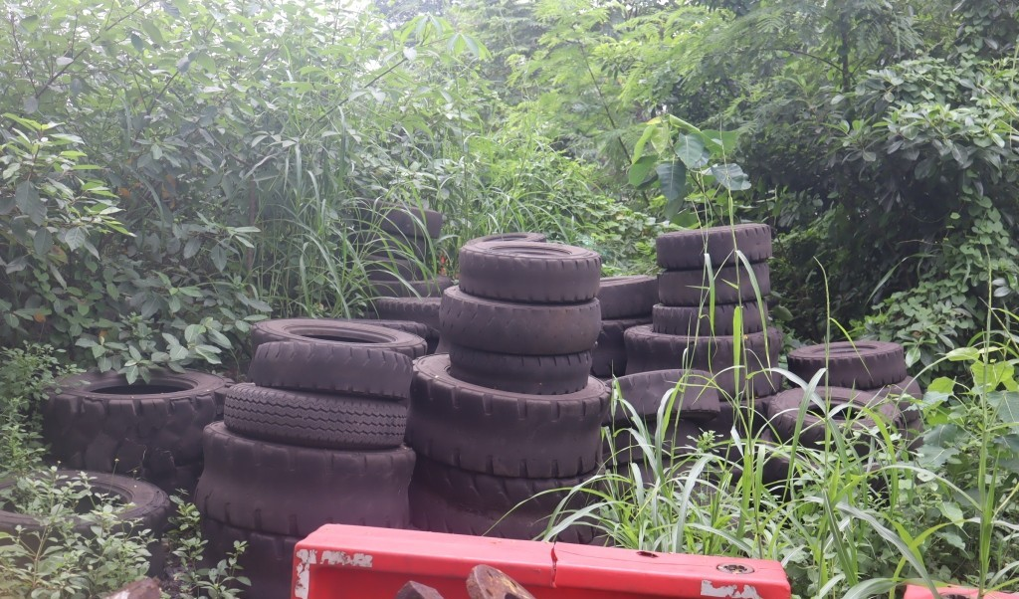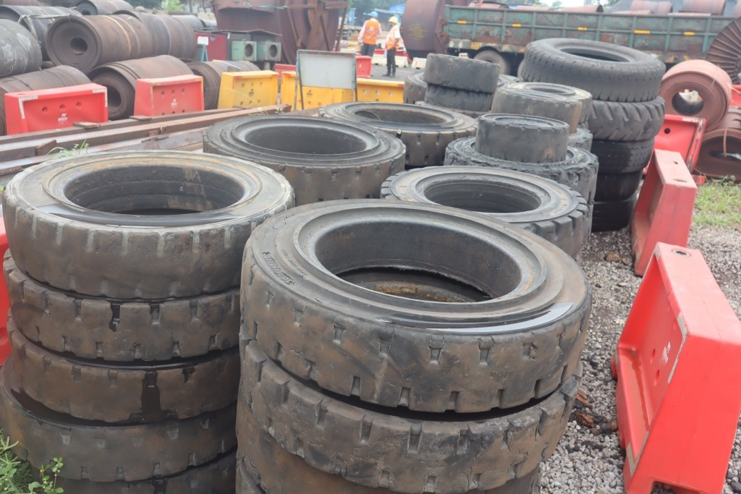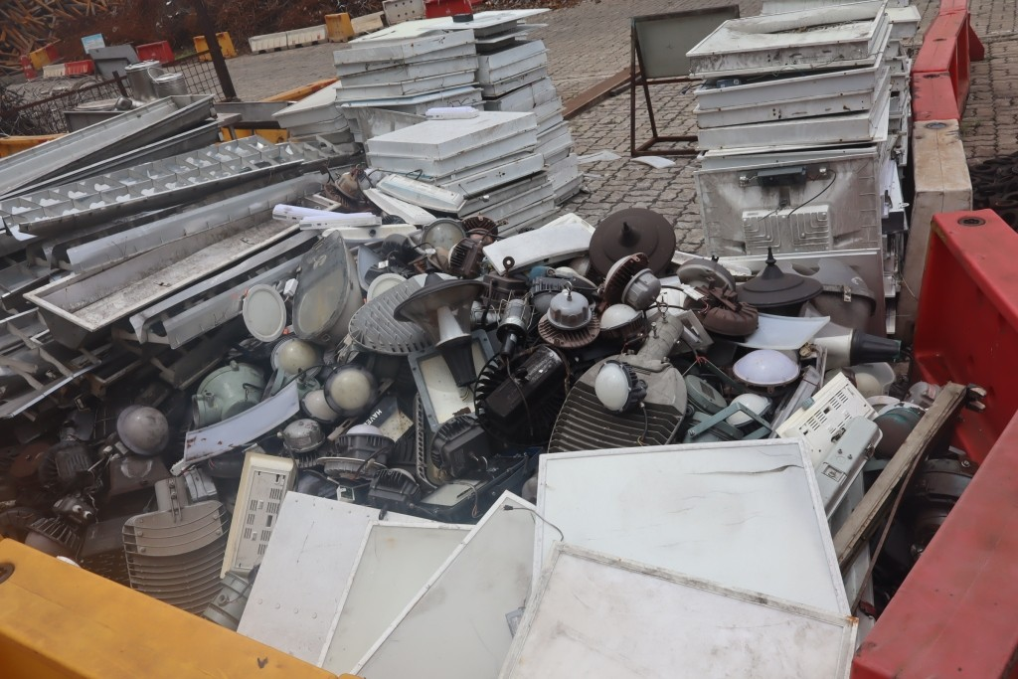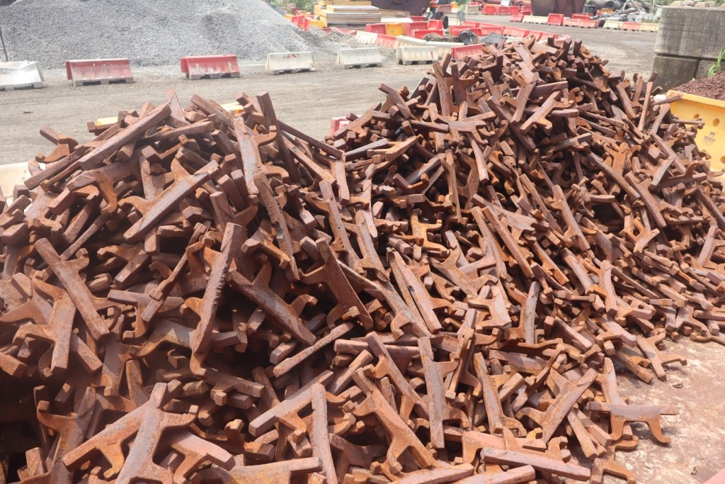
RYJUN26040 RYJUN26040 RYJUL26059 RYAUG26040
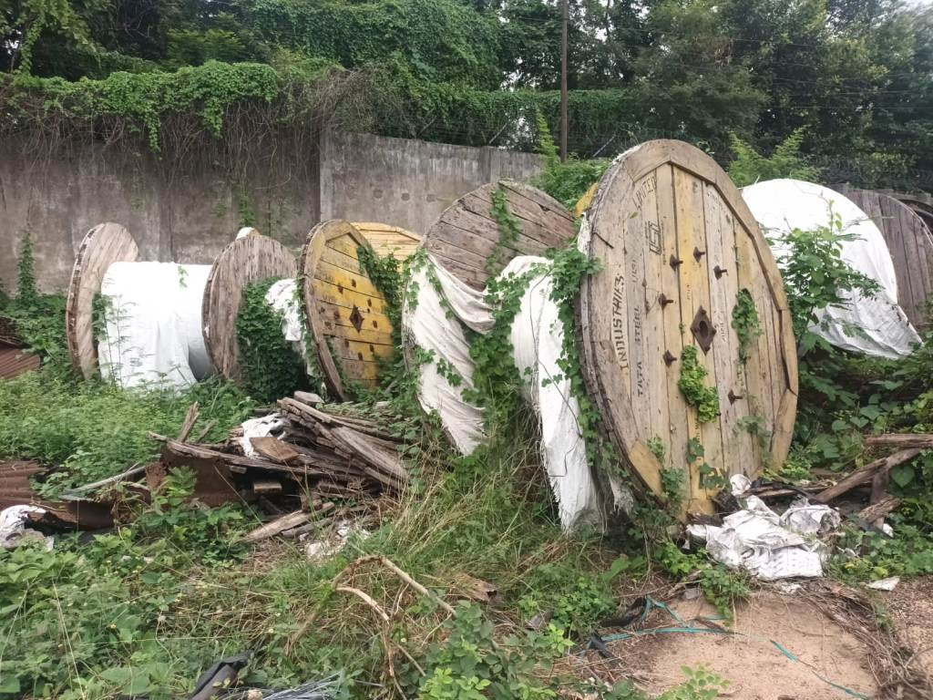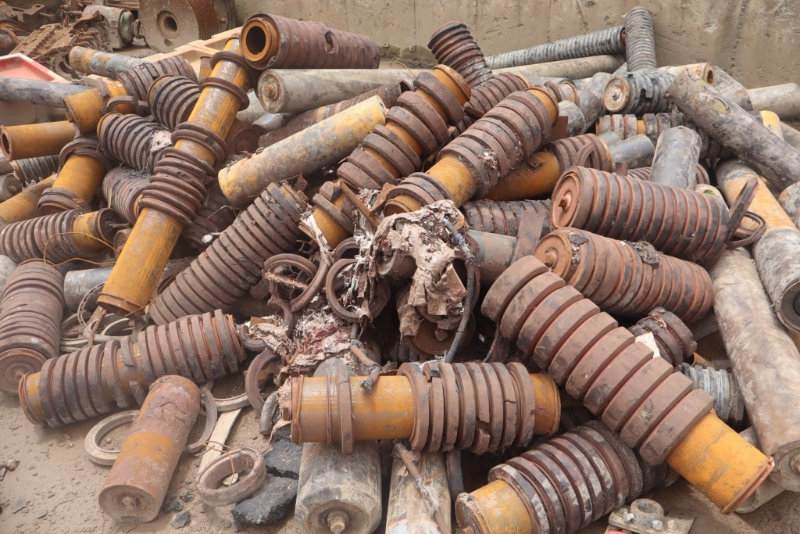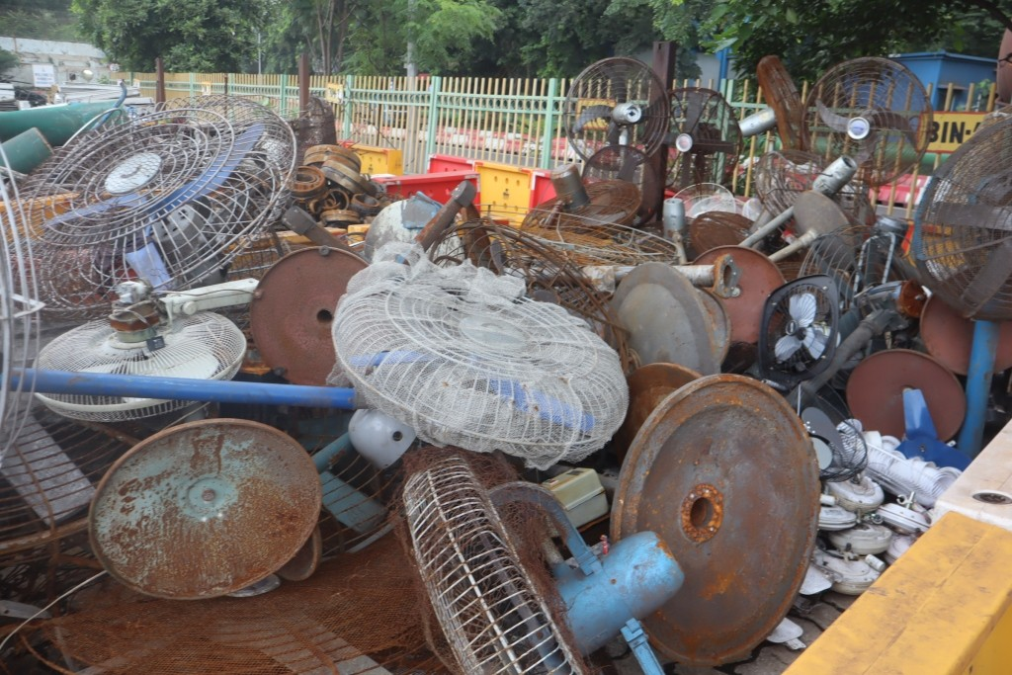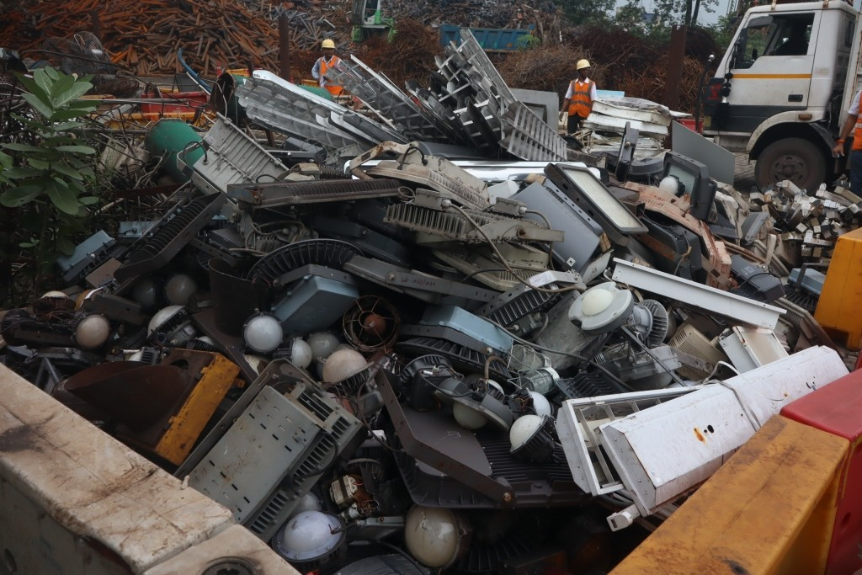
SON-260601 RYAUG26033 RYJUL26044 RYAUG26050
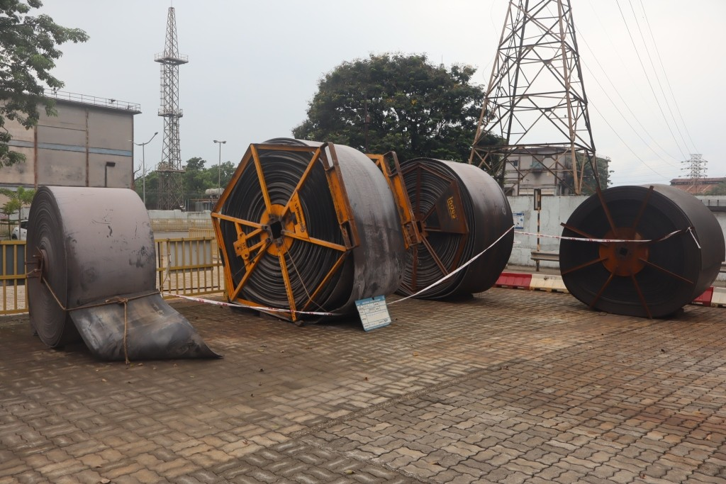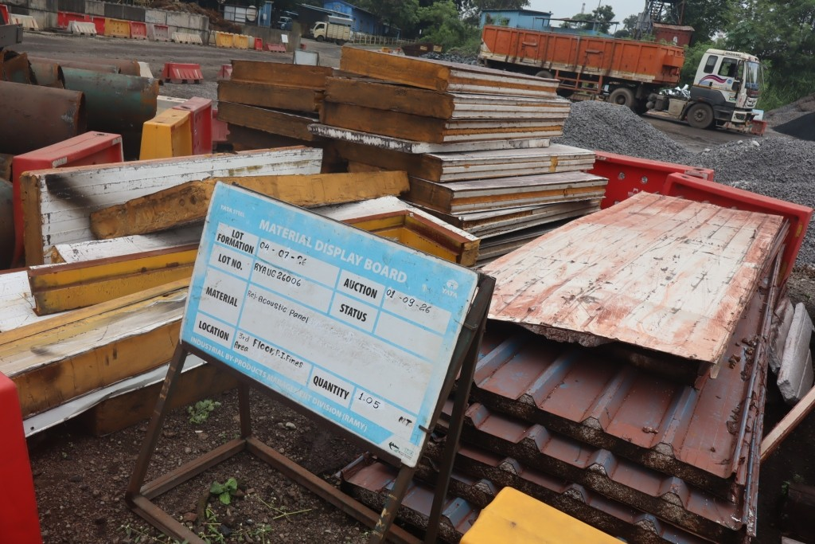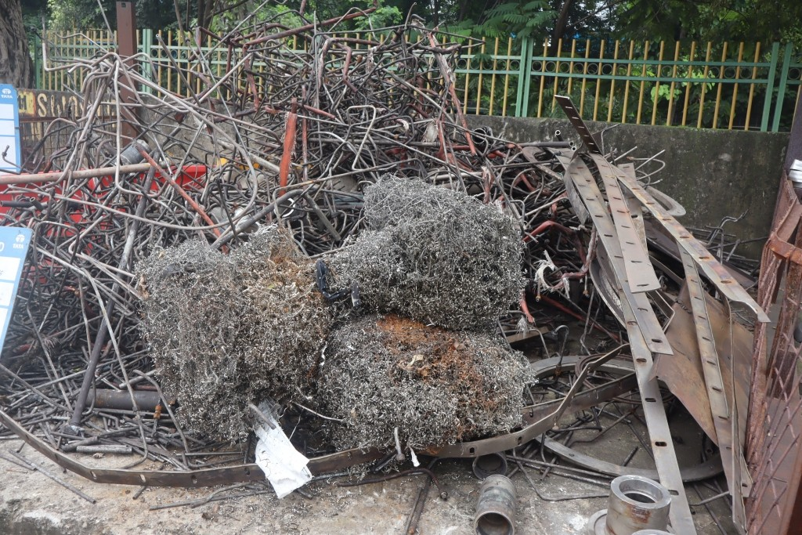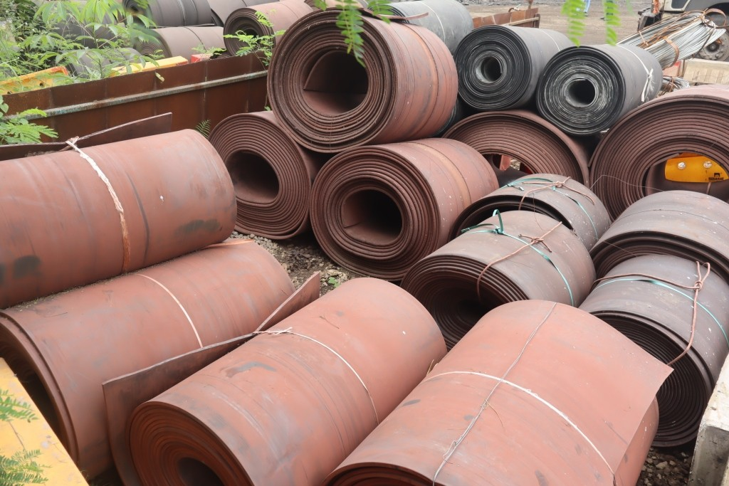
NLSEP26001 RYAUG26006 RYAUG26010 RYAUG26018
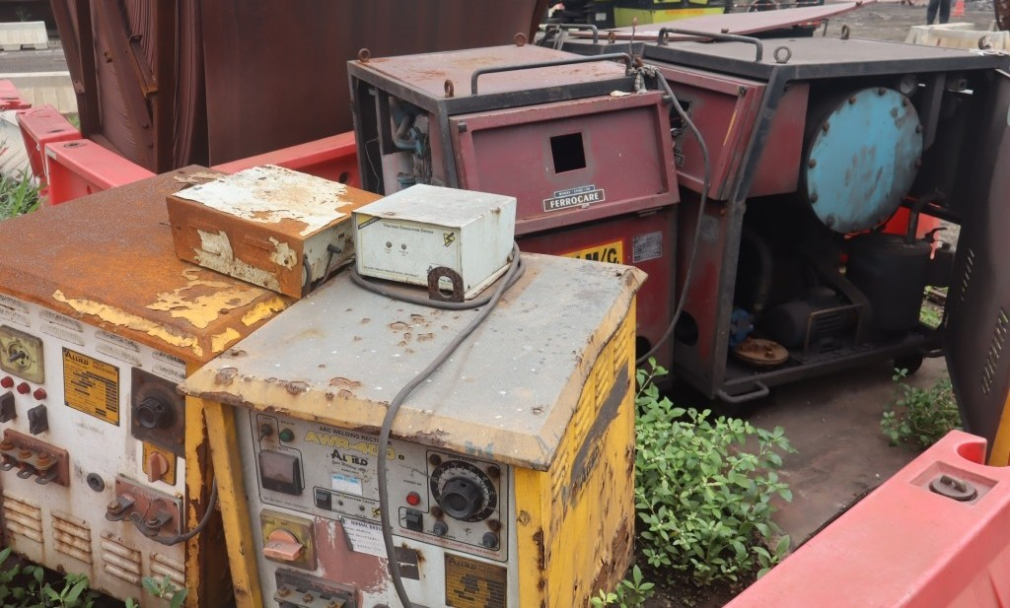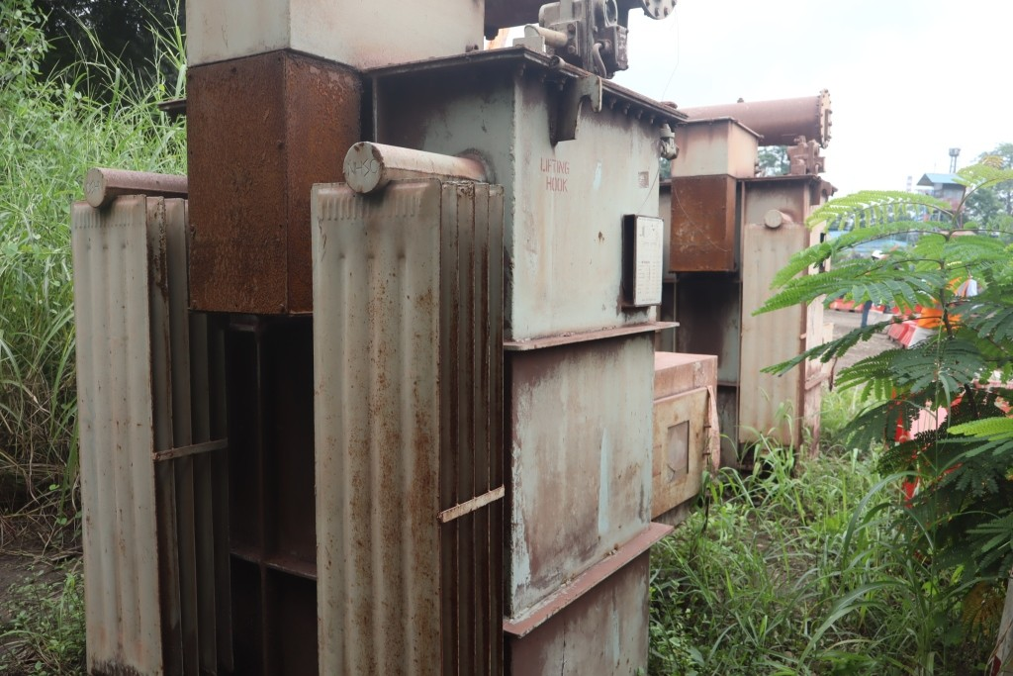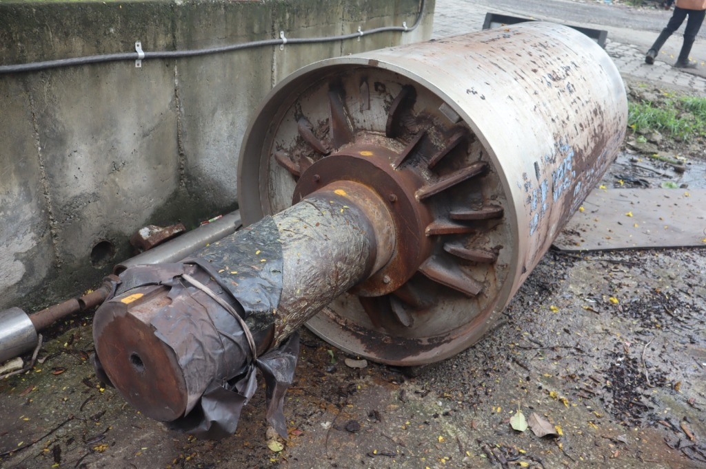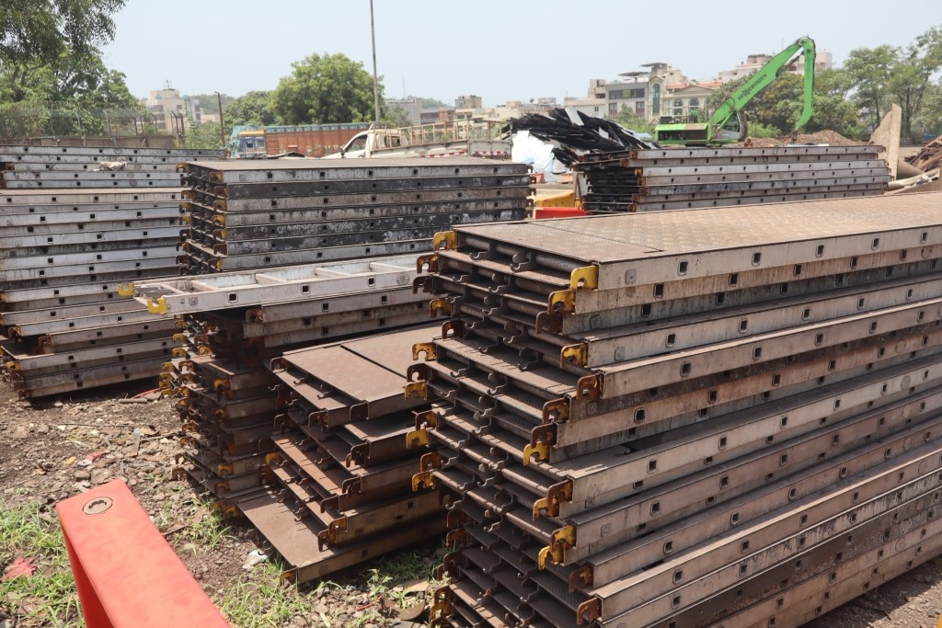
RYJUL26028 RYJUL26031 RYJUL26040 RYMAY26074
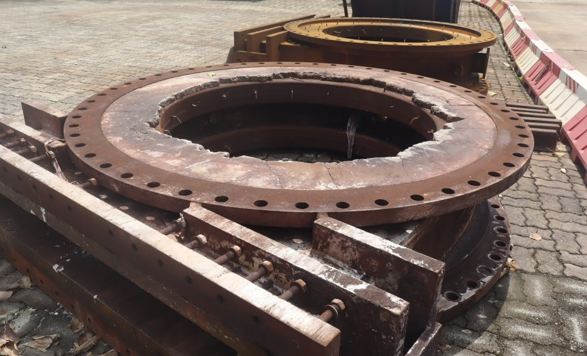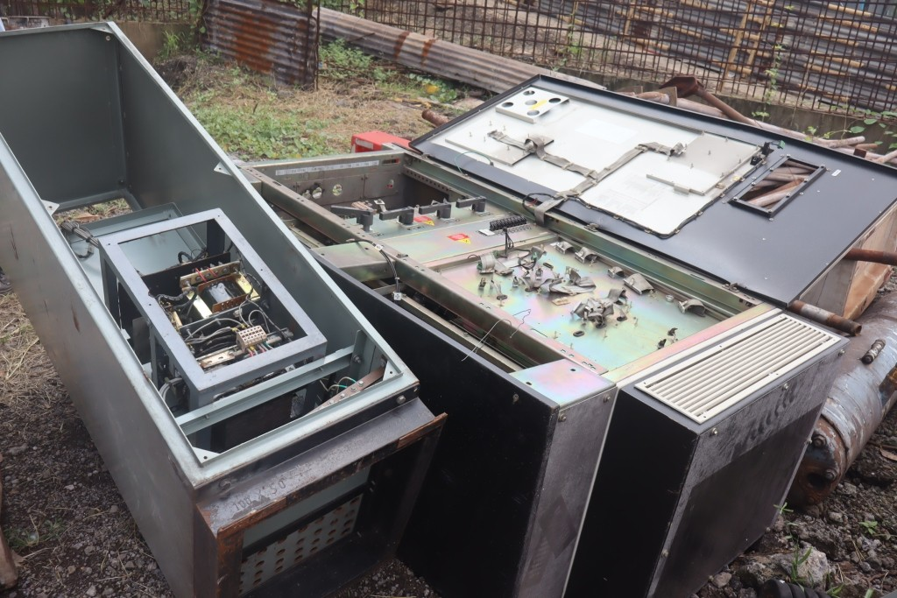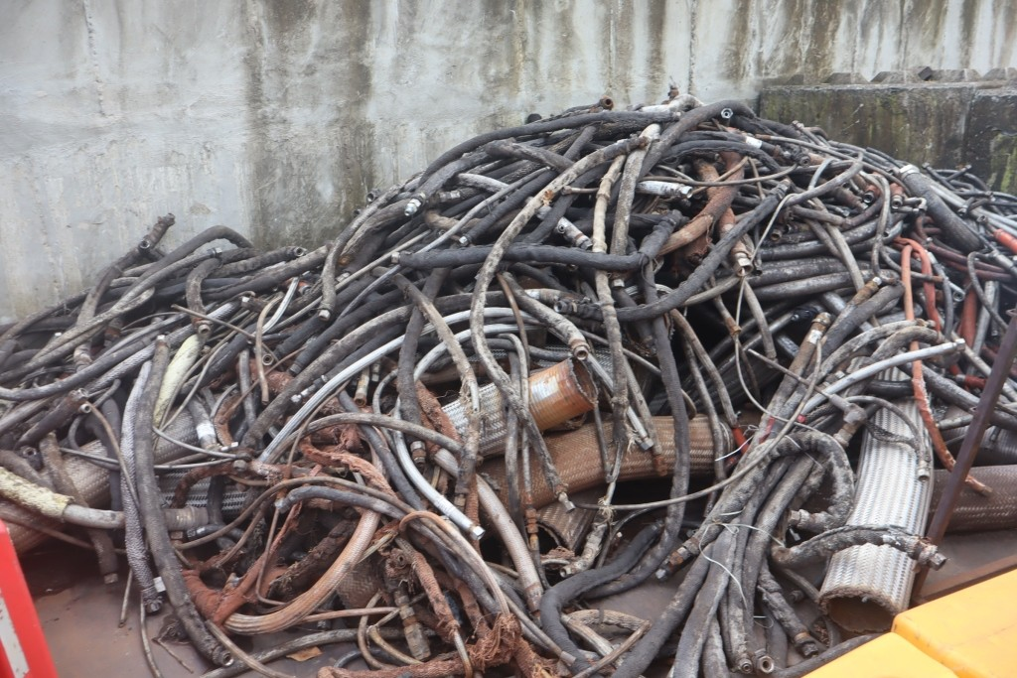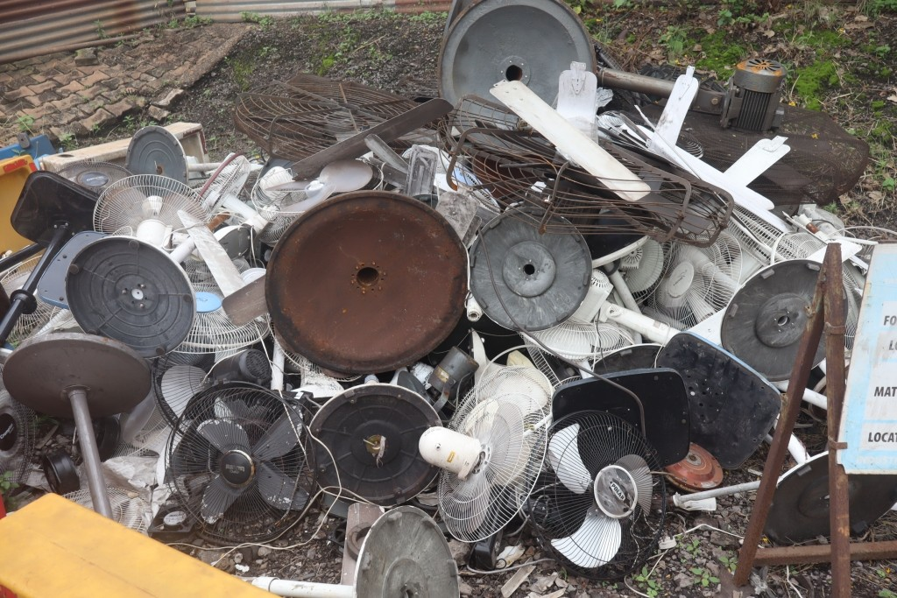
NLSEP26002 RYAUG26021 RYAUG26024 RYAUG26051
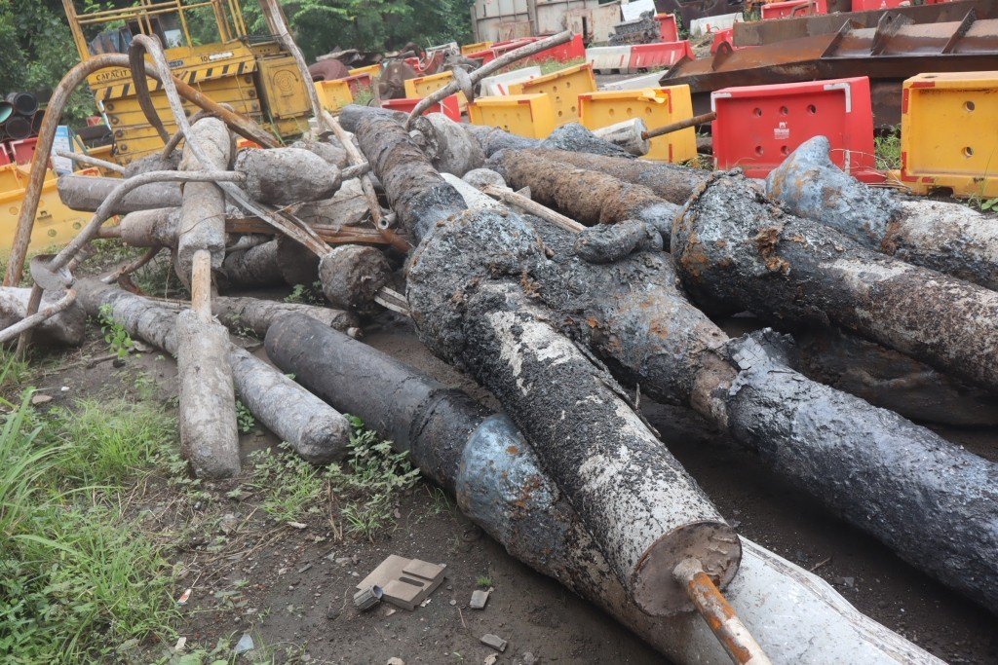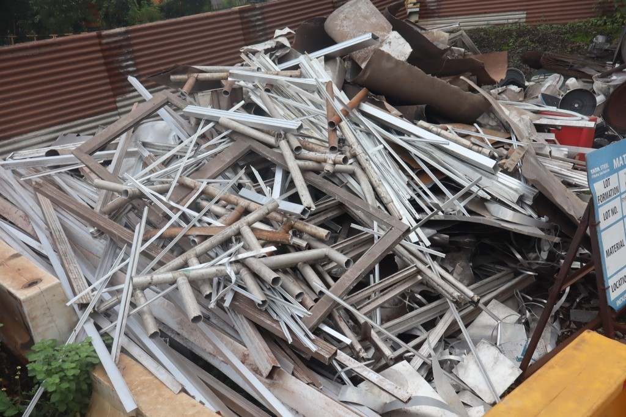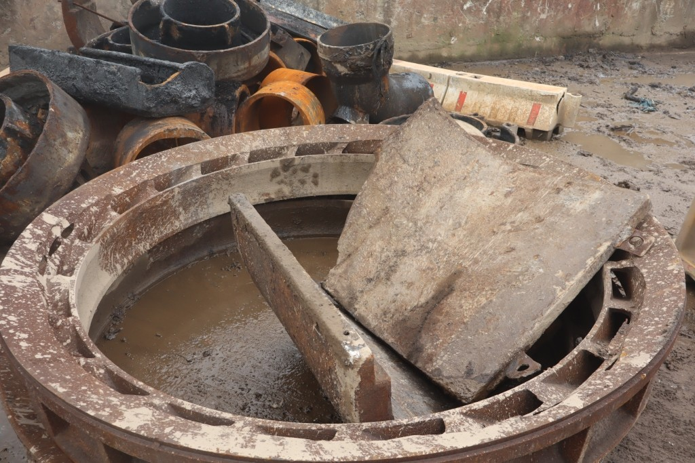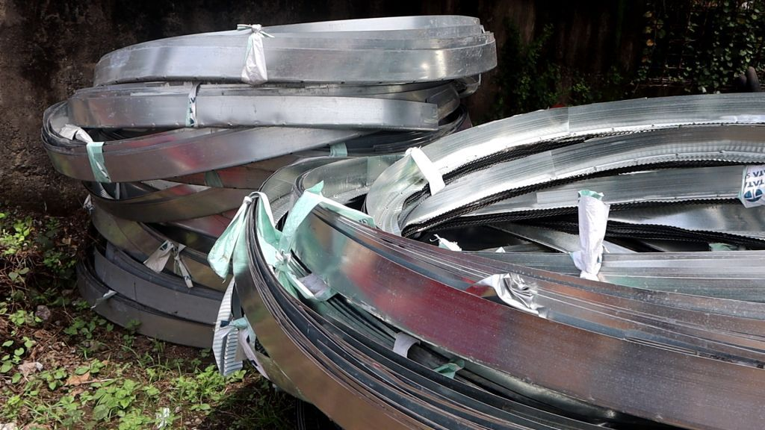
RYAUG26052 RYAUG26054 RYAUG26057 RYJUL26032
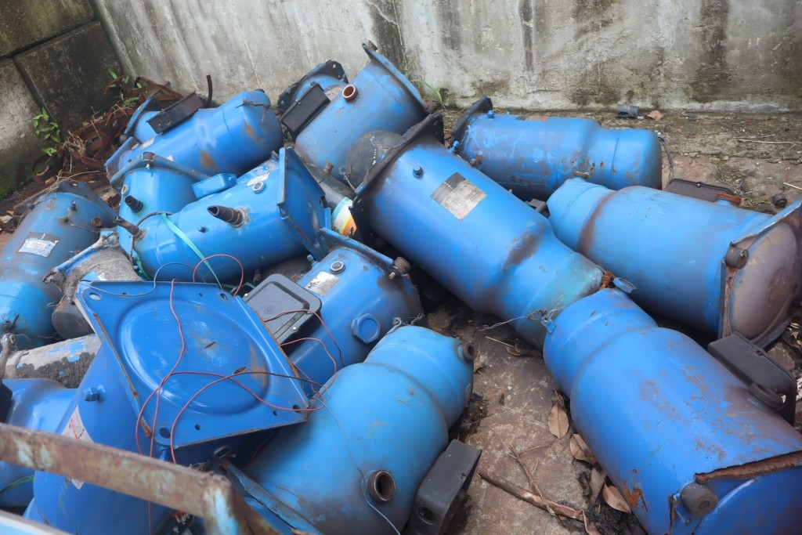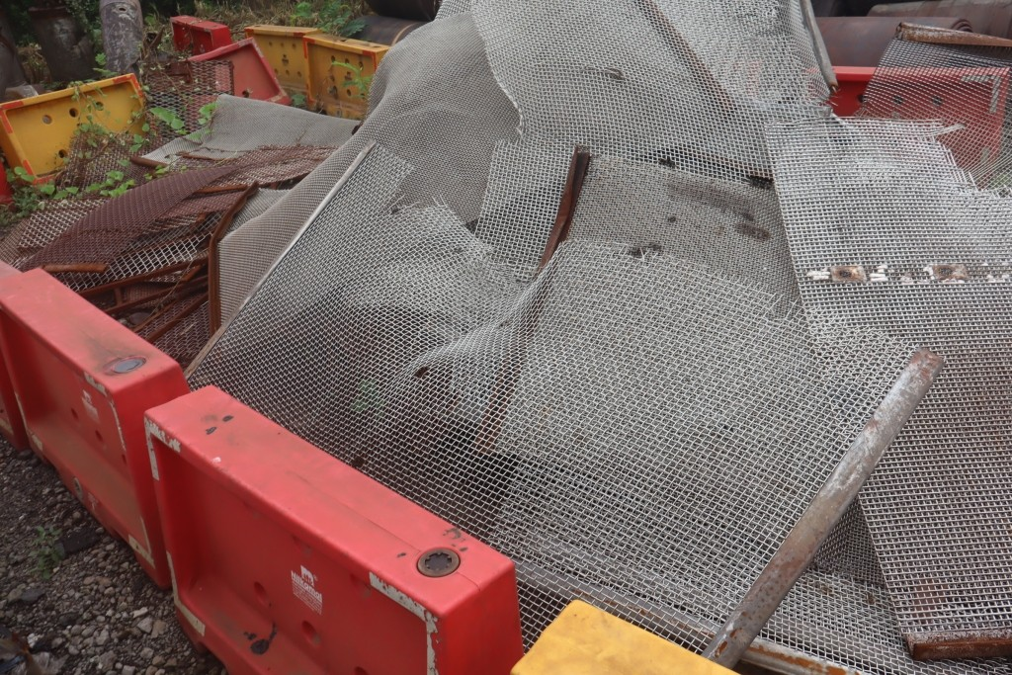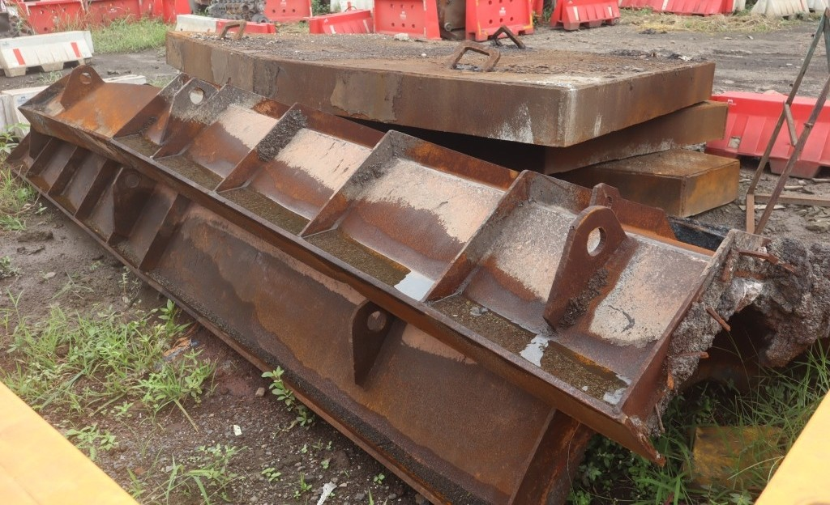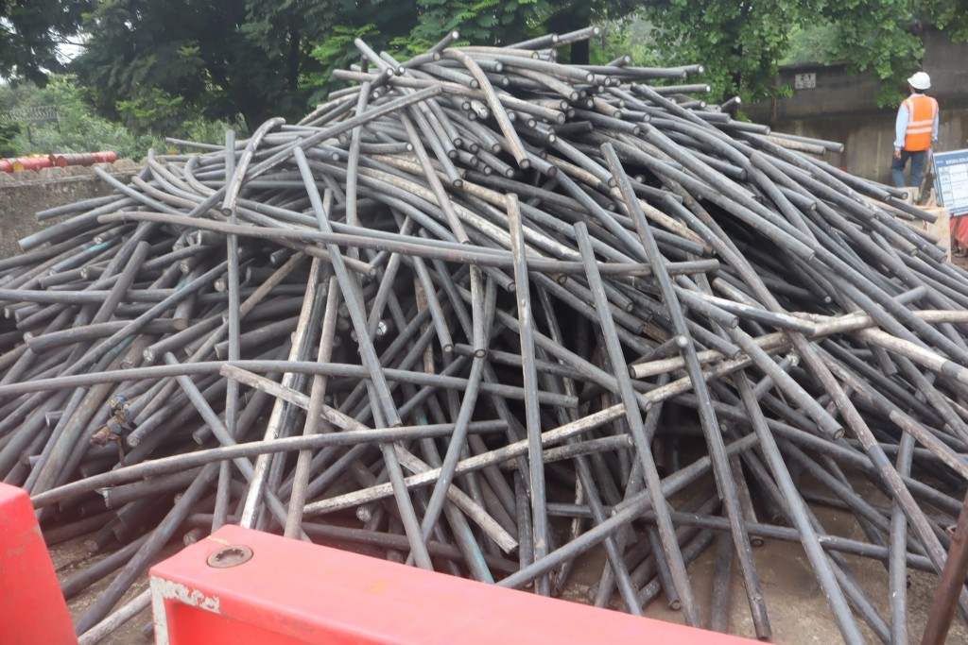
RYJUL26054 RYJUN26071 RYSEP26007 RYSEP26010
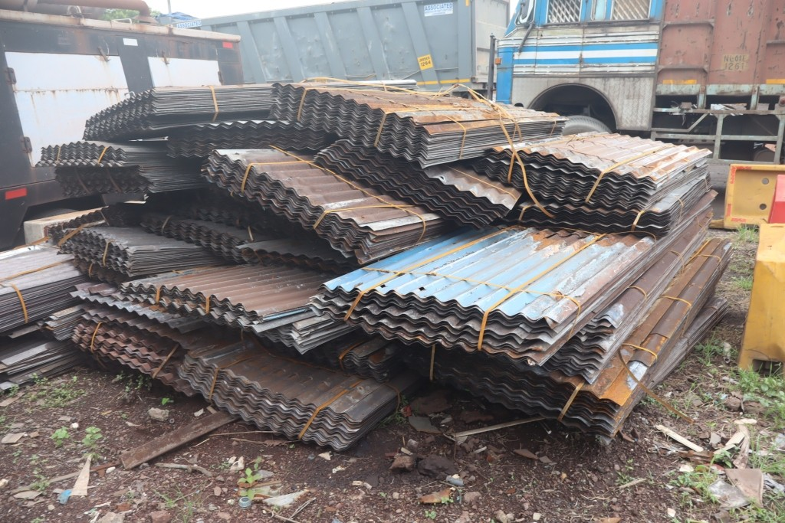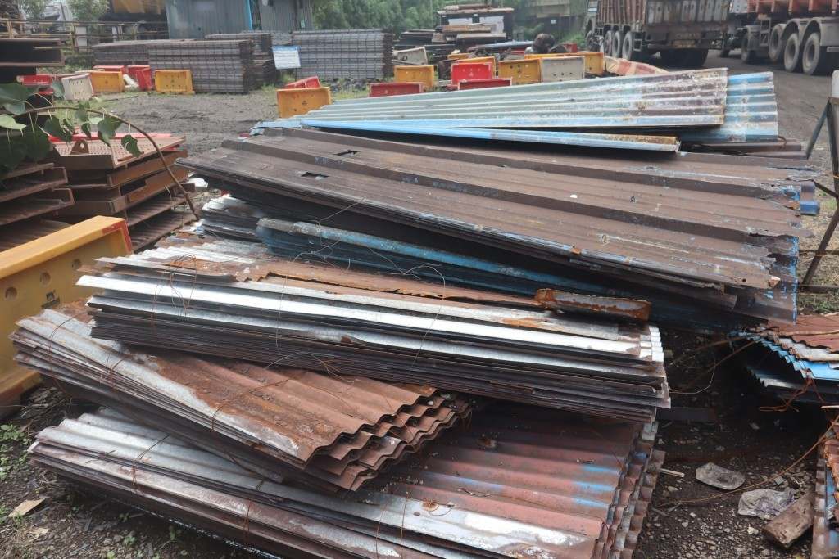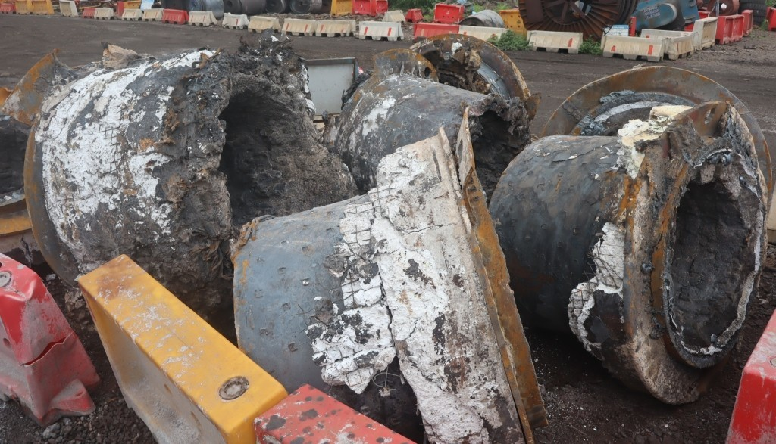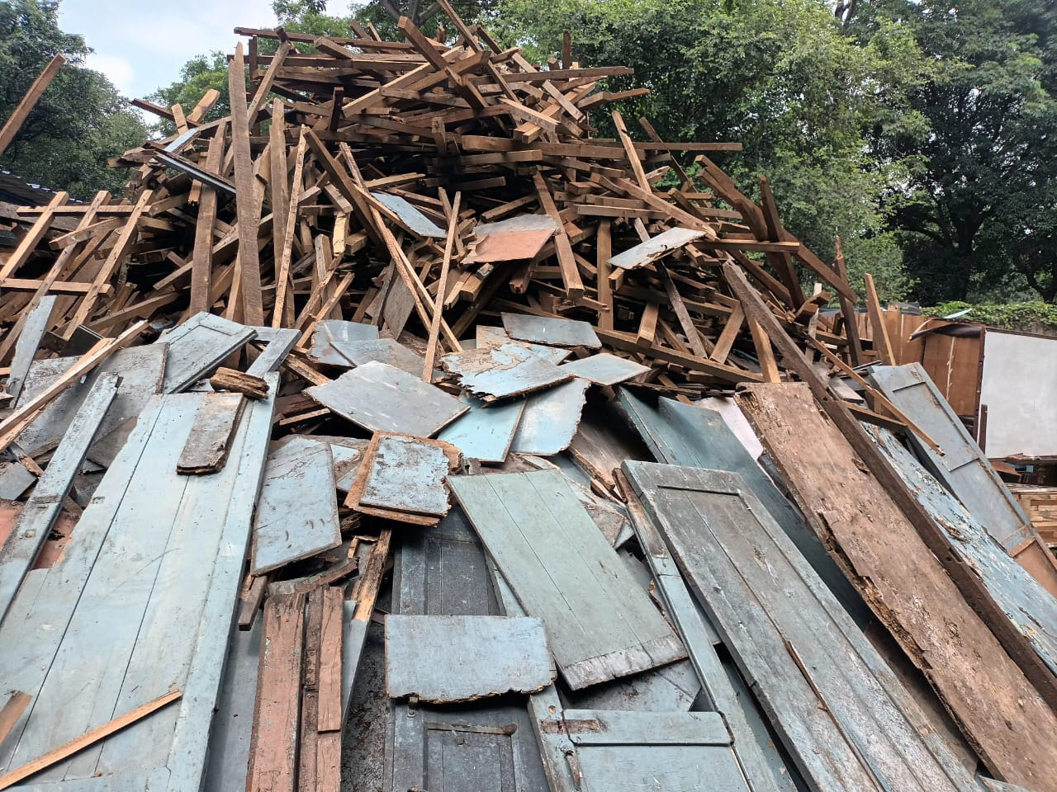
RYSEP26011 RYSEP26019 RYSEP26020 WOODSEP2026
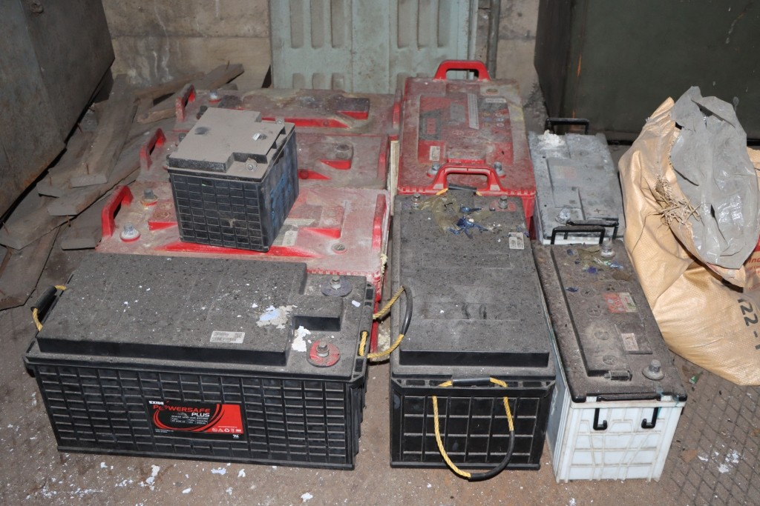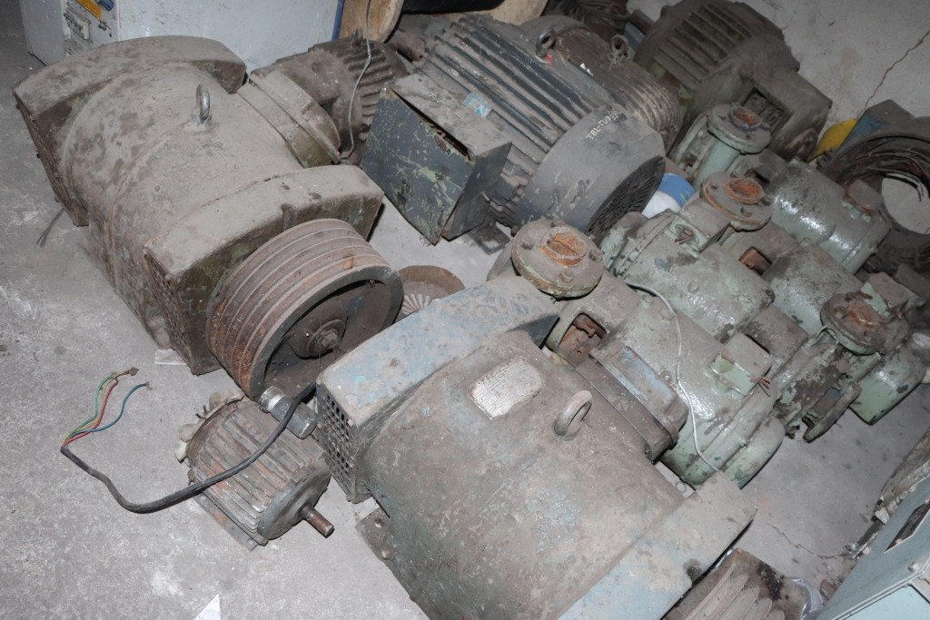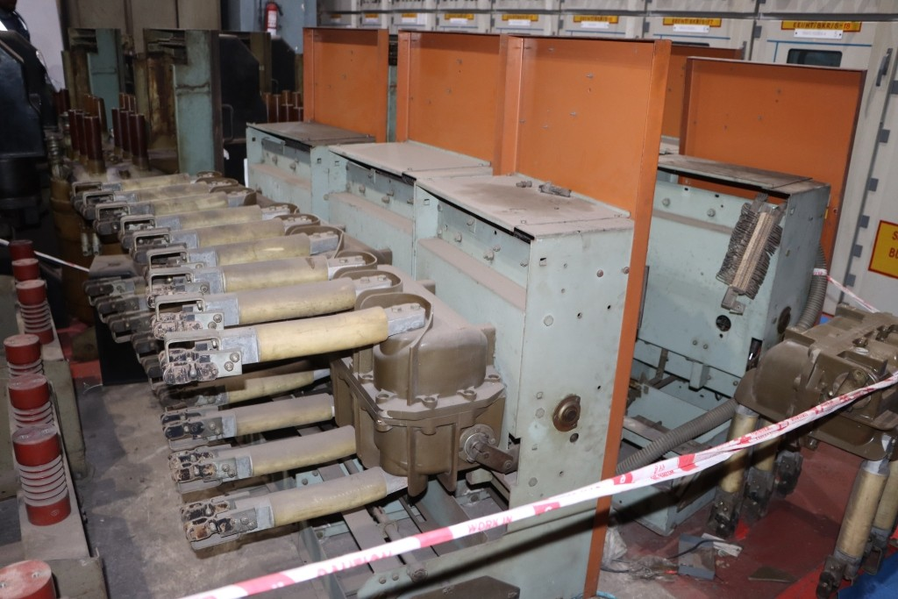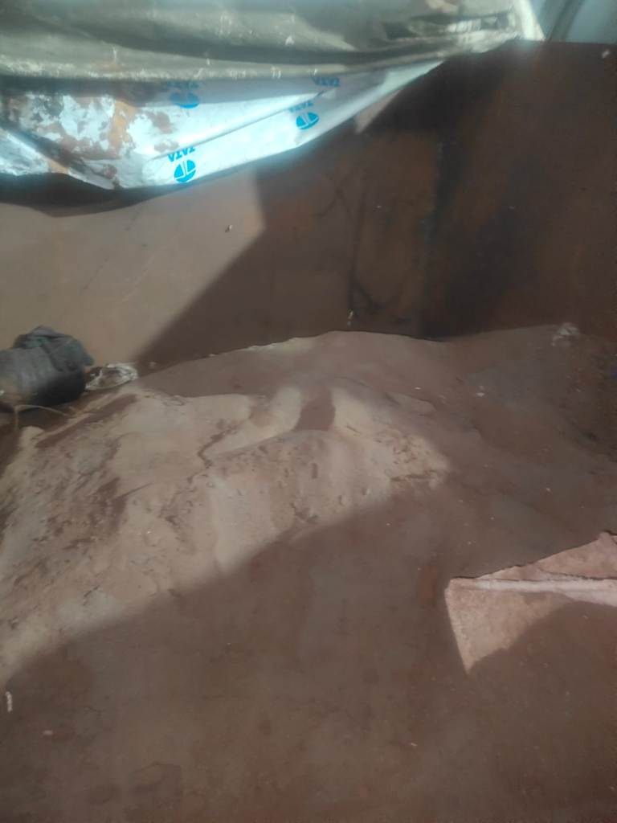
TUBBAT2604 TUBMOT2605 TUBBKR2601 CRMB260905
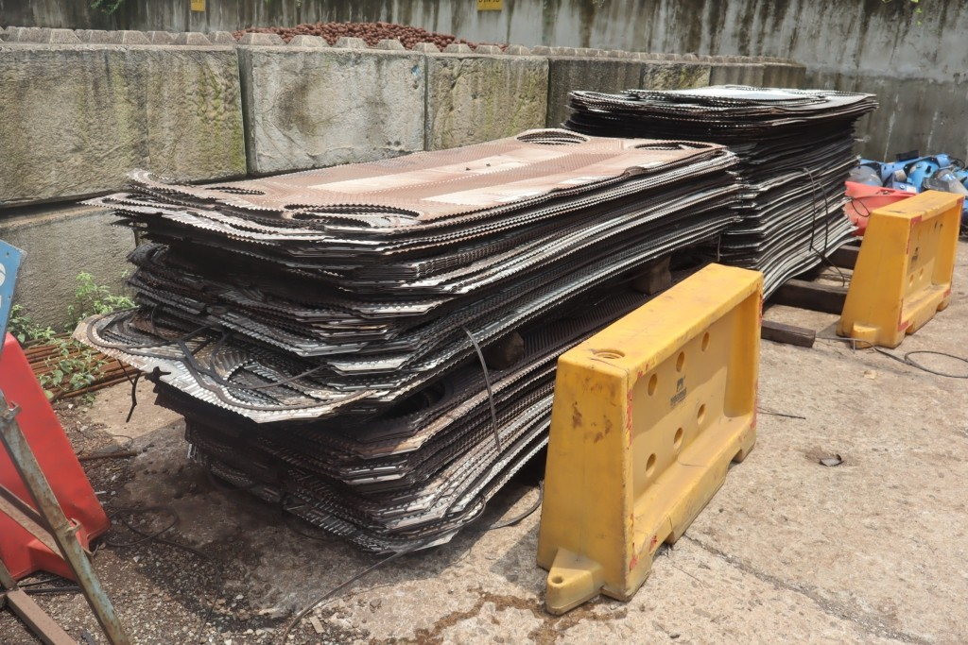
RYAUG26043

Open www.ahbilimoria.com ->Click on Customer Complaint Management Portal
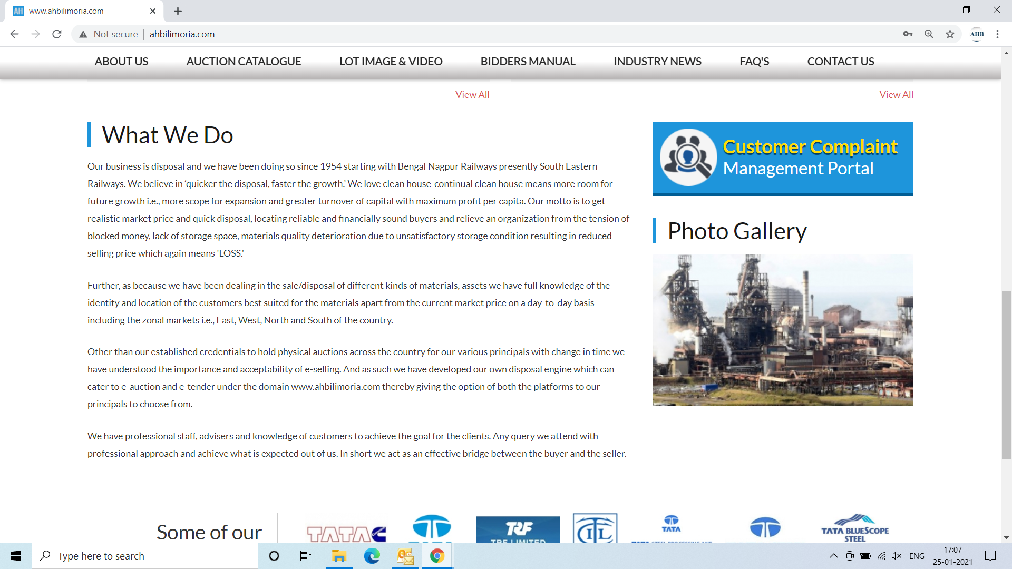

Use your User ID & Password for login

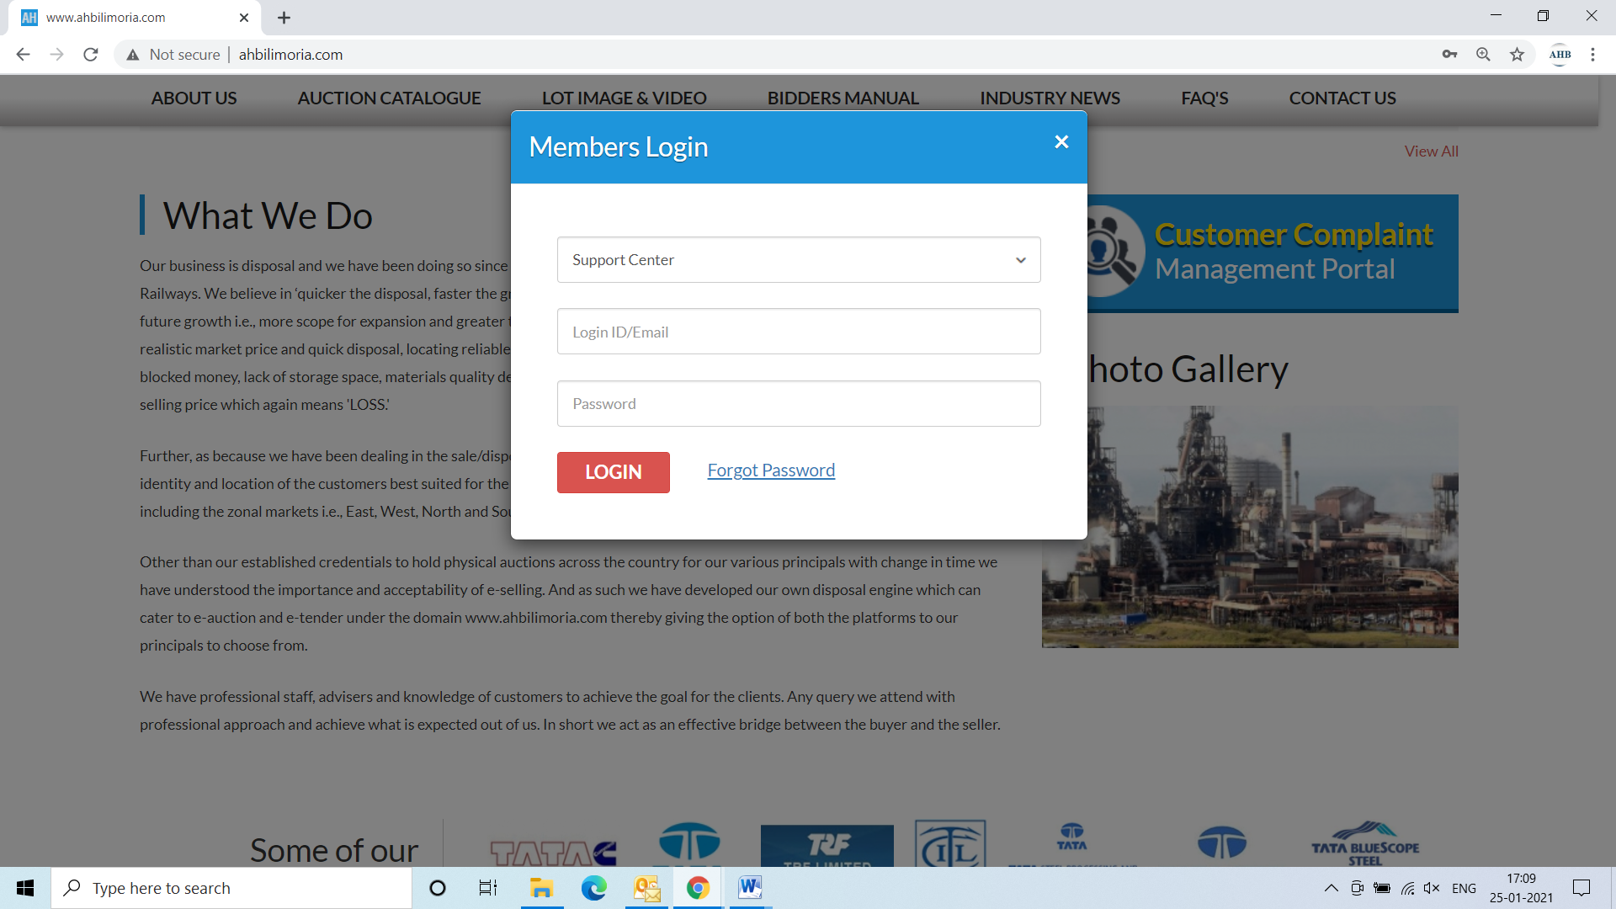
Click Complaint Portal-> Click on “Post a New Ticket”

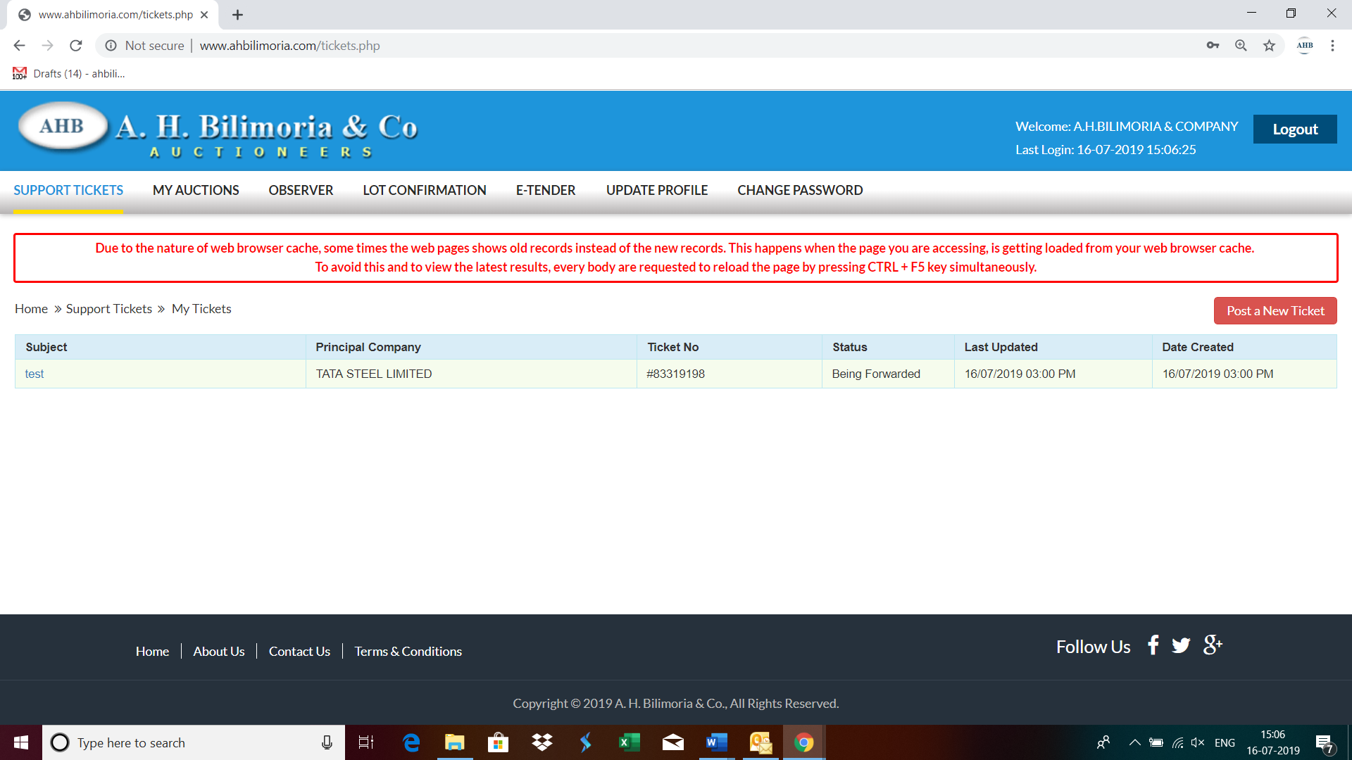

Post a New Ticket->Subject* ->Message* -> Email*->Principal Company*->Attach Document (If required any attachment) ->Submit

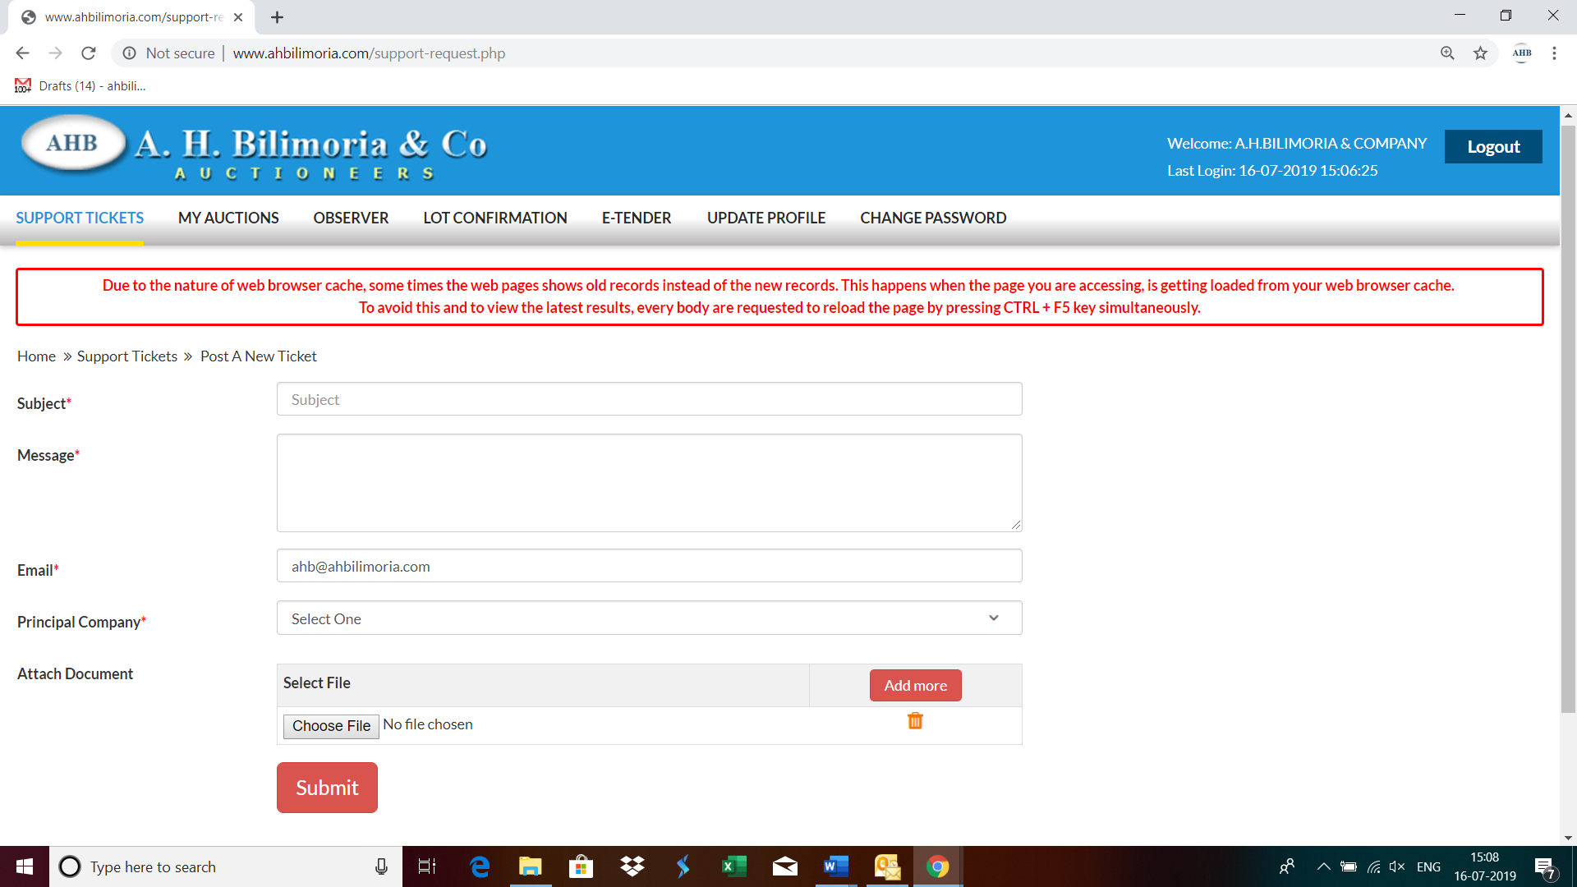

Your support request has been submitted successfully and the Reference No ----- is generated automatically



