Auction Catalogue
Auction conducted by A H Bilimoria & Co.
Auction of Capital Items, TSL HMC Div. Haldia
BEING SOLD ON ‘’AS IS WHERE IS AND NO COMPLAINT BASIS’’
Catalogue Serial Number: | TSL/HMC/AHB/FEBRUARY/006/25-26
Seller: | Tata Steel Limited, HMC Division
Auction website: | www.ahbilimoria.com
e-Auction Date & Time: | 27th February, 2026…..….. Starting at 02:30 PM
Inspection Date & Time: | 26th February, 2026 :At 11:00 AM ----------For inspection of Plant materials the interested customers should report at Tata Steel Limited, HMC division, Simplex Gate, HFC complex, beside IOC refinery, Patikhali, Dist: Purba Medinipur, Haldia – 721606 BY 10:30 AM.  Interested bidders have to come with safety shoes, safety fluorescent jackets and safety helmets as per TSL HMC Div. norms at the time of inspection.  Gate pass creation link:  https://webapp01.tatasteel.co.in/VGP/reg_login_screen.aspx
Date of Security Money Deposit | 27th February, 2026…….. till at 02:00 PM
Contact Details:
For Post Auction @ A H Bilimoria & Company
Area | Contact No. | Email Id
Auction Room | 07003840027/09883421336
Lot Confirmation Related | 08987460668 | ahb@ahbilimoria.com, ahbilimoria.company@gmail.com
Payment Related | 08987460668/09073711453 | ahb@ahbilimoria.com, ahbilimoria.company@gmail.com, ahbjsr@ahbilimoria.com, b.bhardwaj@ahbilimoria.com, m.paul@ahbilimoria.com,sukumar.chandra@ahbilimoria.com
Delivery Order Related | 09073711453 | ahb@ahbilimoria.com, ahbilimoria.company@gmail.com, ahbjsr@ahbilimoria.com, b.bhardwaj@ahbilimoria.com, m.paul@ahbilimoria.com, sukumar.chandra@ahbilimoria.com
Material Value Refund Related | 09073711453 | ahb@ahbilimoria.com, ahbilimoria.company@gmail.com, ahbjsr@ahbilimoria.com, b.bhardwaj@ahbilimoria.com, m.paul@ahbilimoria.com,sukumar.chandra@ahbilimoria.com,
Refund Related | 09073711453 | ahb@ahbilimoria.com, ahbilimoria.company@gmail.com, ahbjsr@ahbilimoria.com, b.bhardwaj@ahbilimoria.com, m.paul@ahbilimoria.com, sukumar.chandra@ahbilimoria.com
TCS Related | 09073711453 | ahb@ahbilimoria.com, ahbilimoria.company@gmail.com, ahbjsr@ahbilimoria.com, b.bhardwaj@ahbilimoria.com, m.paul@ahbilimoria.com, sukumar.chandra@ahbilimoria.com
Payment Deviation/Disablement in Tata Steel | 09073711453 | ahb@ahbilimoria.com, ahbilimoria.company@gmail.com, ahbjsr@ahbilimoria.com, b.bhardwaj@ahbilimoria.com, m.paul@ahbilimoria.com, sukumar.chandra@ahbilimoria.com
Collection of Delivery Order-Tata Steel | 09073711453/09883421336 | ahb@ahbilimoria.com, ahbilimoria.company@gmail.com, ahbjsr@ahbilimoria.com, b.bhardwaj@ahbilimoria.com, m.paul@ahbilimoria.com, sukumar.chandra@ahbilimoria.com
Collection of Delivery Order for Tata Steel Kalinganagar | 09664062791 | ahb@ahbilimoria.com, ahbilimoria.company@gmail.com, ahbjsr@ahbilimoria.com, b.bhardwaj@ahbilimoria.com, m.paul@ahbilimoria.com,sukumar.chandra@ahbilimoria.com, m.k.bal1994@gmail.com
For time bound resolution of unresolved issues log into our Customer Complaint Management portal | Type in www.ahbilimoria.com> Go to “Customer Complaint Management Portal” >Log in with your user id and password and write the details of issue.

For Any unresolved Issues beyond two (02) days mail to A H Bilimoria & Company :
Mr. A K Sil (M-09830074122) & Mr. D Pyne (M-09830738481), E-mail: ahb@ahbilimoria.com, ahbilimoria.company@gmail.com
Copy to Tata Steel Ltd, HMC Div. : Mr. Suvobroto Ray Chaudhuri (suvo.rc@tatasteel.com)

SPECIAL NOTE: -It is the responsibility of the buyer to furnish the valid GST no. & necessary documents to A H Bilimoria & Company before participating in the Auction. In case during the transactions, it is found that valid GST no. has not been provided, then all necessary liabilities if any & so accrued would be on account of the buyer. TATA Steel & A H Bilimoria & Company would not be responsible for any such liabilities.

Note: TSL reserves the right to track IP address, MAC number and geolocation of bidding customers whenever customers participate in any Auction on the A H Bilimoria & Co. Auction platform for TATA Steel.

- Payment and Lifting Schedule:

Lot No. | Payment Schedule |  |  | Lifting Schedule  (working days from the next day of DO release)
Lot No. | EMD | 1st installment | 2nd installment | 1st installment lifting days | 2nd installment lifting days
For All Material | 02 Working days from Date of Lot Confirmation | 03 Working Days From Date of EMD | 03 Working Days from the 1st Installment date  [Only Applicable if material value (Rate X Tonnage) crosses Rs. 10 Lakh] | As mentioned in the material list | 3 additional working days at the expiry of 1st Installment DO validity.

- Suitable extension of due date for payment and lifting will be accorded in case of any eventualities like Strike/ Bandh/ Special restriction on vehicular movement imposed by the local Administration etc.
- Requirements of participation:
  - Registration: Before participation in the Auction, a prospective bidder shall be required to get registered with A H Bilimoria & Co. For details visit www.ahbilimoria.com

  - Security Deposit: Non-Interest bearing security deposit of Rs.60,000/- (Rupees Sixty Thousand only) in favour of “A H Bilimoria & Co.” through Online Payment only : Details as under :

Beneficiary Name | A. H. BILIMORIA & COMPANY
Bank Name | HDFC Bank
Branch Name | 31, Chowringhee Road, Kolkata – 700016
Account No | 06932560001205
IFSC Code | HDFC0000693

Account No: All the customers will have a unique account number. The unique account number is an alpha numeric code consisting of 12 characters. The Customer’s unique “account number” is a combination of the AHB’ SAP code along with the 6 digit bidder SAP ID and can be used as reference. for all subsequent transactions. The Customer’s Account Number detail is available in “Profile” after the customer logs into our website using the user id and password.

- Inspection Rules & Policy:
All parties to send their request for registration of inspection through registered e-mail toahb@ahbilimoria.com, ahbilimoria.company@gmail.com, ahbjsr@ahbilimoria.com, b.bhardwaj@ahbilimoria.com one day prior to the date of inspection.
(Mail request should contain – Person Name, ID Proof, Firm Name, Mobile No., Name of the Rank Based Sealed Bid Tender& Letter of authorization for inspection)
Visitor GP of only those customers would be approved, who have sent their request via mail to A H Bilimoria & Co, one day prior to inspection.
All interested parties should reach at Tata Steel Limited, HMC division, HFC complex, beside IOC refinery, Patikhali, Dist: Purba Medinipur, Haldia – 721606, by 10:00 AM (or as announced) on the date of inspection.
Only registered customers/bidders/representatives of firms shall be allowed for inspection of material, subject to fulfilling their safety requirement of the steel works.
Taking photographs of the material is strictly prohibited.
Customers are advised to ensure that they inspect the materials on offer on the scheduled date as mentioned in the catalogue, before Participating in the Rank Based Sealed Bid Tender. It is reiterated that all materials are offer / sold by Tata Steel on “AS-IS-WHERE-IS” and “NO-COMPLAINTS” basis, and no complaint what so evershall be entertained regarding the quality of materials after the sale.
“TATA Steel would not accept any claim from any customer for non-inspection of materials.”
Interested bidders have to come with safety shoes, safety fluorescent jackets, and safety goggles & safety helmets at the time of inspection. All interested parties have to arrange for their own safety shoes, safety jackets, safety helmets and safety goggles as per Tata Steel standards. No person will be allowed to enter the works without these. Compliance to Tata Steel safety norms is a must. No complaints during lifting, in what-so-ever manner, will be entertained if customers fail to inspect the materials during scheduled inspection dates. No ''people movement'' shall be allowed at the loading point during loading/delivery of materials from the yards. Tata Steel will not be responsible for any delays arising out of non-compliance to Tata Steel norms.

- Bidding modalities:
  - Price Bid Basis: In Indian rupees as per unit of measurement as given in Material List. Price to be quoted is basic, ex- location exclusive of taxes and any other statutory levies.
  - Bid Increment: As specified in the e-auction page
  - Type of Auction: English No Ties
  - Bid Validity: Bid shall be valid for 10 (Ten working days excluding Saturdays, Sundays and Bank holidays) working days counted from the next day of Auction process in case of Auction against a catalogue which is completed on the same day. And if it is continuing on any other day the counting of days for lot confirmation shall be from the next day of completion of entire Auction process.
  - Bid duration: For 1st four lots 20 minutes and balance lots 10 minutes. If, No bids received within these specified time the lots are closed automatically.

- Taxes & duties:
  - GST : As applicable
  - TCS : As applicable. In case of availing of concessional rate of TCS proper certificate issued by appropriate Income Tax authority are to be issued in favour of the Principal Company along with payment. Self certification of Form no 27C is not acceptable.
  - Any change in taxes applicable at the time of lifting shall be applicable.
  - Customers are required to submit Form 27C/Form 27G against the month of dispatch/expected dispatches. In the absence of Form 27C, TCS will be charged at the time of invoicing.

- Payment terms & conditions :
  - Payments: PAYMENT FACILITY BY RTGS / NEFT ONLY

Account No | TATAHB followed by Party code (Each individual customer will be provided with Account number to be provided by AHB)
Beneficiary Name | TATA STEEL LIMITED A H B
Bank Name | HDFC BANK LTD.
Branch Name | Sandoz Branch, Mumbai
IFSC Code | HDFC0000240

  - EMD: 10% of the material value to be paid within 02 (Two) working days from the date of lot confirmation. EMD to be adjusted in the final installment only.
EMD payment is to be made within the time limit as given in letter of confirmation. No extension will be provided for the same.
  - Balance Payment Time: (As per payment schedule)
  - Delayed Payment Charges (DPC) : Installment payments with DPC @ five (05) paise per Rs. 100 per day will be accepted up to 4 (Four) working days from due date of installment payment as mentioned in the confirmation letter. This is not applicable for EMD payment.
  - Saturdays, Sundays and Bank holidays are excluded for counting purpose for payment schedule.
  - In the event of Non-Receipt of Payment within the stipulated period of Payment, the Sale Offer for the approved Lot shall stand withdrawn automatically (Refer Clause#8).
  - Buyers have to send the payment deposit slip (UTR No /Scan Copy of NEFT/RTGS Transaction Slip) against Lot No. immediately after the payment to AHB at email id: ahb@ahbilimoria.com& ahbilimoria.company@gmail.com

- Lifting terms & conditions:
7.1 DOs will be handed over to authorized representatives of bidders on receipt of payment. Authorization letter to be issued via registered e-mail id’s. Authorized letter must be duly stamped and signed by the proprietor or partner or director on receipt of payment. Lifting date is calculated from the next day of DO Release date.
7.2 Loading Charges: Processing and loading of goods is in the scope of HMC. Shape and size of the goods will be final as it has been shown during inspection before bidding. Overloading of vehicle is strictly restricted. Speed limit of vehicle inside the plant should be maintained below 30KM/Hr.
If the party does not lift the material within free delivery period, party may request HMC for the extension of free delivery date, which HMC may consider but there will be no obligation to do so.
7.3 Loading shall be given strictly as per the statutory norms & safety norms of Tata Steel Ltd. HMC Division.
7.4 Lifting with Ground Rent: Lifting along with ground rent will be allowed up to 4 (four) working days from the last date of lifting period. In case the lifting is not complete, and no request is made by the customer within the period of four days, the company reserves the right to close the lot, and refund the balance to the party after deducting for any shortfall in lifting as per norms laid down in the catalogue. Ground Rent will be calculated on balance unlifted quantity @ 05 paise (inclusive of tax) per Rs.100/- per day
7.5 Additional lifting days for advance payment of installment - If the installment payment is made in advance, then additional lifting days (equivalent to the number of days payment made in advance) would be given. This would not be applicable for EMD payment.
7.6 At the time of obtaining delivery of any goods, the purchaser shall not be entitled to pick or choose any particular item or items from the lots sold to purchaser. The purchaser will have to operate the lot from one side of the heap or as described during inspection until the entire quantity is lifted.
7.7 LOT TRANSFER WILL NOT BE ALLOWED.

7.8 Process for transfer of ownership of vehicles sold in Auction: Customer shall submit their authorization letter to AHB. AHB will hand over the same to SCMC with a forwarding letter along the authenticated DO copy. AHB will collect the ownership papers from SCMC for handing over to the customer for applying for transfer of ownership in DTO’s office. After transfer of ownership, the customer will show the approach SCMC to collect the delivery advice for the vehicle. AHB will arrange the gate pass for the customer to visit SCMC.

- Penalty:
  - The following penalties shall be applicable in the eventuality of a buyer defaulting in making the payment of EMD (wherever applicable) or any installment/s, as per the stipulated schedule for each lot, in a financial year:
- In the first instance, a penalty of Rs. 60,000/- (Rupees Sixty Thousand only) shall be recovered from the customer.
- In the second instance, a penalty of Rs.100,000/- (Rupees One Lakh only) shall be recovered from the customer.
- In the third, and any subsequent instance, a penalty of Rs.150,000/-(Rupees One Lakh Fifty thousand only) shall be recovered and the customer shall be debarred from participating in any Auction for a period of three months from the date of debarment.
In the event of any default, the customer’s user id will be disabled and the customer will be blocked from participating in any Auction of TSL with immediate effect.

The defaulting customer shall be allowed 06 (six) working days to deposit the penalty as mentioned above. In case the penalty is not received within the stipulated period, the customer’s security deposit shall be forfeited, and the defaulting customer shall be immediately debarred from participating in any Auction of TSL.

  - If after making payment of EMD (wherever applicable), the installment payment/s are not made by the customer as per the stipulated schedule for each lot, the entire EMD amount against such lot shall be forfeited.

  - In case of non- lifting of full lot quantity after making full payment, a penalty equivalent to 20% of the material value for the un-lifted quantity against each lot shall be recovered from the customer.

- Lot Closure Norms :
For Lot Closure, the tolerance would be ± 10% of the original quantity or mentioned in the material list.
For High Value Items (>/= Rs 50000 per MT) tolerance for Lot closure is 0% of the lot quantity.

- Refund :
Refunds will only be made by TATA Steel vide RTGS/NEFT and hence all customers are required to submit their bank details to A H Bilimoria & Company or mail at ahb@ahbilimoria.com, ahbilimoria.company@gmail.com, ahbjsr@ahbilimoria.com, b.bhardwaj@ahbilimoria.com. TATA Steel or A H Bilimoria & Company will not be responsible for any delay in refunds owing to absence of bank details of the customer.

- Complaints :
Complaints, if any, with regard to any transaction shall have to be lodged by the buyer within three calendar months from the date of last invoice. No complaint shall be entertained thereafter, under any circumstances. Customers can log their complaints at (www.ahbilimoria.com> Go to “Customer Complaint Management Portal” >Log in with your user id and password and write the details of issue.)

- Jurisdiction :
Any dispute arising out of any contract shall be decided in Kolkata by the courts in Kolkata and by no other courts. The courts in Kolkata shall have exclusive jurisdiction to adjudicate upon any such dispute.

- General terms & conditions:
  - Any dispute on quality & quantity of material and bid cancellation shall not be entertained at any point after the Auction.
  - All lots are offered/sold on “As is Where is Basis” and “No Complaint Basis”.
  - Lot transfer will not be allowed. Payment and invoicing has to done in the name of the H1 bidder, subject to the prices being approved.
  - Lot purchased should consist of material from the same lot and designated location only. Tata Steel has the right to check any vehicle at any moment of time. If material lifted differs from the material that is purchased by the buyer, then the buyer and authorized representative will be permanently debarred. Also Tata Steel can take any penal action against the buyer/authorized representative. All the material loaded in the vehicle is to be covered in order to follow the safety compliance of Tata Steel works.
  - If the safety compliance is not followed, then Tata Steel can penalize the buyer / authorized representative as deemed fit.
  - Customer attested photocopy of valid id proof (Voter id/Aadhar/Pan card) of all lifters / Authorized persons engaged by customers for lifting of materials from TSL is to be enclosed with the authorization letters & to be forwarded to TSL for issue of gate pass.
  - Dispatch is subjected to FORCE MAJEURE conditions
  - The seller reserves the right to terminate any offer at any point of time without assigning any reasons
  - In the event of termination of the offer, seller shall refund the balance amount after due reconciliation
  - No claims whatsoever would be entertained after cancellation of the bid
  - In addition of earlier safety norms, the following would be compulsory:
The drivers of the vehicle must have the eye test certificate. The frequency of the testing would be as below:
1. If the age of the person is less than 45 years - Once in a year
2. If the age of the person is 45 years or more, the testing is required to be done once in every 6 months
Please ensure to comply with the safety norms
  - GST (Goods & Service Tax) and all other taxes, duties (imposed) whether payable to the central government or to the state government or to the municipal, local or other authorities shall be deposited by the purchaser with HMC.
Customer’s needs to note the GST No. and Invoicing address of Tata Steel as below:
GST No- 19AAACT2803M1Z8, Invoicing Address: Patikhali, PO: Haldia Oil Refinery, PurbaMedinipur, Haldia-721606, West Bengal, India.
Undertaking: Purchaser needs to submit GST registration no. along registration certificate.

  - HMC and A H BILIMORIA & COMPANY shall not be liable for or be bound in any manner for any representation or statements which are not contained in the general conditions of sale and/or catalogue or are contrary to and inconsistent therewith purported to be made by any officer upon of HMC/ A H BILIMORIA & COMPANY.

  - All complaint or whatsoever nature should be referred to A H BILIMORIA & COMPANY, Kolkata, immediately by the parties concerned.

  - Purchasers are warned that any attempt to misuse gate pass, challans authorizing delivery or any such documents will open them to serious penalties or such other action as may be open to HMC. The purchasers should, therefore, ensure that important documents relating to sale are in the custody only of trust worth and responsible persons.

  - If any non-ferrous metal is found in any of the lots while effecting delivery the same shall be treated as steel company`s property except where such non-ferrous metals are specifically mentioned. The purchaser shall not lift from the lots any such pieces containing non-ferrous metals and shall have no claim to the same or ask for any compensation on account thereof.
  - The general condition of the goods against all lots of the catalogue shall be treated as rejected, obsolete and condemned unless otherwise specifically mentioned against the items or lots.
  - Delivery of goods sold shall be granted on working days (Monday to Friday) during working hours between 8:30 am and 4 pm on production of dispatch advice issued by HMC or the A H BILIMORIA & COMPANY as the case may be and a signed copy of authorization letter for taking delivery. Deliveries will not be affected on Sundays or Saturdays on any other days being holidays observed in the works.

  - HMC/ A H BILIMORIA & COMPANY shall not be liable for non-performance of any contract either wholly or in part nor for any delay in performance resulting from or due to any cause beyond HMC`s/ A H BILIMORIA & COMPANY’s control including fires, strikes, go-slow, lock-out, closure, dispute with workmen, uncertain and unstable labour situation, power shortage, war, riots, civil commotion, pestilence, epidemics, floods, accidents, damages or accidents to machinery, shortage of truck ,shortage of fuel, shortage of any raw materials, shortage of labour, governments or railway restrictions, acts, demands or requirements of government, force majeure or any circumstances beyond the control of HMC/ A H BILIMORIA & COMPANY whether directly due to or in consequence of the aforesaid causes or not and the existence of such causes of consequences shall operate to extend the time of the performance on the part of HMC/ A H BILIMORIA & COMPANY by such period as may be necessary to enable HMC shall have no claim upon HMC/ A H BILIMORIA & COMPANY of any kind. The provision of this paragraph shall not be limited or abrogated by any other terms of the contract whether printed or written nor will the provisions of this clause abrogate or limit the effect of any other clause mentioned in this catalogue.
  - In the event of any designation of an official of HMC mentioned in these general conditions of sale being replaced at any time by any other designation such designation shall be deemed to be substituted by the corresponding new designation wherever it occurs in these general conditions of sale.
  - If it is detected at any time that the purchaser has loaded a material and/or materials for which he is not the Auction purchaser, HMC will be within its rights to detain the truck, unload the materials at the cost and expenses of the purchaser and take such other and further action as may deem fit and necessary for the purpose.
  - The purchaser has to provide safety shoes, helmet, fluorescent jacket & goggles to the driver & helper of vehicle during loading of scrap materials.
  - Materials to be invoiced on the basis of the weight as recorded on weighbridge which should be treated as final.
  - EMS stipulation: - successful bidder has to comply with the following two (2) requirements
a) put up display boards at the site indicating name of the party, nature of work, sales order number, date of commencement etc.
b) cordon the area where the work is in progress.
  - Compliance to labour laws: - successful bidders connected with purchase/disposal and removal of old structures, equipment and other materials through secondary products from works premises and other sites, will have to strictly adhered to the relevant statutory provisions under the factories act & rules, contract labour (R&A) act & rules, ESI act & rules, bonus act & rules, pf act & rules and other applicable labour laws during the period of the order. Guidelines regarding the statutory obligations are available with the contractors` cell, HMC works, which will monitor the timely compliance of all the appropriate statutory matters by the concerned agencies/successful bidders.
  - Special Instruction :
a) The party can make correspondence through e-mail also.
b) For arising lots- the party has to lift the entire available qty’s within the specified date. In any type of failure the EMD will be forfeited.
Please note: -
Please note that according to the notification file no.23.11/94 part iii dated 3.2.2000 issued by ministry of environment & forests, govt. of India, New Delhi, old & used ferrous/non-ferrous metal scrap, lead acid battery scrap, used oil can only be purchased by actual users enlisted with ministry of environment & forests (MOEF)./WBPCB.
However, concerns who are actual users can purchase the above items provided they submit the following documents :
i) valid license to process waste/scrap
ii) valid consents under air and water act
iii) valid authorization under hazardous waste rules
iv) Environment friendly technology for processing scientific disposal facility approved by the state pollution control board/central pollution control board.

  - IMPORTANT NOTE:
Party has to abide by all the safety rules and legal aspects applicable in the company before bidding.,
a) Driver and helper must fulfill relevant Personal Protection Equipment (Safety Helmet, Safety Shoe, Safety Goggles, High visibility jacket) for the job.
b)Vehicle used for loading and transporting will be checked by Tata Steel security at plant entry gate before allowing inside to ensure that, Seat belt, lights, Blinkers with horns, side mirrors, hand brakes, driving license & legal documents like road tax, registration, pollution control certificates etc. are available in good condition.
13.28 Weighment : Weight recorded by Tata Steel weighbridge will be considered final and binding on the customer.
  - This transaction falls u/s 206C(1). Hence Section 194Q will not be applicable.
  - Compliance in relation to section 206AB/206AA (Furnishing of I.T Return for past 2 Years) will be taken directly from Income Tax Portal till 28th June-2021. If any compliance made in IT Portal by the customer (after 28th June-21), shall be communicated to AHB over mail.

14. Compliance to safety norms
14.1 Authorized persons (of the customer) involved in lifting of the materials will be allowed only with Personal Protective Equipment’s (PPE) i.e., Safety Shoes, Safety Helmet, Safety Goggles, Fluorescent Jacket and Hand Gloves. No "people movement" shall be allowed at the time of loading/delivery of materials from the yards" Tata Steel will not be responsible for any delays arising out of Non- Compliance to the Safety Norms.

14.2 Documents for verification regarding entry of vehicles inside Tata Steel works :
All customers to note that presentation of following set of documents to TATA STEEL authorities is COMPULSORY at the time of reporting of vehicles at TSL designated Gate for entry of Customer trucks/vehicles.
a. Driving License of driver,
b. Registration Card,
c. Commercial Certificate,
d. Fitness Certificate of Vehicle,
e. Re-registration for vehicles older than 15 years
f. Insurance
The checklist form will be filled in at TSL designated Gate for entry of Customer trucks/vehicles before entry of vehicle.

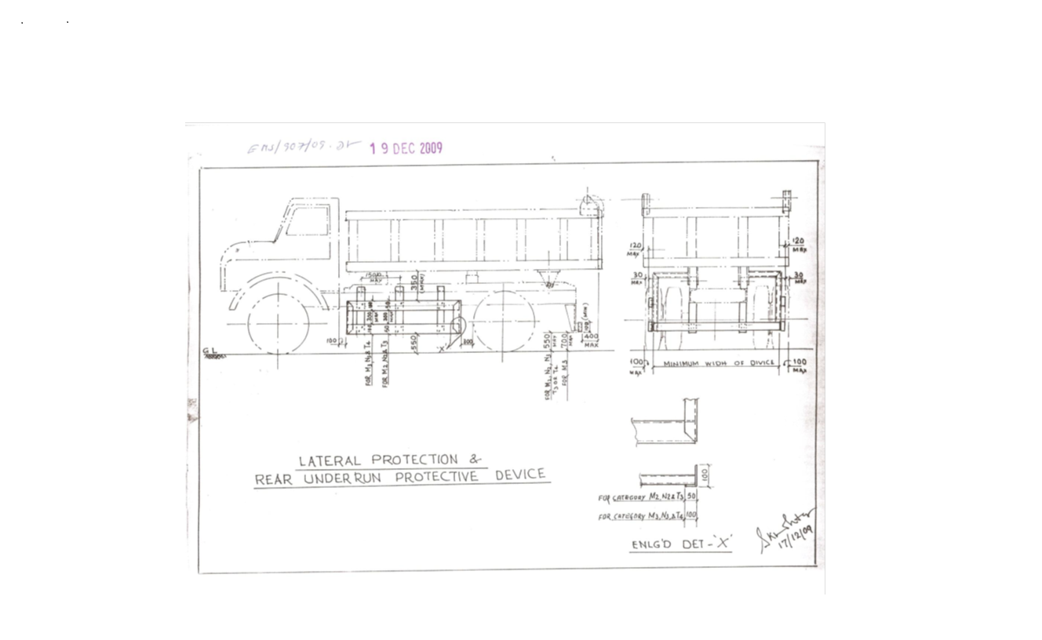

Sl. No. | Safety Parameters to be checked
1 | Three Piece Mirror(Truck, Trailer & Dumper)-Helper side
2 | Single Mirror- Driver side
3 | Rear View Mirror (Tata Ace, 207, Jeep etc.)
4 | Service Brake
5 | Parking Brake
6 | Seat Belt
7 | Head Light
8 | Parking Light
9 | Blinker
10 | Horn
11 | Reverse Alarm
12 | Wiper
13 | Windshield Glass
14 | Air Pressure Min. 7 Kg/Cm^2
15 | Run Under Protection Guard as per TSL standard
16 | Side under Protection Guard as per TSL standard
17 | Tyre Condition (Tread Depth, Cut Mark etc.)
18 | Any Oil Leakage from the vehicle
19 | Physical condition of Dallah
20 | Availability of scotch block
21 | Buzzer with side indicator
22 | Driver's eye examination report
Legal Documents to be checked:
Sl. No. | Documents to be Checked
1 | RC Book
2 | Insurance
3 | Pollution
4 | Driving licence
5 | Fitness for more than 15 years old vehicle
6 | NOC for outside vehicles
- DISCLAIMER FOR E-AUCTION
BANDWIDTH PROBLEMS, CONNECTIVITY PROBLEMS WITH THE LOCAL ISP (INTERNET SERVICE PROVIDER), SLOWNESS TO ACCESS PAGES FOR DOWNLOADING ETC. ARE BEYOND THE CONTROL OF THE STEEL LTD. AND A H BILIMORIA & COMPANY. HENCE NO RESPONSIBILITY LIES WITH THE STEEL LTD. OR A H BILIMORIA & COMPANY FOR THE ABOVE PROBLEMS FACED, IF ANY, BY THE BIDDERS BEFORE/DURING THE AUCTION ANY. BID PLACED USING THE BIDDER'S USERNAME AND PASSWORD IS UNCONDITIONALLY BINDING ON THE BIDDER TO WHOM SUCH USERNAME AND PASSWORD HAD BEEN ALLOTTED AND HE SHALL BE SOLELY RESPONSIBLE FOR MAINTAINING THE CONFIDENTIALITY OF THE SAME AND FULLY RESPONSIBLE FOR ALL ACTIVITIES THAT OCCUR UNDER THEIR USERNAME AND PASSWORD. HENCE THE USER IS ADVISED TO CHECK THE USERNAME AND PASSWORD BEFORE THE AUCTION,IN ORDER TO FAMILIARISE HIMSELF WITH THE SAME AND IS ADVISED NOT TO REVEAL IT TO ANYONE ELSE SO AS TO PREVENT MISUSE OF THE SAME. THE BIDS MADE BY THE BIDDERS AGAINST THEIR USERNAME AND PASSWORD SHALL BE IRREVOCABLE.THE BIDDERS ARE ADVISED TO REGISTER AND PRE-QUALIFY FOR BIDDING WELL IN ADVANCE AND PLACE THEIR BIDS EARLY IN ORDER TO TAKE CARE OF ANY UNFORESEEN TECHNICAL DIFFICULTY THAT MIGHT SURFACE IN THE INTERNET OPERATIONS.

Lot Photograph: Photographs of lots are at best indicative only and do not necessarily reflect the actual condition of lots. All bidders are advised to physically inspect the offered lots before participating in the Auctions. Tata steel or A H Bilimoria & Co. shall not be responsible or liable for any error of judgment or bids put by bidders acting on the basis of these photographs.

Quantity offered is based on eye estimation. Delivery will be made for the estimated quantity or actual ground stock. Estimation error may arise. After physical inspection, no complaint of whatsoever nature on estimated /offered quantity shall be entertained under any circumstances. Bidders are advised to make their own judgment on offered quantity before bidding.

Declaration for Rej plastic items for Traders & Recyclers:
1) All plastic waste processors (recyclers) shall have to register with Central Pollution Control Board (CPCB) in accordance with provision 13(3) of Plastic Waste Management Rules, 2016 on the centralized portal developed by CPCB.
2) All plastic waste processors (recyclers) shall have to mandatorily furnish their EPR certificate along with other environmental NOC’s (EC, CTO etc).
3) Plastic waste processors(Recyclers) registered under Plastic Waste Management Rules, 2016, as amended, shall mandatorily provide certificates i.e. EPR Credits against the amount of plastic waste taken for processing, except in case of use of plastic waste in road construction from the company premises through online mode in the centralised EPR Portal in the name of Tata Steel Limited.
4) The EPR certificates i.e. EPR Credits will be for plastic packaging category-wise taken for processing from the premises.
5) The entity must refrain itself from incinerating & open dumping of plastic wastes taken from the company premises.
6) In future, if any complaint from Pollution Control Board received regarding mis-management of plastic waste by the concerned Indemnifier, then consequence management and liable penalty will be imposed for the same.
7) That the Indemnifier shall pay any such amount as claimed or demanded by the Principal within seven days without any demur and protest against any violation observed on any of the terms mentioned above.

ON Rs. 100/- Non-Judicial Stamp Paper
INDEMNITY CUM UNDERTAKING BOND
This Indemnity Cum Undertaking Bond made on _______ day of _______________ 2023.

In favour of

Tata Steel Limited having its registered office at Bombay House, 24, Homi Mody Street, Fort, Mumbai and having its Works at Jamshedpur hereinafter referred to as “Principal.”
By __________, having its office at ___________ through it’s ___________ Mr./Mrs.___________ S/o, D/o ____________ R/o ___________hereinafter referred to as ‘Indemnifier’ (which term shall include its successors, legal heirs, representatives and assigns) on the following terms

Whereas the Principal is a leading integrated steel manufacturer having its works at Jamshedpur and generates LD slag during steel manufacturing process.
And Whereas the Indemnifier has received waste plastic items under Category-1 as per Plastic Waste Management Rules, 2022 notified by MoEFCC ¹ dt 16.02.2022 as packing or used items on the basis of: -

Now therefore the Indemnifier submits this bond on the following conditions:
- That Indemnifier undertakes that it shall only trade the above-mentioned items without changing the nature of the same.
- In case the nature of items is changed, the traders will ensure to sell the waste plastic to CPCB authorized Plastic Waste Processors having valid EPR Certificate for recycling/processing of plastic waste ³ of same category as per the above-mentioned guidelines.
- Must ensure to prevent open dumping & incineration of the waste plastic taken from the company premises.
- Plastic waste disposal to be complied based on the laid down mandate under Plastic Waste Management Rules, 2022.
- In future, if any complaint from JSPCB received regarding mismanagement of plastic waste by the concerned Indemnifier, then consequence management and liable penalty will be imposed for the same.
- That Indemnifier irrevocably agrees to indemnify and hold harmless the principal and its directors, officers, employees and representatives from and against all actions, inquiry, suits, proceedings, claims, damages, losses, expenses and demands of every nature and description including but not limited to liability under Pollution Control Legislations and rules framed thereunder or guidelines and notifications issued.
- That the Indemnifier shall pay any such amount as claimed or demanded by the principal within seven days without any demur and protest against any violation observed on any of the terms mentioned above.
- That this Indemnity Bond shall remain in force and virtue till the principal releases the Indemnifier from its obligation under this Bond.
- That Mr./Mrs.___________ is competent to sign this Bond on behalf of the Indemnifier.

This Indemnity Bond shall be valid from the date mentioned hereinabove.

Signature of the Indemnifier

Witness

Signature:

Name:

Address:

Special Instruction:
1. Vehicle details along with an Authorization letter should be mailed to TSL representative, one day before loading. The mail should contain the number of vehicles to be placed, their registration numbers, and the name of the authorized person with his/her ID details who will be receiving the material.
2. Vehicle to report at TSL Gate within 08:30 AM.
3. After approval from Secondary Product and Security checking of the vehicle to enter TSL premises before 09:30 AM.
4. Lifting will be done up to 04:00 PM. Loading after 4 PM is not allowed in TSL.
5. Speed Limit for Heavy Vehicles to max. 30 kms. Any body exceeding the same may get penalized.
Terms and Conditions for TDS of 2 % on metallic Scrap sales :
- Compliance of GST-TDS Provisions: It shall be the responsibility of the customer to comply with all the requirements prescribed under GST law related to GST-TDS in case of material sold to them.

- Payment of GST-TDS to the Government: The GST-TDS shall be deposited by the customer to the Government within due date prescribed under GST law.

- Filing of GST-TDS Returns: Customer shall file the periodic statements/returns as per GST law. GST-TDS deposited by the customer to the Government shall be refunded to the customer within one month of the day, the paid amount is reflected in GST portal of TSL at GSTN.

- Sharing of GST-TDS payment details with TSL: The customer shall share the invoice wise details of GST-TDS with TSL in excel file to the email id GSTRECON@TATASTEEL.COM.

- Implication of Non- Compliance: Any Impact of non-compliance for GST-TDS under GST law at customer’s end either in financial or other form, shall be borne by the customer only. Further, the customer shall at all times keep TSL indemnified and harmless from any loss/penalty/cost/damages suffered by TSL due to non-compliance of the applicable law by the customer.

- MATERIAL DETAILS:
Sl. No | Location | Lot No. | Material code | Material Description | Qty | UOM | GST | TCS | Loading | LIFTING PERIOD | CONTACT PERSON | CONTACT NO
1 | Tata Steel Limited, HMC division, Patikhali | 223HMC-022026 | 140005290 | Scrap Oven Doors (CI) with  refractory (30%) (Loading with Crane) Vehicle requirement: Truck with 12 tonne permissible limit: 15 nos. | 180 | MT | 18% | 1% | Free Loading by HMC | 30 Days from the D/O date | Mr. Suvobroto Ray Chaudhuri | 9038071526
2 | Tata Steel Limited, HMC division, Patikhali | 224HMC-022026 | 146000363 | IMPACT IDLER WITHOUT RUBBER | 10 | MT | 18% | 1% | Free Loading by HMC | 10 Days from the D/O date | Mr. Suvobroto Ray Chaudhuri | 9038071526
3 | Tata Steel Limited, HMC division, Patikhali | 225HMC-022026 | 140007960 | SCRAP NYLON CONVEYOR BELTS ABOVE 25 MTRS (Loading with Crane) | 25 | MT | 18% | 1% | Free Loading by HMC | 15 Days from the D/O date | Mr. Suvobroto Ray Chaudhuri | 9038071526
4 | Tata Steel Limited, HMC division, Patikhali | 226HMC-022026 | 140003270 | WOODEN SCRAP | 10 | MT | 5% | 1% | Free Loading by HMC | 15 Days from the D/O date | Mr. Suvobroto Ray Chaudhuri | 9038071526
5 | Tata Steel Limited, HMC division, Patikhali | 227HMC-022026 | 140008050 | Rej. & Scrap Stainless steel (Non-Magnetic) | 15 | MT | 18% | 1% | Free Loading by HMC | 20 Days from the D/O date | Mr. Suvobroto Ray Chaudhuri | 9038071526
6 | Tata Steel Limited, HMC division, Patikhali | 228HMC-022026 | 140005360 | USED LUBRICATING OIL (FULL) BARREL  Authorized by WBPCB Recycler within WB state Lifting with fork lift (Valid CTE/CTO, EPR Authorisation Letter from CPCB/SPCB for recycling of used Oil/recycler) | 12 | MT | 18% | 1% | Free Loading by HMC | 30 Days from the D/O date | Mr. Suvobroto Ray Chaudhuri | 9038071526
7 | Tata Steel Limited, HMC division, Patikhali | 229HMC-022026 | 140008120 | OLD SCRAP ALUMINIUM CABLE | 6 | MT | 18% | 1% | Free Loading by HMC | 30 Days from the D/O date | Mr. Suvobroto Ray Chaudhuri | 9038071526
8 | Tata Steel Limited, HMC division, Patikhali | 230HMC-022026 | 140008110 | OLD SCRAP MULTI CORE COPPER CABLE (Only authorized COPPER CERTIFICATE recyclers are allowed to participate in the lot) | 7 | MT | 18% | 1% | Free Loading by HMC | 10 Days from the D/O date | Mr. Suvobroto Ray Chaudhuri | 9038071526
9 | Tata Steel Limited, HMC division, Patikhali | 231HMC-022026 | 150001861 | REJ. & SCRAP ALUMINIUM | 8 | MT | 18% | 1% | Free Loading by HMC | 10 Days from the D/O date | Mr. Suvobroto Ray Chaudhuri | 9038071526
10 | Tata Steel Limited, HMC division, Patikhali | 232HMC-022026 | 140004763 | IMPACT IDLER CONTAINING  RUBBER & IRON | 10 | MT | 18% | 1% | Free Loading by HMC | 10 Days from the D/O date | Mr. Suvobroto Ray Chaudhuri | 9038071526
11 | Tata Steel Limited, HMC division, Patikhali | 233HMC-022026 | 140004023 | USED DAMAGED TARPAULIN SHEET, EPR with valid CTO / CTE and having validity of authorization under category II | 50 | MT | 18% | 1% | Free Loading by HMC | 30 Days from the D/O date | Mr. Suvobroto Ray Chaudhuri | 9038071526
12 | Tata Steel Limited, HMC division, Patikhali | 234HMC-22026 | 146000052 | PULLEY CONTAINING RUBBER & IRON | 35 | MT | 18% | 1% | Free Loading by HMC | 20 Days from the D/O date | Mr. Suvobroto Ray Chaudhuri | 9038071526
13 | Tata Steel Limited, HMC division, Patikhali | 235HMC-022026 | 140006947 | REJECTED GEAR BOX | 15 | MT | 18% | 1% | Free Loading by HMC | 10 Days from the D/O date | Mr. Suvobroto Ray Chaudhuri | 9038071526
14 | Tata Steel Limited, HMC division, Patikhali | 236HMC-022026 | 140007045 | REJ. NYLON CONVEYOR BELTS CUT PIECE BELOW 10MTR | 9 | MT | 18% | 1% | Free Loading by HMC | 10 Days from the D/O date | Mr. Suvobroto Ray Chaudhuri | 9038071526
15 | Tata Steel Limited, HMC division, Patikhali | 237HMC-022026 |  | SCRAP DRAG CHAIN | 3 | MT | 18% | 1% | Free Loading by HMC | 10 Days from the D/O date | Mr. Suvobroto Ray Chaudhuri | 9038071526

ALL THE PHOTOGRAPHS ARE INDICATIVE ONLY
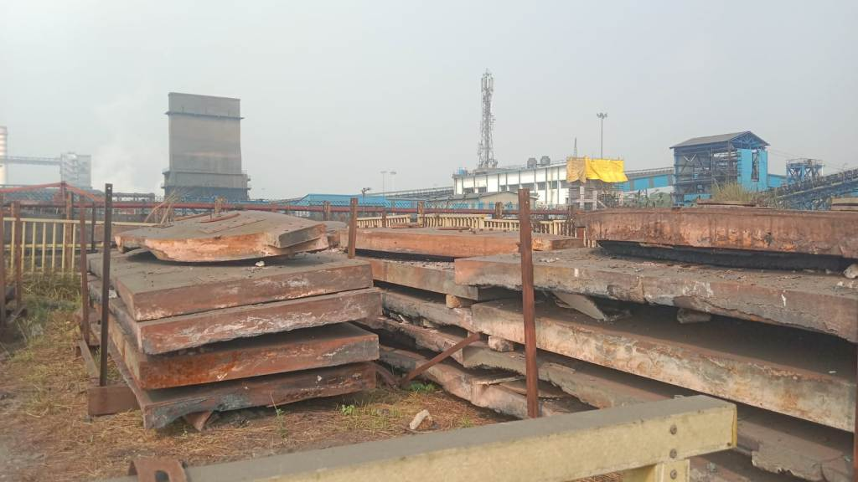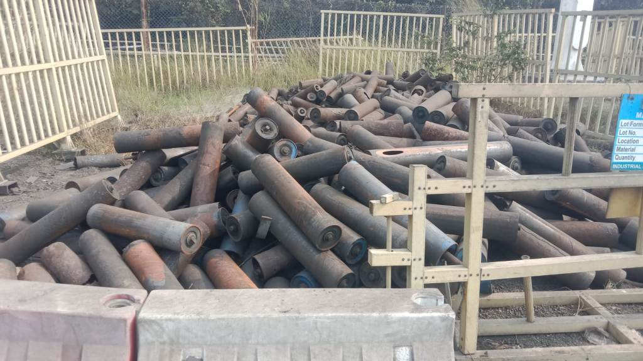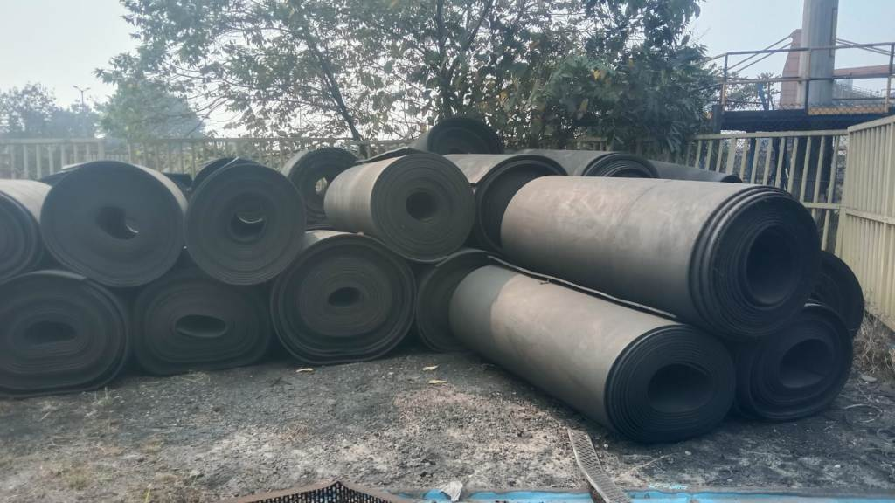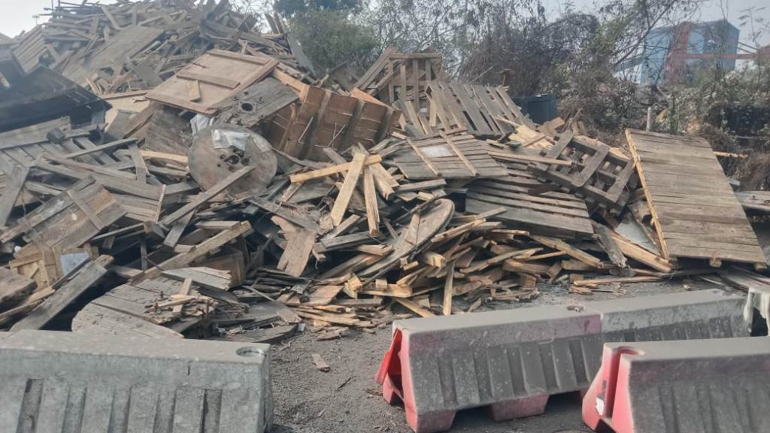
223HMC-022026 224HMC-022026 225HMC-022026 226HMC-022026
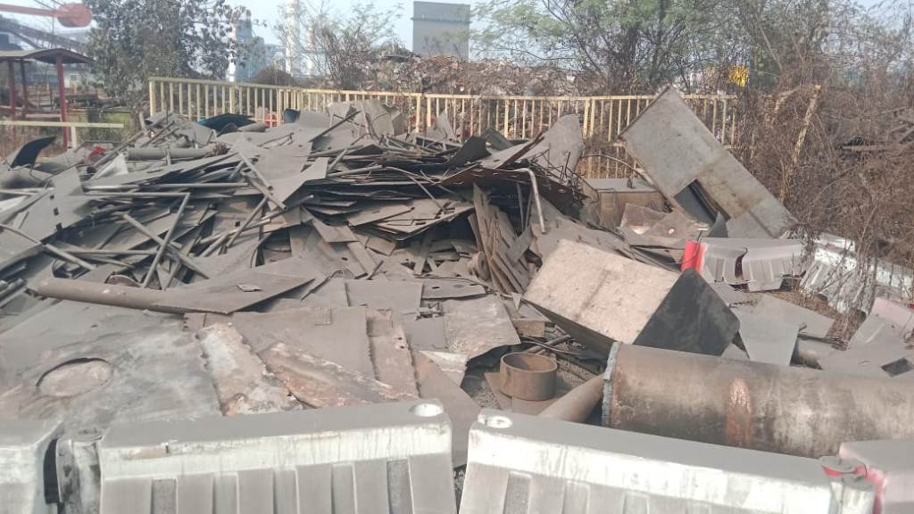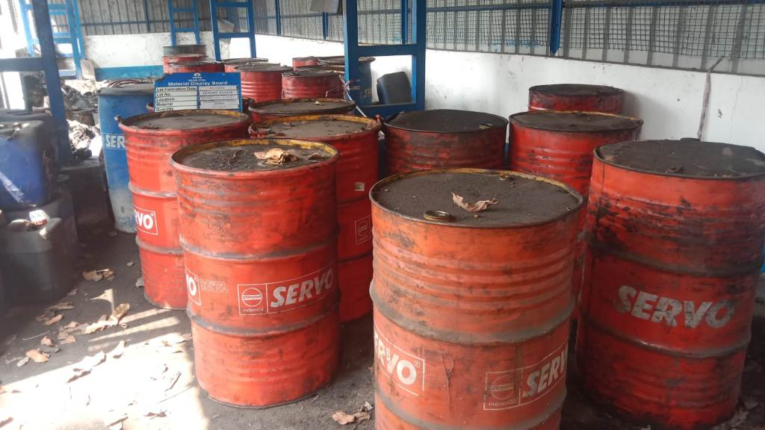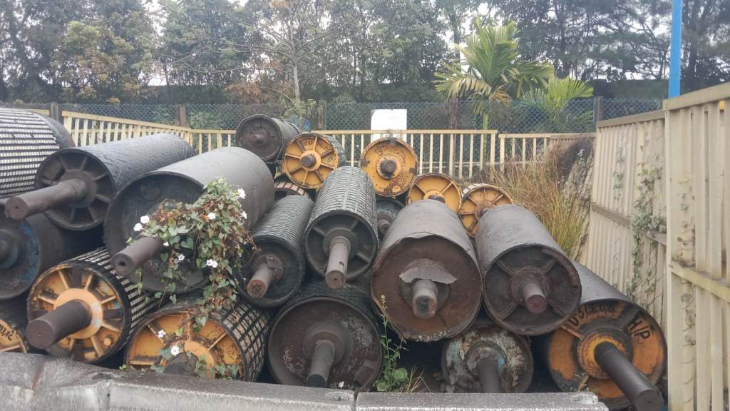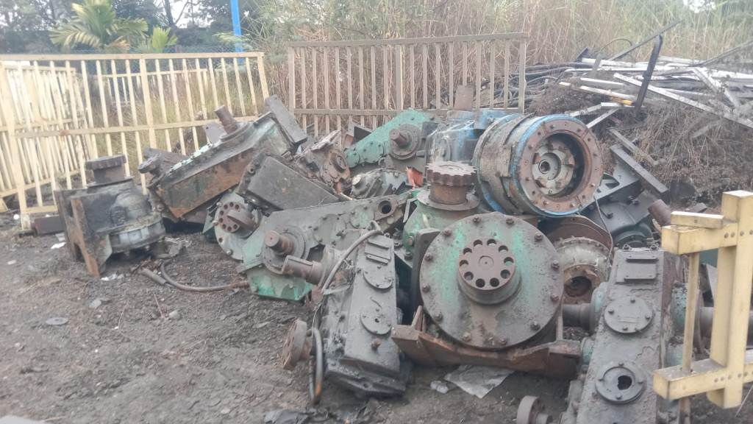
227HMC-022026 228HMC-022026 234HMC-022026 235HMC-022026
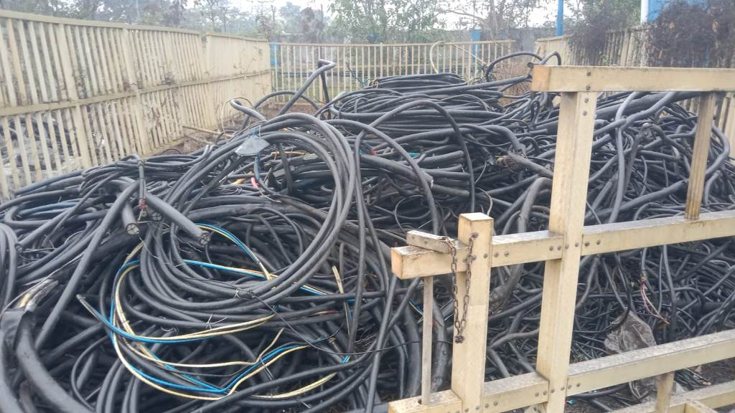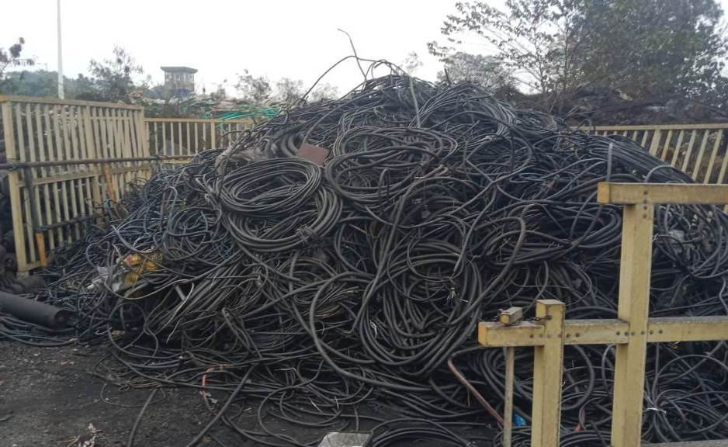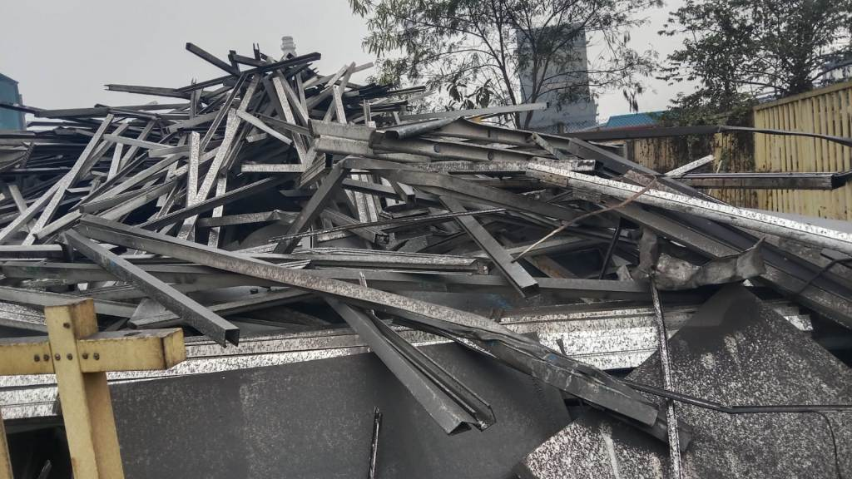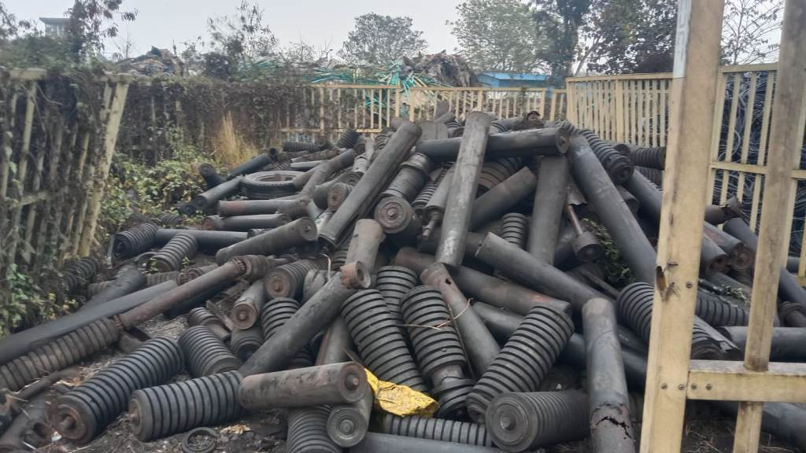
229HMC-022026 230HMC-022026 231HMC-022026 232HMC-022026
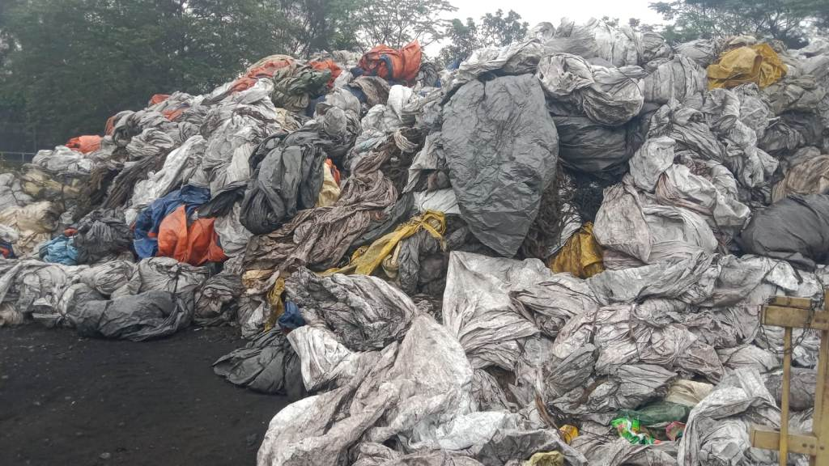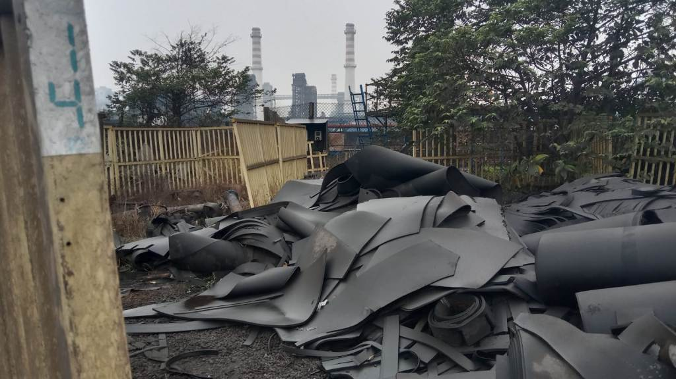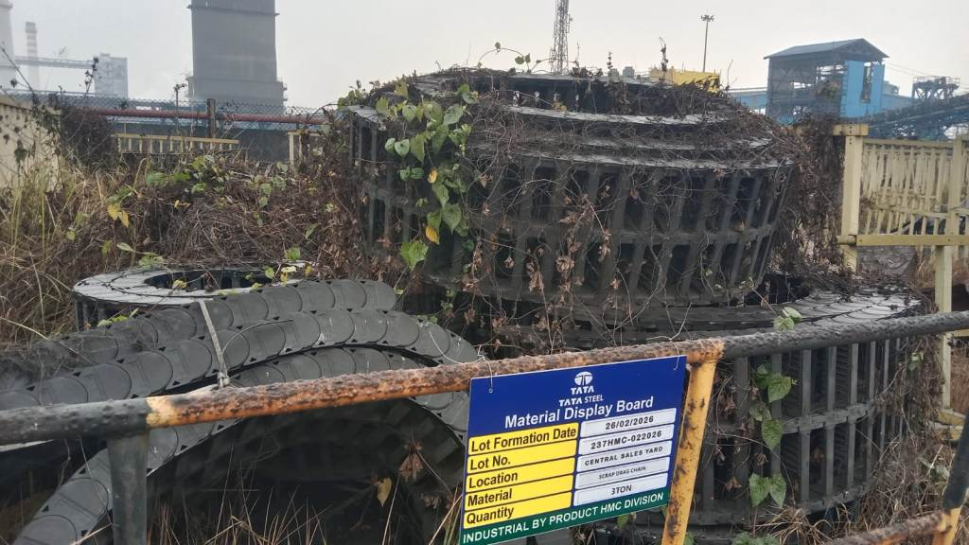
233HMC-022026 236HMC-022026 237HMC-022026

Open www.ahbilimoria.com ->Click on Customer Complaint Management Portal

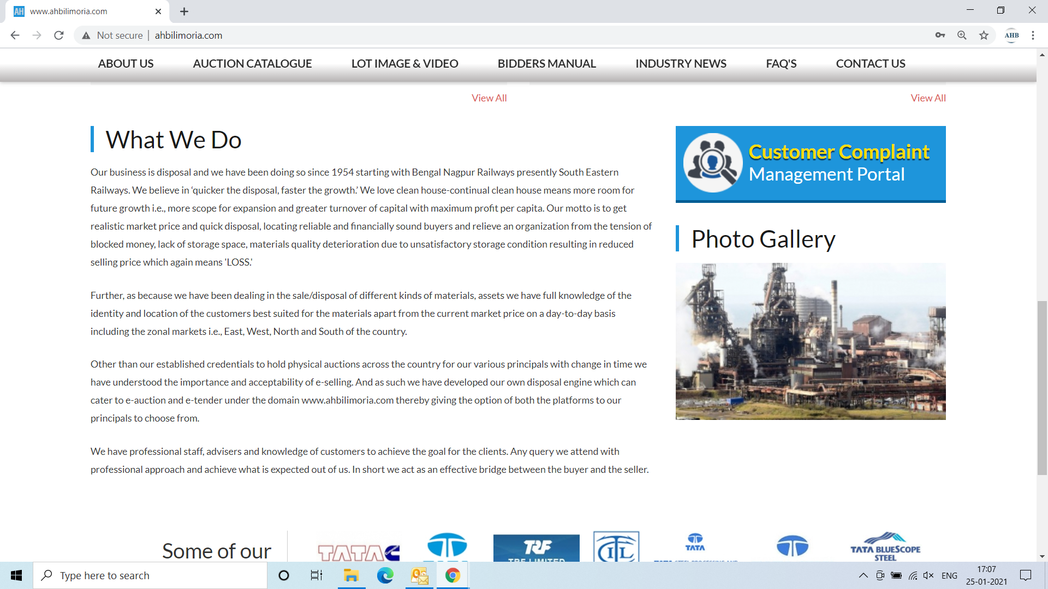

Use your User ID & Password for login

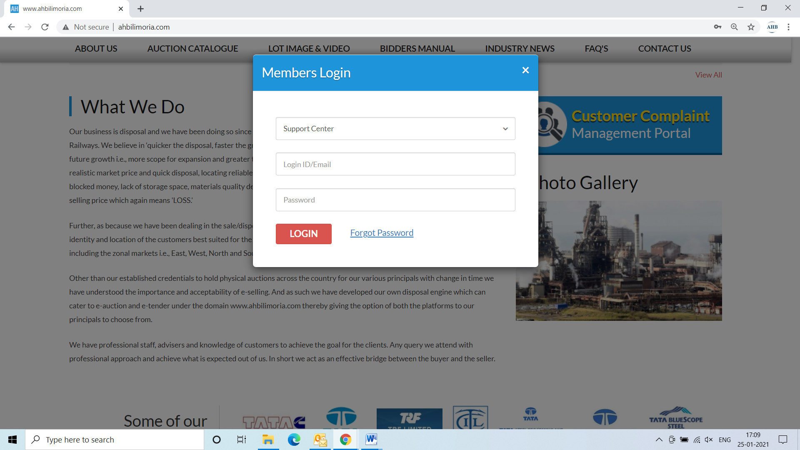

Click Complaint Portal-> Click on “Post a New Ticket”

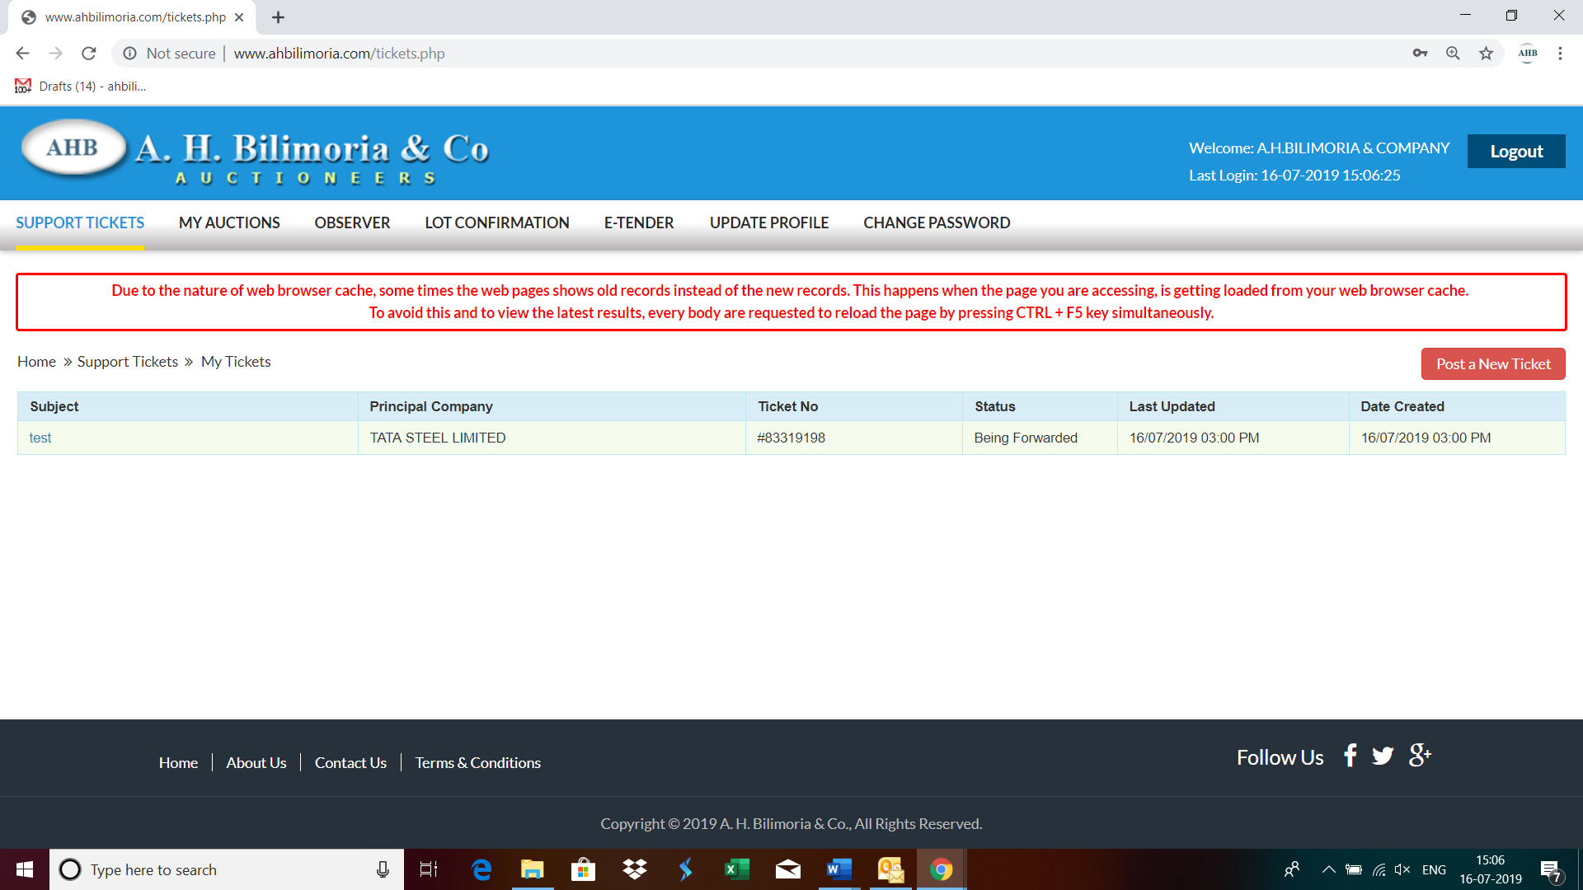

Post a New Ticket->Subject* ->Message* -> Email*->Principal Company*->Attach Document (If required any attachment) ->Submit

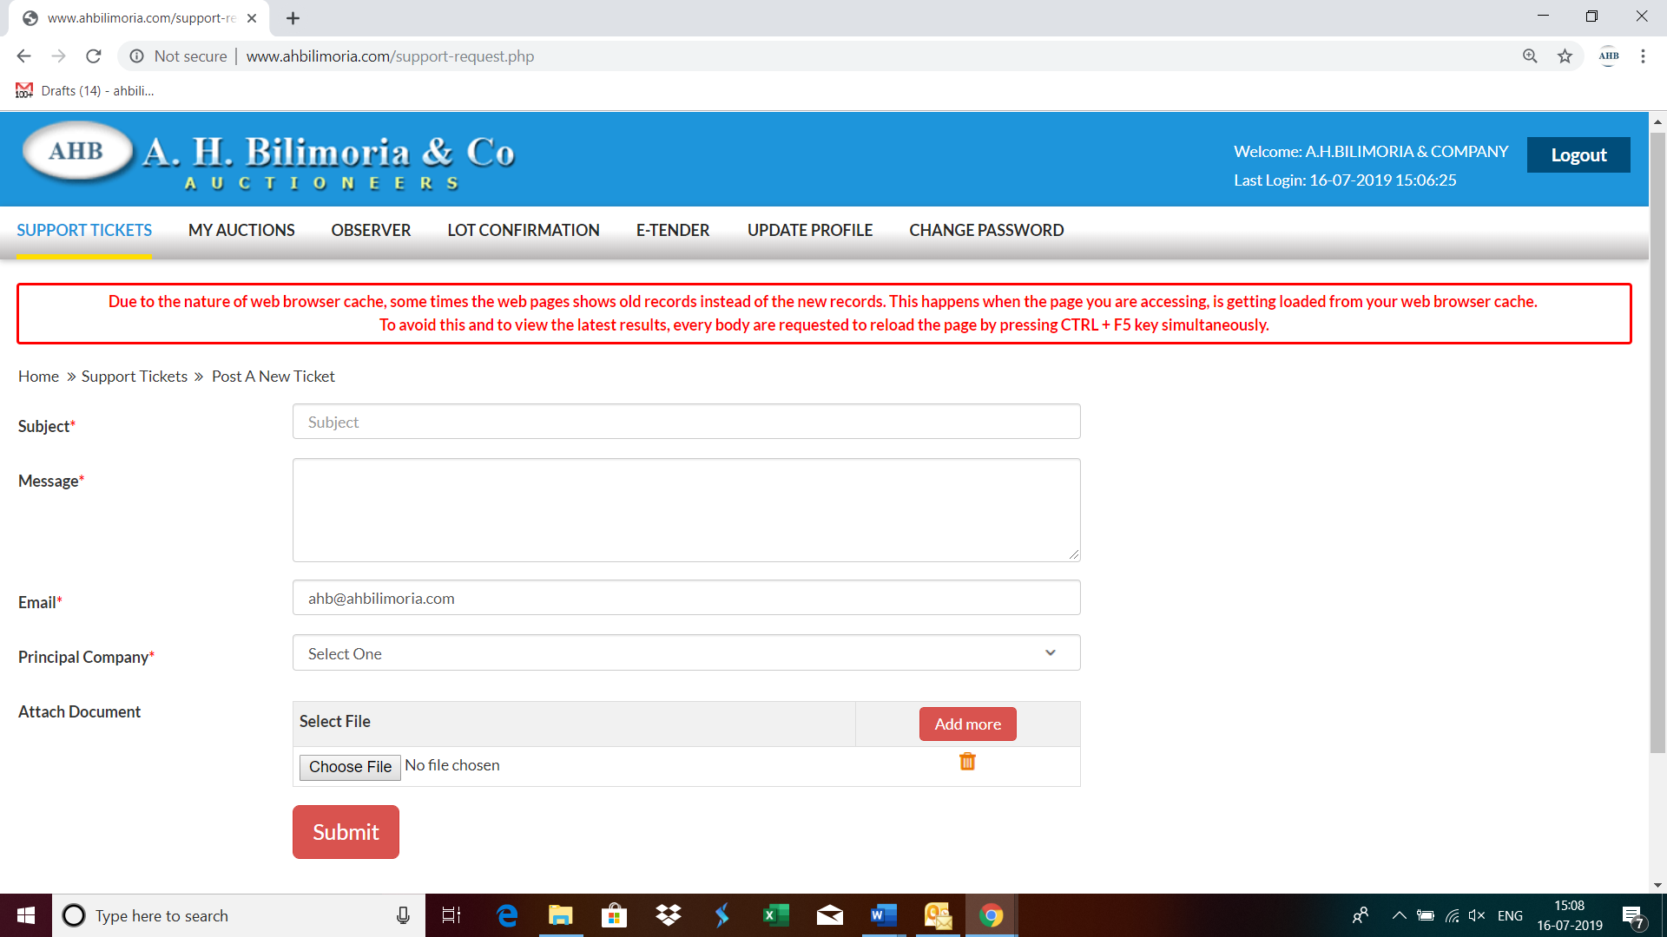

Your support request has been submitted successfully and the Reference No ----- is generated automatically

