Auction Catalogue
Auction conducted by A H Bilimoria & Co.
Auction of Capital Items, Noamundi, Joda & Khondbond - IBMD
BEING SOLD ON ‘’AS IS WHERE IS AND NO COMPLAINT BASIS’’
Catalogue Serial Number: | TSL/AHB/SEPTEMBER/211/26-27
Seller: | Tata Steel Limited
Auction website: | www.ahbilimoria.com
e-Auction Date & Time: | 07th September, 2026…..….. at 12:00 PM
Inspection Date & Time: | No physical inspection to be conducted. Interested customers please visit our website for indicative lot photographs/videos. For any assistance please call AHB (9334722391/7003840027) or IBMD Officer (9175901521).
Date of Security Money Deposit | 07th September, 2026 Till ……… at 11:30 AM
Contact Details:
For Post Auction @ A H Bilimoria & Company
Area | Contact No. | Email Id
Auction Room | 07003840027/09883421336
Lot Confirmation Related | 08987460668 | ahb@ahbilimoria.com, ahbilimoria.company@gmail.com
Payment Related | 08987460668/09073711453 | ahb@ahbilimoria.com, ahbilimoria.company@gmail.com, ahbjsr@ahbilimoria.com, b.bhardwaj@ahbilimoria.com, m.paul@ahbilimoria.com, sukumar.chandra@ahbilimoria.com
Delivery Order Related | 09073711453 | ahb@ahbilimoria.com, ahbilimoria.company@gmail.com,ahbjsr@ahbilimoria.com, b.bhardwaj@ahbilimoria.com, m.paul@ahbilimoria.com, sukumar.chandra@ahbilimoria.com
Material Value Refund Related | 09073711453 | ahb@ahbilimoria.com, ahbilimoria.company@gmail.com,ahbjsr@ahbilimoria.com, b.bhardwaj@ahbilimoria.com, m.paul@ahbilimoria.com, sukumar.chandra@ahbilimoria.com
Refund Related | 09073711453 | ahb@ahbilimoria.com, ahbilimoria.company@gmail.com,ahbjsr@ahbilimoria.com, b.bhardwaj@ahbilimoria.com, m.paul@ahbilimoria.com, sukumar.chandra@ahbilimoria.com
TCS Related | 09073711453 | ahb@ahbilimoria.com, ahbilimoria.company@gmail.com,ahbjsr@ahbilimoria.com, b.bhardwaj@ahbilimoria.com,m.paul@ahbilimoria.com, sukumar.chandra@ahbilimoria.com
Payment Deviation/Disablement in Tata Steel | 09073711453 | ahb@ahbilimoria.com, ahbilimoria.company@gmail.com,ahbjsr@ahbilimoria.com, b.bhardwaj@ahbilimoria.com,m.paul@ahbilimoria.com, sukumar.chandra@ahbilimoria.com
Collection of Delivery Order-Tata Steel | 09073711453/09883421336 | ahb@ahbilimoria.com, ahbilimoria.company@gmail.com,ahbjsr@ahbilimoria.com, b.bhardwaj@ahbilimoria.com, m.paul@ahbilimoria.com, sukumar.chandra@ahbilimoria.com
Collection of Delivery Order for Tata Steel Kalinganagar | 09664062791 | ahb@ahbilimoria.com, ahbilimoria.company@gmail.com,ahbjsr@ahbilimoria.com, b.bhardwaj@ahbilimoria.com,m.paul@ahbilimoria.com,sukumar.chandra@ahbilimoria.com, ahbjajpur@gmail.com
For time bound resolution of unresolved issues log into our Customer Complaint Management portal | Type in www.ahbilimoria.com> Go to “Customer Complaint Management Portal” >Log in with your user id and password and write the details of issue.

For Any unresolved Issues beyond two (02) days mail to A H Bilimoria & Company :
Mr. A K Sil (M-09830074122) & Mr. D Pyne (M-09830738481), E-mail: ahb@ahbilimoria.com, ahbilimoria.company@gmail.com
Copy to Tata Steel Ltd : Mr. SK Khajavali (sk.khajavali@tatasteel.com)

SPECIAL NOTE: -It is the responsibility of the buyer to furnish the valid GST no. & necessary documents to A H Bilimoria & Company before participating in the auction. In case during the transactions, it is found that valid GST no. has not been provided, then all necessary liabilities if any & so accrued would be on account of the buyer. TATA Steel & A H Bilimoria & Company would not be responsible for any such liabilities.

Note: TSL reserves the right to track IP address, MAC number and geolocation of bidding customers whenever customers participate in any auction on the A H Bilimoria & Co. auction platform for TATA Steel.

- Payment and Lifting Schedule:

Lot No. | Payment Schedule |  |  | Lifting Schedule  (working days from the next day of DO release)
Lot No. | EMD (10%) | 1st installment | 2nd installment | 1st installment lifting days | 2nd installment lifting days
For All Materials | 01 Working day from Date of Lot Confirmation | 01 Working Days From Date of EMD | 03 Working Days from the 1st Installment date  [Only Applicable if material value (Rate X Tonnage) crosses Rs. 20 Lakh] | As per material list | 3 additional working days at the expiry of 1st Installment DO validity.
- Suitable extension of due date for payment and lifting will be accorded in case of any eventualities like Strike/ Bandh/ Special restriction on vehicular movement imposed by the local Administration etc.

- Requirements of participation:
  - Registration: Before participation in the e-Auction, a prospective bidder shall be required to get registered with A H Bilimoria & Co. For details visit www.ahbilimoria.com

  - Security Deposit: Non-Interest bearing security deposit of Rs.60,000/- (Rupees Sixty Thousand only) in all lots in favour of “A H Bilimoria & Co.” through Online Payment only : Details as under :

Beneficiary Name | A. H. BILIMORIA & COMPANY
Bank Name | HDFC Bank
Branch Name | 31, Chowringhee Road, Kolkata – 700016
Account No | 06932560001205
IFSC Code | HDFC0000693

Account No: All the customers will have a unique account number. The unique account number is an alpha numeric code consisting of 12 characters. The Customer’s unique “account number” is a combination of the AHB’ SAP code along with the 6 digit bidder SAP ID and can be used as reference. for all subsequent transactions. The Customer’s Account Number detail is available in “Profile” after the customer logs into our website using the user id and password.

- Inspection Rules & Policy:
No physical inspection to be conducted. Interested customers please visit our website for indicative lot photographs/videos. For any assistance please call AHB (9334722391/7003840027) or IBMD Officer (9175901521).

- Bidding modalities:
  - Price Bid Basis: In Indian rupees as per unit of measurement as given in Material List. Price to be quoted is basic, ex- location exclusive of taxes and any other statutory levies.
  - Bid Increment: As specified in the e-auction bid page
  - Type of Auction: English No Ties
  - Bid Validity: Bid shall be valid for 10 (Ten working days excluding Saturdays, Sundays and Bank holidays) working days counted from the next day of auction process in case of auction against a catalogue which is completed on the same day. And if it is continuing on any other day the counting of days for lot confirmation shall be from the next day of completion of entire auction process.
  - Bid duration: For 1st four lots 20 minutes and balance lots 10minutes. If, No bids received within these specified time the lots are closed automatically.

- Taxes & duties:
  - GST : As applicable
  - TCS : As applicable.
  - Any change in taxes applicable at the time of lifting shall be applicable.

- Payment terms & conditions :
  - Payments: PAYMENT FACILITY BY RTGS / NEFT ONLY

Account No | TATAHB followed by Party code (Each individual customer will be provided with Account number to be provided by AHB)
Beneficiary Name | TATA STEEL LIMITED A H B
Bank Name | HDFC BANK LTD.
Branch Name | Sandoz Branch, Mumbai
IFSC Code | HDFC0000240
  - EMD: 10% of the material value to be paid within 01 (One) working days from the date of lot confirmation for all lots. EMD to be adjusted in the final installment only.
EMD payment is to be made within the time limit as given in letter of confirmation. No extension will be provided for the same.
  - Balance Payment Time: (As per payment schedule)
  - Delayed Payment Charges (DPC) : Installment payments with DPC @ five (05) paise per Rs. 100 per day will be accepted up to 02 (Two) working days (after on approval from TSL authority) from due date of installment payment as mentioned in the confirmation letter. This is not applicable for EMD payment. GST @ 18% would be charged in addition to the above DPC amount.
  - 2nd & 4th Saturdays, Sundays and Bank holidays are excluded for counting purpose for payment schedule.
  - In the event of Non-Receipt of Payment within the stipulated period of Payment, the Sale Offer for the approved Lot shall stand withdrawn automatically (Refer Clause#8).
  - Buyers have to send the payment deposit slip (UTR No /Scan Copy of NEFT/RTGS Transaction Slip) against Lot No. immediately after the payment to AHB at email id: ahb@ahbilimoria.com& ahbilimoria.company@gmail.com
  - GST number of TSL Noamundi : 20AAACT2803M2ZO; TSL Joda: 21AAACT2803M1ZN

- Lifting terms & conditions:
7.1 DOs will be handed over to authorized representatives of bidders on receipt of payment. Authorization letter to be issued via registered e-mail id’s. Authorized letter must be duly stamped and signed by the proprietor or partner or director on receipt of payment. Lifting date is calculated from the next day of DO Release date.
7.2 Loading Charges: As mentioned in material list
7.3 Loading shall be given strictly as per the statutory norms & safety norms of Tata Steel Ltd.
7.4 Lifting with Ground Rent: Lifting along with ground rent will be allowed up to 4 (four) working days from the last date of lifting period. In case the lifting is not complete, and no request is made by the customer within the period of four days, the company reserves the right to close the lot, and refund the balance to the party after deducting for any shortfall in lifting as per norms laid down in the catalogue. Ground Rent will be calculated on balance unlifted quantity @ 05 paise (inclusive of tax) per Rs.100/- per day. GST @ 18% would be charged in addition to the above ground rent amount.
7.5 Additional lifting days for advance payment of installment - If the installment payment is made in advance, then additional lifting days (equivalent to the number of days payment made in advance) would be given. This would not be applicable for EMD payment.
7.6 PICK & CHOOSE NOT ALLOWED FOR ANY OF THE LOTS.

7.7 LOT TRANSFER WILL NOT BE ALLOWED.

- Penalty:
  - The following penalties shall be applicable in the eventuality of a buyer defaulting in making the payment of EMD (wherever applicable) or any installment/s, as per the stipulated schedule for each lot, in a financial year:
- In the first instance, a penalty of Rs. 60,000/- (Rupees Fifty Thousand only) shall be recovered from the customer. The above penalty amount would be inclusive of GST amount @18%.
- In the second instance, a penalty of Rs.120,000/- (Rupees One Lakh Twenty thousand only) shall be recovered from the customer. The above penalty amount would be inclusive of GST amount @18%.
- In the third, and any subsequent instance, a penalty of Rs.180,000/-(Rupees One Lakh Eighty thousand only) shall be recovered and the customer shall be debarred from participating in any auction for a period of three months from the date of debarment. The above penalty amount would be inclusive of GST amount @18%.

In the event of any default, the customer’s user id will be disabled and the customer will be blocked from participating in any auction of TSL with immediate effect.

The defaulting customer shall be allowed 06 (six) working days to deposit the penalty as mentioned above. In case the penalty is not received within the stipulated period, the customer’s security deposit shall be forfeited, and the defaulting customer shall be immediately debarred from participating in any auction of TSL.

  - If after making payment of EMD (wherever applicable), the installment payment/s are not made by the customer as per the stipulated schedule for each lot, the entire EMD amount against such lot shall be forfeited.

  - In case of non- lifting of full lot quantity after making full payment, a penalty equivalent to 20% of the material value for the un-lifted quantity against each lot shall be recovered from the customer.

- Lot Closure Norms :
For Lot Closure, the tolerance would be ± 10% or 1MT whichever is higher of the original quantity (Refer lot description in material list for each lot norms)
- Refund :
Refunds will only be made by TATA Steel vide RTGS/NEFT and hence all customers are required to submit their bank details to A H Bilimoria & Company or mail at ahb@ahbilimoria.com, ahbilimoria.company@gmail.com, ahbjsr@ahbilimoria.com, b.bhardwaj@ahbilimoria.com. TATA Steel or A H Bilimoria & Company will not be responsible for any delay in refunds owing to absence of bank details of the customer.

- Complaints :
Complaints, if any, with regard to any transaction shall have to be lodged by the buyer within three calendar months from the date of last invoice. No complaint shall be entertained thereafter, under any circumstances. Customers can log their complaints at (www.ahbilimoria.com> Go to “Customer Complaint Management Portal” >Log in with your user id and password and write the details of issue.)

- Jurisdiction :
Any dispute arising out of any contract shall be decided in Jamshedpur by the courts in Jamshedpur and by no other courts. The courts in Jamshedpur shall have exclusive jurisdiction to adjudicate upon any such dispute.

- General terms & conditions:
  - Any dispute on quality & quantity of material and bid cancellation shall not be entertained at any point after the auction.
  - All lots are offered/sold on “As is Where is Basis” and “No Complaint Basis”.
  - Lot transfer will not be allowed. Payment and invoicing has to done in the name of the H1 bidder, subject to the prices being approved.
  - Lot purchased should consist of material from the same lot and designated location only. Tata Steel has the right to check any vehicle at any moment of time. If material lifted differs from the material that is purchased by the buyer, then the buyer and authorized representative will be permanently debarred. Also Tata Steel can take any penal action against the buyer/authorized representative. All the material loaded in the vehicle is to be covered in order to follow the safety compliance of Tata Steel works.
  - If the safety compliance is not followed, then Tata Steel can penalize the buyer / authorized representative as deemed fit.
  - Customer attested photocopy of valid id proof (Voter id/Aadhar/Pan card) of all lifters / Authorized persons engaged by customers for lifting of materials from TSL is to be enclosed with the authorization letters & to be forwarded to TSL for issue of gate pass.
  - Dispatch is subjected to FORCE MAJEURE conditions
  - The seller reserves the right to terminate any offer at any point of time without assigning any reasons
  - In the event of termination of the offer, seller shall refund the balance amount after due reconciliation
  - No claims whatsoever would be entertained after cancellation of the bid
  - In addition of earlier safety norms, the following would be compulsory:
The drivers of the vehicle must have the eye test certificate. The frequency of the testing would be as below:
1. If the age of the person is less than 45 years - Once in a year
2. If the age of the person is 45 years or more, the testing is required to be done once in every 6 months
Please ensure to comply with the safety norms
  - Weighment : Weight recorded by Tata Steel weighbridge will be considered final and binding on the customer
  - This transaction falls u/s 206C(1). Hence Section 194Q will not be applicable.
  - Compliance in relation to section 206AB/206AA (Furnishing of I.T Return for past 2 Years) will be taken directly from Income Tax Portal till 28th June-2021. If any compliance made in IT Portal by the customer (after 28th June-21), shall be communicated to AHB over mail.

14. Compliance to safety norms
14.1 Authorized persons (of the customer) involved in lifting of the materials will be allowed only with Personal Protective Equipment’s (PPE) i.e.,Safety Shoes, Safety Helmet, Safety Goggles, Fluorescent Jacket and Hand Gloves. No "people movement" shall be allowed at the time of loading/delivery of materials from the yards" Tata Steel will not be responsible for any delays arising out of Non- Compliance to the Safety Norms.

14.2 Documents for verification regarding entry of vehicles inside Tata Steel works :
All customers to note that presentation of following set of documents to TATA STEEL authorities is COMPULSORY at the time of reporting of vehicles at TSL designated Gate for entry of Customer trucks/vehicles.
a. Driving License of driver,
b. Registration Card,
c. Commercial Certificate,
d. Fitness Certificate of Vehicle,
e. Re-registration for vehicles older than 15 years
f. Insurance
The checklist form will be filled in at TSL designated Gate for entry of Customer trucks/vehicles before entry of vehicle.

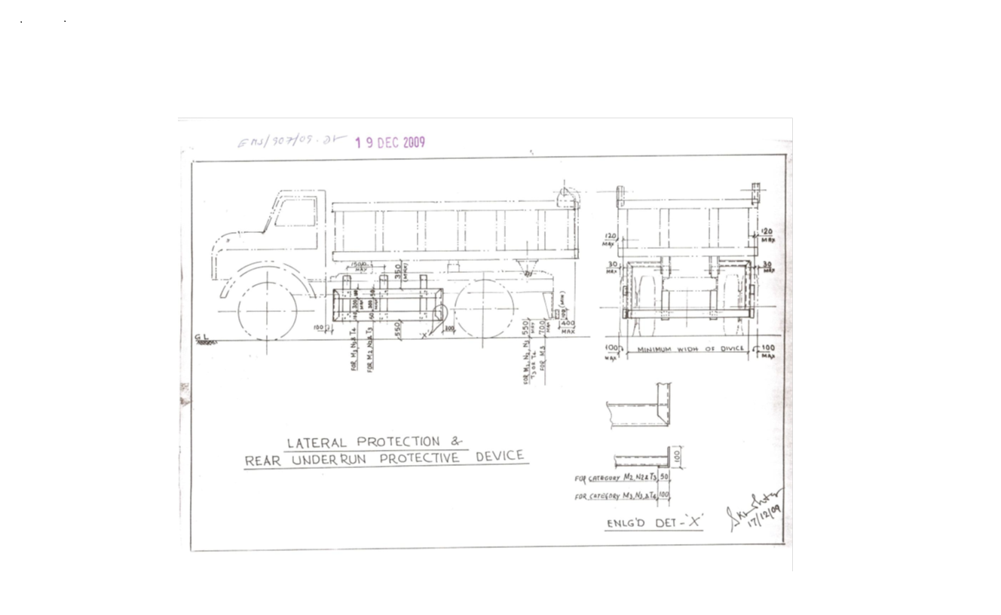

Sl. No. | Safety Parameters to be checked
1 | Three Piece Mirror(Truck, Trailer & Dumper)-Helper side
2 | Single Mirror- Driver side
3 | Rear View Mirror (Tata Ace, 207, Jeep etc.)
4 | Service Brake
5 | Parking Brake
6 | Seat Belt
7 | Head Light
8 | Parking Light
9 | Blinker
10 | Horn
11 | Reverse Alarm
12 | Wiper
13 | Windshield Glass
14 | Air Pressure Min. 7 Kg/Cm^2
15 | Run Under Protection Guard as per TSL standard
16 | Side under Protection Guard as per TSL standard
17 | Tyre Condition (Tread Depth, Cut Mark etc.)
18 | Any Oil Leakage from the vehicle
19 | Physical condition of Dallah
20 | Availability of scotch block
21 | Buzzer with side indicator
22 | Driver's eye examination report
Legal Documents to be checked:
Sl. No. | Documents to be Checked
1 | RC Book
2 | Insurance
3 | Pollution
4 | Driving licence
5 | Fitness for more than 15 years old vehicle
6 | NOC for outside vehicles
For ODC (Over Dimensional Consignment) items Customer / Authorised Lifter has to do Route Mapping in consultation with IBMD prior to vehicle placement for delivery. Customer / Authorised Lifter to indicate final date of vehicle placement.

15. DISCLAIMER FOR E-AUCTION
BANDWIDTH PROBLEMS, CONNECTIVITY PROBLEMS WITH THE LOCAL ISP (INTERNET SERVICE PROVIDER), SLOWNESS TO ACCESS PAGES FOR DOWNLOADING ETC. ARE BEYOND THE CONTROL OF TATA STEEL LTD. AND A H BILIMORIA & COMPANY. HENCE NO RESPONSIBILITY LIES WITH TATA STEEL LTD. OR A H BILIMORIA & COMPANY FOR THE ABOVE PROBLEMS FACED, IF ANY, BY THE BIDDERS BEFORE/DURING THE AUCTION ANY. BID PLACED USING THE BIDDER'S USERNAME AND PASSWORD IS UNCONDITIONALLY BINDING ON THE BIDDER TO WHOM SUCH USERNAME AND PASSWORD HAD BEEN ALLOTTED AND HE SHALL BE SOLELY RESPONSIBLE FOR MAINTAINING THE CONFIDENTIALITY OF THE SAME AND FULLY RESPONSIBLE FOR ALL ACTIVITIES THAT OCCUR UNDER THEIR USERNAME AND PASSWORD. HENCE THE USER IS ADVISED TO CHECK THE USERNAME AND PASSWORD BEFORE THE AUCTION,IN ORDER TO FAMILIARISE HIMSELF WITH THE SAME AND IS ADVISED NOT TO REVEAL IT TO ANYONE ELSE SO AS TO PREVENT MISUSE OF THE SAME. THE BIDS MADE BY THE BIDDERS AGAINST THEIR USERNAME AND PASSWORD SHALL BE IRREVOCABLE.THE BIDDERS ARE ADVISED TO REGISTER AND PRE-QUALIFY FOR BIDDING WELL IN ADVANCE AND PLACE THEIR BIDS EARLY IN ORDER TO TAKE CARE OF ANY UNFORESEEN TECHNICAL DIFFICULTY THAT MIGHT SURFACE IN THE INTERNET OPERATIONS.

Lot Photograph: Photographs of lots are at best indicative only and do not necessarily reflect the actual condition of lots. All bidders are advised to e- inspect the offered lots before participating in the auctions. Tata steel or A H Bilimoria & Co. shall not be responsible or liable for any error of judgment or bids put by bidders acting on the basis of these photographs.

Quantity offered is based on eye estimation. Delivery will be made for the estimated quantity or actual ground stock. Estimation error may arise. After e-inspection, no complaint of whatsoever nature on estimated /offered quantity shall be entertained under any circumstances. Bidders are advised to make their own judgment on offered quantity before bidding.

Speed Limit for Heavy Vehicles to max.25 kms. Anybody exceeding the same may get penalized.
Temporary Gate Pass (GP) will be issued to authorized customer representative’s as per DO validity period. For lots having DO validity more than one month, GP will be issued max. 30 days.

Customers are requested to get lifting program from the Tata Steel Ltd. Authority within 3 days of received of delivery order.
Customers to speak to Mr. Manik Paul Or other personnel of A H Bilimoria & Co. and make plan of lifting at least 2-3 days in advance as loading facility is low, which we will increase very shortly as no cutting is allowed. For placement of vehicles please contact Mr. Srikant Badaik/Ms. Suravi Das/ ACHYUTANANDA SAHOO one day in advance.
The H1 party is responsible to lift the material himself or through his representative of his own firm against the Delivery Order. The selling and buying of auctioned materials inside Tata Steel premises is strictly prohibited. Any deviation in this regard will be viewed seriously and necessary action will be initiated against the buyer.

Special Instruction:
W.e.f. 10th October, 2024, the CBIC has notified that there shall be deduction of GST TDS @ 2% on supply of metal scrap falling under Chapters 72 to 81 in the First Schedule to the Customs Tariff Act by registered person in B to B supply. The GST TDS shall be deducted when the payment is made or credited to the suppliers Account. The deductor will be liable to pay the TDS amount to the Govt. within ten days after the end of the month in which such deduction is made. A certificate of tax deduction at source shall also be issued by the supplier in the format prescribed in GSTR 7A. Accordingly, it is advised to kindly take necessary actions at your end such as obtaining GST TDS registration and ensure compliances with the GST TDS provisions.

Terms and Conditions for TDS of 2 % on metallic Scrap sales :
- Compliance of GST-TDS Provisions: It shall be the responsibility of the customer to comply with all the requirements prescribed under GST law related to GST-TDS in case of material sold to them.

- Payment of GST-TDS to the Government: The GST-TDS shall be deposited by the customer to the Government within due date prescribed under GST law.

- Filing of GST-TDS Returns: Customer shall file the periodic statements/returns as per GST law. GST-TDS deposited by the customer to the Government shall be refunded to the customer within one month of the day, the paid amount is reflected in GST portal of TSL at GSTN.

- Sharing of GST-TDS payment details with TSL: The customer shall share the invoice wise details of GST-TDS with TSL in excel file to the email id GSTRECON@TATASTEEL.COM.

- Implication of Non- Compliance: Any Impact of non-compliance for GST-TDS under GST law at customer’s end either in financial or other form, shall be borne by the customer only. Further, the customer shall at all times keep TSL indemnified and harmless from any loss/penalty/cost/damages suffered by TSL due to non-compliance of the applicable law by the customer.

STANDARD OPERATING PROCEDURE
FORM.NO.EHSMSM/446/4013 FORM REV.NO.:01 EFFECTIVE DATE:01.04.2009
SOP NO. | IBMD/BPSS/Tran/SOP | EFFECTIVE DATE | 01.04.2022 | REVISION NO. | 01
SOP DESCRIPTION | Management of External Despatch Vehicle at Transport Park | SECTION | BPS Steel
DEPARTMENT | IBMD(BPSS) | PAGE | 12 Of 8

S.No. | Work | Work related hazrads/impact | Responsibility | Process / PPEs (How) | Remarks/References
01 | General Awareness | Safety:  - Unaware of dangers of steel plant  - Unaware of use of PPEs  - Unaware of Tata Steel’s Safety Standards  - Unaware of workplace hazards  - Unaware of Covid-19 virus  Environment:- Not Applicable  Quality:- Not Applicable | Transport park Supervisor | - Ensure that all drivers/lifters are trained on safety and the records are well maintained | SS/ENGG-07
01 | General Awareness |  | All workers | - Be sure to use PPE such as a safety helmet, safety shoe, safety goggles, fluorescent jacket, dust mask.  - Check all PPE before inspection  - Replace the faulty one immediately.  - Ensure that COVID 19 guidelines such as social distancing, travel history, temperature check and use of face masks are followed. | SS/ENGG-07
01 | General Awareness |  | Driver of the vehicle | - Keep the required documents | SS/ENGG-07
02 | Checking of documents |  |  | Verification of documents like Driving License, Driver's Aadhar Card/Voter Card, PPE, Vehicle Registration Card/Book, Pollution Test, Permit, Road Tax, Vehicle Fitness, Vehicle Parking Slip, Work Order/DO Copy, Covid Test and Eye Test Certificate  - Entry of details in the register  - Revealing the veracity of the documents to the vehicle security checking team.
03. | Vehicle safety check | Safety:  • Car colliosion  •Run over  • Vehicle rolling  • Slip/Trip/Fall  Environment: N/A  Quality: N/A | Transport park Supervisor | - Get the details of the vehicle checked from the document verification team  - Proceed to the parking lot for security check using the barricaded path.  - Make sure to use proper PPE as per the standard.  - Follow all road safety rules.  - Vehicles are to be checked as per Vehicle Checklist. (Form no SHE/WP/RRM/FOR/16)  - Do not use mobile in parking and during vehicle checking.  - Do not check vehicles parked in no parking areas and outside the parking lot.  - During inspection ensure proper body condition of the vehicle and scotch block in the wheels  - Maintain a safe distance from previously checked vehicles.  - If the vehicle is found to be fine as per the checklist (tyres, blinkers, back camera, head light, back horn etc.), the completed checklist may be handed over to the driver/lifter.  - If the vehicle is not found in good condition, then checklist with proper remarks is to be given to the concerned driver/lifter for rectification and re-examined after rectification.  - Ensure that no vehicle is checked more than twice in a day
04. | Safety training to driver and issue of security pass and photo pass to driver | Safety:  • Safety training to drivers • Workplace Safety  Environment: N/A  Quality: N/A | Transport park Supervisor | - Check Vehicle Safety Checklist issued by Vehicle Safety Checking Agency  - If vehicle is fine as per check list then proceed for driver safety training.  - Make sure that the concerned driver has verified vehicle check list, Aadhar/Voter card, driving license, vehicle parking slip, work order/DO copy, eye check certificate and proper PPE before making security pass.  - Driver is fit to drive the vehicle.  - Drivers should be shown safety videos.  - Following guidelines for mobile usage to be given to Drivers:  - Heavy Vehicle /Mobile crane /HEMM drivers should keep his mobile in switch off or silent mode while on driving seat. Mobile phone should only be used after stopping the vehicles appropriately .  (Cell Phone/Mobile phone signifies any device that makes or receives phone calls, sends text messages, surfs the Internet, or downloads and allows for the reading of and responding to email, whether the device is company owned or personally owned. Earphones / Headphones / Hands free / Bluetooth enabled hearing devices will be considered a part of Cell Phone. It also includes any type of music/ gaming device such as iPods, Portable Music through earphone etc.)  - Make sure the driving license is verified through the Mparivahan App.  - The photo pass (entry gate pass) should be made and handed over to the concerned driver only after security training, verification of ID (Aadhaar/Voter Card, Driving License, Security Pass, Vehicle Parking Slip) of the concerned driver and verification of registration number of the concerned vehicle and verified checklist as well as DO copy for IBMD vehicle and for supply/store car
05 | Issuance of loading advice and GPS | Safety: NA  Environment: NA  Quality: N/A | Transport park Supervisor | - loading advice to be made only after checking paper like DO copy, vehicle safety verified checklist, lifter authority etc.  - Entry of DO number in TSL(IBMD IS) system.  - Check DO details in the system  - If found correct, print out the loading advice to be given after entering the loading location as mentioned in the DO  - After mapping the loading location, GPS should be given as per the loading advice issued to the driver.
06. | Emergency preparedness. | Safety:  Bodily injury to any worker during the course of work.  Environment: N/A  Quality: N/A | All Tata Steel workers and contract wokers | In case of any emergency, immediately inform the following concerned agencies clearly mentioning the exact location of the incident. • Hire one person as a guide, who will escort the agencies to the right location if the location is a bit internal. • Keep a fire extinguisher and first aid box in the office  TSL Emergency no.: - 0657 66 47777  Fire Brigade – 06572645101  First aid (East) - 0657 66 43214  First aid (West) - 0657 66 43412  Security officer – 9204652485  Manager MRD- 9234500733 (Mobile)  Sr. Manager MRD- 9040094833 (Mobile)  Head (MR & SPP) - 9204058272 (Mobile)

FORMAT: SHE/WP/RRM/FOR/16
Checklist for HMV & LMV (Supply material, outbound material and Raw material)
Vehicle Type: |  |  | Capacity of the vehicle:
Vehicle Regd. No |  |  | Projection details(mm):
Transporter Name |  |  | Right Side: |  |  | Left Side:
Consignment Type |  |  | Length: |  |  | Height:
SL. No. | Items to be Inspected |  |  | OK | Not OK | Remarks
1 | PPE must be in good condition & available with driver/operator
2 | General:
 | a) Front Wide shields – no crack, no scratches, and clear visibility.
 | b) Seat Belt in usable condition.
 | c) Physical Condition of Dallah /Bed.
 | d) Rear view mirror, Helper side – 03 Pcs & Driver side- 01 Pcs.
 | e) Visible registration number plate in front & rear side.
 | f) Wiper blade in working condition.
 | g) Scotch block in place at the time of parking.
 | h) Lights, Horn & Electrical :
 | - Parking Light(Front & Rear).
 | - Head Light & Dipper light
 | - Indicator Light (Front & Rear) with buzzer
 | - Brake light (Rear & Side)
 | - Reverse light
 | - Trolley side light(If applicable)
 | - Extended material
 | - Reverse horn(Compulsory) & Camera
 | - Main horn
 | - Battery clamp condition & tightness
 | - Self-starter (vehicle should start within 5-8sec). Tie rod end play(Within 20 to 30 mm)
3 | Tyre Condition & Under Carriage:
 | a) Resoling /rethreading/surface plain in front wheel is not allowed.
b) If central part is at/thread depth less than 1 inch-Not ok(Only trailer may be allowed for single
tyre problem. Supporting tyre to be ok).
 | c) Centre part of the tyre should not be at.
 | d) Any kind of side cut not allowed-depth more than ½ inch not allowed
 | e) Air pressure-Min 7kg/CM2 (Visual Checking).
4 | R.U.P.G / S.U.P.G:
 | a) 550MM height from ground
 | b) Distance From horse (Cabin side)-500 mm.
 | c) Distance from Rear Tyre-300mm
5 | Brakes:
 | a) Foot brake (Service brake)
 | b) Hand brake/Parking brake( No loose of brake chamber stud)
 | c) Fail safe brake ( It will work when air fall below 6.0 kg/cm2).
 | d) Trolley brake in working condition ( If applicable ).
 | e) Leakage from wheel brake actuators & hoses.
6 | Others:
 | a) Alcohol Checking
b) Driving License
c) Diesel Level
7 | Ensure safety during Transportation –If Applicable
 | a) Fixing Proper Wedge.
 | b) Side guard/post.
 | c) Welding of clit, wedge.
 | d) Fixing of ag & caution light.
8 | Chain: (Only For Trailers)
 | a) All link chains of 16 mm dia. of iron / 12mm dia. of steel (Test load = 6.3 t) as per IS 2429.
 | b) The chain shall be free from bent, twisted, damaged or cracked links.
 | c) Chain should not be hammered.
 | d) It must have Valid TPI certi cate & No. of chain :03.
9 | D shackle:
 | 1.D Shackle: D shackle of ¾”dia
 | 2.Hook of 16mm dia
 | 3.Locking pin: ¾” dia
10 | Turn buckles of dia. 1 & 1/2 " diameter (38 MM) (test load = 6.3 t) as per IS 3121

For permanent gate pass

Sign. Of Vendor Representative ______________________________Vehicle Fitness Validity Up to___________________________Sign. Of TSL representative___________________________

In case of safety violations by customer vehicle drivers as mentioned below:

S.no | Violation Type | Consequence Management (Penalty)
i. | Unwanted and unauthorized movement | Penalty as per major road safety violation. (Pls refer point. 2.a)
ii. | Use of mobile phone in areas where the use is prohibited
iii. | During driving or working under the influence of ‘alcohol or drugs’ inside the plant
iv. | Any other site-specific Fatality / Serious injury potential unsafe act / Behaviour

1. Consequence management on drivers:
- Unwanted and unauthorized movement/ Use of mobile phone in areas where the use is prohibited / Non-compliance in use of PPE – Driver gate pass will be blocked for 1 day
- During driving or working under the influence of ‘alcohol or drugs’ inside the plant – 1st instance driver gate pass will be blocked for 30 days & in case of 2nd instance in the same year – Permanent blocking of gate pass.
- Any other site-specific Fatality / Serious injury potential unsafe act / Behaviour – Driver gate pass will be blocked for 15 days.
- Guidance from road safety team will be taken regarding banning of driver/vehicle, if required.

- Non-compliances of Road safety / Workplace safety standards

a. Major safety violations:
- 1st instance – Rs. 50000/- will be deducted as penalty or actual loss occurred to TSL if any whichever is higher.
- In case of 2nd instance within the same year amount of Rs. 100000/- will be deducted.
- Minor safety violations:
- In case of noncompliance of PPE- Rs. 2000/- will be deducted from the customer.
- In case of High speed, unsafe parking, not putting barricades around breakdown vehicles, vehicle breakdown due to low fuel etc. an amount of Rs. 25000/- will be deducted as penalty.
- All other violation which does not the part of Major safety violation list will be treated as minor safety violation.
- Consequence management on drivers involved in the major road safety violation:
- In case of 1st violation- 7 days blocking of gate pass.
- In case of 2nd violation within 1 year – 30 days blocking of gate pass.
- In case of 3rd violation within 1 year – Permanent blocking of gate pass.

- Consequence management on vehicle involved in the major road safety violation:
- Vehicle gate pass to be seized and vehicle to be banned for 15 Days,

- List of Major road safety violations are given below:
- Vehicle dashing to any person/structure or collision to any other vehicle causing serious injury or property damage.
- Persons sitting in material body or inside cabin without proper permission.
- Poor upkeep of vehicles and not maintaining safety features of vehicles like RUPD, SUPD, fail safe break, three-piece mirror, rear view camera, wiper etc.
- Wrong overtaking/ Overtaking in no overtaking zones
- Vehicle moving on restricted road or in wrong direction on one-way road.
- Not wearing seat belt (Front & rear).
- Vehicle forcibly entering the manned or unmanned level crossing despite stop signal.
- Heavy vehicle movement in non-specified time.
- Driving without valid driving license / training certificate not available with flagman.
- Repeated road safety violations (3 times and more within 12 months).
- Driver absconding after any road incident.
- Any spillage from vehicle on the road and potential to lead major incident.
- Any major noncompliance identified during Road/Rail Safety audit by safety professionals / line managers.
- Hyvas /Tipper truck moving with Dala in raised condition.
- Toppling incident involving Tipper/Hyva/Dumper/Truck.
- Movement of Over Dimensional Consignments (ODC) at unspecified times.
- No scotch block on vehicle parked (or unattended)
- Tailgating (driving closely behind) a HEMM.

MATERIAL DETAILS: AS PER ANNEXURE:
Sr. No. | Location | Lot No | Material Code | Lot Description | QTY | UOM | GST | TCS | Loading | Lifting Period | Contact person | Contact no
1 | IBMD SCRAP YARD NOAMUNDI | NIM-27-80 | 150003039 | Rejected and Scrap Conveyor Belts (Nylon) BELOW 25 meters, As is where is basis, Quantity on eye estimation. Loading Vehicle: TRUCK. Lot Closure Norms : For Lot Closure, the tolerance would be ±10% or 1MT whichever is higher of the original quantity. | 20 | MT | 18% | 2% | By TSL | 7 Working Days from the D/O date | SK Khajavali /Suravi Das | 9175901521/9204679789
2 | IBMD SCRAP YARD NOAMUNDI | NIM-27-81 | 150004781 | Rejected and Scrap Conveyor Belts (Nylon) ABOVE 25 meters, As is where is basis. Quantity on eye estimation. Loading Vehicle: TRUCK. Lot Closure Norms : For Lot Closure, the tolerance would be ±10% or 1MT whichever is higher of the original quantity. | 18 | MT | 18% | 2% | By TSL | 7 Working Days from the D/O date | SK Khajavali /Suravi Das | 9175901521/9204679789
3 | IBMD SCRAP YARD NOAMUNDI | NIM-27-82 | 150004883 | Rejected and Scrap CONVEYOR CUT PIECES (NYLON), As is where is basis. Quantity on eye estimation. Loading Vehicle: TRUCK. Lot Closure Norms : For Lot Closure, the tolerance would be ±10% or 1MT whichever is higher of the original quantity. | 10 | MT | 18% | 2% | By TSL | 5 Working Days from the D/O date | SK Khajavali /Suravi Das | 9175901521/9204679789
4 | IBMD SCRAP YARD NOAMUNDI | NIM-27-83 | 150003043 | Rejected and Scrap BOWL MANTLE, As is where is basis. Quantity on eye estimation. Loading Vehicle: TRUCK. Lot Closure Norms : For Lot Closure, the tolerance would be ±10% or 1MT whichever is higher of the original quantity. | 10 | MT | 18% | 2% | By TSL | 5 Working Days from the D/O date | SK Khajavali /Suravi Das | 9175901521/9204679789
5 | IBMD SCRAP YARD NOAMUNDI | NIM-27-84 | 150003723 | Rejected and Scrap MANGANESE, CONE CRUSHER, PLATE, PAN FEEDER attached with negligible amount of MS, As is where is basis. Quantity on eye estimation. Loading Vehicle: TRUCK. Lot Closure Norms : For Lot Closure, the tolerance would be ±10% or 1MT whichever is higher of the original quantity. | 15 | MT | 18% | 2% | By TSL | 7 Working Days from the D/O date | SK Khajavali /Suravi Das | 9175901521/9204679789
6 | IBMD SCRAP YARD NOAMUNDI | NIM-27-85 | 150003735 | Rejected and Scrap RUBBER ATTACH MS negligible Aluminium, As is where is basis. Quantity on eye estimation. Loading Vehicle: TRUCK. Lot Closure Norms : For Lot Closure, the tolerance would be ±10% or 1MT whichever is higher of the original quantity. | 10 | MT | 18% | 2% | By TSL | 5 Working Days from the D/O date | SK Khajavali /Suravi Das | 9175901521/9204679789
7 | IBMD SCRAP YARD NOAMUNDI | NIM-27-86 | 150003735 | Rejected and Scrap PU-PANELS, As is where is basis. Quantity on eye estimation. Loading Vehicle: TRUCK. Lot Closure Norms : For Lot Closure, the tolerance would be ±10% or 1MT whichever is higher of the original quantity. | 10 | MT | 18% | 2% | By TSL | 5 Working Days from the D/O date | SK Khajavali /Suravi Das | 9175901521/9204679789
8 | NOAMUNDI | NIM-27-87 | 150003726 | Rej. & used Empty oil/grease (FERROUS DRUMS) with or without lid, As is where is basis. Loading Vehicle: TRUCK. Loading will not allowed above Vehicle Dala body. Lot closure norms is +/-10%. Only authorized parties who have valid authorization, CTO/CTE from CPCB/State Pollution Control Board are authorized to participate in the auction as per hazardous and other waste rule | 432 | No | 18% | 2% | By TSL | 12 Working Days from the D/O date | SK Khajavali /Suravi Das | 9175901521/9204679789
9 | IBMD SCRAP YARD NOAMUNDI | NIM-27-88 | 150003207 | Rej. & Scrap TOOTH POINT, As is where is basis. Quantity on eye estimation. Loading Vehicle: TRUCK. Lot Closure Norms : For Lot Closure, the tolerance would be ±10% or 1MT whichever is higher of the original quantity. | 8 | MT | 18% | 2% | By TSL | 5 Working Days from the D/O date | SK Khajavali /Suravi Das | 9175901521/9204679789
10 | IBMD SCRAP YARD NOAMUNDI | NIM-27-89 | 150005870 | Rej. & Scrap TRACK ROLLER, As is where is basis. Quantity on eye estimation. Loading Vehicle: TRUCK. Lot Closure Norms : For Lot Closure, the tolerance would be ±10% or 1MT whichever is higher of the original quantity. | 6 | MT | 18% | 2% | By TSL | 5 Working Days from the D/O date | SK Khajavali /Suravi Das | 9175901521/9204679789
11 | IBMD SCRAP YARD NOAMUNDI | NIM-27-90 | 150001866 | Rej. & Scrap MS/ TMT, As is where is basis. Quantity on eye estimation. Loading Vehicle: TRUCK. Lot Closure Norms : For Lot Closure, the tolerance would be ±10% or 1MT whichever is higher of the original quantity. | 25 | MT | 18% | 2% | By TSL | 8 Working Days from the D/O date | SK Khajavali /Suravi Das | 9175901521/9204679789
12 | IBMD SCRAP YARD NOAMUNDI | NIM-27-91 | 150003731 | Rejected and Scrap GC, CC & GP SHEET, As is where is basis. Quantity on eye estimation. Loading Vehicle: TRUCK. Lot Closure Norms : For Lot Closure, the tolerance would be ±10% or 1MT whichever is higher of the original quantity. | 10 | MT | 18% | 2% | By TSL | 5 Working Days from the D/O date | SK Khajavali /Suravi Das | 9175901521/9204679789
13 | IBMD SCRAP YARD NOAMUNDI | NIM-27-92 | 150003735 | Rejected and Scrap RUBBER AND CONVEYOR CUT PIECES, As is where is basis, Quantity on eye estimation, Loading vehicle: Truck. Lot Closure Norms : For Lot Closure, the tolerance would be 10% or 1MT whichever is higher of the original quantity. | 12 | MT | 18% | 2% | By TSL | 7 Working Days from the D/O date | SK Khajavali /Suravi Das | 9175901521/9204679789
14 | IBMD SCRAP YARD NOAMUNDI | NIM-27-93 | 150004360 | Rejected and Scrap PLASTIC MATERIALS, As is where is basis, Quantity on eye estimation, Loading vehicle: Truck. Lot Closure Norms : For Lot Closure, the tolerance would be 10% or 1MT whichever is higher of the original quantity. (Customer must have Valid CTO/CTE, EPR registration certificate as a PWP from SPCB or CPCB (CAT-I). | 0.7 | MT | 18% | 2% | By TSL | 5 Working Days from the D/O date | SK Khajavali /Suravi Das | 9175901521/9204679789
15 | IBMD SCRAP YARD NOAMUNDI | NIM-27-95 | 150005920 | Rejected and Scrap MS IDLERS, As is where is basis, Quantity on eye estimation, Loading vehicle: Truck. Lot Closure Norms : For Lot Closure, the tolerance would be 10% or 1MT whichever is higher of the original quantity. | 10 | MT | 18% | 2% | By TSL | 5 Working Days from the D/O date | SK Khajavali /Suravi Das | 9175901521/9204679789
16 | NEW MEGA CENTRE NOAMUNDI | NIM-27-96 | 150005870 | Rejected and Scrap TRACK CHAIN, As is where is basis, Quantity on eye estimation. Lot Closure Norms : For Lot Closure, the tolerance would be ±10% or 1MT whichever is higher of the original quantity. | 20 | MT | 18% | 2% | By TSL | 7 Working Days from the D/O date | SK Khajavali /Suravi Das | 9175901521/9204679789
17 | IBMD SCRAP YARD NOAMUNDI | NIM-27-97 |  | Rejected and Scrap 7.5 KVA DG ALONG WITH CANOPY, As is where is basis, Quantity on eye estimation. Lot Closure Norms : Entire material to be lifted. | 1 | No | 18% | 2% | By TSL | 5 Working Days from the D/O date | SK Khajavali /Suravi Das | 9175901521/9204679789
18 | NEW MEGA CENTRE NOAMUNDI | NIM-27-98 | 150003664 | Rejected and Scrap ENGINE ATTACH WITH MS STAND.As is where is basis. Entire material to be lifted .The below information is for reference only - Engine No - 85004705, Model - QSK 23 engine . | 1 | No | 18% | 2% | By TSL | 5 Working Days from the D/O date | SK Khajavali /Suravi Das | 9175901521/9204679789
19 | NEW MEGA CENTRE NOAMUNDI | NIM-27-99 | 150003664 | Rejected and Scrap ENGINE ATTACH WITH MS STAND. Model - QSK 23,As is where is basis. Entire material to be lifted. | 1 | No | 18% | 2% | By TSL | 5 Working Days from the D/O date | SK Khajavali /Suravi Das | 9175901521/9204679789
20 | NEW MEGA CENTRE NOAMUNDI | NIM-27-100 | 150003664 | Rejected and Scrap ENGINE ATTACH WITH MS STAND. As is where is basis, Entire material to be lifted. The below information is for reference only Engine SL No-85000988 Model - QSK 23 . | 1 | No | 18% | 2% | By TSL | 5 Working Days from the D/O date | SK Khajavali /Suravi Das | 9175901521/9204679789
21 | NEW MEGA CENTRE NOAMUNDI | NIM-27-101 | 150003664 | Rejected and Scrap ENGINE ATTACH WITH MS STAND.As where is basis. Entire material to be lifted. Engine SL No-84506849, Engine Model -6CTA-8.3-C. | 1 | No | 18% | 2% | By TSL | 8 Working Days from the D/O date | SK Khajavali /Suravi Das | 9175901521/9204679789
22 | IBMD SCRAP YARD NOAMUNDI | NIM-27-102 | 150001900 | Rejected and Scrap PUMP & VALVE PARTS attached with/without actuator, As is where is basis, Quantity on eye estimation. Lot Closure Norms : For Lot Closure, the tolerance would be ±10% or 1MT whichever is higher of the original quantity. | 5 | MT | 18% | 2% | By TSL | 5 Working Days from the D/O date | SK Khajavali /Suravi Das | 9175901521/9204679789
23 | IBMD SCRAP YARD NOAMUNDI | NIM-27-104 | 150001863 | Rejected and Scrap HEMM/MACHINARY PARTS, As is where is basis, Quantity on eye estimation. Lot Closure Norms : For Lot Closure, the tolerance would be ±10% or 1MT whichever is higher of the original quantity. | 22 | MT | 18% | 2% | By TSL | 8 Working Days from the D/O date | SK Khajavali /Suravi Das | 9175901521/9204679789
24 | IBMD SCRAP YARD NOAMUNDI | NIM-27-105 | 150003213 | Rejected and Scrap DRILL ROD, As is where is basis, Quantity on eye estimation. Lot Closure Norms : For Lot Closure, the tolerance would be ±10% or 1MT whichever is higher of the original quantity. | 10.5 | MT | 18% | 2% | By TSL | 7 Working Days from the D/O date | SK Khajavali /Suravi Das | 9175901521/9204679789
25 | IBMD SCRAP YARD NOAMUNDI | NIM-27-106 | 150007512 | Rejected and Scrap E-WASTE, As is where is basis, Quantity on eye estimation. Lot Closure Norms : For Lot Closure, the tolerance would be ±10% or 1MT whichever is higher of the original quantity. (Valid EPR Authorized from CPCB/SPCB as a producer/recycler/Re furbisher of E-Waste). | 1 | MT | 18% | 2% | By TSL | 5 Working Days from the D/O date | SK Khajavali /Suravi Das | 9175901521/9204679789
26 | IBMD SCRAP YARD NOAMUNDI | NIM-27-27 | 150003725 | Rejected and Scrap RADIATOR ATTACHED WITH MS STAND, As is where is basis, Quantity on eye estimation. Lot Closure Norms : For Lot Closure, the tolerance would be ±10% or 1MT whichever is higher of the original quantity. | 5 | MT | 18% | 2% | By TSL | 5 Working Days from the D/O date | SK Khajavali /Suravi Das | 9175901521/9204679789
27 | LRP/IOPP NOAMUNDI | NIM-27-107 | 150003728 | Rejected and Scrap EMPTY PLASTIC POLY CONTAINER WITH STAND, As is where is basis. Quantity on eye estimation. Loading Vehicle: TRUCK. Lot closure norms - Lot closure is +/- 10% of original Quantity. Only authorized parties who have valid authorization from CPCB/State Pollution Control Board are authorized to participate in the auction as per hazardous and other waste rule. | 162 | No | 18% | 2% | By TSL | 20 Working Days from the D/O date | SK Khajavali /Suravi Das | 9175901521/9204679789
28 | IBMD SCRAP YARD NOAMUNDI | NIM-27-44 | 150001852 | Rej. & Scrap RUBBER IDLER, As is where is basis. Quantity on eye estimation. Loading Vehicle: TRUCK. Lot closure norms :+/- 10% or 1MT whichever is higher of the original quantity. | 8 | MT | 18% | 2% | By TSL | 5 Working Days from the D/O date | SK Khajavali /Suravi Das | 9175901521/9204679789
29 | BOTTOM BIN NOAMUNDI | NIM-27-67 | 150003039 | Rejected and Scrap Conveyor Belts (Nylon) BELOW 25 meters, As is where is basis. Quantity on eye estimation. Loading Vehicle: TRUCK. Lot closure norms :+/- 10% or 1MT whichever is higher of the original quantity. | 16 | MT | 18% | 2% | By TSL | 7 Working Days from the D/O date | SK Khajavali /Suravi Das | 9175901521/9204679789
30 | BOTTOM BIN NOAMUNDI | NIM-27-68 | 150004883 | Rejected and Scrap CONVEYOR BELT CUT PIECES (Nylon), As is where is basis. Quantity on eye estimation. Loading Vehicle: TRUCK. Lot closure norms :+/- 10% or 1MT whichever is higher of the original quantity. | 10 | MT | 18% | 2% | By TSL | 7 Working Days from the D/O date | SK Khajavali /Suravi Das | 9175901521/9204679789
31 | NEW MEGA CENTRE/IBMD SCRAP YARD NOAMUNDI | NIM-27-71 | 150006181 | Rejected and Scrap METALIC DRY FILTERS, As is where is basis. Quantity on eye estimation. Loading Vehicle: TRUCK. Lot Closure Norms : For Lot Closure, the tolerance would be ± 10% or 1MT whichever is higher of the original quantity. | 4 | MT | 18% | 2% | By TSL | 5 Working Days from the D/O date | SK Khajavali /Suravi Das | 9175901521/9204679789
32 | IBMD SCRAP YARD NOAMUNDI | NIM-27-74 | 150004883 | Rejected and Scrap CONVEYOR BELT CUT PIECES (Nylon), As is where is basis. Quantity on eye estimation. Loading Vehicle: TRUCK. Lot closure norms :+/- 10% or 1MT whichever is higher of the original quantity. | 6 | MT | 18% | 2% | By TSL | 5 Working Days from the D/O date | SK Khajavali /Suravi Das | 9175901521/9204679789
33 | IBMD SCRAP YARD NOAMUNDI | NIM-27-78 | 150003039 | Rejected and Scrap Conveyor Belts (Nylon) BELOW 25 meters, As is where is basis. Quantity on eye estimation. Loading Vehicle: TRUCK. Lot closure norms :+/- 10% or 1MT whichever is higher of the original quantity. | 25 | MT | 18% | 2% | By TSL | 8 Working Days from the D/O date | SK Khajavali /Suravi Das | 9175901521/9204679789
34 | IBMD SCRAP YARD NOAMUNDI | NIM-27-81 | 150007461 | Rejected and Scrap MOTOR (Includes 3 NOS OF VIBTRATING MOTOR). As is where is basis. Quantity on eye estimation. Loading Vehicle: TRUCK. Lot closure norms :+/- 10% or 1MT whichever is higher of the original quantity. | 1.1 | MT | 18% | 2% | By TSL | 5 Working Days from the D/O date | SK Khajavali /Suravi Das | 9175901521/9204679789
35 | CENTRAL WORKSHOP NOAMUNDI | JH06A9253 | 150007356 | Rej. & Scrap SERVICE VAN. De-registered and MEVRC done, As is where is basis. Entire material to be lifted. Loading by customer through Tow Vehicle (towed by a towing vehicle) as per TSL Safety norms. Only RVSF customer to be participate in auction. RVSF will do the needful for all the documented works related to the scrapping of vehicle. RVSF will have to adhere with the scrap policy and provide COD and CVS as per the provision mentioned in Scrap Policy. DO Will be released post Issuance of Form-2 document. Delivery period will be 7 Working days from the date of submission of Form –2 | 1 | No | 18% | 2% | Loading by customer through Tow Vehicle (towed by a towing vehicle) as per TSL Safety norms. | DO Will be released post Issuance of Form-2 document.  Delivery period will be 7 Working days from the date of submission of Form –2 | SK Khajavali /Suravi Das | 9175901521/9204679789
36 | CENTRAL WORKSHOP NOAMUNDI | KA09-3950 | 150007356 | Rej. & Scrap WATER TANKER. De-registered and MEVRC done, As is where is basis. Entire material to be lifted. Loading by customer through Tow Vehicle (towed by a towing vehicle) as per TSL Safety norms. Only RVSF customer to be participate in auction. RVSF will do the needful for all the documented works related to the scrapping of vehicle. RVSF will have to adhere with the scrap policy and provide COD and CVS as per the provision mentioned in Scrap Policy. DO Will be released post Issuance of Form-2 document. Delivery period will be 7 Working days from the date of submission of Form –2 | 1 | No | 18% | 2% | Loading by customer through Tow Vehicle (towed by a towing vehicle) as per TSL Safety norms. | DO Will be released post Issuance of Form-2 document.  Delivery period will be 7 Working days from the date of submission of Form –2 | SK Khajavali /Suravi Das | 9175901521/9204679789
37 | IBMD SCRAP YARD JEIM | OR092419 | 150007356 | Rej. & Scrap MINI TRUCK, De-registered and MEVRC done, as is where is basis , Entire material to be lifted. Blaster shelter will be removed by TSL prior to loading. Without Blaster shelter. Loading by customer through Tow Vehicle (towed by a towing vehicle) as per TSL Safety norms. RVSF will do the needful for all the documented works related to the scrapping of vehicle. RVSF will have to adhere with the scrap policy and provide COD and CVS as per the provision mentioned in Scrap Policy. DO Will be released post Issuance of Form-2 document. Delivery period will be 7 Working days from the date of submission of Form –2 | 1 | NO | 18% | 2% | Loading by customer through Tow Vehicle (towed by a towing vehicle) as per TSL Safety norms. | DO Will be released post Issuance of Form-2 document.  Delivery period will be 7 Working days from the date of submission of Form –2 | Srikant Badaik/SK Khajavali | 8018003312/9175901521
38 | IBMD SCRAP YARD JEIM | ORN8659 | 150007356 | Rej. & Scrap 407 TRUCK, De-registered and MEVRC done, as is where is basis , Entire material to be lifted. Loading by customer through Tow Vehicle (towed by a towing vehicle) as per TSL Safety norms. RVSF will do the needful for all the documented works related to the scrapping of vehicle. RVSF will have to adhere with the scrap policy and provide COD and CVS as per the provision mentioned in Scrap Policy. DO Will be released post Issuance of Form-2 document. Delivery period will be 7 Working days from the date of submission of Form –2 | 1 | NO | 18% | 2% | Loading by customer through Tow Vehicle (towed by a towing vehicle) as per TSL Safety norms. | DO Will be released post Issuance of Form-2 document.  Delivery period will be 7 Working days from the date of submission of Form –2 | Srikant Badaik/SK Khajavali | 8018003312/9175901521
39 | IBMD SCRAP YARD JEIM | OR095798 | 150007356 | Rej. & Scrap JEEP, De-registered and MEVRC done, as is where is basis, Entire material to be lifted. Loading by customer through Tow Vehicle (towed by a towing vehicle) as per TSL Safety norms. RVSF will do the needful for all the documented works related to the scrapping of vehicle. RVSF will have to adhere with the scrap policy and provide COD and CVS as per the provision mentioned in Scrap Policy. DO Will be released post Issuance of Form-2 document. Delivery period will be 7 Working days from the date of submission of Form –2 | 1 | NO | 18% | 2% | Loading by customer through Tow Vehicle (towed by a towing vehicle) as per TSL Safety norms. | DO Will be released post Issuance of Form-2 document.  Delivery period will be 7 Working days from the date of submission of Form –2 | Srikant Badaik/SK Khajavali | 8018003312/9175901521
40 | IBMD SCRAP YARD JEIM | JIM-27-68 | 150001863 | Rejected and Scrap LOADER TYRE CHAIN As is where is basis, Quantity on eye estimation. Loading vehicle: Truck Lot Closure Norms : For Lot Closure, the tolerance would be ±10% or 1MT whichever is higher of the original quantity. | 5 | MT | 18% | 2% | By TSL | 5 Working Days from the D/O date | SK Khajavali/Srikant Badaik | 9175901521/8018003312
41 | IBMD SCRAP YARD JEIM | JIM-27-69 | 150003043 | Rejected and Scrap Bowl mantle liners As is where is basis, Quantity on eye estimation. Loading vehicle: Truck Lot Closure Norms : For Lot Closure, the tolerance would be ±10% or 1MT whichever is higher of the original quantity. | 8 | MT | 18% | 2% | By TSL | 5 Working Days from the D/O date | SK Khajavali/Srikant Badaik | 9175901521/8018003312
42 | IBMD SCRAP YARD JEIM | JIM-27-70 | 150001278 | Rejected and Scrap ALUMINIUM CABLES As is where is basis, Quantity on eye estimation. Loading vehicle: Truck Lot Closure Norms : For Lot Closure, the tolerance would be ±10% or 1MT whichever is higher of the original quantity. | 7 | MT | 18% | 2% | By TSL | 5 Working Days from the D/O date | SK Khajavali/Srikant Badaik | 9175901521/8018003312
43 | IBMD SCRAP YARD JEIM | JIM-27-71 | 150001865 | Rejected and Scrap COPPER CABLES (Multicore) As is where is basis, Quantity on eye estimation. Loading Vehicle: TRUCK Lot Closure Norms : For Lot Closure, the tolerance would be ±10% or 1MT whichever is higher of the original quantity.(Only authorized COPPER CERTIFICATE recyclers are allowed to participate in the auction).Entire material to be lifted within tolerance limit of Lot closure norms. | 1 | MT | 18% | 2% | By TSL | 5 Working Days from the D/O date | SK Khajavali/Srikant Badaik | 9175901521/8018003312
44 | IM SECTION YARD JEIM | JIM-27-72 | 150005440 | Rejected and Scrap OBSOLETE RUBBER LINED PIPES As is where is basis, Quantity on eye estimation. Loading Vehicle: TRUCK Lot Closure Norms : For Lot Closure, the tolerance would be ±10% or 1MT whichever is higher of the original quantity. | 30 | MT | 18% | 2% | By TSL | 8 Working Days from the D/O date | SK Khajavali/Srikant Badaik | 9175901521/8018003312
45 | IBMD SCRAP YARD JEIM | JIM-27-73 | 150003735 | Rejected and Scrap PIPES WITH RUBBER ATTACHED As is where is basis, Quantity on eye estimation. Loading Vehicle: TRUCK Lot Closure Norms : For Lot Closure, the tolerance would be ±10% or 1MT whichever is higher of the original quantity. | 4 | MT | 18% | 2% | By TSL | 5 Working Days from the D/O date | SK Khajavali/Srikant Badaik | 9175901521/8018003312
46 | IBMD SCRAP YARD JEIM | JIM-27-74 | 150005920 | Rejected and Scrap MS IDLERS As is where is basis, Quantity on eye estimation. Loading Vehicle: TRUCK Lot Closure Norms : For Lot Closure, the tolerance would be ±10% or 1MT whichever is higher of the original quantity. | 3 | MT | 18% | 2% | By TSL | 5 Working Days from the D/O date | SK Khajavali/Srikant Badaik | 9175901521/8018003312
47 | IBMD SCRAP YARD JEIM | JIM-27-75 | 150001866 | Rejected and Scrap STRUCTURAL PIPES As is where is basis, Quantity on eye estimation. Loading Vehicle: TRUCK Lot Closure Norms : For Lot Closure, the tolerance would be ±10% or 1MT whichever is higher of the original quantity. | 20 | MT | 18% | 2% | By TSL | 7 Working Days from the D/O date | SK Khajavali/Srikant Badaik | 9175901521/8018003312
48 | IBMD SCRAP YARD JEIM | JIM-27-76 | 150005560 | Rejected and Scrap DRILL BITS As is where is basis, Quantity on eye estimation. Loading Vehicle: TRUCK Lot Closure Norms : For Lot Closure, the tolerance would be ±10% or 1MT whichever is higher of the original quantity. | 1 | MT | 18% | 2% | By TSL | 5 Working Days from the D/O date | SK Khajavali/Srikant Badaik | 9175901521/8018003312
49 | IBMD SCRAP YARD JEIM | JIM-27-77 | 150005870 | Rejected and Scrap MACHINERY EQUIPMENT PARTS As is where is basis, Quantity on eye estimation. Loading Vehicle: TRUCK Lot Closure Norms : For Lot Closure, the tolerance would be ±10% or 1MT whichever is higher of the original quantity. | 18 | MT | 18% | 2% | By TSL | 7 Working Days from the D/O date | SK Khajavali/Srikant Badaik | 9175901521/8018003312
50 | IBMD SCRAP YARD JEIM | JIM-27-78 | 150003731 | Rejected and Scrap GCI SHEETS As is where is basis, Quantity on eye estimation. Loading Vehicle: TRUCK. Lot Closure Norms : For Lot Closure, the tolerance would be ±10% or 1MT whichever is higher of the original quantity. | 4 | MT | 18% | 2% | By TSL | 5 Working Days from the D/O date | SK Khajavali/Srikant Badaik | 9175901521/8018003312
51 | IBMD SCRAP YARD JEIM | JIM-27-80 | 150004038 | Rejected and Scrap SMALL TYRES As is where is basis, Quantity on eye estimation. Loading Vehicle: TRUCK. Lot Closure Norms : For Lot Closure, the tolerance would be ±10% or 1MT whichever is higher of the original quantity.(Valid EPR authorized waste tyre recyclers are allowed to participate in the Lot) | 2 | MT | 18% | 2% | By TSL | 5 Working Days from the D/O date | SK Khajavali/Srikant Badaik | 9175901521/8018003312
52 | IBMD SCRAP YARD JEIM | JIM-27-81 | 150004883 | Rejected and Scrap RUBBER with conveyor cut pieces As is where is basis, Quantity on eye estimation. Loading Vehicle: TRUCK Lot Closure Norms : For Lot Closure, the tolerance would be ±10% or 1MT whichever is higher of the original quantity. | 15 | MT | 18% | 2% | By TSL | 7 Working Days from the D/O date | SK Khajavali/Srikant Badaik | 9175901521/8018003312
53 | IBMD SCRAP YARD JEIM | JIM-27-82 | 150003207 | Rejected and Scrap Manganese with negligible ms attached As is where is basis, Quantity on eye estimation. Loading Vehicle: TRUCK Lot Closure Norms : For Lot Closure, the tolerance would be ±10% or 1MT whichever is higher of the original quantity. | 6 | MT | 18% | 2% | By TSL | 5 Working Days from the D/O date | SK Khajavali/Srikant Badaik | 9175901521/8018003312
54 | IBMD SCRAP YARD and TOWN ELECTRICAL JEIM | JIM-27-83 | 150003732 | Rejected and Scrap E waste Electrical items, As is where is basis, Quantity on eye estimation. Loading Vehicle: TRUCK Lot Closure Norms : For Lot Closure, the tolerance would be ±10% or 1MT whichever is higher of the original quantity. (Valid EPR Authorized from CPCB/SPCB as a producer/recycler/ Re furbisher of E-Waste). | 4 | MT | 18% | 2% | By TSL | 5 Working Days from the D/O date | SK Khajavali/Srikant Badaik | 9175901521/8018003312
55 | IBMD SCRAP YARD ,CIVIL GODOWN JEIM | JIM-27-18 | 150004360 | Rejected and Scrap SINTEX TANK As is where is basis, Quantity on eye estimation. Loading vehicle: Truck .Lot Closure Norms : For Lot Closure, the tolerance would be ±10% or 1MT whichever is higher of the original quantity. (Only authorized parties who have valid authorization, CTO/CTE from Odisha State Pollution Control Board are authorized to participate in the auction as per hazardous and other waste rule) | 2 | MT | 18% | 2% | By TSL | 5 Working Days from the D/O date | SK Khajavali/Srikant Badaik | 9175901521/8018003312
56 | IBMD SCRAP YARD JEIM | JIM-27-04 | 150003039 | Rejected and Scrap Conveyor belts BELOW 25 meter (Nylon) As is where is basis, Quantity on eye estimation. Loading Vehicle: TRUCK. Lot Closure Norms : For Lot Closure, the tolerance would be ±10% or 1MT whichever is higher of the original quantity. | 30 | MT | 18% | 2% | By TSL | 11 Working Days from the D/O date | SK Khajavali/Srikant Badaik | 9175901521/8018003312
57 | IBMD SCRAP YARD JEIM | JIM-27-53 | 150004781 | Rejected and Scrap Conveyor belts ABOVE 25 meter (Nylon) As is where is basis, Quantity on eye estimation. Loading Vehicle: TRUCK. Lot Closure Norms : For Lot Closure, the tolerance would be ±10% or 1MT whichever is higher of the original quantity. | 25 | MT | 18% | 2% | By TSL | 8 Working Days from the D/O date | SK Khajavali/Srikant Badaik | 9175901521/8018003312
58 | IBMD SCRAP YARD JEIM | JIM-27-55 | 150005870 | Rejected and Scrap EQUIPMENT PARTS As is where is basis, Quantity on eye estimation. Loading Vehicle: TRUCK. Lot Closure Norms : For Lot Closure, the tolerance would be ±10% or 1MT whichever is higher of the original quantity. | 8 | MT | 18% | 2% | By TSL | 5 Working Days from the D/O date | SK Khajavali/Srikant Badaik | 9175901521/8018003312
59 | IBMD SCRAP YARD JEIM | JIM-27-56 | 150004781 | Rejected and Scrap Conveyor belts Above 25 meter (Nylon) As is where is basis, Quantity on eye estimation. Loading Vehicle: TRUCK. Lot Closure Norms : For Lot Closure, the tolerance would be ±10% or 1MT whichever is higher of the original quantity. | 18 | MT | 18% | 2% | By TSL | 7 Working Days from the D/O date | SK Khajavali/Srikant Badaik | 9175901521/8018003312
60 | IBMD SCRAP YARD JEIM | JIM-27-64 | 150004883 | Rejected and Scrap CONVEYOR CUT PIECES As is where is basis, Quantity on eye estimation. Loading Vehicle: TRUCK. Lot Closure Norms : For Lot Closure, the tolerance would be ±10% or 1MT whichever is higher of the original quantity. | 12 | MT | 18% | 2% | By TSL | 7 Working Days from the D/O date | SK Khajavali/Srikant Badaik | 9175901521/8018003312
61 | IBMD SCRAP YARD JEIM | JIM-27-58 | 150003735 | Rejected and Scrap PU PANELS As is where is basis, Quantity on eye estimation. Loading Vehicle: TRUCK Lot Closure Norms : For Lot Closure, the tolerance would be ±10% or 1MT whichever is higher of the original quantity. | 6 | MT | 18% | 2% | By TSL | 5 Working Days from the D/O date | SK Khajavali/Srikant Badaik | 9175901521/8018003312
62 | IBMD SCRAP YARD JEIM | JIM-27-65 | 150004360 | Rejected and Scrap HDPE PIPES As is where is basis, Quantity on eye estimation. Loading Vehicle: TRUCK. Lot Closure Norms : For Lot Closure, the tolerance would be ±10% or 1MT whichever is higher of the original quantity. (Customer must have Valid CTO/CTE, EPR registration certificate as a PWP from SPCB or CPCB (CAT-I). | 3.5 | MT | 18% | 2% | By TSL | 5 Working Days from the D/O date | SK Khajavali/Srikant Badaik | 9175901521/8018003312
63 | IBMD SCRAP YARD JEIM | JIM-27-66 | 150003726 | Rej. & used Empty oil/grease Drums with or without lid (CONDEMNED EMPTY FERROUS DRUMS), As is where is basis, Quantity on eye estimation. Loading Vehicle: TRUCK. Lot Closure Norms : For Lot Closure, the tolerance would be ±10% or 1MT whichever is higher of the original quantity.(Only authorized parties who have valid authorization, CTO/CTE from Odisha State Pollution Control Board are authorized to participate in the auction as per hazardous and other waste rule) | 54 | NOS | 18% | 2% | By TSL | 7 Working Days from the D/O date | SK Khajavali/Srikant Badaik | 9175901521/8018003312
64 | KIM PLANT | KIM-27-43 | 150003728 | Rejected and Scrap EMPTY PLASTIC POLY CONTAINER WITH STAND, As is where is basis. Quantity on eye estimation. Loading Vehicle: TRUCK. Lot closure norms - Lot closure is +/- 10% of original Quantity .Only authorized parties who have valid authorization from Odisha State Pollution Control Board are authorized to participate in the auction as per hazardous and other waste rule | 70 | NOS | 18% | 2% | By TSL | 10 Working Days from the D/O date | SK Khajavali/Srikant Badaik | 9175901521/8018003312
65 | IBMD SCRAP YARD KIM | KIM-27-46 | 150005560 | Rejected and Scrap DRILL BIT, As is where is basis. Loading Vehicle: TRUCK. Lot Closure Norms : For Lot Closure, the tolerance would be ±10% or 1MT whichever is higher of the original quantity. | 3 | MT | 18% | 2% | By TSL | 5 Working Days from the D/O date | SK Khajavali/Srikant Badaik | 9175901521/8018003312
66 | IBMD SCRAP YARD KIM | KIM-27-47 | 150003039 | Rejected and Scrap Conveyor Belts (Nylon) BELOW 25 meters, As is where is basis. Loading Vehicle: TRUCK. Lot Closure Norms : For Lot Closure, the tolerance would be ±10% or 1MT whichever is higher of the original quantity. | 25 | MT | 18% | 2% | By TSL | 8 Working Days from the D/O date | SK Khajavali/Srikant Badaik | 9175901521/8018003312
67 | IBMD SCRAP YARD KIM | KIM-27-48 | 150001278 | Rejected and Scrap ALUMINIUM CABLE, As is where is basis. Loading Vehicle: TRUCK. Lot Closure Norms : For Lot Closure, the tolerance would be ±10% or 1MT whichever is higher of the original quantity. | 4 | MT | 18% | 2% | By TSL | 5 Days from the D/O date | SK Khajavali/Srikant Badaik | 9175901521/8018003312
68 | IBMD SCRAP YARD KIM | KIM-27-45 | 150003726 | Rej. & used Empty oil/grease Drums with or without lid (Ferrous Drum), As is where is basis. Loading Vehicle: TRUCK. Loading will not allow above Vehicle Dala body. Customer will place vehicle within four days after giving confirmation of lifting material by department. For Lot Closure, the tolerance would be ±10% of the original quantity. (Only authorized parties who have valid authorization, CTO/CTE from Odisha State Pollution Control Board are authorized to participate in the auction as per hazardous and other waste rule) | 162 | NOS | 18% | 2% | By TSL | 8 Working Days from the D/O date | SK Khajavali/Srikant Badaik | 9175901521/8018003312
69 | PLANT PRIMERY SECTION KIM | KIM-27-50 | 150003043 | Rejected and Scrap BOWL MANTEL, As is where is basis. Loading Vehicle: TRUCK. Lot Closure Norms : For Lot Closure, the tolerance would be ±10% or 1MT whichever is higher of the original quantity. | 12 | MT | 18% | 2% | By TSL | 7 Working Days from the D/O date | SK Khajavali/Srikant Badaik | 9175901521/8018003312
70 | IBMD SCRAP YARD KIM | KIM-27-51 | 150003731 | Rejected and Scrap GCI SHEET, As is where is basis. Loading Vehicle: TRUCK. Lot Closure Norms : For Lot Closure, the tolerance would be ±10% or 1MT whichever is higher of the original quantity. | 3 | MT | 18% | 2% | By TSL | 5 Working Days from the D/O date | SK Khajavali/Srikant Badaik | 9175901521/8018003312
71 | IBMD SCRAP YARD KIM | KIM-27-52 | 150003735 | REJECTED AND SCRAP RUBBER ATTACHED MS & negligible ALUMINUM, As is where is basis, Quantity on eye estimation, entire materials to be lifted. Loading vehicle: Truck. For Lot Closure, the tolerance would be ±10% or 1MT whichever is higher of the original quantity. | 3 | MT | 18% | 2% | By TSL | 5 Working Days from the D/O date | SK Khajavali/Srikant Badaik | 9175901521/8018003312
72 | IBMD SCRAP YARD KIM | KIM-27-53 | 150001863 | REJECTED AND SCRAP DRUM PULLY, As is where is basis. entire materials to be lifted. Loading vehicle: Truck. Lot Closure Norms : For Lot Closure, the tolerance would be ±10% or 1MT whichever is higher of the original | 3 | MT | 18% | 2% | By TSL | 5 Working Days from the D/O date | SK Khajavali/Srikant Badaik | 9175901521/8018003312
73 | IBMD SCRAP YARD KIM | KIM-27-54 | 150003664 | REJ. & SCRAP ENGINE IN BROKEN CONDITION ATTACHED WITH MS STAND. As is where is basis ,Entire materials to be lifted. Loading vehicle: Truck. | 1 | NOS | 18% | 2% | By TSL | 5 Working Days from the D/O date | SK Khajavali/Srikant Badaik | 9175901521/8018003312
74 | IBMD SCRAP YARD KIM | KIM-27-32 | 150003039 | Rejected and Scrap Conveyor Belts (STEEL CORD) BELOW 25 meters As is where is basis. Quantity on eye estimation. Loading Vehicle: TRUCK. Lot Closure Norms : For Lot Closure, the tolerance would be ±10% or 1MT whichever is higher of the original quantity. | 30 | MT | 18% | 2% | By TSL | 11 Working Days from the D/O date | SK Khajavali/Srikant Badaik | 9175901521/8018003312
75 | IBMD SCRAP YARD KIM | KIM-27-36 | 150001907 | REJECTED AND SCRAP (23.5-25-V-LUG) TYRES, As is where is basis, Quantity on eye estimation, entire materials to be lifted. Site to be cleared. Loading vehicle: Truck. (Valid EPR authorized waste tyre recyclers are allowed to participate in the Lot) | 2 | NOS | 18% | 2% | By TSL | 5 Working Days from the D/O date | SK Khajavali/Srikant Badaik | 9175901521/8018003312
76 | IBMD SCRAP YARD KIM | KIM-27-37 | 150001907 | REJECTED AND SCRAP (35/65R33) TYRES, As is where is basis, Quantity on eye estimation, entire materials to be lifted. Site to be cleared. Loading vehicle: Truck. (Valid EPR authorized waste tyre recyclers are allowed to participate in the Lot) | 1 | NOS | 18% | 2% | By TSL | 5 Working Days from the D/O date | SK Khajavali/Srikant Badaik | 9175901521/8018003312
77 | IBMD SCRAP YARD KIM | KIM-27-38 | 150001907 | REJECTED AND SCRAP (18R25) TYRES, As is where is basis, Quantity on eye estimation, entire materials to be lifted. Site to be cleared. Loading vehicle: Truck. (Valid EPR authorized waste tyre recyclers are allowed to participate in the Lot) | 2 | NOS | 18% | 2% | By TSL | 5 Working Days from the D/O date | SK Khajavali/Srikant Badaik | 9175901521/8018003312
78 | IBMD SCRAP YARD KIM | KIM-27-39 | 150001907 | REJECTED AND SCRAP (24R35) TYRES, As is where is basis, Quantity on eye estimation, entire materials to be lifted. Site to be cleared. Loading vehicle: Truck. (Valid EPR authorized waste tyre recyclers are allowed to participate in the Lot) | 1 | NOS | 18% | 2% | By TSL | 5 Working Days from the D/O date | SK Khajavali/Srikant Badaik | 9175901521/8018003312
79 | IBMD SCRAP YARD KIM | KIM 27-42 | 150003039 | Rejected and Scrap Conveyor Belts (Nylon) BELOW 25 meters, As is where is basis. Quantity on eye estimation. Loading Vehicle: TRUCK. Lot Closure Norms : For Lot Closure, the tolerance would be ±10% or 1MT whichever is higher of the original quantity. | 8 | MT | 18% | 2% | By TSL | 5 Working Days from the D/O date | SK Khajavali/Srikant Badaik | 9175901521/8018003312
80 | IBMD SCRAP YARD KIM | KIM-27-01 | 150004360 | REJECTED AND SCRAP SINTEX WATER TANK, As is where is basis, Quantity on eye estimation. Loading vehicle: Truck. Lot Closure Norms : Entire material to be lifted. (Only authorized parties who have valid authorization from Odisha State Pollution Control Board, CTO/CTE from pollution control board are authorized to participate in the auction as per hazardous and other waste rule) | 6 | NO | 18% | 2% | By TSL | 5 Working days from the DO Date | SK Khajavali/Atchyutanada Sahoo | 9175901521/8249001457
81 | IBMD SCRAP YARD KIM | KIM-27-32 | 150003039 | Rejected and Scrap Conveyor Belts (STEEL CORD) BELOW 25 meters As is where is basis. Quantity on eye estimation. Loading Vehicle: TRUCK. Lot Closure Norms : For Lot Closure, the tolerance would be ±10% or 1MT whichever is higher of the original quantity. | 30 | MT | 18% | 2% | By TSL | 11 Working Days from the D/O date | SK Khajavali/Srikant Badaik | 9175901521/8018003312
82 | IBMD SCRAP YARD KIM | KIM-27-05 | 150003039 | Rejected and Scrap Conveyor Belts (Nylon) BELOW 25 meters As is where is basis. Quantity on eye estimation. Loading Vehicle: TRUCK. Lot Closure Norms : For Lot Closure, the tolerance would be +/-10% or 1MT whichever is higher of the original quantity. | 20 | MT | 18% | 2% | By TSL | 8 Working days from the DO Date | SK Khajavali/Atchyutanada Sahoo | 9175901521/8249001457
83 | IBMD SCRAP YARD KIM | KIM-27-18 | 150004883 | Rejected and Scrap RUBBER & CONVEYOR CUT PIECES (NYLON), As is where is basis, Quantity on eye estimation. Loading vehicle: Truck. Lot Closure Norms : For Lot Closure, the tolerance would be ±10% or 1MT whichever is higher of the original quantity. | 20 | MT | 18% | 2% | By TSL | 8 Working Days from the D/O date | SK Khajavali/Atchyutanada Sahoo | 9175901521/8249001457
84 | IBMD SCRAP YARD KIM | KIM-27-27 | 150003039 | Rejected and Scrap Conveyor Belts (Nylon) BELOW 25 meters As is where is basis. Quantity on eye estimation. Loading Vehicle: TRUCK. Lot Closure Norms : For Lot Closure, the tolerance would be ±10% or 1MT whichever is higher of the original quantity. | 25 | MT | 18% | 2% | By TSL | 8 Working Days from the D/O date | SK Khajavali/Atchyutanada Sahoo | 9175901521/8249001457
85 | IBMD SCRAP YARD KIM | KIM-27-28 | 150003039 | Rejected and Scrap Conveyor Belts (Nylon) BELOW 25 meters As is where is basis. Quantity on eye estimation. Loading Vehicle: TRUCK. Lot Closure Norms : For Lot Closure, the tolerance would be ±10% or 1MT whichever is higher of the original quantity. | 25 | MT | 18% | 2% | By TSL | 8 Working Days from the D/O date | SK Khajavali/Atchyutanada Sahoo | 9175901521/8249001457
86 | IBMD SCRAP YARD KIM | KIM-27-26 | 150003726 | REJECTED AND SCRAP MS PAINT DRUMS, As is where is basis, Quantity on eye estimation. Loading vehicle: Truck. Lot Closure Norms : For Lot Closure, the tolerance would be ±10% of the original quantity. (Only authorized parties who have valid authorization from Odisha State Pollution Control Board, CTO/CTE from pollution control board are authorized to participate in the auction as per hazardous and other waste rule) | 300 | NOS | 18% | 2% | By TSL | 7 Working Days from the D/O date | SK Khajavali/Atchyutanada Sahoo | 9175901521/8249001457

ALL THE PHOTOGRAPHS ARE INDICATIVE ONLY
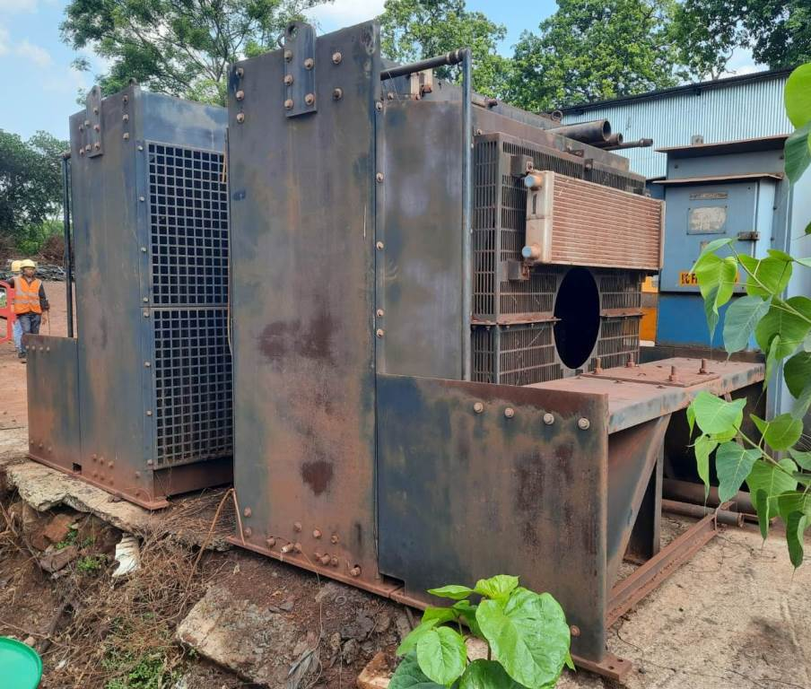
NIM-27-27
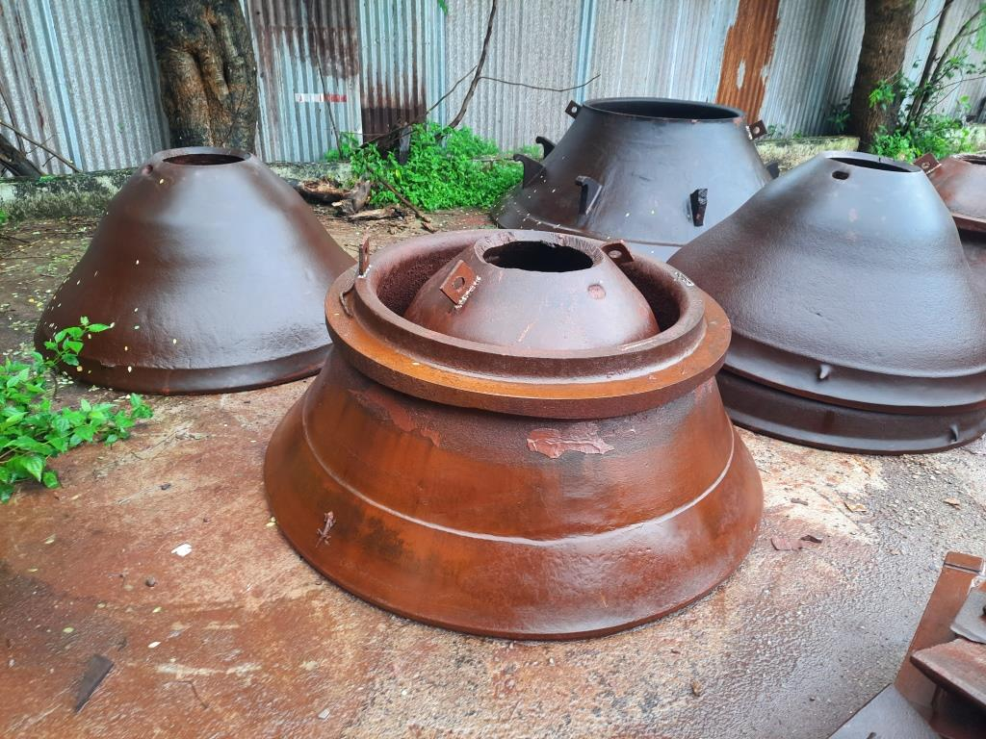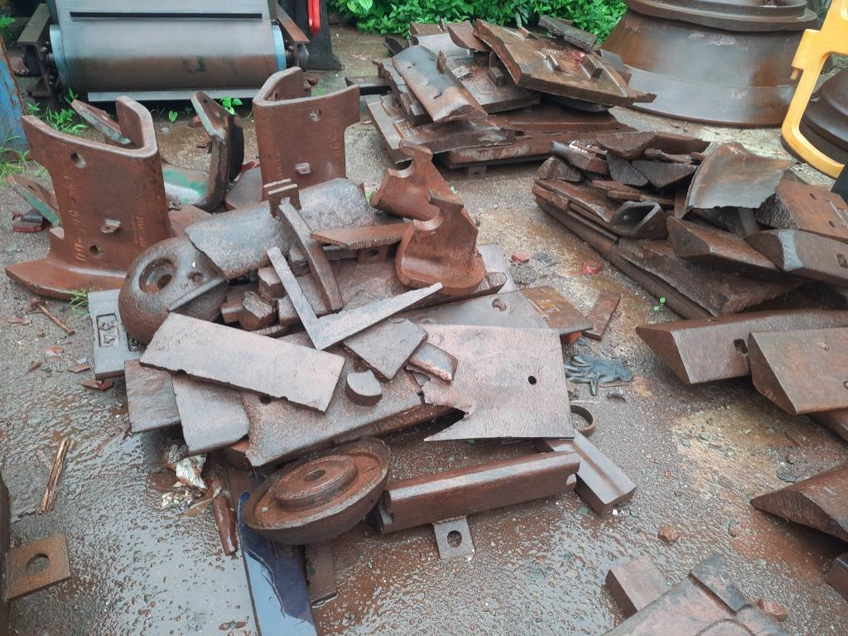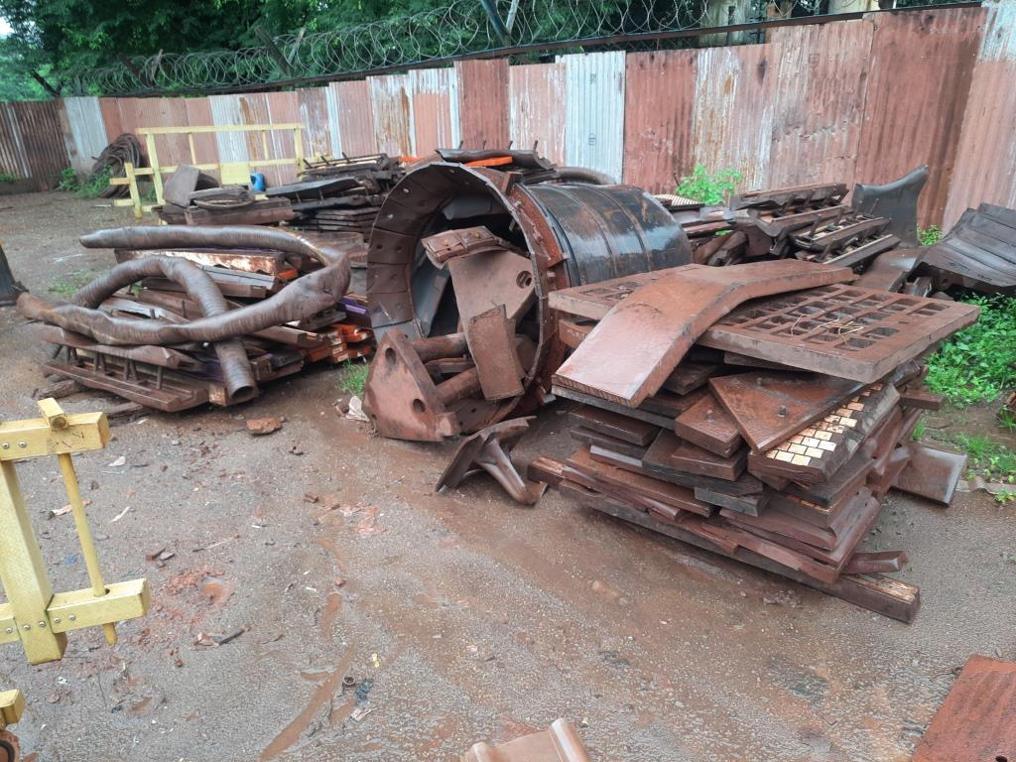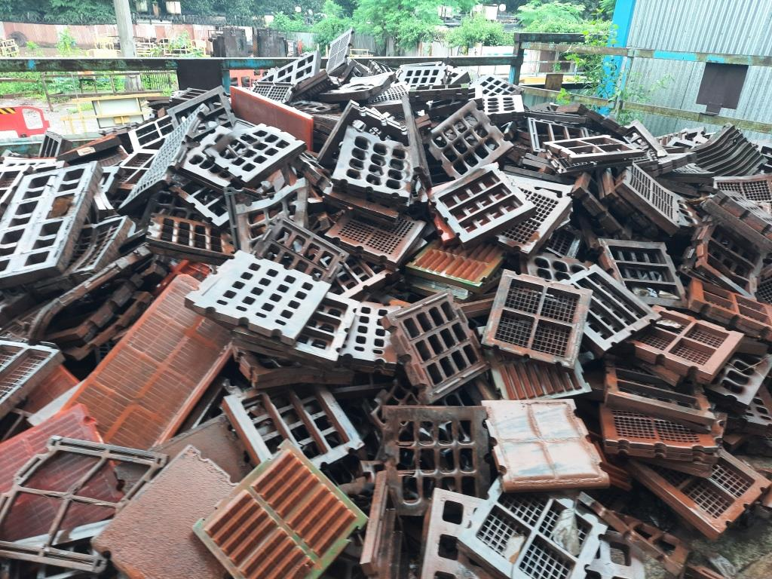
NIM-27-83 NIM-27-84 NIM-27-85 NIM-27-86
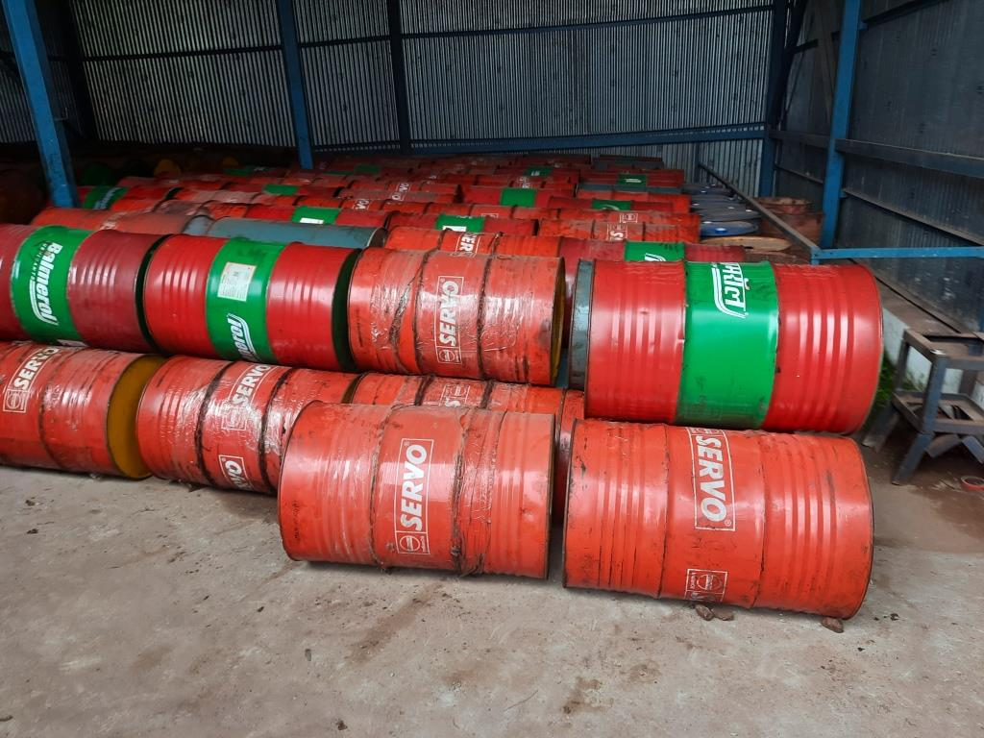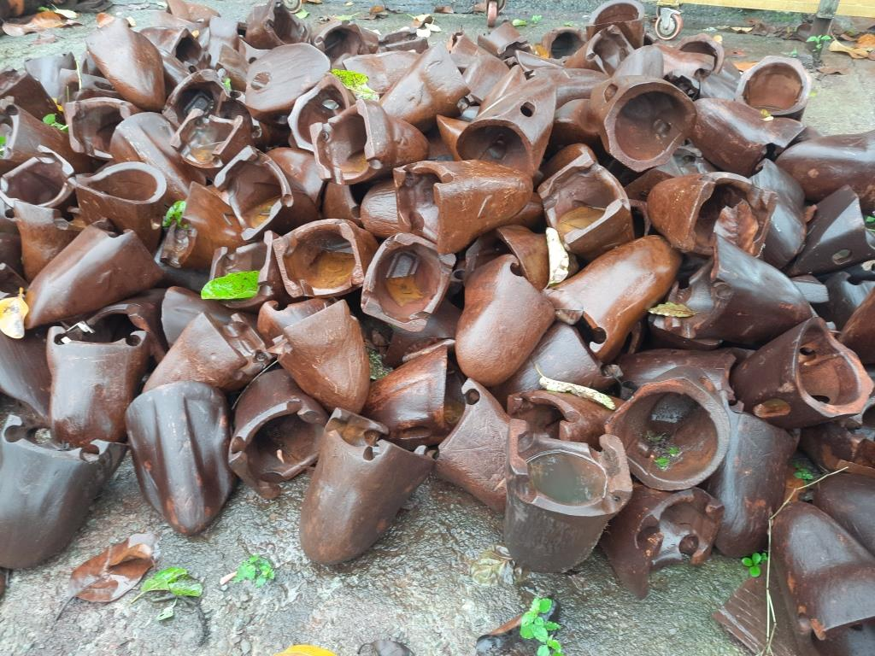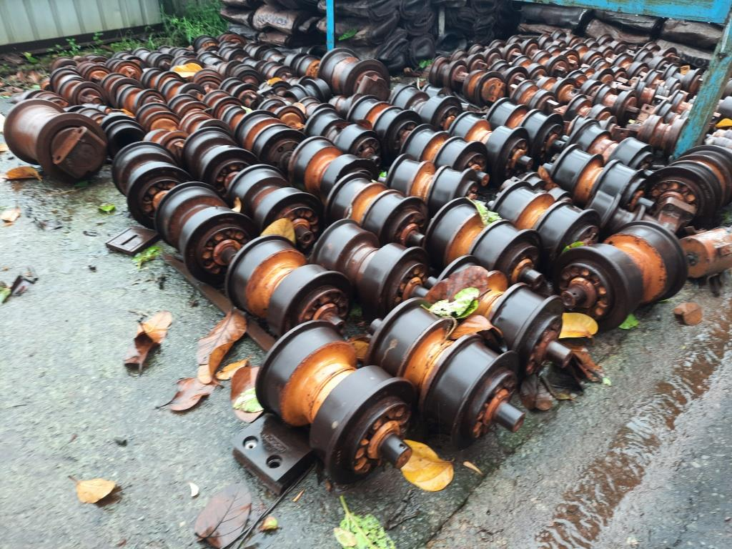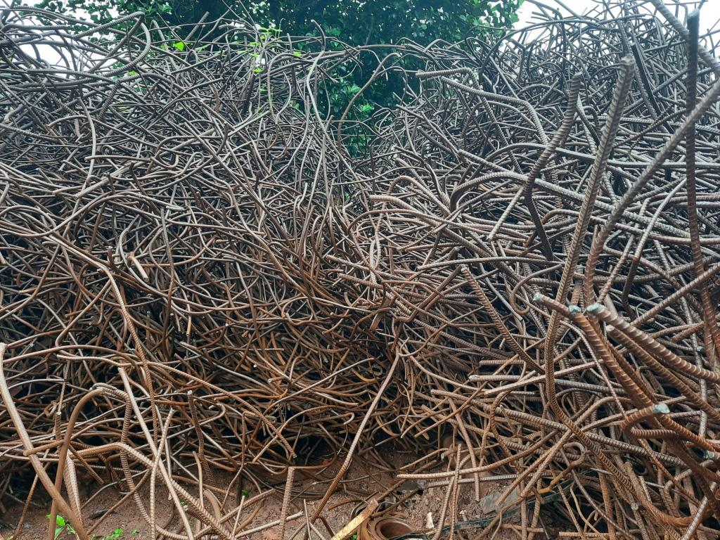
NIM-27-87 NIM-27-88 NIM-27-89 NIM-27-90
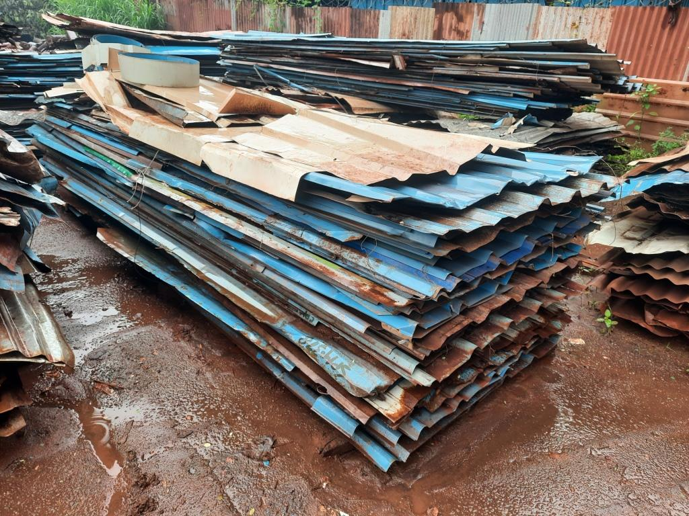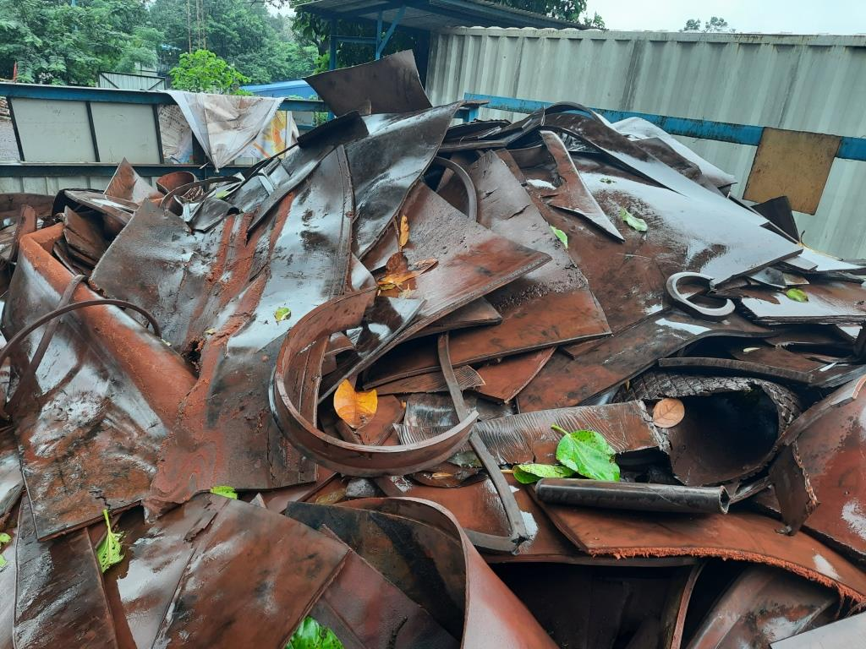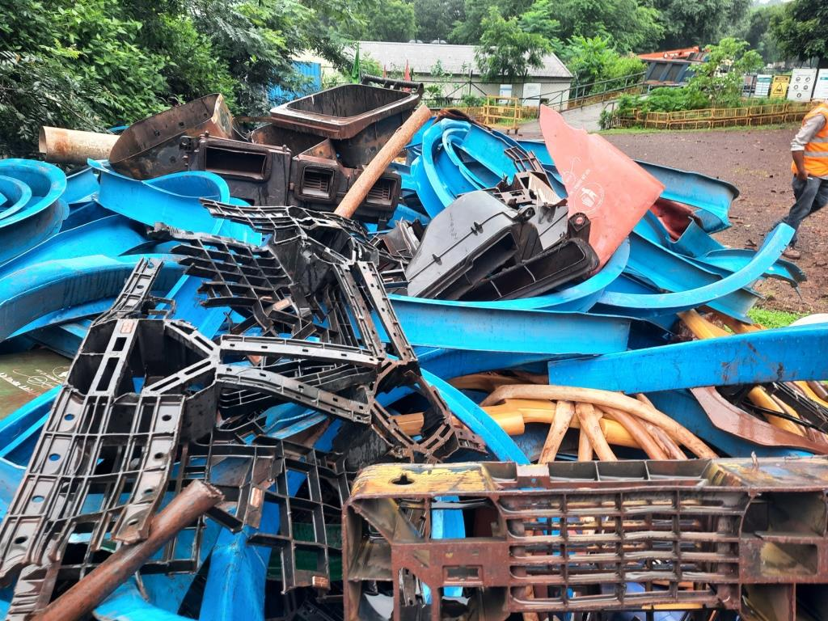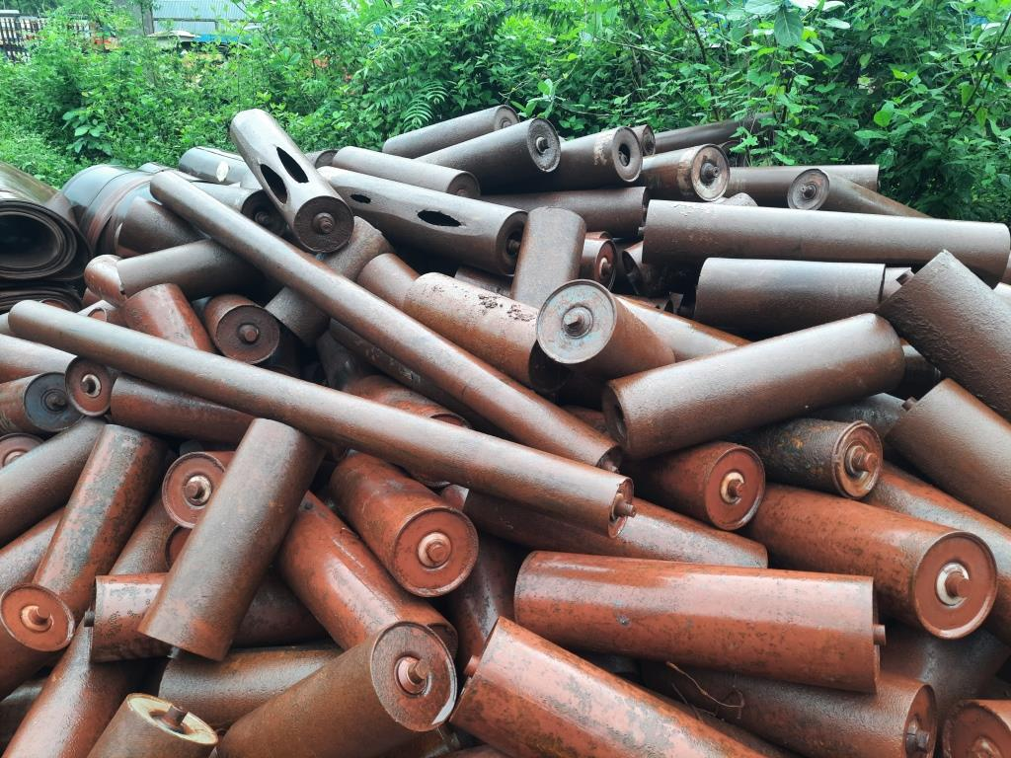
NIM-27-91 NIM-27-92 NIM-27-93 NIM-27-95
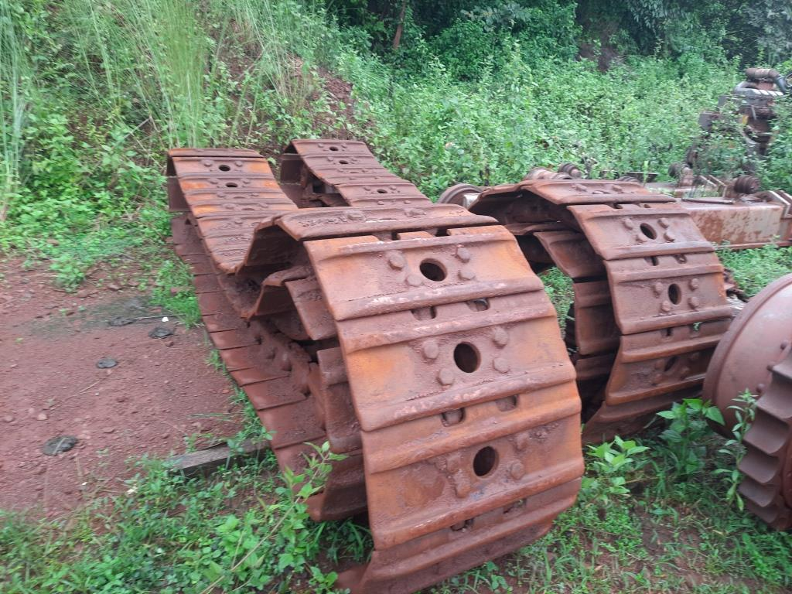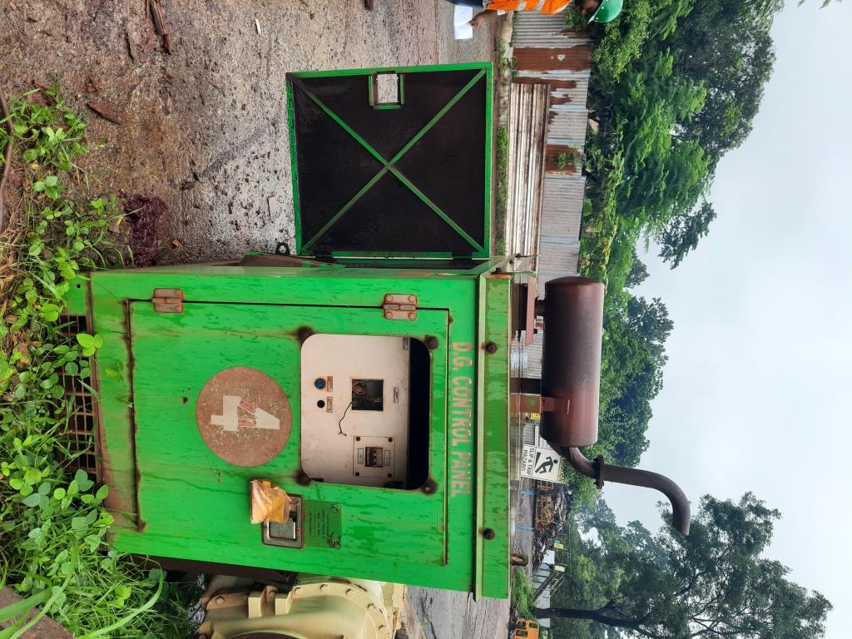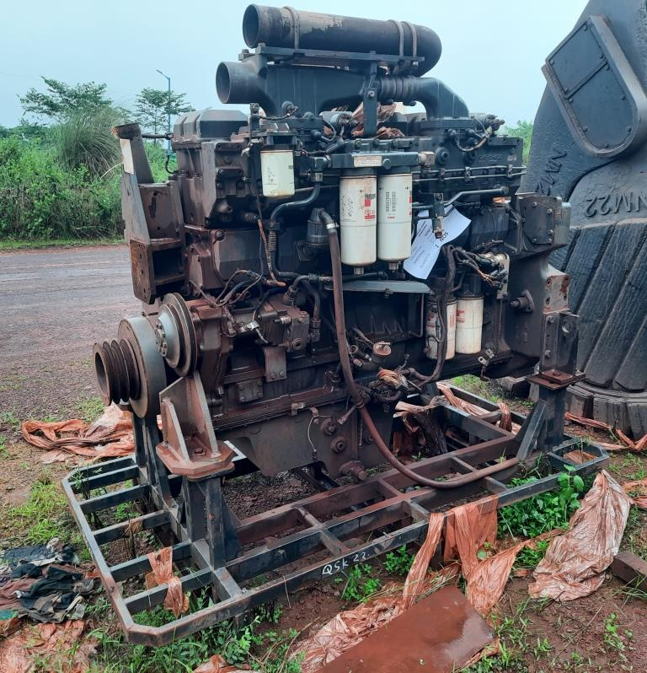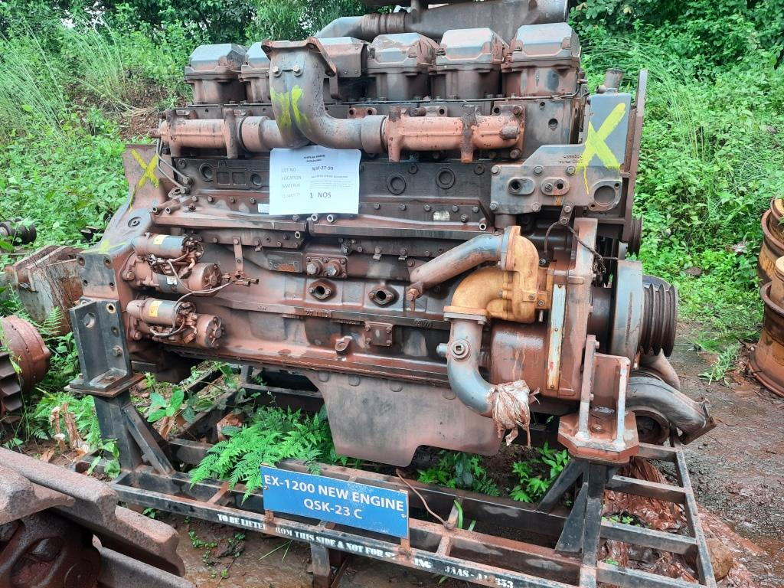
NIM-27-96 NIM-27-97 NIM-27-98 NIM-27-99
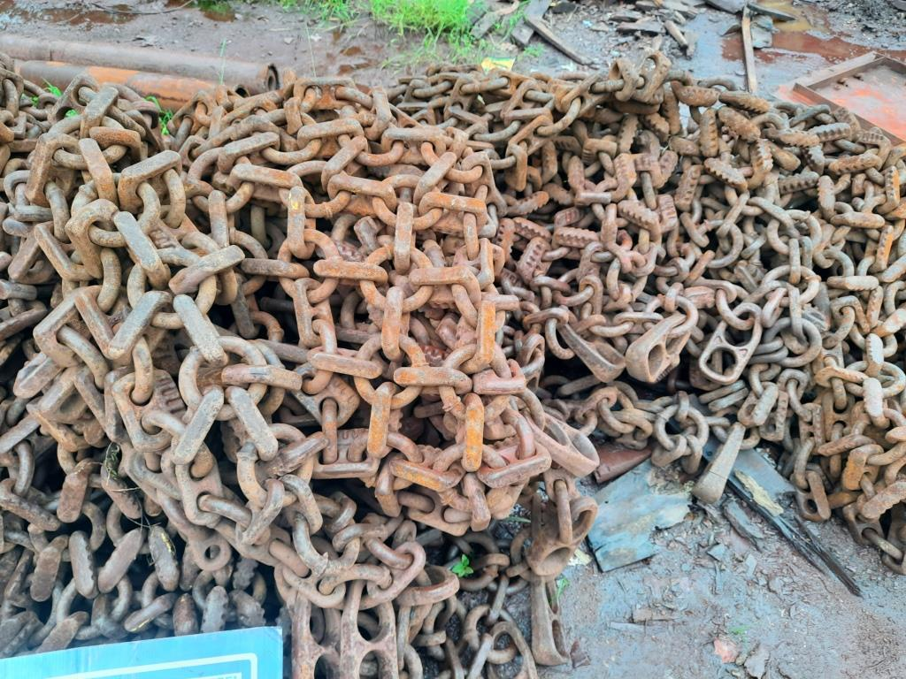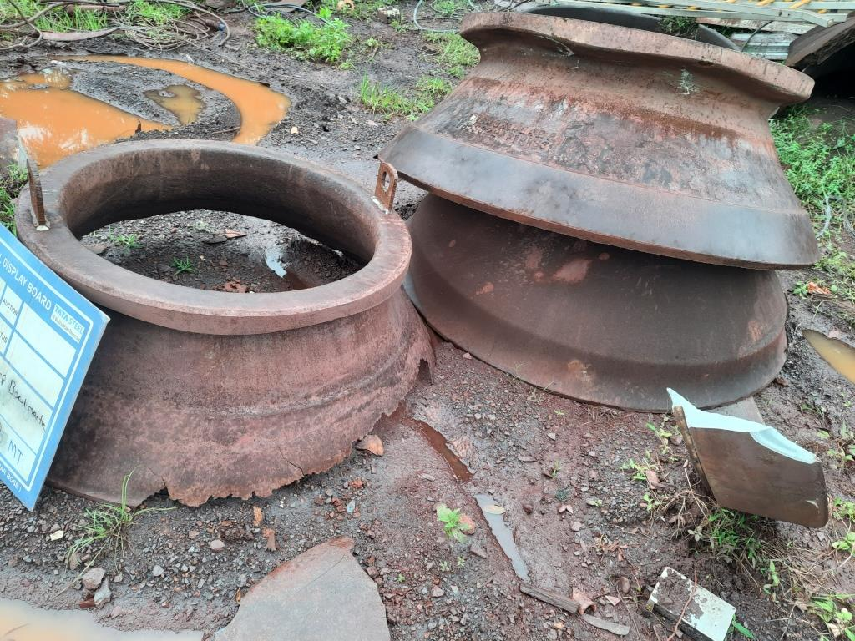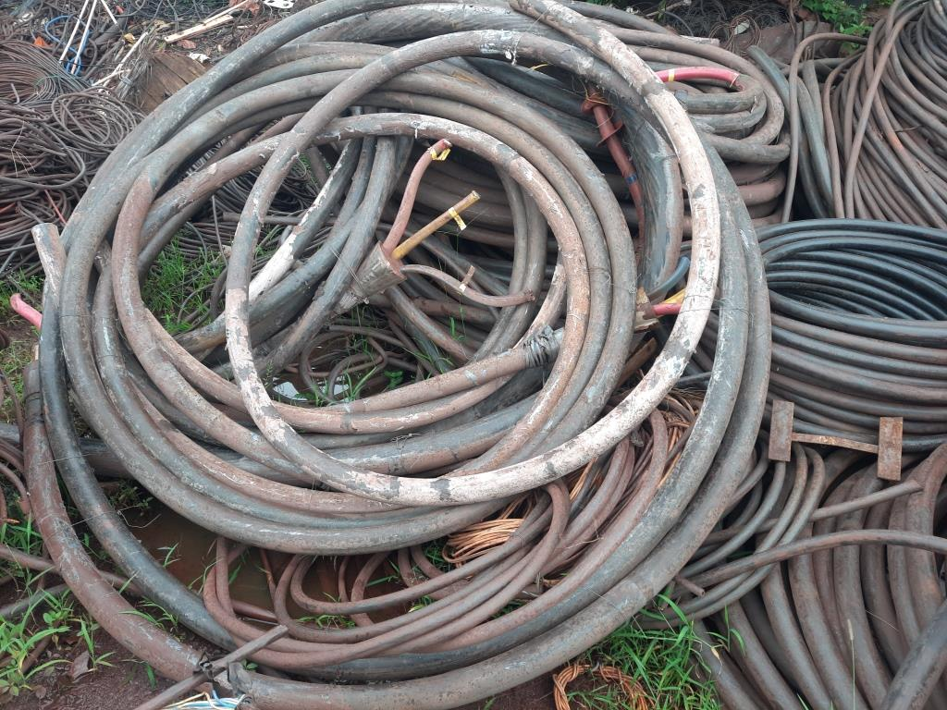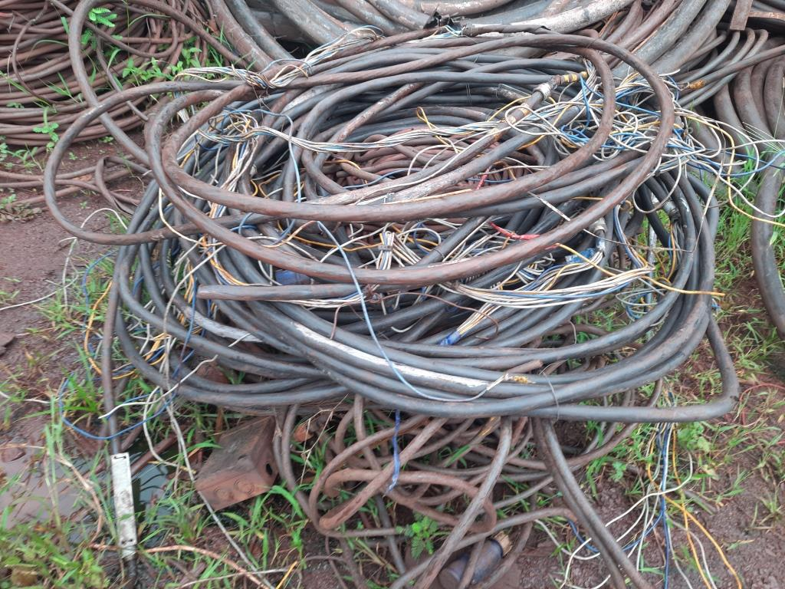
JIM-27-68 JIM-27-69 JIM-27-70 JIM-27-71
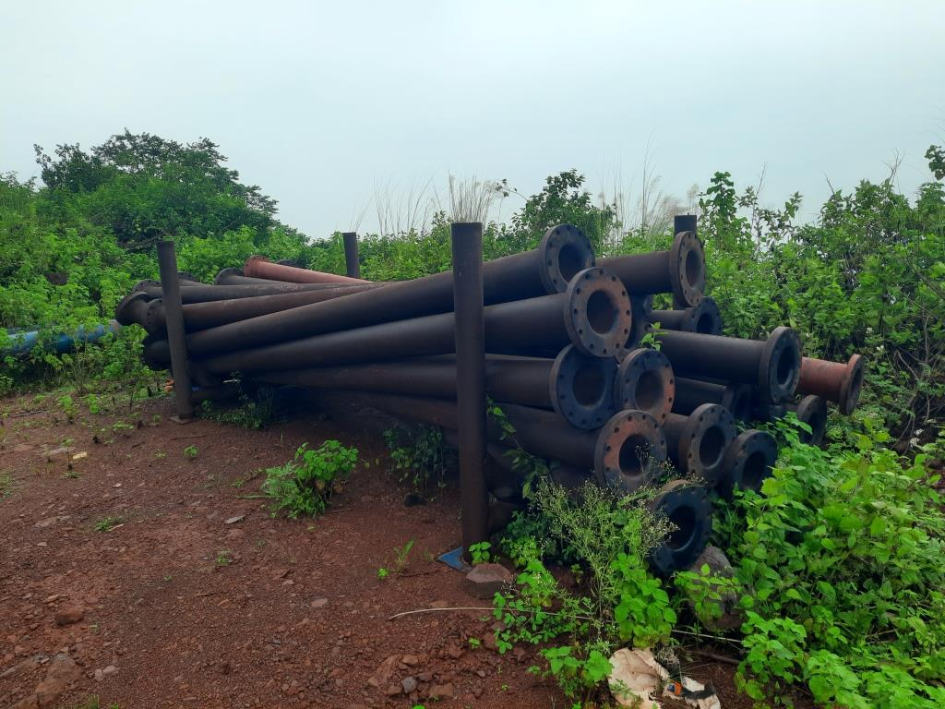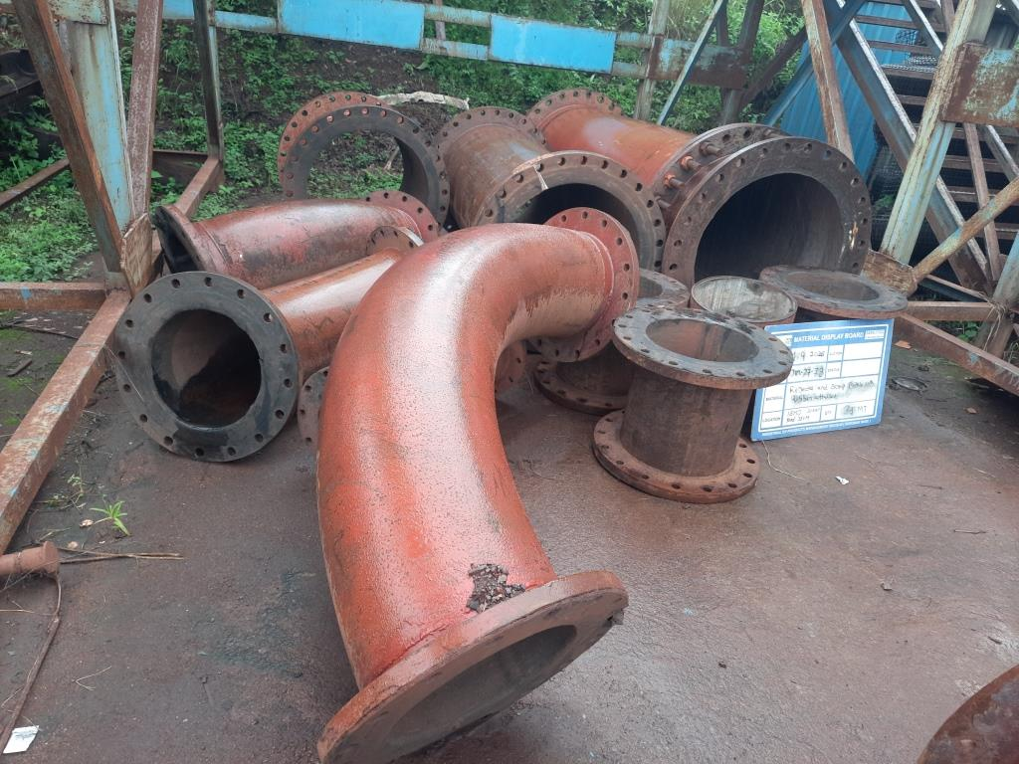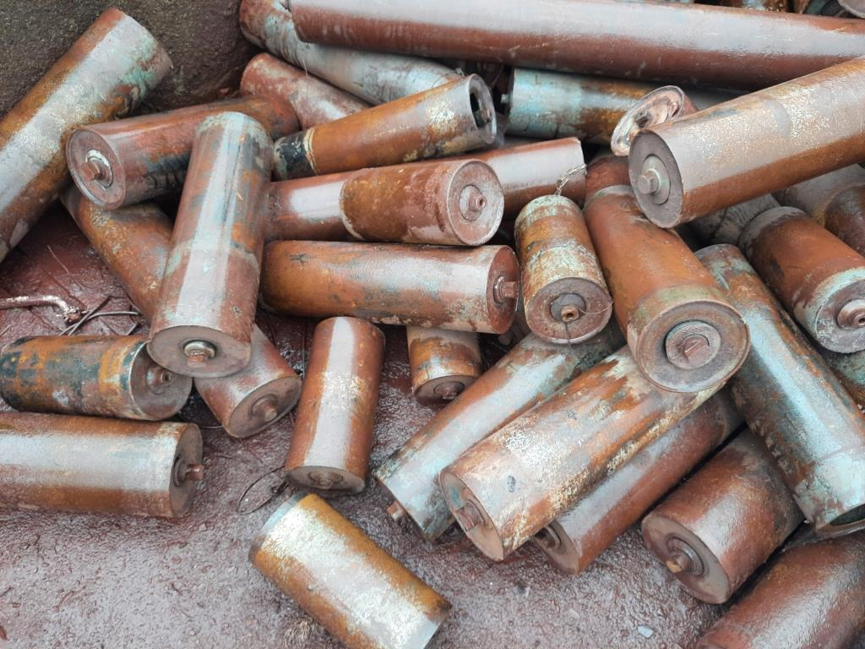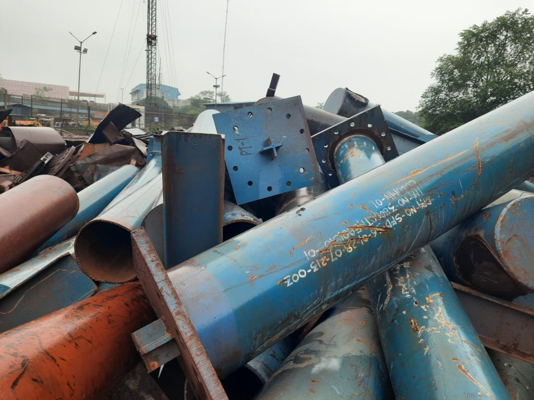
JIM-27-72 JIM-27-73 JIM-27-74 JIM-27-75
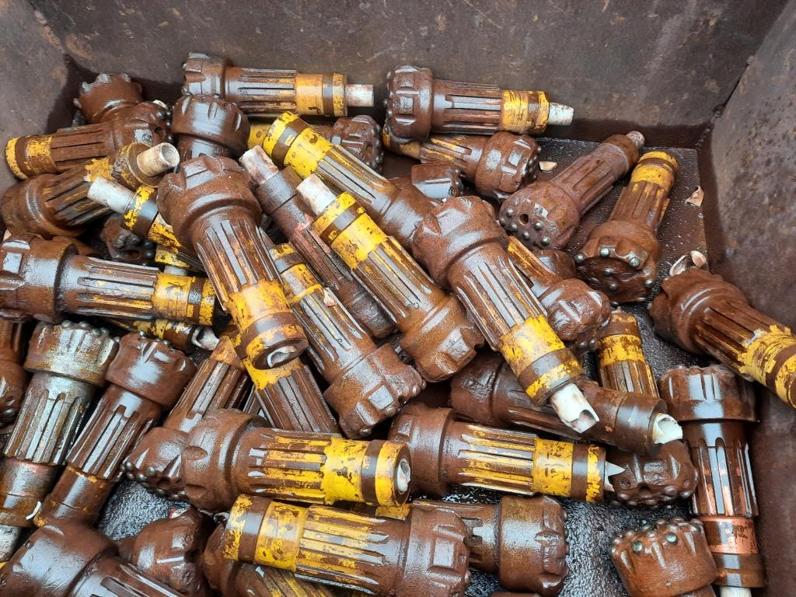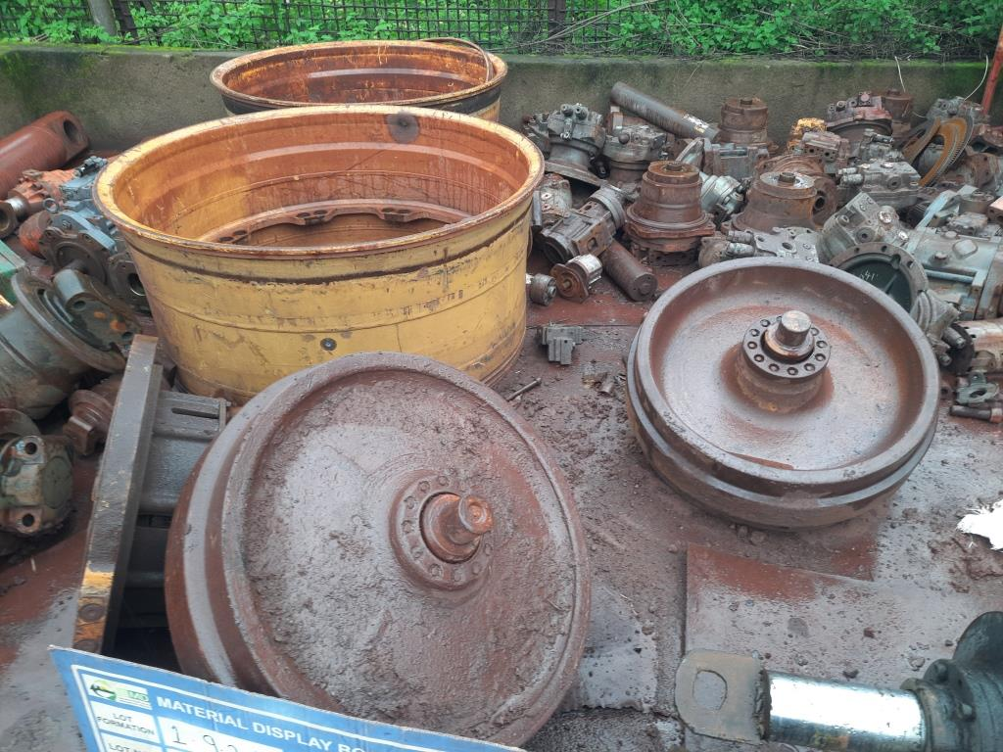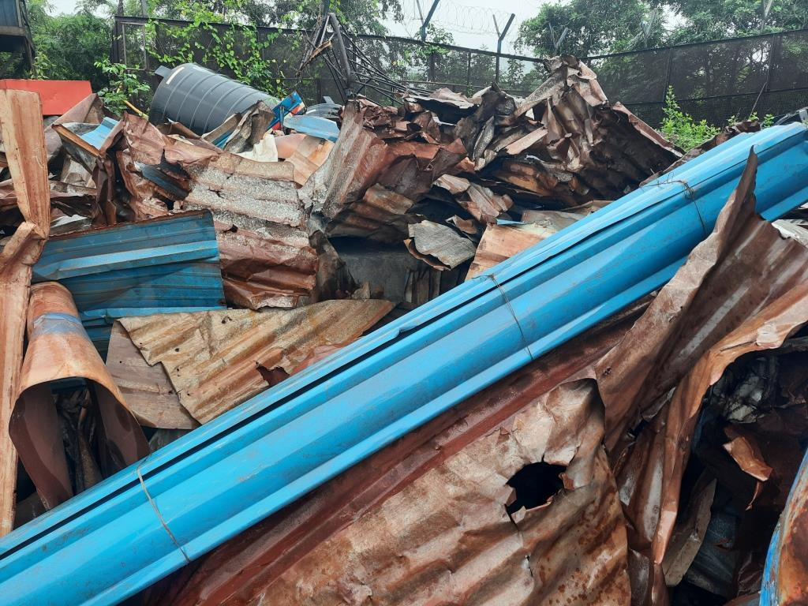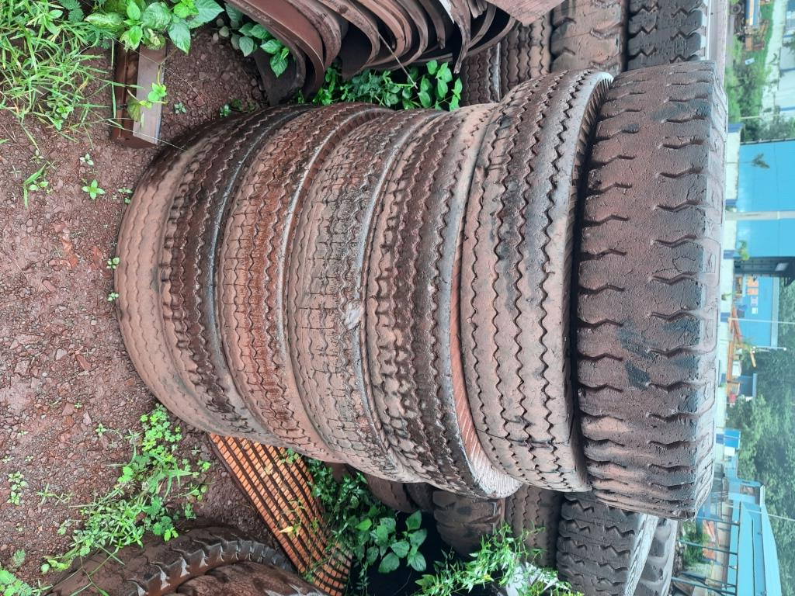
JIM-27-76 JIM-27-77 JIM-27-78 JIM-27-80
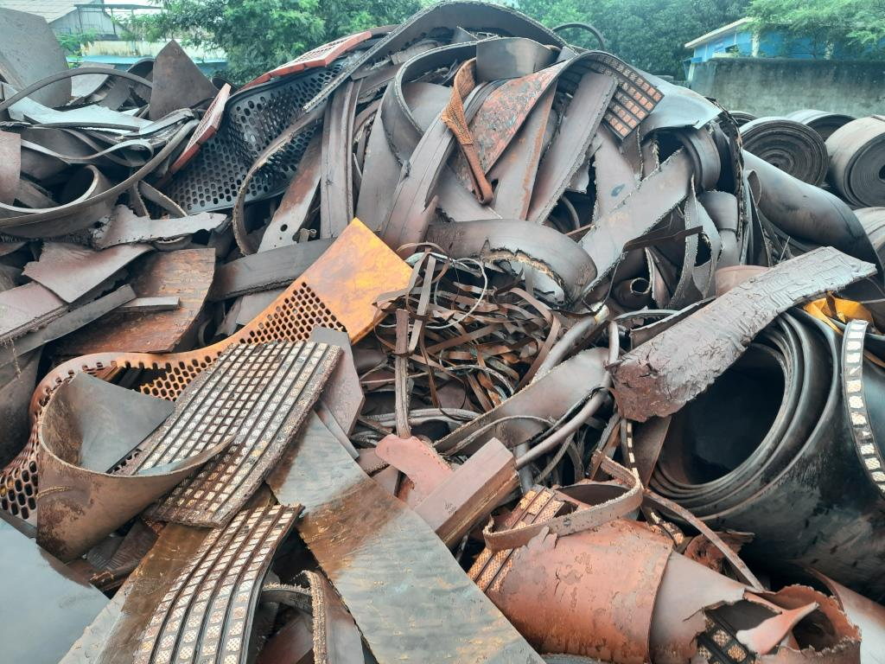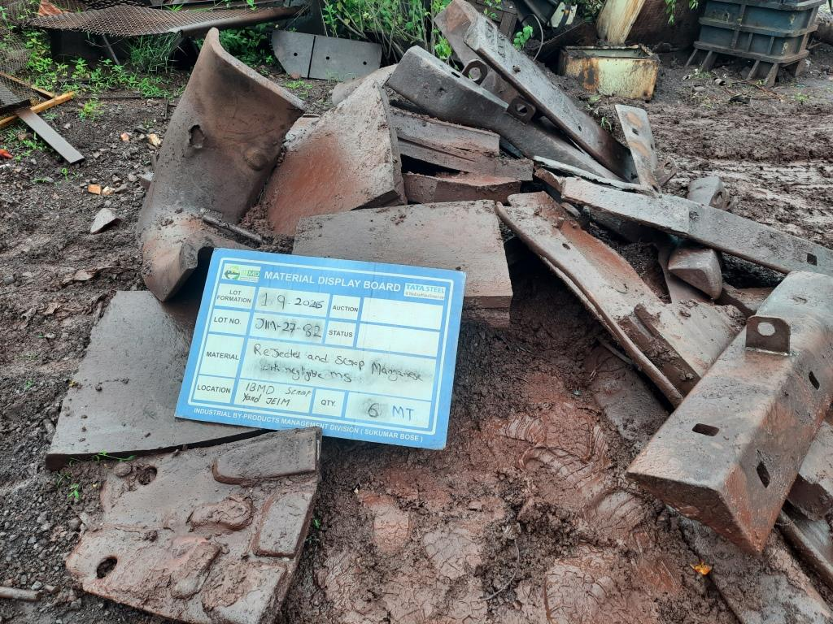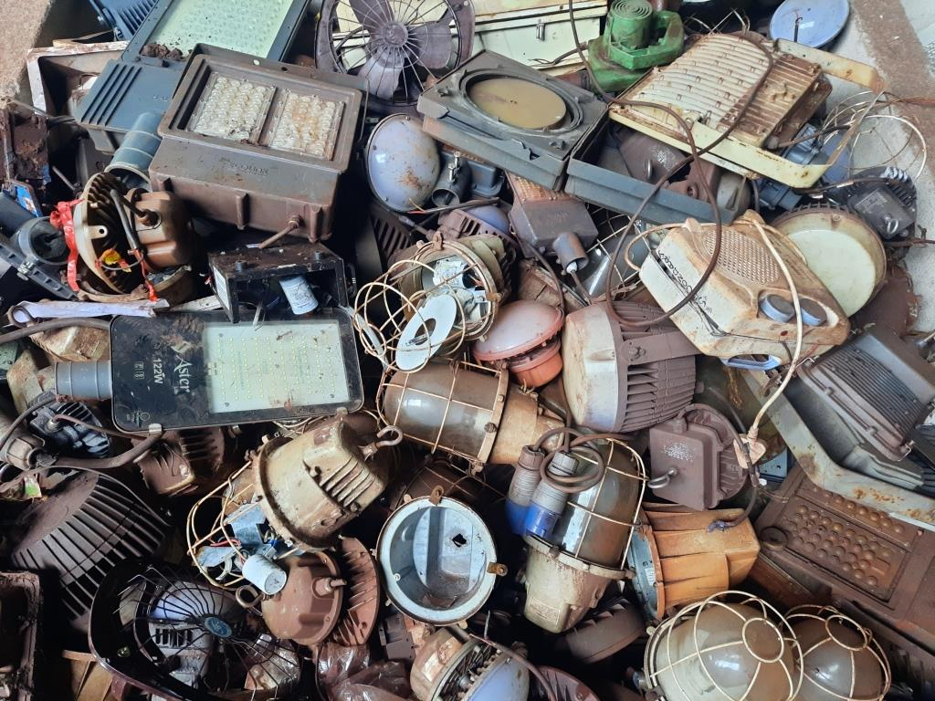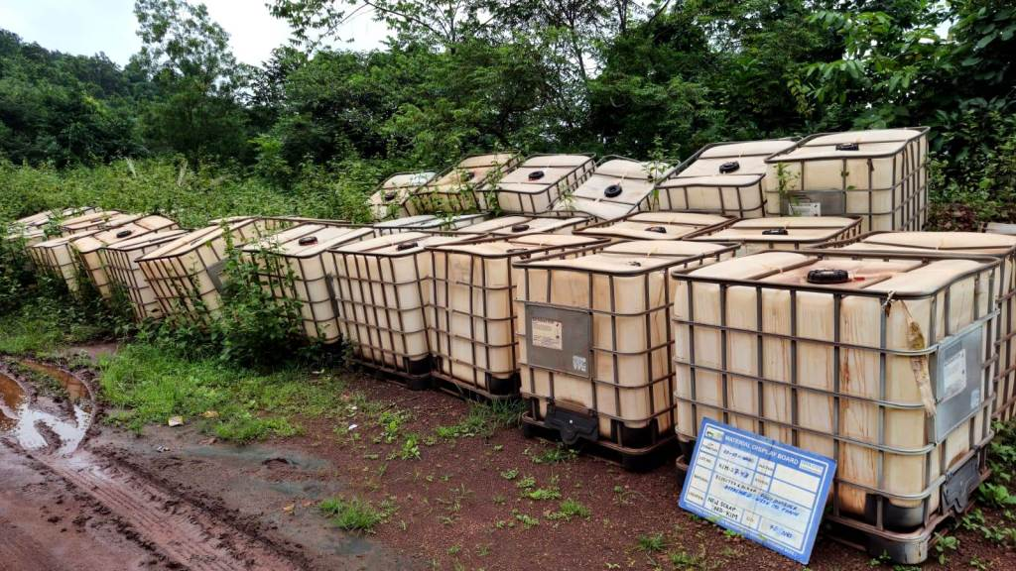
JIM-27-81 JIM-27-82 JIM-27-83 KIM-27-43
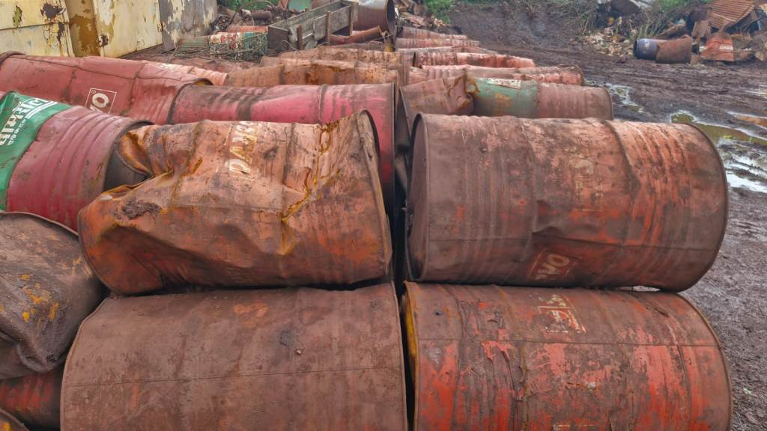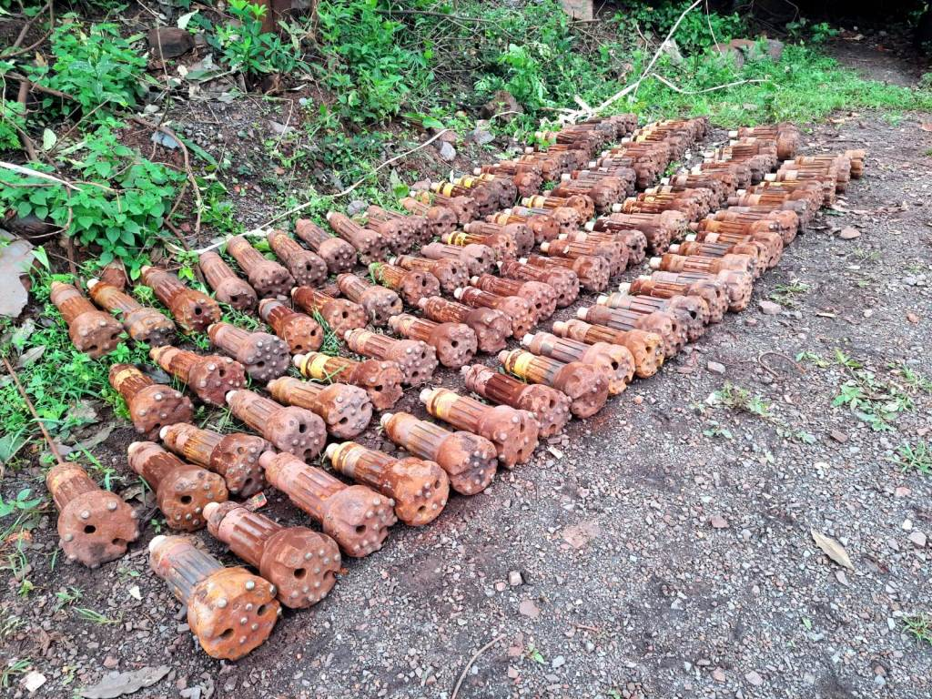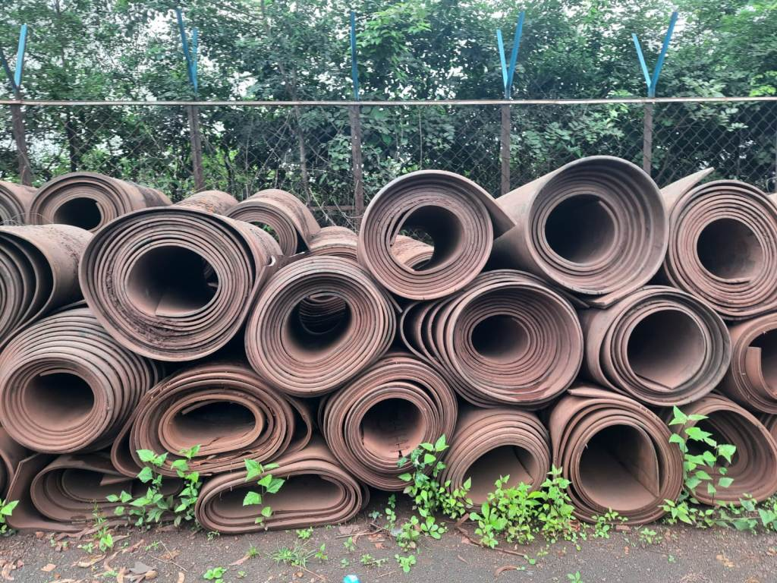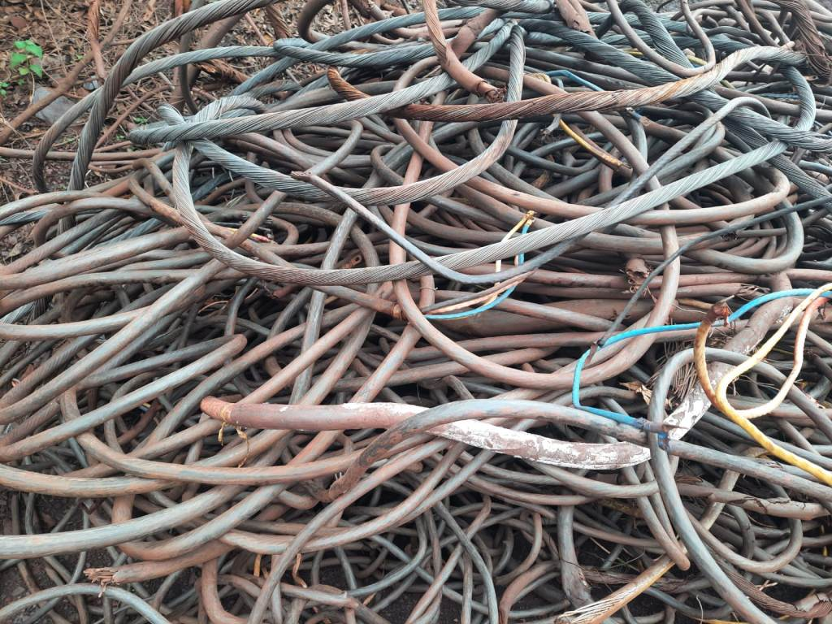
KIM-27-45 KIM-27-46 KIM-27-47 KIM-27-48
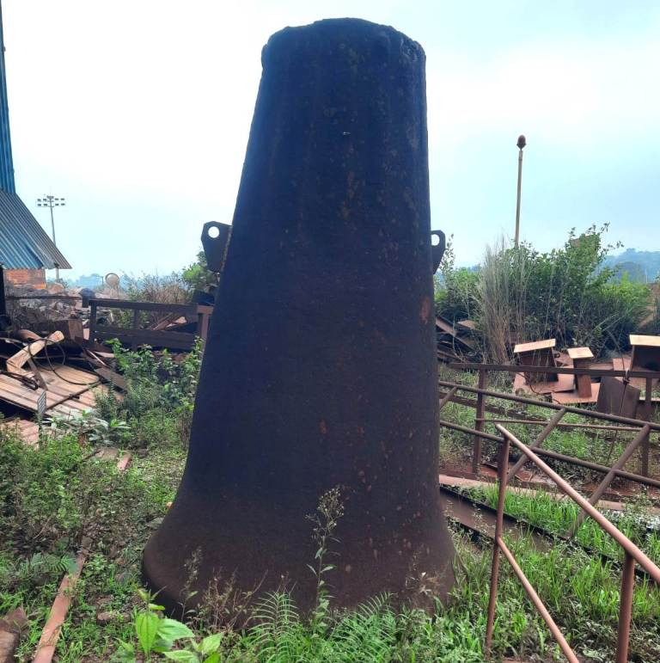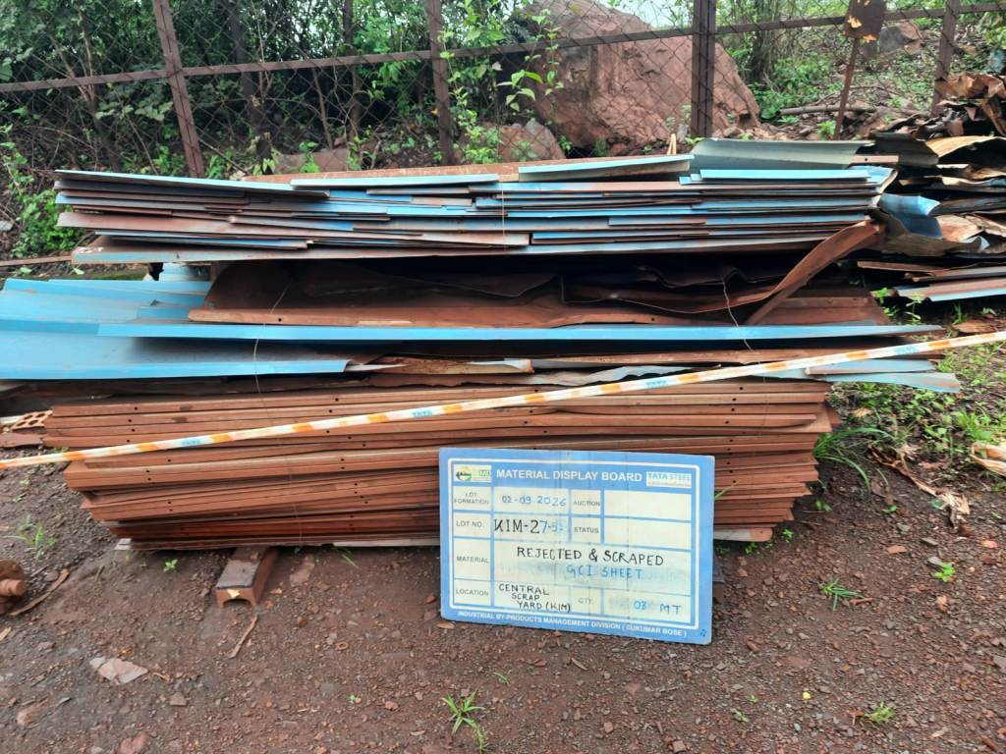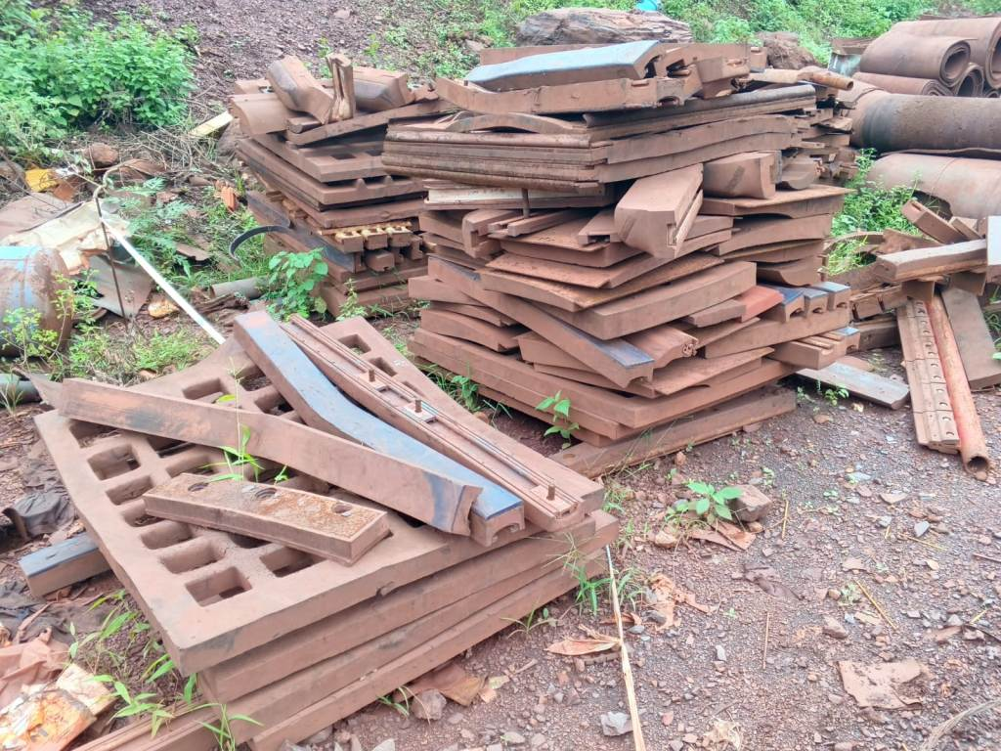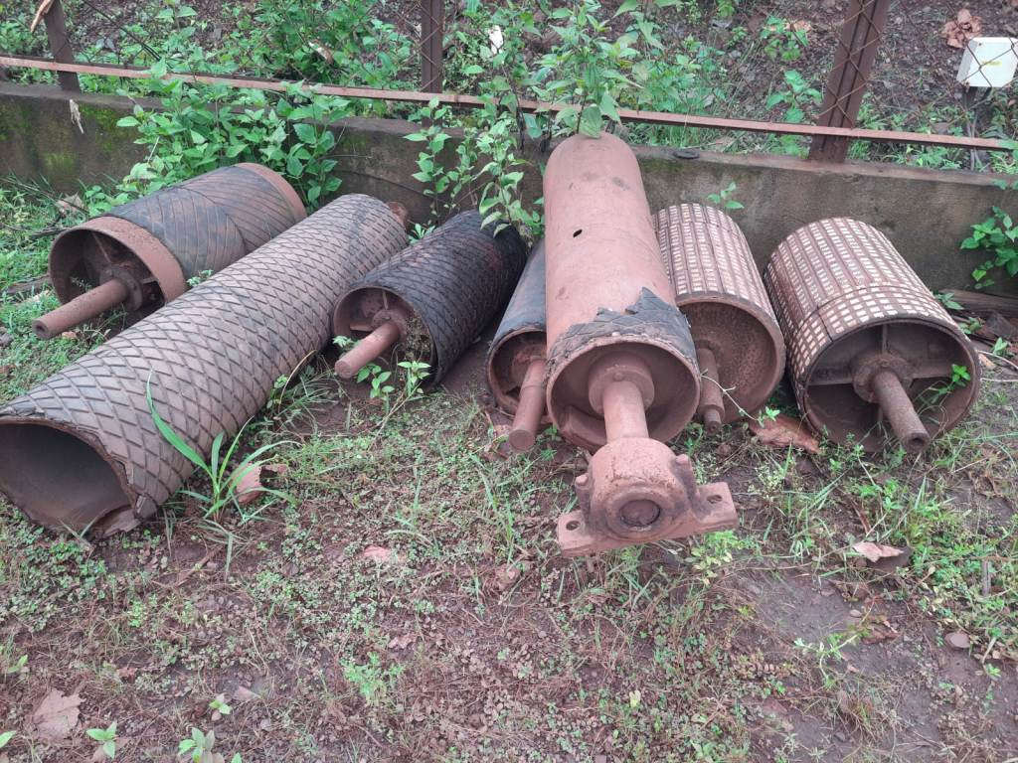
KIM-27-50 KIM-27-51 KIM-27-52 KIM-27-53
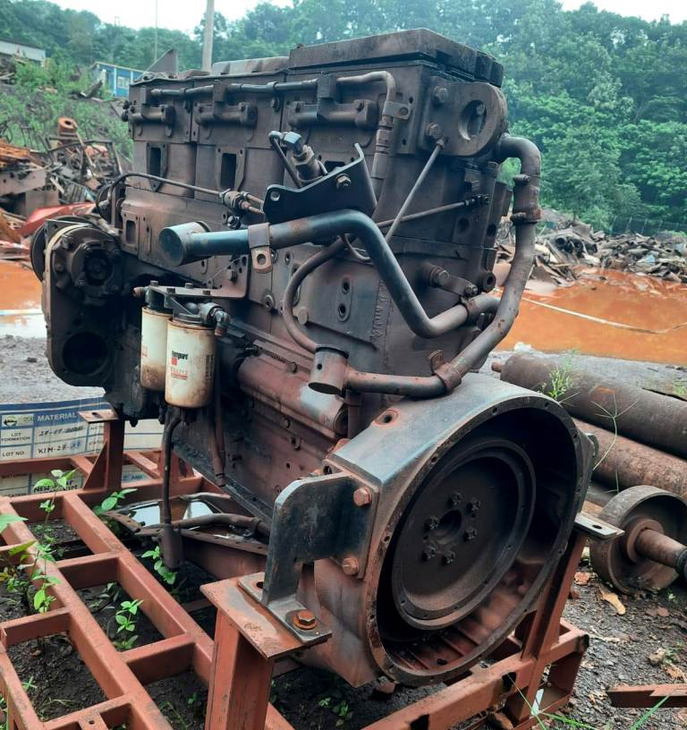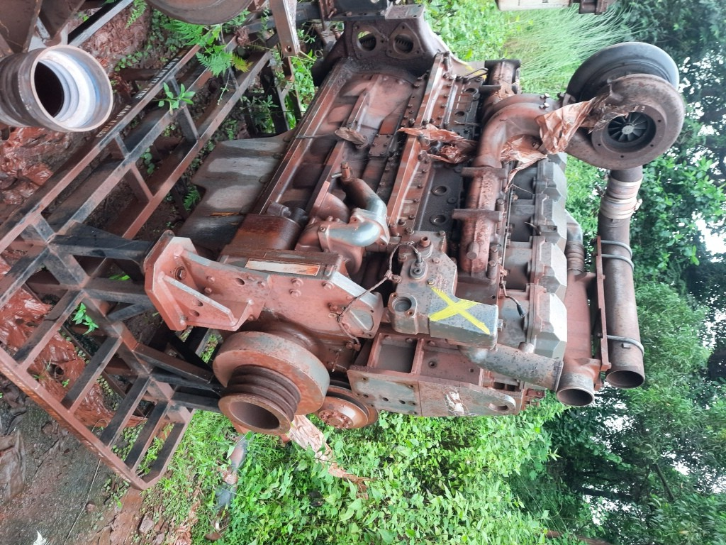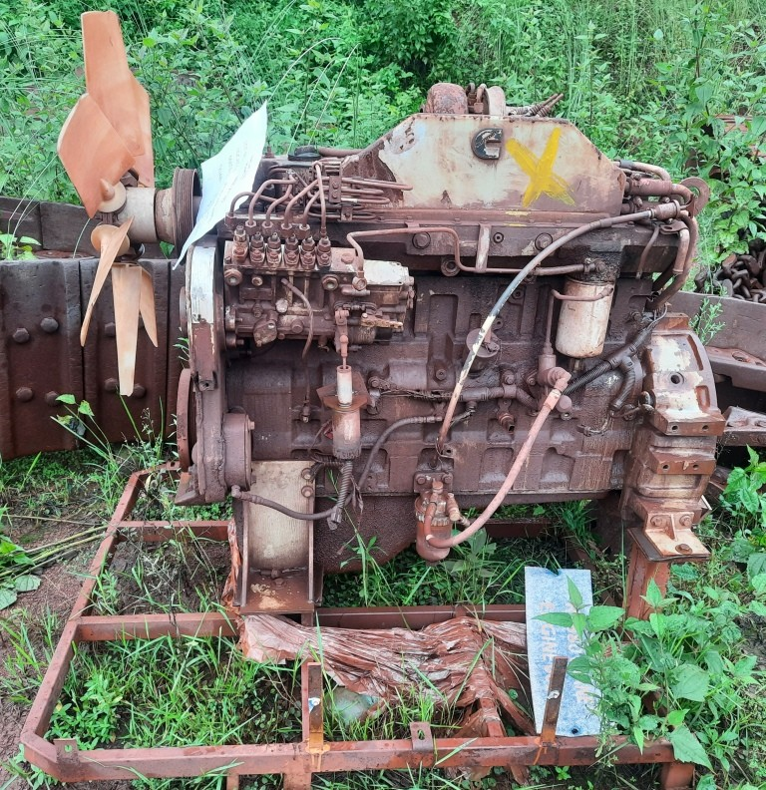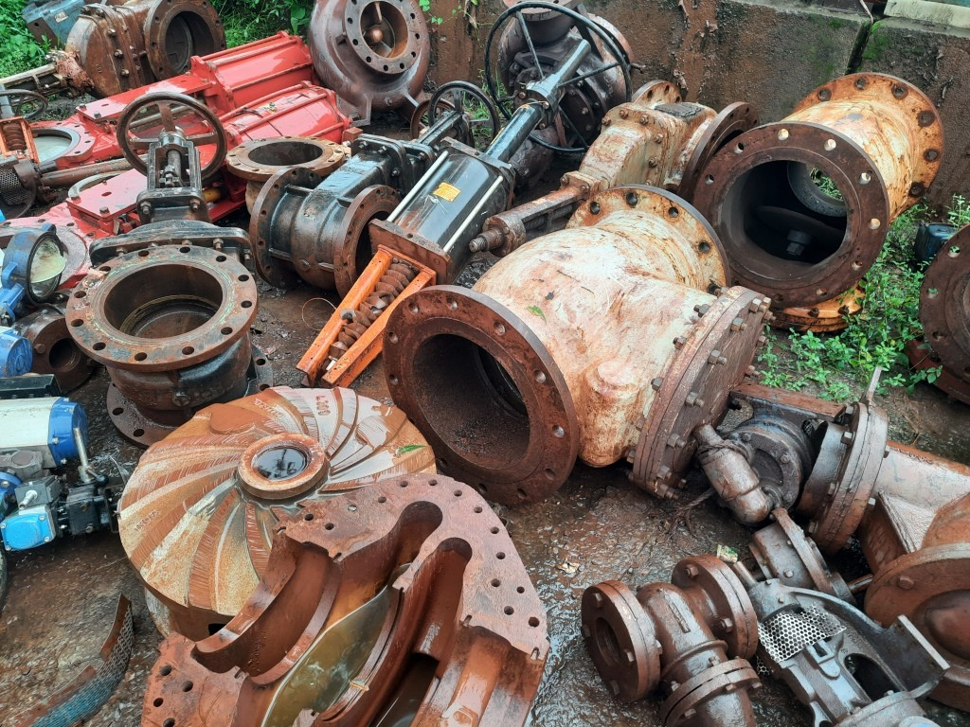
KIM-27-54 NIM-27-100 NIM-27-101 NIM-27-102
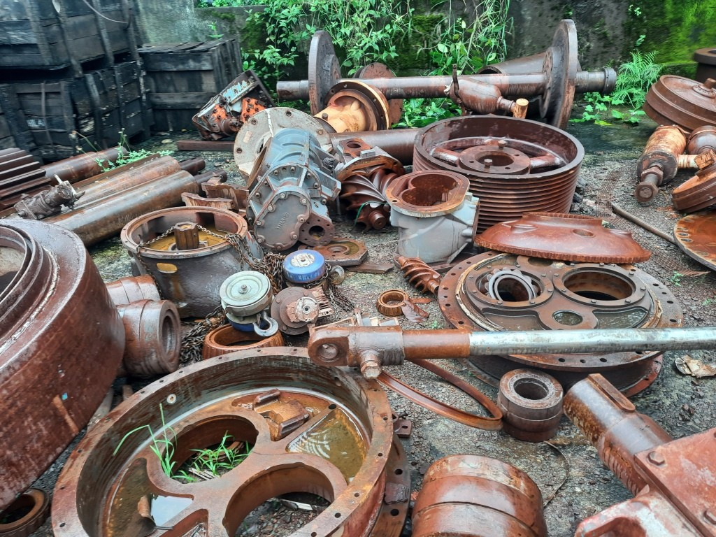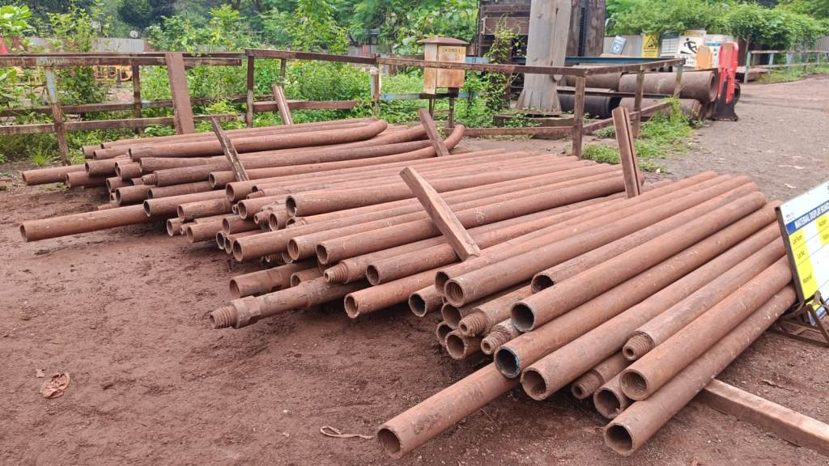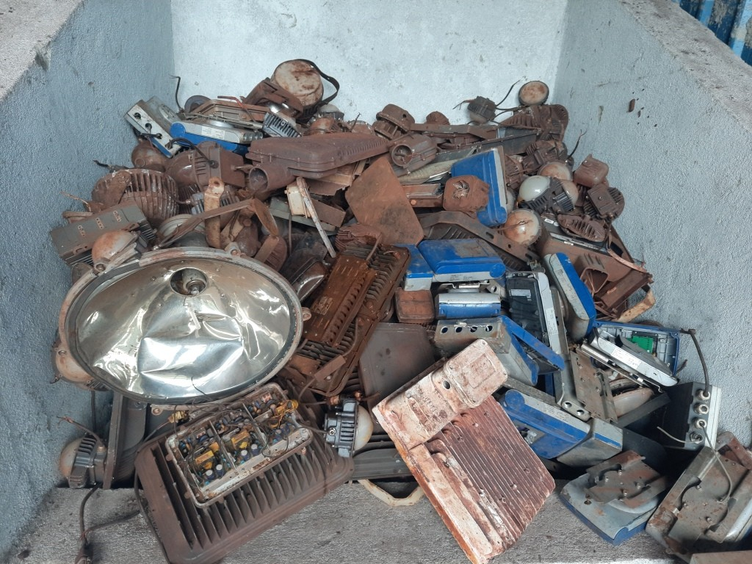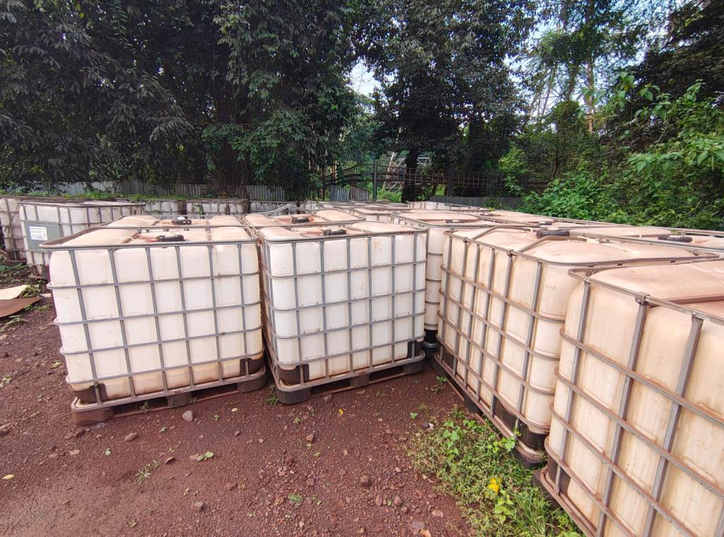
NIM-27-104 NIM-27-105 NIM-27-106 NIM-27-107
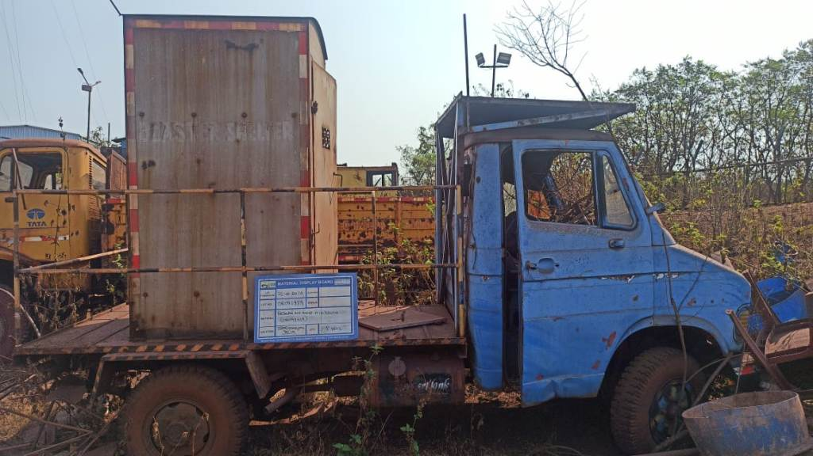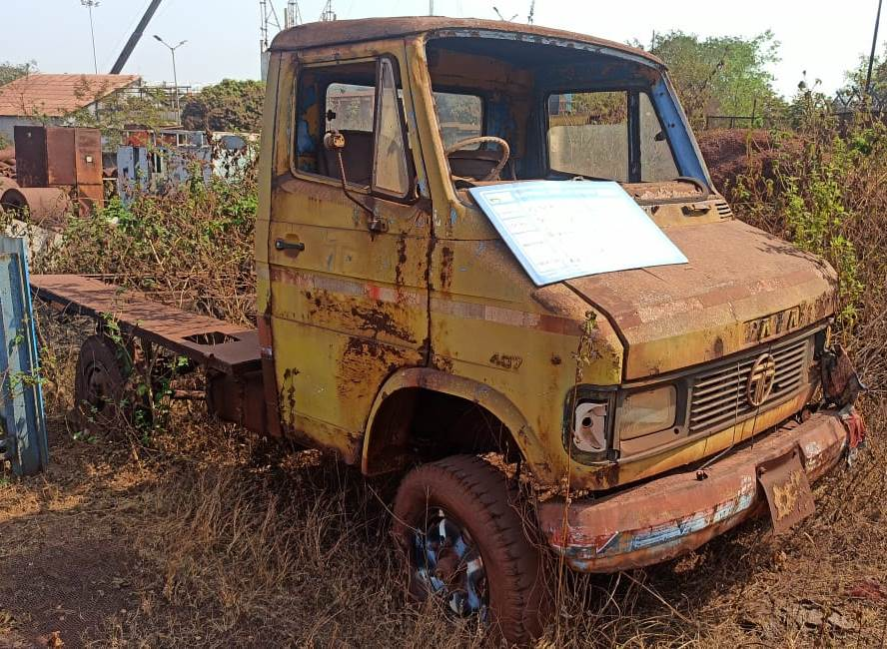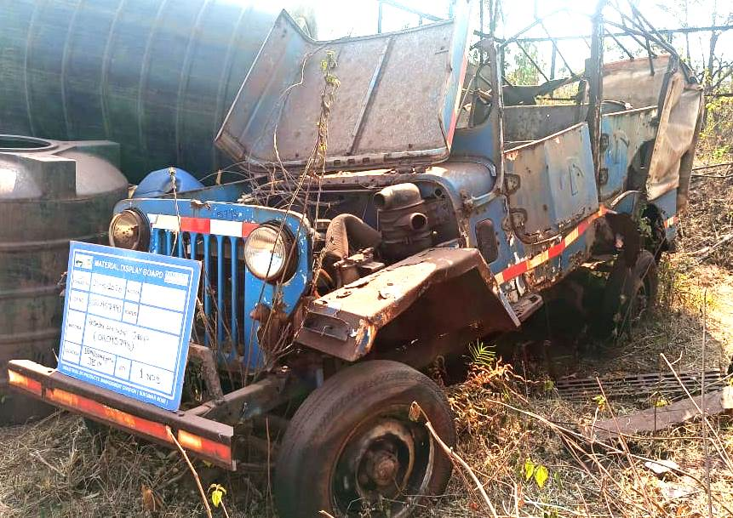
OR092419(Blaster shed will be removed) ORN8659 OR095798
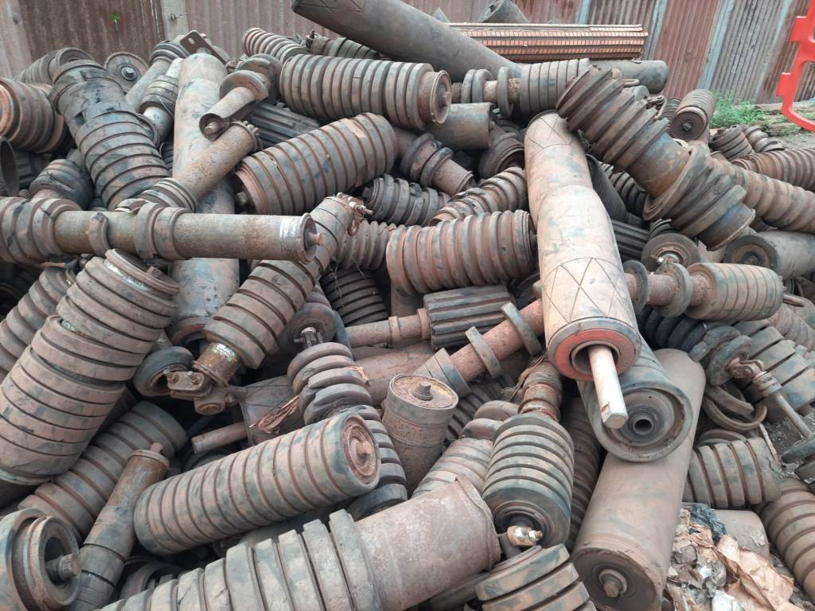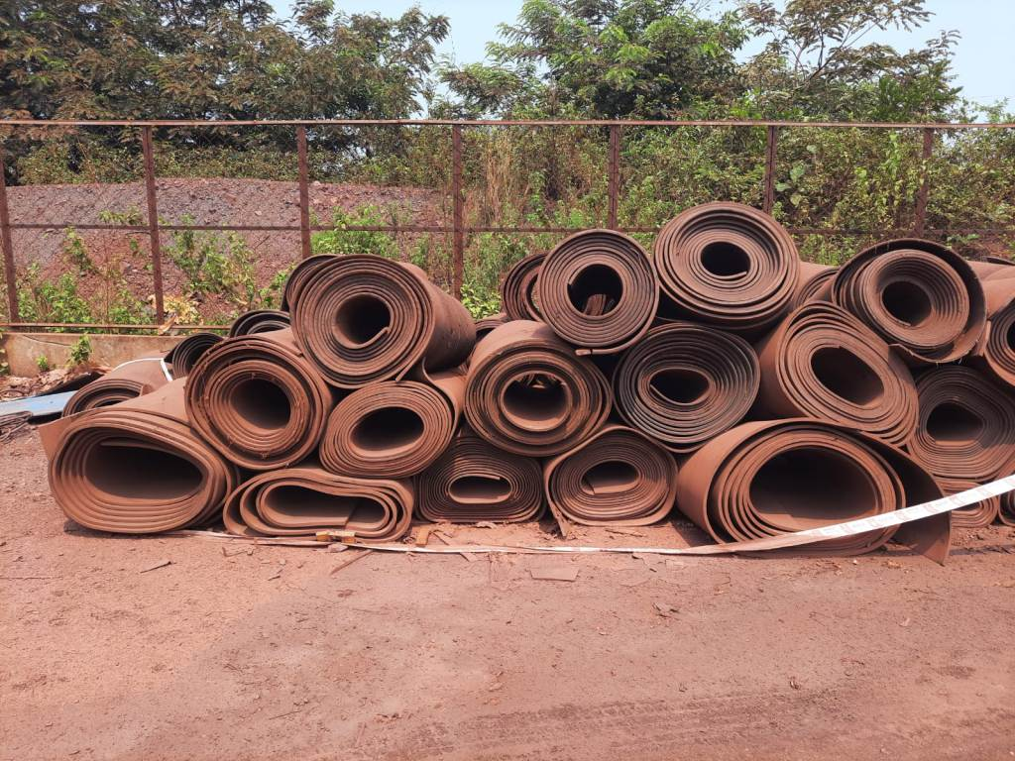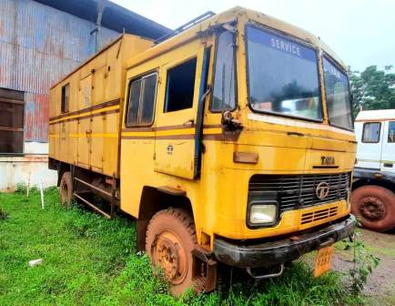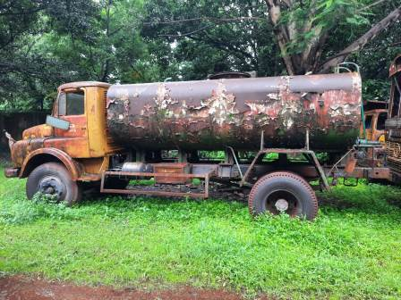
NIM-27-44 KIM-27-05 JH06A9253 KA09-3950
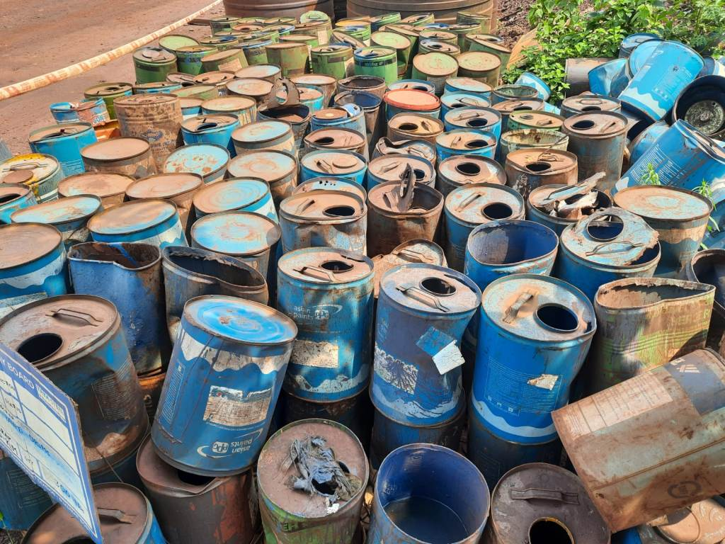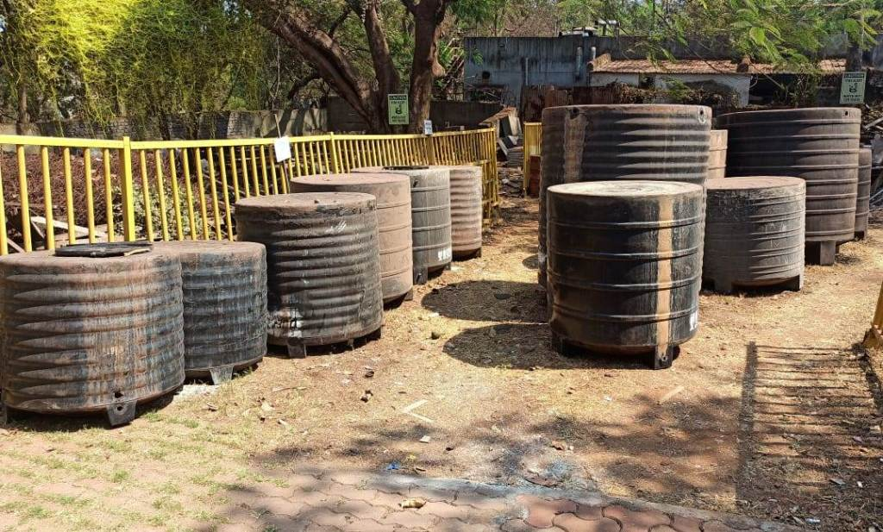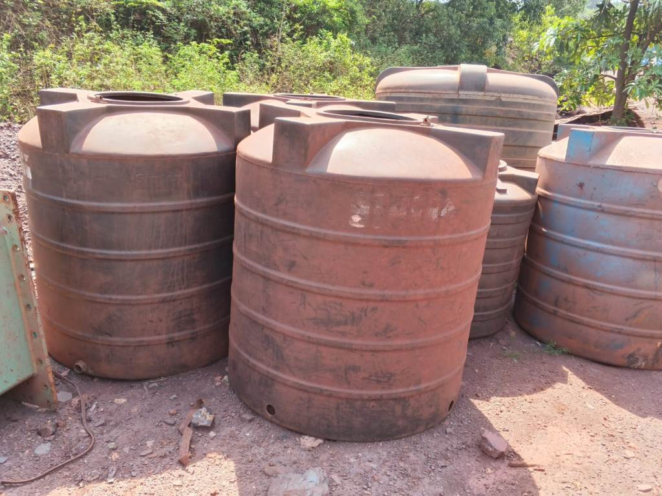
KIM-27-26 JIM-27-18 KIM-27-01
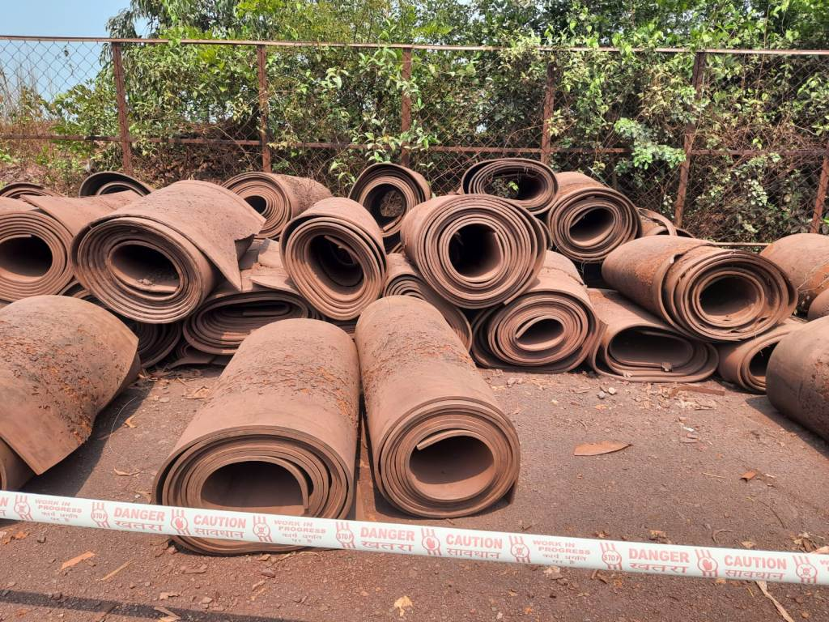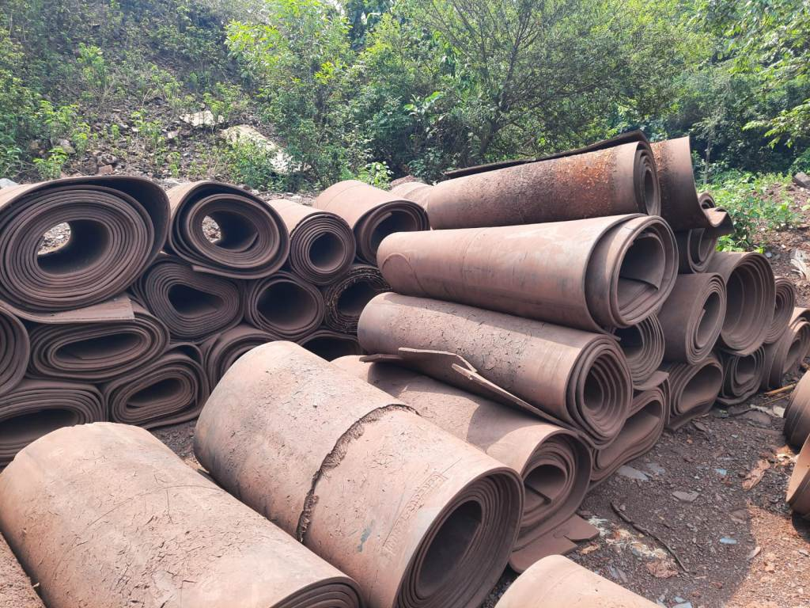
KIM-27-27 KIM-27-28
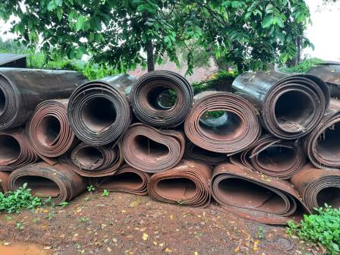 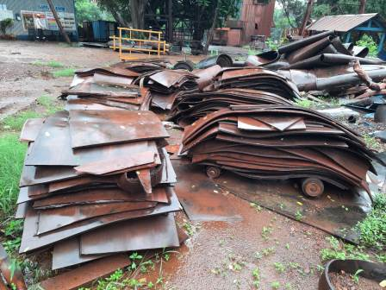 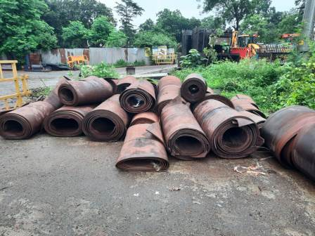 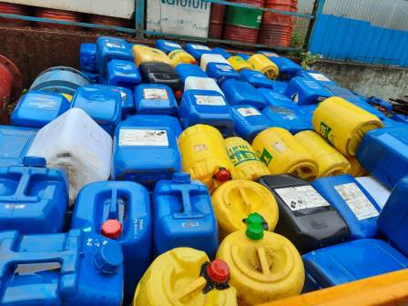 NIM-27-67 NIM-27-68 NIM-27-74 NIM-27-76
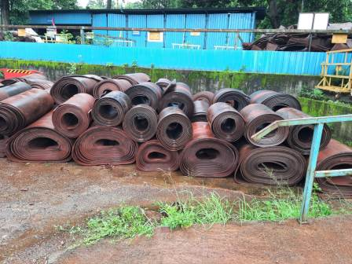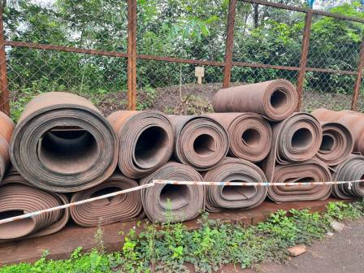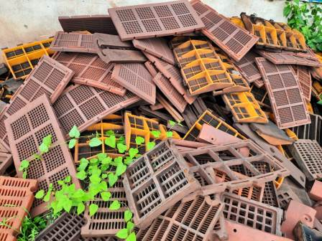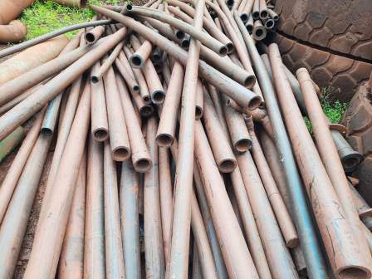
NIM-27-78 KIM 27-42 JIM-27-58 JIM-27-65
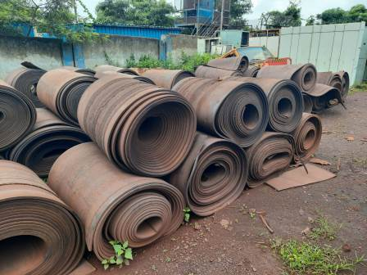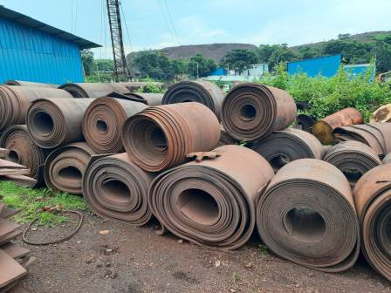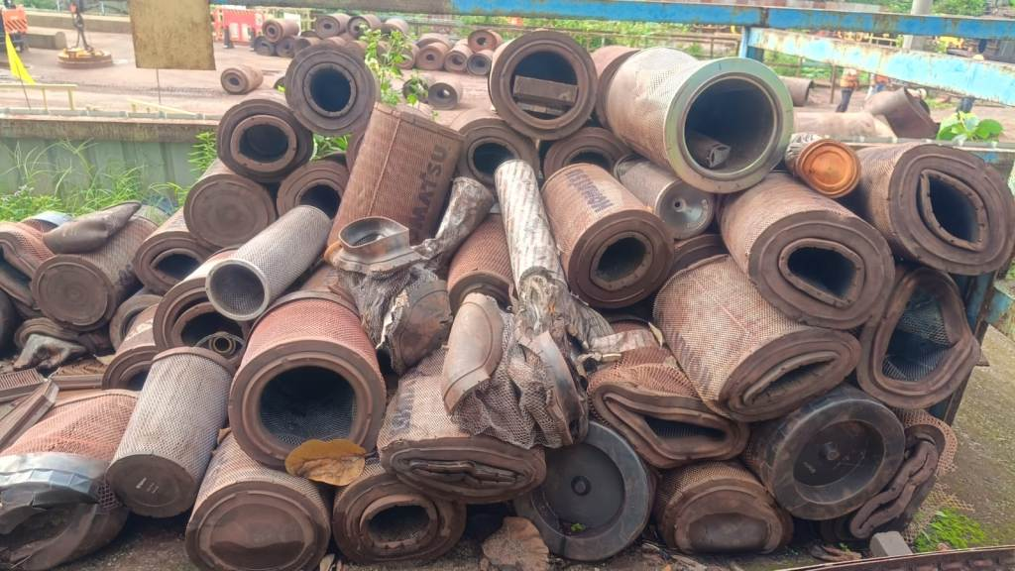
JIM-27-53 JIM-27-56 NIM-27-71
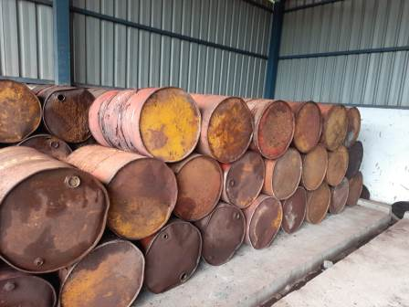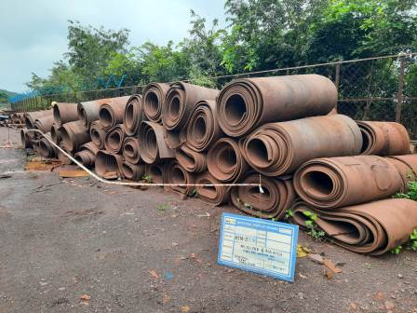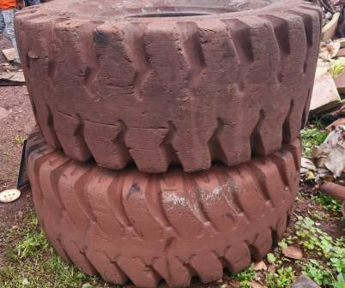
JIM-27-66 KIM-27-32 KIM-27-36
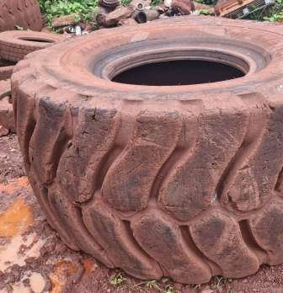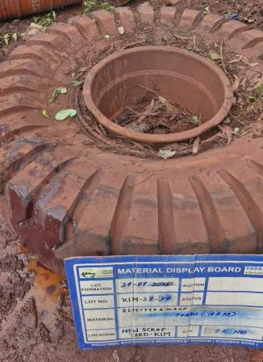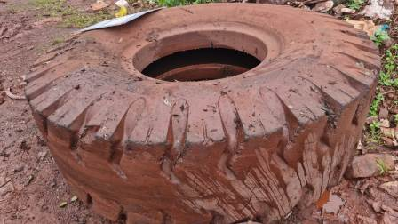
KIM-27-37 KIM-27-38 KIM-27-39

Open www.ahbilimoria.com ->Click on Customer Complaint Management Portal

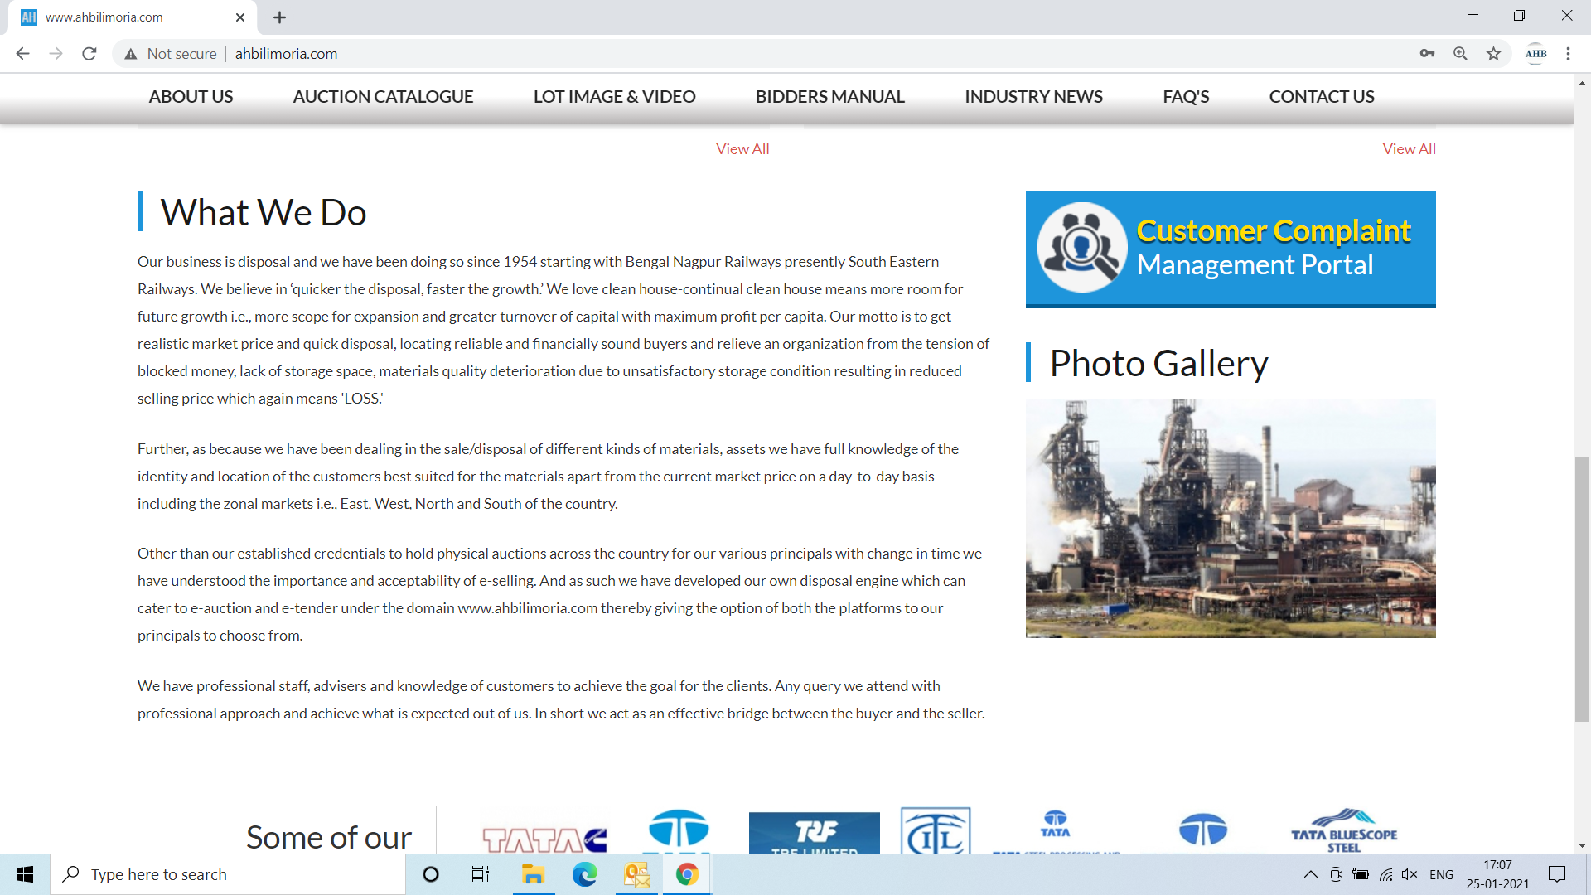

Use your User ID & Password for login

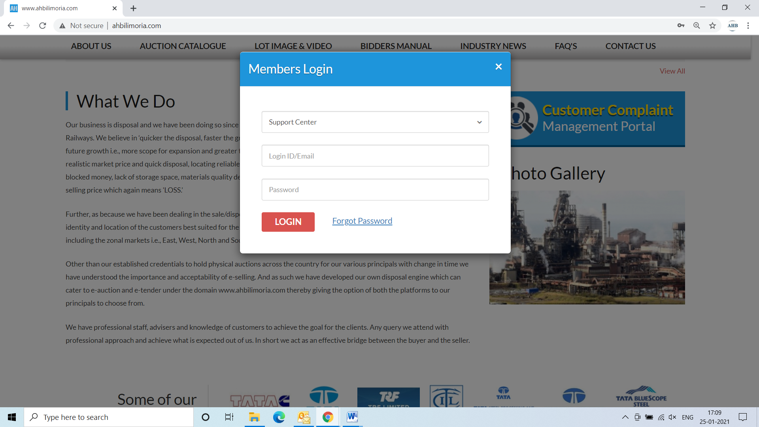

Click Complaint Portal-> Click on “Post a New Ticket”

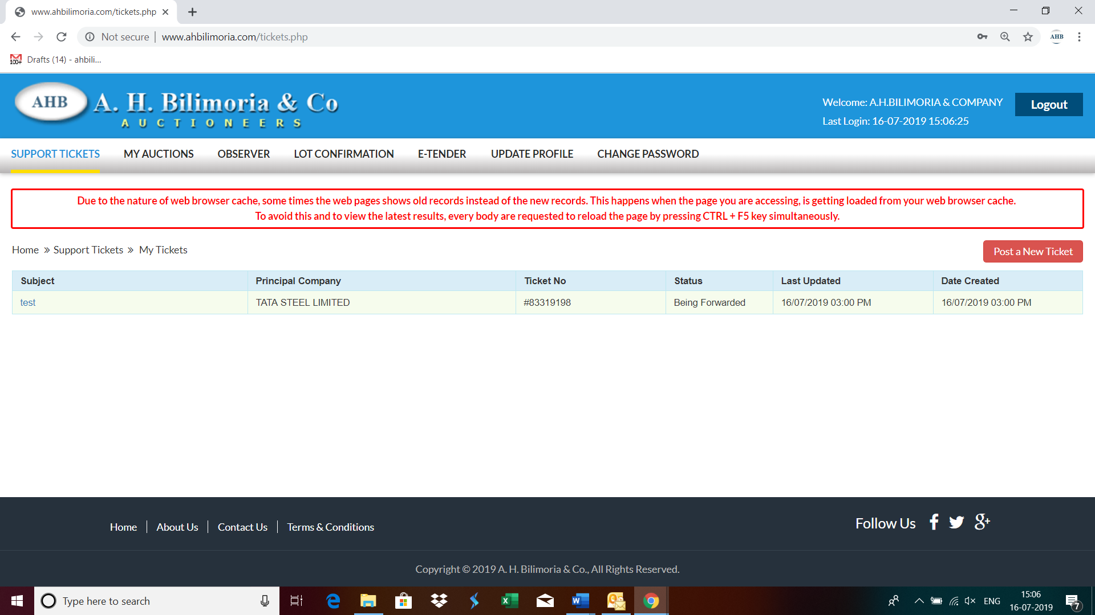

Post a New Ticket->Subject* ->Message* -> Email*->Principal Company*->Attach Document (If required any attachment) ->Submit

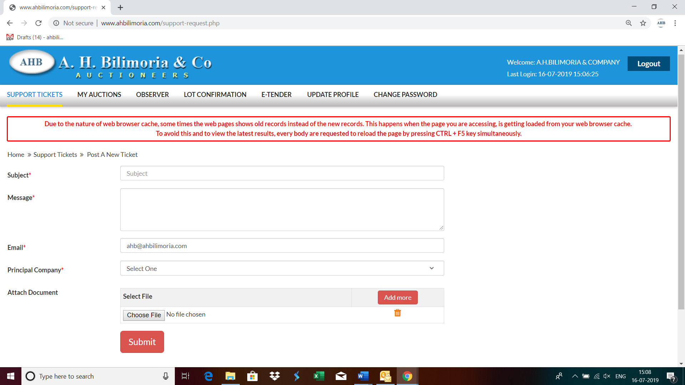

Your support request has been submitted successfully and the Reference No ----- is generated automatically

