Auction Catalogue
Auction conducted by A H Bilimoria & Co.
SALE OF SECONDARY PRODUCTS MATERIALS OF TATA STEEL LIMITED-West Bokaro/Capital & Misc Items,
ON “AS IS WHERE IS AND NO COMPLAINT BASIS”
Catalogue Serial Number: | TSL/WB/AHB/MAY/063/26-27
Materials : | Capital & Items
Seller: | Tata Steel Limited, West Bokaro
Auction website: | www.ahbilimoria.com
Auction Date & Time: | 22nd May, 2026 (Friday) ……… at 02:00 PM
Inspection Date & Time: | No physical inspection to be conducted. Interested customers please visit our website for indicative lot photographs/video. For any assistance please call AHB (7003840027) or IBMD Officer West Bokaro (09523099330/09204066824).
Date of Security Money Deposit | Up to 22.05.2026 till 01:30 PM
Contact Details:
For Post Auction @ A H Bilimoria & Company
Auction Room | 7003840027/9883421336
Inspection & Helpdesk | Mr. Bimal Bhardwaj- 09431373386
Money Receipts | Mr. Y John – 09432368402
Delivery Order | Mr. A Mazumdar- 09883421336
Sale Confirmation Letter | Mr. A Das - 033-2229-4833 / 6577 / 2760, 30290771
Refund | Mr. S Paul - 033-2229-4833 / 6577 / 2760,
Demand Note | Mr. Bimal Bhardwaj- 09431373386, Mr. S Paul - 033-2229-4833 / 6577 / 2760,
Disablement | Mr. A Mazumdar- 09883421336
Security Deposit | Mr. S Paul - 033-2229-4833 / 6577 / 2760,
Customer Complaint | Mr. A K Sil – 09830074122, Mr. D Pyne – 09830438481
For any unresolved issues | Mr. Bimal Bhardwaj- Email_ ahbjsr@ahbilimoria.com;b.bhardwaj@ahbilimoria.com
Escalation for unresolved issues | Mr. A K Sil – 09830074122,  Email : ahb@ahbilimoria.com, ahbilimoria.company@gmail.com, asis.sil@ahbilimoria.com

For Commercial Issues@ Tata Steel Limited:-
Contact Person | Mr. Pritish Pradhan (West Bokaro), M: 7368806055  Mr. Mohit Raj (West Bokaro), M: 09035025731

For Delivery related issues @ Tata Steel Limited:-
Contact Person | Mr. Pritish Pradhan (West Bokaro), M: 7368806055  Mr. Indrajit Dey (West Bokaro), M: 9204532820

Quantity offered is based on eye estimation. Delivery will be made for the estimated quantity or actual ground stock. Estimation error may arise. After e-inspection, no complaint of whatsoever nature on estimated /offered quantity shall be entertained under any circumstances. Bidders are advised to make their own judgment on offered quantity before bidding.

Note: TSL reserves the right to track IP address, MAC number and geolocation of bidding customers whenever customers participate in any Auction on the A H Bilimoria & Co. Auction platform for TATA Steel.

Special Note: Driver and vehicle safety
1. No helper is allowed inside yard
2. Driver should be in full PPE's
3. No loose clothes for driver
4. Speed limit of not more than 7 km/hr inside yard and 15 km/hr outside yard.
5. Scotch block 2 pcs
6. Back horn in vehicle
7. Driver must carry nose mask & hand gloves
8. Transporter must declare about the physical fitness of driver
9. Must declare about the fever, cold, cough & running nose.
10. Hand sanitizer/soap must be available with driver.
11. Driver must be aware about the safety norms of Covid-19.
12. Mandatory Under protection guard & Fire extinguisher safety check from 1st March 2021.
13. All the drivers placing vehicles for lifting materials need to show a proof of vaccination certificate at the gate for entry to TSL West Bokaro premises. Else, they will need to show a COVID-19 RT PCR Testing done certificate within 48 hours at site.
14. Reverse parking camera is mandatory, without the reverse parking camera no vehicles will be allowed to enter West Bokaro operational area.
15. Authorisation letter is mandatory while placing vehicle at West Bokaro. The driver / authorised person would not be allowed to enter TSL premises without valid authorisation letter from concerned firm.

Special Instruction:
W.e.f. 10th October, 2024, the CBIC has notified that there shall be deduction of GST TDS @ 2% on supply of metal scrap falling under Chapters 72 to 81 in the First Schedule to the Customs Tariff Act by registered person in B to B supply. The GST TDS shall be deducted when the payment is made or credited to the suppliers Account. The deductor will be liable to pay the TDS amount to the Govt. within ten days after the end of the month in which such deduction is made. A certificate of tax deduction at source shall also be issued by the supplier in the format prescribed in GSTR 7A. Accordingly, it is advised to kindly take necessary actions at your end such as obtaining GST TDS registration and ensure compliances with the GST TDS provisions.

Terms and Conditions for TDS of 2 % on metallic Scrap sales :
- Compliance of GST-TDS Provisions: It shall be the responsibility of the customer to comply with all the requirements prescribed under GST law related to GST-TDS in case of material sold to them.

- Payment of GST-TDS to the Government: The GST-TDS shall be deposited by the customer to the Government within due date prescribed under GST law.

- Filing of GST-TDS Returns: Customer shall file the periodic statements/returns as per GST law. GST-TDS deposited by the customer to the Government shall be refunded to the customer within one month of the day, the paid amount is reflected in GST portal of TSL at GSTN.

- Sharing of GST-TDS payment details with TSL: The customer shall share the invoice wise details of GST-TDS with TSL in excel file to the email id GSTRECON@TATASTEEL.COM.

- Implication of Non- Compliance: Any Impact of non-compliance for GST-TDS under GST law at customer’s end either in financial or other form, shall be borne by the customer only. Further, the customer shall at all times keep TSL indemnified and harmless from any loss/penalty/cost/damages suffered by TSL due to non-compliance of the applicable law by the customer.

- MATERIAL DETAILS:
List of materials
Sl. No. | Lot no. | Location | Material Description | QTY | UOM | GST | TCS | Loading | Lifting Period
1 | WR-26-15 | Scrap Yard | Used & obsolete GI sheets, as is where is basis, Lot to be cleared. Material will be loaded through The Grabber Machine, no manual loading involved | 5 | MT | 18% | 2% | By company | 07 days from date of order
2 | WR-26-16 | Scrap Yard | Used & obsolete Gear boxes, as is where is basis, Lot to be cleared. | 18 | MT | 18% | 2% | By company | 07 days from date of order
3 | WR-26-17 | Scrap Yard | Used & obsolete Air Compressors and accessories, as is where is basis. Quantity may vary, Lot to be cleared. | 3 | MT | 18% | 2% | By company | 07 days from date of order
4 | WC-26-01 | Central Workshop | Used and De-registered Tata 407 vehicle, JH02G-1450, not working; as is where is basis. Dispatch of vehicle through suitable Towing facilities. | 1 | NO | 18% | 2% | By company | 15 days from date of order
5 | WR-26-18 | Scrap Yard | Used Empty Plastic Drums, as is where is basis. Lot to be cleared. Only authorized parties who have valid authorization, CTO/CTE from pollution control board are authorized to participate in the auction as per hazardous and other waste rule, Manual loading by TSL. | 39 | NOS | 18% | 2% | By company | 10 days from date of order
6 | WR-26-19 | Scrap Yard | Unused Rechargeable Torch (approx. 757nos), as is where is basis. Quantity may vary, Lot to be cleared. | 757 | NOS | 18% | 2% | By company | 10 days from date of order
7 | WR-26-20 | Scrap Yard | Used & obsolete Motor and motor parts, as is where is basis. Quantity may vary, Lot to be cleared. | 15 | MT | 18% | 2% | By company | 10 days from date of order
8 | WR-26-21 | CMC | Misc. Used HEMM tyres: 1. 35/65 R33 : 4 nos.  2. 50/65 R51 : 3 nos  3. 24.00-35 : 9 nos  4. 21.00-35 : 2 nos  5. 29.50-25 : 2 nos  Loading will be done by Tyre handler and given to Trailer only (Valid EPR authorized waste tyre recyclers are allowed to participate in the Lot) | 20 | NOS | 18% | 2% | By company | 20 days from date of order
9 | WR-26-22 | CMC | Misc. Used HEMM tyres: 1. 23.50-25 : 17 nos.  2. 20.50-25 : 5 nos  3. 18.00-25 : 12 nos  Loading will be done by Grabber (Valid EPR authorized waste tyre recyclers are allowed to participate in the Lot) | 34 | NOS | 18% | 2% | By company | 20 days from date of order
10 | WR-26-23 | CMC | Misc. Used HEMM tyres:  1. 16.00-24 : 6 nos.  2. 16.00-25 : 1 nos  3. 10.00-20 : 23 nos  4. 7.50-16 : 13 nos  5. 6.00-16 : 2 nos  6. 400/70-20 : 4 nos  Loading will be done by Grabber (Valid EPR authorized waste tyre recyclers are allowed to participate in the Lot) | 49 | NOS | 18% | 2% | By company | 20 days from date of order
11 | WR-26-24 | Chainpur C Point | Used MS strips bunch mixed with slight qty. of wooden log, plastic wrapper etc. on arising basis. Multiple Trucks are required for the materials.  Material cutting is not allowed and loading will be done by Grabber machine only. Each 12-wheeler Trucks loading with approx. 4-5 MT of materials at a time. | 20 | MT | 18% | 2% | By company | 45 days from date of order
12 | WR-26-04 (Re-Auction) | Q AB (FRS Tyre Yard, LNG area) | Used & obsolete HEMM tyres  1. 27R49 : 51 nos.  as is where is basis.  Tyre loading will be done by Tyre handler and loading will be given in Flat bed Trailer only. 12 nos of tyres for 27R49; will be loaded in each trailer as per SOP. (Valid EPR authorized waste tyre recyclers are allowed to participate in the Lot) | 51 | NOS | 18% | 2% | By company | 20 days from date of order
13 | WR-26-08 (Re-Auction) | Scrap Yard | Used and obsolete Miscellaneous tyres; as is where is basis. Lot to be cleared. (Valid EPR authorized waste tyre recyclers are allowed to participate in the Lot) | 33 | NOS | 18% | 2% | By company | 10 days from date of order
14 | WR-25-72 (Re-Auction) | CMC | Used & obsolete HEMM tyres. Tyre loading will be done by Tyre handler and loading will be given in Flat bed Trailer only. 12 nos of tyres for 27R49; will be loaded in each trailer as per SOP. Valid EPR authorized waste tyre recyclers are allowed to participate in the lot | 47 | NOS | 18% | 2% | By company | 20 days from date of order
15 | WC-24-06 (Re-Auction) | QASB | Used Excavator EX-2500, Electric Excavator; Make - HITACHI.  Dismantling of the equipment are in the scope of TSL by following the TSL Standards to facilitate safe loading in Trailer. Material will be delivered in Trailer only. 2 nos. of Low Bed Trailers and 7 nos High Bed trailers are required for entire loading. | 1 | No | 18% | 2% | By company | 90 days from date of order
16 | WC-25-18 (Re-Auction) | Quarry SEB  (Near Tailing Yard) | Condemned and De-registered Dumper RD-110, Make-Caterpillar, Model: 777D C II; Capacity-100T, as is where is basis, Lot to be cleared. Parts available: Engine(without alternator), Transmission, Differential, cabin, Dump body, Hydraulic Tank, Fuel Tank, Rear & Front suspension, Tyres(5 nos), Radiator, Hoist cylinder etc. Material will be delivered in dismantled condition. For dispatch 2 nos of Low-Bed Trailers and 1 no. Standard trailer are required as per the plan. | 1 | No | 18% | 2% | By company | 60 days from date of order
17 | WC-25-19 (Re-Auction) | Quarry SEB  (Near Tailing Yard) | Condemned and De-registered Dumper RD-101, Make-Caterpillar, Model: 777D C II; Capacity-100T, Major parts available: Cabin, Transmission, Differential, Engine(without alternator), Dump body, Tyres (6 nos), Hydraulic & Diesel Tank, Rare & Front Suspension, Hoist cylinder etc.; as is where is basis, Lot to be cleared. Material will be delivered in dismantled condition. For dispatch 2 nos of Low-Bed Trailers and 1 no. Standard trailer are required as per the plan | 1 | No | 18% | 2% | By company | 80 days from date of order
18 | WR-26-02 (Re-Auction) | Scrap Yard | Used & obsolete Al cables mixed with some wood, Fiber Optic cable, Loose armed wire. As is where is basis, Lot to be cleared.  Loading to be done by Grabber Machine only | 4 | MT | 18% | 2% | By company | 15 days from date of order
19 | WR-25-88 (Re-Auction) | West Bokaro misc. (CHP) | Used & obsolete Miscellaneous Electrical items (Fan, LED tube light, Junction boxes etc.), as is where is basis. Lot to be cleared, weight may vary. (Valid EPR Authorized from CPCB/SPCB as a producer/recycler/ Refurbisher of E-Waste) | 2.5 | MT | 18% | 2% | By company | 20 days from date of order
20 | WR-25-86 (Re-Auction) | Scrap Yard | Used & Obsolete Crush Hammers, as is where is basis, Lot to be cleared | 35 | MT | 18% | 2% | By company | 20 days from date of order
21 | WR-25-85 (Re-Auction) | Scrap Yard | Used & Obsolete Steel fitted MS , as is where is basis, Lot to be cleared | 15 | MT | 18% | 2% | By company | 20 days from date of order
22 | WR-25-84 (Re-Auction) | West Bokaro misc.(Central Stock Yard) | Unused & Obsolete Track Rope 52mm with Reel (1 no), as is where is basis, Lot to be cleared. Weight may vary, Loading will be given in flatbed trailer only. | 10 | MT | 18% | 2% | By company | 30 days from date of order
23 | WR-25-78 (Re-Auction) | Scrap yard | Used and obsolete Track Chains, as is where is basis. Lot to be cleared. | 18 | MT | 18% | 2% | By company | 20 days from date of order
24 | WR-25-64 (Re-Auction) | West Bokaro Misc.(Washery#2,3, Central Workshop) | Used and obsolete Liquid ring Vacuum Pump, Make-Kakati; 5 nos. Site to be cleared, weight may vary.  Material will be delivered in Flat Bed Trailer only. More than one Trailer is required. | 37 | MT | 18% | 2% | By company | 20 days from date of order
25 | WR-25-49 (Re-Auction) | Scrap Yard | Used & Obsolete Vibrator (3 nos), as is where is basis, Lot to be cleared | 5 | MT | 18% | 2% | By company | 15 days from date of order
26 | WR-24-96 (Re-Auction) | Scrap Yard | Used & obsolete miscellaneous E-waste items: 1. Telephones : 180 nos. 2. Printer machine: 2 nos. 3. CRT monitor: 1 no. as is where is basis, Quantity of Telephones in numbers may vary; Lot to be cleared. CTE/CTO, EPR Authorization Letter from CPCB/SPCB as a producer/ recycler/refurbisher of E-Waste. | 0.2 | MT | 18% | 2% | By company | 20 days from date of order
B: Payment and Lifting Schedule:
Lot No. | Payment Schedule |  |  | Lifting Schedule  (working days from the next day of DO release)
Lot No. | EMD (10%) | 1st installment | 2nd installment | 1st installment lifting days | 2nd installment lifting days
For All Material (Except WC-25-19, WC-25-18, WC-24-06) | 02 working days from Date of Lot Confirmation | 03 working Days from the date of EMD | If material value (For each individual lot) is more than 10 lakhs excluding taxes and duties then 2nd installment within 3 working days from the 1st Installment date. | As per schedule | As per schedule
Lot No. | EMD (20%) | 1st installment | 2nd installment | Lifting Schedule  (working days from the next day of DO release)
WC-25-18, WC-25-19, WC-24-06 | 02 working days from Date of Lot Confirmation | 50% of Balance payment within 5 working days of 1st Loading confirmation date. | 50% of Balance payment within 10 working days of 1st installment date. | As per schedule
- Suitable extension of due date for payment and lifting will be accorded in case of any eventualities like Strike/ Bandh/ Special restriction on vehicular movement imposed by the local Administration etc.

- Requirements of participation:
  - Registration: Before participation in the Auction, a prospective bidder shall be required to get registered with A H Bilimoria & Co. For details visit www.ahbilimoria.com

  - Security Deposit: Non-Interest bearing security deposit of Rs.60,000/- (Rupees Sixty Thousand only) in favour of “A H Bilimoria & Co.” through Online Payment only : Details as under :

Beneficiary Name | A. H. BILIMORIA & COMPANY
Bank Name | HDFC Bank
Branch Name | 31, Chowringhee Road, Kolkata – 700016
Account No | 06932560001205
IFSC Code | HDFC0000693

Account No: All the customers will have a unique account number. The unique account number is an alpha numeric code consisting of 12 characters. The Customer’s unique “account number” is a combination of the AHB’ SAP code along with the 6 digit bidder SAP ID and can be used as reference. for all subsequent transactions. The Customer’s Account Number detail is available in “Profile” after the customer logs into our website using the user id and password.

3. Inspection registration & policy:
No physical inspection to be conducted. Interested customers please visit our website for indicative lot photographs/video. For any assistance please call AHB (7003840027) or IBMD Officer West Bokaro (09523099330/09204066824).

- Bidding modalities:
  - Price Bid Basis: In Indian rupees as per unit of measurement as given in Material List. Price to be quoted is basic, ex- location exclusive of taxes (In case of consignment agency sale price to be quoted ex location inclusive of taxes), any other statutory levies.
  - Bid Increment : Rs.100/- ( Rupees Hundred only )/ (or as specified)
  - Type of Auction : English No Ties
  - Bid Validity: Bid shall be valid for 10 (Ten working days excluding Saturdays, Sundays and Bank holidays) working days counted from the next day of Auction process in case of Auction against a catalogue which is completed on the same day. And if it is continuing on any other day the counting of days for lot confirmation shall be from the next day of completion of entire Auction process.
  - Bid duration: Lots open for bidding would be 10 minutes only. If, No bids received within these 10 minutes the lots are closed automatically.
  - Auto Extension of the Auction Timings: In the event of bids in the last sixty (60) seconds of the scheduled bid time, the Bid Timings are automatically extended for One hundred eighty (180) seconds from each such bid. Such Auto Extension shall continue until no bids are placed for sixty (60) seconds (Engine remains inactive for sixty (60) seconds. The Inactivity Time for Auto Extension purpose is normally “3” minutes. "Service Provider" however retains the right to change the “Inactivity Time” as well as “Extension Period”. The Inactivity Time applicable for the particular Online Bid shall be visible to the customers on the Bidding page.

- Taxes & duties:
  - GST : As applicable
  - TCS : As applicable
  - Any change in taxes applicable at the time of lifting shall be applicable.
  - Customers are required to submit Form 27C/Form 27G against the month of dispatch/expected dispatches. In the absence of Form 27C, TCS will be charged at the time of invoicing.

- Payment terms & conditions :
  - Payments:
- PAYMENT FACILITY BY RTGS / NEFT ONLY
- Account no. [Sample: TATAHB followed by Party code]
(Each individual customer will be provided with Account number to be provided by AHB)
- Beneficiary name: TATA STEEL LIMITED A H B
- Bank Name: HDFC BANK LTD.
- Branch Name: Sandoz Branch, Mumbai
- IFSC Code: HDFC0000240

  - EMD: 20% against lot no. WC-25-18, WC-25-19, WC-24-06 and 10% of the material value to be paid within 02 (Two) working days from the date of lot confirmation for all lots. EMD to be adjusted in the final installment only. EMD payment is to be made within the time limit as given in letter of confirmation. No extension will be provided for the same.
  - Balance Payment Time: (As per payment schedule)
  - Delayed Payment Charges (DPC): Installment payments with DPC @ five (05) paise per Rs. 100/- per day will be accepted up to 4 (Four) working days from due date of installment payment as mentioned in the confirmation letter. This is not applicable for EMD payment.
  - Saturdays, Sundays and Bank holidays are excluded for counting purpose for payment schedule.
  - In the event of Non-Receipt of Payment within the stipulated period of Payment, the Sale Offer for the approved Lot shall stand withdrawn automatically and treated as defaulter.
  - Buyers have to send the payment deposit slip (UTR No /Scan Copy of NEFT/RTGS Transaction Slip) against Lot No. immediately after the payment to AHB at email id: ahb@ahbilimoria.com

- Lifting terms & conditions:
  - DOs will be handed over to authorized representatives of bidders on receipt of payment. Lifting date is calculated from the next day of DO Release date.
  - Cutting and loading of scraps will be done by Company except Vehicles
7.3 In case of waste oil loading arrangement will be customer’s responsibility as per following terms and conditions
- Use of proper PPE by all workmen during loading of used oil under supervision of vendor’s supervisor.
- Customer will assure all safety norms as per contract, however in case of any incident they will be fully responsible.
- All tools & tackles will be used as per safety standard by the workmen duly safety trained as per applicable safety norms of the TSL.
- To be compulsorily used body harness if working height is more than two meters.
- Lifting of used oil will be done by pumping of oil in proper way.
- During pumping of oil if any leakage observed, immediately sand dust/dry soil will be poured in the area for drying of oil contaminated area.
- The spilled area will be immediately cleaned by water and saw dust/dry soil and sand.
- Lifting schedule will be from 1st to 10th every month and as and when required on five days prior information.
- In case of lifting failure customer will be treated as defaulter.
7.4 Loading shall be given strictly as per the statutory norms & safety norms of Tata Steel Ltd.
7.5 Lifting with Ground Rent: Lifting along with ground rent will be allowed up to 4 (four) working days from the last date of lifting period. In case the lifting is not complete, and no request is made by the customer within the period of four days, the company reserves the right to close the lot, and refund the balance to the party after deducting for any shortfall in lifting as per norms laid down in the catalogue. Ground Rent will be calculated on balance unlifted quantity @ 05 paise (inclusive of tax) per Rs.100/- per day

7.6 Additional lifting days for advance payment of installment - If the installment payment is made in advance, then additional lifting days (equivalent to the number of days payment made in advance) would be given. This would not be applicable for EMD payment.

7.7 PICK & CHOOSE NOT ALLOWED FOR ANY OF THE LOTS.

7.8 LOT TRANSFER WILL NOT BE ALLOWED & NO STOCK TRANSFER WILL BE DONE.

- Penalties:
  - The following penalties shall be applicable in the eventuality of a buyer defaulting in making the payment of EMD (wherever applicable) or any installment/s, as per the stipulated schedule for each lot, in a financial year:

- In the first instance, a penalty of Rs. 60,000/- (Rupees Sixty Thousand only) shall be recovered from the customer and the customer shall be debarred from participating in any Auction for a period of one month from the date of debarment.

- In the second instance, a penalty of Rs.100,000/- (Rupees One Lakh only) shall be recovered from the customer and the customer shall be debarred from participating in any Auction for a period of two months from the date of debarment.
- In the third, and any subsequent instance, a penalty of Rs.150,000/-(Rupees One Lakh Fifty thousand only) shall be recovered and the customer shall be debarred from participating in any Auction for a period of three months from the date of debarment.

In the event of any default, the customer’s user id will be disabled and the customer will be blocked from participating in any Auction of TSL with immediate effect.

The defaulting customer shall be allowed 06 (six) working days to deposit the penalty as mentioned above. In case the penalty is not received within the stipulated period, the customer’s security deposit shall be forfeited, and the defaulting customer shall be debarred from participating in any Auction of TSL.

  - If after making payment of EMD (wherever applicable), the installment payment/s are not made by the customer as per the stipulated schedule for each lot, the entire EMD amount against such lot shall be forfeited.

  - In case of non- lifting of full lot quantity after making full payment, a penalty equivalent to 20% of the material value for the un-lifted quantity against each lot shall be recovered from the customer.

- Lot Closure Norms :
For Lot Closure, the tolerance would be ± 10% of the original quantity and lot be cleared (mentioned in the material list).
For High Value Items (>/= Rs 50000 per MT) tolerance for Lot closure is 0% of the lot quantity.

- Refund :
For refund issues please contact Mr. John (9073711453). Bidders have to mention their contact address, contact person, telephone number and email ID.

- Complaints :
Complaints, if any, with regard to any transaction shall have to be lodged by the buyer within three calendar months from the date of last invoice. No complaint shall be entertained thereafter, under any circumstances.

- Jurisdiction :
Any dispute arising out of any contract shall be decided in Jamshedpur by the courts in Jamshedpur and by no other courts. The courts in Jamshedpur shall have exclusive jurisdiction to adjudicate upon any such dispute.

- General terms & conditions:
  - Any dispute on condition of material shall not be entertained at any point after confirmation of lot.
  - All materials are offered/sold on “As is Where is Basis” and “No Complaint Basis”.
  - Payment and invoicing has to done in the name of the H1 bidder, subject to the prices being approved.
  - Material purchased should be the only material being lifted from the designated location. Tata Steel has the right to check any vehicle at any moment of time. If material lifted differs from the material that is purchased by the buyer, and then the buyer/authorized representative will be permanently debarred and penal action against the buyer/ authorized representative as deemed fit shall be taken by Tata Steel Ltd.

  - If the safety compliance is not followed then Tata Steel can penalize the buyer/authorized representative as deemed fit.

  - These terms and conditions as stated above supersede the relevant terms & conditions that are given in Tata Steel Secondary General Terms and Conditions.
The terms & conditions not covered above will be as per Tata Steel’s Secondary General Terms and Conditions.
Revised Standard Terms & Conditions For Tata Steel Secondary Products Auction w.e.f. 1-April-05.
  - Vehicle fitment will be checked before loading as per check list.
  - Not below four wheeler vehicle will allowed to enter in the scrap yard.
  - Scotch Block is compulsory for vehicles
  - Customers are requested to get lifting program from the Tata Steel Ltd. Authority within 5 days of received of delivery order.
  - Lot transfer will not be allowed. Payment and invoicing has to done in the name of the H1 bidder, subject to the prices being approved.
  - Lot purchased should consist of material from the same lot and designated location only. Tata Steel has the right to check any vehicle at any moment of time. If material lifted differs from the material that is purchased by the buyer, then the buyer and authorized representative will be permanently debarred. Also Tata Steel can take any penal action against the buyer/authorized representative. All the material loaded in the vehicle is to be covered in order to follow the safety compliance of Tata Steel works.
  - If the safety compliance is not followed, then Tata Steel can penalize the buyer / authorized representative as deemed fit.
  - Customer attested photocopy of valid id proof (Voter id/Aadhar/Pan card) of all lifters / Authorized persons engaged by customers for lifting of materials from TSL is to be enclosed with the authorization letters & to be forwarded to TSL for issue of gate pass.
  - Dispatch is subjected to FORCE MAJEURE conditions
  - The seller reserves the right to terminate any offer at any point of time without assigning any reasons
  - In the event of termination of the offer, seller shall refund the balance amount after due reconciliation
  - No claims whatsoever would be entertained after cancellation of the bid
  - In addition of earlier safety norms, the following would be compulsory:
The drivers of the vehicle must have the eye test certificate. The frequency of the testing would be as below:
1. If the age of the person is less than 45 years - Once in a year
2. If the age of the person is 45 years or more, the testing is required to be done once in every 6 months
Please ensure to comply with the safety norms
  - Weighment : Weight recorded by Tata Steel weighbridge will be considered final and binding on the customer.
  - This transaction falls u/s 206C(1). Hence Section 194Q will not be applicable.
  - Compliance in relation to section 206AB/206AA (Furnishing of I.T Return for past 2 Years) will be taken directly from Income Tax Portal till 28th June-2021. If any compliance made in IT Portal by the customer (after 28th June-21), shall be communicated to AHB over mail.
  - The vehicle ownership transfer process need to be coordinated/executed by the customer itself.

- Compliance to safety norms :
13.1 Authorized persons (of the customer) involved in lifting of the materials will be allowed only with Personal Protective Equipment’s (PPE) i.e., Safety Shoes, Safety Helmet, Safety Goggles, Fluorescent Jacket and Hand Gloves. No "people movement" shall be allowed at the time of loading/delivery of materials from the yards" Tata Steel will not be responsible for any delays arising out of Non- Compliance to the Safety Norms.

13.2 Documents for verification regarding entry of vehicles inside Tata Steel works :
All customers to note that presentation of following set of documents to TATA STEEL authorities is COMPULSORY at the time of reporting of vehicles at TSL designated Gate for entry of Customer trucks/vehicles.
a. Driving License of driver,
b. Registration Card,
c. Commercial Certificate,
d. Fitness Certificate of Vehicle,
e. Re-registration for vehicles older than 15 years
f. Insurance
The checklist form will be filled in at TSL designated Gate for entry of Customer trucks/vehicles before entry of vehicle.

13.3 Side and Rear Under Protection devices
All heavy vehicles of categories M2, M3, N2, N3, and T3 & T4 must be fitted with rear and side protection device. Trailers specially designed and constructed for the carriage of very long loads of indivisible length, such as timber, steel bars, etc.
Vehicles designed and constructed for special purpose where it is not possible, for practical reasons, to fit such lateral protection and rear under protection should not be used.

13.4 SUPD (Side Under Protection device):
Any load which is project more than 150 mm over the sides of the trailer, and must not be more than 2.5 meters in total width.
The device shall not exceed the overall width of the vehicle and the main part of its outer surface shall not be more than 120 mm inboard from the outermost plane (maximum width) of the vehicle. Its rearward end shall not be more than 30 mm inboard from the outermost edge of the rear tyre. The device may consist of a continuous flat surface, or of one or more horizontal rails, or a combination of surface and rails.
When rails are used, they shall not be more than 300 mm apart and not less than 50 mm high in the case of category M2, N2 and T3 vehicles, and 100 mm high and essentially flat in the case of M3, N3 and T4 vehicles.
On a motor vehicle without cabin not more than 300 mm to the rear of the transverse vertical plane tangential to the rearmost part of the tyre. On a vehicle with cabin the gap between forward edge of SUPD and the cab panels does not exceed 100 mm and if necessary, shall be turned in through an angle not exceeding 45°.

The lower edge of the side guard shall at no point be more than 550 mm above the ground.

The upper edge of the guard shall not be more than 350 mm below that part of the structure (Body) of the vehicle. The outer and forward faces of this member shall measure at least 50 mm rearward and be turned 100mm inwards in the case of M2, N2 and T3 and at least 100mm rearwards and be turned 100mm inwards in case of M3, N3 and T4.

Side guards shall be essentially rigid, securely mounted (they shall not be liable to loosening due to vibration in normal use of the vehicle) made of metal.

13.5 RUPD (Rear Under Protection device):
Any load projected more than 1.2 meters over the rear side of the trailer. If measured from the Centre of the trailer axle or axle group, a load must be not more than 3.7 meters, and not longer than the length of the load in front of the axle, or axle group.

A device for protection against under running from the rear, generally consists of a cross-member and linking components connected to the chassis side members or to whatever replaces them. It shall have the following characteristics: The device shall be fitted as close to the rear of the vehicle as possible. When the vehicle is unladen, the lower edge of the device shall at no point be more than 550 mm above the ground for M2, N2, N3, T3 or T4 categories of vehicles. In case of M3 category of vehicles, the lower edge of the device shall at no point be more than 700 mm above the ground.

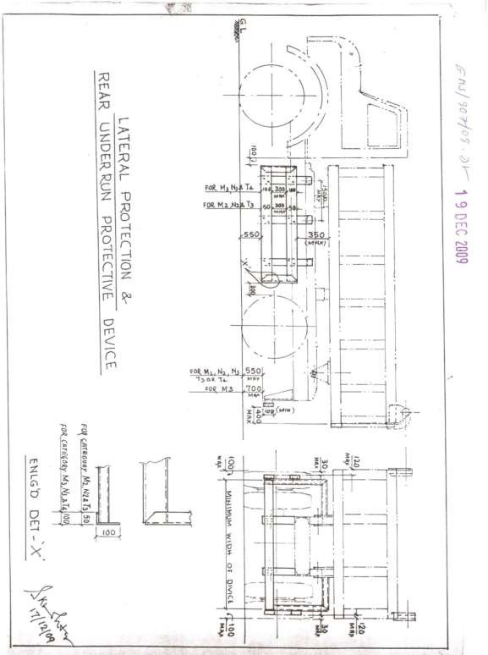
Νοτε: M2 Category: Seating capacity more than 9 and less than 25 Nos;M3 Category: Seating capacity more than 25 Nos;N2 Category: Vehicle having maximum mass exceeding 3.5 tones and not exceeding 12 tones;N3 Category: Vehicle having a maximum mass exceeding 12 tones;T3 Category: Trailer having maximum mass more than 3.5 tones and not exceeding 10 tones ;T4 Category: Trailer having maximum mass exceeding 10 tones

- SPECIAL TERMS AND CONDITIONS FOR INTERNET AUCTION
BANDWIDTH PROBLEMS, CONNECTIVITY PROBLEMS WITH THE LOCAL ISP (INTERNET SERVICE PROVIDER), SLOWNESS TO ACCESS PAGES FOR DOWNLOADING ETC. ARE BEYOND THE CONTROL OF TATA STEEL LTD. AND A H BILIMORIA & COMPANY. HENCE NO RESPONSIBILITY LIES WITH TATA STEEL LTD. OR A H BILIMORIA & COMPANY FOR THE ABOVE PROBLEMS FACED, IF ANY, BY THE BIDDERS BEFORE/DURING THE AUCTION ANY. BID PLACED USING THE BIDDER'S USERNAME AND PASSWORD IS UNCONDITIONALLY BINDING ON THE BIDDER TO WHOM SUCH USERNAME AND PASSWORD HAD BEEN ALLOTTED AND HE SHALL BE SOLELY RESPONSIBLE FOR MAINTAINING THE CONFIDENTIALITY OF THE SAME AND FULLY RESPONSIBLE FOR ALL ACTIVITIES THAT OCCUR UNDER THEIR USERNAME AND PASSWORD. HENCE THE USER IS ADVISED TO CHECK THE USERNAME AND PASSWORD BEFORE THE AUCTION,IN ORDER TO FAMILIARISE HIMSELF WITH THE SAME AND IS ADVISED NOT TO REVEAL IT TO ANYONE ELSE SO AS TO PREVENT MISUSE OF THE SAME. THE BIDS MADE BY THE BIDDERS AGAINST THEIR USERNAME AND PASSWORD SHALL BE IRREVOCABLE.THE BIDDERS ARE ADVISED TO REGISTER AND PRE-QUALIFY FOR BIDDING WELL IN ADVANCE AND PLACE THEIR BIDS EARLY IN ORDER TO TAKE CARE OF ANY UNFORESEEN TECHNICAL DIFFICULTY THAT MIGHT SURFACE IN THE INTERNET OPERATIONS.

ALL THE PHOTOGRAPHS ARE INDICATIVE FOR AUCTION
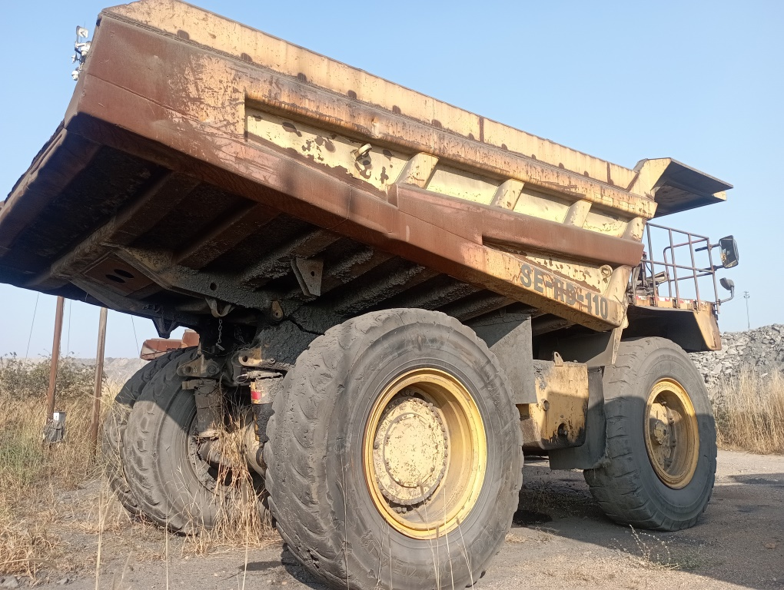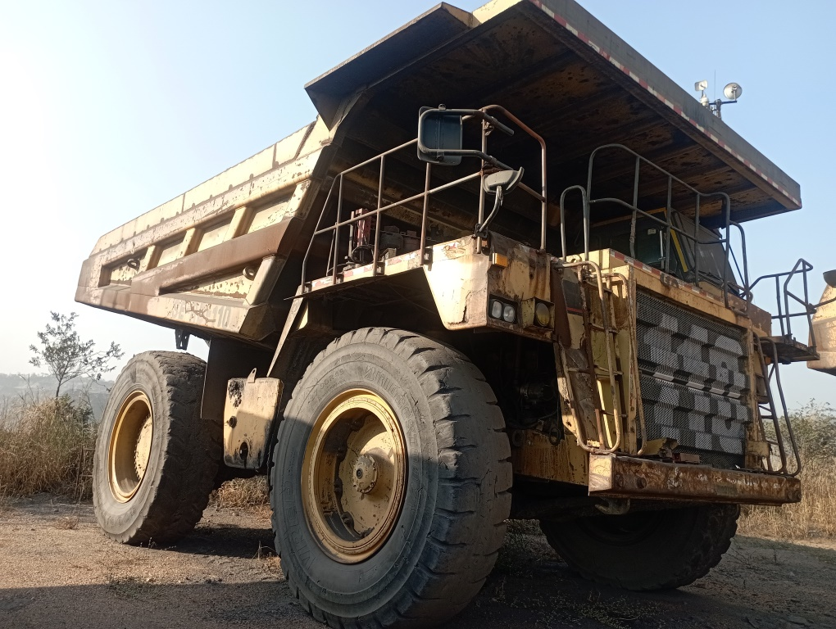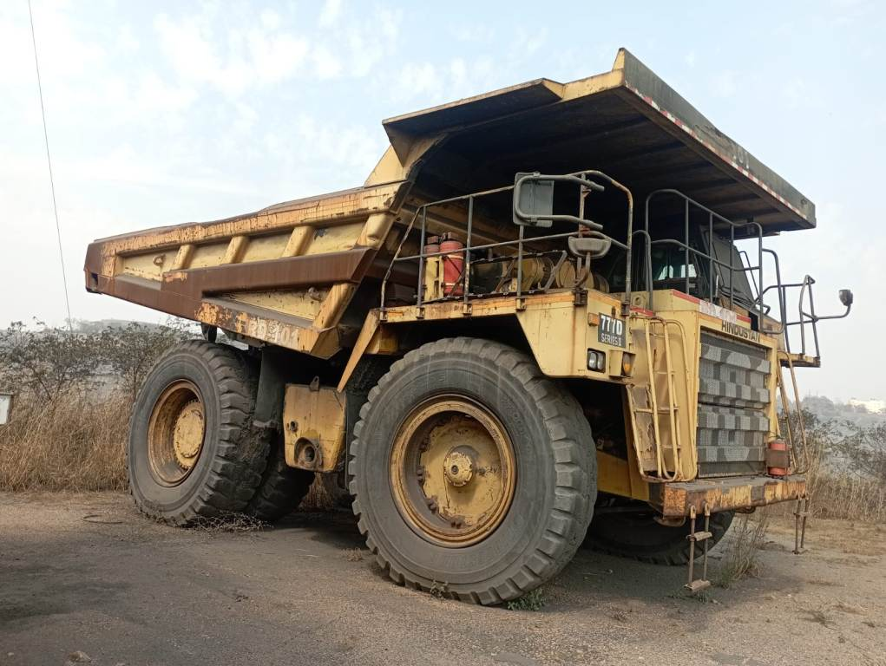
WC-25-18 WC-25-18 WC-25-19
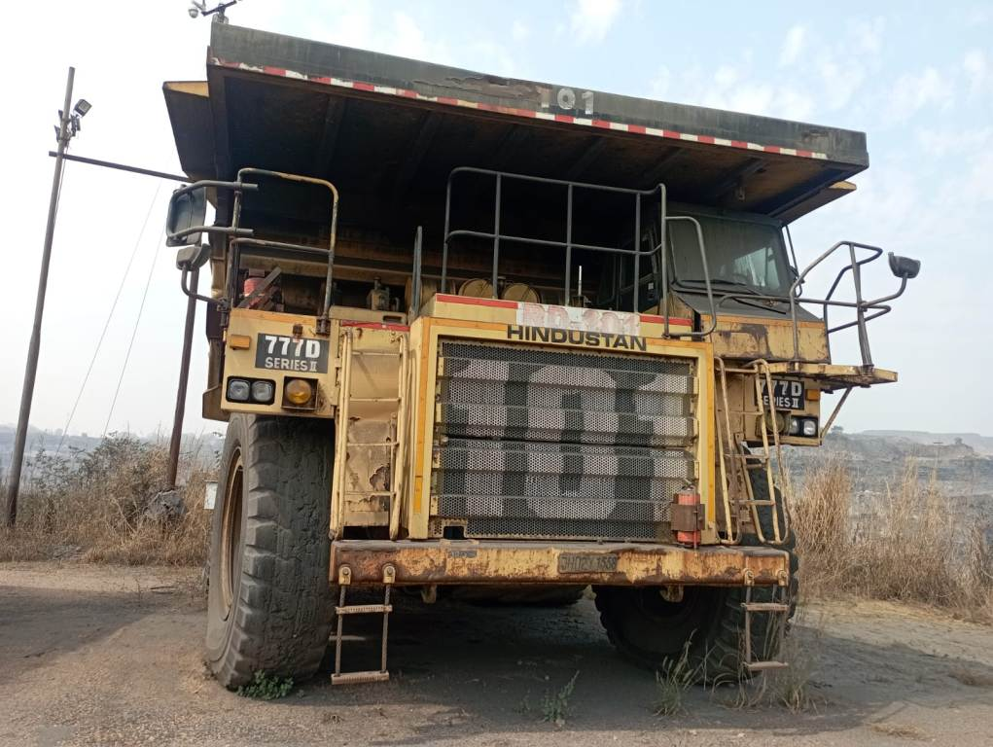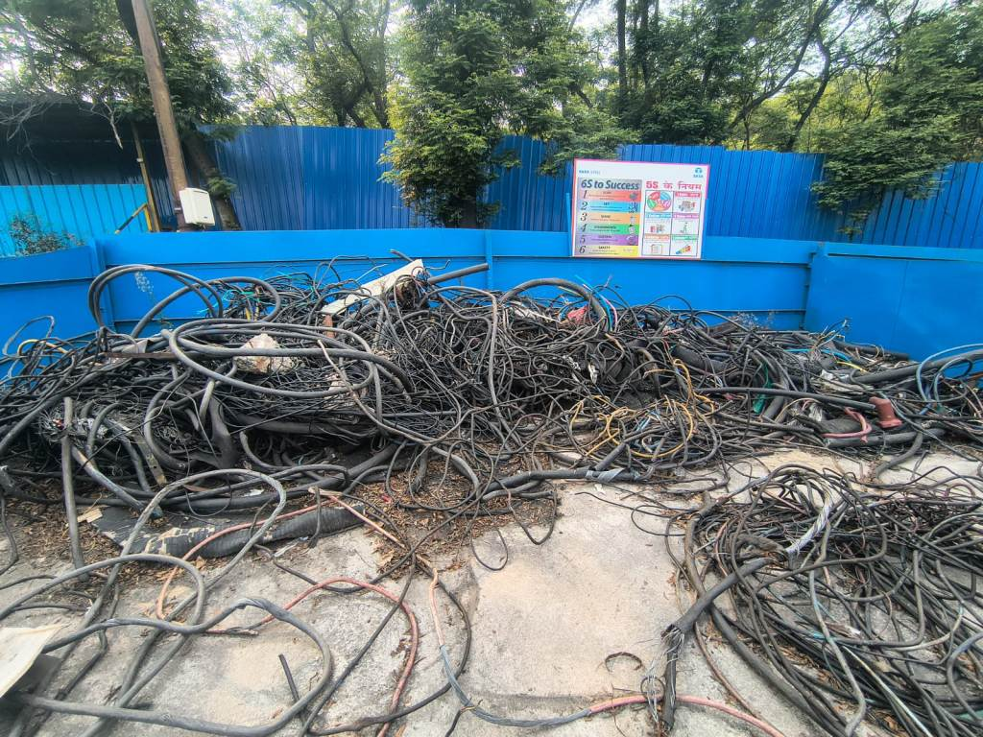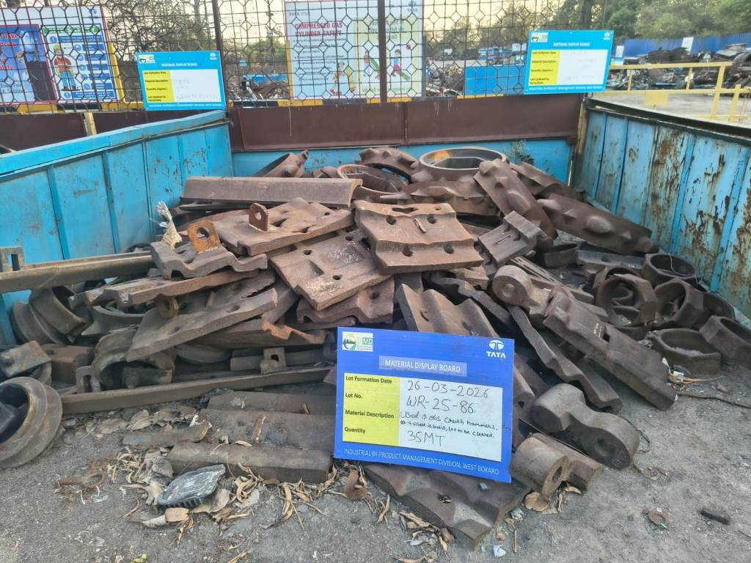
WC-25-19 WR-26-02 WR-25-86
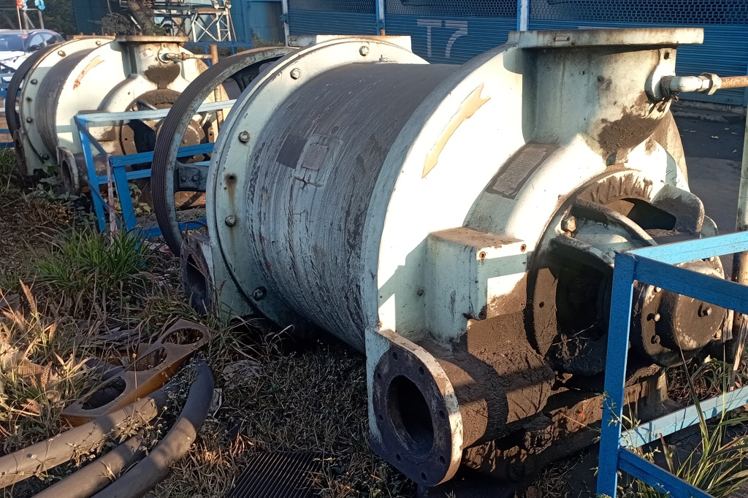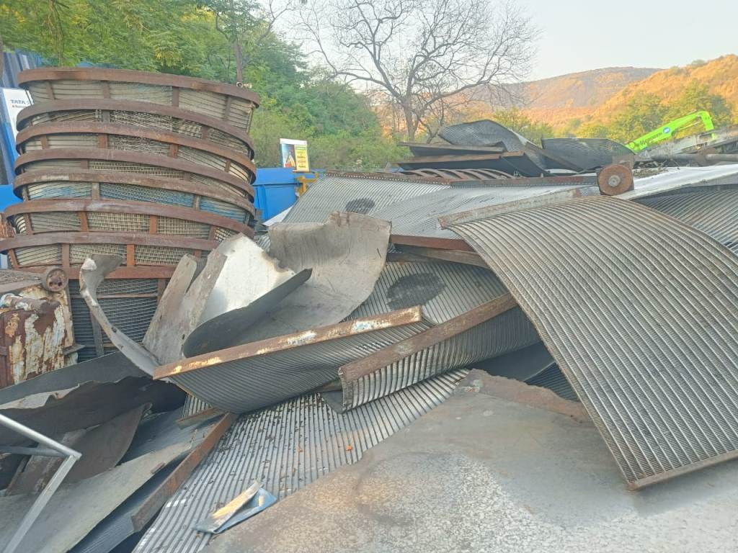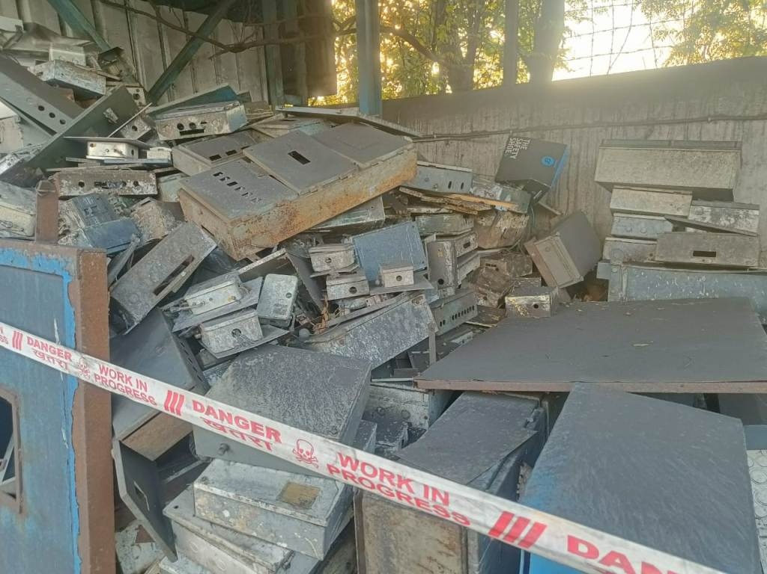
WR-25-64 WR-25-85 WR-25-88
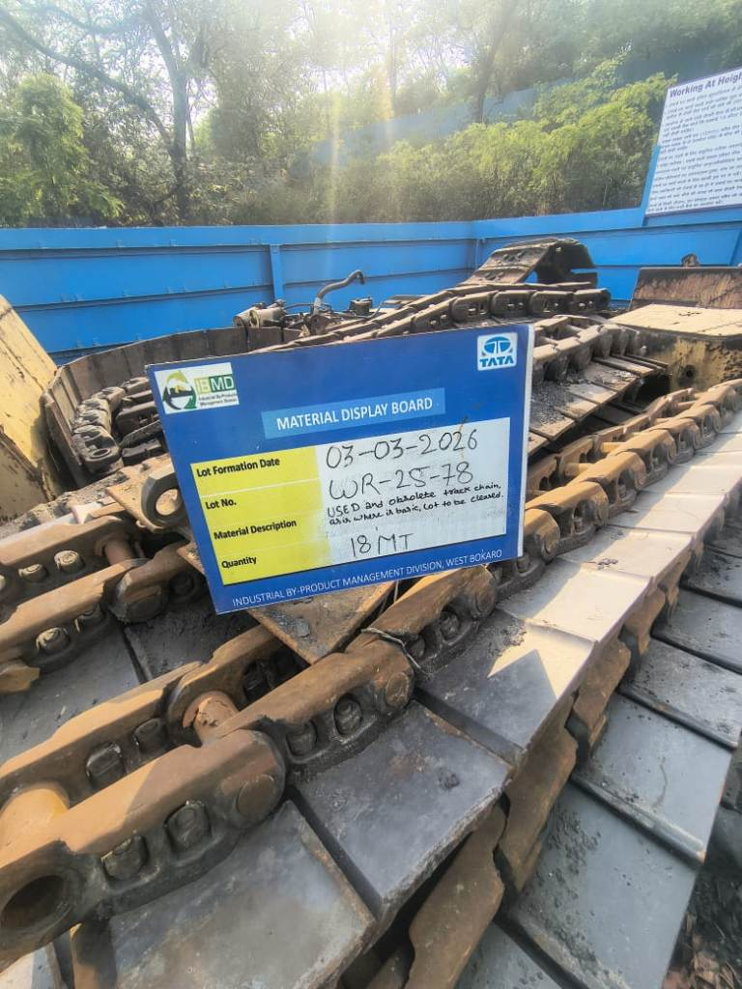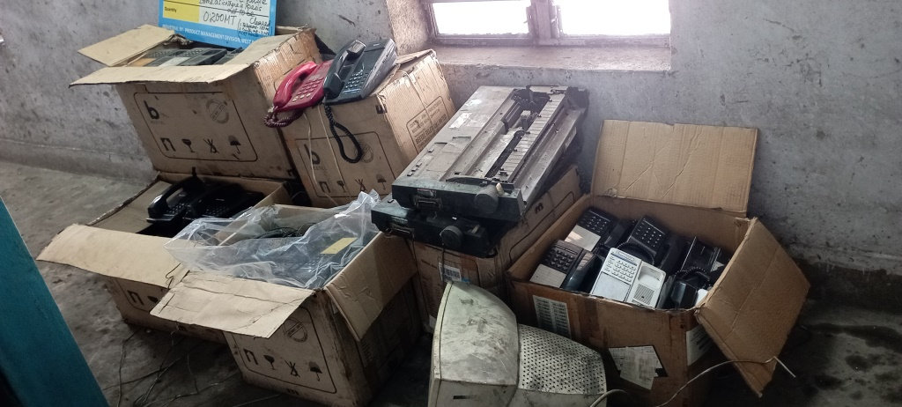
WR-25-78 WR-24-96
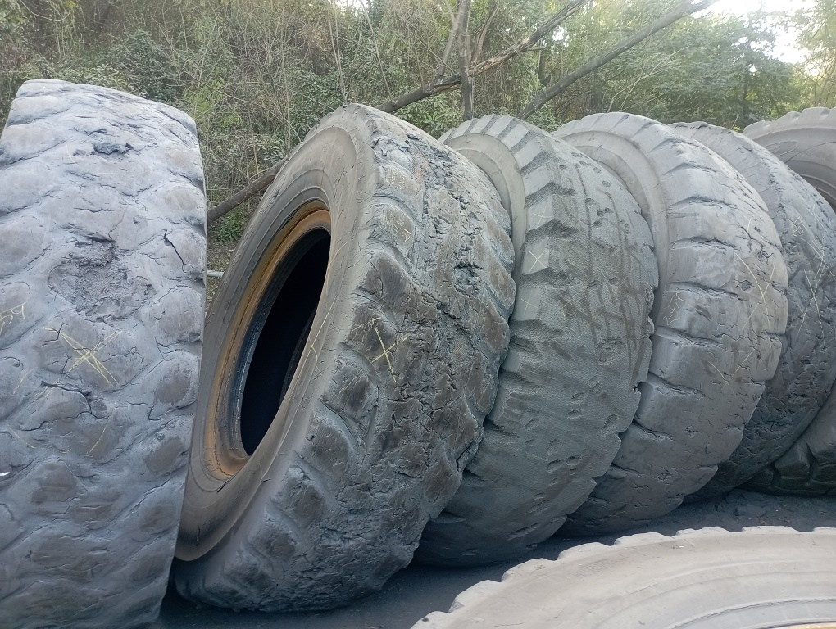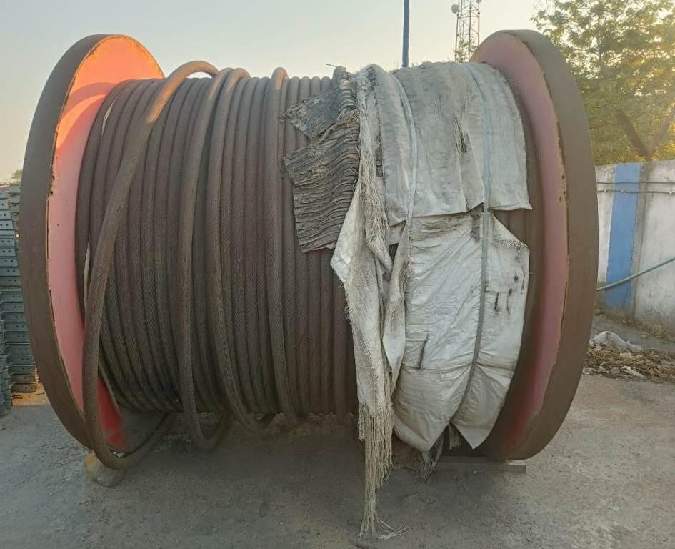
WR-25-72 WR-25-84
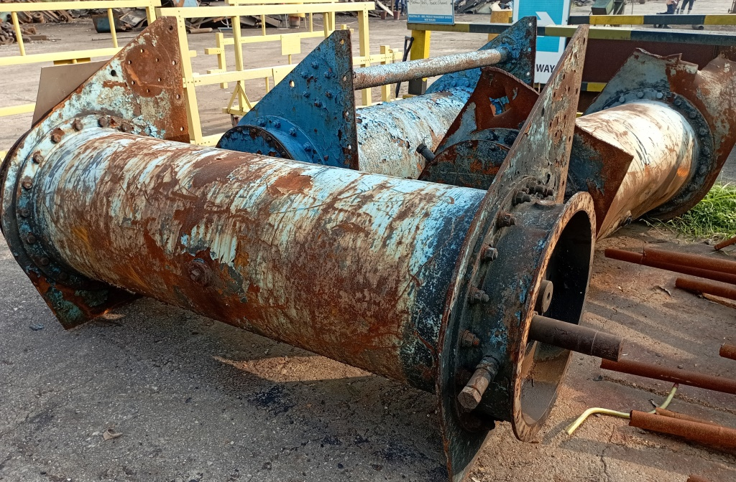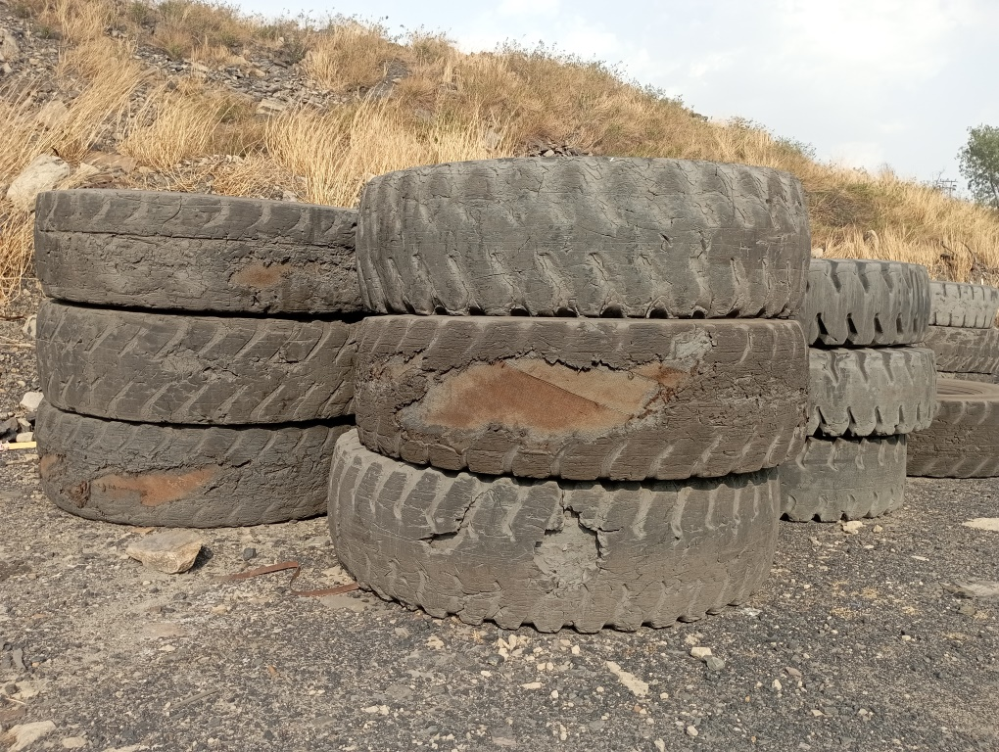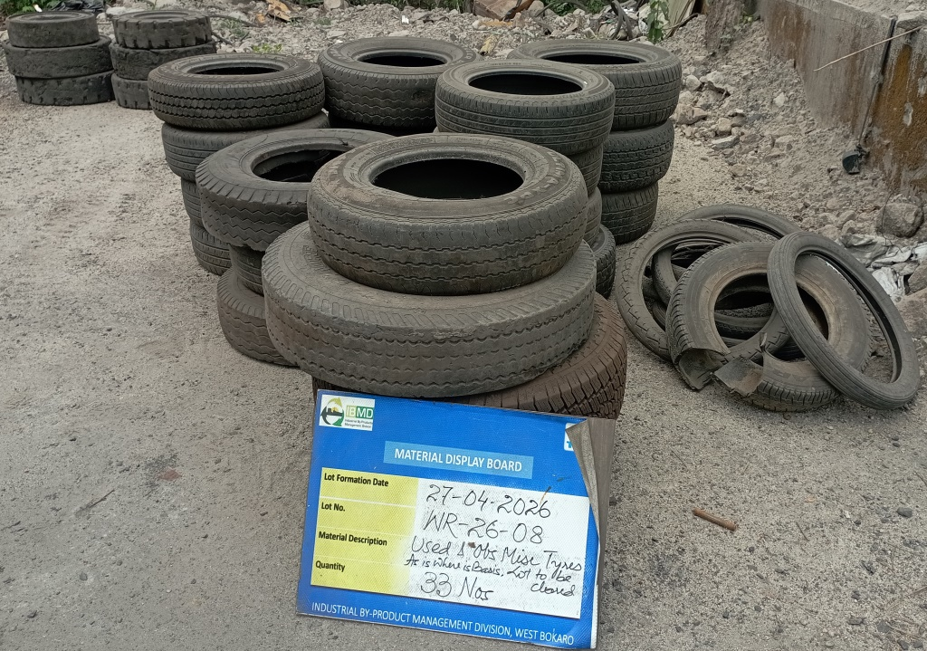
WR-25-49 WR-26-04 WR-26-08
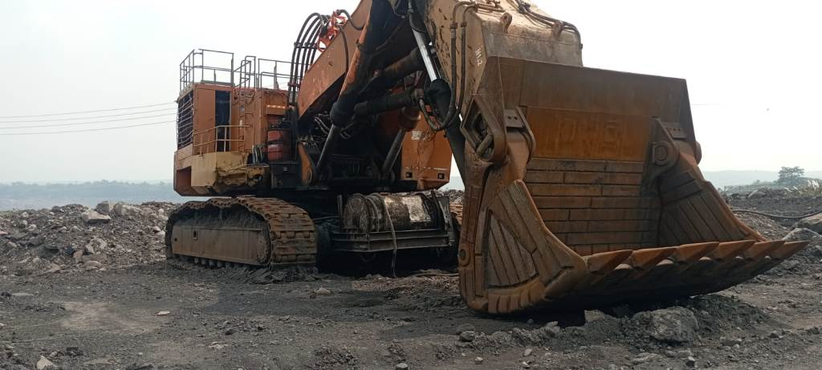 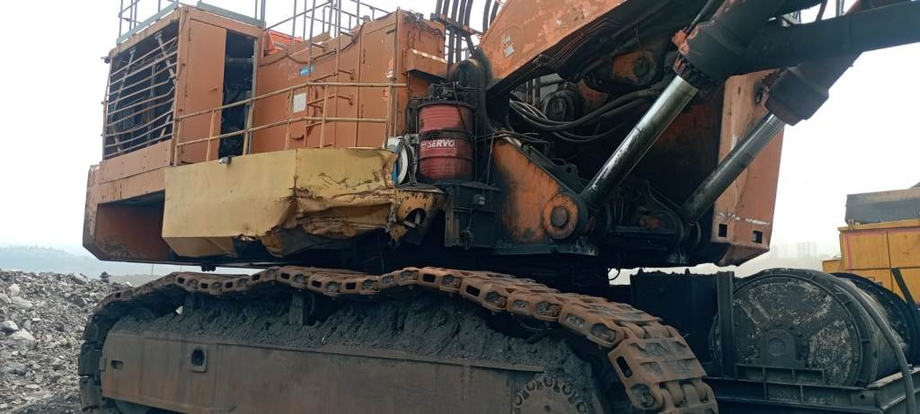 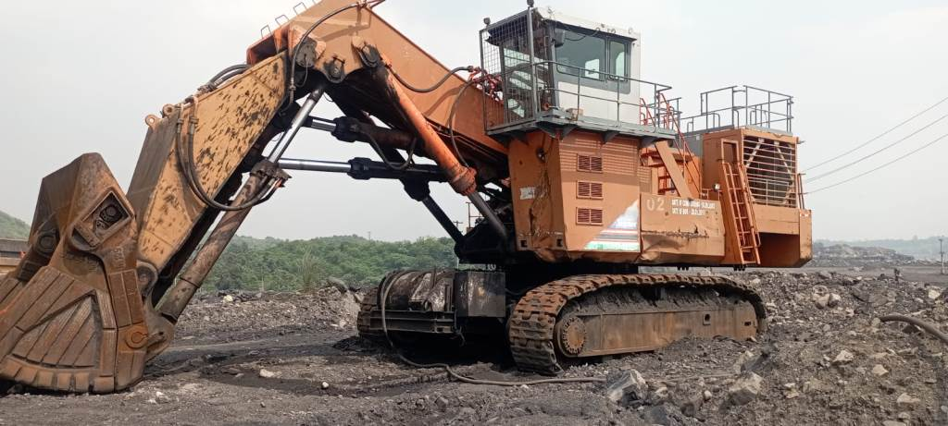 WC-24-06 WC-24-06 WC-24-06
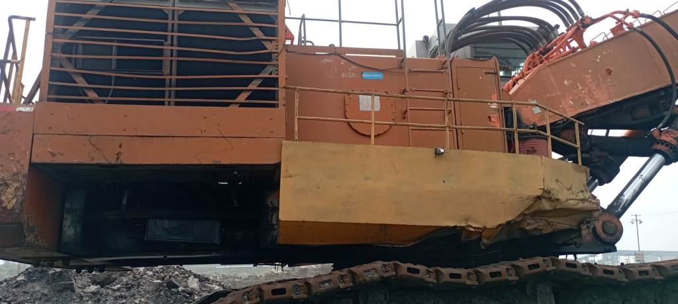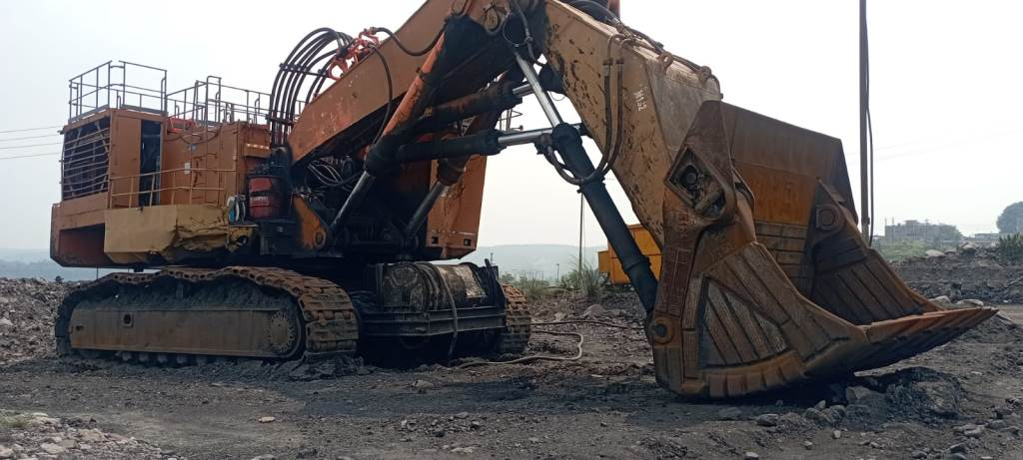
WC-24-06 WC-24-06 WC-24-06
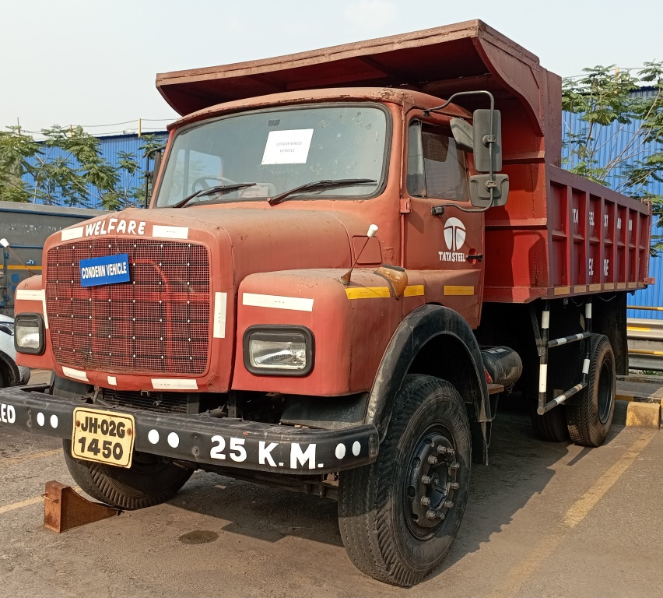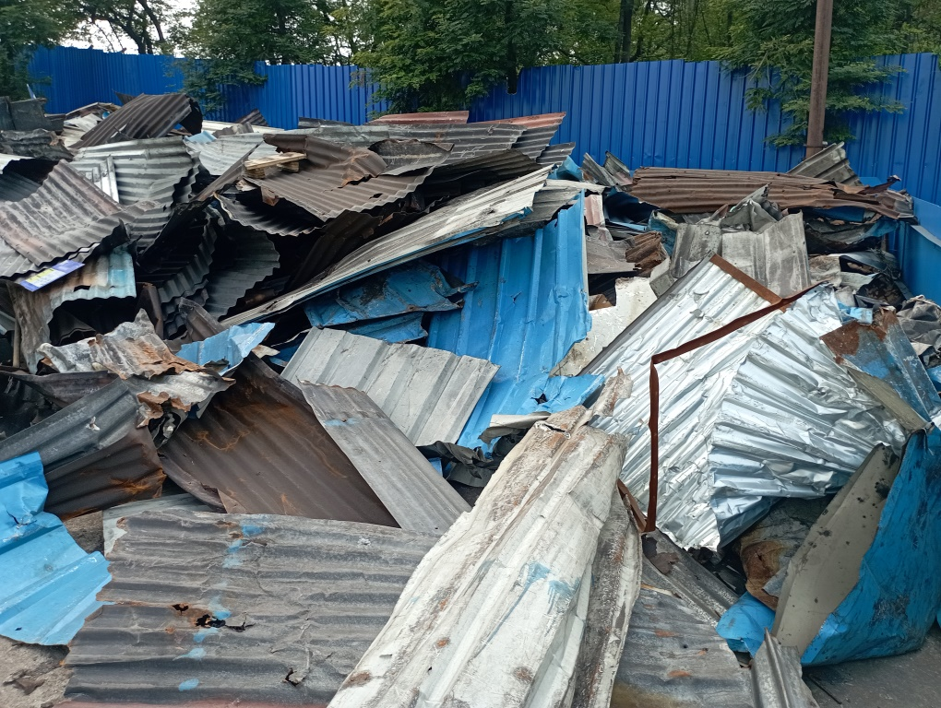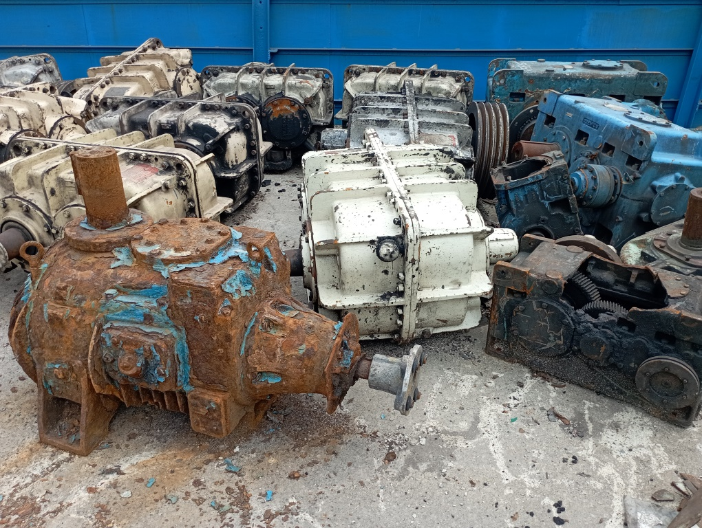
WC-26-01 WR-26-15 WR-26-16
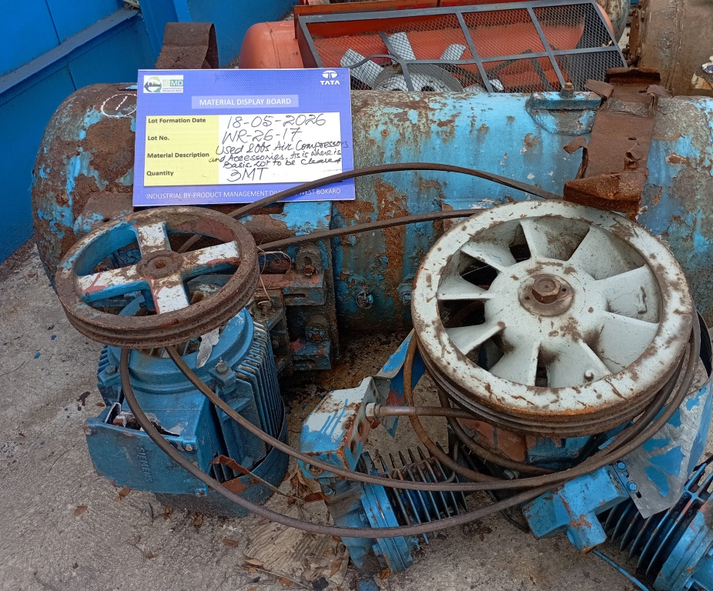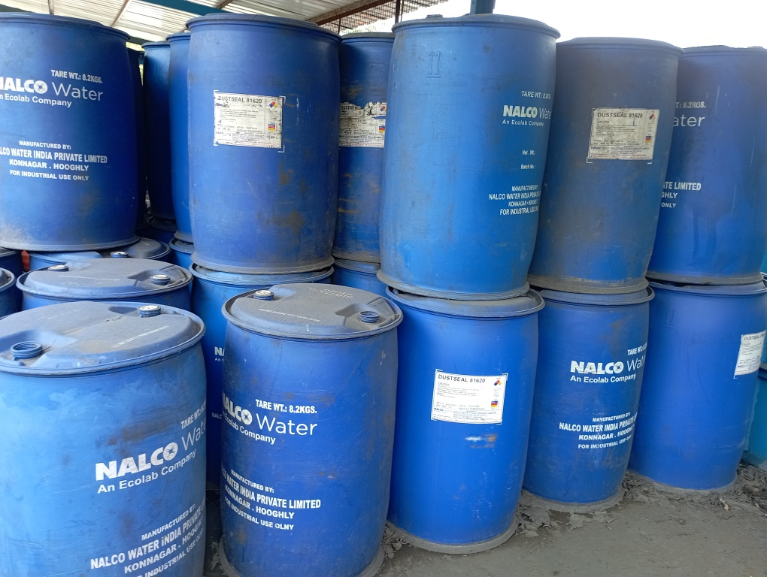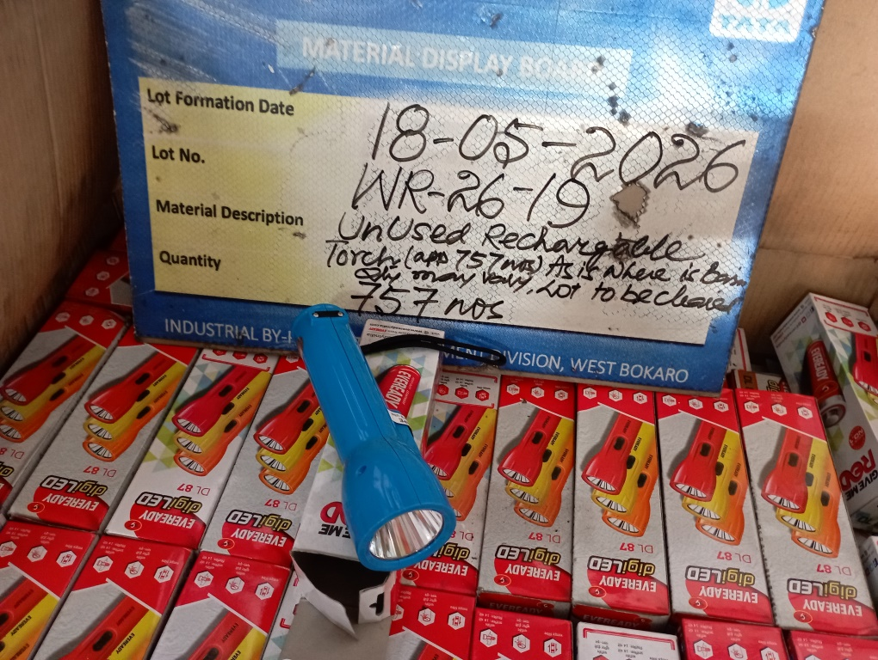
WR-26-17 WR-26-18 WR-26-19
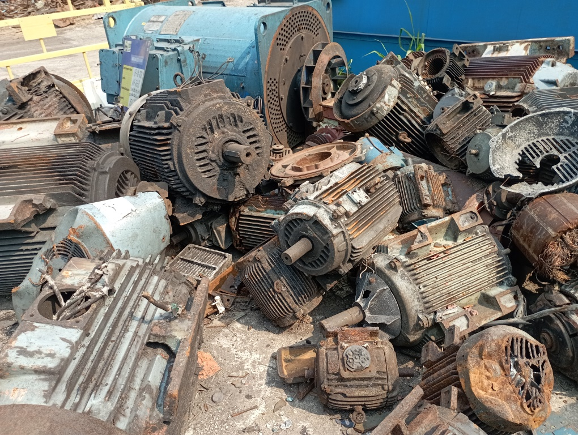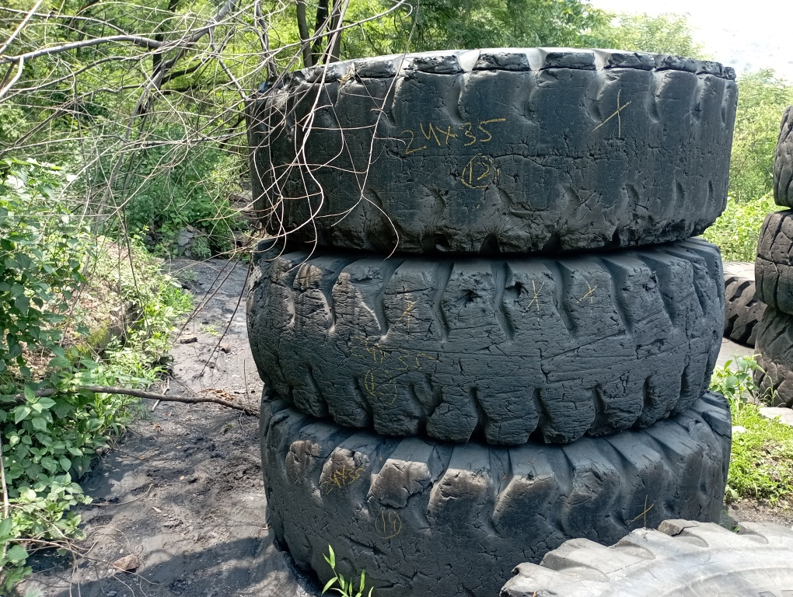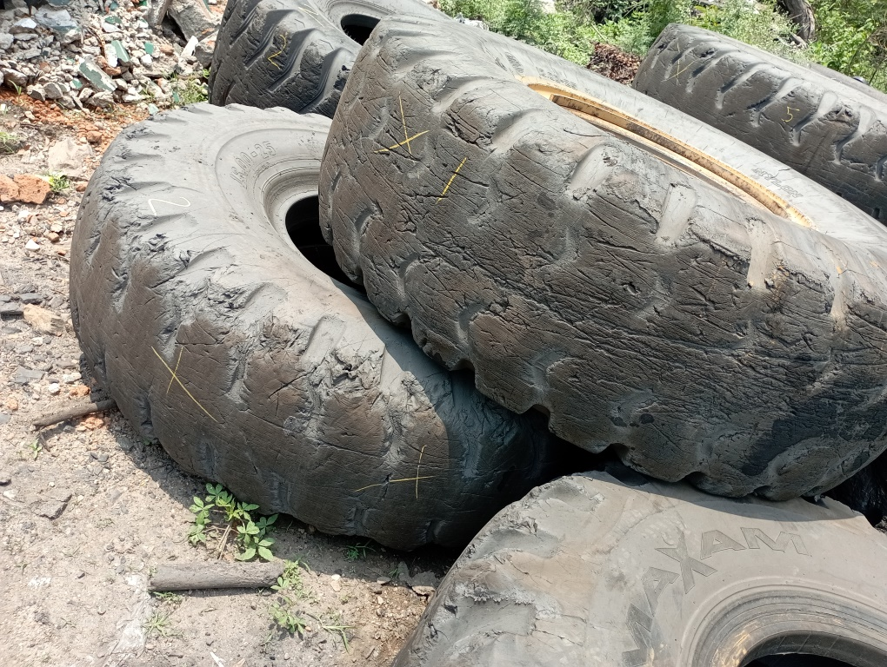
WR-26-20 WR-26-21 WR-26-22
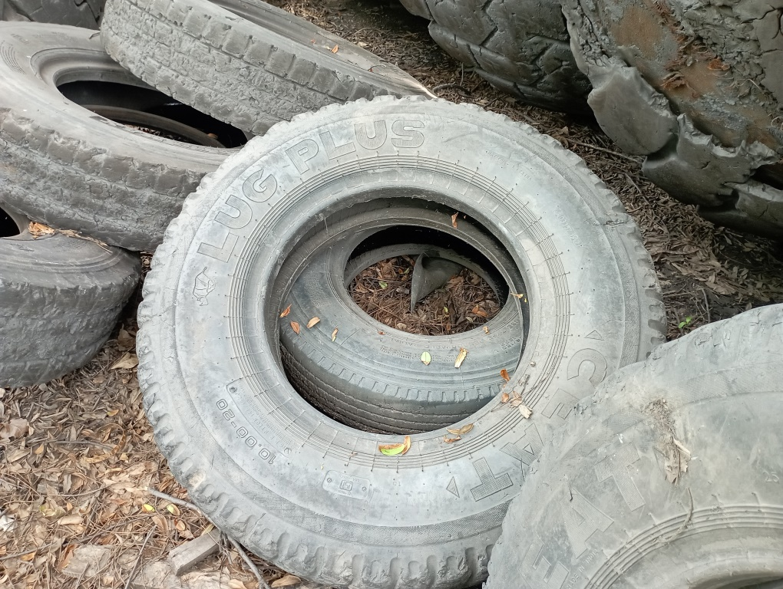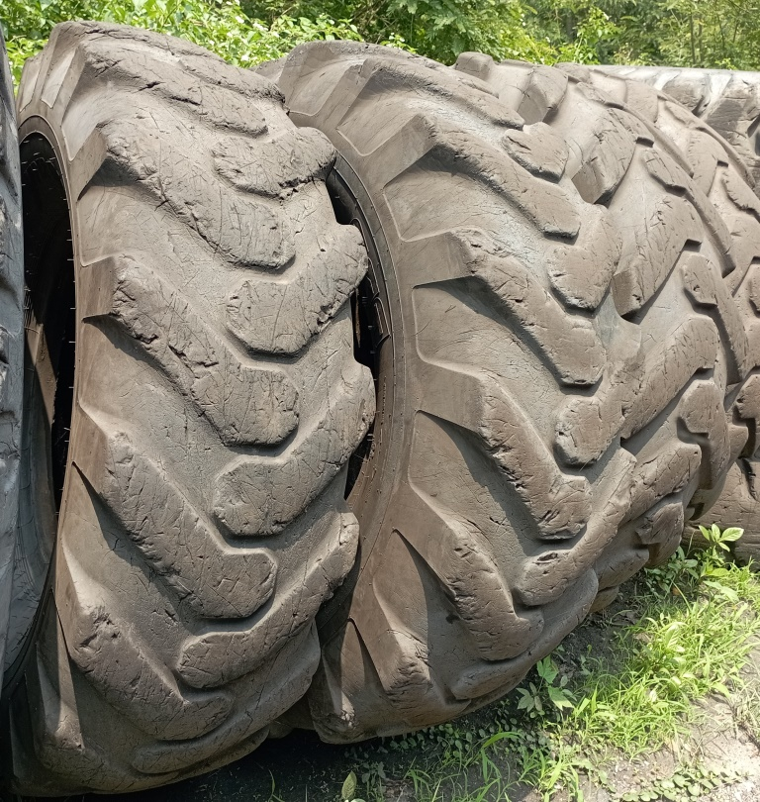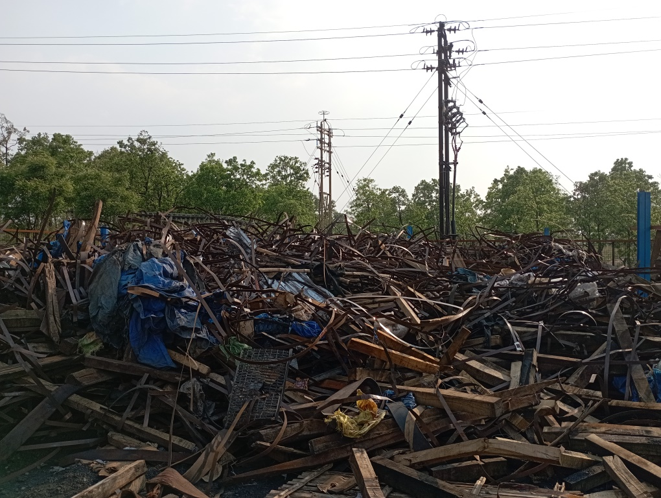
WR-26-23 WR-26-23 WR-26-24
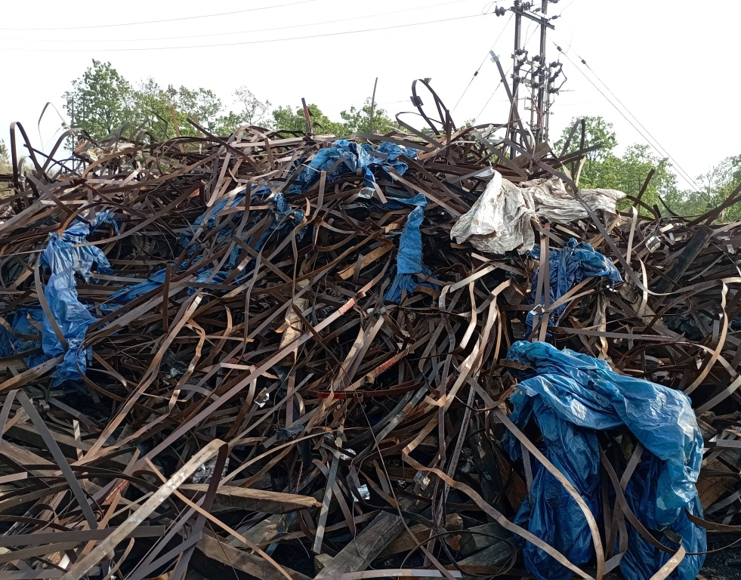
WR-26-24
Open www.ahbilimoria.com ->Click on Customer Complaint Management Portal

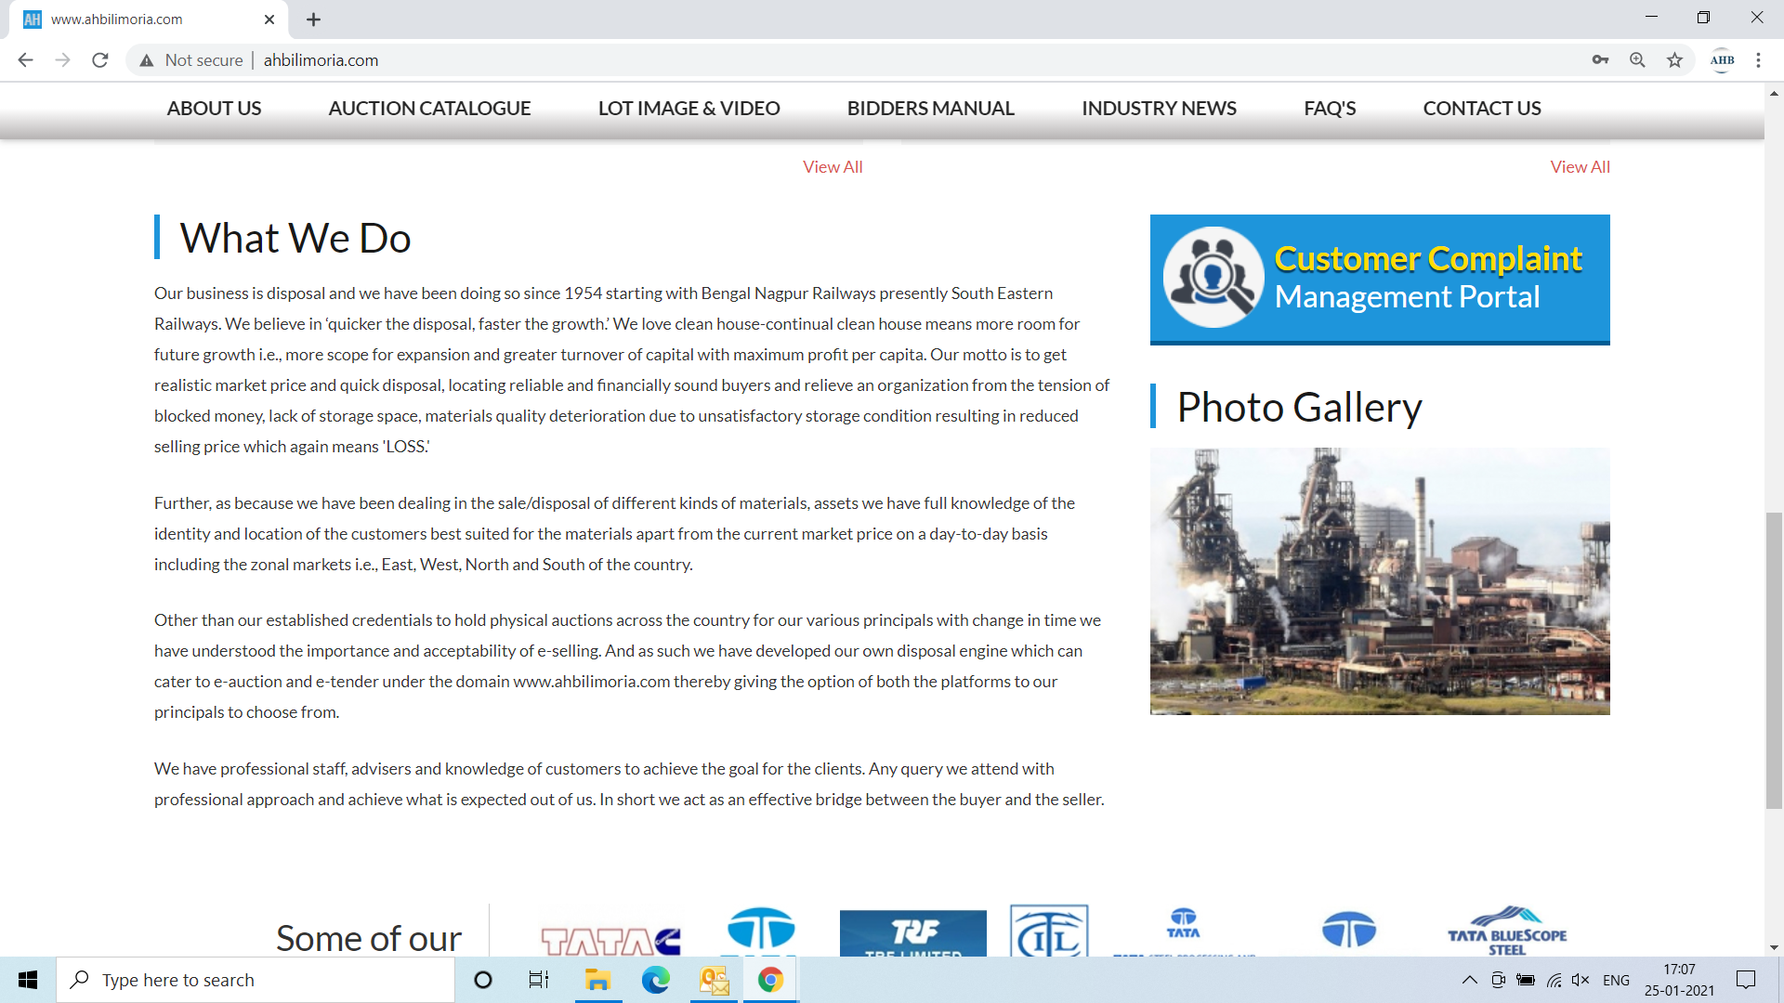

Use your User ID & Password for login

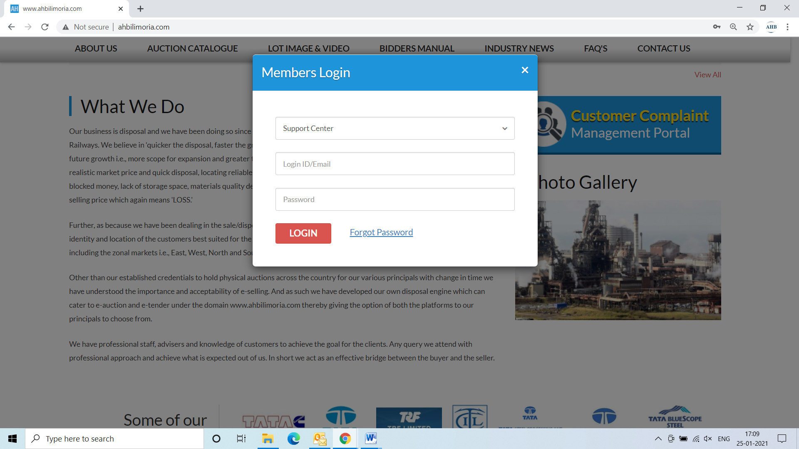

Click Complaint Portal-> Click on “Post a New Ticket”

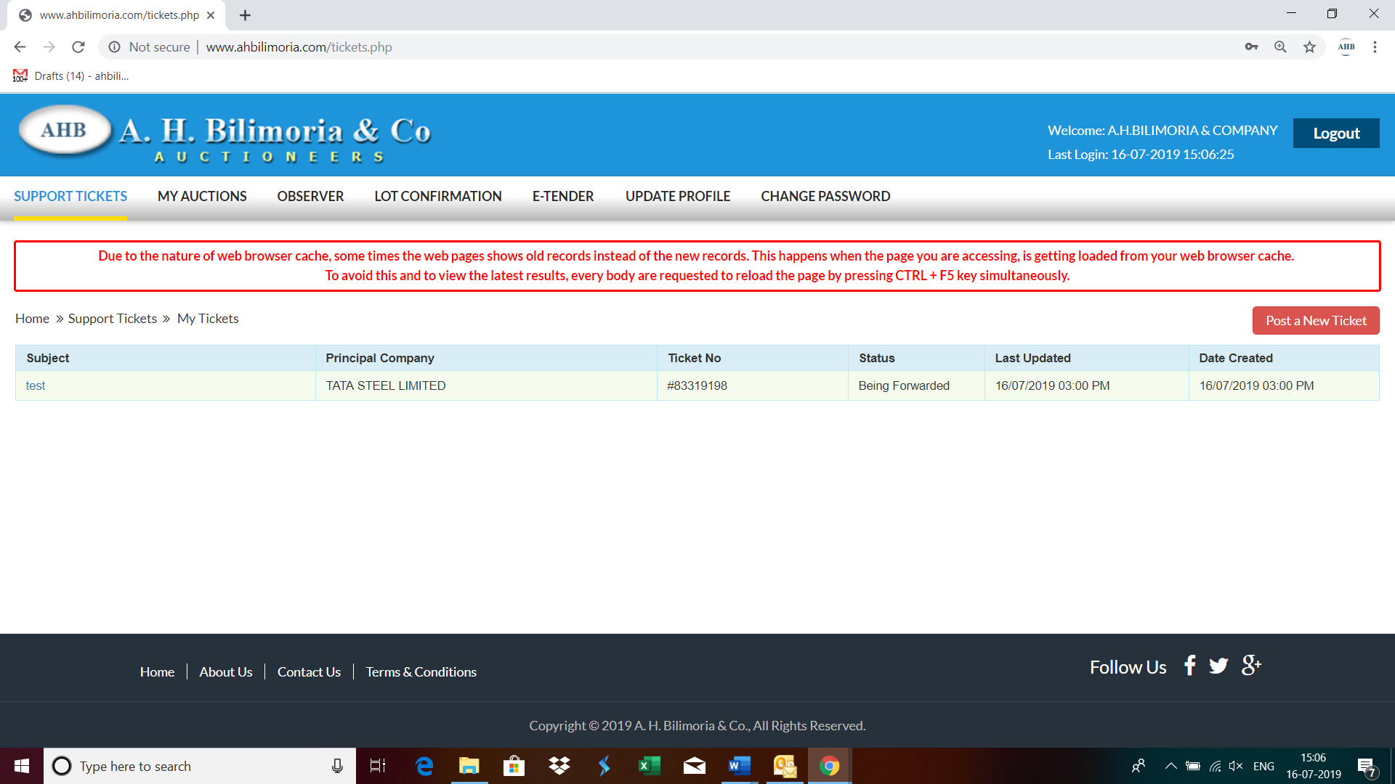

Post a New Ticket->Subject* ->Message* -> Email*->Principal Company*->Attach Document (If required any attachment) ->Submit

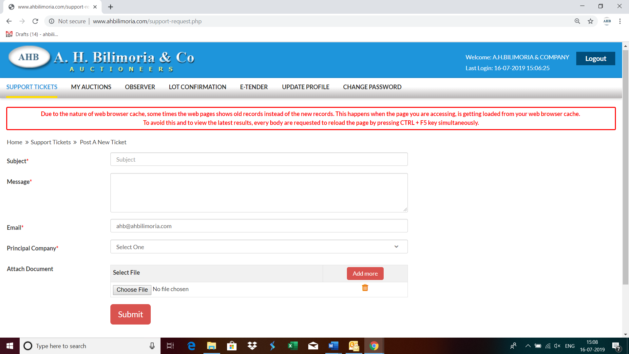

Your support request has been submitted successfully and the Reference No ----- is generated automatically

